Jonathon Walmsley
09/06/2026
Module 5.2

Deliverables
- Front-End Style Guide
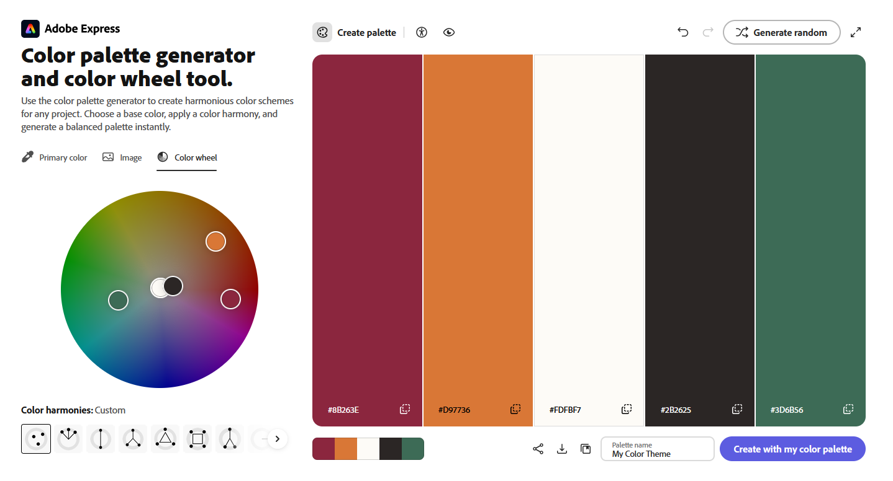
Color Palette
Primary (#8B263E - Cranberry Rose): Deep, warm rose for main navigation bars, primary header typography (h1, h2), and primary action buttons.
Secondary (#D97736 - Terracotta Gold): Warm accent for card top-borders, section subheadings (h3), and key badges.
Accent (#3D6B56 - Sage Green): Used for hyperlinks, active navigation indicators, and quote block borders.
Background (#FDFBF7 - Warm Parchment): Soft, warm off-white canvas that reduces eye strain and provides an editorial feel.
Surface / Container (#FFFFFF - Pure White): Clean white fill used for cards, text containers, and modal surfaces.
Text Dark (#2B2625 - Dark Espresso): High-contrast body copy and descriptive text without the starkness of pure black.
Border Muted (#E7E0D8 - Warm Gray): Dividing horizontal rules, image container outlines, and component borders.

Typography Hierarchy
Headings Font Family: Merriweather, Serif (Traditional, warm, editorial tone).
Body Font Family: Open Sans, Sans-Serif (Clean, legible, modern screen readability).
Heading 1 (h1): 2.2rem (Bold / 700), Line-height: 1.3, Color: --primary (#8B263E).
Heading 2 (h2): 1.6rem (Bold / 700), Color: --primary (#8B263E), Bottom Border: 2px solid #E7E0D8.
Heading 3 (h3): 1.2rem (Regular / 500), Color: --secondary (#D97736).
Body Text (p): 16px (1rem), Regular / 400, Line-height: 1.6, Color: --text (#2B2625).
Blockquote / Callout: 1.1rem, Italic, Left Border: 4px solid #3D6B56, Background: #F4EFEB, Padding: 20px 24px.

Atoms & Core UI Elements
Buttons (.btn-primary):
- Default: Background --primary (#8B263E), Text #FFFFFF, Border-radius: 8px, Padding: 10px 22px, Box-shadow: 0 2px 4px rgba(0,0,0,0.15).
- Hover / Focus: Background #6F1E31, Text #FFFFFF, Cursor: pointer.
Text Hyperlinks (a):
- Default: Color --accent (#3D6B56), Font-weight: 600, Text-decoration: none.
- Hover / Focus: Color --primary (#8B263E), Text-decoration: underline.

Molecules & Structural Components
Navigation Bar (<nav>): Full-width #8B263E container, site brand aligned left in white Serif font, flex unordered list aligned right with horizontal white text links (#FFFFFF).
Milestone / Story Card (.card): Pure white container (#FFFFFF), rounded corners (8px), 1px border (#E7E0D8), topped with a distinct 4px solid #D97736 accent border to showcase achievements on the Landing page.
Alternating Feature Row (.feature-row): Reusable Flexbox row pairing an image placeholder (140px minimum height) with an adjacent text block, utilizing flex-direction: row-reverse on alternating entries for the Hobbies timeline.

- Wireframes/Sketches
Landing Page Sketch:
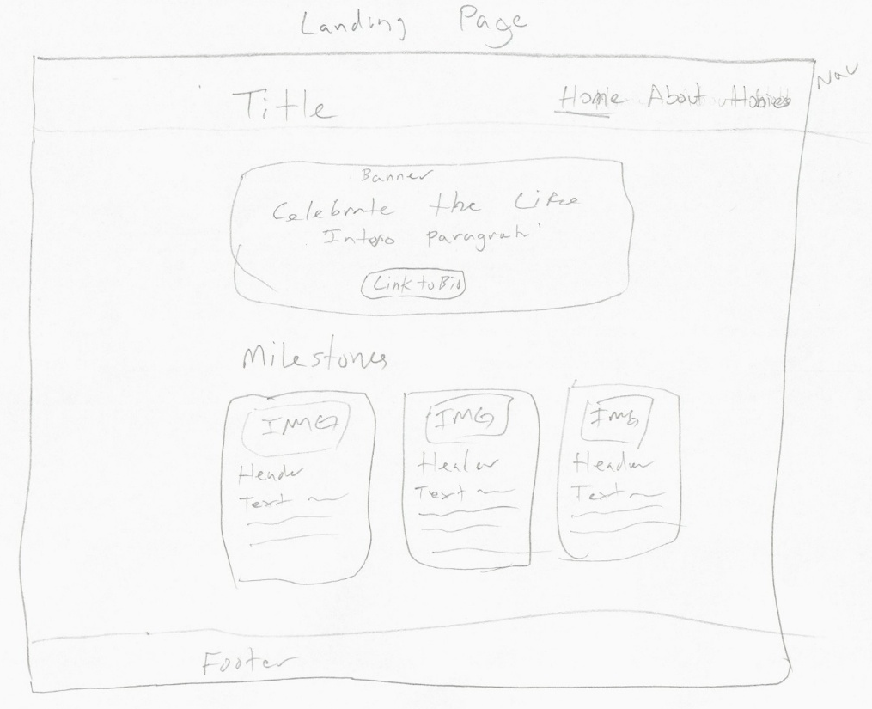

About Page Sketch:
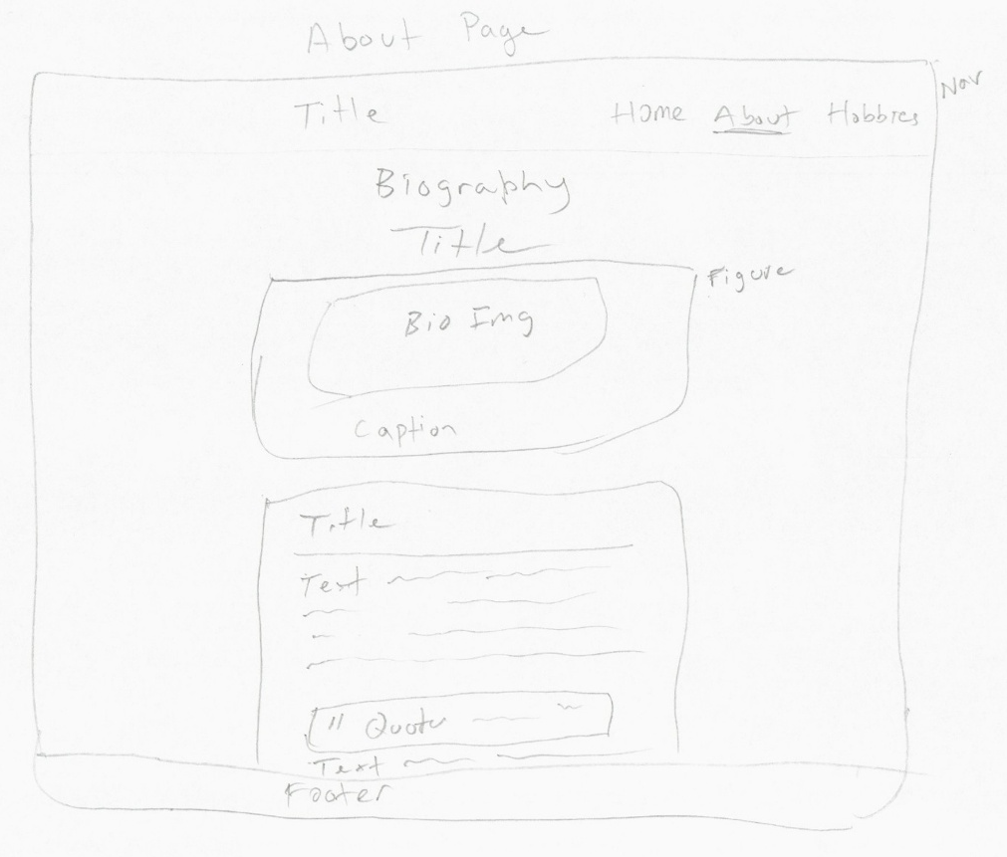
Hobbies Page Sketch:
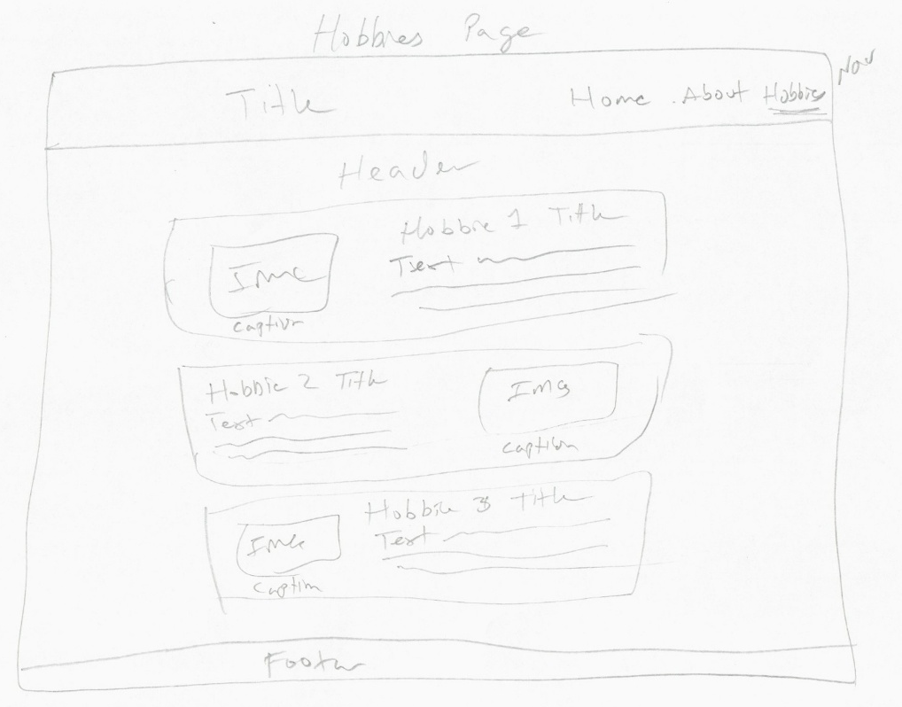

- The 10-Question Interview
1. What is your full name and date of birth?
"My name is Jolene (family nickname 'Gma'). I was born on May 5, 1930 on Cinco de Mayo, along with my twin sister."
2. Where were you born and where did you grow up?
“I was born in a house on a street called Central in San Diego. My parents then moved when I was just 3 months old to Ocean Beach where I grew up.”
3. What was one of your earliest memories from childhood?
"When I was four and a half years old my parents had an orange tree and my twin sister and I were trying to pick them and we were told no, no, no…"
4. What was your primary career or focus as an adult?
"Working in the Pepper Drive school in the children’s library"
5. What is your favorite tradition centered around your May 5th birthday?
"Having big family get-togethers. It was always fun to celebrate with my twin sister."
6. At 95, what motivates you to keep traveling across the country?
"Family is spread out across different states, and seeing my children, grandchildren, and great-grandchildren in person keeps me young and energetic."
7. What is your favorite way to travel?
"I still enjoy flying because it gets me to family quickly, but taking scenic road trips through the mountains has always been a special treat."
8. What hobbies have you enjoyed the most throughout your life?
"Working on craft projects for my grandchildren, and great-grandchildren."
9. What major historical change has amazed you the most during your 95 years?
"Being married to the love of my life and having four healthy children."
10. What piece of advice do you share most with younger generations?
"Aways be happy, don’t be angry, if you can’t do anything about it don’t sweat it!"

- Biography
Jolene, affectionately known to generations of family members as Gma, was born in a house on Central Avenue in San Diego on May 5, 1930. Arriving on Cinco de Mayo alongside her twin sister, her birthday marked the start of a lifelong tradition of festive family get-togethers where celebrating side by side with her sister made every milestone unforgettable. When she was just three months old, her family moved to Ocean Beach, where she spent her formative years. Growing up near the coast provided fond early memories that she still shares today, including the time she and her twin sister were four and a half years old trying to pick fresh fruit from their parents' backyard orange tree, only to be met with a chorus of "no, no, no."
As an adult, Jolene dedicated her professional career to community education and early literacy, working in the children's library at the Pepper Drive school. In the library, she introduced young students to the joy of reading, created welcoming learning spaces, and shared her appreciation for books. Beyond her work, her family was the center of her life. When reflecting on nearly a century of lived history, she considers her greatest personal achievement to be marrying the love of her life and raising four healthy children. Her home was always grounded in warmth, creativity, and lasting generational connections.
At 96 years old, Jolene continues to maintain an active routine. Because her children, grandchildren, and great-grandchildren live across multiple states, she frequently travels across the country by airplane to visit them in person, while also enjoying scenic road trips through the mountains. When she is not traveling, she channels her energy into handcrafting art and keepsake projects designed especially for her grandchildren and great-grandchildren. Her life reflects an enduring philosophy that she regularly passes down to younger generations: "Always be happy, don't be angry, if you can't do anything about it don't sweat it!"

- Images & Captions
- Portrait (About Page):
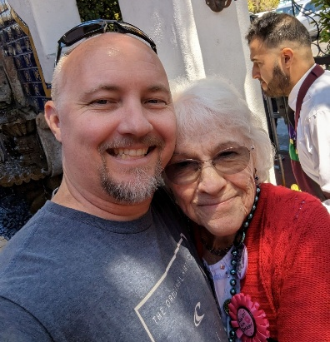
Caption: "A recent portrait of Gma and her favorite Grandson."
- Milestone 1 (Landing Page):
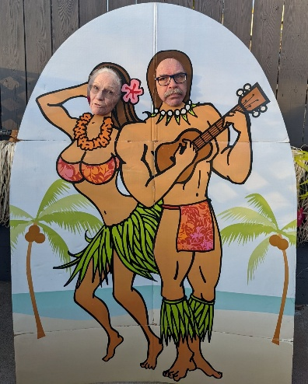
Caption: "Having fun with her son at a family reunion."
- Milestone 2 (Landing Page):
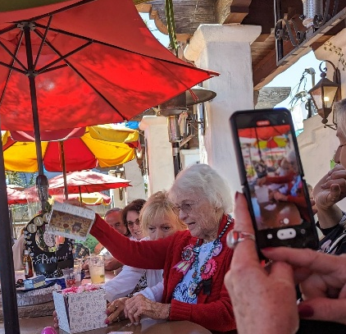
Caption: " Reaching her 95-year milestone, celebrated with family on Cinco de Mayo."

- Milestone 3 (Landing Page):
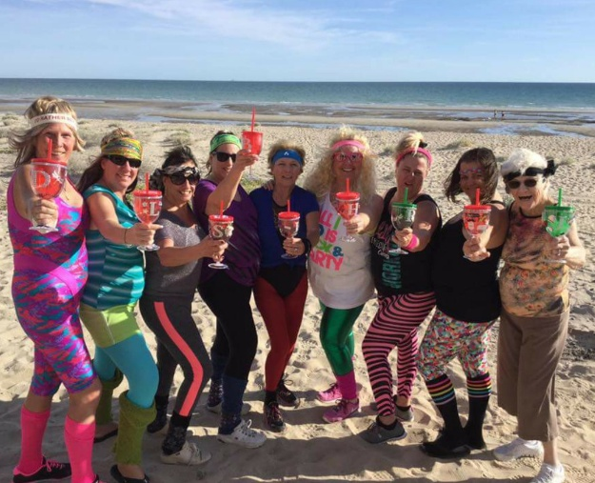
Caption: "80’s theme Martini Party at the Beach."
- Hobby 1 (Hobbies Page):
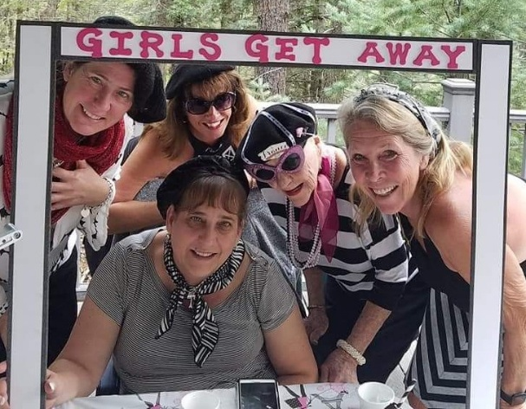
Caption: "Having fun on a girls vacation get away."
- Hobby 2 (Hobbies Page):
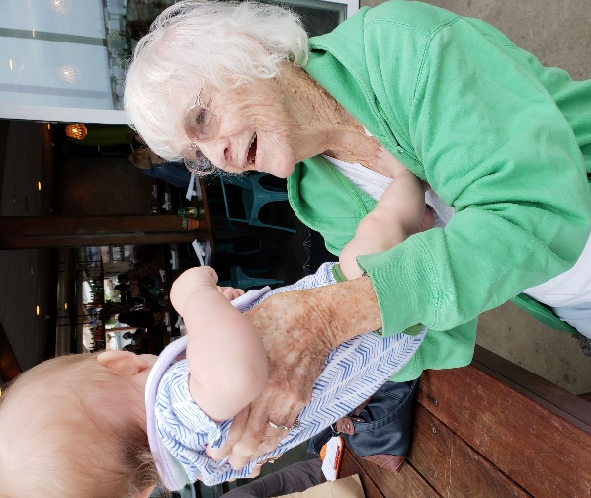
Caption: "Enjoying playing time with the newest great-grand child."
- Hobby 3 (Hobbies Page):
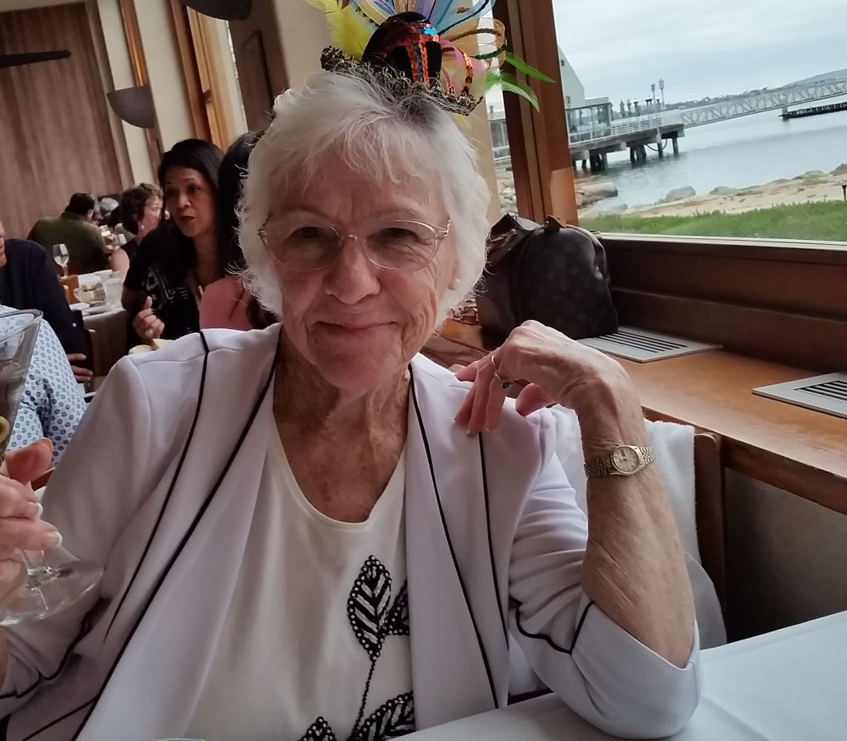
Caption: "Toasting many years to come…"

