Jonathon Walmsley
08/16/2026
Module 1.2

GitHub repo:
https://github.com/jonathon-walmsley/csd-340
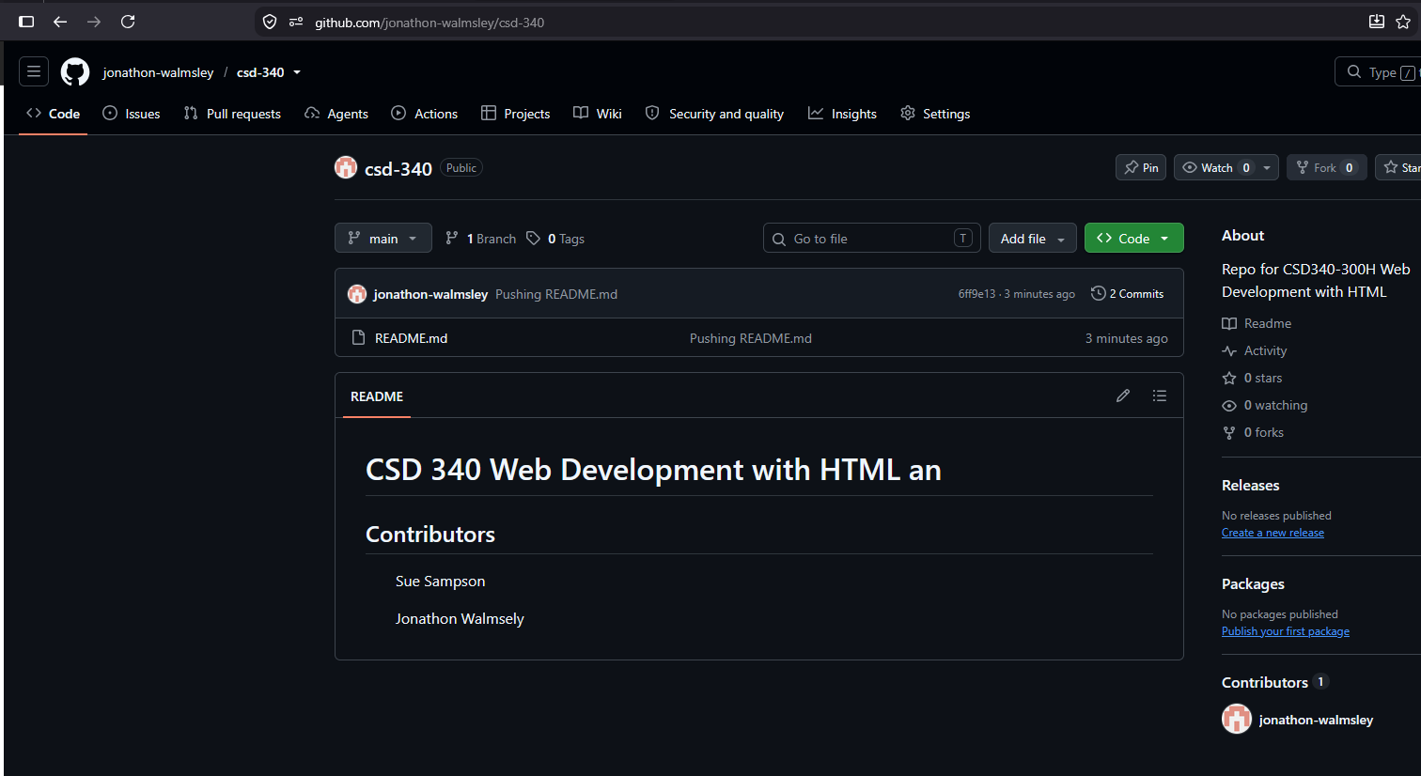

Local Directory: