Jonathon Walmsley
08/16/2026
Module 1.3

Java Install Path
C:\Program Files\Microsoft\jdk-25.0.4.7-hotspot
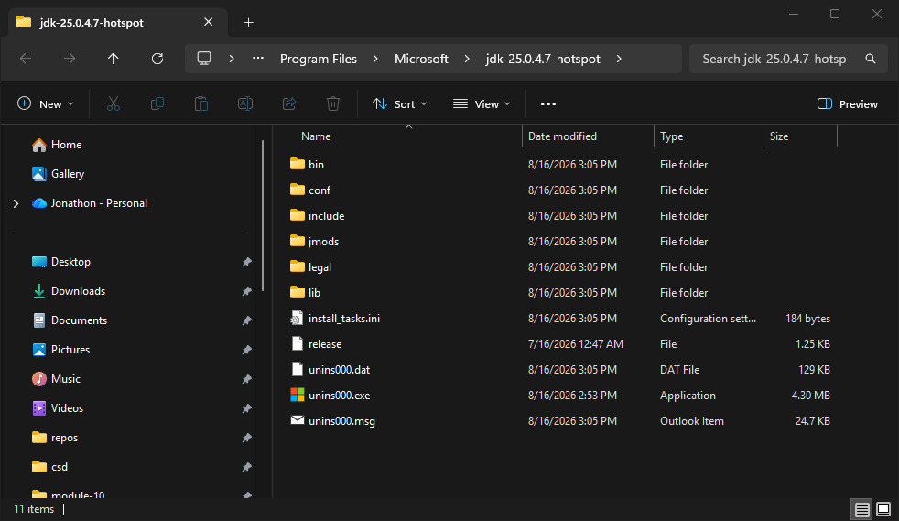

JavaFX Install Path
C:\Program Files\Java\javafx-sdk-26.0.2
