Jonathon Walmsley
10/25/2026
Module 1.2

GitHub Repo: https://github.com/jonathon-walmsley/csd-420
GitHub Repo Screenshot:
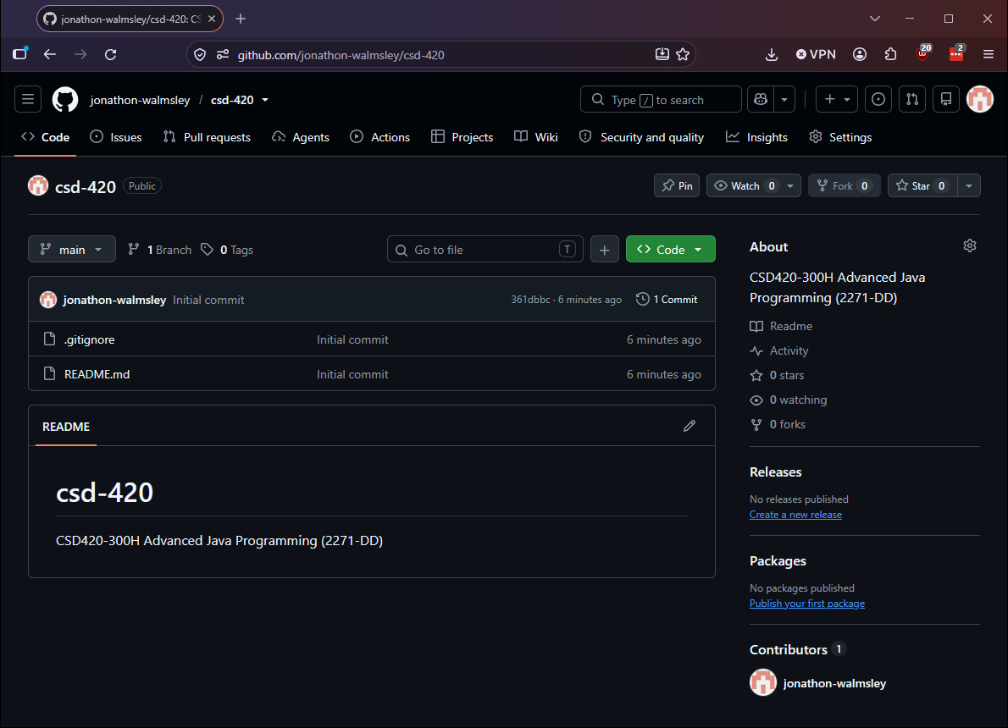
Local Directory Screenshot:
