DIN PERSONLIGE HELSESJEF

Oslo Concierge GP

Full Business Plan & Implementation Roadmap

AI-Powered Personalised Private Medical Practice for Oslo Executives

Version 2S | March 2026 | CONFIDENTIAL

1. Executive Summary
Din Personlige Helsesjef — 'Your Personal Health Chief' — is Norway's first AI-native concierge GP practice, designed to serve Oslo's executive market with proactive, personalised, data-driven healthcare that the Norwegian public system is structurally incapable of providing.
The practice operates on a monthly membership model with three tiers (NOK 2,500 / 5,000 / 10,000 per month), targeting a panel of 50–100 members. At full capacity, the practice generates NOK 3–6 million in annual recurring revenue at net margins of 70–80% — comparable to the best consulting or legal practices in Oslo.
The core innovation is not the service concept itself — concierge medicine is a proven global model — but the AI infrastructure layer that makes it operationally viable for a single physician. Built on locally-hosted, GDPR-compliant AI (OpenClaw on Mac Mini M4), it automates the cognitive overhead that typically requires an entire support team: between-visit monitoring, pre-consultation briefings, lab result interpretation, protocol management, and proactive member outreach. The physician focuses on the high-value clinical relationship. The AI handles everything else.
This is not a technology startup. It is a medical practice — one powered by the most sophisticated personal AI infrastructure in Norway today.

Key Metrics at Full Operation
Metric | Value
Annual Recurring Revenue | NOK 6,000,000
Estimated Net Margin | 70–80%
Panel Size | 50–100 members (vs. 1,100+ for a standard fastlege)
Time Commitment | 3–4 clinical days/week
Break-even | ~15 members (NOK 900,000–1,125,000/year)
Launch Timeline | First paying members within 60–90 days

2. The Market Opportunity

2.1 A Structural Failure at the Top End
The Norwegian fastlege system was designed for coverage, not for quality at the executive level. The average fastlege manages 1,100+ patients, delivers 10-minute consultations, has no infrastructure for between-visit contact, and operates almost entirely reactively — treating illness when it arrives rather than preventing or optimising health.
Oslo's executive class experiences this as a jarring contrast to every other premium service in their life. These are people who apply data-driven thinking to every corner of their professional existence. They have personal trainers with biometric programmes, financial advisors who know their complete picture, lawyers on retainer, executive coaches. Their health — often their most valuable asset — gets a 10-minute appointment every few years.
The problem is not access to emergency care. It is the complete absence of a long-term, proactive, personalised health relationship. That product does not exist in Norway. This practice creates it.

2.2 Target Market
The ideal member is 38–58, earning NOK 2M+ household income, already investing in premium wellness, and frustrated by the public system's inability to know them as an individual:
- Partners and senior associates at Oslo law, finance, and consulting firms
- C-suite and senior executives at Equinor, DNB, Statkraft, Kongsberg, Aker, and comparable companies
- Senior management at PE/VC funds and Oslo-based family offices
- Successful founders and tech entrepreneurs
- High-income expats in senior Oslo roles
- Professionals already spending on Oura rings, nutritionists, and personal trainers

2.3 Market Size
Oslo has ~700,000 inhabitants. An estimated 15,000–25,000 fit the executive profile. Reaching 100 members is less than 0.7% penetration — achievable through personal network outreach alone in Year 1.

2.4 Global Validation & International Analogues
Concierge medicine is proven and fast-growing globally — USD 20.5B in 2025, projected USD 44.3B by 2034. What is new — and absent in Norway — is the combination of concierge medicine with locally-hosted AI infrastructure.

Practice | Location | Pricing | Model | Key Insight
MDVIP | USA | USD 1,800–3,000/yr | Network of 1,100+ GPs, ~600 patients/doctor | Proven at scale — premium over public care
Parsley Health | USA/UK | USD 150–250/mo | Functional medicine + health coaching | Closest analogue — data-driven, preventive
One Medical | USA | USD 199/yr + insurance | App-based, now Amazon-owned | Tech integration at volume; validates market
Lanserhof | Germany/Austria/UK | EUR 500–1,500/day | Longevity resort, executive clientele | Validates executive appetite for premium health
PrivateDoc / Concierge GP | UK (London) | GBP 3,000–12,000/yr | Boutique solo GP practices | Closest structural analogue to Oslo model
Coa / Nemo Health | Scandinavia | NOK 600–1,500/mo | Digital primary care, limited relationship | Proves Norwegian willingness to pay
Aleris / Volvat | Norway | NOK 2,000–5,000/consult | Private specialist care, no retainer | Current ceiling — no ongoing relationship product

Key insight: The most successful international concierge practices compete on depth of relationship, not price. In London and New York, practices charging USD/GBP 5,000–10,000+/year have multi-year waiting lists. Oslo has comparable purchasing power and zero competition in this segment.

3. The Service Model

3.1 Membership Tiers
Feature | Klienten — NOK 2,500/mo | Partneren — NOK 5,000/mo | Partneren Pro — NOK 10,000/mo
Annual health assessment | 2 hours | 2 hours + advanced labs | 3 hours + full longevity panel
Follow-up consultations | Quarterly (4/year) | Every 2 months (6/year) | Monthly (12/year)
Messaging access | WhatsApp, same-day reply | WhatsApp + direct mobile | Unlimited calls + messages
Appointment guarantee | Same week | Same day (urgent) | Same day always
Lab panel | Standard annual | Advanced metabolic + cardiovascular | Full longevity panel incl. ApoB, GlycanAge
Wearable integration | Optional | Included (Oura/Garmin/Apple) | Included + monthly analysis
AI health brief | Quarterly summary | Monthly personalised report | Monthly + annual roadmap
Supplement protocol | On request | Included, reviewed 2x/year | Full protocol, quarterly review
Home/office visit | Not included | 1 per year | Unlimited
Travel medicine | Standard advice | Included | Full remote support abroad
Annual prepay discount | 10% | 10% | 10%
Max panel members | 40 | 40 | 20

3.2 The Core Differentiator
The differentiator is not speed of access — private Oslo clinics already offer that. The differentiator is continuity and depth. Every member has a living health dossier accumulating data across years. Every consultation builds on the last. The AI infrastructure means the physician arrives at every appointment already knowing what changed, what trends need attention, and what questions matter.
Members do not feel like patients. They feel like they have a personal health director.

3.3 The Annual Health Roadmap
Every Tier 2 and Tier 3 member receives a 90-minute Annual Health Roadmap Review at their membership anniversary — reviewing progress, updating risk stratification, and setting measurable objectives for the coming year. This ritual creates a powerful retention anchor. International data from comparable practices shows 40% lower churn rates among members completing annual roadmap reviews.

4. AI & Technology Architecture

4.1 The Infrastructure Advantage
The entire technology stack runs locally on Mac Mini M4 hardware. No patient data ever leaves the physician's premises — a GDPR compliance requirement and a premium marketing differentiator.

Component | Specification
Hardware | Mac Mini M4 (current) → Mac Studio M5 Max 128GB (Year 2–3)
Orchestration | OpenClaw — local AI agent framework
LLM Models | Qwen 3.5 35B (local) for analysis; Claude Sonnet API for drafting (non-PII only)
Knowledge Base | Per-member RAG folders, markdown-structured, updated after every interaction
Secure Access | Cloudflare Tunnel — encrypted remote access
Communication | Signal/WhatsApp — end-to-end encrypted member messaging
Lab Integration | PDF ingestion pipeline → structured JSON → member dossier
Wearable Pipeline | Garmin/Oura/Apple Health → weekly structured summaries
Billing | Stripe or Vipps recurring membership payments

4.2 The Five AI Agents
Agent | Trigger | Function
Nightly Monitor | 02:00 daily | Reads all member dossiers, flags anomalies vs. personal baselines, generates morning briefing
Pre-Consultation Briefer | 60 min before appointment | Summarises changes since last consult, suggests consultation structure
Lab Result Processor | New PDF in lab folder | Parses results, flags out-of-range values, drafts lay-language interpretation
Monthly Health Brief | 1st of each month | Synthesises wearable, consult, and messaging data into personalised health brief
Protocol Reviewer | Quarterly | Reviews supplement/diet/exercise protocols against latest labs, flags adjustments

5. Financial Projections

5.1 Revenue & Net Income
 | Year 1 (ramp) | Year 2 | Year 3 | Full Capacity
Members | 35–50 | 60–75 | 80–100 | 100
Monthly Revenue | NOK 175–250K | NOK 350–450K | NOK 450–500K | NOK 500K
Annual Revenue | NOK 2.1–3.0M | NOK 4.2–5.4M | NOK 5.4–6.0M | NOK 6.0M
Estimated Net (70–80%) | NOK 1.5–2.4M | NOK 2.9–4.3M | NOK 3.8–4.8M | NOK 4.2–4.8M

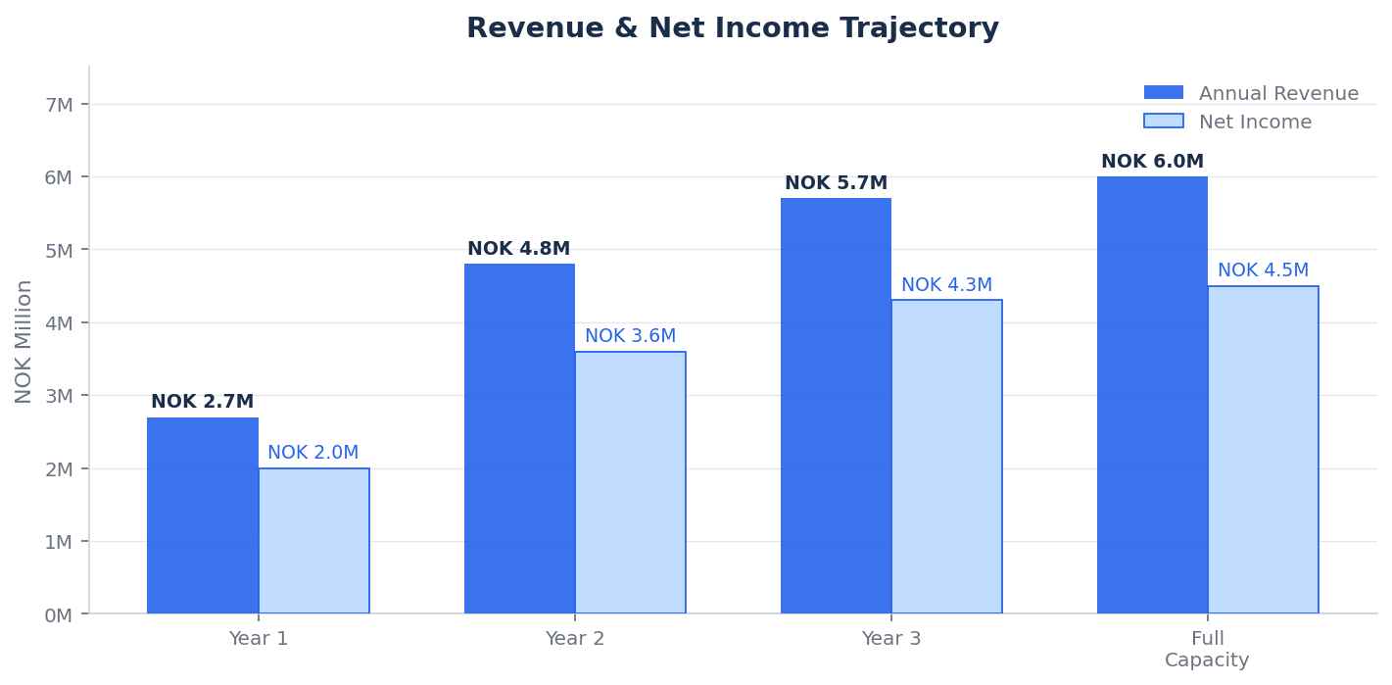
Figure 1 — Annual Revenue & Net Income by Year

5.2 Member Growth Projection
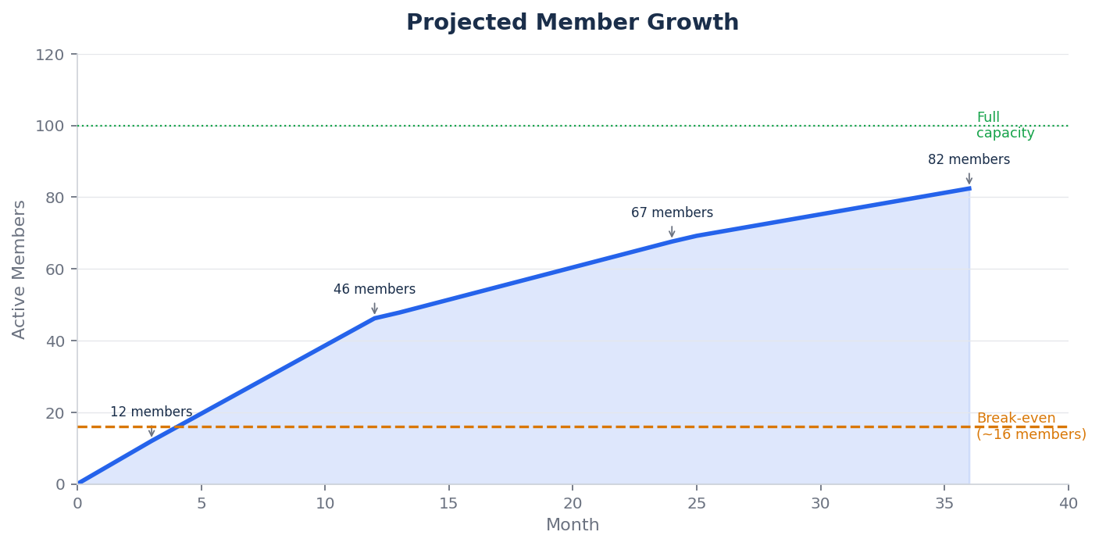
Figure 2 — Projected Member Growth with Break-Even Threshold

5.3 Break-Even Analysis
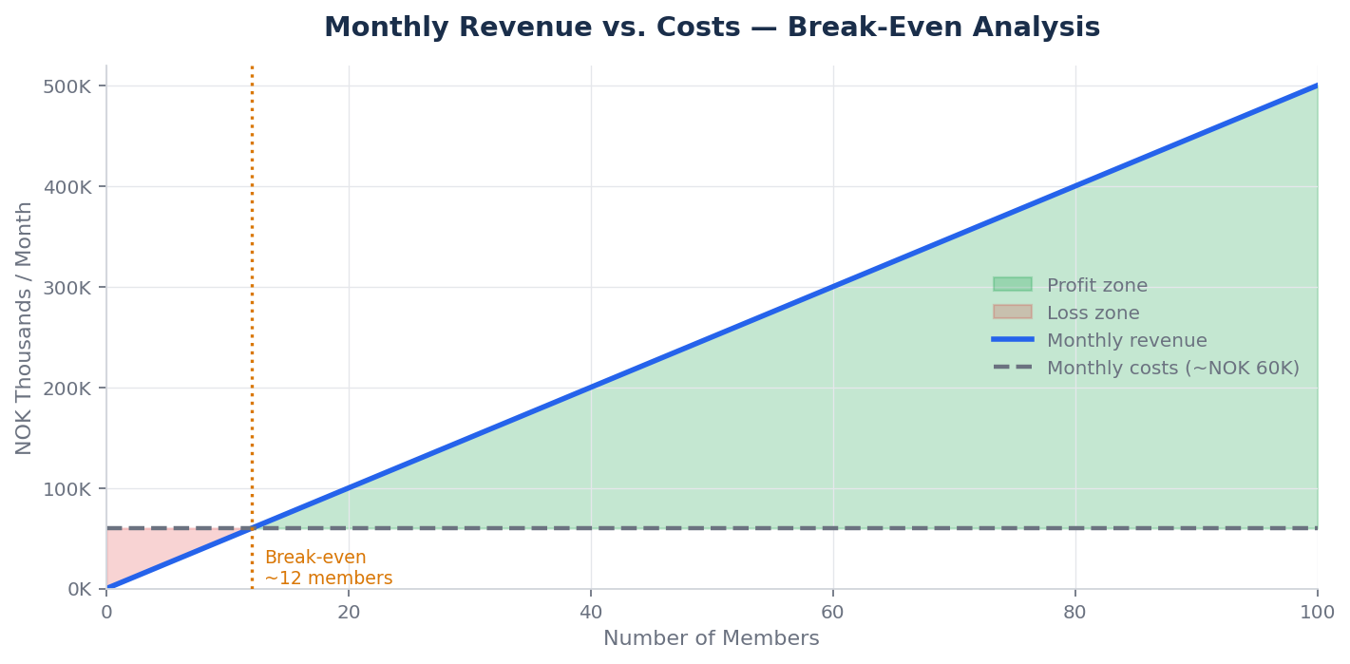
Figure 3 — Monthly Revenue vs. Costs (Break-Even at ~12–15 members)

Break-even point: 15–18 members generating NOK 75,000–90,000/month vs. NOK 40,000–60,000/month costs
Timeline to break-even: 60–90 days from launch given existing professional network
Payback on setup investment: Within 6–12 months at Tier 2 average pricing

5.4 Revenue Mix by Tier
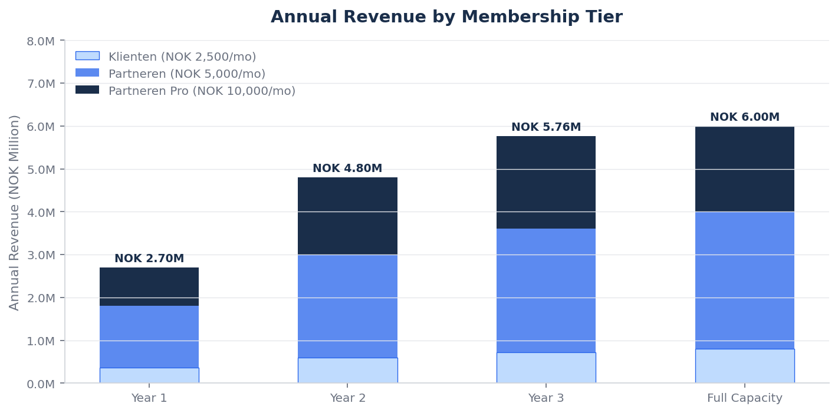
Figure 4 — Annual Revenue by Membership Tier

5.5 5-Year Financial Waterfall
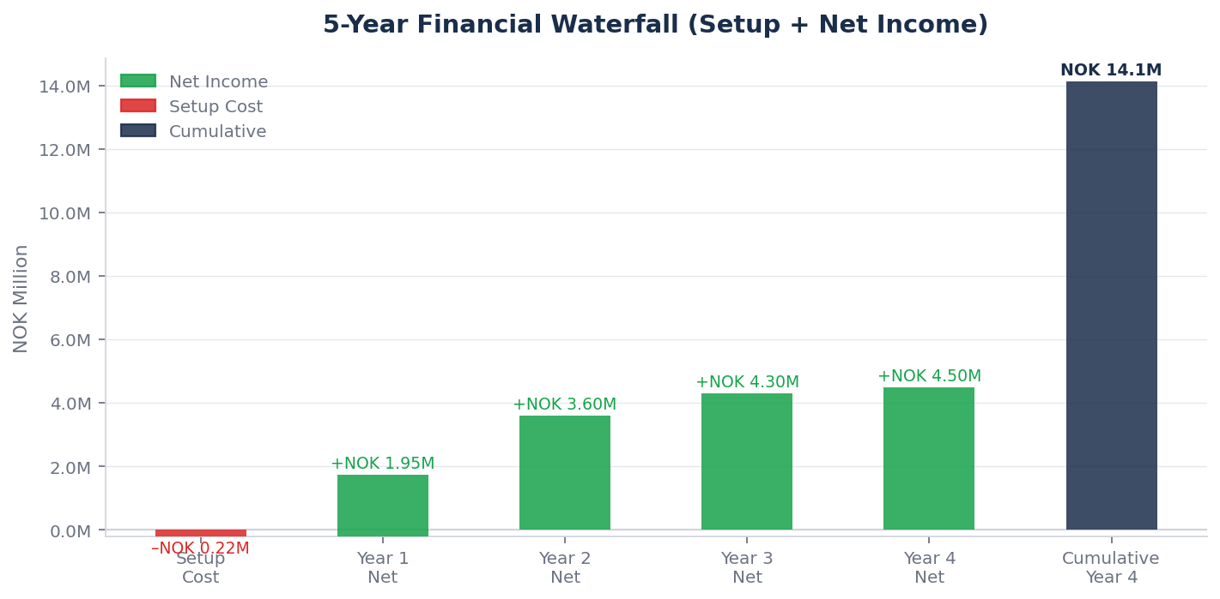
Figure 5 — 5-Year Cumulative Net Income Waterfall (setup costs deducted)

5.6 Cost Structure
Cost Item | Monthly | Annual
Clinic room rental (Oslo centre) | NOK 10,000–20,000 | NOK 120,000–240,000
Lab costs | NOK 5,000–15,000 | NOK 60,000–180,000
OpenClaw / AI infrastructure | NOK 1,000–2,000 | NOK 12,000–24,000
EPJ system (EG Pasientsky) | NOK 600–800 | NOK 7,200–9,600
NPE contribution | — | NOK 1,000–2,500
Professional liability insurance | — | NOK 20,000–40,000
Accountant / legal | — | NOK 30,000–60,000
Marketing and content | — | NOK 20,000–40,000
Total (at full operation) | NOK 40,000–80,000 | NOK 480,000–720,000

5.7 Tax Structure
Register as AS (Aksjeselskap). Corporate tax rate 22%. Optimal structure: salary of NOK 700,000–900,000 with retained earnings compounding in the company. Dividends extracted at 37.84% effective rate. A skilled skatteadvokat can optimise this structure to be worth NOK 200,000–500,000/year in after-tax income.

6. Marketing & Customer Acquisition

6.1 Core Positioning
"Din personlige helsesjef — legen som faktisk kjenner deg."

This is not a healthcare pitch. It is a relationship pitch. Oslo's most successful people are missing one thing their peers in London and New York increasingly have: a doctor who actually knows them. The physician who remembers their labs from three years ago, who messages when sleep data looks concerning, who treats health as an ongoing project — not a series of 10-minute appointments.

6.2 Acquisition Channels
Channel | Timeline | Target | ROI
Personal network outreach | Month 1–3 | 10–15 founding members | Highest — zero cost
Executive Health Audit (NOK 15,000) | Month 3+ | Corporate entry, ~40% convert to membership | High — self-funding
Corporate executive benefits | Month 3–6 | 5–10 Oslo companies | High — scales revenue
Thought leadership (Finansavisen/DN) | Ongoing | Inbound leads | High — brand-building
Referral programme (1 free month) | Month 4+ | Member-driven acquisition | Highest — trust transfer
Premium partnerships (gym, physio, coaching) | Month 6+ | Warm wellness audiences | Medium

6.3 The Corporate Benefits Channel
The corporate pitch is straightforward: executive health membership as a benefit costs NOK 30,000–120,000 per executive annually — trivial against the cost of an executive vacancy (typically 1–2× annual salary). A single agreement covering five executives generates NOK 150,000–600,000 in recurring annual revenue.
Secure 2-year exclusivity agreements with one premium private clinic and one premium gym (e.g. SATS Elite). This prevents direct replication and creates a defensible referral network.

7. Implementation Roadmap
Phase | Timeline | Objectives | Key Milestones
Foundation | Weeks 1–4 | Legal, systems, clinical infrastructure | AS registered, EPJ live, lab partnerships, OpenClaw configured
Founder Launch | Weeks 5–12 | Soft-launch to personal network | 10–15 founding members, all tiers tested, first dossiers built
Growth | Months 4–12 | Full-rate acquisition, corporate outreach | 40–50 members, first corporate agreement, content published
Scale | Year 2 | Expand capacity, add clinical support | 75–100 members, nurse practitioner/PA hired
Optimise | Year 3+ | Full concierge operation | 80–100 members, optional second physician or expansion

7.1 90-Day Launch Checklist
- Week 1: Review fastlegeavtale for competing activity clauses; consult Legeforeningen legal support if needed
- Week 1: Register AS via Altinn; notify municipality of private practice; notify employer per contract
- Week 1–2: Engage lawyer — membership agreement, privacy notice, consent forms
- Week 1–2: Apply for ansvarsforsikring (professional liability insurance)
- Week 2: Identify and secure consultation room (shared privatklinikk space to start)
- Week 2–4: Set up OpenClaw on Mac Mini M4 with member dossier structure and all 5 AI agents
- Week 2–4: Establish lab partnership accounts (Unilabs and/or Fürst)
- Week 2–4: Register with NPE before first patient; configure EPJ, intake form, scheduling, billing
- Week 4–6: Draft member handbook, supplement protocol templates, SOAP consultation templates
- Week 6–8: Write personal outreach to 30–50 professional network contacts
- Week 8–10: Host 2–3 informal conversations; offer founding member pricing (NOK 1,500–2,500/mo)
- Week 10–12: Onboard first 5–10 members; run first agent briefing cycle
- Day 90 Target: 15+ members, NOK 75,000+/month recurring revenue

8. Risk Management & Competitive Moat

8.1 Key Risks
Risk | Probability | Impact | Mitigation
Physician illness/unavailability | Low | High | 1–2 locum GP relationships; coverage dossiers; force majeure clause
Fastlege agreement conflict | Medium | High | Review contract before launch; clear practice separation; legal advice
Competitive entry | Medium | Medium | 2-year exclusive partnerships; proprietary AI stack; data moat
Member churn | Medium | Medium | Annual Roadmap ritual; prepay discount; engagement scoring; pause option
Regulatory change | Low | Medium | Monitor helfrivat rules; annual healthcare legal review

8.2 Competitive Moat
Moat Layer | Description | Time to Replicate
Data accumulation | Member dossiers grow richer with every interaction — irreplaceable after 2+ years | 2+ years
AI infrastructure | The OpenClaw agent stack requires significant technical expertise to build | 12–18 months
Exclusive partnerships | 2-year lock-in with clinic and gym partners blocks referral network access | 24 months
Personal trust | The physician-member relationship is the primary retention driver — irreplaceable | Irreplaceable

9. Regulatory & Legal Framework

9.1 Practice Structure: Helfrivat
The practice operates as a hjelprivat praksis — fully private, no public funding, no trygderefusjon. Patients pay 100% out-of-pocket. No Helfo registration required. Full pricing freedom. No normaltariff obligations.

9.2 Registration Requirements
Requirement | Details | Timeline
Business Entity | Register AS or ENK via Altinn | Week 1
Municipality Notification | Notify kommune: name, address, size, financing model | Week 1–2
Employer Notification | Inform municipality of secondary commercial activity | Week 1
NPE Registration | Notify Norsk pasientskadeerstatning before first patient (pasientskadeloven §8) | Before first patient
EPJ System | Compliant electronic patient journal per pasientjournal-forskrift §4 | Week 2–4
Professional Insurance | Ansvarsforsikring | Week 1–2

10. Member Retention Strategy
Retaining a member is worth NOK 30,000–120,000 per year. The retention framework is built around four principles: demonstrate ongoing value, create commitment anchors, reduce friction to staying, and make leaving feel like a genuine loss.

Strategy | Mechanism | Target Metric
Annual Health Roadmap | 90-min anniversary review: progress, goals, risk update | Roadmap completion >90%
Quarterly 'Health Win' | One concrete data-driven improvement highlighted per quarter | Engagement score >80%
Engagement Scoring | Track message frequency, consult attendance, wearable sync, lab completion | Monthly churn <2%
Pause Option | 1–3 month pause available (max 1/year); full dossier maintained | Pause-to-resume >70%
Referral Incentive | One free month per successful referral staying 3+ months | Referral rate >20%/year
Annual Prepay Discount | 10% off for 12-month upfront commitment | Annual retention >85%

11. Funding & Investment Options
Din Personlige Helsesjef is operationally lean — setup costs of NOK 150,000–300,000 and a break-even of 15–18 members mean it can be self-funded by a physician with modest personal capital. However, several Norwegian and European funding options can accelerate growth and de-risk the investment.

11.1 Innovation Norway (Innovasjon Norge)
Innovation Norway is the primary government instrument for supporting innovative businesses. Frame the practice as Norway's first AI-native health platform — not just a GP practice. The technology angle (locally-hosted LLM, real-time biomarker monitoring, AI agent infrastructure) is what secures funding. Innovation Norway funds technology, not services; position accordingly.

Programme | Amount | Fit
Startup Grant (Etablerertilskudd) | NOK 500,000–900,000 | Strong — AI-native medical practice is novel; clear market gap
Innovation Loan (Innovasjonslån) | NOK 500,000–50M | Moderate — de-risks AI infrastructure investment
IFU/OFU (Industrial R&D) | Up to 50% of R&D costs | Strong — if co-developing AI with a clinic or hospital partner
Market Introduction Support | NOK 100,000–500,000 | Moderate — targeting Norwegian corporate market systematically

11.2 Research Council of Norway (Norges Forskningsråd)
Programme | Amount | Fit
BIA (User-Driven Research) | NOK 1–10M over 3 years | Strong — AI in personalised medicine is a priority area
HelseOmsorg21 initiatives | Variable | Moderate — frame as contribution to Norwegian health tech leadership

11.3 Oslo Business Region & Local Ecosystem
Entity | Support Type | Fit
Oslo Business Region | Mentorship, network, introductions to investors | High — Oslo-focused; health and tech sectors prioritised
Oslo Cancer Cluster Innovation Park | Co-location, network, AI-in-health partners | Moderate — health sector focus
Gründerskolen | Training, network, alumni community | Useful for business development

11.4 EU Innovation Funding
Programme | Amount | Fit
Horizon Europe — EIC Accelerator | Up to EUR 2.5M grant + EUR 15M equity | Strong if practice scales to a replicable platform product
EIC Pathfinder | Up to EUR 4M | Earlier stage; suitable for AI-in-medicine research component
Eurostars (bilateral R&D) | Up to EUR 2M | Viable for AI development with an international partner
EEA/Norway Grants — Health programme | Variable | Accessible for Norwegian SMEs; health innovation focus

11.5 Private Capital
Source | Amount | Considerations
Angel investors / HNWIs | NOK 500K–5M | Oslo health and tech angels; personal network overlaps with member target
Nordic health-tech VCs | NOK 5–50M (Series A) | Requires platform narrative and scalability proof; viable by Year 2–3
Strategic investors (private clinic groups) | Variable | Aleris, Capio, Volvat — potential to acquire, partner, or license the AI model
Family offices | NOK 1–20M | Several Oslo family offices active in health and wellness

11.6 Recommended Phased Approach
Phase | Recommended Approach | Target
Launch (Phase 0–1) | Self-fund setup; apply to Innovation Norway Startup Grant in parallel | NOK 150K–300K personal + NOK 500K–900K grant
Growth (Phase 2) | Reinvest cash flow; secure IFU/BIA grant for AI development | Revenue-funded + NOK 1–3M research grant
Scale (Phase 3+) | Evaluate strategic partnership or angel round if platform ambition exists | NOK 2–10M if applicable

Note: The practice does not require external funding to be viable. A profitable practice by Month 3–4 is the strongest possible negotiating position for any future funding or partnership.

12. Setup & Investment Summary
Category | Item | Cost (NOK) | Notes
Legal | AS registration | 5,570 | One-time
Legal | Lawyer (membership agreement, privacy docs) | 15,000–25,000 | One-time
Legal | Accountant (setup + Year 1) | 10,000–15,000 | First year
Insurance | Ansvarsforsikring (professional liability) | 20,000–40,000 | Annual
Infrastructure | Mac Mini M4 (if not owned) | 8,000–12,000 | One-time
Infrastructure | Clinical equipment (ECG, BP, scale) | 15,000–30,000 | One-time
Infrastructure | Cloudflare Tunnel + domain | 500–1,000 | Annual
Clinical | EPJ system (EG Pasientsky) | 7,200–9,600 | Annual
Clinical | NPE registration contribution | 1,000–2,500 | Annual
Clinical | Lab partnership setup | 0–5,000 | Variable
Clinical | Intake questionnaire + scheduling tools | 0–4,200 | Annual
Marketing | Website (can DIY) | 0–10,000 | One-time
Working Capital | Clinic room deposit (3 months) | 30,000–60,000 | Refundable
Working Capital | Operating buffer (3 months) | 50,000–100,000 | Recommended
 | TOTAL ESTIMATED SETUP | ~NOK 162,000–314,000

The product does not exist in Norway.
You are not competing — you are creating a category.

The global market validates the model. Oslo's executive market is ready.
The AI infrastructure exists. The only variable is execution.

Din Personlige Helsesjef | Oslo Concierge GP | CONFIDENTIAL | March 2026 | v2S

