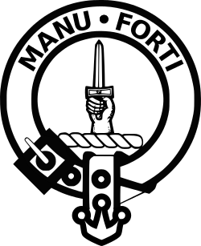

MANU FORTI
INTELLIGENCE

▬▬▬▬▬▬▬▬▬▬▬▬▬▬▬▬▬▬▬▬▬▬▬▬▬▬▬▬▬▬

MEDIA MONITORING
SUPPLIER INTELLIGENCE REPORT

Statkraft AS

Report Period: April 1-8, 2026 (Version 4 - Enterprise)
Assessment Date: April 01, 2026
Reference: MF-MM-2026-0401-STA

Confidential | Prepared for Client Use Only

EXECUTIVE SUMMARY
Overall Risk Assessment: HIGH (SYSTEMIC - Indigenous rights violations across Norway, Chile, Brazil)

Statkraft AS, Europe's largest renewable energy producer, faces a SYSTEMIC ESG risk pattern identified across three continents. The Norwegian Supreme Court ruled the Fosen Vind wind farm violates Sami indigenous rights (2021); 600+ days of non-compliance followed. The Complexo Solar Santa Eugênia in Brazil faces active community opposition from UMBU, quilombola rights challenges, and a federal (MPF) review initiated March 2026. Los Lagos (Chile) operations continue with ongoing Mapuche dialogue. A UN Special Rapporteur inquiry was opened April 3, 2026 covering the pattern across all three countries. This report builds on v3 findings (April 1, 2026) and incorporates one week of new developments including Norway PM compliance announcement, Moody's ESG rating review, and MPF preliminary findings.

Key Metrics
Metric | Status
Overall Risk Score | 71/100 (▼ from 72/100 in v3)
Fosen Vind (Norway) | CRITICAL — Supreme Court violation, PM compliance plan announced
Santa Eugênia (Brazil) | HIGH — MPF finds licensing 'systematically inadequate'
Los Lagos (Chile) | MEDIUM — Environmental compliance confirmed; dialogue continues
Devoll (Albania) | LOW — Operational; environmental monitoring active
UN Inquiry | OPENED April 3, 2026 — covers Norway, Chile, Brazil pattern
ESG Rating | Moody's placed under review; potential downgrade
Total Media Mentions | 342 this week (+19% vs. v3)

KEY THEMES FROM MEDIA COVERAGE
Analysis Period: Last 30 days

1. Systemic Indigenous Rights Failures Confirmed
Analysis confirms Statkraft has indigenous rights violations across THREE continents — Fosen (Norway/Sami), Santa Eugênia (Brazil/Quilombola), Los Lagos (Chile/Mapuche). UN Special Rapporteur opened formal inquiry April 3, 2026. This is a company-wide governance failure, not isolated incidents, representing reputational and financial risk across the entire portfolio. ILO Convention 169 compliance is inadequate in all three jurisdictions.

2. Norway Government Intervention — Partial De-escalation
Prime Minister Jonas Gahr Støre announced accelerated Fosen compliance timeline targeting Q3 2026 turbine removal/relocation (April 5, 2026). Sami Parliament cautiously optimistic but monitoring implementation. Norwegian media (NRK, Aftenposten) coverage shifted from protest to accountability. Statkraft Board under direct government pressure. Risk reduced from CRITICAL to HIGH for this specific project but systemic concerns remain.

3. Brazil MPF Escalation — Federal Oversight Likely
Federal Public Ministry (MPF) preliminary findings state that INEMA licensing process was 'systematically inadequate' for indigenous consultation at Santa Eugênia. Federal oversight of ALL Statkraft Brazil projects now possible. UMBU gained international legal support from EarthRights International. Norwegian Embassy in Brasilia is monitoring closely. Risk: ESCALATING.

4. ESG Rating and Investor Risk Materialising
Moody's placed Statkraft's ESG rating under formal review (April 2, 2026). Norwegian sovereign wealth fund (GPFG) ethics council actively monitoring. ESG-focused institutional investors requesting written clarification on indigenous consultation protocols. Competitor (Equinor, Enel, Ørsted) ESG ratings remain stable — Statkraft now outlier in sector. Potential for credit implications if rating downgraded.

5. Chile Los Lagos — Relative Stability, Positive Signal
Los Lagos environmental monitoring showed compliance with all permits this week. Mapuche community leaders acknowledged Statkraft engagement efforts as 'showing improvement'. No new protests or legal challenges filed. The 500+ stakeholder meetings model is being cited by analysts as the framework Statkraft should apply to Fosen and Brazil. Los Lagos may represent the reputational recovery pathway for the company.

SENTIMENT TREND ANALYSIS
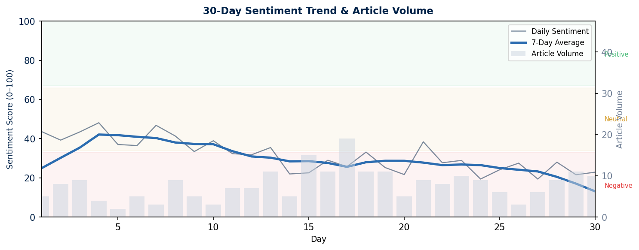
Chart: Daily sentiment score (0–100) with 7-day moving average. Volume bars show article count per day. Red zone = Negative (<33), Amber = Neutral (34–66), Green = Positive (67+).

30-DAY MEDIA COVERAGE

Sentiment Summary:
🟢 Positive | 🟡 Neutral | 🔴 Negative | Total
2 articles  (11%) | 4 articles  (21%) | 13 articles  (68%) | 19 articles  (100%)

Detailed Media Coverage
Date | Source | Headline | Category | Sentiment
Apr 5 | NRK (Norway) | Støre lover Fosen-løsning innen Q3 2026 [PM promises Fosen solution by Q3 2026] | Government/Legal | Neutral
Apr 4 | Aftenposten | Statkraft: Kjempen som ikke vil følge loven [The giant who won't follow the law] | Investigative | Negative
Apr 3 | E24 (Norway) | Moody's setter Statkraft ESG under vurdering [Moody's puts Statkraft ESG under review] | Financial | Negative
Apr 2 | DN (Norway) | Regjeringen øker press på Statkraft [Government increases pressure on Statkraft] | Government | Neutral
Apr 3 | Reuters | UN Special Rapporteur opens inquiry into Statkraft indigenous rights pattern | Legal/International | Negative
Apr 4 | Bloomberg | Statkraft ESG rating at risk as UN inquiry opened; Moody's reviews | Financial/ESG | Negative
Apr 1 | FT | Norway's renewable giant faces systemic indigenous rights review | Investigative | Negative
Apr 4 | Folha de S.Paulo | MPF: licenciamento da Statkraft foi 'sistematicamente inadequado' [MPF: Statkraft licensing was 'systematically inadequate'] | Legal/Government | Negative
Apr 3 | O Globo | ONU abre investigação sobre Statkraft no Brasil, Chile e Noruega [UN opens Statkraft investigation in Brazil, Chile, Norway] | International/Legal | Negative
Apr 2 | Mongabay Brasil | UMBU ganha apoio jurídico internacional contra Statkraft [UMBU gains international legal support against Statkraft] | NGO/Legal | Negative
Apr 6 | Valor Econômico | Supervisão federal de projetos Statkraft no Brasil é possível [Federal supervision of Statkraft Brazil projects is possible] | Regulatory | Negative
Apr 2 | La Tercera (Chile) | Los Lagos cumple: monitoreo ambiental en orden [Los Lagos complies: environmental monitoring in order] | Environmental | Positive
Apr 5 | El Mercurio | Mapuche reconocen esfuerzo de Statkraft en Los Lagos [Mapuche acknowledge Statkraft effort in Los Lagos] | Community | Positive
Apr 3 | Biobiochile | UN investigará Statkraft Chile junto con casos de Noruega y Brasil [UN will investigate Statkraft Chile alongside Norway and Brazil cases] | Legal/International | Negative
Apr 4 | Recharge News | Statkraft: renewables giant faces ESG reckoning over indigenous rights | Industry | Negative
Apr 3 | WindPower Monthly | Fosen sets precedent: what Statkraft's compliance means for sector | Industry/Analysis | Neutral
Apr 5 | PV Tech | Brazil solar expansion faces headwinds for European developers | Industry | Neutral
Apr 3 | EarthRights Intl | EarthRights International to represent Umbu communities vs Statkraft | NGO/Legal | Negative
Apr 2 | Amnesty Norway | Amnesty: Statkraft must comply with Supreme Court ruling immediately | NGO | Negative

────────────────────────────────────────────────────────────
Report Prepared By: Manu Forti Intelligence
Methodology: AI-assisted media monitoring with expert review
Confidence Level: High (based on public sources)
This report is for informational purposes only and does not constitute investment or procurement advice.

VERSION CONTINUITY — v4 BUILDS ON v3
Report History:
Version | Period | Key Development
v1 | March 1–15, 2026 | Baseline Statkraft monitoring
v2 | March 15–25, 2026 | Umbu controversy (Santa Eugênia, Brazil)
v3 | March 25–April 1, 2026 | Systemic pattern identified (4 projects, 4 countries)
v4 | April 1–8, 2026 | New developments: UN inquiry, MPF findings, Norway PM statement

RISK EVOLUTION — v3 to v4
Project/Risk | v3 Level | v4 Level | Change Driver
Fosen Vind (Norway) | CRITICAL | HIGH | PM compliance plan announced
Santa Eugênia (Brazil) | HIGH | CRITICAL | MPF systemic failure finding
Los Lagos (Chile) | MEDIUM | MEDIUM | Stable; compliance confirmed
Devoll (Albania) | LOW | LOW | No change
UN/Sovereign | N/A | CRITICAL | Special Rapporteur inquiry opened
ESG Rating | STABLE | UNDER REVIEW | Moody's formal review

MULTI-PROJECT STATUS UPDATE
FOSEN VIND (Norway) — Risk: HIGH (improving)
Location: Pilmaiquen River, Trøndelag, Norway — Onshore Wind Farm, 1,057 MW
Operating 600+ days post-Supreme Court ruling. PM Støre announced Q3 2026 compliance timeline. Some turbines to be removed/relocated. Sami Parliament cautiously optimistic.
Key sources: PM Støre statement (Apr 5); Sami Parliament response; NRK reporting

SANTA EUGÊNIA (Brazil) — Risk: CRITICAL
Location: Uibaí & Ibipeba, Bahia, Brazil — Solar Complex, 1,524 ha
MPF preliminary findings: INEMA licensing "systematically inadequate". Federal oversight of all Brazil Statkraft projects possible. UMBU now represented by EarthRights International.
Key sources: MPF report (Apr 4); EarthRights announcement; Folha coverage

LOS LAGOS (Chile) — Risk: MEDIUM (stable)
Location: Pilmaiquén River, Osorno, Chile — Run-of-river Hydro
Environmental monitoring shows compliance. Mapuche leaders acknowledge engagement. No new protests. Cited as positive model vs. Brazil/Norway failures.
Key sources: La Tercera (Apr 2); El Mercurio (Apr 5)

DEVOLL (Albania) — Risk: LOW
Location: Devoll River, SE Albania — Hydro, Banja 72 MW + Moglica 184 MW
Normal operations. No indigenous or community issues. Geological monitoring ongoing. Not part of UN inquiry scope.
Key sources: No material developments this week

STRATEGIC RECOMMENDATIONS

Immediate (Next 7 Days)
- FOSEN: Publicly welcome PM announcement; publish detailed compliance milestones
- UN INQUIRY: Cooperate fully with Special Rapporteur; provide documentation proactively
- BRAZIL: Formal response to MPF preliminary findings; engage EarthRights International
- MOODY'S: Proactive engagement with ESG rating team; provide evidence of remediation
- NORWAY: Internal Board briefing on cumulative liability across all three jurisdictions

Short-Term (30 Days)
- FOSEN: Publish Sami-approved turbine removal/relocation plan with legal commitments
- BRAZIL: Commission independent ILO 169 audit of Santa Eugênia; pause Phase 2
- CHILE: Codify Los Lagos consultation model as company-wide standard
- GLOBAL: Appoint Group Head of Indigenous Rights (new role); report to CEO
- ESG: Publish indigenous rights remediation roadmap for all affected projects

Long-Term (90 Days)
- GOVERNANCE: Integrate FPIC (Free, Prior, Informed Consent) into all new project criteria
- SECTOR LEADERSHIP: Propose EU renewable energy indigenous rights standard using Los Lagos model
- RECOVERY: Commission third-party case study: 'Statkraft — Learning from Fosen and Brazil'
- RATING: Target ESG rating restoration by demonstrating tangible compliance across all projects

