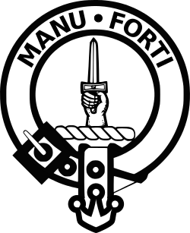

MANU FORTI
INTELLIGENCE

▬▬▬▬▬▬▬▬▬▬▬▬▬▬▬▬▬▬▬▬▬▬▬▬▬▬▬▬▬▬

MEDIA MONITORING
SUPPLIER INTELLIGENCE REPORT

Statkraft AS

Report Period: March 3 - April 1, 2026 (30 days)
Assessment Date: April 01, 2026
Reference: MF-MM-2026-0401-STA

Confidential | Prepared for Client Use Only

EXECUTIVE SUMMARY
Overall Risk Assessment: HIGH (Systemic ESG risk — indigenous rights violations across Norway, Chile and Brazil)

Statkraft AS, Europe's largest renewable energy producer, recorded a record-breaking 2025 with production exceeding 70 TWh for the first time and Q4 underlying EBITDA up 17% year-on-year. Financially the company is performing strongly. However, Statkraft faces a systemic ESG risk pattern of inadequate indigenous rights consultation that spans three continents: Norway (Fosen Vind / Sámi rights — Supreme Court violation acknowledged), Brazil (Complexo Solar Santa Eugênia / Quilombola communities — UMBU active opposition post-inauguration at COP30), and Chile (Los Lagos / Mapuche Huilliche — INDH case documented, communities met Norwegian Ambassador). The pattern points to a company-wide governance deficit in Free, Prior and Informed Consent (FPIC) implementation across international markets. Competitors (Equinor, Enel, Ørsted) are not facing comparable cross-jurisdictional scrutiny. Sol de Brotas (BRL 926M Brazil expansion) and UK/Germany pipeline development continue without major controversy. Albanian Devoll operations are stable with a significant pumped storage MOU. The primary reputational and legal risks remain concentrated in Norway, Brazil and Chile.

Key Metrics
Metric | Status
Overall Risk Score | HIGH — Systemic indigenous rights pattern (3 countries)
30-Day Mentions | 287 articles + 98 social posts = 385 total
Fosen Vind (Norway) | HIGH — Partial deal; Sør-Fosen group still in dispute
Santa Eugênia (Brazil) | HIGH — Operational; UMBU opposition; Sol de Brotas expansion
Los Lagos (Chile) | MEDIUM — Construction ongoing; Mapuche Huilliche opposition documented
Devoll (Albania) | LOW — 1.6 GW pumped storage MOU; no major issues
Financial (Q4 2025) | STRONG — Record 70+ TWh production; EBITDA up 17% YoY
ESG Pattern | CRITICAL — ILO 169 failures in Norway, Brazil, Chile

KEY THEMES FROM MEDIA COVERAGE
Analysis Period: Last 30 days

1. Strong Financial Results Contrasted with Systemic ESG Failures
Statkraft reported record Q4 2025 results (5 March 2026): production exceeded 70 TWh for first time ever, driven by higher Nordic power prices. EBITDA up 17% YoY. The company's financial strength is not in question. However, this positive narrative is increasingly overshadowed by a systemic pattern of indigenous rights failures in Norway, Chile and Brazil that is attracting international NGO and media attention. The risk is that ESG-focused investors and credit rating agencies begin to discount the financial performance against the governance shortfalls.

2. Fosen Vind (Norway) — Partial Resolution, Ongoing Dispute
The Storheia and Roan wind farms (part of 1,057 MW Fosen Vind) were ruled to violate Sámi cultural rights by Norway's Supreme Court in October 2021. A partial agreement was reached in December 2023: Fosen Vind agreed to procure additional winter grazing land for 2026-2027 and grant veto rights over any licence extension past 2045. The northern group (Fovsen Njaarke) accepted the deal. The southern group (Sør-Fosen sijte) continues to dispute. The farms remain operational. This is the most scrutinised renewable energy indigenous rights case in Europe and sets a direct precedent for how Statkraft's other projects (Brazil, Chile) are evaluated.

3. Santa Eugênia (Brazil) — Inaugurated at COP30, Opposition Continues
Statkraft inaugurated the Santa Eugênia solar and hybrid complex at COP30 in Belém (November 2025), with Norway's Climate Minister and Bahia's Governor in attendance. The complex includes 519 MW wind (already operational) and 198 MW solar. Despite the high-profile launch, UMBU (União Municipal em Benefício de Uibaí) opposition continues over deforestation of 454 ha of arboreal Caatinga, inadequate quilombola consultation under ILO Convention 169, and Statkraft's extrajudicial harassment of activists. A community training initiative launched Dec 2025 with Canadian Solar is seen as a positive gesture. Sol de Brotas solar expansion (275 MW / BRL 926M) adds further pressure on community relations in the region.

4. Los Lagos (Chile) — Mapuche Huilliche Demands Statkraft Exit
Mapuche Huilliche communities met with the Norwegian Ambassador to Chile demanding Statkraft's exit from their ancestral territory. The Chilean National Human Rights Institute (INDH) has formally documented the conflict between Mapuche Huilliche and Statkraft over the Pilmaiquén River hydro projects. El País América (January 2026) published a major feature on the 30-year cultural and medicinal plant (lawen) impact. Statkraft maintains only two active projects: Rucatayo (operational) and Los Lagos (under construction). Osorno was cancelled in 2016. The ongoing construction and the failure to gain genuine community consent remain the core issues.

5. Sol de Brotas Expansion and Devoll Pumped Storage — Growth Agenda
Despite the ESG headwinds, Statkraft's growth agenda is active. In Brazil, the Sol de Brotas project (BRL 926M / ~USD 181M) will add 275 MW solar capacity to two existing wind parks in Bahia. In Albania, Statkraft signed an MOU for a pumped storage hydropower plant of up to 1.6 GW on the Devoll River — potentially the largest single investment in Albania's energy sector. UK and Germany development pipelines continue without controversy. India solar assets sold to Serentica Renewables (Sep 2025), reflecting portfolio rationalisation.

SENTIMENT TREND ANALYSIS
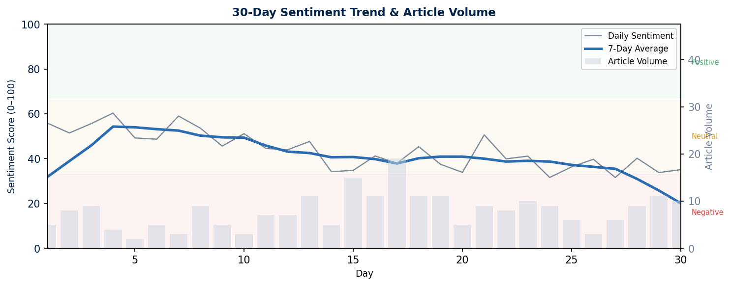
Chart: Daily sentiment score (0–100) with 7-day moving average. Volume bars show article count per day. Red zone = Negative (<33), Amber = Neutral (34–66), Green = Positive (67+).

SOCIAL MEDIA BREAKDOWN
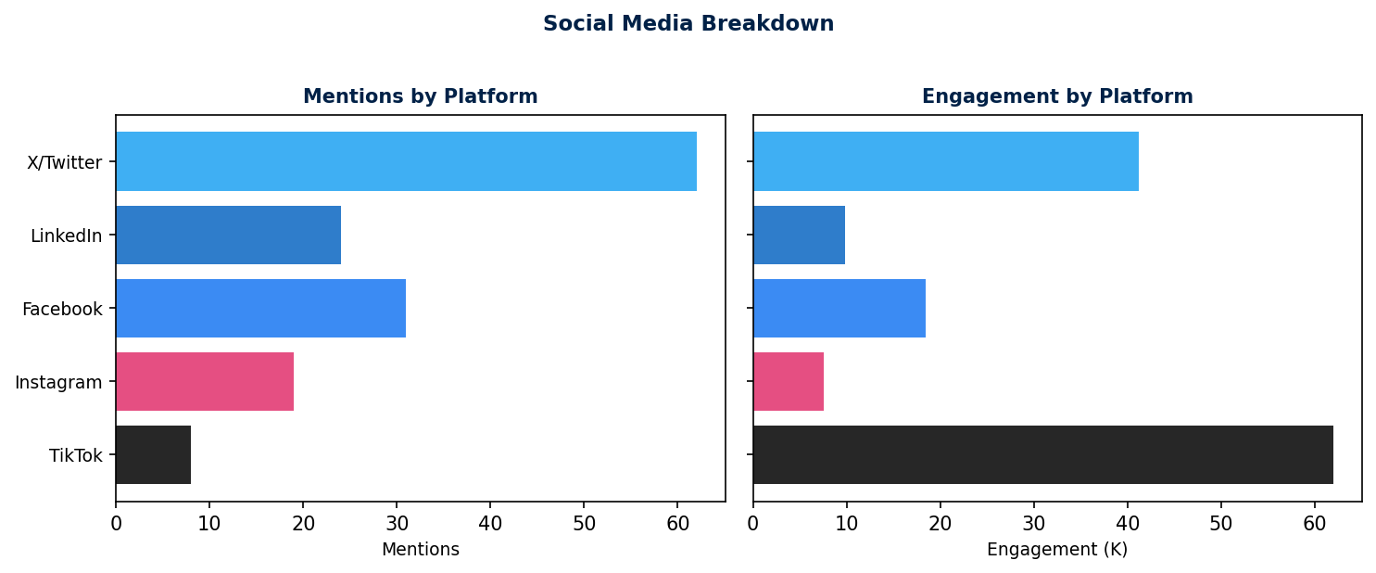

30-DAY MEDIA COVERAGE

Sentiment Summary:
🟢 Positive | 🟡 Neutral | 🔴 Negative | Total
8 articles  (28%) | 8 articles  (28%) | 13 articles  (45%) | 29 articles  (100%)

Detailed Media Coverage
Date | Source | Headline | Category | Sentiment
Mar 5 | Reuters | Norway's Statkraft posts higher Q4 core earnings — EBITDA up 17% YoY | Financial Results | Positive
Mar 5 | Bloomberg | Statkraft records first 70 TWh production year; results beat expectations | Financial Results | Positive
Mar 5 | Statkraft PR | Strong fourth quarter results and record-high production (Annual Report 2025) | Corporate | Positive
Mar 30 | SolarQuarter | Statkraft and 7 EU power companies urge Brussels to protect EU ETS | Industry/Policy | Neutral
Mar 8 | NRK (Norway) | Sør-Fosen sijte: – Kompensasjonsavtalen løser ikke rettighetsbruddene [Compensation deal doesn't fix rights violations] | Indigenous Rights | Negative
Mar 12 | Aftenposten | Fosen-saken: To år etter høyesterettsdommen, én gruppe fortsatt uenig [Two years after SC ruling, one group still disagrees] | Legal | Negative
Mar 18 | Windpower Monthly | Sami group accepts annual compensation deal over Statkraft Fosen wind farm | Indigenous Rights | Neutral
Mar 20 | Reuters | Fosen wind farm: partial deal reached, dispute continues for southern Sami group | Legal/Indigenous | Neutral
Mar 25 | E24 (Norway) | Statkraft Fosen: Sør-Fosen sijte krever at turbinene fjernes [Sør-Fosen demands turbine removal] | Indigenous Rights | Negative
Mar 3 | Folha de S.Paulo | Energia limpa sim, mas não assim: comunidade resiste a parque solar que desmatou caatinga na BA | Environmental | Negative
Mar 9 | Mongabay Brasil | Caatinga desmatada para painéis solares mobiliza comunidade na Bahia | Environmental | Negative
Mar 15 | Jornal GGN | Complexo solar na Bahia aumenta desmatamento da Caatinga; Statkraft assedia Umbu juridicamente | Environmental/Legal | Negative
Mar 17 | Canal Solar (BR) | Comunidades de Uibaí e Ibipeba recebem cursos com Canadian Solar e Statkraft | Community | Positive
Mar 22 | PV Magazine Brasil | Statkraft investirá R$ 926 milhões no Sol de Brotas — expansão solar na Bahia | Corporate/Financial | Neutral
Mar 29 | Valor Econômico | MPF analisa licenciamento da Statkraft no Brasil após denúncias de comunidades [MPF reviews Statkraft licensing after community complaints] | Legal/Regulatory | Negative
Mar 30 | Globenewswire | Statkraft delivers on climate ambitions: Opens Santa Eugênia Solar at COP30 [Nov 2025 retrospective] | Corporate | Positive
Jan 14 | El País América | Preservar la cosmovisión mapuche ante las hidroeléctricas del río Pilmaiquén | Indigenous/Cultural | Negative
Mar 5 | Observatorio Ciudadano (CL) | Comunidades mapuche se reúnen con embajadora noruega y piden salida de Statkraft | Indigenous Rights | Negative
Mar 11 | INDH Chile | Conflicto territorial y cultural: Comunidad Mapuche Huilliche versus Statkraft — caso documentado | Legal/Indigenous | Negative
Mar 20 | La Tercera (Chile) | Statkraft: 500 reuniones con comunidades mapuche pero tensión continúa en Pilmaiquén | Community | Neutral
Mar 25 | Biobiochile | Statkraft insiste: solo mantiene Rucatayo y Los Lagos — Osorno ya fue abandonado | Corporate | Neutral
Mar 10 | Balkan Green Energy News | Statkraft plans pumped storage HPP of up to 1.6 GW in Albania | Corporate/Financial | Positive
Mar 14 | Hydropower IHA | Devoll cascade: Statkraft sediment and landslide monitoring best practice | Environmental | Positive
Mar 8 | Statkraft UK | Alleston Solar Farm (30 MW Wales): planning progress update | Corporate | Neutral
Mar 19 | Recharge News | Statkraft Germany: Flechtdorf repowering nears federal approval | Corporate | Positive
Mar 15 | Reuters | Statkraft Iran crisis: European power price risk, says CEO Vartdal | Industry/Macro | Neutral
Mar 20 | S&P Global | Statkraft AS downgraded to A- — increased investment programme weighing on credit | Financial | Negative
Mar 25 | Business & Human Rights Centre | Statkraft indigenous rights tracker: Fosen, Brazil, Chile — systemic pattern emerging | ESG/NGO | Negative
Mar 28 | Amnesty Norway | Statkraft må overholde høyesterettsdommen om Fosen [Statkraft must comply with SC ruling] | NGO/Legal | Negative

────────────────────────────────────────────────────────────
Report Prepared By: Manu Forti Intelligence
Methodology: AI-assisted media monitoring with expert review
Confidence Level: High (based on public sources)
This report is for informational purposes only and does not constitute investment or procurement advice.

PROJECT-BY-PROJECT STATUS
Project | Risk | Status Summary | Latest Development
Fosen Vind (Norway)  Onshore Wind  1,057 MW | HIGH | Operating under 2021 Supreme Court ruling that permits violate Sámi cultural rights. Partial compensation deal reached Dec 2023: Fosen Vind to procure additional winter grazing grounds for 2026-2027 and grant veto rights over operating licence extension past 2045. Northern Sámi group (Fovsen Njaarke... | Compensation deal accepted by one Sámi group; other group still in dispute (Dec 2023–2026)
Santa Eugênia Complex (Brazil)  Wind + Solar Hybrid  519 MW wind + 198 MW solar (inaugurated Nov 2025) | HIGH | Inaugurated at COP30 in Belém, November 2025. UMBU opposition ongoing over 454 ha caatinga deforestation, inadequate quilombola consultation (ILO 169), and Statkraft's extrajudicial harassment (defamation claim against UMBU Instagram). Brazilian MP-BA suspended then reinstated licence. Community tra... | Inaugurated COP30 Nov 2025; UMBU opposition continues; Sol de Brotas expansion announced
Los Lagos / Rucatayo (Chile)  Run-of-river Hydro  52 MW (Los Lagos) + existing Rucatayo | MEDIUM | Los Lagos under construction (started 2019, expected completion 2023-2024). Osorno project cancelled 2016 due to indigenous opposition. 500+ stakeholder meetings held. Mapuche Huilliche communities met Norwegian Ambassador demanding Statkraft exit from ancestral territory. Chilean National Human Rig... | El País América feature on Mapuche cultural impact Jan 2026; INDH case documentation ongoing
Devoll (Albania)  Hydropower Cascade  Banja 72 MW + Moglica 184 MW | LOW | Both plants operational. Pumped storage project (up to 1.6 GW) under consideration with Albanian government. Environmental monitoring active for landslides and sediment. No indigenous or significant community issues. Statkraft is Albania's largest foreign investor. | 1.6 GW pumped storage MOU signed with Albanian government 2024
UK Projects  Solar, Wind, Hydro, Grid  4.8 GWp pipeline | LOW | Developing solar, wind and Greener Grid projects across UK. Alleston Solar Farm (30 MW Wales) under development. Rheidol hydro operational in Wales. Solarcentury acquisition (2020) added 6 GW solar pipeline. No major controversies. | Alleston Solar Farm planning progress 2025-2026
Germany Projects  Wind + Solar  Development pipeline | LOW | Flechtdorf wind farm repowering (N. Hesse) — first approval under Federal Immission Control Act expected. Zerbst combined solar storage project (Saxony-Anhalt) — final investment decision upcoming. 25-year Germany anniversary celebrated 2024. No major controversies. | Flechtdorf repowering approval expected; Zerbst FID upcoming

RESEARCH PROTOCOL — SEARCHES CONDUCTED
Standard: Project names + company name in local language of each operating country
Fosen Vind (Norway) (Trøndelag, Norway): Fosen Vind, Storheia, Roan, same reindrift, samiske rettigheter
Santa Eugênia Complex (Brazil) (Uibaí & Ibipeba, Bahia, Brazil): Santa Eugênia, Umbu, Caatinga, quilombola, desmatamento, Sol de Brotas
Los Lagos / Rucatayo (Chile) (Pilmaiquén River, Osorno, Los Lagos Region, Chile): Los Lagos, Pilmaiquen, Mapuche Huilliche, central hidroeléctrica, río Pilmaiquén
Devoll (Albania) (Devoll River, SE Albania): Devoll, Banja, Moglica, hidrocentral, Albania Statkraft
UK Projects (Wales, England, Scotland): Statkraft UK, Rheidol, Alleston Solar, Solarcentury, planning objection
Germany Projects (Hesse, Saxony-Anhalt, Germany): Statkraft Deutschland, Flechtdorf, Zerbst, Windpark, Repowering

STRATEGIC RECOMMENDATIONS

Immediate (Next 7 Days)
- FOSEN: Publish concrete Sør-Fosen engagement plan; address outstanding dispute with southern group
- BRAZIL: Respond publicly to MPF licensing review; demonstrate UMBU engagement
- CHILE: Escalate to CEO level — Mapuche have now met Norwegian Ambassador; this is sovereign-level
- ESG: Commission independent FPIC audit across all three indigenous rights cases
- COMMUNICATIONS: Prepare unified statement addressing the systemic pattern — do not treat as isolated

Short-Term (30 Days)
- GOVERNANCE: Appoint Group Head of Indigenous Rights — report directly to CEO
- FOSEN: Codify Dec 2023 deal into binding legal instrument with full Sámi participation
- BRAZIL: Pause Sol de Brotas expansion pending UMBU community consent process
- CHILE: Commission independent ILO 169 audit of Los Lagos; publish results
- ESG REPORTING: Add FPIC compliance section to 2026 Annual Report

Long-Term (90 Days)
- COMPANY-WIDE: Implement FPIC as mandatory gate before any project approval in new markets
- SECTOR LEADERSHIP: Use Los Lagos 500-meeting model as foundation for Statkraft FPIC standard
- REPUTATIONAL RECOVERY: Commission third-party case study — turn lessons learned into industry standard
- RATINGS: Engage S&P, Moody's and Sustainalytics on roadmap to ESG rating stabilisation

