DIN PERSONLIGE HELSESJEF

Oslo Concierge GP

Full Business Plan & Implementation Roadmap

AI-Powered Personalised Private Medical Practice for Oslo Executives

Version 4S | April 2026 | CONFIDENTIAL

1. Executive Summary
Din Personlige Helsesjef — 'Your Personal Health Chief' — is Oslo's first dedicated Medical Concierge practice. It delivers the proactive, personalised healthcare Oslo's executive market has always needed but never been offered: a physician who genuinely knows you, tracks your health over time, and is available when you need them.
The practice operates on a monthly membership model with three tiers (NOK 2,500 / 5,000 / 10,000 per month), targeting a panel of 50–100 members. At full capacity, it generates NOK 3–6 million in annual recurring revenue at net margins of 70–80% — comparable to the best consulting or legal practices in Oslo.
The core innovation is the infrastructure that makes this operationally viable for a single physician. A sophisticated back-office system automates the administrative overhead that typically requires an entire support team: between-visit health monitoring, pre-consultation briefings, lab result processing, protocol management, and proactive member outreach. The physician focuses on the clinical relationship. The technology handles everything else.
This is a medical practice — one that operates at a level of personal service Oslo's executive market has never been offered before.

Key Metrics at Full Operation
Metric | Value
Annual Recurring Revenue | NOK 6,000,000
Estimated Net Margin | 70–80%
Panel Size | 50–100 members (vs. 1,100+ for a standard fastlege)
Time Commitment | 3–4 clinical days/week
Break-even | ~15 members (NOK 900,000–1,125,000/year)
Launch Timeline | First paying members within 60–90 days

2. The Market Opportunity

2.1 A Structural Failure at the Top End
The Norwegian fastlege system was designed for coverage, not for quality at the executive level. The average fastlege manages 1,100+ patients, delivers 10-minute consultations, has no infrastructure for between-visit contact, and operates almost entirely reactively — treating illness when it arrives rather than preventing or optimising health.
Oslo's executive class experiences this as a jarring contrast to every other premium service in their life. These are people who apply data-driven thinking to every corner of their professional existence. They have personal trainers with biometric programmes, financial advisors who know their complete picture, lawyers on retainer, executive coaches. Their health — often their most valuable asset — gets a 10-minute appointment every few years.
The problem is not access to emergency care. It is the complete absence of a long-term, proactive, personalised health relationship. That product does not exist in Norway. This practice creates it.

2.2 Target Market
Din Personlige Helsesjef serves two complementary segments — both underserved by the Norwegian public system, and both willing to pay for the service they deserve.

Primary Segment — The Optimisers
The ideal primary member is 38–58, earning NOK 2M+ household income, already investing in premium wellness, and frustrated by a system that treats them as one of 1,100 patients. These are executives who apply rigour to every corner of their professional lives — except their health, which gets a 10-minute appointment every few years.
- Partners and senior associates at Oslo law, finance, and consulting firms
- C-suite and senior executives at Equinor, DNB, Statkraft, Kongsberg, Aker, and comparable companies
- Senior management at PE/VC funds and Oslo-based family offices
- Successful founders and tech entrepreneurs
- High-income expats in senior Oslo roles
- Professionals already spending on Oura rings, nutritionists, and personal trainers

Secondary Segment — Reversal & Management (60+)
A significant and underserved secondary segment consists of individuals aged 60+ with existing health conditions — cardiovascular risk, metabolic syndrome, early-stage diabetes, or musculoskeletal issues. They are highly motivated to take control of their health and willing to pay for a physician who will genuinely engage with them over time.
This dual-segment model is well-established in the most successful international concierge practices. The entry point differs; the product overlap is substantial.

Segment | Age Profile | Core Motivation | Entry Point | Monthly Investment
Optimisers | 38–58 | Performance, longevity, proactive health management | Executive network, corporate benefits | NOK 5,000–10,000
Reversal & Management | 60+ | Condition management, lifestyle change, peace of mind | GP referral, family recommendation | NOK 2,500–5,000
Both segments benefit from the same core offering: a physician who knows them, monitors their health continuously, and is available when it matters.

2.3 Market Size
Oslo has ~700,000 inhabitants. An estimated 15,000–25,000 fit the executive profile. Reaching 100 members represents less than 0.7% penetration — achievable through personal network outreach alone in Year 1.

2.4 Competitive Landscape
Medical Concierge is an established global category. Oslo is ready for its first dedicated practice. Adjacent players exist but none offer the combination of physician-led continuity and depth of relationship that defines true concierge medicine.

Oslo Market
Provider | Model | Why It Falls Short
Epivity | Digital health / corporate wellness | No ongoing physician relationship; not concierge medicine
Livity | Digital primary care app | Transactional; no depth or personalisation over time
Amino / Dr. Dropin | Walk-in private GP clinics | Volume-based; no member dossier or continuity of care
Aleris / Volvat | Private specialist clinics | Episodic, reactive care; no retainer or proactive monitoring
Coa / Nemo Health | Digital primary care (Nordic) | No back-office infrastructure; limited relationship depth

International Benchmarks
Concierge medicine is proven and fast-growing globally — USD 20.5B in 2025, projected USD 44.3B by 2034. Oslo has comparable purchasing power to London and New York, where practices charging USD/GBP 5,000–10,000+/year carry multi-year waiting lists.

Practice | Location | Annual Pricing | Key Insight
MDVIP | USA | USD 1,800–3,000 | Proven at scale — premium over public care
Parsley Health | USA / UK | USD 150–250/mo | Data-driven, preventive — closest analogue to Oslo model
PrivateDoc / Concierge GP | London | GBP 3,000–12,000 | Boutique solo GP — closest structural parallel; multi-year waitlists
Lanserhof | Germany / Austria | EUR 500–1,500/day | Validates executive appetite for premium health investment
Coa / Nemo Health | Scandinavia | NOK 600–1,500/mo | Proves Norwegian willingness to pay
Key insight: The most successful international concierge practices compete on depth of relationship, not price. Oslo has the purchasing power, the demand, and no equivalent product.

3. The Service Model

3.1 Membership Tiers
Feature | Klienten — NOK 2,500/mo | Partneren — NOK 5,000/mo | Partneren Pro — NOK 10,000/mo
Annual health assessment | 2 hours | 2 hours + advanced labs | 3 hours + full longevity panel
Follow-up consultations | Quarterly (4/year) | Every 2 months (6/year) | Monthly (12/year)
Messaging access | WhatsApp, same-day reply | WhatsApp + direct mobile | Unlimited calls + messages
Appointment guarantee | Same week | Same day (urgent) | Same day always
Lab panel | Standard annual | Advanced metabolic + cardiovascular | Full longevity panel incl. ApoB, GlycanAge
Wearable integration | Optional | Included (Oura/Garmin/Apple) | Included + monthly analysis
AI health brief | Quarterly summary | Monthly personalised report | Monthly + annual roadmap
Supplement protocol | On request | Included, reviewed 2x/year | Full protocol, quarterly review
Home/office visit | Not included | 1 per year | Unlimited
Travel medicine | Standard advice | Included | Full remote support abroad
Annual prepay discount | 10% | 10% | 10%
Max panel members | 40 | 40 | 20

3.2 The Core Differentiator
The differentiator is not speed of access — private Oslo clinics already offer that. The differentiator is continuity and depth. Every member has a living health dossier accumulating data across years. Every consultation builds on the last. The AI infrastructure means the physician arrives at every appointment already knowing what changed, what trends need attention, and what questions matter.
Members do not feel like patients. They feel like they have a personal health director.

3.3 The Annual Health Roadmap
Every Tier 2 and Tier 3 member receives a 90-minute Annual Health Roadmap Review at their membership anniversary — reviewing progress, updating risk stratification, and setting measurable objectives for the coming year. This ritual creates a powerful retention anchor. International data from comparable practices shows 40% lower churn rates among members completing annual roadmap reviews.

3.4 Scalable Business Model
Din Personlige Helsesjef is designed to scale beyond the founding physician's direct hours — like a law firm, not a solo practitioner. The physician focuses on high-value clinical decisions and the member relationship. A nurse practitioner handles routine monitoring, procedure administration, and check-ins under physician oversight.
Phase | Staffing Model | Member Capacity
Year 1 — Launch | Solo physician | 50–75 members
Year 2 — Growth | + Nurse practitioner under physician oversight | 75–100 members
Year 3+ — Scale | + Health coach + specialist referral partnerships | 100+ members

4. Practice Operations & Technology

4.1 Back-Office Infrastructure
Operating principle: The physician handles the relationship. The technology handles everything else — monitoring, documentation, lab processing, briefing preparation, and protocol management. It is never used for direct patient communication.
The practice runs a sophisticated back-office infrastructure on dedicated local hardware. No patient data ever leaves the physician's premises — a structural GDPR guarantee and a genuine differentiator from large clinic groups whose data flows through third-party cloud systems.

Component | Specification
Hardware | Mac Mini M4 (current) → Mac Studio M5 Max 128GB (Year 2–3)
Orchestration | OpenClaw — local AI agent framework
LLM Models | Qwen 3.5 35B (local) for analysis; Claude Sonnet API for drafting (non-PII only)
Knowledge Base | Per-member RAG folders, markdown-structured, updated after every interaction
Secure Access | Cloudflare Tunnel — encrypted remote access
Communication | Signal/WhatsApp — end-to-end encrypted member messaging
Lab Integration | PDF ingestion pipeline → structured JSON → member dossier
Wearable Pipeline | Garmin/Oura/Apple Health → weekly structured summaries
Billing | Stripe or Vipps recurring membership payments

4.2 The Five Back-Office Workflows
Agent | Trigger | Function
Nightly Monitor | 02:00 daily | Reads all member dossiers, flags anomalies vs. personal baselines, generates morning briefing
Pre-Consultation Briefer | 60 min before appointment | Summarises changes since last consult, suggests consultation structure
Lab Result Processor | New PDF in lab folder | Parses results, flags out-of-range values, drafts lay-language interpretation
Monthly Health Brief | 1st of each month | Synthesises wearable, consult, and messaging data into personalised health brief
Protocol Reviewer | Quarterly | Reviews supplement/diet/exercise protocols against latest labs, flags adjustments

5. Financial Projections

5.1 Revenue & Net Income
 | Year 1 (ramp) | Year 2 | Year 3 | Full Capacity
Members | 35–50 | 60–75 | 80–100 | 100
Monthly Revenue | NOK 175–250K | NOK 350–450K | NOK 450–500K | NOK 500K
Annual Revenue | NOK 2.1–3.0M | NOK 4.2–5.4M | NOK 5.4–6.0M | NOK 6.0M
Estimated Net (70–80%) | NOK 1.5–2.4M | NOK 2.9–4.3M | NOK 3.8–4.8M | NOK 4.2–4.8M

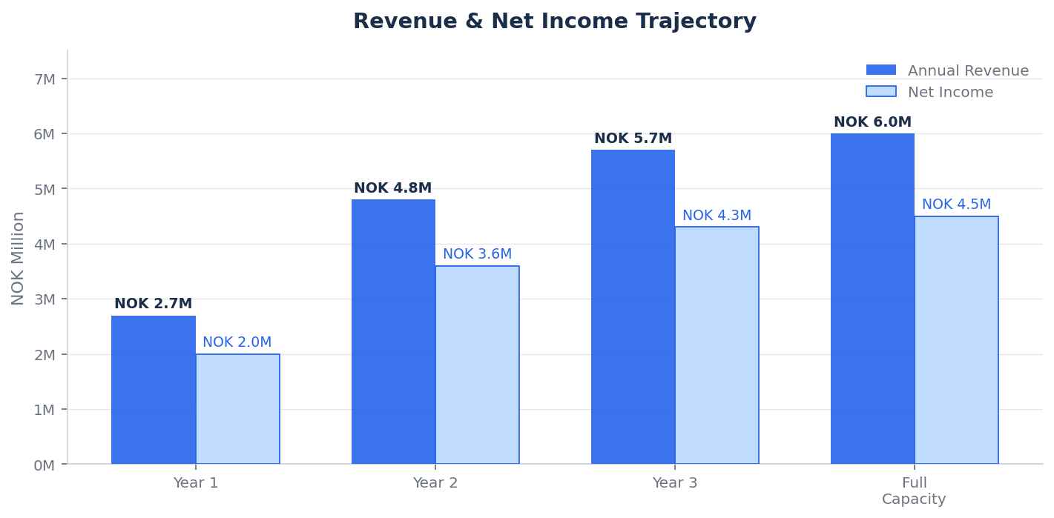
Figure 1 — Annual Revenue & Net Income by Year

5.2 Member Growth Projection
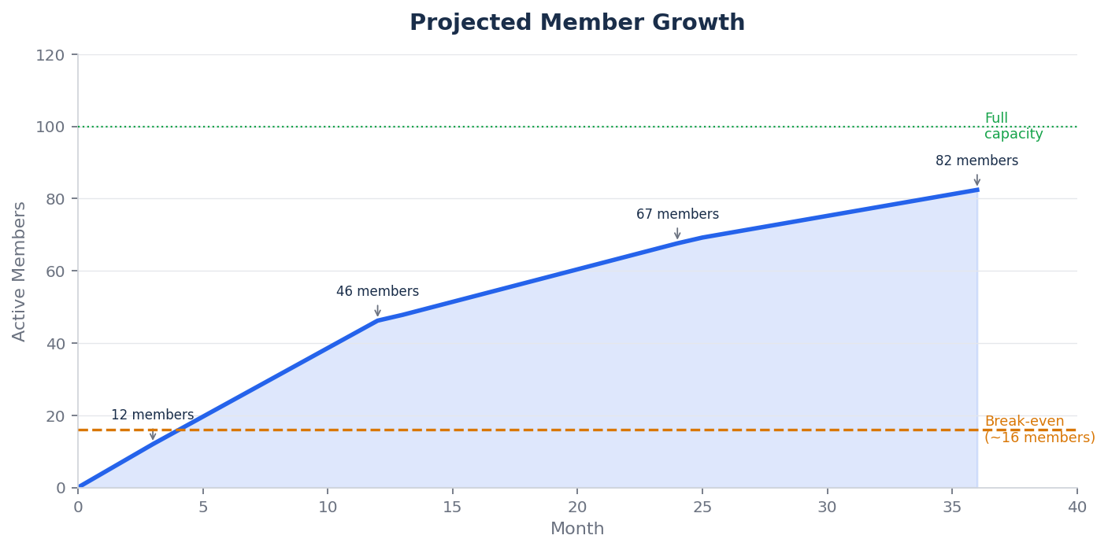
Figure 2 — Projected Member Growth with Break-Even Threshold

5.3 Break-Even Analysis
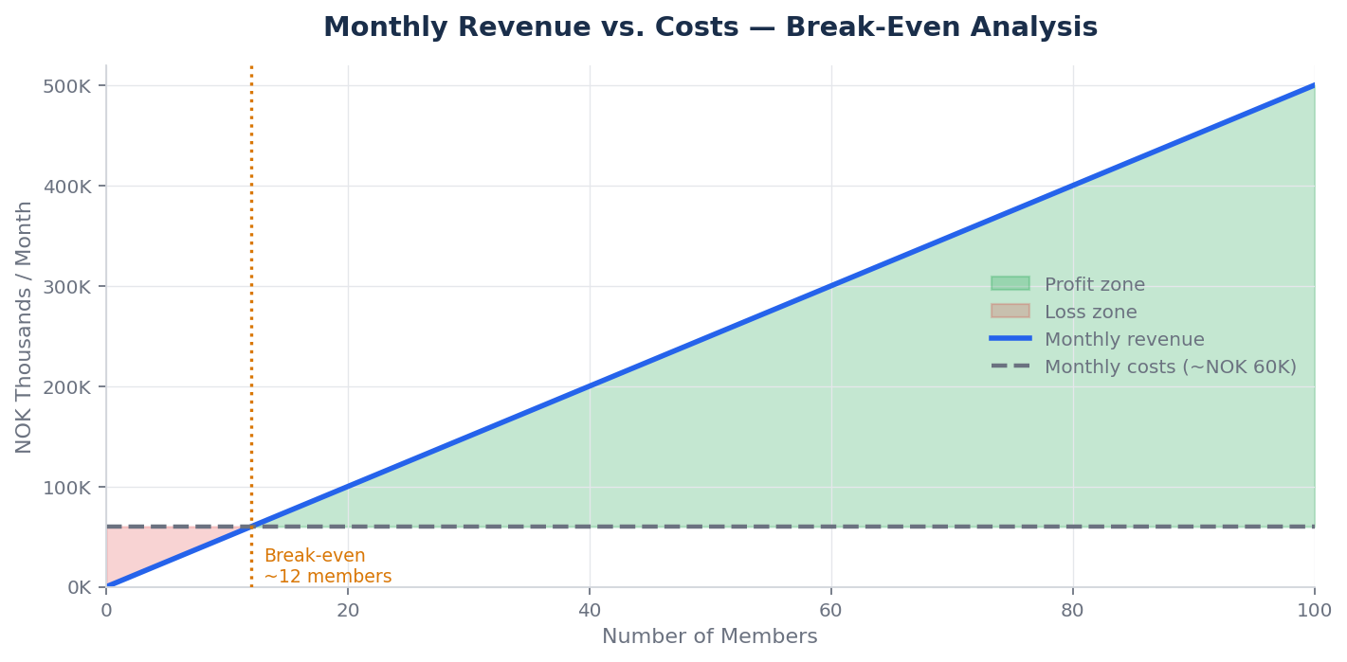
Figure 3 — Monthly Revenue vs. Costs (Break-Even at ~12–15 members)

Break-even point: 15–18 members generating NOK 75,000–90,000/month vs. NOK 40,000–60,000/month costs
Timeline to break-even: 60–90 days from launch given existing professional network
Payback on setup investment: Within 6–12 months at Tier 2 average pricing

5.4 Revenue Mix by Tier
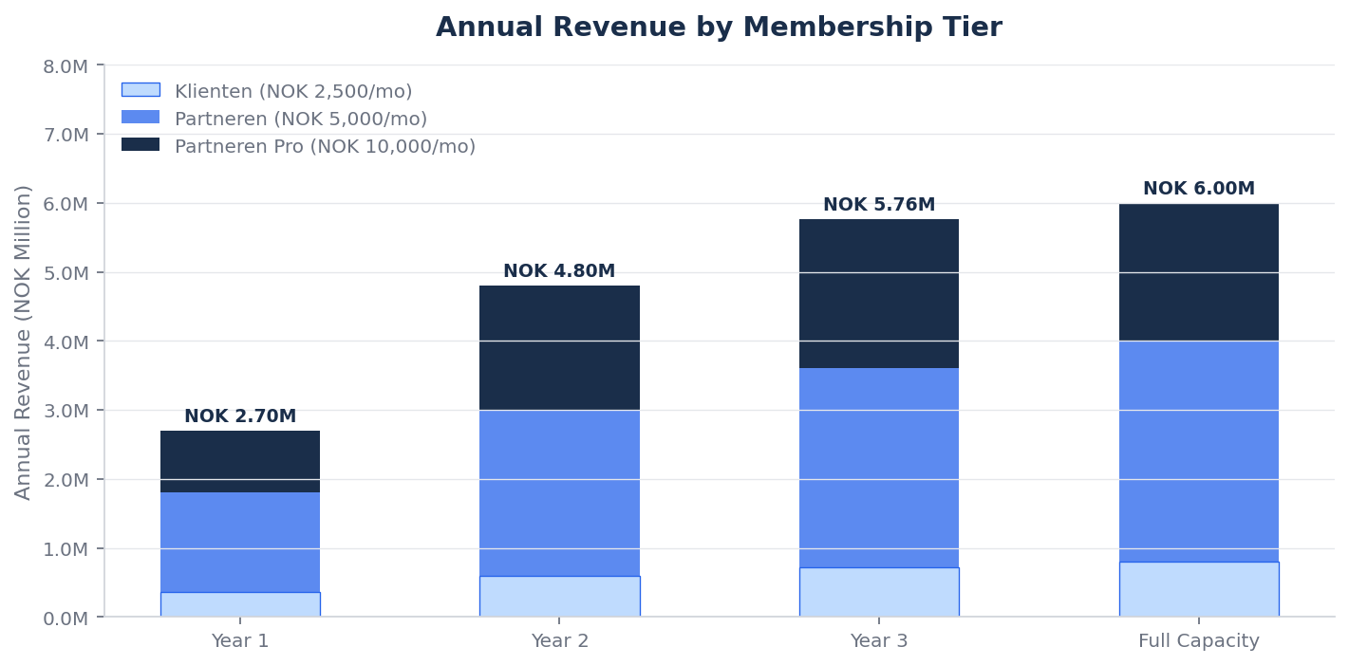
Figure 4 — Annual Revenue by Membership Tier

5.5 5-Year Financial Waterfall
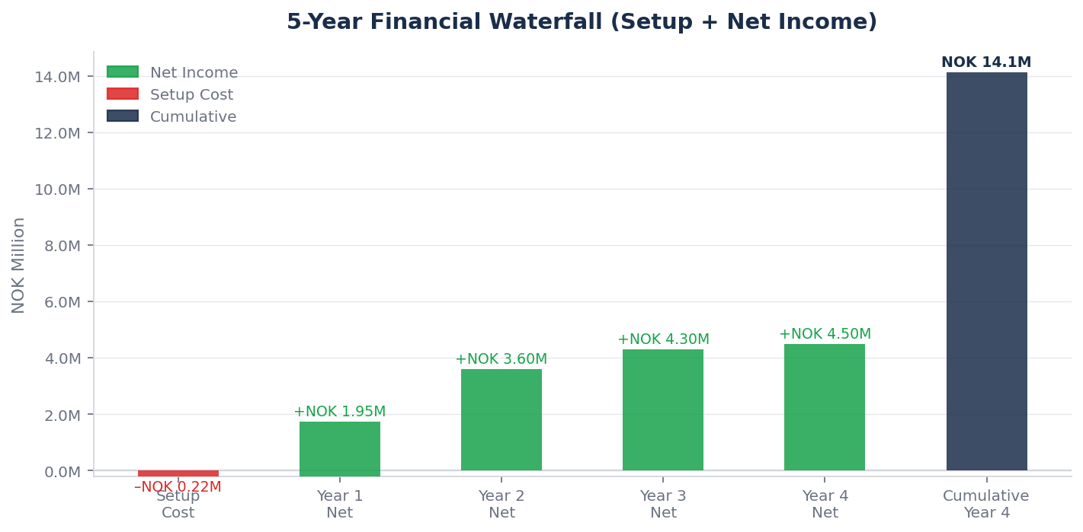
Figure 5 — 5-Year Cumulative Net Income Waterfall (setup costs deducted)

5.6 Cost Structure
Cost Item | Monthly | Annual
Clinic room rental (Oslo centre) | NOK 10,000–20,000 | NOK 120,000–240,000
Lab costs | NOK 5,000–15,000 | NOK 60,000–180,000
OpenClaw / AI infrastructure | NOK 1,000–2,000 | NOK 12,000–24,000
EPJ system (EG Pasientsky) | NOK 600–800 | NOK 7,200–9,600
NPE contribution | — | NOK 1,000–2,500
Professional liability insurance | — | NOK 20,000–40,000
Accountant / legal | — | NOK 30,000–60,000
Marketing and content | — | NOK 20,000–40,000
Total (at full operation) | NOK 40,000–80,000 | NOK 480,000–720,000

5.7 Tax Structure
Register as AS (Aksjeselskap). Corporate tax rate 22%. Optimal structure: salary of NOK 700,000–900,000 with retained earnings compounding in the company. Dividends extracted at 37.84% effective rate. A skilled skatteadvokat can optimise this structure to be worth NOK 200,000–500,000/year in after-tax income.

6. Marketing & Customer Acquisition

6.1 Core Positioning
"Din personlige helsesjef — legen som faktisk kjenner deg."

This is not a healthcare pitch. It is a relationship pitch. Oslo's most successful people are missing one thing their peers in London and New York increasingly have: a doctor who actually knows them. The physician who remembers their labs from three years ago, who messages when sleep data looks concerning, who treats health as an ongoing project — not a series of 10-minute appointments.

6.2 Acquisition Channels
Channel | Timeline | Target | ROI
Personal network outreach | Month 1–3 | 10–15 founding members | Highest — zero cost
Executive Health Audit (NOK 15,000) | Month 3+ | Corporate entry, ~40% convert to membership | High — self-funding
Corporate executive benefits | Month 3–6 | 5–10 Oslo companies | High — scales revenue
Thought leadership (Finansavisen/DN) | Ongoing | Inbound leads | High — brand-building
Referral programme (1 free month) | Month 4+ | Member-driven acquisition | Highest — trust transfer
Premium partnerships (gym, physio, coaching) | Month 6+ | Warm wellness audiences | Medium

6.3 The Corporate Benefits Channel
The corporate pitch is straightforward: executive health membership as a benefit costs NOK 30,000–120,000 per executive annually — trivial against the cost of an executive vacancy (typically 1–2× annual salary). A single agreement covering five executives generates NOK 150,000–600,000 in recurring annual revenue.
Secure 2-year exclusivity agreements with one premium private clinic and one premium gym (e.g. SATS Elite). This prevents direct replication and creates a defensible referral network.

6.4 Pilot Phase — Validate Before You Scale
Before committing to premium premises or external investors, the practice runs a lean proof-of-concept pilot — modelled on the Oslo longevity clinic that started at Startup-lab alongside day jobs and tested 30+ users before raising capital.
Phase | Timeline | Objective
Phase 0 — Pilot | Months 1–2 | Recruit 5–10 founding members; test all pricing tiers; confirm payment willingness; stress-test operations
Funding path | Months 1–6 | Personal funds → Innovasjon Norge grant → pilot revenue → scale
Investor gate | Month 6 | Proceed to external pitch only with confirmed recurring revenue and 3+ months of member data

6.5 Barriers to Competitive Entry
Competitive Moat | Description | Time to Replicate
Member data & dossiers | Each dossier grows richer with every interaction — irreplaceable after 2+ years | 2+ years
Back-office infrastructure | The operational system requires significant time and expertise to replicate | 12–18 months
Exclusive partnerships | 2-year lock-in with clinic and gym partners | 24 months
Physician brand & trust | The doctor-member relationship is the primary retention driver — cannot be replicated | Irreplaceable
Medical credential (2021 law) | Norwegian law restricts aesthetic injectables to licensed healthcare personnel — eliminates non-physician competitors | Irreplaceable

7. Implementation Roadmap
Phase | Timeline | Objectives | Key Milestones
Phase 0 — Pilot | Months 1–2 | Proof-of-concept; confirm payment willingness; refine service model | First 5–10 founding members; all tiers tested; investor gate set for Month 6
Foundation | Weeks 1–4 | Legal, systems, clinical infrastructure | AS registered, EPJ live, lab partnerships, OpenClaw configured
Founder Launch | Weeks 5–12 | Soft-launch to personal network | 10–15 founding members, all tiers tested, first dossiers built
Growth | Months 4–12 | Full-rate acquisition, corporate outreach | 40–50 members, first corporate agreement, content published
Scale | Year 2 | Expand capacity, add clinical support | 75–100 members, nurse practitioner/PA hired
Optimise | Year 3+ | Full concierge operation | 80–100 members, optional second physician or expansion

7.1 90-Day Launch Checklist
- Week 1: Review fastlegeavtale for competing activity clauses; consult Legeforeningen legal support if needed
- Week 1: Register AS via Altinn; notify municipality of private practice; notify employer per contract
- Week 1–2: Engage lawyer — membership agreement, privacy notice, consent forms
- Week 1–2: Apply for ansvarsforsikring (professional liability insurance)
- Week 2: Identify and secure consultation room (shared privatklinikk space to start)
- Week 2–4: Set up OpenClaw on Mac Mini M4 with member dossier structure and all 5 AI agents
- Week 2–4: Establish lab partnership accounts (Unilabs and/or Fürst)
- Week 2–4: Register with NPE before first patient; configure EPJ, intake form, scheduling, billing
- Week 4–6: Draft member handbook, supplement protocol templates, SOAP consultation templates
- Week 6–8: Write personal outreach to 30–50 professional network contacts
- Week 8–10: Host 2–3 informal conversations; offer founding member pricing (NOK 1,500–2,500/mo)
- Week 10–12: Onboard first 5–10 members; run first agent briefing cycle
- Day 90 Target: 15+ members, NOK 75,000+/month recurring revenue

8. Risk Management & Competitive Moat

8.1 Key Risks
Risk | Probability | Impact | Mitigation
Physician illness/unavailability | Low | High | 1–2 locum GP relationships; coverage dossiers; force majeure clause
Fastlege agreement conflict | Medium | High | Review contract before launch; clear practice separation; legal advice
Competitive entry | Medium | Medium | 2-year exclusive partnerships; proprietary AI stack; data moat
Member churn | Medium | Medium | Annual Roadmap ritual; prepay discount; engagement scoring; pause option
Regulatory change | Low | Medium | Monitor helfrivat rules; annual healthcare legal review

8.2 Competitive Moat
Moat Layer | Description | Time to Replicate
Data accumulation | Member dossiers grow richer with every interaction — irreplaceable after 2+ years | 2+ years
AI infrastructure | The OpenClaw agent stack requires significant technical expertise to build | 12–18 months
Exclusive partnerships | 2-year lock-in with clinic and gym partners blocks referral network access | 24 months
Personal trust | The physician-member relationship is the primary retention driver — irreplaceable | Irreplaceable

9. Regulatory & Legal Framework

9.1 Practice Structure: Helfrivat
The practice operates as a hjelprivat praksis — fully private, no public funding, no trygderefusjon. Patients pay 100% out-of-pocket. No Helfo registration required. Full pricing freedom. No normaltariff obligations.

9.2 The Legeforeningen Clinical Indication Norm
Investors will raise this: Legeforeningen's norm requires documented clinical indication before ordering tests or prescribing treatments. It is currently in force and must be addressed proactively.
The norm is not incompatible with the concierge model — but it requires disciplined documentation. Every test order must be tied to a documented clinical rationale. The pilot phase will stress-test all documentation workflows before scale-up.
Requirement | Current Status | Mitigation Strategy
Clinical indication before testing | In force — Legeforeningen norm | All testing tied to documented clinical rationale; intake questionnaire establishes baseline indication
Documentation standard | SOAP notes per EPJ regulations | EPJ configured with concierge-specific templates; every test order documented
Regulatory oversight | Ragnhild as practising physician | Physician's medical authority and documentation are the practice's regulatory shield
Pre-launch legal review | Strongly recommended | Engage Norwegian healthcare law specialist before onboarding the first member

9.3 Registration Requirements
Requirement | Details | Timeline
Business Entity | Register AS or ENK via Altinn | Week 1
Municipality Notification | Notify kommune: name, address, size, financing model | Week 1–2
Employer Notification | Inform municipality of secondary commercial activity | Week 1
NPE Registration | Notify Norsk pasientskadeerstatning before first patient (pasientskadeloven §8) | Before first patient
EPJ System | Compliant electronic patient journal per pasientjournal-forskrift §4 | Week 2–4
Professional Insurance | Ansvarsforsikring | Week 1–2

10. Member Retention Strategy
Retaining a member is worth NOK 30,000–120,000 per year. The retention framework is built around four principles: demonstrate ongoing value, create commitment anchors, reduce friction to staying, and make leaving feel like a genuine loss.

Strategy | Mechanism | Target Metric
Annual Health Roadmap | 90-min anniversary review: progress, goals, risk update | Roadmap completion >90%
Quarterly 'Health Win' | One concrete data-driven improvement highlighted per quarter | Engagement score >80%
Engagement Scoring | Track message frequency, consult attendance, wearable sync, lab completion | Monthly churn <2%
Pause Option | 1–3 month pause available (max 1/year); full dossier maintained | Pause-to-resume >70%
Referral Incentive | One free month per successful referral staying 3+ months | Referral rate >20%/year
Annual Prepay Discount | 10% off for 12-month upfront commitment | Annual retention >85%

11. Funding & Investment Options
Din Personlige Helsesjef is operationally lean — setup costs of NOK 150,000–300,000 and a break-even of 15–18 members mean it can be self-funded by a physician with modest personal capital. However, several Norwegian and European funding options can accelerate growth and de-risk the investment.

11.1 Innovation Norway (Innovasjon Norge)
Innovation Norway is the primary government instrument for supporting innovative businesses. Frame the practice as Norway's first AI-native health platform — not just a GP practice. The technology angle (locally-hosted LLM, real-time biomarker monitoring, AI agent infrastructure) is what secures funding. Innovation Norway funds technology, not services; position accordingly.

Programme | Amount | Fit
Startup Grant (Etablerertilskudd) | NOK 500,000–900,000 | Strong — AI-native medical practice is novel; clear market gap
Innovation Loan (Innovasjonslån) | NOK 500,000–50M | Moderate — de-risks AI infrastructure investment
IFU/OFU (Industrial R&D) | Up to 50% of R&D costs | Strong — if co-developing AI with a clinic or hospital partner
Market Introduction Support | NOK 100,000–500,000 | Moderate — targeting Norwegian corporate market systematically

11.2 Research Council of Norway (Norges Forskningsråd)
Programme | Amount | Fit
BIA (User-Driven Research) | NOK 1–10M over 3 years | Strong — AI in personalised medicine is a priority area
HelseOmsorg21 initiatives | Variable | Moderate — frame as contribution to Norwegian health tech leadership

11.3 Oslo Business Region & Local Ecosystem
Entity | Support Type | Fit
Oslo Business Region | Mentorship, network, introductions to investors | High — Oslo-focused; health and tech sectors prioritised
Oslo Cancer Cluster Innovation Park | Co-location, network, AI-in-health partners | Moderate — health sector focus
Gründerskolen | Training, network, alumni community | Useful for business development

11.4 EU Innovation Funding
Programme | Amount | Fit
Horizon Europe — EIC Accelerator | Up to EUR 2.5M grant + EUR 15M equity | Strong if practice scales to a replicable platform product
EIC Pathfinder | Up to EUR 4M | Earlier stage; suitable for AI-in-medicine research component
Eurostars (bilateral R&D) | Up to EUR 2M | Viable for AI development with an international partner
EEA/Norway Grants — Health programme | Variable | Accessible for Norwegian SMEs; health innovation focus

11.5 Private Capital
Source | Amount | Considerations
Angel investors / HNWIs | NOK 500K–5M | Oslo health and tech angels; personal network overlaps with member target
Nordic health-tech VCs | NOK 5–50M (Series A) | Requires platform narrative and scalability proof; viable by Year 2–3
Strategic investors (private clinic groups) | Variable | Aleris, Capio, Volvat — potential to acquire, partner, or license the AI model
Family offices | NOK 1–20M | Several Oslo family offices active in health and wellness

11.6 Recommended Phased Approach
Phase | Recommended Approach | Target
Launch (Phase 0–1) | Self-fund setup; apply to Innovation Norway Startup Grant in parallel | NOK 150K–300K personal + NOK 500K–900K grant
Growth (Phase 2) | Reinvest cash flow; secure IFU/BIA grant for AI development | Revenue-funded + NOK 1–3M research grant
Scale (Phase 3+) | Evaluate strategic partnership or angel round if platform ambition exists | NOK 2–10M if applicable

Note: The practice does not require external funding to be viable. A profitable practice by Month 3–4 is the strongest possible negotiating position for any future funding or partnership.

12. Setup & Investment Summary

12.1 Base Case — Lean Launch (~NOK 162,000–314,000)
Category | Item | Cost (NOK) | Notes
Legal | AS registration | 5,570 | One-time
Legal | Lawyer (membership agreement, privacy docs) | 15,000–25,000 | One-time
Legal | Accountant (setup + Year 1) | 10,000–15,000 | First year
Insurance | Ansvarsforsikring (professional liability) | 20,000–40,000 | Annual
Infrastructure | Mac Mini M4 (if not owned) | 8,000–12,000 | One-time
Infrastructure | Clinical equipment (ECG, BP, scale) | 15,000–30,000 | One-time
Infrastructure | Cloudflare Tunnel + domain | 500–1,000 | Annual
Clinical | EPJ system (EG Pasientsky) | 7,200–9,600 | Annual
Clinical | NPE registration contribution | 1,000–2,500 | Annual
Clinical | Lab partnership setup | 0–5,000 | Variable
Clinical | Intake questionnaire + scheduling tools | 0–4,200 | Annual
Marketing | Website (can DIY) | 0–10,000 | One-time
Working Capital | Clinic room deposit (3 months) | 30,000–60,000 | Refundable
Working Capital | Operating buffer (3 months) | 50,000–100,000 | Recommended
 | TOTAL ESTIMATED SETUP | ~NOK 162,000–314,000

12.2 High-End Worst Case — Premium Launch (NOK 1,390,000–2,105,000)
For investor-facing planning: premium Oslo city-centre clinic with high-end finishes, full service suite, and a 6-month capital buffer. No surprises.
Category | Item | Cost (NOK)
Premises | Premium clinic fit-out — high-end finishes, furniture, reception | 300,000–500,000
Premises | Clinic deposit + 3 months premium Oslo rent | 120,000–200,000
Legal | Full corporate setup: AS, GDPR, employment, member agreements | 80,000–120,000
Legal | AS registration + accountant Year 1 | 40,000–60,000
Insurance | Full professional liability (ansvarsforsikring) | 40,000–60,000
Infrastructure | Premium workstation + peripherals + backup hardware | 50,000–80,000
Infrastructure | Domain + security + backup systems | 10,000–15,000
Clinical | Full equipment suite: ECG, advanced BP, body composition, spirometry, POC labs | 100,000–200,000
Clinical | IV therapy setup: stands, pumps, refrigerated storage, initial pharma stock | 80,000–120,000
Clinical | Medical aesthetics: training + equipment + initial product | 60,000–100,000
Clinical | EPJ system + full integrations Year 1 | 20,000–30,000
Marketing | Website + brand + professional photography (premium) | 80,000–150,000
Marketing | Launch campaign | 50,000–100,000
Working Capital | 6-month operating buffer | 200,000–300,000
Contingency | 15% | 160,000–270,000
TOTAL HIGH-END WORST CASE |  | ~NOK 1,390,000–2,105,000
The pilot phase begins with the Base Case. Premium premises and the full service suite are Phase 2–3 investments, funded by pilot revenue and Innovasjon Norge grants.

The product does not exist in Norway.
Medical Concierge is an established global category. Oslo is ready for its first dedicated practice.

The global market validates the model. Oslo's executive market is ready.
The AI infrastructure exists. The only variable is execution.

Din Personlige Helsesjef | Oslo Concierge GP | CONFIDENTIAL | March 2026 | v3S

Appendix A: Evidence-Based Supplement Protocols
Personalised supplementation is one of the highest-value deliverables in the concierge model — and one of the most under-served by the standard fastlege system, where supplementation advice is rarely biomarker-led and almost never monitored over time.
In Din Personlige Helsesjef, every supplement recommendation is driven by three inputs: the member's lab results, their wearable data trends, and their stated health goals. Protocols are reviewed at every consultation and updated quarterly. Nothing is prescribed speculatively — every recommendation is tied to a measurable clinical trigger.

A.1 Foundation Protocols — Applicable to Most Members
These supplements have strong evidence bases and high prevalence of need in the Oslo executive demographic:

Supplement | Clinical Trigger | Protocol | Evidence
Vitamin D3 + K2 (MK-7) | 25-OH-D3 <75 nmol/L — extremely common in Oslo latitude | 2,000–5,000 IU D3 + 100–200 mcg K2 daily | Strong — deficiency widespread; supplementation effective and safe
Magnesium glycinate | RBC Mg <0.85, poor sleep, muscle cramps, stress indicators in wearable | 300–400 mg elemental Mg, evening | Strong for sleep; moderate for stress, BP, and insulin sensitivity
Omega-3 (EPA/DHA) | Omega-3 index <8%, elevated TG, cardiovascular risk score | 2–4 g EPA+DHA daily (high-quality fish oil) | Strong — cardiovascular, anti-inflammatory, cognitive
Creatine monohydrate | Cognitive performance goals, strength training, age >45 | 3–5 g daily, any time | Strong — cognitive performance, muscle health, longevity signal
B12 (methylcobalamin) | B12 <300 pmol/L, vegan diet, age >60, metformin use | 1,000 mcg sublingual; IM injection if severe | Strong for deficiency states
Zinc bisglycinate | Serum Zn <11 µmol/L, frequent illness, low testosterone pattern | 15–25 mg elemental Zn with food | Moderate — immune support, testosterone cofactor
Collagen peptides + Vit C | Joint symptoms, skin goals, connective tissue concerns | 10–15 g hydrolysed collagen + 50 mg vitamin C, AM | Moderate — growing evidence base

A.2 Condition-Specific Protocols
Condition / Goal | Supplement Stack | Protocol | Monitor
Elevated hsCRP / inflammation | Curcumin + piperine, high-dose Omega-3 | 500 mg curcumin 2x/day + 5 mg piperine; increase Omega-3 to 4g | Recheck hsCRP at 12 weeks
Sleep dysfunction | Magnesium glycinate, low-dose melatonin, ashwagandha KSM-66 | Mg 400 mg + 0.5–1 mg melatonin 30 min pre-sleep + ashwagandha 600 mg PM | HRV trend, sleep stage data via wearable
Subclinical low testosterone | Zinc, D3, ashwagandha, DHEA (if DHEA-S low) | Zinc 25 mg + D3 4,000 IU + ashwagandha 600 mg daily | Recheck T + SHBG at 3 months; consider TRT referral if inadequate
Cognitive performance / executive stress | Lion's Mane, Rhodiola rosea, L-theanine + caffeine stack | Lion's Mane 500–1,000 mg AM; Rhodiola 200 mg AM; L-theanine 200 mg with coffee | Subjective cognitive scores, wearable HRV
Insulin resistance / elevated HOMA-IR | Berberine, chromium, Omega-3 | Berberine 500 mg 2–3x/day with meals | Recheck fasting insulin + HbA1c at 8 weeks
Cardiovascular risk (elevated ApoB/Lp(a)) | High-dose niacin (if tolerated), Omega-3, plant sterols | Titrate niacin to 1–2 g/day; Omega-3 4g; psyllium husk 5–10g | Specialist referral likely required for Lp(a)
Iron deficiency (non-anaemic) | Ferrous bisglycinate + vitamin C | 25–50 mg elemental iron every other day + 100 mg Vit C | Recheck ferritin at 8 weeks
Longevity / anti-ageing | NMN or NR (NAD+ precursor), resveratrol, spermidine | NMN 500–1,000 mg AM; resveratrol 500 mg with fat | GlycanAge, HRV trends, body composition

A.3 Prescribable Therapeutics (Physician-Only)
As a licensed physician, Ragnhild can prescribe therapeutics that go beyond the over-the-counter supplement range. These offer significant clinical value and represent a meaningful differentiator over non-physician wellness providers:

Therapeutic | Indication | Mechanism | Regulatory Status
Low-dose naltrexone (LDN) | Autoimmune conditions, chronic inflammation, ME/CFS, mood disorders | Modulates endorphin system; anti-inflammatory at low doses (1.5–4.5 mg) | Prescription; off-label use — well-evidenced
Metformin (longevity protocol) | Insulin resistance, longevity optimisation, metabolic risk | AMPK activation, mTOR inhibition — significant longevity data emerging | Prescription; off-label for longevity
Testosterone replacement (TRT) | Confirmed low testosterone with symptoms | Hormone replacement; gel, injection, or cream | Prescription; refer to endocrinologist or manage in-practice
Thyroid optimisation (T3/T4) | Subclinical hypothyroidism, poor response to T4 alone | Direct hormone replacement | Prescription; collaborative with endocrinology
DHEA | Low DHEA-S confirmed on labs, adrenal insufficiency pattern | Adrenal hormone precursor | Prescription in Norway; lab-guided
Peptide therapies (emerging) | BPC-157 (tissue repair), Semax (cognitive), TB-500 (recovery) | Regenerative signalling molecules | Regulatory status evolving in Norway — legal review required before prescribing

A.4 Supplement Revenue Model
Supplement protocols offer an optional revenue stream beyond the membership fee. Options include:
- Pharmaceutical-grade supplement dispensing (white-label or partner brand) — NOK 500–3,000/month per member
- Personalised supplement subscription (quarterly protocol + fulfilment) — NOK 1,500–4,000/quarter
- Referral partnership with premium supplement suppliers (e.g. Thorne, Pure Encapsulations) — commission model
- Annual protocol review as a standalone service — NOK 3,000–5,000 (non-members)

Note: In Norway, supplement sales by physicians are permissible but require care to avoid conflicts of interest. The safest model is to recommend specific products without financial involvement, or to operate through a clearly disclosed partnership arrangement.

Appendix B: Premium Optional Services — The Wellness Menu
Inspired by the Ways2Well model — a leading US concierge wellness practice offering functional medicine, IV therapy, peptides, hormone optimisation, and aesthetics — the following optional services extend Din Personlige Helsesjef beyond primary care into a comprehensive longevity and performance offering.

These services are add-ons, not membership inclusions. They are offered to members who want to go deeper, generate additional revenue per member, and significantly differentiate the practice from any competitor. As a licensed physician, Ragnhild can offer services that nurses and wellness practitioners legally cannot.

B.1 Wellness IV Therapy
IV therapy delivers vitamins, minerals, amino acids, and hydration directly into the bloodstream — bypassing gut absorption for immediate systemic availability. In the Oslo executive market, IV therapy is gaining traction as a performance and recovery tool. It is currently available at a handful of private clinics in Oslo at NOK 1,500–4,500 per session.

Drip Protocol | Key Ingredients | Indication | Session Price (NOK)
Executive Performance Drip | High-dose Vit C, B-complex, Magnesium, Zinc, L-Carnitine, Glutathione | Energy, cognitive performance, stress recovery | 2,500–3,500
Immunity Shield | Vit C 10g+, Zinc, Selenium, B12, Glutathione | Immune boost, pre/post travel, infection recovery | 2,000–3,000
NAD+ Infusion | Nicotinamide adenine dinucleotide 250–500 mg | Cellular energy, longevity, cognitive clarity, post-illness recovery | 4,000–6,000
Hydration + Recovery | Saline, Electrolytes, B-complex, Magnesium | Jet lag, post-exercise, hangover, dehydration | 1,500–2,500
Longevity & Anti-Ageing | NAD+, Glutathione, Vit C, Alpha-lipoic acid, Selenium | Oxidative stress reduction, cellular repair, energy | 5,000–7,500
Myers Cocktail (Classic) | Magnesium, Calcium, B-vitamins, Vit C | General wellness, fatigue, fibromyalgia, migraines | 2,000–3,000
Glutathione Push | Reduced glutathione 1,200–2,400 mg IV push | Detoxification, skin brightening, antioxidant replenishment | 1,500–2,500
Custom Protocol | Biomarker-led formulation | Fully personalised based on member labs | 3,000–8,000

Revenue potential: At 5 sessions/week across the member base: NOK 50,000–150,000/month additional revenue
Equipment required: IV stands, infusion pumps, pharmaceutical-grade supplements (Braun or Fresenius Kabi), refrigerated storage
Regulatory note: IV therapy in Norway requires physician oversight. As the prescribing physician, Ragnhild can administer or delegate to a trained nurse under medical supervision.

B.2 Medical Aesthetics
Medical aesthetics is a rapidly growing premium category in Oslo. Performed by a physician with a clinical framing — not a beauty salon — it commands both premium pricing and strong repeat business. The key differentiator is integrating aesthetics with health: Botox to treat migraines as well as lines; filler with collagen biomarker monitoring; skin treatments guided by inflammatory markers.

Service | Description | Indication | Price Range (NOK)
Botox / Botulinum Toxin | Wrinkle relaxation: forehead, crow's feet, glabella, lip flip | Aesthetic — also therapeutic for migraines, hyperhidrosis, bruxism | 3,000–8,000/session
Dermal Fillers (HA) | Lip volume, nasolabial folds, cheek augmentation, under-eye hollow | Volume restoration, facial contouring | 4,000–12,000/area
Profhilo / Skin Boosters | Injectable hyaluronic acid skin remodelling — not filler | Skin laxity, hydration, texture improvement — popular 40–60 demographic | 5,000–8,000/treatment
Microneedling with PRP | Controlled skin injury + platelet-rich plasma from member's own blood | Skin rejuvenation, scarring, collagen stimulation | 4,000–7,000/session
Chemical Peels | Medical-grade peels (TCA, glycolic, Jessner's) | Pigmentation, texture, acne scarring | 2,500–5,000/session
Mesotherapy | Micro-injections of vitamins, amino acids, hyaluronic acid into skin | Hair loss (scalp), skin rejuvenation, localised fat reduction | 3,000–5,000/session
Medical-Grade Skincare Protocol | Prescription-strength retinoids, azelaic acid, topical Vit C | Anti-ageing, pigmentation, acne — physician-prescribed | 1,500–4,000/protocol
Hyperhidrosis Treatment | Botox to axillae, hands, or feet for excessive sweating | Therapeutic — significant quality-of-life impact | 4,000–6,000
Migraine Prevention (Botox) | 31-injection protocol across head and neck every 12 weeks | Therapeutic — chronic migraine diagnosis | 6,000–9,000/cycle

Revenue potential: A member booking 4 aesthetic appointments/year generates NOK 12,000–30,000 in additional revenue
Training required: Botox and filler courses for physicians — widely available; 1–3 day certification. Norwegian Dermatological Society and private course providers.
Regulatory note: In Norway, Botox and filler injections are restricted to licensed healthcare personnel (doctors, dentists, nurses under medical supervision) following the 2021 regulatory tightening. Physician administration is the gold standard.

B.3 Hormone Optimisation Programme
Hormone imbalances are among the most commonly missed contributors to executive underperformance — fatigue, weight gain, cognitive fog, mood dysregulation, sleep dysfunction. The Ways2Well model places hormone optimisation at the centre of its offering, with significant member uptake and high retention.

Programme | Target | Approach | Price (NOK)
Male Hormone Optimisation | Testosterone, SHBG, LH, FSH, free T, DHEA-S, cortisol | Full panel → lifestyle + supplement → TRT if indicated. Quarterly monitoring. | 15,000–25,000/year (incl. labs)
Female Hormone Balance | Oestradiol, progesterone, testosterone, DHEA-S, cortisol, thyroid full panel | Perimenopause/menopause management; HRT where appropriate; adrenal support | 15,000–25,000/year (incl. labs)
Thyroid Optimisation | TSH, free T3, free T4, reverse T3, antibodies | Beyond TSH-only approach; T3/T4 combination therapy if symptomatic | 8,000–15,000/year (incl. labs)
Adrenal & Cortisol Programme | 4-point salivary cortisol, DHEA, morning cortisol, ACTH | Burnout pattern identification; adaptogen + lifestyle protocol | 6,000–12,000/year
Metabolic Health Programme | Fasting insulin, HOMA-IR, HbA1c, ApoB, Lp(a), CGM trial | Insulin resistance reversal; CGM-guided dietary changes; berberine/metformin if indicated | 10,000–18,000/year (incl. CGM)

B.4 Longevity & Performance Optimisation
Inspired by the global longevity medicine movement (Peter Attia, Andrew Huberman, David Sinclair) and concierge practices like Ways2Well and Parsley Health, the longevity offering positions the practice at the cutting edge of what evidence-based medicine can offer executives who want to perform at their peak for decades.

Service | Description | Price (NOK)
VO2max Testing & Training Protocol | CPET or field test estimation; personalised Zone 2 and interval protocol | 5,000–8,000 (assessment + 3-month protocol)
Body Composition Deep Dive | DEXA scan referral + InBody + visceral fat tracking over time | 3,000–5,000 (annual programme)
Continuous Glucose Monitor (CGM) Trial | 14–28 day CGM with AI-guided dietary feedback and pattern analysis | 4,000–6,000 (device + interpretation)
Comprehensive Longevity Panel | ApoB, Lp(a), homocysteine, GlycanAge, omega-3 index, advanced thyroid, hormones, cancer screening | 8,000–15,000 (labs + full interpretation)
Sleep Optimisation Programme | Oura data analysis + lab review (cortisol, magnesium, melatonin) + protocol | 5,000–8,000
Cognitive Performance Programme | Baseline cognitive testing + lab review + supplement/lifestyle protocol | 6,000–10,000
NAD+ Optimisation Programme | Baseline NAD+ precursor protocol + quarterly IV NAD+ infusions | 20,000–30,000/year (supplements + 4 IV sessions)
Annual Longevity Report | Comprehensive 12-month health review; AI-synthesised trends; 5-year health roadmap | 8,000–12,000

B.5 Pricing Strategy for Premium Services
Premium services should be priced to reflect their clinical value, physician expertise, and the exclusivity of the setting — not to compete with beauty clinics or walk-in IV bars. The physician credential commands a premium.

Pricing Principle | Application
Anchor high, offer packages | Present individual session prices first; offer 3-session or annual packages at 10–15% discount
Member pricing vs. non-member | Members receive 15–20% discount on all premium services vs. walk-in rate — reinforces membership value
Bundle with membership tier upgrade | Partneren Pro members receive 1 IV session/quarter included — drives tier upgrades
Corporate wellness packages | Negotiate annual agreements with Oslo companies — IV sessions + aesthetics + longevity panels as executive wellness benefits
Gift certificates | Premium gift option for spouses, partners — strong demand in Oslo corporate gifting culture

B.6 Additional Revenue from Premium Services
Conservative estimates for a 50-member practice with optional service uptake of 30%:

Service Category | Sessions/Month | Avg. Price | Monthly Revenue
IV Therapy (various protocols) | 12–20 | NOK 3,000 | NOK 36,000–60,000
Medical Aesthetics (Botox/filler/skin) | 8–15 | NOK 6,000 | NOK 48,000–90,000
Hormone Optimisation Programmes | 5–10 new/year | NOK 20,000/year | NOK 8,000–17,000
Longevity Panels & Reports | 5–8 | NOK 10,000 | NOK 50,000–80,000
Supplement Protocols (dispensed) | 15–25 members | NOK 1,500/month | NOK 22,500–37,500
Total Additional Revenue |  |  | NOK 164,500–284,500/month

At full service uptake, premium services could match or exceed core membership revenue — effectively doubling the practice's revenue potential to NOK 10–12M per year.

B.7 Regulatory Considerations for Premium Services in Norway
Service | Regulatory Status | Action Required
IV Therapy | Legal — physician must prescribe and supervise | Standard pharmaceutical procurement; sterile technique training
Botox / Botulinum Toxin | Restricted to licensed healthcare personnel (2021 law) | Physician can administer directly — gold standard; may delegate to nurse under supervision
Dermal Fillers | Restricted to licensed healthcare personnel (2021 law) | Same as Botox — physician administration preferred
Hormone Prescribing (TRT, HRT) | Prescription required; physician authority | Standard prescribing rights; document clinical indication thoroughly
Peptide Therapies (BPC-157 etc.) | Regulatory status unclear in Norway — grey area | Legal review required; prescribe with caution; document clinical rationale
NAD+ IV Infusions | Legal as physician-administered IV | Source pharmaceutical-grade NAD+ from licensed supplier
Medical-grade skincare (retinoids) | Prescription strength requires physician | Standard prescribing; document clinical indication
CGM Prescribing | Prescription in Norway for non-diabetic use | Off-label; document clinical rationale; patient consent

Key insight: Being a physician is the licence that makes all of this possible. The 2021 Norwegian law restricting aesthetic injectables to licensed healthcare personnel effectively eliminated non-physician aesthetic providers from the premium market. This is a competitive advantage, not a barrier.

The product does not exist in Norway.
Medical Concierge is an established global category. Oslo is ready for its first dedicated practice.

The global market validates the model. Oslo's executive market is ready.
The AI infrastructure exists. The only variable is execution.

Din Personlige Helsesjef | Oslo Concierge GP | CONFIDENTIAL | March 2026 | v3S

