Client: {client_name}

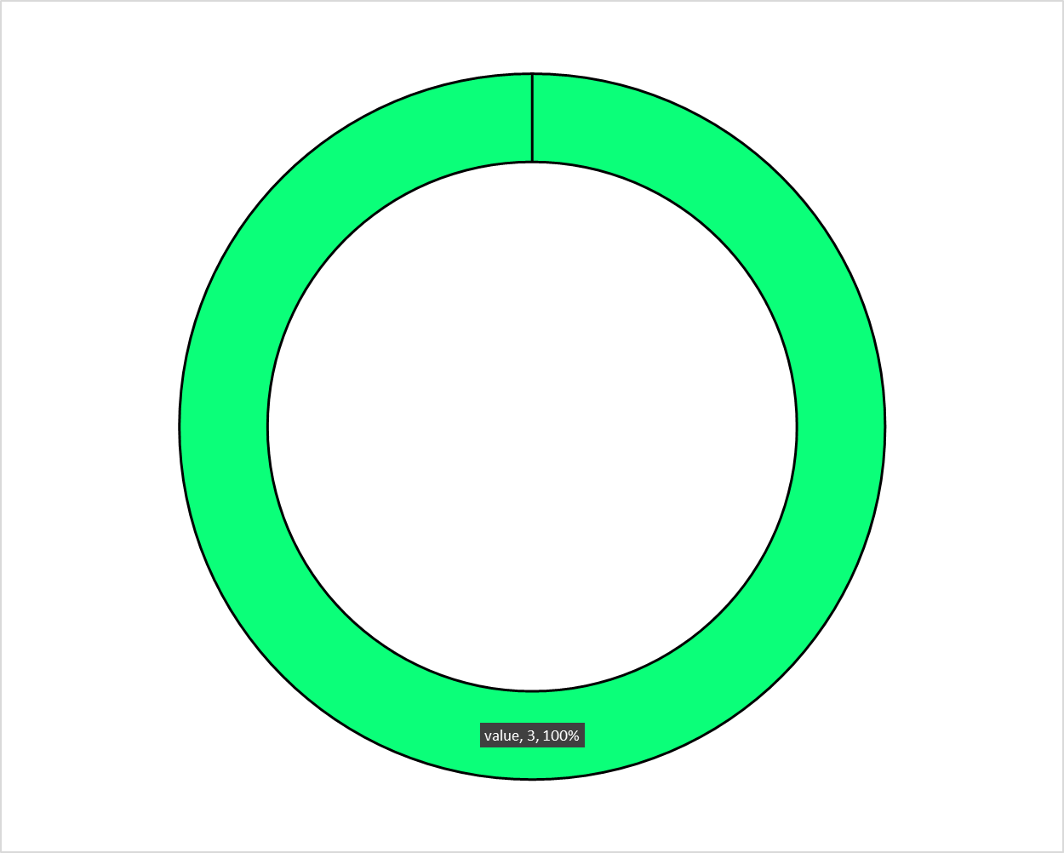

|  |  |  |  |
| --- | --- | --- | --- |
| Category | Value | Score | Percent Change |
| Click Through Rate | {ctr_value} | {ctr_score} | {ctr_change} |
| Cost Per Click | {cpc_value} | {cpc_score} | {cpc_change} |
| Frequency | {frequency_value} | {frequency_score} | {frequency_change} |
| CPM | {cpm_value} | {cpm_score} | {cpm_change} |
| Impressions | {impression_value} | {impression_score} | {impression_change} |
| Reach | {reach_value} | {reach_score} | {reach_change} |

So with python you open up the HTML file and then have a loop go through every word and search for the ones above. If it hits the word you replace the word with the actual value.