EE446 TinyML Lab 9 Report
American Sign Language Gesture Recognition | Arduino Nano 33 BLE Sense Rev2 | June 5, 2026

Overview
This lab trained a compact neural-network classifier for two ASL-inspired IMU gestures, converted the trained TensorFlow model to TensorFlow Lite, exported the model as an Arduino header, and deployed it on the Arduino board for serial-monitor testing.
Item | Value | Item | Value
Gestures | hi, sup | Samples/gesture | 50 recordings
Input shape | 100 x 714 | Split | 60 train / 20 validation / 20 test
Final train accuracy | 0.9000 | Validation accuracy | 0.8000
Test accuracy | 0.8500 | TFLite size | 148,296 bytes
Header size | 926,943 bytes | Tensor arena | 16 KB

Software Fixes and Consistency Changes
- Fixed the intentional training-setup issue by treating the task as multi-class classification: the output layer uses softmax over the two gesture classes, the labels are one-hot encoded, and the model is compiled with categorical_crossentropy and accuracy.
- Kept the downstream plots and metrics consistent with that fix by plotting loss, validation loss, accuracy, and validation accuracy using the matching history keys.
- Used the same normalization in the notebook and Arduino sketch: accelerometer values are scaled with (value + 4) / 8 and gyroscope values with (value + 2000) / 4000.
- Exported gesture_model.tflite and model.h, then included model.h in the Arduino classifier sketch with the gesture labels ordered as hi then sup.

Model Results
The final run trained for 100 epochs. The last epoch reported loss 0.2016, training accuracy 0.9000, validation loss 0.3173, and validation accuracy 0.8000. On the held-out test set, the model reported loss 0.2339 and accuracy 0.8500. The exported TensorFlow Lite model is 148,296 bytes and the generated Arduino header is 926,943 bytes.

Hardware Deployment Evidence
The Arduino sketch was configured for the Nano 33 BLE Sense Rev2 IMU library, uses 119 IMU samples per inference window, and runs inference after significant motion crosses the 2.5 G acceleration threshold. The Serial Monitor output below shows both gestures being identified with the higher confidence score: hi at 0.884913 and sup at 0.857895 or higher in later tests.
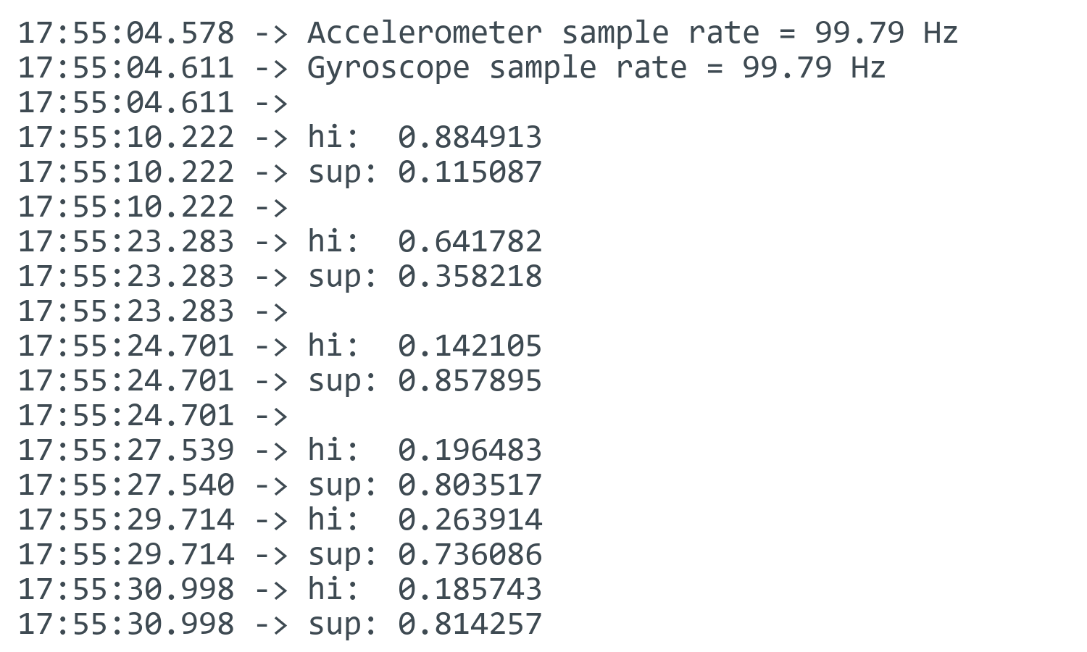
Figure 1. Arduino Serial Monitor deployment output from the provided screenshot.

Files Included for Submission
- Completed notebook: EE446_TinyML_Lab9.ipynb
- Submission PDF: Lab9_Report.pdf
- Arduino sketch: lab9-classifier-dual-board.ino
- Deployed model header: model.h
- Related verification files: hi.csv, sup.csv, gesture_model.tflite, and this Word report source.

