ART OF LIVING
AOL101
Task No: 01
Task Name: Explore different types of professions.

Submitted To
Name: Tasmiah Rahman
Designation: Lecturer
Department of CSE
Daffodil International University

Submitted By

Md: Jonayed Hossan  ID: 251-15-057 | Sajjad Mahmud  ID: 251-15-202
Md: Samiul Rahaman Alif  ID:251-15-271 | Imranul Islam Sarker  ID:251-15-569

Semester: Summer 2026
Department of CSE
Daffodil International University

Date of Submission:17/07/2026

First Interviews
Name:MD.Ataur Rahman
Occupation:Customer Service Excutive,British Council.

He works as a Customer Service Executive at the British Council and has been working in this position for the past three years. His primary responsibilities include assisting customers, answering their questions, providing accurate information about the British Council's services, guiding candidates through different procedures, and resolving complaints in a professional and friendly manner. He believes that strong communication, patience, problem-solving ability, and teamwork are the most important skills for success in this profession.

His profession requires a disciplined and professional lifestyle. He starts his workday on time, dresses formally, and communicates with people from different backgrounds. He usually works from 9:00 AM to 5:00 PM on weekdays, but during busy periods, such as IELTS registration, examination sessions, or special events, he often needs to work extra hours to manage the increased workload and ensure quality customer service.

One of the biggest challenges of his job is dealing with dissatisfied or frustrated customers while maintaining a calm and positive attitude. Sometimes he has to handle multiple customers at the same time, answer a large number of phone calls and emails, and solve urgent problems within a short period. He manages these challenges by listening carefully to customers, understanding their concerns, staying patient, communicating clearly, and providing the best possible solution according to the organization's policies.

According to him, this profession has greatly improved his communication and interpersonal skills, increased his confidence, and taught him how to work effectively under pressure. It has also helped him become more organized, responsible, and customer-focused while maintaining a balanced professional lifestyle. He advises anyone who wants to build a career in customer service to improve their communication skills, practice active listening, remain patient, develop problem-solving abilities, and always maintain a positive and respectful attitude toward customers.
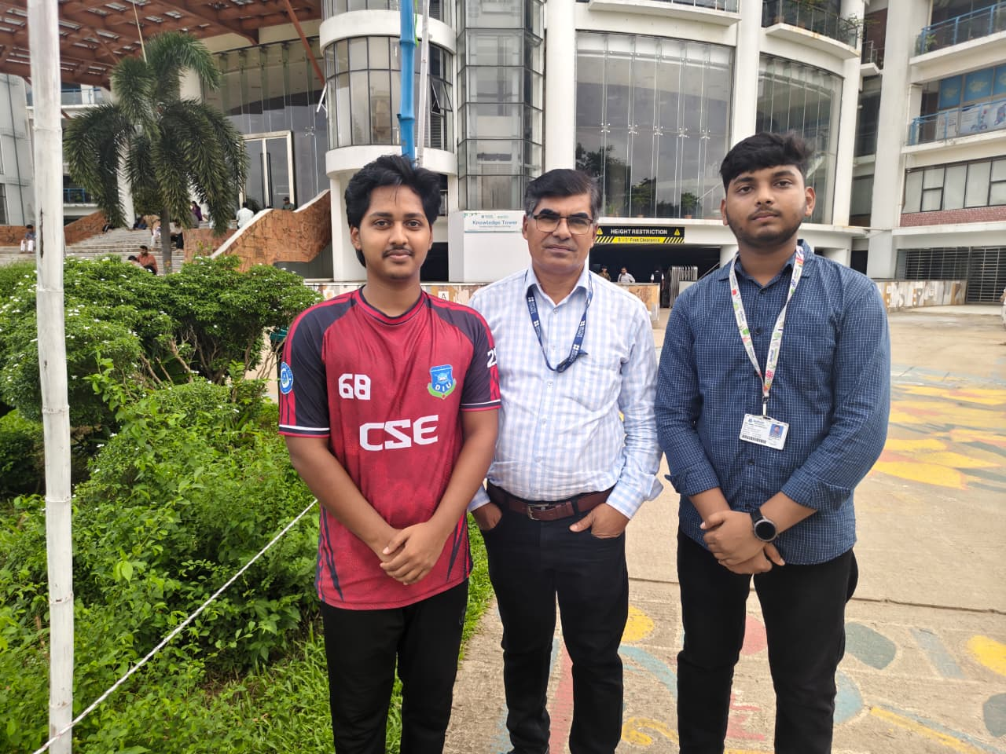

Second Interviews
Name:Mohammad Jahid
Occupation: Security Guard

He has been working as a Security Guard more then three years. His main responsibilities include protecting people and property, monitoring the premises through regular patrols, checking visitors, controlling access to the building, preventing unauthorized entry, and responding quickly to emergencies. He explained that this profession requires constant alertness, discipline, responsibility, and the ability to make quick decisions in difficult situations.

His work usually involves 8–12-hour shifts, depending on the organization. He often works both day and night shifts, including weekends and public holidays. Because of the rotating schedule, maintaining a healthy work-life balance can be challenging. He tries to maintain a disciplined lifestyle by getting enough rest between shifts, eating healthy meals, and exercising regularly to stay physically fit.

One of the biggest challenges of his job is staying alert throughout long working hours, especially during night shifts. He also faces difficult situations such as handling suspicious activities, managing large crowds, and responding to emergencies. He deals with these challenges by following security procedures, remaining calm under pressure, and immediately informing the appropriate authorities whenever necessary.

He said that the salary of a Security Guard is generally modest, so he manages his expenses carefully by preparing a monthly budget, avoiding unnecessary spending, and saving a portion of his income for future needs. According to him, this profession has taught him discipline, responsibility, patience, and the importance of protecting others. He believes that honesty, physical fitness, discipline, good observation skills, and the ability to remain calm under pressure are essential qualities for becoming a successful Security Guard.

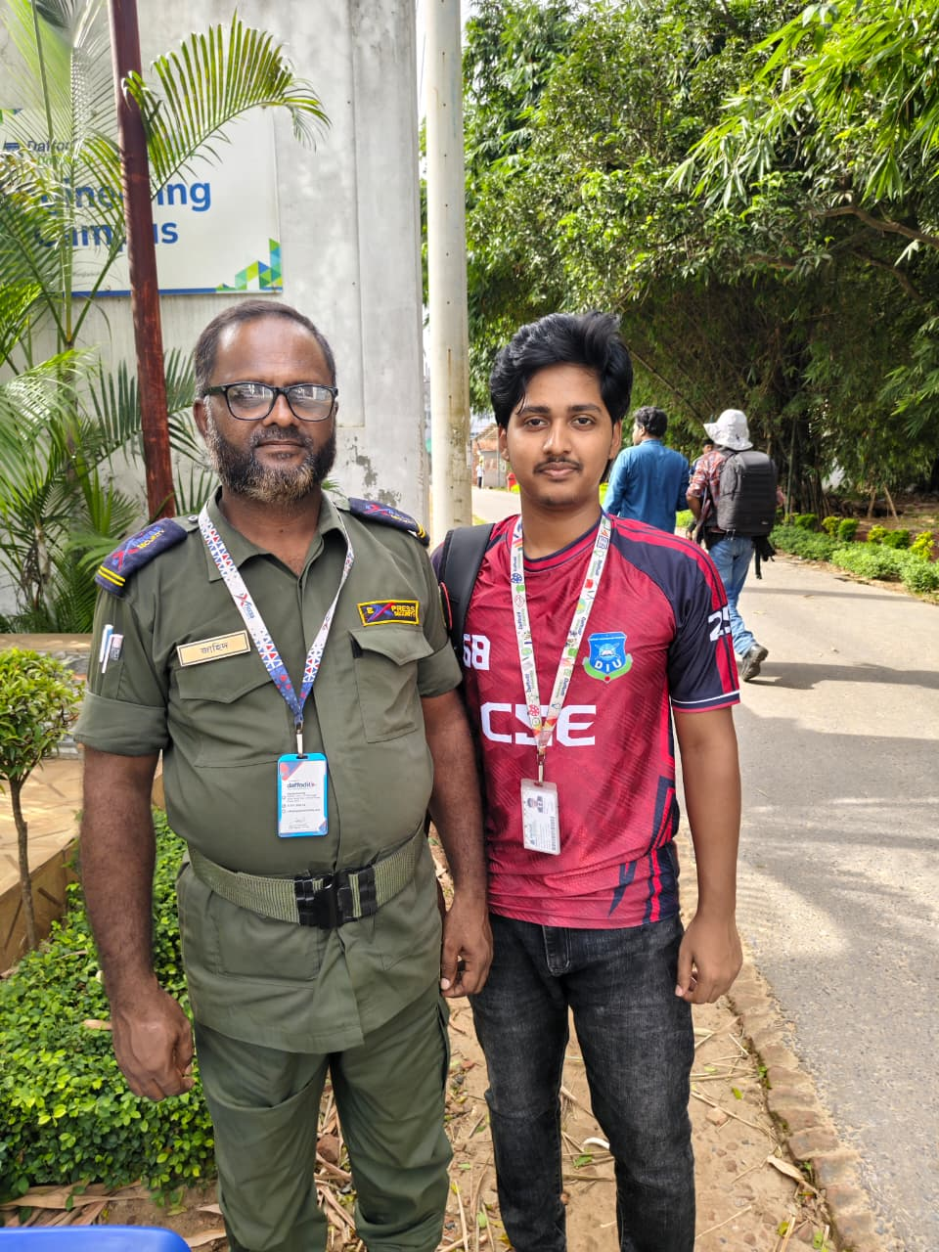

Third Interviews
Name: Shah Alam
Occupation: Bus Driver

He has been working as a Bus Driver for the past eleven years. His main responsibilities include transporting passengers safely to their destinations, following traffic rules, checking the bus before each trip to ensure it is in good condition, and maintaining the safety and comfort of passengers throughout the journey. He explained that this profession requires excellent driving skills, patience, responsibility, and full concentration at all times.

He usually works 10–12 hours a day, although he sometimes works longer hours due to traffic congestion, long-distance routes, or additional trips. His work schedule may start early in the morning or continue until late at night. Despite his busy routine, he tries to maintain a healthy lifestyle by getting enough rest, eating nutritious food, and ensuring he is physically fit before driving.

According to him, one of the biggest challenges of this profession is driving safely for long hours while dealing with heavy traffic, bad weather, and sometimes difficult passengers. He handles these challenges by staying calm, following traffic regulations, remaining focused, and always putting passengers' safety first.

He also mentioned that a bus driver's salary is usually fixed, with opportunities to earn extra income through overtime or additional trips. To manage his finances, he prepares a monthly budget, avoids unnecessary expenses, and saves a portion of his income for future needs. He believes that this profession has taught him discipline, punctuality, patience, and responsibility. He advises anyone interested in becoming a bus driver to develop strong driving skills, learn traffic laws, stay physically and mentally fit, and always prioritize the safety of passengers.
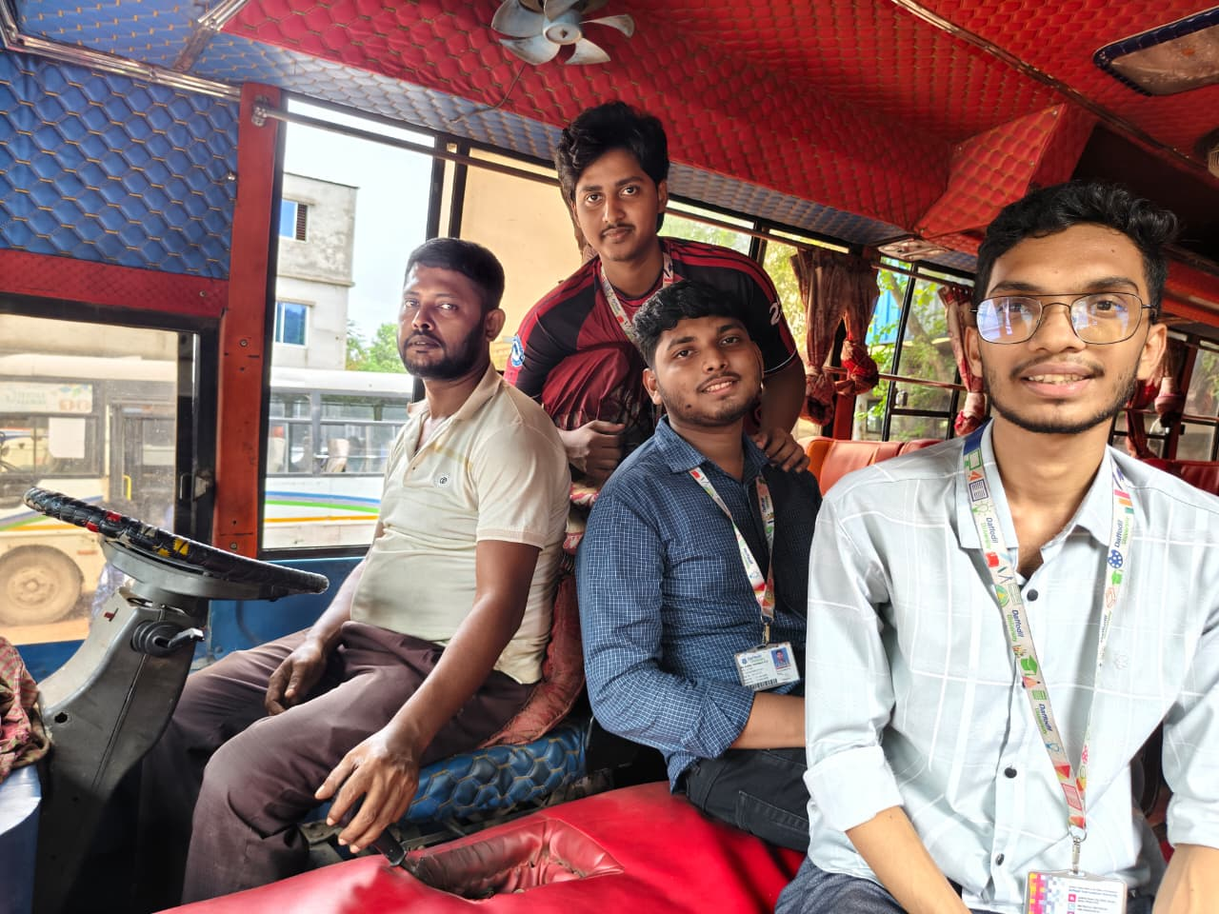

Fourth Interviews
Name: Jahangir
Occupation: Roadside weight measurement service provider.

He has been working as a Roadside Weight Measurement Service Provider for the past two years. His main responsibility is to measure people's weight using a weighing machine set up on the roadside. He also keeps the weighing machine clean and accurate, collects service fees, and interacts politely with customers. He explained that this profession requires honesty, patience, and good communication skills to build trust with customers.

He usually works 10–13 hours a day, starting in the morning and continuing until the evening. His income depends on the number of customers he serves each day, so his earnings may vary. Since he works outdoors, he has to face different weather conditions, such as extreme heat, rain, and cold. Despite these challenges, he tries to maintain a simple and disciplined lifestyle. He manages his expenses by making a monthly budget, avoiding unnecessary spending, and saving part of his income for his family's future needs.

According to him, one of the biggest challenges of this profession is finding enough customers, especially during bad weather or less crowded days. He also needs to ensure that the weighing machine provides accurate results at all times. He deals with these challenges by being friendly with customers, maintaining his equipment properly, and choosing busy locations where more people pass by.

He believes that this profession has taught him patience, responsibility, and the importance of treating every customer with respect. He advises anyone interested in this work to be honest, polite, hardworking, and committed to providing accurate and reliable service to customers.
