**Ans to the Question No- a**

What is illustration in MS Word?

**Ans** : Illustration in MS Word refers to visual elements like images, charts, shapes, SmartArt, or diagrams inserted to enhance or clarify content.

**Pictures:**



**Online pictures:**



**Shapes:**

**SmartArt:**

**A chart:**

**Screenshot:**

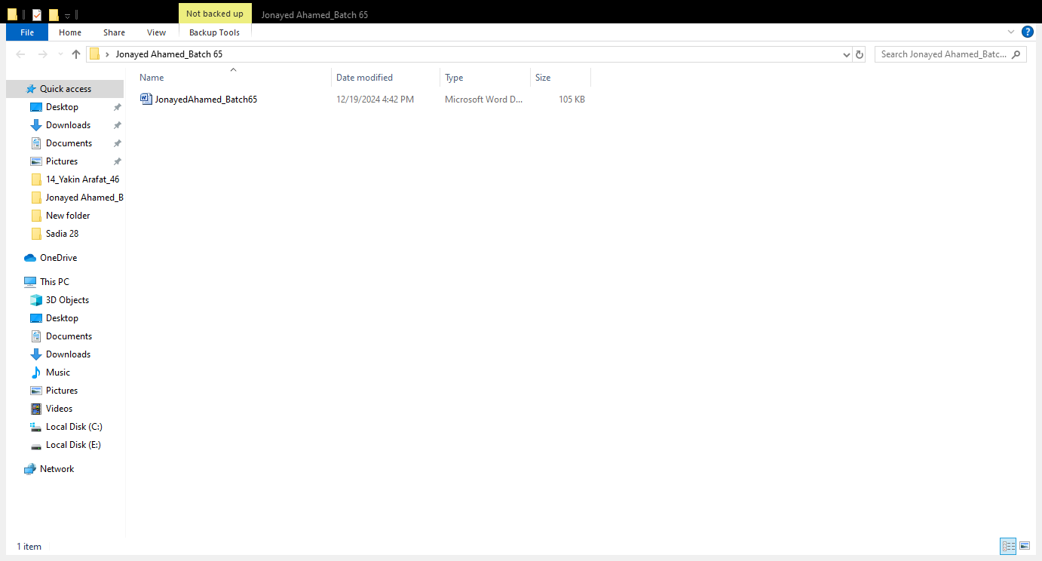

**Insert the more than 2 shapes and group an ungroup the shapes**

**Group Shapes**

**Ungroup Shapes**

**Ans to the question No:b**

The Santals are one of the largest indigenous communities in South Asia, primarily found in India (Jharkhand, West Bengal, Odisha, Bihar, and Assam) and parts of Bangladesh and Nepal. Their culture is deeply rooted in nature, oral traditions, music, and dance. Here's an overview of Santal culture.

**Practical Preparation**

**Ans to the Question No- c**

**Ans to the question No: d**

|  |  |  |  |  |
| --- | --- | --- | --- | --- |
| **January Tests** | | | | |
| Surname | Name | English | German | Computer |
| XUEREB | Norbert | 85 | 42 | 98 |
| Spiteri | Richard | 53 | 45 | 75 |
| Briffa | Paola | 42 | 25 | 48 |
| Brog | Clive | 55 | 85 | 82 |
| Caruna | Michelle | 45 | 45 | 25 |

C:\Program Files (x86)\Microsoft Office\MEDIA\CAGCAT10\j0195384.wmf