**Human uses of tunicates, including the colonial, invasive *Ciona intestinalis*: a review**

Regeneration of body parts in chordates and even vertebrates is not uncommon; in fact, a well known example is the ability of a lizard to regenerate its tail after the tail is easily broken off. The ability of humans to similarly regenerate damaged body parts is an area of interest, and while all species, including humans, have some degree of regenerative capabilities (Tsonis 2000), the possibility of a human regenerating an entire lost limb is still in the realm of science fiction.

One vertebrate does have the ability to regenerate large portions of lost body parts: the axolotl (*Ambystoma mexicanum).* However, despite several key insights drawn from studying the axolotl, there are several problems with the axolotl model, especially when studying potential molecular links to regeneration in the animal. Firstly, many axolotls are inbred as wild populations are critically endangered by the IUCN. Secondly, axolotls take around 18-24 months to become sexually mature. Thirdly, axolotls are an expensive organism, with costs for them surpassing more than $50 USD for a single animal. Fourthly, axolotls require extensive care, as well as a relatively large volume of water for a single animal. All of these factors and more heavily favor another model organism to serve as a means for analyzing chordate regeneration.

Enter the tunicate. Tunicates, such as *Ciona intestinalis* (Figure 1 a-b), may not be as closely related to humans as axolotls are, but they are much more viable than the salamanders as a model organism for a variety of reasons. Firstly, unlike axolotls, tunicates are plentiful in the wild; in fact, some of them are invasive in areas such as Puget Sound. Secondly, tunicates exhibit rapid development, with a zygote being able to develop into a larva in just under seven hours. Thirdly, not only can tunicates be readily collected from the wild (as they are plentiful and even invasive), in fact, they can also easily be cultured in a laboratory setting en masse and do not require large volumes of water per organism (Joly et al., 2007).

Unlike other invertebrate model organisms (such as the roundworm *Caenorhabditis elegans* and the fruit fly *Drosophila melanogaster*), the tunicates have one main advantage over current commonly used organisms: it is taxonomically close to humans. Both are placed in the phylum Chordata, and tunicates exhibit the four distinctive chordate characteristics in their larval stage. Like other chordates (including humans), it has a nervous system, and this exists in the form of a neural complex with a brain. However, unlike humans (but similar to axolotls), tunicates have shown high capabilities for regenerating their neural crest.

Various investigations have confirmed the regenerative capabilities of the neural crest (Bollner et al., 1995), as well as the oral siphon and oral siphon pigment organs (Auger et al., 2010) (Figure 1 c-d). What is special about these organs that gives them a regenerative ability? One possible explanation is that these organs, based on their placement within the organism (Figure 1a) are more exposed to the open and thus more prone to predation or being damaged by the elements, while the visceral (lower) organs are more protected by other tunicates in the surroundings (Figure 1b). Alternatively, this phenomenon could be explained by the relative importance of these structures; the oral siphon takes in food and water the organism needs to survive, the pigment organs serve as sensory structures, and the neural crest controls the bodily functions.

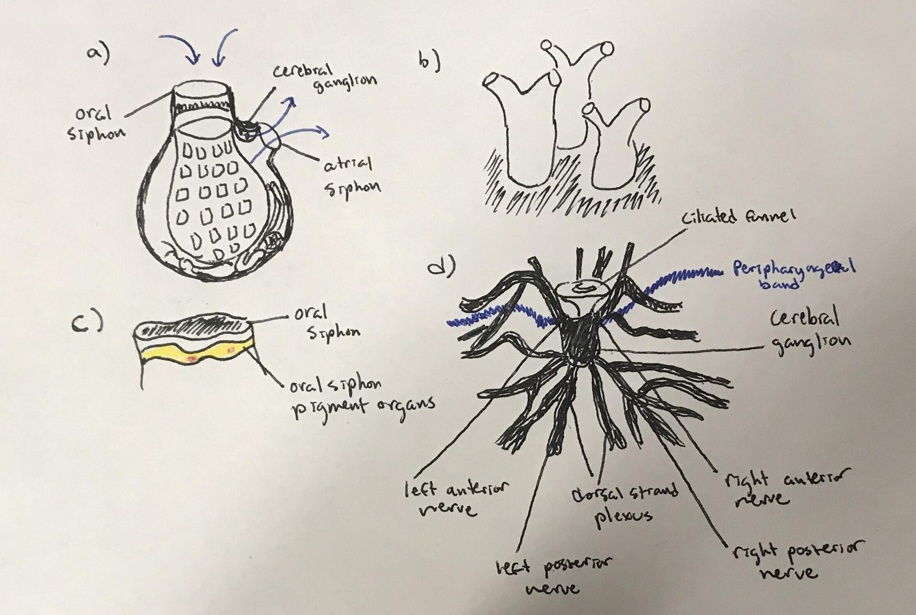

Figure 1: Various views of the tunicate *Ciona intestinalis*: a) an overview of the internal anatomy of the tunicate, with key siphons and ganglia labeled and water flow through the tunicate marked in blue; b) tunicate colonies as they appear in the wild; c) a close-up view of two of the tunicate organs with regenerative properties, the oral siphon and oral siphon pigment organs; d) a detailed view of the neural network with cerebral ganglion and various nerves, also exhibiting regenerative properties. All images hand-drawn by the author.

To examine the regenerative abilities of the oral siphon and oral siphon pigment organs, Auger et al. (2010) and Jeffery (2012) first anesthetized the tunicate *Ciona intestinalis* in MS222 (tricaine methanesulfonate) in seawater before amputating the oral siphon along with the pigment organs. Similarly, both studies removed the neural crest of some of the tunicates with forceps. Both observed regeneration qualitatively and visually with some quantitative analysis.

One of the insights by Auger et al. (2010) suggested a local blastema as a source of new cells for regenerating oral siphons and oral siphon pigment organs. A similar process is seen in the neural crest, where cells from the dorsal strand plexus are primarily involved in the healing of neural crest damages (Bollner et al., 1995). The process of regeneration in tunicates is similar to the process of regeneration in axolotls, further confirming the value of *Ciona intestinalis* as a model organism for studying regeneration.

However, *Ciona intestinalis* provided even more insights than just general regeneration; rather, it showed a link between regenerative abilities and animal aging, which is much harder to study in an axolotl (due to the axolotl’s longer lifespan). Generally speaking, longer tunicates are older; hence, the studies by Auger et al. (2010) and Jeffery (2012) also examined the correlation between tunicate length and the time it took for the tunicates to regenerate oral siphons and oral siphon pigment organs after removal. Both studies found that for both organs, a longer tunicate length had a negative correlation with the time it took to regenerate the removed organ(s); that is, the older a tunicate was, the longer it took to regenerate an organ (Figure 2a). In addition, Jeffery (2012) found that older tunicates not only took longer to regenerate their oral siphon but also could not fully regenerate the siphon in the same way that the younger tunicates could (Figure 2b).

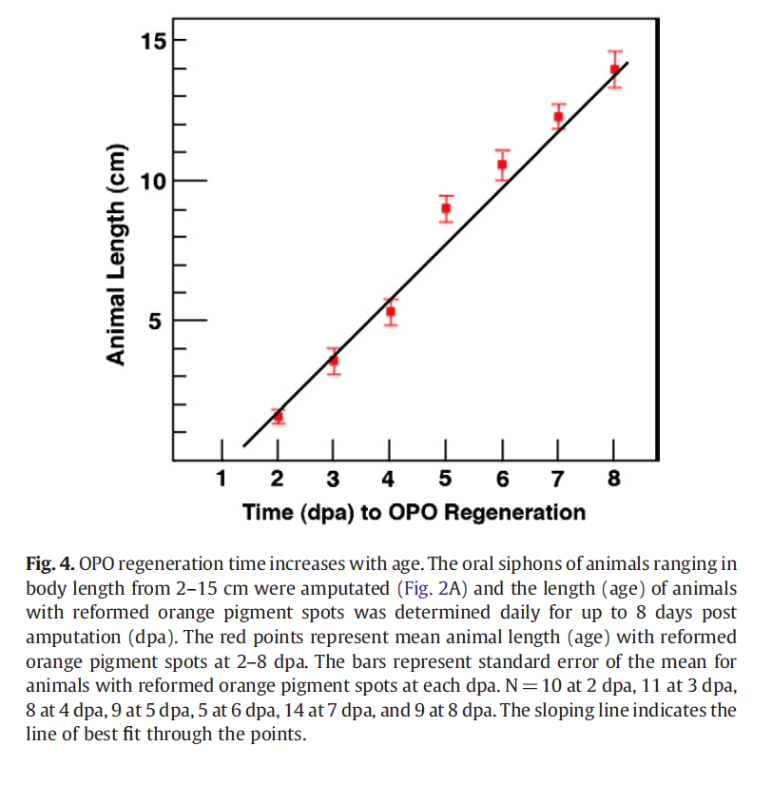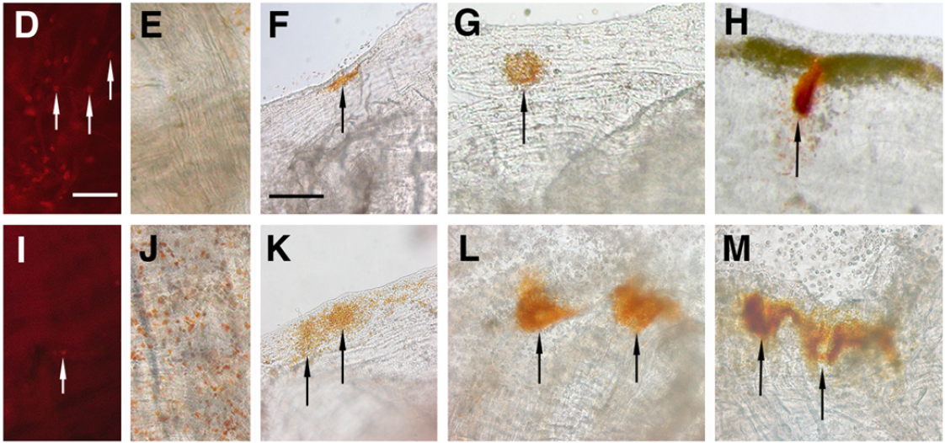

Figure 2: (left, a) A section from Auger et al. (2010) showing the negative correlation between tunicate length and the time it took for oral siphon pigment organs (OPOs) to regenerate; tunicate length correlates directly to age. (right, b) A section from Jeffery (2012) showing the difference between younger (top) and older (bottom) tunicates in regenerating the oral siphon pigment organs over time. Arrows point out the regenerated pigment spots in the organism.

While the implications of these insights might not be able to provide humans with the ability to regrow a kidney, they can certainly provide some insight on the physiological challenges elderly people face in human society. Just like tunicates, as humans age, their ability to carry out usual bodily functions decreases. This makes elderly workers inadvertently discriminated against in workplaces across various occupations despite their greater experience. One significant reason contributing to this is that their voices are generally slower and less engaging than those of their younger counterparts due to slowing language processing speed in the brain and weakening voice muscles (Rojas et al., 2020), and because of this, they are inadvertently perceived as less capable.

Other potential uses of tunicates stem far beyond use as a model organism in a laboratory setting. Some of them are eaten as food, specifically *Halocynthia roretzi*, or the sea pineapple, which is a common foodstuff in Korea. Humans also benefit from the cellulose-rich tunic of *Ciona intestinalis*, which can be converted into ethanol and used as fuel while the rest of the body gets turned into food for aquaculture (Hrůzová et al., 2020). Finally, various pharmaceuticals can isolated from tunicate bodies, including plitidepsin (Figure 3), also known by its trademark name Aplidin, which is being researched as a potential treatment for COVID-19, with some trials showing the drug to be more effective than remdesivir (Taglialatela-Scafati, 2021).

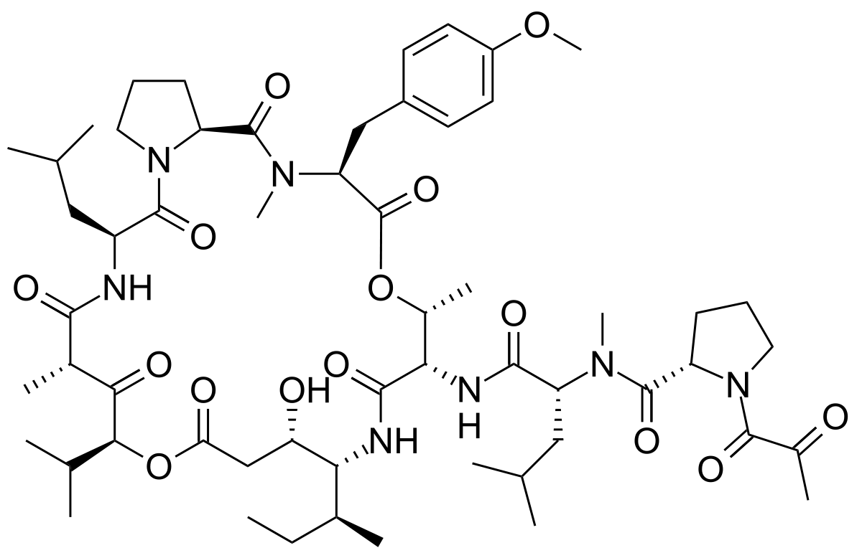

Figure 2: The structure of plitidepsin, also known as the trademark drug Aplidin, isolated from the tunicate *Aplidium albicans*, which is being researched as a treatment for COVID-19. Image from wikipedia.com

In light of all of the benefits that tunicates can bring to us as humans, it is quite sad that many people do not even know about their existence. With so much to give us and so many tunicates in the world, it is high time that we as humans took advantage of this relatively untapped abundance.

Works Cited

Auger, H., Sasakura, Y., Joly, J.-S., & Jeffery, W. R. (2010). Regeneration of oral siphon pigment organs in the ascidian *Ciona intestinalis. Developmental Biology, 339,* 374-389. doi:10.1016/j.ydbio.2009.12.040

Bollner, T., Howalt, S., Thorndyke, M.C., & Beesley, P. W. (1995). Regeneration and post-metamorphic development of the central nervous system in the protochordate *Ciona intestinalis*: a study with monoclonal antibodies. *Cell and Tissue Research, 279,* 421-432. doi:10.1007/BF00318500

Hrůzová, K., Matsakas, L., Karnaouri, A., Norén, F., Rova, U., & Christakopoulos, P. (2020). Second-Generation Biofuel Production from the Marine Filter Feeder *Ciona intestinalis. ACS Sustainable Chemistry & Engineering, 8,* 8373-8380. doi:10.1021/acssuschemeng.0c02417

Jeffery, W. R. (2012). Siphon regeneration capacity is compromised during aging in the ascidian *Ciona intestinalis*. *Mechanisms of Aging and Development, 133,* 629-636. doi:10.1016/j.mad.2012.08.030.

Jeffery, W. R. (2015). The tunicate *Ciona*: a model system for understanding the relationship between regeneration and aging. *Invertebrate Reproduction and Development, 59,* 17-22. doi:10.1080/07924259.2014.925515

Joly, J.-S., Kano, S., Matsuoka, T., Auger, H., Hirayama, K., Satoh, N., Awazu, S., Legendre, L., & Sasakura, Y. (2007). Culture of *Ciona intestinalis* in Closed Systems. *Developmental Dynamics, 236,* 1832-1840. doi:10.1002/dvdy.21124

Rojas, S., Kefalianos, E., & Vogel, A. (2020). How Does Our Voice Change as We Age?A Systematic Review and Meta-Analysis of Acoustic and Perceptual Voice Data From Healthy Adults Over 50 Years of Age. *Journal of Speech, Language, and Hearing Research, 63,* 533-551. doi:10.1044/2019_JSLHR-19-00099

Taglialatela-Scafati, O. (2021). New Hopes for Drugs against COVID-19 Come from the Sea. *Marine Drugs, 19.* doi:10.3390/md19020104

Tsonis, P. A. (2000). Regeneration in Vertebrates. *Developmental Biology, 221,* 273-284. doi:10.1006/dbio.2000.9667