PHOTOS
Every Driveline Plan or Project requires at least one Digital photo to be uploaded. As a rule, you should take one photo of each section that you worked on each day. Plans such as Greeting cards, only require a panoramic shot of the entire card racks. Even if the plan calls for a fixture install, photos are required. It is a good idea to write your “Photo sequences” down on a piece of paper each day, especially if you visit multiple retail locations. For example, if you started a day with a visit to an assigned dollar General store and serviced Greeting cards, (1Photo #1) BCI Sunglasses and Reading glasses (Photos # 2, 3, and possibly 4, depending on rack counts) and then went to another dollar General store and serviced the same categories (Photos 5, 6, 7 and 8), when you transfer the photos from your camera to your computer, they will be in the order you wrote down. This will ensure that you assign the right photos to the right planograms in the right stores.
PHOTO UPLOAD
The link for “PHOTOS” will appear, ONLY after you have completed your on line work order. As you can see below, the “UPLOAD” under photos only appears after the work order has been entered.
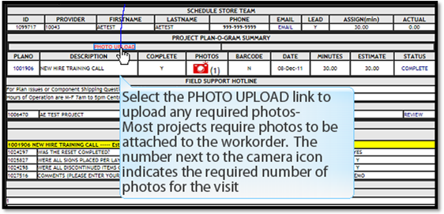
After transferring photos to your computer, click on UPLOAD, under photos, and the following screen will appear---Run the application, as requested: You may need to upload the Photo Uploader software first ( If the below screen shows a Red X instead of the ability to select the folder you have your photos in, see the troubleshooting page below)
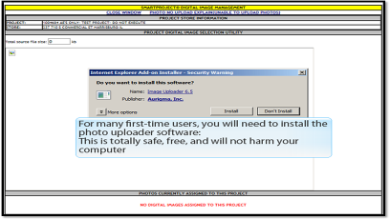
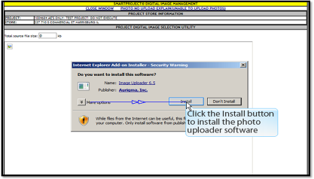
Follow the steps shown below to orientate, select, and upload your photos:
