**Use Case 1: Starting the Game**

**Objective**

* To start playing the game

**Pre-conditions**

* Player can connect to a LAN (if playing multiplayer)

**Post-conditions**

* Success
  + Single player game starts
  + Players able to join lobby and start the game
* Failure
  + App crashes
  + Player disconnect from the LAN

**Actors**

* 1-4 Players

**Triggers**

* Player launches the app

**Normal flow**

* Start Screen
  + Choose Single player

**Alternative flow 1**

* Start Screen
  + Choose Multiplayer
    - Join game
      * Exit lobby
      * Starting room: initial action word choice

**Alternative flow 2**

* Start Screen
  + Choose Multiplayer
    - Host game
      * Exit lobby
      * Starting room: initial action word choice

**Exception flow**

* Start Screen
  + Choose Multiplyaer
    - Join game/Host game
      * Disconnect from LAN
      * Return to Start Screen

**Interacts with**

* Triggering action word prompts

**Open issues**

* Do all players have to give assent before the game starts or can the host choose to start whenever it wishes?

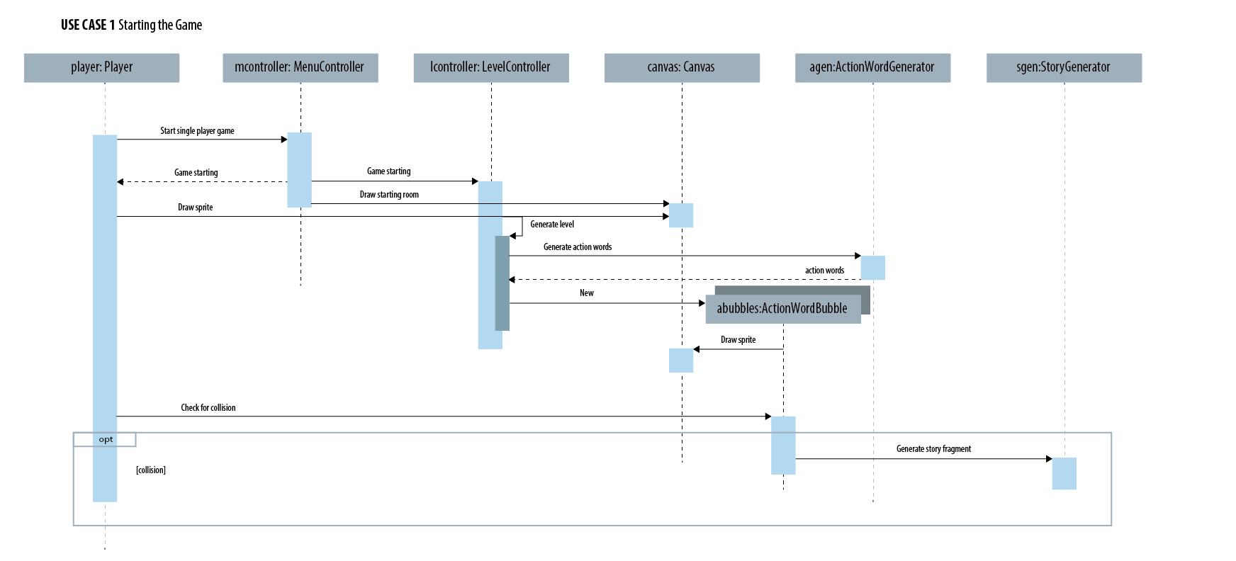

**Use Case 2: Interacting with in-game objects**

**Objective**

* To interact with an in-game object (immersive experience; player collaboration)

**Pre-conditions**

* Players have started the game

**Post-conditions**

* Success
  + Object responds if player chooses to interact
  + Nothing changes if player chooses not to interact
* Failure
  + App crashes
  + Player disconnect from the LAN (for multiplayer)

**Actors**

* 1-4 Players

**Triggers**

* Player walks over in-game object

**Normal flow**

* Dialogue pops up, prompts player
  + Player chooses to interact further
    - Object responds
    - Aesthetic changes to environment
    - Trigger action word prompts
    - Affect global mechanics (eg. increased gravity)
    - Reveal more storyline

**Alternative flow**

* Dialogue pops up, prompts player
  + Player chooses not to interact further

**Exception flow**

* Multiple players try to interact with the object at the same time

**Interacts with**

**Open issues**

* How to prevent multiple players from interacting with the same object simultaneously?

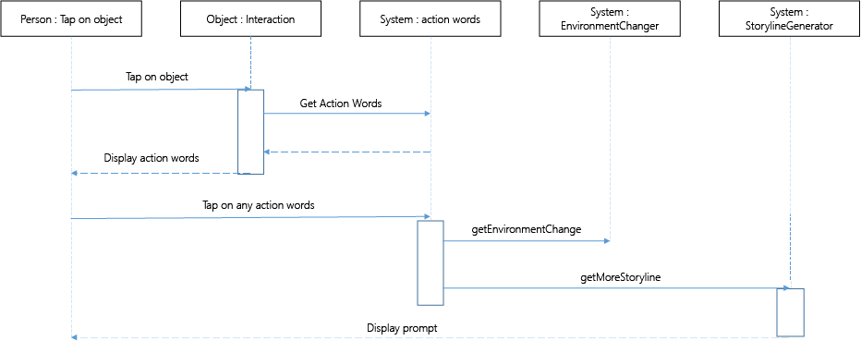

**Use Case 3: Interacting with enemies**

**Objective**

* Kill/avoid enemy or get killed by enemies

**Pre-conditions**

* Players have started the game
* There are enemies on the map

**Post-conditions**

* Player kills enemy
  + enemy disappears
  + enemy respawns after a while/ is permanently gone
* Enermy kills player
  + player respawns at original spawn point

**Actors**

* 1- 4 players

**Triggers**

* Attack and collide into enemy
* Collide into enemy without attacking

**Normal flow**

* Press A button
  + Collide with enemy
  + Enemy dies

**Alternative flow**

* Collide with enemy
  + Player dies

**Interacts with**

* Trigger action words prompt

**Open issues**

**User Case 4: Interacting with other players**

**Objective**

* To interact with other players

**Pre-conditions**

* Players have started the game
* Multiplayer game

**Post-conditions**

* Players gain new information

**Actors**

* 2-4 Players

**Triggers**

* Players collide (overlap) with each other and press the A button

**Normal flow (aesthetic interaction)**

* One player moves over the other, interaction prompt appears (change in color, or dialogue pop-up)  
  + Any one player presses the A button to interact
    - Triggers aesthetic change (sound or animation)

**Alternative flow (information passing)**

* One player moves over the other, interaction prompt appears (change in color, or dialogue pop-up)  
  + Any one player presses the A button to interact
    - Dialogue appears with information

**Exception flow (multiple players trying to interact together)**

* More than two players overlap/collide, try to interact
  + The first pair that starts to interact is no longer interactable with other players for the duration of their interaction
    - Interacting pairs interact as normal

**Interacts with**

**Open issues**

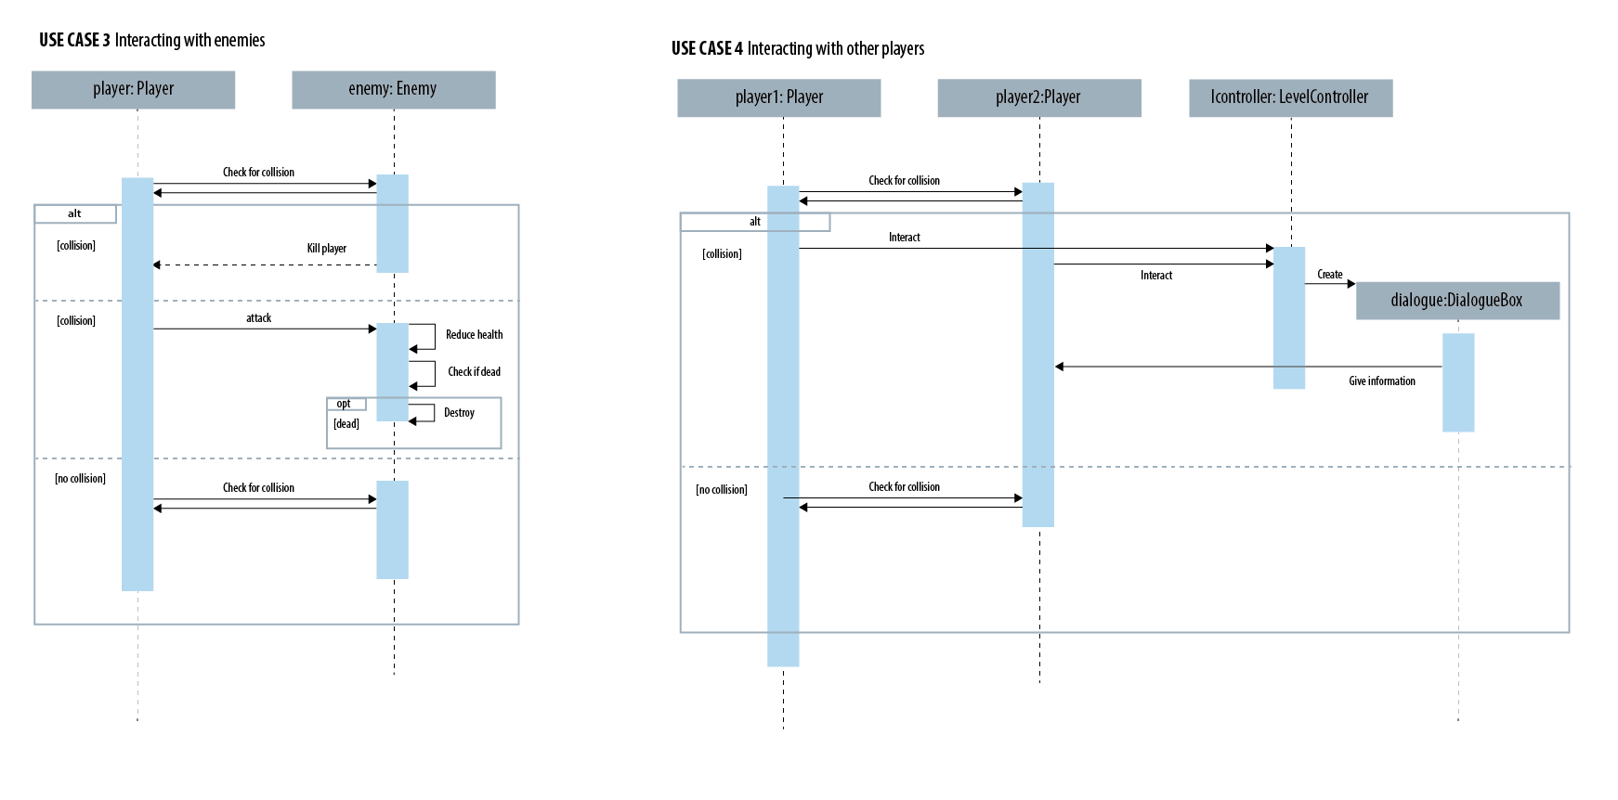

**User Case 5: Triggering action word prompts**

**Objective**

* To allow players to choose story elements that will affect gameplay

**Pre-conditions**

* Players have started the game

**Post-conditions**

* Map is altered
* Story is added to
* Triggering next level block

**Actors**

1-4 Players

**Triggers**

* Interact with some key object
* Unlocked post boss-fight
* End of level-block

**Normal flow**

* Action word bubbles appear on screen
  + Player jumps to touch a bubble and presses A button to choose word
  + Dialogue appears to elaborate on the chosen scenario
    - Map is altered in some way
      * Aesthetic changes
      * New objects appear on the map
      * Unlock NPC dialogue

**Interacts with**

* Interacting with objects
* Ending of level block
* Interacting with enemies

**Open issues**

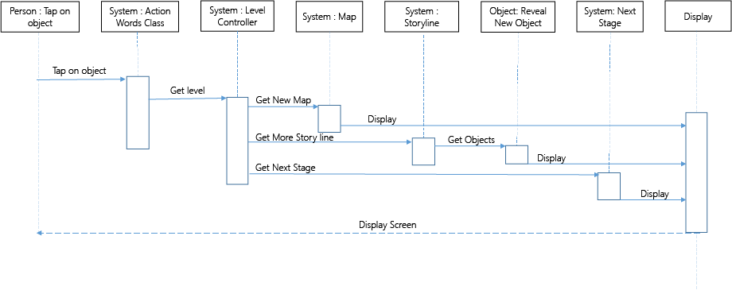

**User Case 6: Ending of level block**

**Objective**

* Allow user to progress to the next level/end the game

**Pre-conditions**

* Player have started the game
* Players have finished the main quest for each level

**Post-conditions**

* Players choose action words to set the next level
  + Players advance to next level block

**Actors**

1-4 Players

**Triggers**

* Players finish main level quest

**Normal flow**

* Main level quest is completed
  + Dialogue appears on each player's screen to notify them on quest completion and story progression
    - Direction prompt appears on players screens to prompt them to move to gathering point (denoted by some structure?)
      * All players reach gathering point
      * Action word selection for the next level is triggered
      * Players advance to next level

**Interacts with**

* Interacting with objects
* Ending of level block
* Interacting with enemies

**Open issues**

* How to categorize and track story elements in the game? (to determine how next level is generated based on the chosen action word)

