Little Landscapes by Amy Grace Laura

A ‘What To Expect’ Story


Originally supported by
The Performing Arts Foundation of Wellington

THE SHOW



I am going to see Little Landscapes.
It is a live theatre show.

The performer will tell stories, make sounds with objects, and whisper quietly.

Only 10 people can watch at a time.
It goes for 25 minutes.

THE PERFORMER

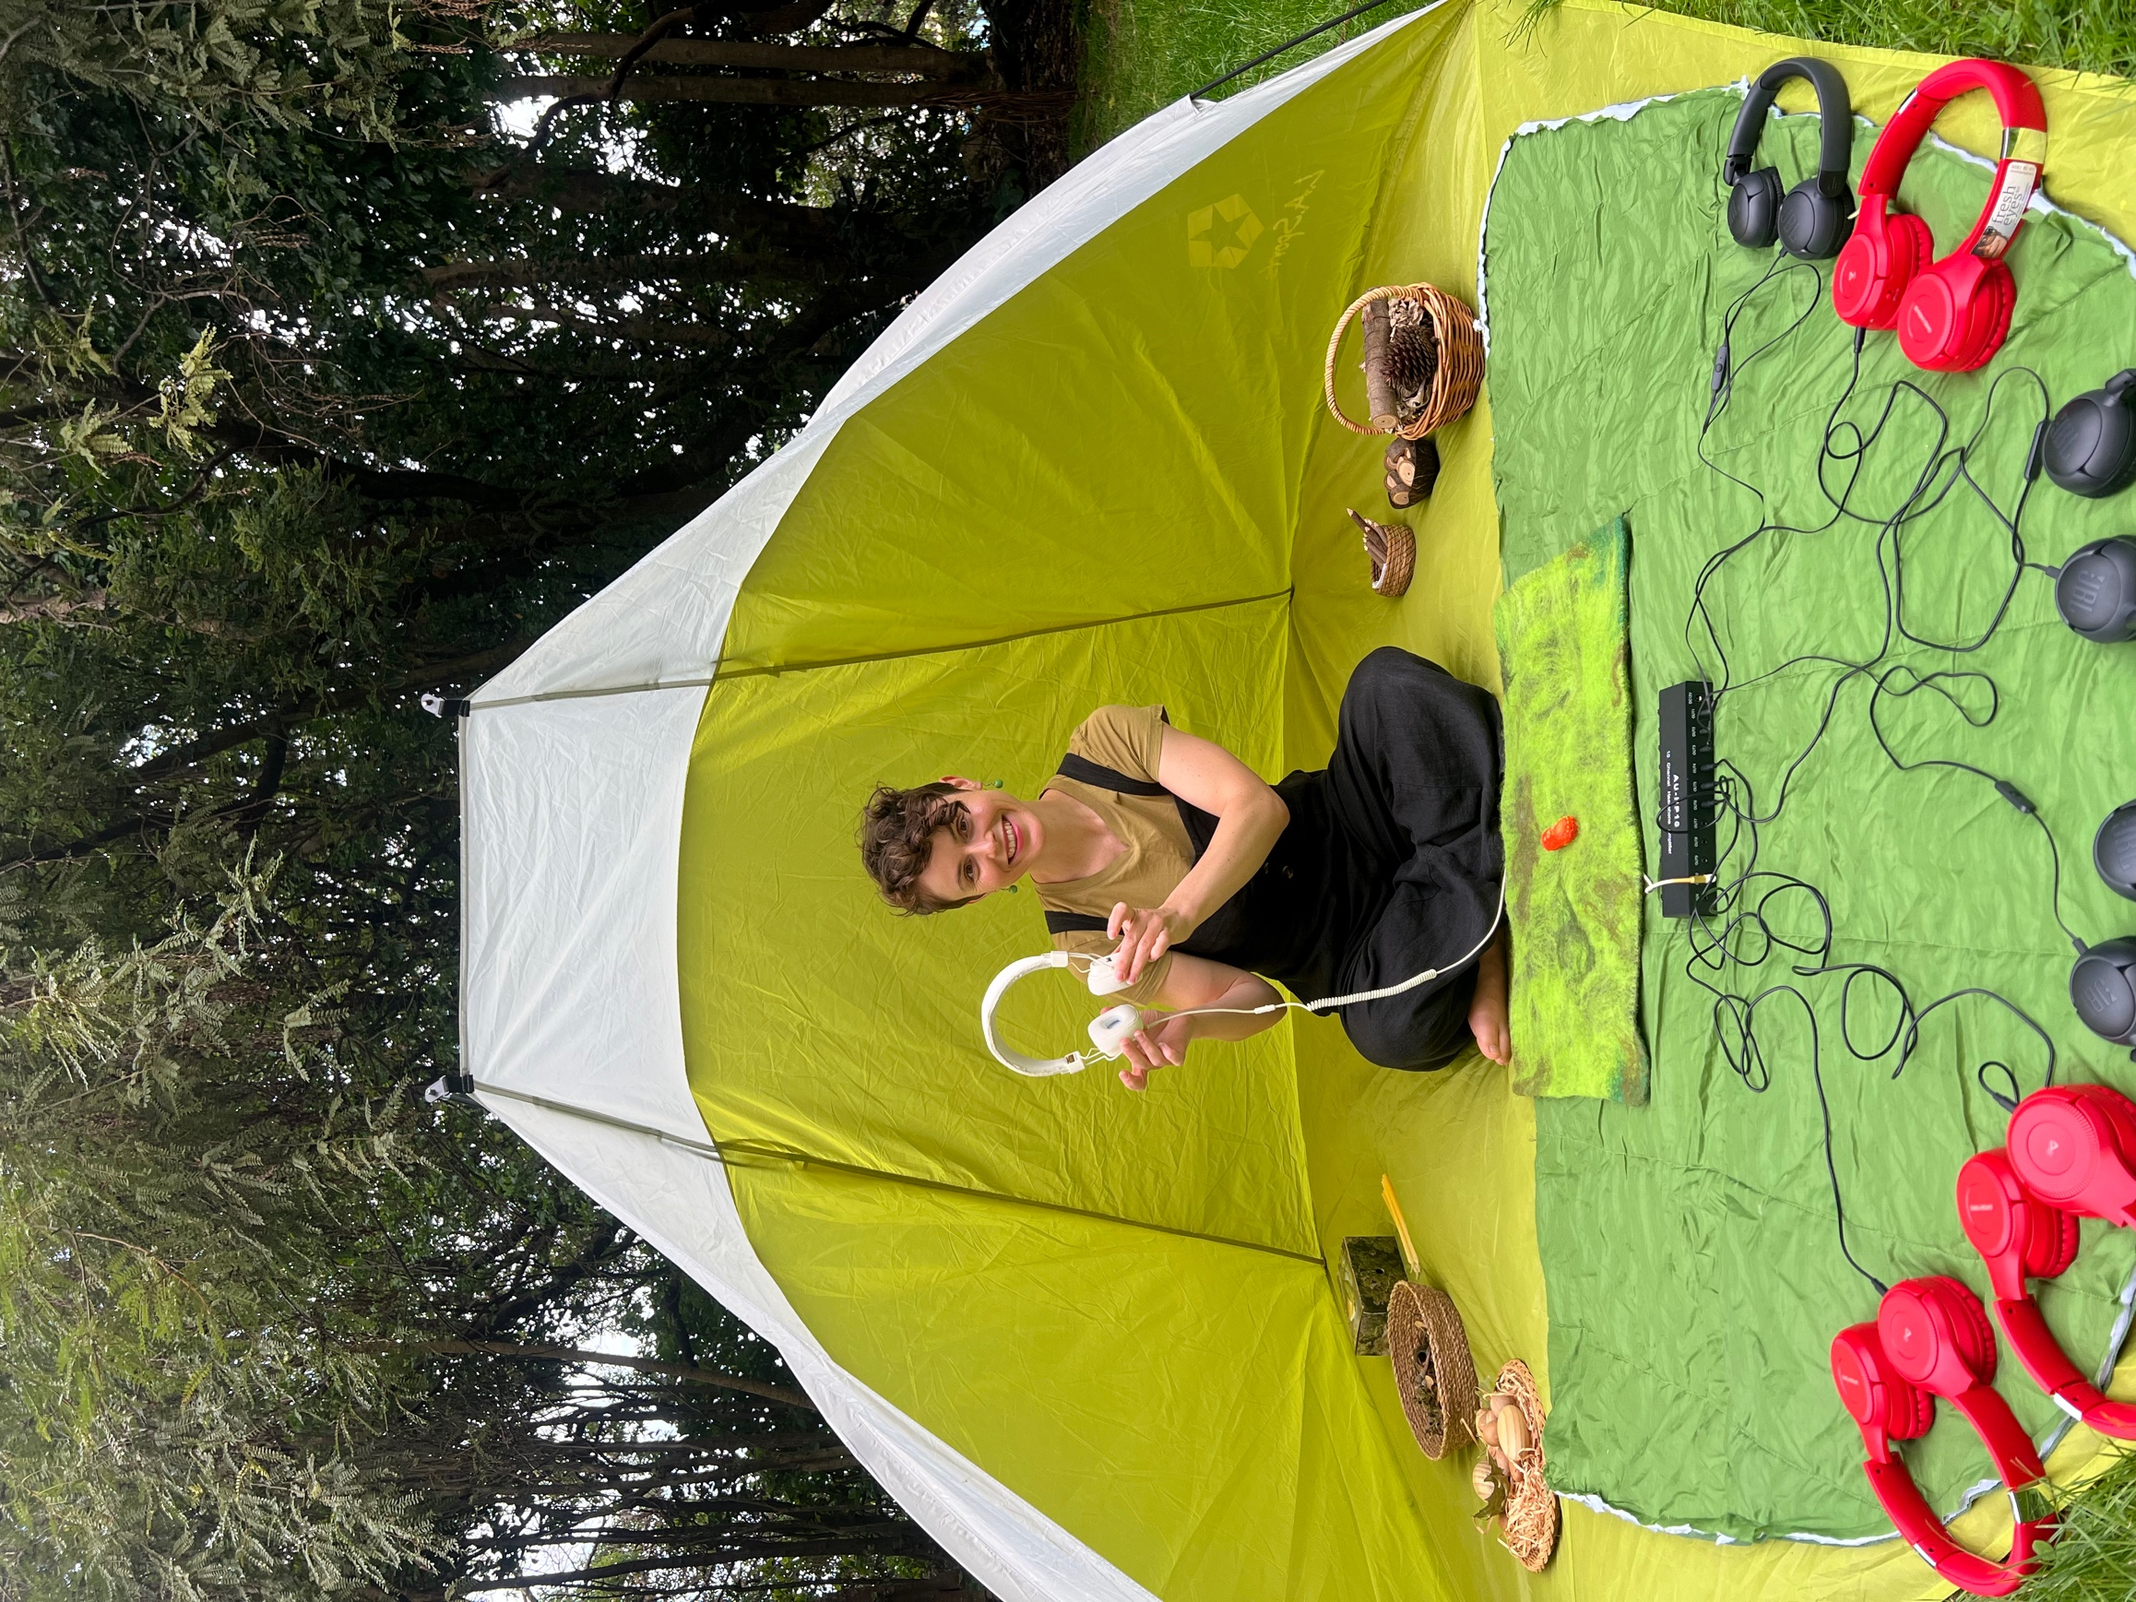

This is Amy Grace Laura.

Amy is the only performer in the show.

All the voices and sounds I hear in the show are made by Amy.

THE STAGE

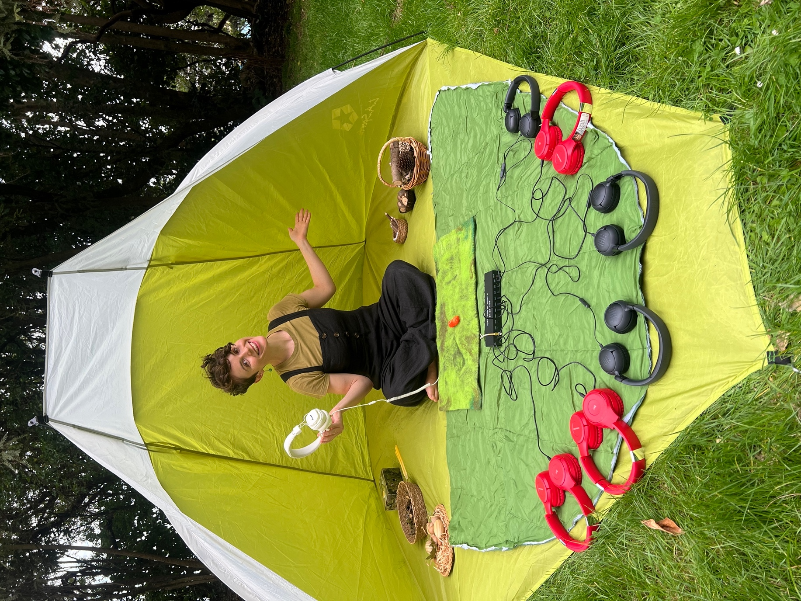

This is the stage for Little Landscapes.

I can sit with my grown-up to watch the show.

HEADPHONES



I will wear headphones during the show.

I will hear the show through my headphones.

If I don’t like a sound I can take my headphones off.

If it’s too loud I can ask the performer to turn the volume down.

OTHER PEOPLE

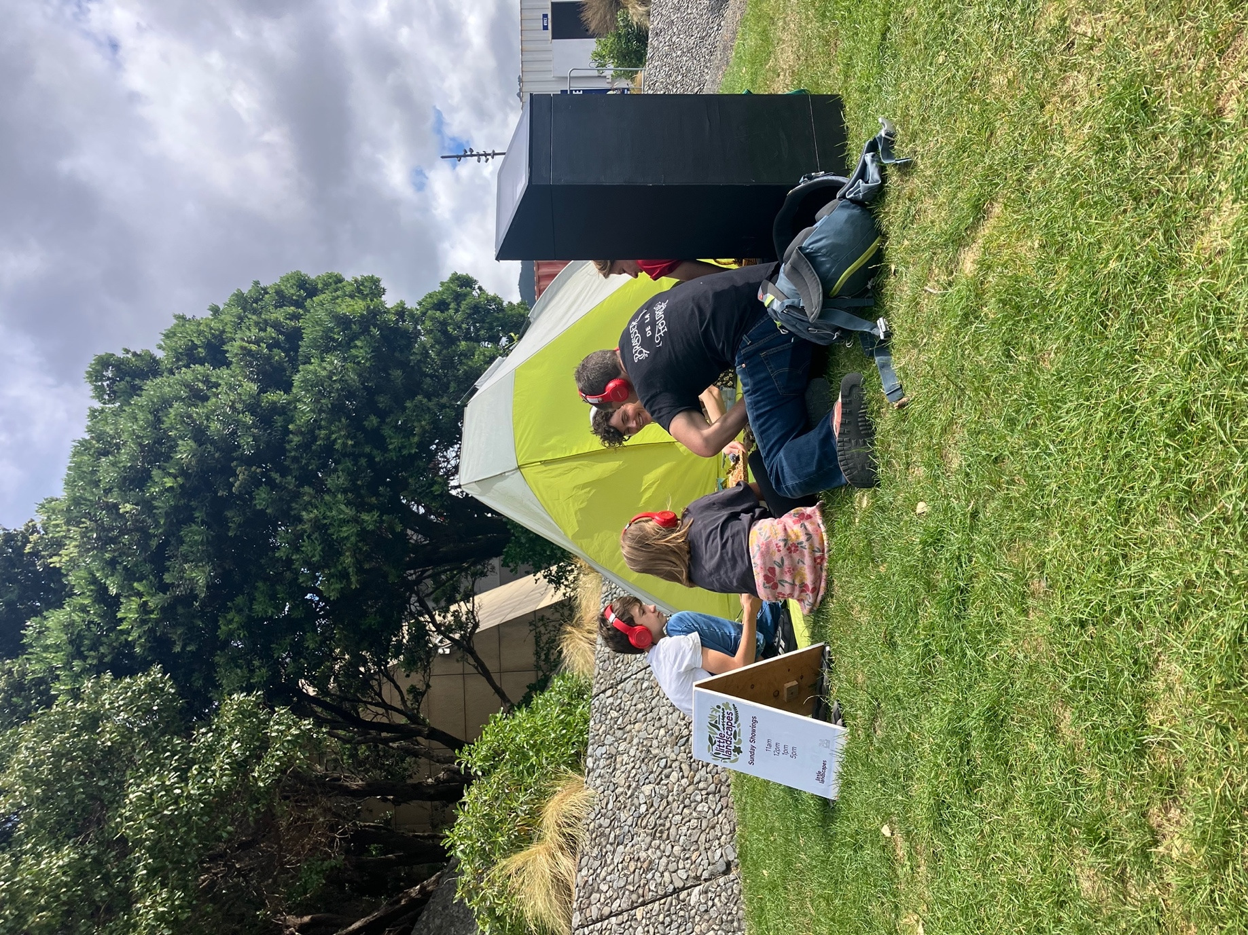

There will be other people attending the show.

We will all sit close together.

We can all join in and be a part of the show.

It will be fun!

THE END + APPLAUSE

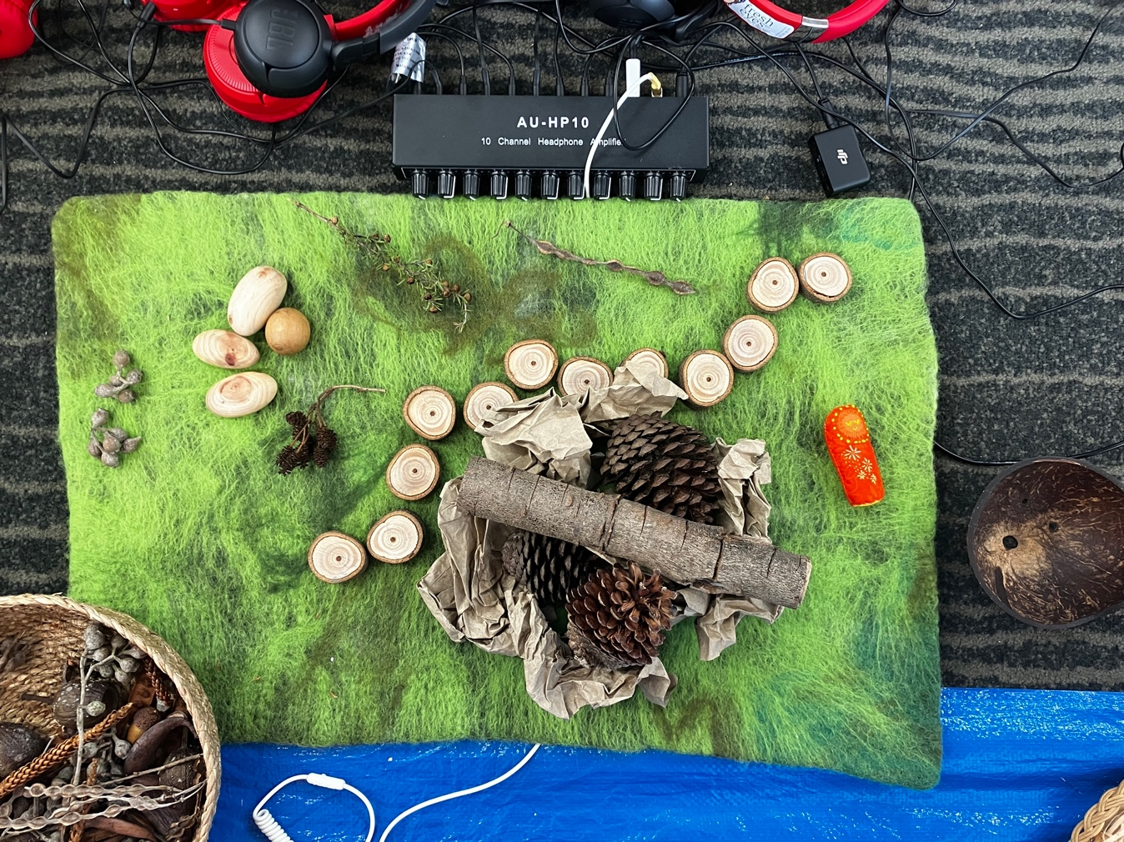
When the show finishes Amy will say ‘The End.’

I can clap at the end of the show if I liked it.

I can cover my ears if the clapping is too loud.

I will take my headphones off at the end and then we will leave.

Today I went to see Little Landscapes…

conversation starters for whānau


I liked the…
I didn’t like the…
The show makes me want to…

