Sympl PM
Product Development Platform

Product Manager SOP
Standard Operating Procedures for Product Managers
Version | Date | Audience
2.2 | October 30, 2026 | Product Managers, Directors, Contributors

CONFIDENTIAL — for internal use only

Contents
1. Purpose and Scope
1.1 Who this is for
1.2 Key terms
2. Signing In and Finding Your Way
2.1 Signing in
2.2 The dashboard
2.3 Navigation
3. Projects
3.1 Creating a project
3.2 The project list
3.3 Inside a project
4. Products and the Product Catalog
4.1 How the catalog works
4.2 Adding products to a project
4.3 Selecting rows: Bulk Edit, Duplicate, Remove
4.4 Grid tips
4.5 The Products page (catalog browser)
4.6 The product page
4.7 Setting the product's category
4.8 Pulling a product from Salsify
5. Category Requests
5.1 Submitting a request
5.2 Tracking a request
6. Exporting and Importing Excel
6.1 Exporting a project
6.2 Importing
7. PSIR Generator
8. Notifications and Your Profile
9. Quick Reference
Troubleshooting

1. Purpose and Scope
This SOP describes how Product Managers (PMs) use Sympl PM to run product development projects: creating projects, building and maintaining product data in the shared product catalog, requesting new categories, exporting and importing data, and generating PSIRs.
It reflects the October 2026 release, which introduced the product master catalog, Category Requests, Excel export dropdowns and custom branding.

1.1 Who this is for
- Product Managers (role PRODUCT_MANAGER).
- Directors, who carry the same permissions plus portfolio-wide visibility.
- Contributors, for the sections on editing products in the grid.

1.2 Key terms
Term | Meaning
Project | A body of work (for example a line refresh) with an owner, members, a status, a workflow and a set of products.
Product catalog | The single list of every product in Sympl. Each part number exists once.
Link | A product's membership of a project. One product can be linked to several projects.
Remove | Takes a product off one project. The product stays in the catalog and in any other projects.
Category Request | A request to an Admin or Director to add a new Category, Sub-Category or Product Type.
PSIR | Pre-Shipment Inspection Report, built in the PSIR Generator from the PSIR templates.

2. Signing In and Finding Your Way

2.1 Signing in
- Open the Sympl PM address your team uses in a browser (Chrome or Edge recommended).
- Enter your work email and password, then click Sign in.
- Forgot your password? Click Forgot password? on the sign-in page and follow the emailed link (valid for one hour).
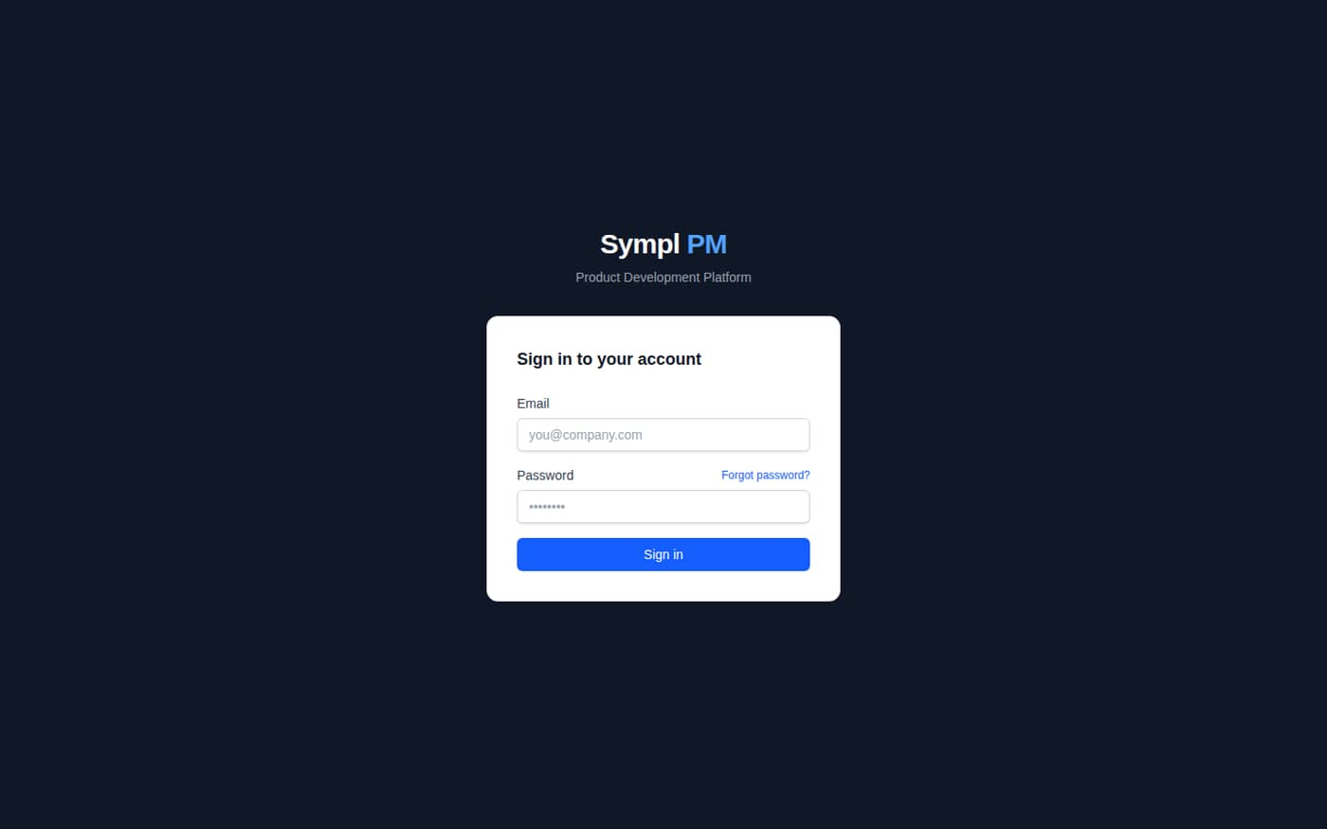
Figure 1. Sign-in page
Note: New users receive an invitation email with a Set Your Password link. The link is single-use and expires after 7 days. Ask an Admin to resend it if it has expired.

2.2 The dashboard
After signing in you land on the dashboard. It shows your project counts, My Projects, items that need your attention, and recent activity for your team.
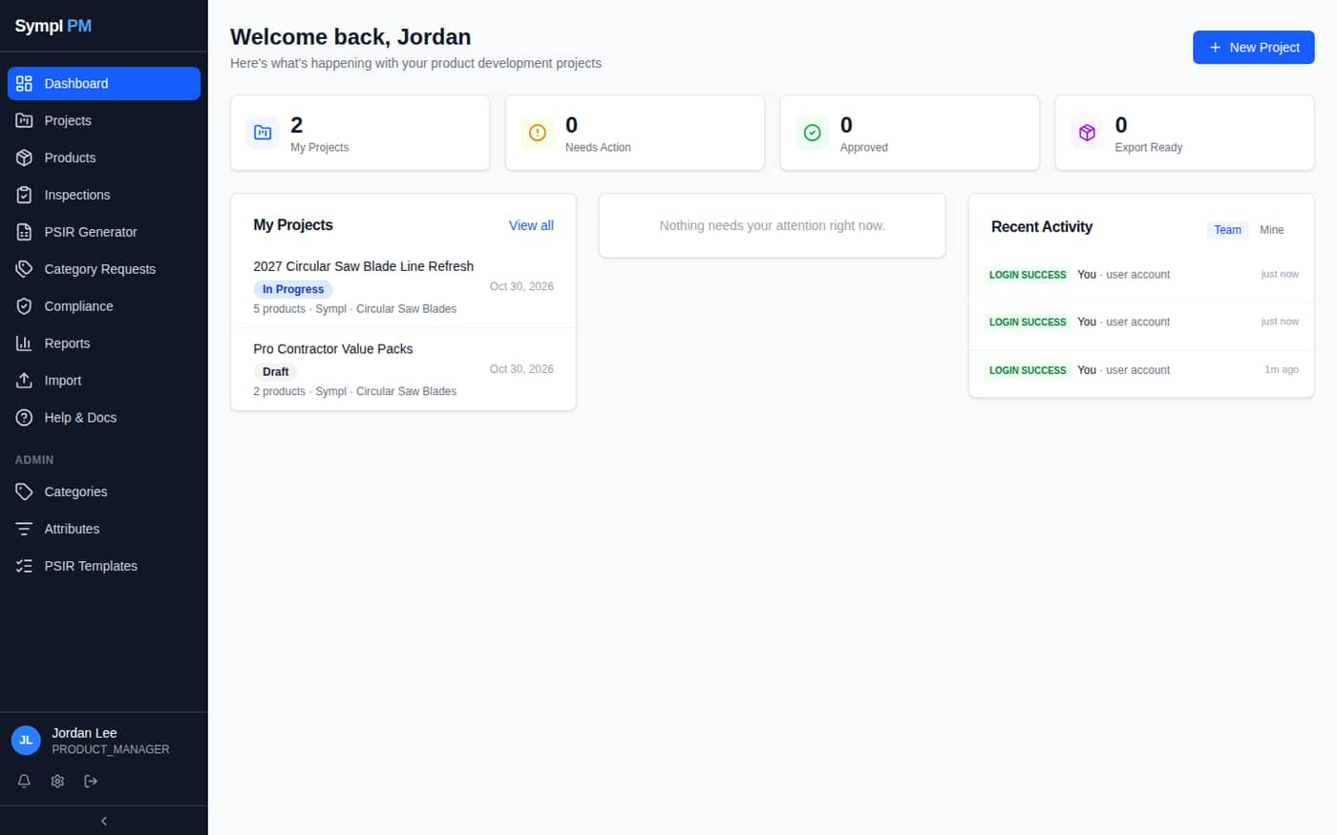
Figure 2. Dashboard for a Product Manager

2.3 Navigation
Menu item | Use it to
Projects | Create and open projects; work in the product grid.
Products | Browse and edit the whole product catalog; create products that aren't in a project yet.
Inspections | Record factory inspection reports.
PSIR Generator | Build a PSIR workbook for a category and part number.
Category Requests | Ask for a new category and track your requests.
Compliance | Track regulatory events (Prop 65, REACH, CPSC…) against products.
Reports | Operational reports with drill-down and Excel export.
Import | Bulk-load product data from Excel.
Help & Docs | In-app reference for every module.

The bell icon at the bottom of the sidebar opens your notifications; the gear opens My Profile.

3. Projects

3.1 Creating a project
- Click Projects in the sidebar (or New Project on the dashboard).
- Click New Project.
- Enter the Project Name (required) and, as available, Description, Brand, Product Family, Retailer / Channel, Target Launch and Product Category.
- Click Create Project. You are the owner.
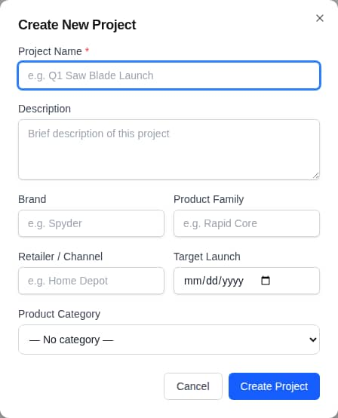
Figure 3. Create New Project dialog

3.2 The project list
Search by name, filter by status, and switch between card and list view with the icons at the top right.
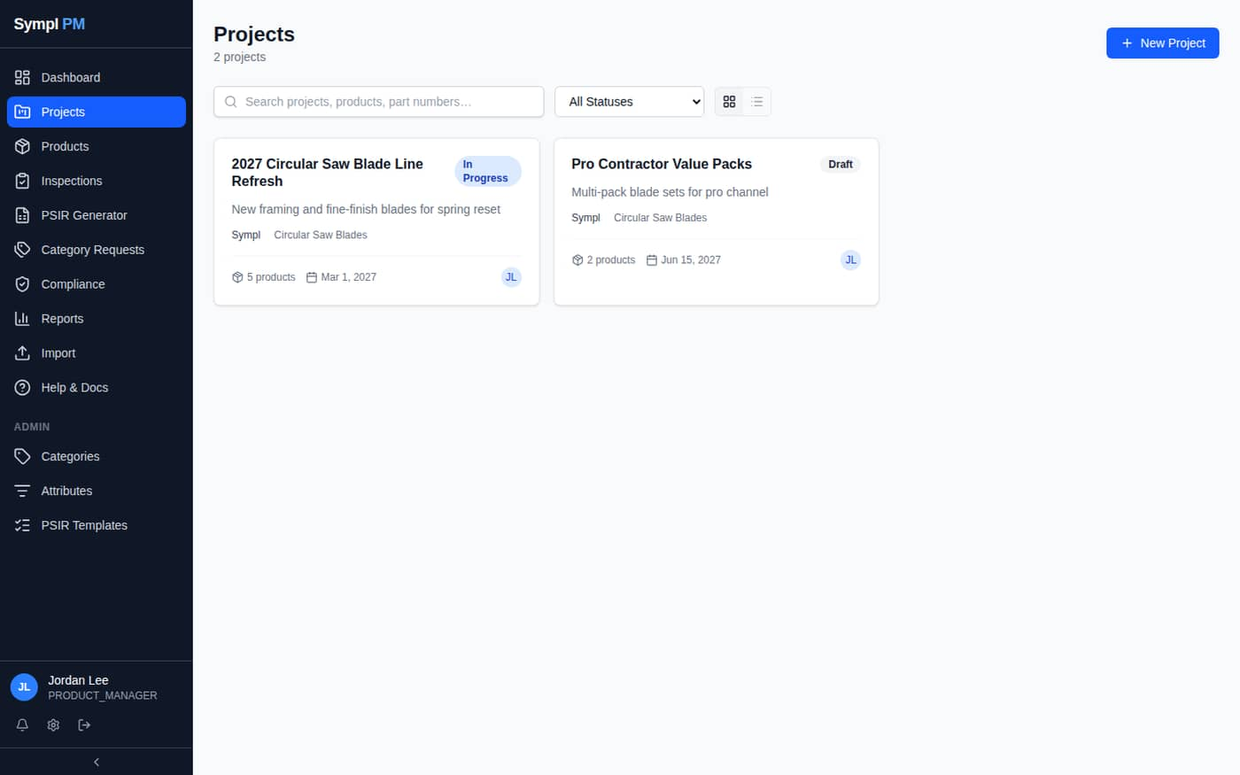
Figure 4. Projects page

3.3 Inside a project
A project opens on its Products tab (the product grid). The other tabs are Workflow, Compliance, Inspections, Comments, Activity, Members and Settings.
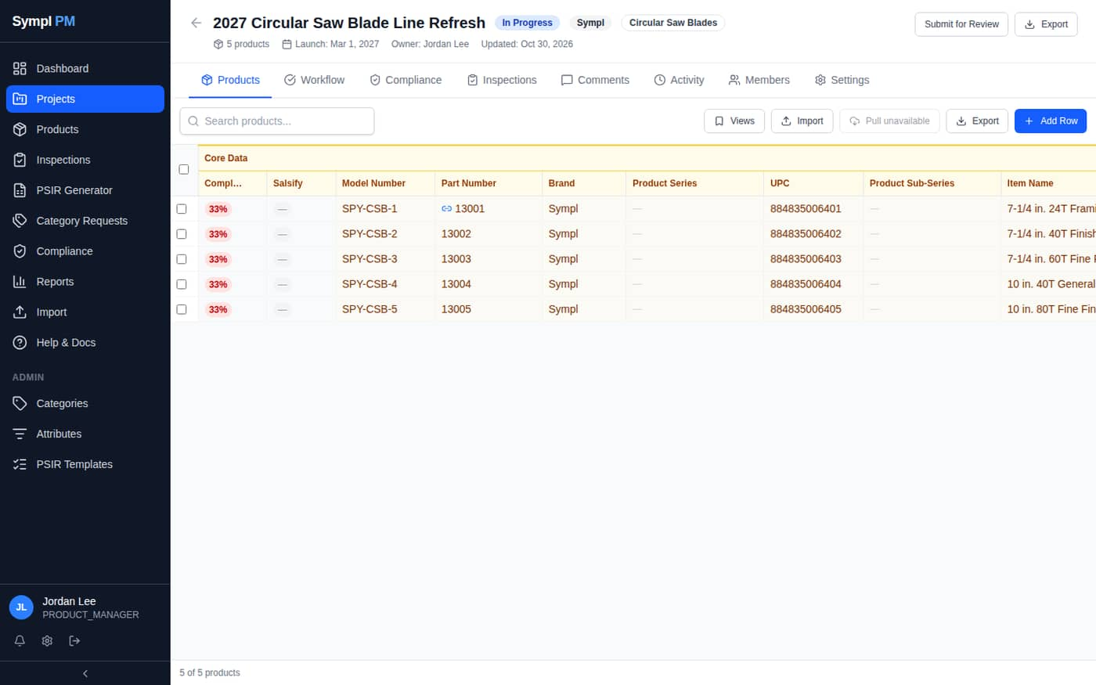
Figure 5. Project product grid

Members
Add teammates on the Members / Settings tab. Members inherit their global role's permissions; editing products requires being the owner or a member with edit rights.

Status and workflow
- Statuses: Draft → In Progress → Needs Review → Changes Requested → Approved → Export Ready → Archived.
- Click Submit for Review in the project header to start the review workflow.
- Workflow stages have approvers who vote Approve or Reject; due dates trigger overdue alerts.
- PMs can override a status from the project Settings tab (Save Status).

4. Products and the Product Catalog

4.1 How the catalog works
Every product lives once in a central product catalog. A project doesn't own copies of products; it links to them. This means:
- Part numbers are unique across the whole platform.
- If a product is in two projects, an edit made in either project changes the same record — both projects see it.
- A blue link icon next to the Part Number in the grid means the product is also in another project.
- Remove takes a product off the current project only. It is not deleted from the catalog.
- A product can exist in the catalog without being in any project.
Important: Because edits are shared, check the link icon before changing a product that is used by another project. Open the product page to see every project it belongs to.

4.2 Adding products to a project

Add a new row
- Open the project's Products tab.
- Click Add Row. A blank row appears at the bottom of the grid.
- Click a cell to type. Tab/Shift+Tab moves across, Enter saves and moves down, Esc cancels. Changes save automatically.
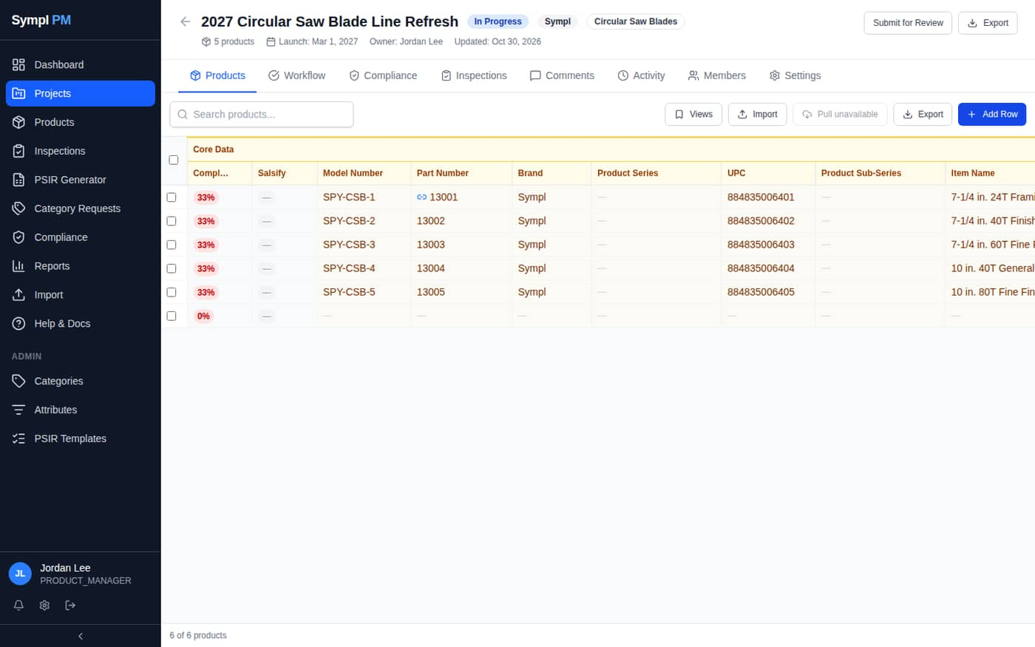
Figure 6. A new blank row after clicking Add Row

Add an existing product (link)
Type the existing part number into the new row's Part Number cell. Sympl detects that it already exists and asks: _“Part number … already exists in the product catalog. Add that existing product to this project instead of this row?”_
- Click OK to link the existing product. The blank row is replaced by the catalog product with all its data.
- Click Cancel to keep editing the row with a different part number. Duplicate part numbers are refused.
You can also add a catalog product from its product page using Add to project… in the Projects panel (users with the Edit Catalog Products permission).

4.3 Selecting rows: Bulk Edit, Duplicate, Remove
Tick one or more row checkboxes to show the selection toolbar.
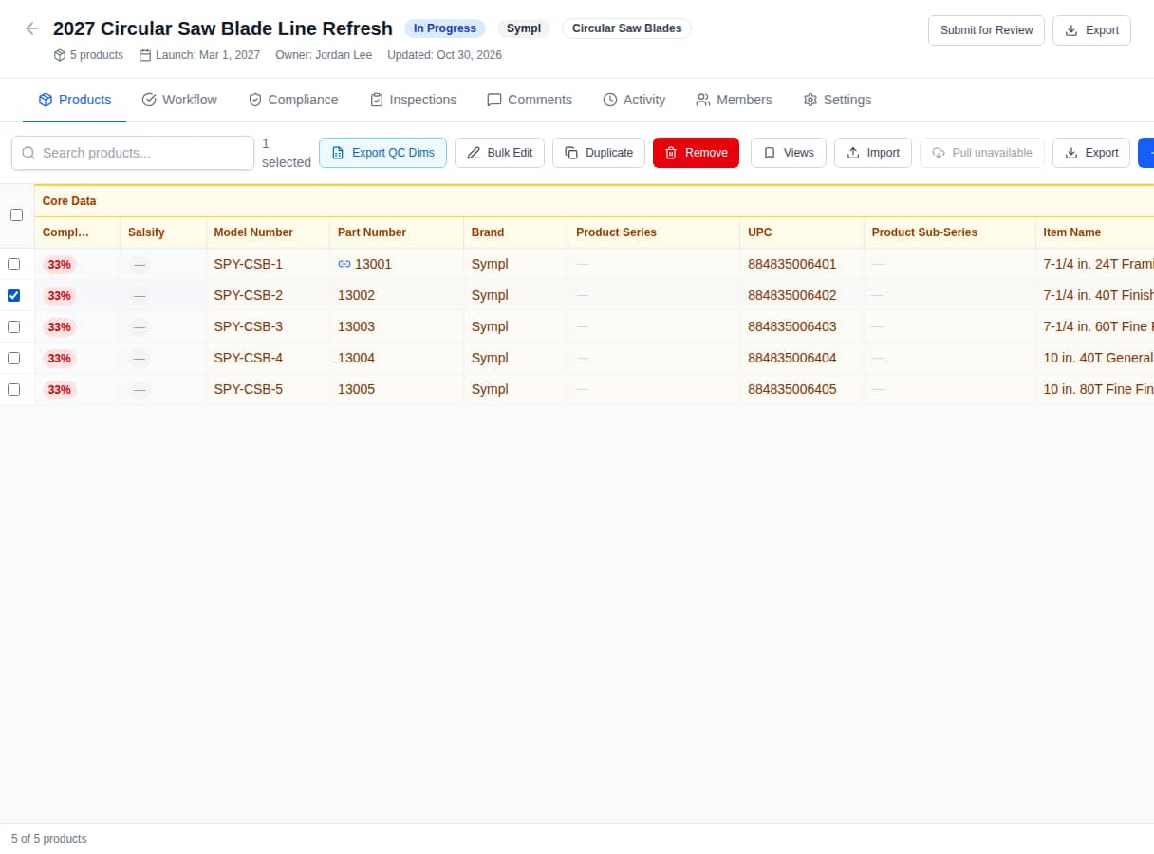
Figure 7. Selection toolbar: Export QC Dims, Bulk Edit, Duplicate and Remove
Button | What it does
Export QC Dims | Downloads the QC dimensions sheet for the selected products in the vendor's format.
Bulk Edit | Sets one field on all selected products (Replace, or Append for multi-value attributes).
Duplicate | Creates a new product row copied from the selected one; give it a new part number.
Remove | Takes the selected products off this project. They stay in the catalog and any other projects.
Sync to Salsify | Shown when the project is Export Ready and Salsify is enabled; opens the change report first.

4.4 Grid tips
- Compl… shows the percentage of required fields filled (green / yellow / red).
- Salsify shows Synced, Changed, or — (never synced).
- Hover a column header for its description; click the pin to freeze it.
- Views saves the current sort, columns, pinning and search as a named view.
- Drag column edges to resize; widths are remembered per project.

4.5 The Products page (catalog browser)
Products in the sidebar lists the whole catalog, 50 per page, with the projects each product belongs to. Filter by search (part number, model, item name, brand, UPC), project, brand, status and category.
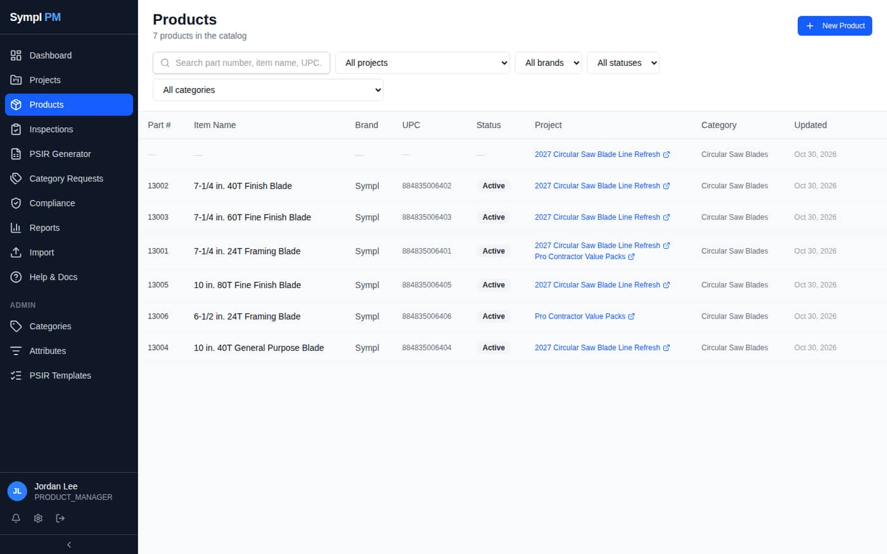
Figure 8. Products catalog. Product 13001 belongs to two projects

Creating a product without a project
- On Products, click New Product (requires the Edit Catalog Products permission).
- Fill in the product page and click Save Changes.
- Use Add to project… in the Projects panel to link it to a project when ready.

4.6 The product page
Click any product to open its full record: every core field and attribute by section, plus Compliance, Inspections and History tabs. The Projects panel at the top lists every project the product is in; click × on a project chip to remove it from that project.
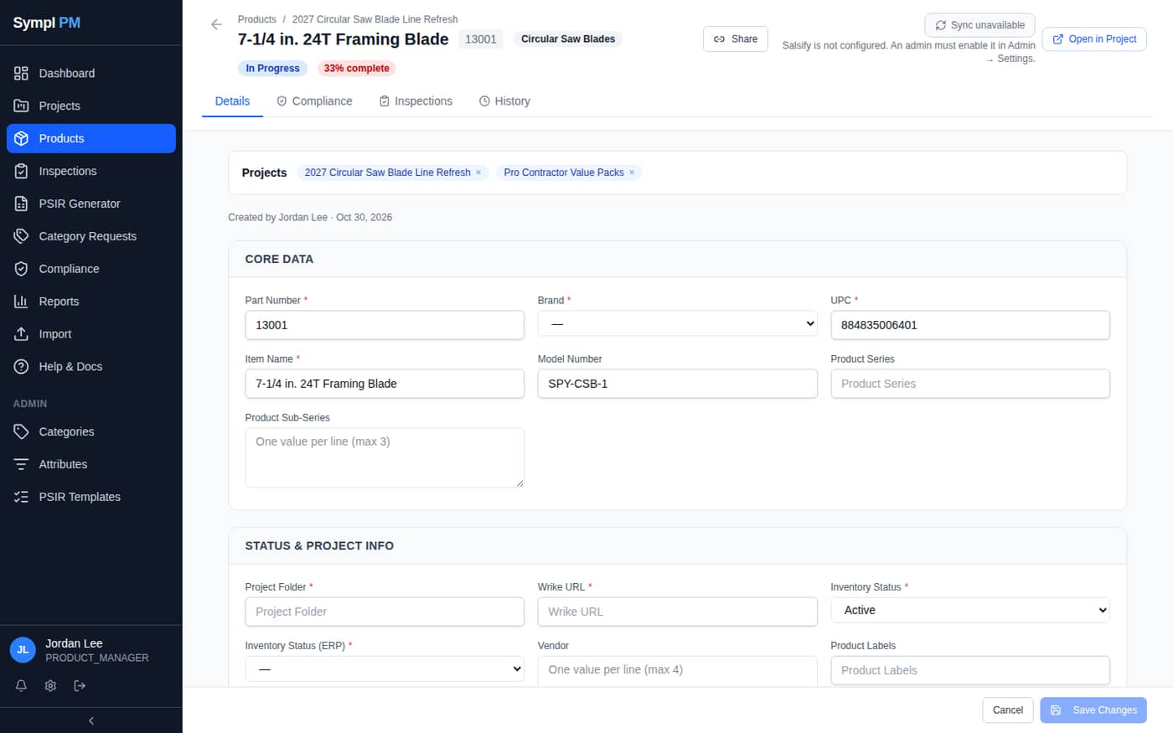
Figure 9. Product page with the Projects panel
History shows every field change: who, when, old → new value, and where it was made (Project Grid, Product Record or Import).
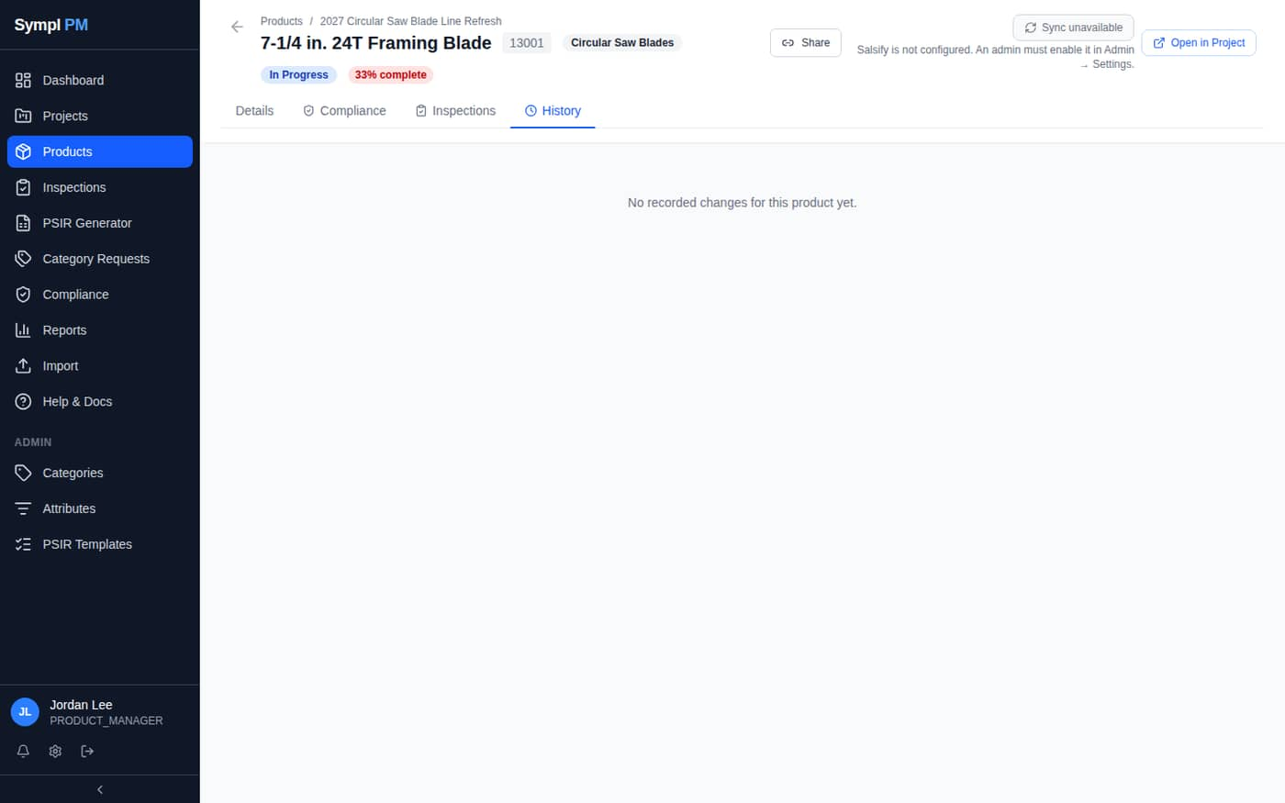
Figure 10. Product History tab
Note: Open in Project jumps to the product's row in a project grid. Share creates an expiring read-only link for people without an account.

4.7 Setting the product's category
The product's category decides which category-specific attributes appear on the product page and in grids. A product that isn't in a project has no category until you set one.
- Open the product. Under the Projects panel, find Category.
- Choose the category from the list. Categories are shown with their full path, e.g. “Power Tool Accessories > Circular Saw Blades”.
- The page reloads with that category's attributes (and its parent categories' attributes). Fill them in and click Save Changes.
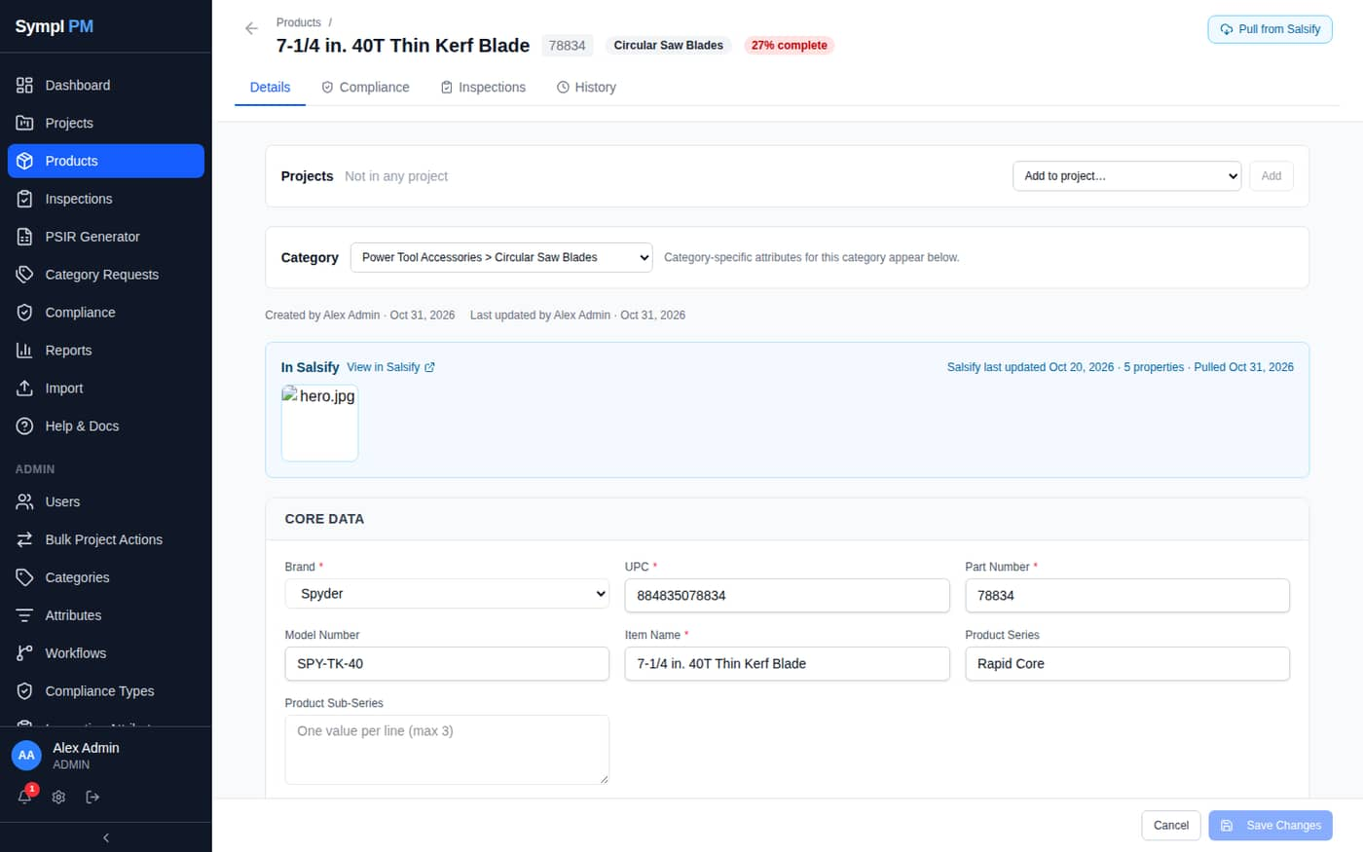
Figure 11. Category picker on a product that isn't in any project
- No category clears it. For a product in a project the option reads Use project category (…): the product then inherits the project's category, as before.
- If you have unsaved edits, Sympl asks before changing the category, because the page reloads.
- Changes are recorded in History with the category names.
- Can't find the right category? Submit a Category Request (section 5).

4.8 Pulling a product from Salsify
A product that already exists in Salsify can be filled from it directly on the product page. This works for any product you can edit, including one created with New Product that isn't in a project yet.
- Enter and save the Part Number. Salsify is looked up by Part Number, so the button stays greyed out until one is saved.
- Click Pull from Salsify at the top right of the product page. If you have unsaved edits, Sympl asks before continuing, because the page reloads after the pull.
- Review the change report: products matched, values to change, and for each field the current value → the Salsify value. Untick any field you don't want overwritten.
- Click Export change report to download the report as Excel (sheets: Changes, Warnings, Lookup Results). The Changes sheet keeps every current value, so it also serves as a backup.
- Click Overwrite & Pull. The page reloads with the new values.
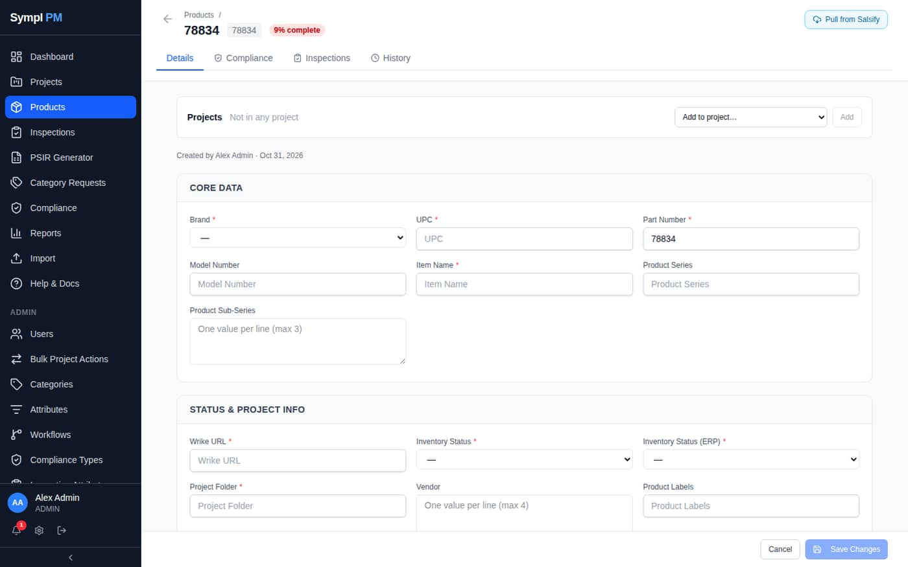
Figure 12. Pull from Salsify on a product that isn't in any project
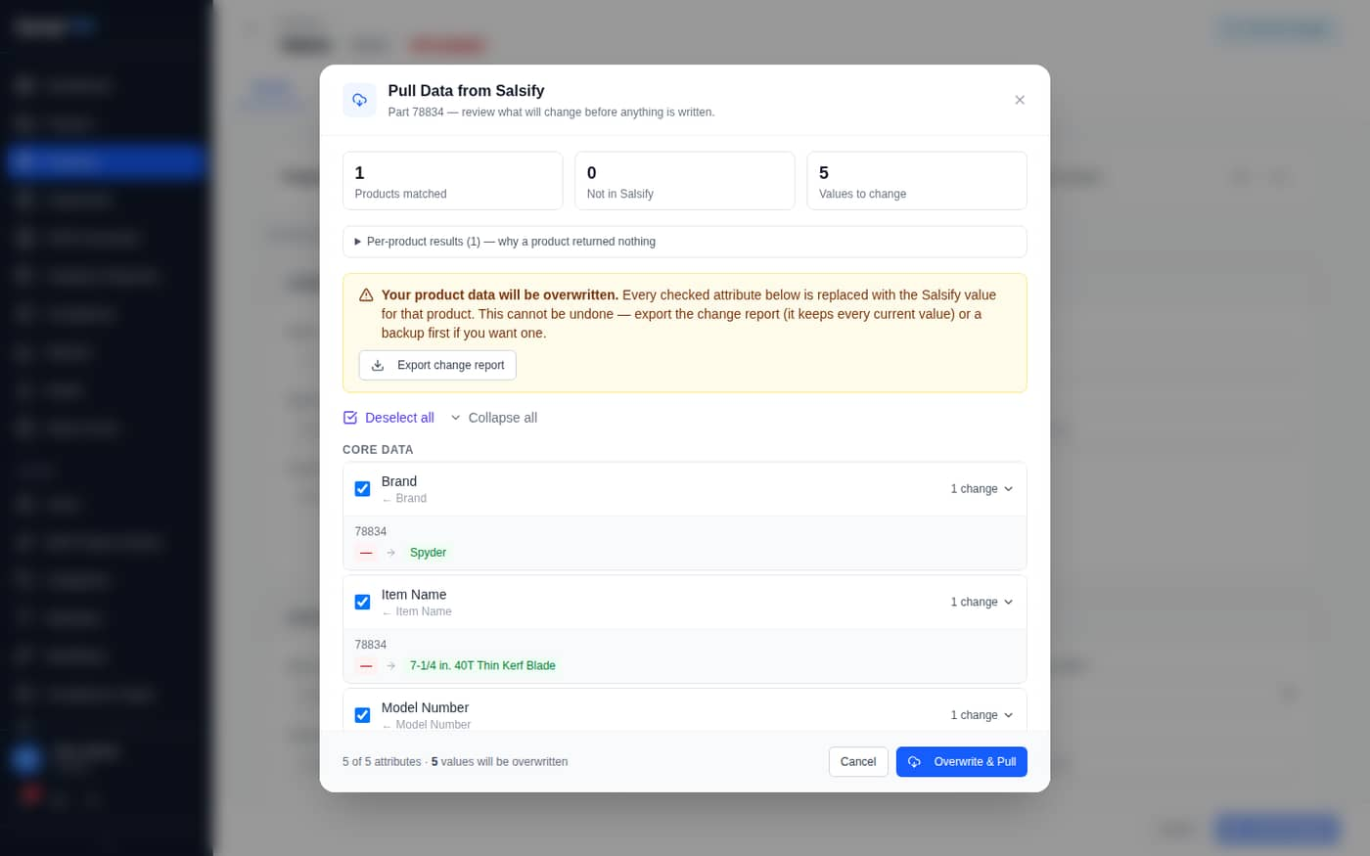
Figure 13. The change report: review every value before anything is written
- Each pulled field is recorded in the product's History with the source “Salsify Pull”.
- Opening the report also refreshes the In Salsify panel (images, Salsify's last-updated date).
- Warnings list values Salsify sent that don't fit the field; they are skipped, not written.
- Needs the Pull from Salsify permission (Admins, Directors and PMs by default) and a Salsify API key in My Profile.
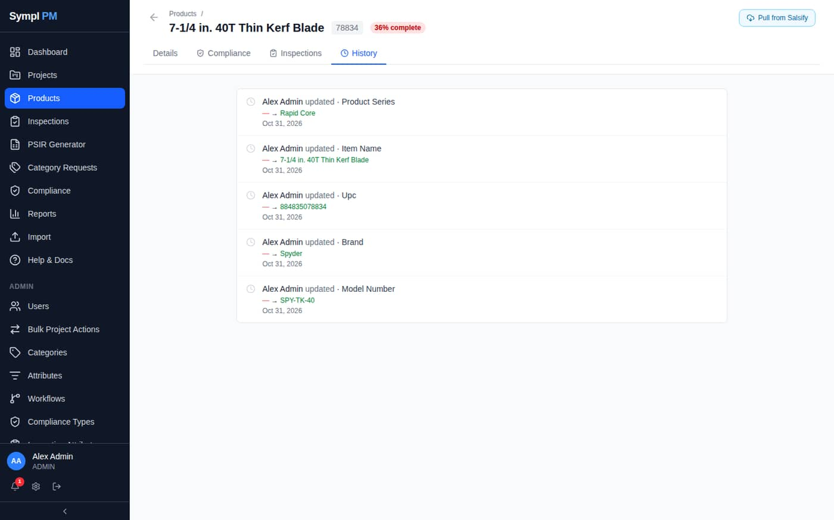
Figure 14. History after a pull: one entry per field
Important: A pull overwrites Sympl values with Salsify's for every ticked field and can't be undone. Export the change report first if you may need the old values.

5. Category Requests
When a product needs a category that doesn't exist, request it instead of using a near match. Admins and Directors review requests.

5.1 Submitting a request
- Click Category Requests in the sidebar, then New Request.
- Where should it go? — pick the parent (or Top level). Choose new parent if the parent doesn't exist either, and name it.
- Requested category name — for example *Thin Kerf Blades*.
- Description — what products belong here. Example products — part numbers or links (optional).
- Required Attributes — one row per field the category needs: name, Type (Text, Long text, Number, Decimal, Yes/No, Date, List, Multi-select, URL, UPC / GTIN), Required tick box, Allowed values (List/Multi-select, comma-separated) and Notes. Click Add attribute for more rows; blank rows are ignored.
- Add a Note for the reviewers (why, timing, which project), then click Submit Request.
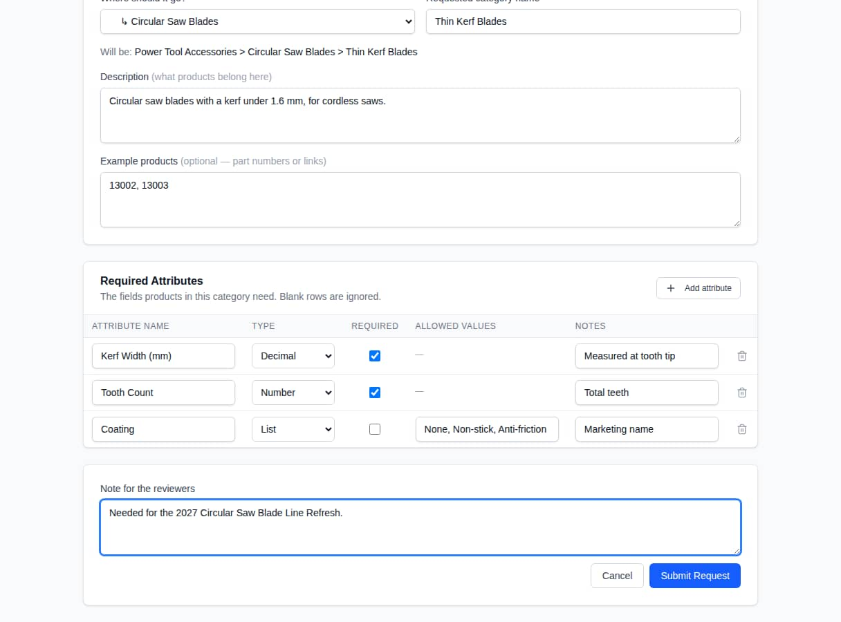
Figure 15. New Category Request form, filled in
Note: If a category with that name already exists under the chosen parent, Sympl tells you instead of creating a duplicate request.

5.2 Tracking a request
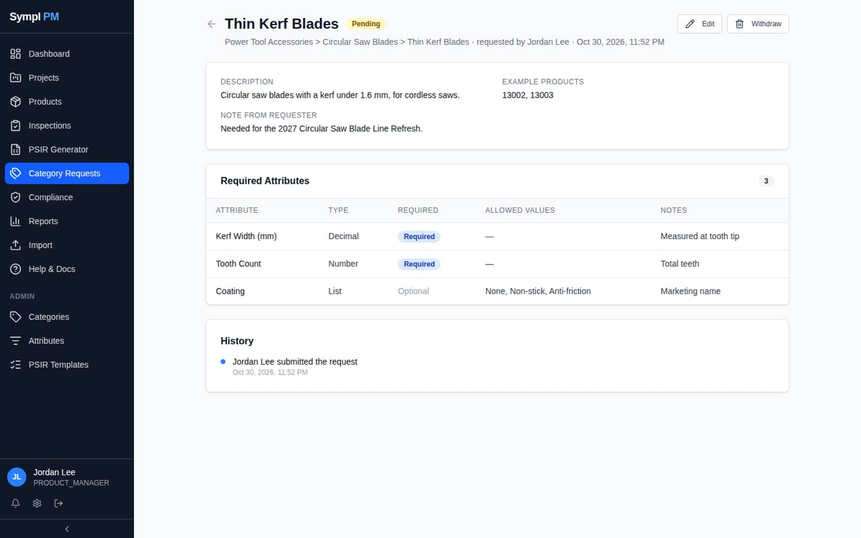
Figure 16. A submitted request
Status | Meaning | What you can do
Pending | Waiting for a reviewer. | Edit or Withdraw.
Needs Info | The reviewer asked a question (see their note). | Edit and resubmit.
Approved | Accepted; an Admin is building it. | Wait for Completed.
Completed | The category exists and is linked to the request. | Use it on projects and products.
Rejected | Not accepted; see the reviewer's note. | Submit a revised request if needed.

You are notified in-app (and by email, unless turned off in My Profile → Notification Preferences) at every step. The request's History shows each action.
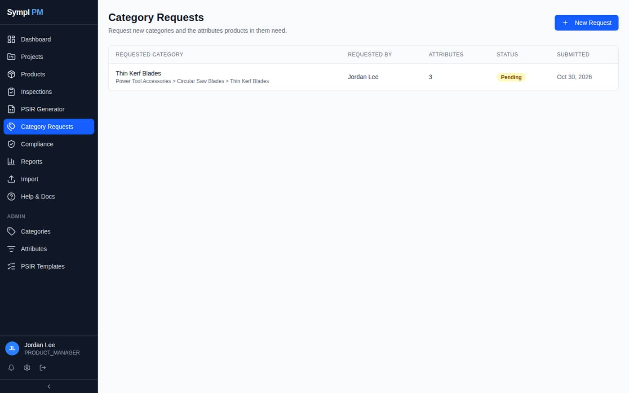
Figure 17. Category Requests list

6. Exporting and Importing Excel

6.1 Exporting a project
- Open the project and click Export (project header or grid toolbar).
- Open the downloaded .xlsx file in Excel.
The export contains every core field and attribute, ordered by attribute section, and now includes:
- Dropdowns on every column with defined valid values (list attributes, Yes/No fields, brand, inventory status…). Pick from the list instead of typing.
- A Valid Values sheet listing the allowed values for each of those columns.
- Header notes describing each column, and a frozen header row and key columns.
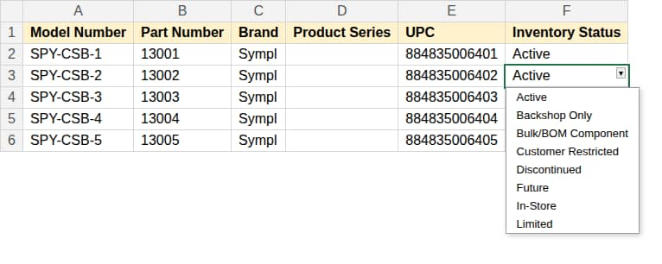
Figure 18. Exported workbook: Inventory Status offers a dropdown of valid values (illustration)
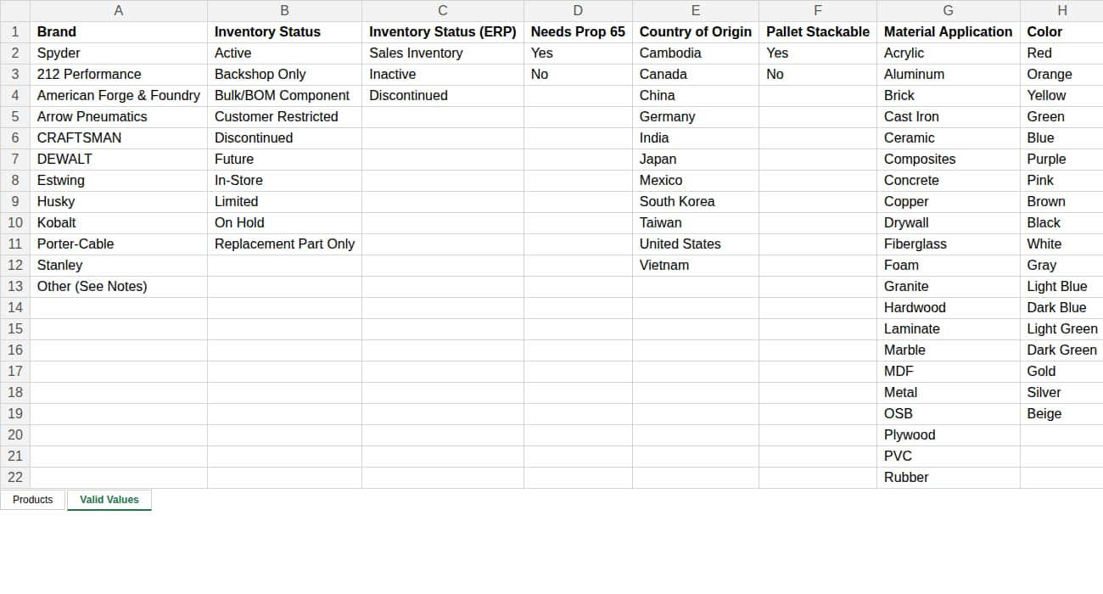
Figure 19. The Valid Values sheet
Note: Typing a value that isn't in the list shows a warning, not a block, so legacy values can still be kept. Fix them before re-importing if possible.

6.2 Importing
Import is unchanged.
- Click Import in the sidebar (or Import in a project's grid toolbar).
- Upload an .xlsx file, choose the sheet, and Preview it.
- Map Columns — headers matching Sympl fields map automatically; correct any others.
- Verify — review exactly which rows will be created or updated, with old → new values.
- Confirm to import.
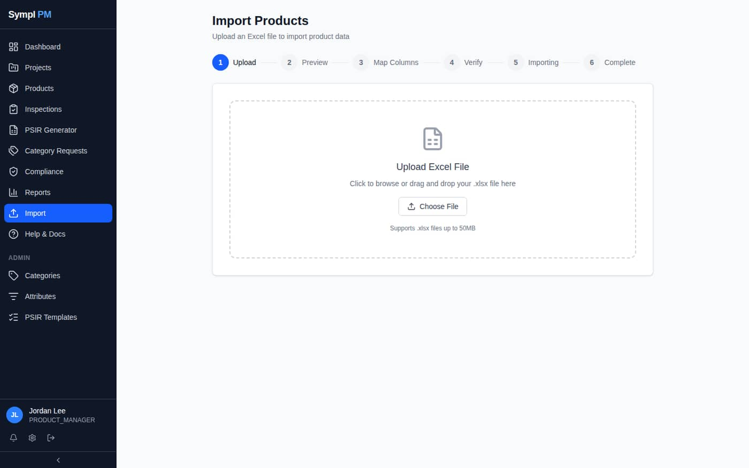
Figure 20. Import Products: the six-step wizard
- Rows are matched by Part Number: existing products update, new part numbers create products.
- Importing a part number that's already in the catalog updates that product everywhere it is used.
- Re-importing the same sheet never creates duplicates.

7. PSIR Generator
- Click PSIR Generator in the sidebar.
- Choose the Category, then a Sub-Category / Product Type if applicable.
- Optionally enter the Part Number and Product Description; they fill the header of every sheet.
- Complete the fill-in fields. Expand a section to preview its lines; filled values show in green.
- Click Export PSIR to download the workbook. Blank fields export as {Field Name} so gaps are obvious.
- With a part number entered, Save to PSIR Product Database stores the values for re-use. Reload them later with Open.
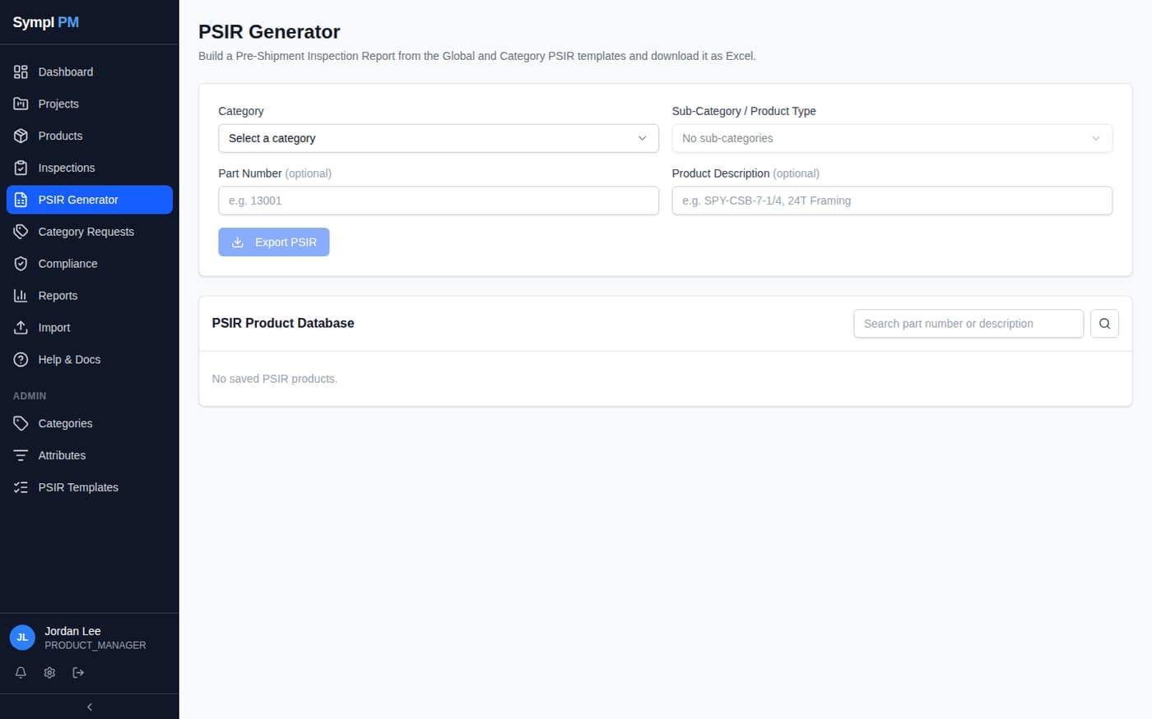
Figure 21. PSIR Generator

8. Notifications and Your Profile
- The bell shows new notifications: workflow votes, mentions (@name in comments), assignments, category request updates and overdue alerts.
- My Profile → Notification Preferences controls which categories also send email.
- My Profile → Salsify API Key stores your personal key if you sync to Salsify.
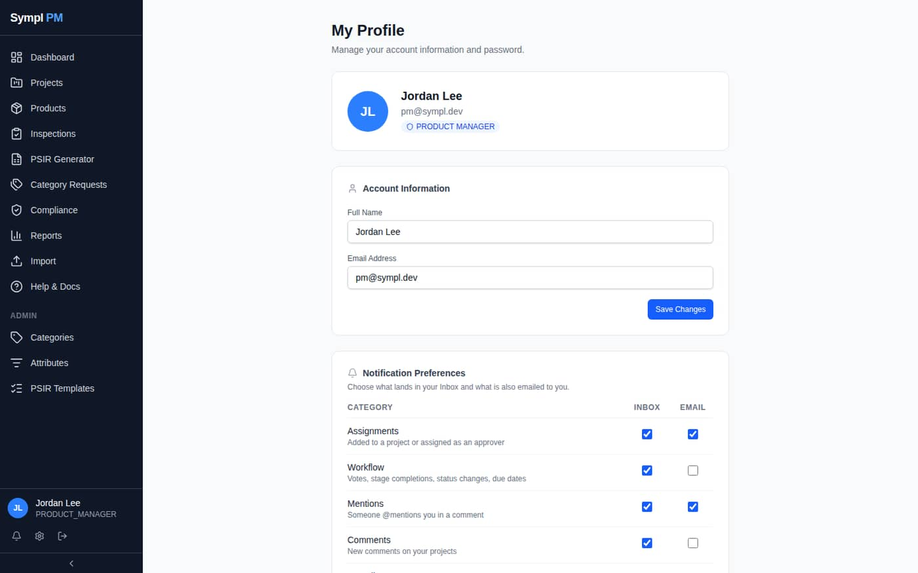
Figure 22. My Profile

9. Quick Reference
I want to… | Do this
Start a project | Projects → New Project
Add a new product to a project | Project → Products → Add Row, type the data
Add an existing product to a project | Add Row, type its part number, click OK to link
Take a product off a project | Tick the row → Remove (it stays in the catalog)
See which projects use a product | Open the product → Projects panel
Create a product with no project | Products → New Product
Set a product's category | Product page → Category picker
Fill a product from Salsify | Product page → Pull from Salsify → review → Overwrite & Pull
Request a new category | Category Requests → New Request
Get an Excel file with dropdowns | Project → Export
Bulk update products | Import → upload .xlsx → map → verify
Build a PSIR | PSIR Generator → choose category → Export PSIR

Troubleshooting
Symptom | What to do
“Part number already exists” prompt | The product is already in the catalog. Click OK to link it rather than creating a duplicate.
Edits appeared in another project | The product is shared (blue link icon). That is expected: there is one record.
A product disappeared from my project | Someone used Remove. Find it on Products and re-add it with Add to project…, or link it again by part number.
I can't edit a product | You need edit access on a project it belongs to, or the Edit Catalog Products permission.
The category I need doesn't exist | Submit a Category Request.
Category-specific fields are missing on a product | Set its Category on the product page (section 4.7).
Pull from Salsify is greyed out | Save a Part Number first. If the button is missing, ask an Admin for the Pull from Salsify permission or add your Salsify API key in My Profile.
Pull report says “Not in Salsify” | Salsify has no product whose ID is this Part Number. Check the Part Number.
Dropdown warning in the export | The value isn't in Valid Values. Pick a listed value, or ask an Admin to add it.

