Sympl PM
Product Development Platform

Administrative & Maintenance SOP
Administration, configuration, deployment and maintenance
Version | Date | Audience
2.0 | October 30, 2026 | Administrators, IT / server operators

CONFIDENTIAL — for internal use only

Contents
1. Purpose and What Changed
1.1 Changes in this version (2.0)
2. Users and Access
2.1 Roles
2.2 Adding a user
2.3 Access Control
3. Catalog Configuration
3.1 Categories
3.2 Attributes
3.3 Workflows, statuses and compliance types
4. Category Requests (Review)
4.1 Reviewing a request
4.2 Completing an approved request
5. Settings
5.1 Custom Branding
5.2 Other settings
5.3 Email providers
6. PSIR Templates
7. Bulk Project Actions and Event Log
8. Backup and Restore
8.1 Creating backups
8.2 Restoring
8.3 API tokens and scheduled jobs
9. Deploying Updates
9.1 Environments
9.2 What the deploy script does
9.3 Production runbook
10. Product Master Migration
10.1 Rollback
11. Server Administration
11.1 Process control
11.2 Orphaned processes
11.3 Health and configuration
12. Troubleshooting

1. Purpose and What Changed
This SOP covers administration and maintenance of Sympl PM: users and access, platform configuration, review of category requests, backups, deployment, data migrations, server operations and troubleshooting. It replaces Administrative SOP v1.1.

1.1 Changes in this version (2.0)
Area | Change
Product master catalog | Products live once in a catalog and are linked to projects (ProjectProduct). Part numbers are unique platform-wide. Remove unlinks; it does not delete.
Data migration | npm run db:migrate-product-master runs before every schema push, with --check, --recover and --rename-archived-duplicates options.
Category Requests | New module: PMs request categories; Admins and Directors review, approve and complete them.
Custom Branding | Admin → Settings → Branding sets the site name, tagline and logo used in the app, sign-in pages and email.
Excel export | Project exports include dropdowns, a Valid Values sheet, header notes and frozen panes. Import is unchanged.
Deploy scripts | deploy-prod.sh and deploy.sh run the migration first and push the schema with stdin closed, so a data-loss warning stops the deploy.

2. Users and Access

2.1 Roles
Role | Scope
Admin | Full platform access: users, settings, attributes, workflows, backups and all data.
Director | Sees every project; PM permissions plus Bulk Project Actions and Review Category Requests.
Product Manager | Creates and runs projects; edits catalog products; requests categories; PSIR Generator and templates.
Contributor | Edits products in projects they belong to.
Reviewer / Approver | Comment on projects / vote on assigned workflow stages.
Viewer | Read-only access to their projects.

2.2 Adding a user
- Go to Admin → Users and click Add User.
- Enter name, email and role, then save.
- Sympl emails an invitation with Set Your Password. The link is single-use and expires after 7 days.
- If email isn't configured, copy the invitation link shown on screen and send it another way.
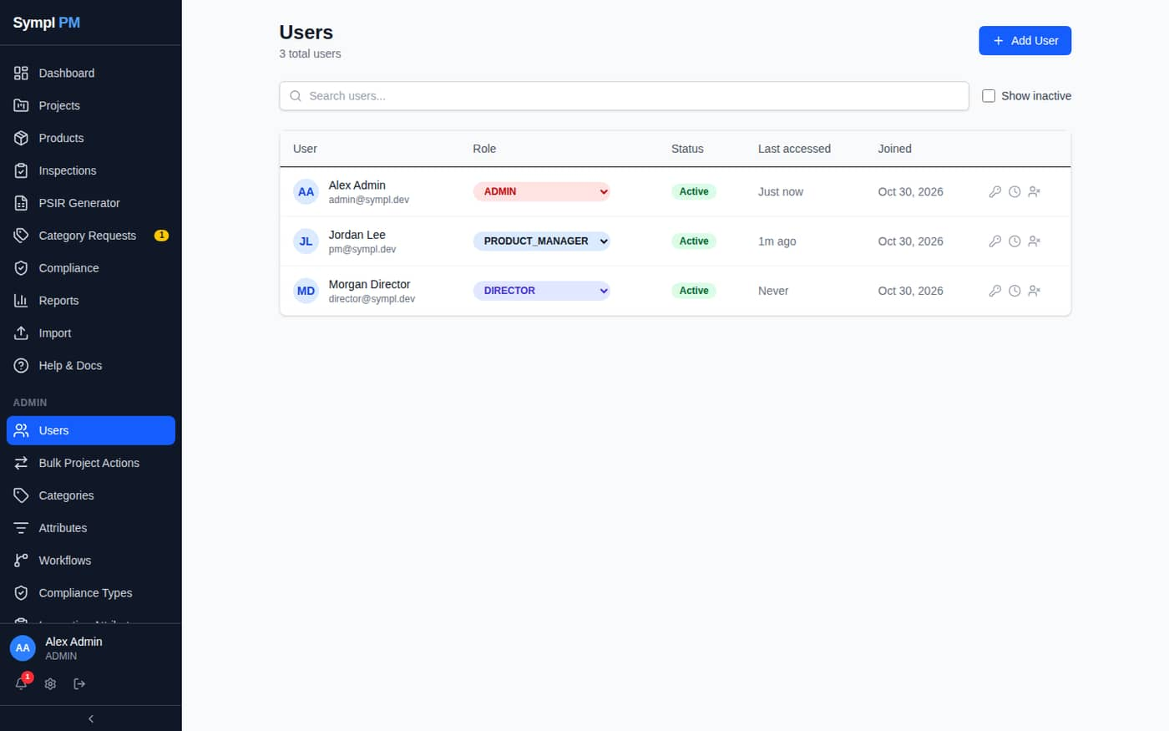
Figure 1. Admin → Users
- Invite pending marks users who haven't set a password; the envelope icon resends the invitation.
- The key icon resets a password: it emails a link valid for one hour. Admins never see or set passwords.
- Deactivate a user to block access immediately; their data and project memberships are kept.
- The clock icon shows a user's last 100 actions.

2.3 Access Control
Admin → Access Control maps permissions to roles. Changes take effect within 30 seconds and are enforced by the server, not just hidden in the UI.
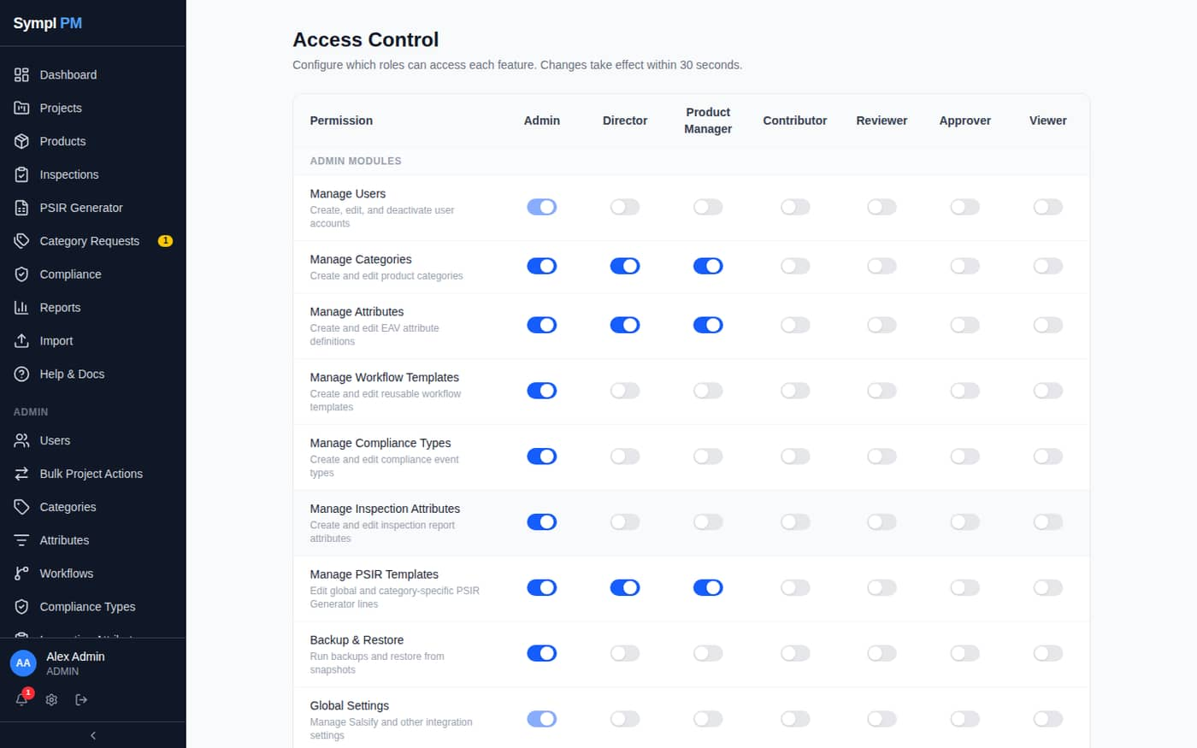
Figure 2. Admin → Access Control
Permission | Default roles | Controls
Edit Catalog Products (products:edit_catalog) | Admin, Director, PM | Editing any catalog product and New Product on the Products page.
Request Categories (categories:request) | Admin, Director, PM | Submitting Category Requests.
Review Category Requests (categories:review_requests) | Admin, Director | Approve / Needs Info / Reject; receiving request notifications.
Bulk Project Actions | Admin, Director | Transfer, status change and archive across projects.
Use PSIR Generator / Manage PSIR Templates | Admin, Director, PM | PSIR modules.

3. Catalog Configuration

3.1 Categories
Categories nest to any depth: Category → Sub-Category → Product Type → … Attributes, PSIR template lines and overrides inherit down the tree.
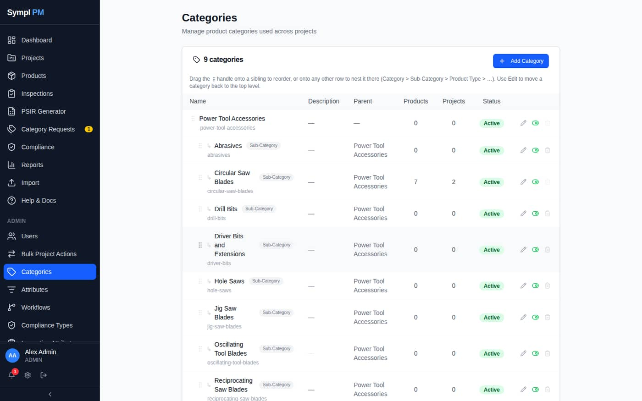
Figure 3. Admin → Categories
- Add Category: enter a name and choose a parent from the indented tree.
- Drag the handle to reorder siblings, or onto another row to move a category under it. Use Edit to move a category back to top level.
- A category can be deleted only when it has no products, projects or sub-categories. Deactivate it instead to hide it from pickers.

3.2 Attributes
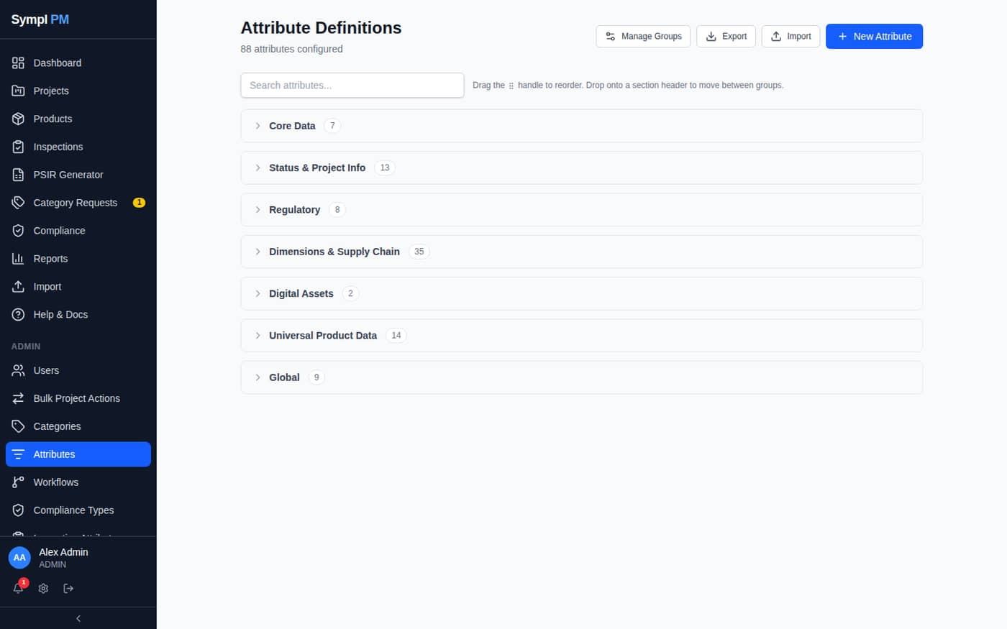
Figure 4. Admin → Attributes
- Types: Text, Text Area, Number, Decimal, Boolean, Date, Select, Multi-select, URL, Email, UPC/GTIN.
- The List of Values of Select/Multi-select attributes drives the dropdowns and the Valid Values sheet in project exports.
- Requirement level (Required/Optional) drives the Complete % in the grid.
- Description becomes the column tooltip in the grid and the header note in exports.
- Map Salsify Property IDs and QC Dims columns per attribute.
- Export / Import on this page bulk-edits attribute definitions; never change the key column.

3.3 Workflows, statuses and compliance types
- Admin → Workflows defines stage templates and approvers applied to projects.
- Admin → Settings → Project Statuses relabels, recolors or disables statuses.
- Admin → Compliance Types defines compliance event types (Prop 65, REACH…).
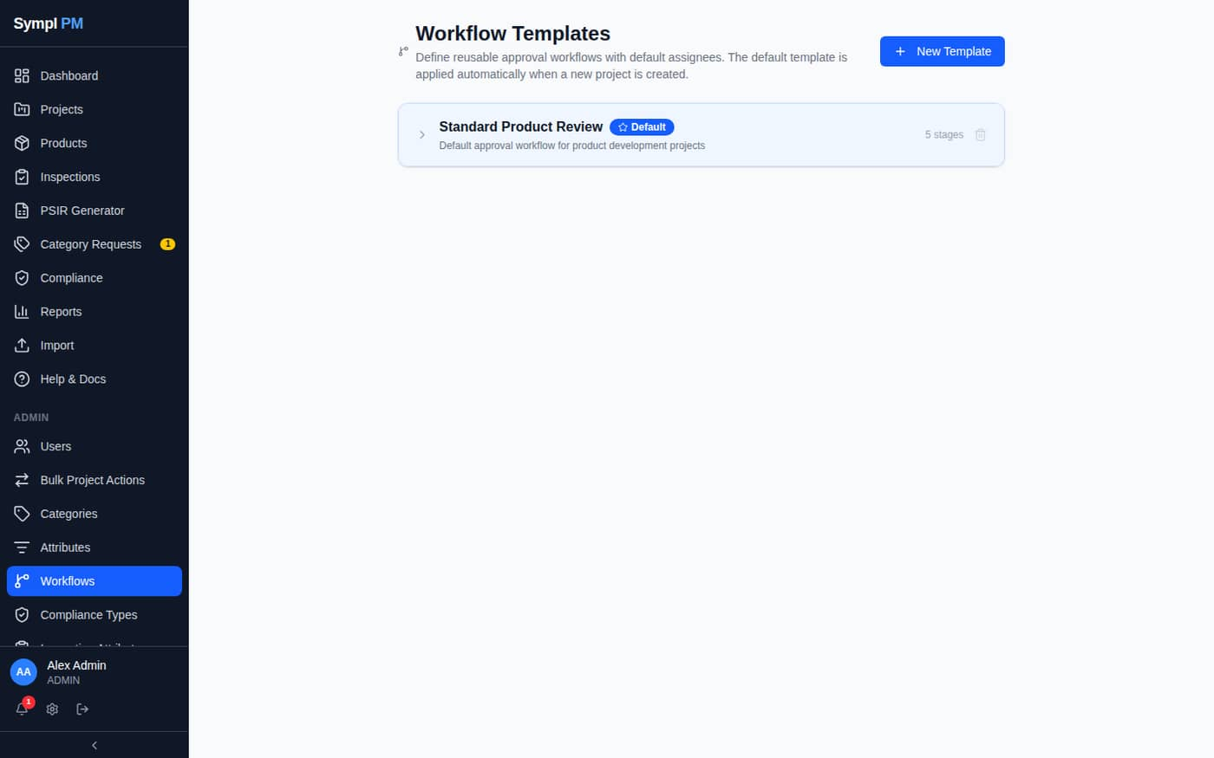
Figure 5. Admin → Workflows

4. Category Requests (Review)
Product Managers request new categories from Category Requests → New Request. Reviewers (Admins and Directors by default) are notified in the inbox and by email, and see pending requests on the dashboard.
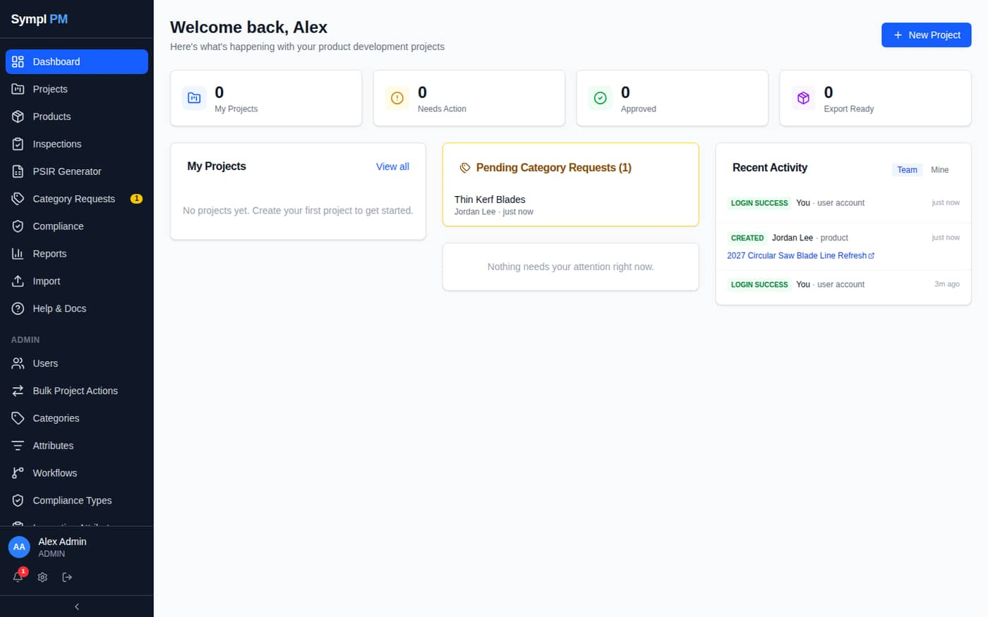
Figure 6. Dashboard: Pending Category Requests card and sidebar badge

4.1 Reviewing a request
- Open the request from the dashboard card, the notification, or Category Requests → Pending.
- Check the proposed location, description, example products and the Required Attributes table.
- Enter a note (required for Needs Info and Reject) and choose Approve, Needs Info or Reject. The requester is notified.
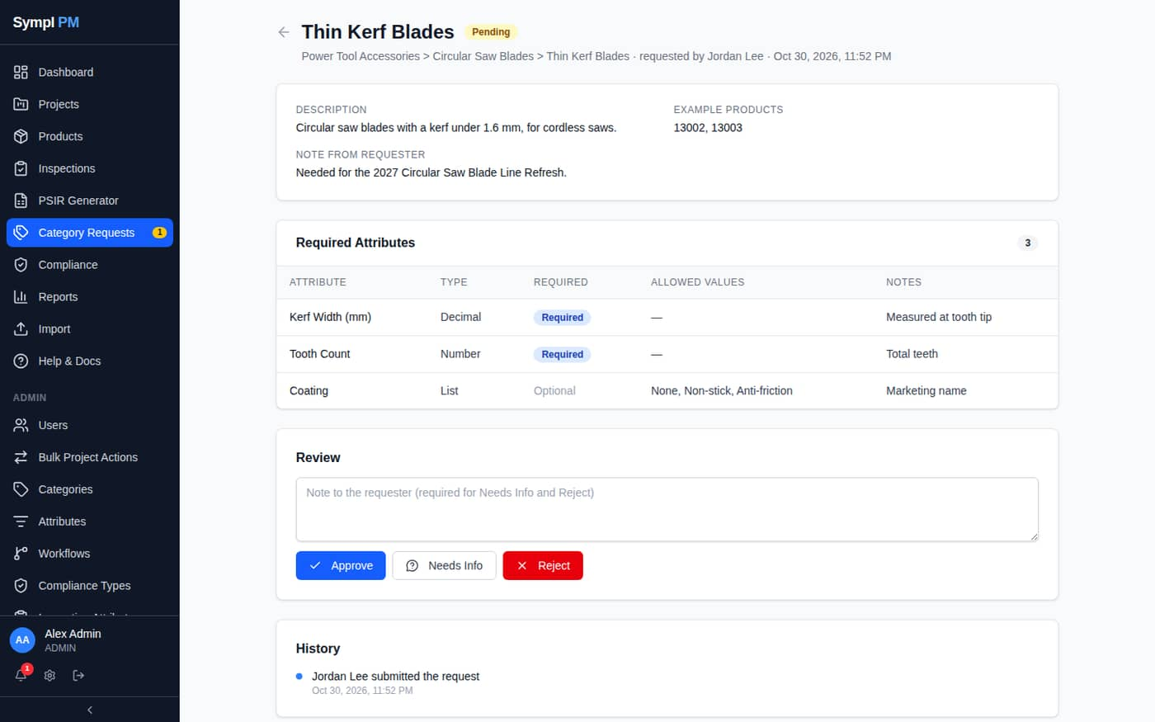
Figure 7. A pending request as seen by a reviewer

4.2 Completing an approved request
Approving does not build anything. After approving:
- Click Open Categories and create the category under the requested parent.
- In Admin → Attributes, create each requested attribute (type, requirement, list values) and scope it to the new category.
- Back on the request, choose the new category under Category created for this request and click Mark Completed.
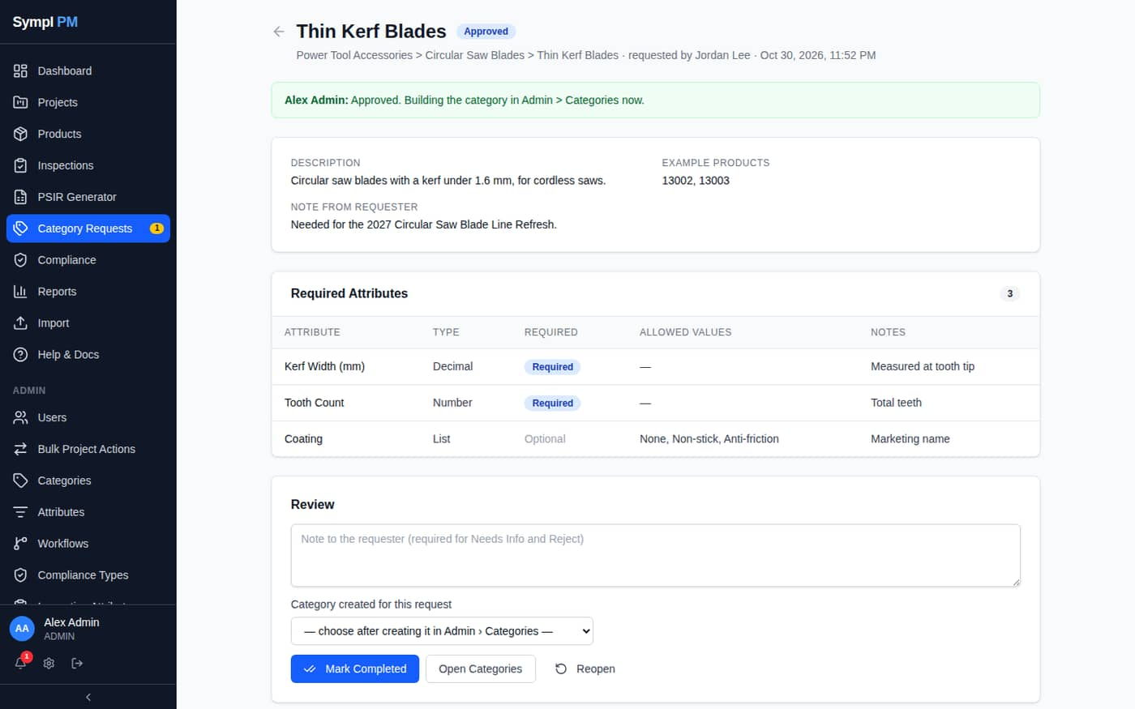
Figure 8. Approved request with Mark Completed, Open Categories and Reopen
Note: Every action is recorded in the request's History and in Admin → Event Log. Reopen returns a closed request to Pending.

5. Settings

5.1 Custom Branding
- Go to Admin → Settings; Branding is the first section.
- Tick Use custom branding.
- Enter the Site name and, optionally, a Tagline for the sign-in page.
- Click Upload logo (PNG, JPEG, GIF, WebP or SVG, up to 1 MB; about 56 px high works best). Check the preview.
- Click Save. The sidebar, sign-in pages, browser tab, shared views and all emails update.
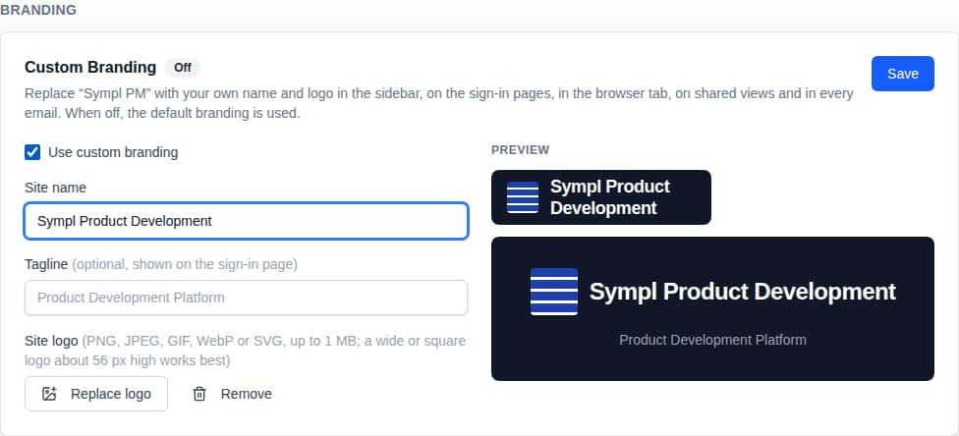
Figure 9. Branding settings with live preview
Important: Emails load the logo from the server address in NEXTAUTH_URL / AUTH_URL in .env. It must be the address users actually open (currently http://10.0.10.106:8010), or the logo won't show in email.

Untick Use custom branding and save to return to the default Sympl PM branding.

5.2 Other settings
- Modules: turn the Inspections module on or off (nothing is deleted).
- Email Notifications: shows the active provider and sends a test email.
- Salsify: organization ID, sync toggle and Debug pages.
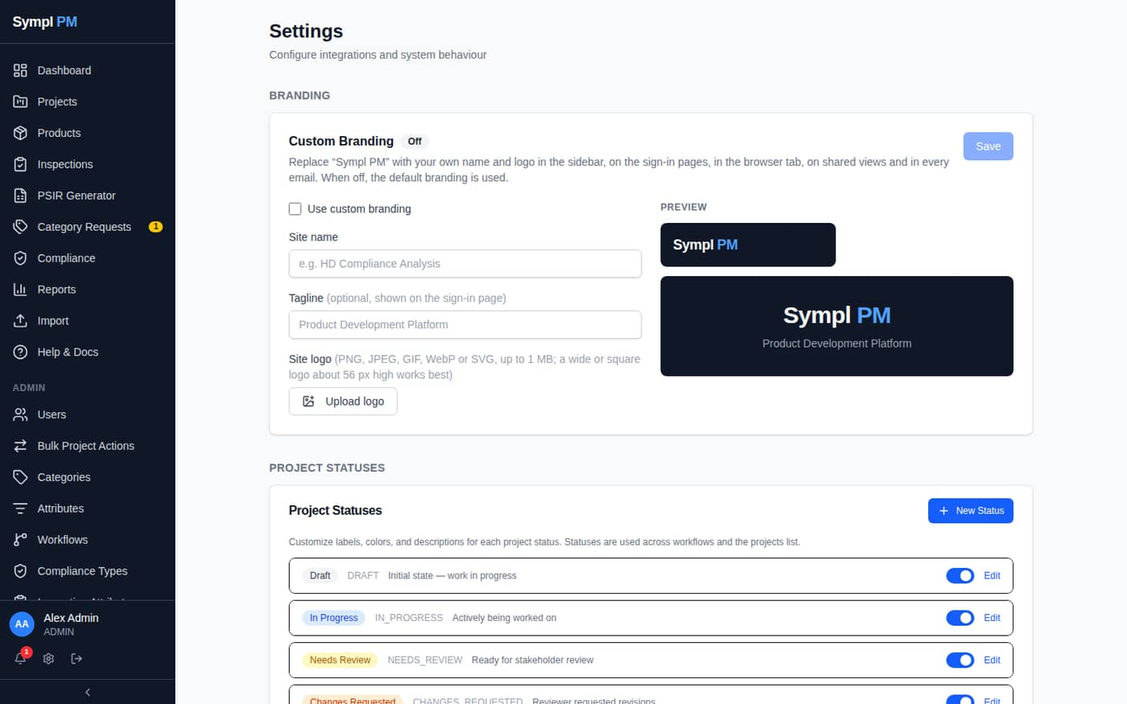
Figure 10. Admin → Settings

5.3 Email providers
Provider | Configuration (.env)
MS Graph (Microsoft 365) | MSGRAPH_TENANT_ID, MSGRAPH_CLIENT_ID, MSGRAPH_CLIENT_SECRET, MSGRAPH_FROM_ADDRESS. Needs Mail.Send. Takes priority over SMTP.
SMTP | SMTP_HOST, SMTP_PORT, SMTP_SECURE, SMTP_USER, SMTP_PASS, SMTP_FROM. Port 587 with SECURE=false, or 465 with SECURE=true.

Email is sent for invitations, password resets, workflow events, mentions, category requests, overdue alerts and the leadership digest. Users choose email categories in My Profile → Notification Preferences.

6. PSIR Templates
Admin → PSIR Templates manages the line library used by the PSIR Generator. Global lines apply everywhere; each Category, Sub-Category and Product Type can override, hide or add lines, and the most specific value wins.
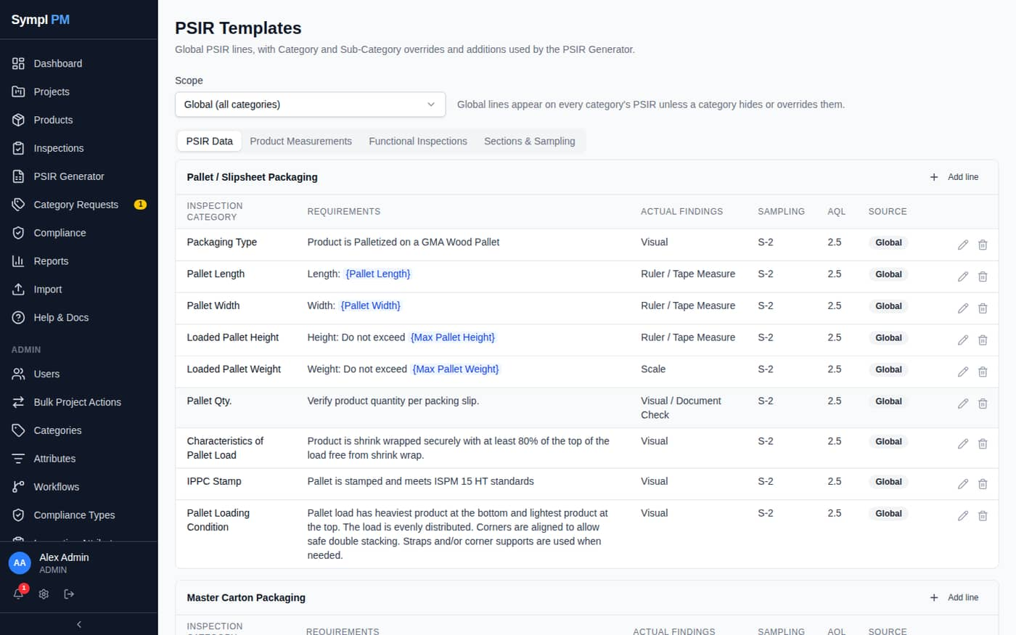
Figure 11. Admin → PSIR Templates
- Use {Field Name} in Requirement or Actual Findings to create a fill-in field on the Generator.
- Inherited lines show Override, Hide/Show and Reset.
- The Sections & Sampling tab manages sections and sampling-level suggestions.
Initial library load (safe to re-run; the category must exist):
cd /home/jsadmin/jsproducts/SymplPM
npm run db:seed-psir -- "Circular Saw Blades"

7. Bulk Project Actions and Event Log
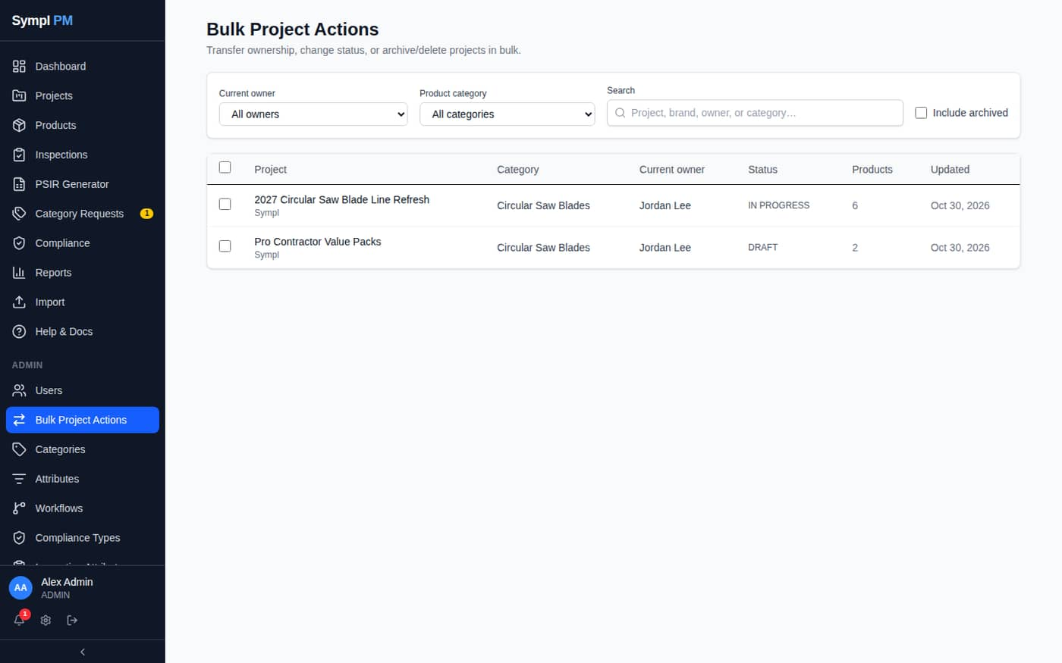
Figure 12. Admin → Bulk Project Actions
- Filter by owner or category, tick projects, then Transfer (optionally keeping the previous owner as an editor), change status, or archive. Permanent delete is Admin-only.
- Admin → Event Log records sign-ins, user changes, permissions, category requests and other platform events.
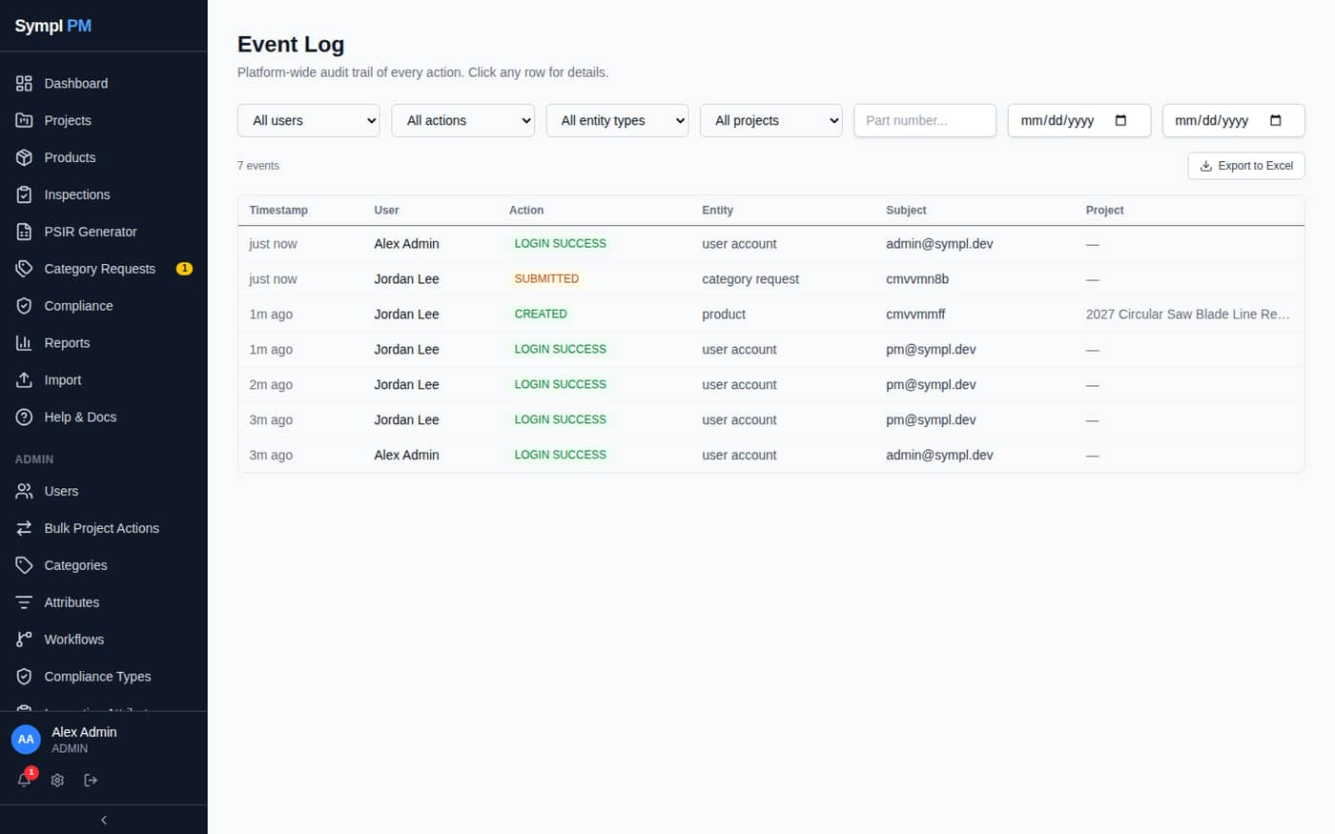
Figure 13. Admin → Event Log

8. Backup and Restore

8.1 Creating backups
- Go to Admin → Backup & Restore.
- Back Up Database creates an encrypted dump (.pgenc).
- Archive Files creates a .tar.gz of uploaded files (data/uploads).
- Download both from the list for off-server copies.
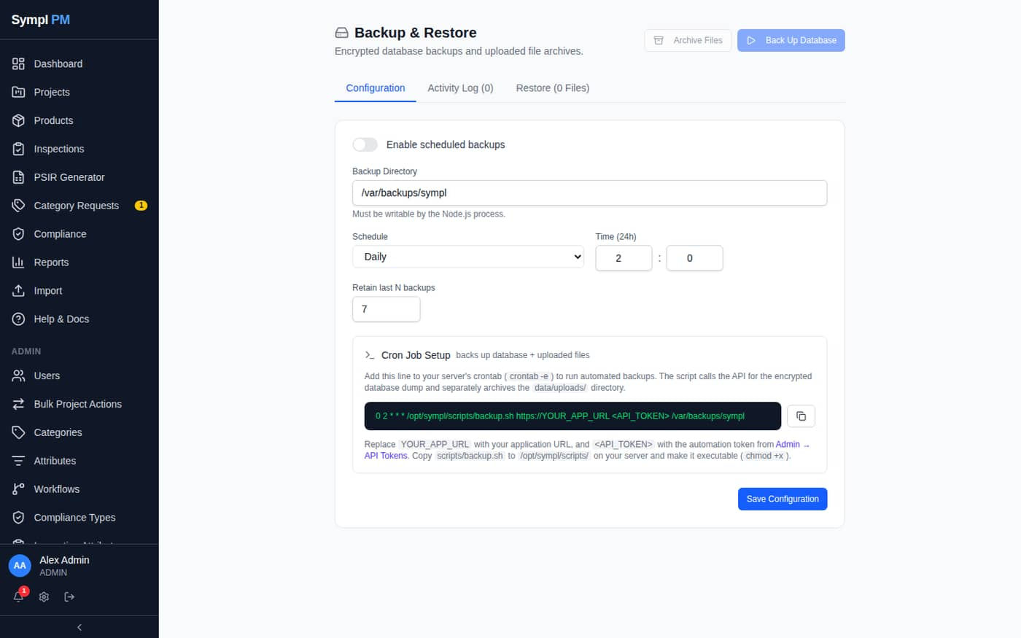
Figure 14. Admin → Backup & Restore

8.2 Restoring
- Database (.pgenc): drops the public schema and restores in one transaction. All current data is replaced. Reload the app afterwards.
- Files (.tar.gz): extracts over data/uploads; same-name files are overwritten.
- Uploaded snapshots must keep their original names (sympl-backup-<timestamp>.pgenc, sympl-uploads-<timestamp>.tar.gz).
- Moving servers: use the same BACKUP_ENCRYPTION_KEY (or NEXTAUTH_SECRET), restore the database first, then files.
Important: Restoring a database backup taken before the product master migration onto new code requires running npm run db:migrate-product-master and npx prisma db push again before the app will work.

8.3 API tokens and scheduled jobs
Token prefix | Purpose
sbk_ | Backup and cron endpoints.
spt_ | Read-only products API for ERP/BI tools. Does not work for cron.

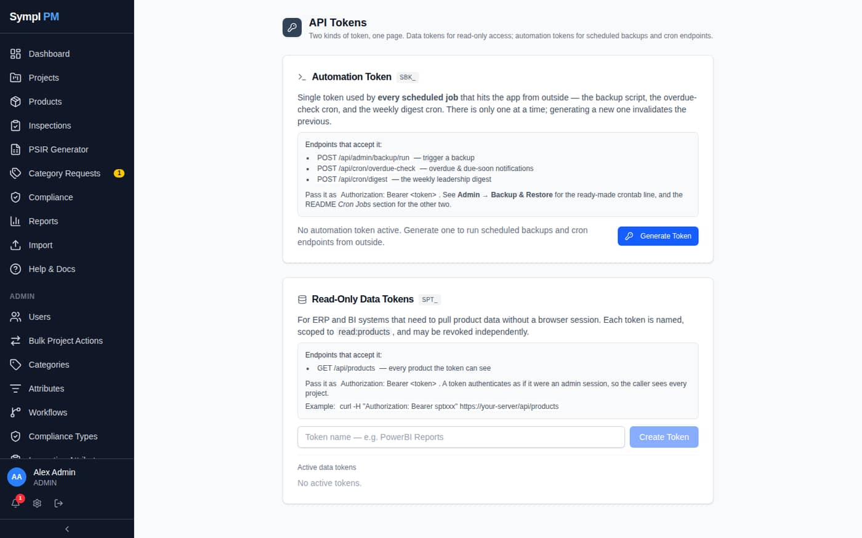
Figure 15. Admin → API Tokens
Job | Schedule | Command
Overdue check | Every 15 min | curl -s -X POST http://localhost:8010/api/cron/overdue-check -H "Authorization: Bearer sbk_<token>"
Leadership digest | Mon 7 AM | curl -s -X POST http://localhost:8010/api/cron/digest -H "Authorization: Bearer sbk_<token>"
Full backup | Daily 2 AM | bash /home/jsadmin/jsproducts/SymplPM/scripts/backup.sh http://localhost:8010 sbk_<token> /home/jsadmin/jsproducts/SymplPM/backups

9. Deploying Updates

9.1 Environments
 | Production | Test server
Path / port | /home/jsadmin/jsproducts/SymplPM, port 8010, user jsadmin | Same layout, pm2-managed
Script | scripts/deploy-prod.sh | scripts/deploy.sh
Process manager | scripts/sympl_manager.py (+ systemd unit SymplPM) | pm2
Branch | Set by BRANCH= in deploy-prod.sh (production currently uses main) | venv-prod

9.2 What the deploy script does
- git pull --ff-only the configured branch (stops instead of merging).
- npm install.
- Data migrations: npm run db:migrate-product-master (idempotent; stops the deploy if its pre-flight fails).
- Schema sync: npx prisma db push < /dev/null — a data-loss warning fails the deploy instead of prompting.
- npx prisma generate, npm run build, then restart.

9.3 Production runbook
- Back up first: Admin → Backup & Restore → Back Up Database and Archive Files; download both.
- SSH in and cd /home/jsadmin/jsproducts/SymplPM. Check git status --short and git log --oneline -1.
- Save local script edits: git diff > ~/symplpm-local-edits-$(date +%F).patch, then git stash them if the pull would conflict. Re-apply only what production needs (for example BRANCH=main).
- Pull: git pull --ff-only origin <branch>.
- Pre-flight the migration: npm install --production=false && npm run db:migrate-product-master -- --check.
- Deploy: bash scripts/deploy-prod.sh.
- Confirm the port owner: sudo fuser 8010/tcp should match cat SymplPM.pid (or be its child — check with ps -o pid,ppid,lstart,cmd -p <PID>).
- Smoke test: open a project grid, the Products page, a product's Projects panel, Category Requests, PSIR Generator, and a project Export.
cd /home/jsadmin/jsproducts/SymplPM
git diff > ~/symplpm-local-edits-$(date +%F).patch
git stash push -m "prod local edits" -- scripts/deploy-prod.sh scripts/deploy.sh scripts/sympl_manager.py
git pull --ff-only origin main
sed -i 's/^BRANCH=.*/BRANCH=main/' scripts/deploy-prod.sh
npm install --production=false
npm run db:migrate-product-master -- --check
bash scripts/deploy-prod.sh
sudo fuser 8010/tcp; cat SymplPM.pid

10. Product Master Migration
The migration moves products from the old project-owned model into the catalog and creates a project link (with the original row order) for each. It runs automatically on every deploy and does nothing once applied.
Command | Use
npm run db:migrate-product-master -- --check | Read-only pre-flight: product counts and duplicate part numbers. Changes nothing.
npm run db:migrate-product-master | Run the migration (also run by the deploy scripts). Verifies products=N links=N mismatched=0.
… -- --rename-archived-duplicates | Renames archived extra copies of a duplicated part number (e.g. 19968 (archived a1b2c3)). Live products are never renamed; aborts if a part number has two live products.
… -- --recover | Repair when prisma db push dropped the old columns before the migration ran: rebuilds missing product → project links from each product's activity and comment history. Combine with --check to preview.

- Each run writes backups/product-master-migration-*.json recording every product's original project and row.
- If --check reports active duplicate part numbers, stop and renumber or merge those products before deploying.
- If prisma db push reports a data-loss warning, the deploy stops safely. Do not force it; run the migration and investigate.
Note: Production (October 2026): 19 archived duplicate copies were renamed by --rename-archived-duplicates; links verified with zero mismatches.

10.1 Rollback
The schema changed, so roll back code and database together: git checkout <previous commit>, restore the pre-deploy database backup, then:
npx prisma generate && npm run build && python3 scripts/sympl_manager.py restart

11. Server Administration

11.1 Process control
python3 /home/jsadmin/jsproducts/SymplPM/scripts/sympl_manager.py start|stop|restart|status
sudo systemctl restart SymplPM # boot-persistent unit
journalctl -u SymplPM # unit logs
tail -f /home/jsadmin/jsproducts/SymplPM/logs/app.log

11.2 Orphaned processes
If the port is held by a stale process (login failures, EADDRINUSE, chunk-load errors):
sudo fuser 8010/tcp && cat SymplPM.pid
ps -o pid,ppid,lstart,cmd -p <PID>
sudo fuser -k 8010/tcp && sleep 2
python3 scripts/sympl_manager.py start

11.3 Health and configuration
- bash scripts/report.sh — uptime, Node memory/CPU, database and table sizes, disk and RAM.
- DATABASE_URL passwords with special characters must be percent-encoded (/ → %2F, @ → %40, # → %23, ? → %3F).
- Key .env values: DATABASE_URL, NEXTAUTH_SECRET, NEXTAUTH_URL/AUTH_URL, BACKUP_ENCRYPTION_KEY, CRON_API_TOKEN, email settings.

12. Troubleshooting
Symptom | Likely cause | Fix
Deploy stops at “Data migrations” | Pre-flight found duplicate part numbers | Run --check; if only archived copies, use --rename-archived-duplicates; otherwise renumber products.
Deploy stops at schema sync with “data loss” | Migration hasn't run or failed | Run npm run db:migrate-product-master, then redeploy. Never force the push.
Projects show no products after a deploy | Schema pushed without the migration | npm run db:migrate-product-master -- --recover
Logo missing from emails | NEXTAUTH_URL isn't the address users open | Fix .env, restart, send a test email.
Branding not showing | “Use custom branding” unticked or not saved | Admin → Settings → Branding → tick, Save.
No one receives category request emails | No email provider, or reviewers turned email off | Test email in Settings; check reviewers' Notification Preferences and Access Control.
Login fails with valid credentials | Orphaned process with stale config | sudo fuser -k 8010/tcp, restart.
“Property does not exist on PrismaClient” | Missing prisma generate | npx prisma generate && npm run build
“Need to specify how to reconcile divergent branches” | Server on a different branch | Check BRANCH; git checkout -B <branch> origin/<branch>; pull with --ff-only.
Cron returns 401 | spt_ token used | Create an sbk_ token.
Snapshot upload returns 413 | Reverse-proxy body limit | nginx client_max_body_size 10g, timeouts 600s.
PSIR Generator: “No PSIR lines are configured” | Library not seeded | npm run db:seed-psir
Import: “Failed to parse the file” | More than 2,000 columns | Delete unused columns and retry.

