
Deploying 1:1 educational models
in large scale:
a practical budgeting tool
based on TCO
Version 1.00 - 6/11/08
Authors: Roxana Bassi (Roxana.bassi@gesci.org) and Jon Camfield (jon@joncamfield.com)
Roxana is an Information Systems Engineer that has worked in ICT for development for 20 years. She currently advises Ministries of Education on ICT4E issues as ICT Specialist for GeSCI (Global e-School and Communities Initiative, http://www.gesci.org). Jon is an ICT and Social Media strategist focused on ways to adapt technologies to international development challenges. He currently serves as the Director of Information and Communication Technologies at YSA (Youth Service America), which provides grants and technical guidance to youth-led community projects globally.

Copyright notice
This manual and its accompanying electronic tools are provided under a Creative Commons License of Attribution-NonCommercial-ShareAlike. For more information on this license, please visit the Creative Commons website at http://creativecommons.org/licenses/by-nc-sa/2.5/
Update and comments:
This document and related tool are updated regularly. The latest version of this document and the electronic tool can be found at http://www.gesci.org/index.php?option=com_content&task=view&id=37&Itemid=43 or at http://www.JonCamfield.com/one-to-one .
The authors welcome every comment, suggestion and recommendation regarding how to improve this manual and tool. Thank you.

Objective of this document
We have developed this guideline and accompanying spreadsheet to support the costing analysis of large scale regional or nation-wide deployments, with specific examples of 1:1 solutions. A one-to-one solution is a specific type of computing solution where each student in a class is given a personal computer that becomes his/her learning space, and that the student can even take home, so that it becomes their property as well. Since every project has their own characteristics, this solution proposes a generic analysis tool that can be adapted according to the specific needs of individual deployments. You should use it if you want to calculate an accurate TCO, if you are preparing a funding proposal or if you are developing your national or regional budget. This tool is not for individual school cost calculation.
Previous versions of this tool have been used in estimating costs for pilots and large scale deployments of 1:1 models in Ghana, Bolivia and Rwanda.

Table of contents
Objective of this document 2
Introduction 5
Introduction to Total Cost of Ownership 7
Deployment models and considerations 8
Other deployment considerations 11
TCO of a nationwide deployment 12
Using the electronic tool 14
Tool Basics 14
Step 0: Initial data 16
Section 0.1: Overall National/regional context of the project 16
Section 0.2: Roll Out schedule 17
Step 1: Central costs 18
1.1 Technology Platform: 19
1.2 Content and Software, Applications 21
1.3 Teacher training and teacher support 22
1.4 Maintenance and technical support 22
1.5 Management, Monitoring and Reporting 23
Step 2: All schools, initial costs 25
2.1 Deployment of technology platform 26
2.2 Content and applications 29
2.3 User training 30
2.4 Maintenance and technical support 31
Step 3: All schools, running costs 31
3.1 Operation of technology platform 32
3.2 Content and applications 33
3.3 User training 33
3.4 Maintenance and technical support 33
Step 4: Totals and Results page 34
Cost estimations recommendations 36
Conclusions 39
Annex 40
Additional information and references: 40

Disclaimer: The authors reserve the right not to be responsible for the topicality, correctness, completeness or quality of the information provided. Liability claims regarding damage caused by the use of any information provided, including any kind of information which is incomplete or incorrect, will therefore be rejected.

Introduction
One to one (1:1) computing is a recently emerged model for ICT in education deployment. In 1:1 computing, each student is provided with a personal device similar to a laptop which they can use as their own, often taking them home. The most well-known of these projects is that of Nicholas Negroponte's One Laptop per Child (OLPC) Foundation, whose device is called “XO”.
1:1 projects are highly innovative in both the technology platform and educational model. As such, there is a short track record to date, and little is known about how to deploy and sustain them over time. This lack of baseline data leads to under-informed implementations and budgeting decisions, since governments find it difficult to collect all the information needed for a Total Cost of Ownership (TCO) analysis. This document will concentrate in the cost analysis of such solutions to create a high level, reusable approach to TCO estimations, in order to provide a starting point for the estimation of a national budget. Since draft versions of this tool have been used in estimating OLPC deployments, we will use OLPC costing as examples. However, there are many potential hardware and software combinations, such as Intel’s Classmate, the Asus Eee PC, as well as low-cost desktops for classrooms. The tool can be applied to any of these situations.
This document is complemented by a Spreadsheet that allows the insertion of local parameters and automatically calculates the elements of a TCO analysis. Before you start, please make sure that you have downloaded the spreadsheet as well as this instruction manual.
Note: For more information on planning a large scale deployment we suggest that you refer to GeSCIs Manual on Piloting and Large scale deploying.
Note: This tool has been designed for large scale implementations. For other TCO estimations considering one school only you can use another GeSCIs TCO tool, available at the website.

Introduction to Total Cost of Ownership
The recommended approach to determining costs and budgets of ICT projects is to use the Total Cost of Ownership. Total Cost of Ownership or TCO is the cost of a complete system over the useful life of the system. Currently, most projects are designed based upon minimizing initial and capital cost with little consideration for lifetime or life-cycle costs. This creates financially promising and attractive projects, but at the cost of long-term sustainability.

A true Total Cost of Ownership or TCO must take into account all the system components: distribution and installment of the ICT platform devices, software and educational content, training for teachers and support staff, technical support and monitoring and reporting, as detailed in the graph below. The sum of each of these over a selected timeframe, usually the useful life of the ICT platform, becomes the TCO value of the ICT deployment. All ICT platforms usually involve initial capital expenditure and then ongoing operating expenditure as depicted in the figure below. 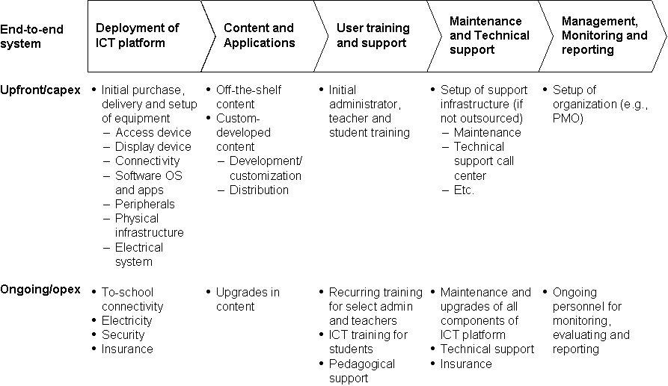
Considering all the components of a TCO is critical in order to guarantee the financial sustainability of a project, which is the capacity to “survive” and thrive over time. Knowing how much it will cost to acquire and maintain all the components of the project will help in guaranteeing that provisions are taken for the funds to be available as they are needed over the years.
In this document we propose the use of TCO as a way of estimating the initial and recurrent costs of 1:1 large scale deployments. For more information on TCO we suggest that you refer to GeSCIs TCO page, which contains specific manuals and tools.

Deployment models and considerations
1:1 is a new educational model and as such there is sparse, often non-quantitative information about what is happening in the field. Current deployments in pilots and large scale deployments use a variety of different models regarding selected schools, selected grades and scaling-up. All these have different incidences in costing. Below we discuss some deployment models and costing considerations.
- Schools: The options are deploying to all schools in one region, some schools (i.e. rural areas) in a few regions, or all schools in all regions. This is a political and logistical decision, but costs are affected as well.
Option | Costing considerations | Planning consideration
Selected - Some schools in a few regions | More transport, connectivity and logistic costs.  More difficult to monitor | Have to have transparent criteria to select the schools/regions  More complicated logistics, teacher training  Easier to fund
Regional saturation - All schools in one region | Infrastructure and deployment costs lower per school  Logistic easier with more concentration | Ideal to do a proper monitoring of results  Concentration makes it easier to maintain and provide technical support  Teacher training simpler and teachers can support each other more efficiently
Full Saturation - All schools, nationwide | Cost per school lowest with large scale planning and long-term contracting of services  Very difficult to monitor, and slow to introduce changes | Complicated logistics require centralized planning and local provision of support  Have to consider regional laws on education  Funding more difficult

- Grades: some pilots and deployments have been done to one class or 1 grade per schools; others have selected to do saturation of the school (all grades in primary).

Option | Costing considerations | Planning consideration
Selected grades | Costing might be too high to allow for connectivity  Lower (initial) cost and time to develop curricula | Critical to select with which grade to start  Easier to develop content  Easier to monitor and evaluate results
All primary or secondary grades | Lower cost per student, as school infrastructure is shared | Requires centralized planning of teacher training, content development, etc.  Longer deployment times. Might require gradual scaling up

- Scaling up: Normally a project of this type will start with a few schools and/or grades and then scale up to the rest of the country. However, depending on the original decisions there can be different ways to scale-up

Option | Costing considerations | Planning consideration
Start with a region, then scale nationwide | Costing optimized as you can learn from local experience and refine costs  More expensive to develop content | Simpler deployment  Chance to learn and improve deployment strategy  Selection of region can be politically challenging
Start with 1-2 grades, then scale to all primary | Lower (initial) cost and time to develop curricula | Content development easier  Infrastructure investment very high in the initial stages

Other deployment considerations
Besides selecting the number and location of schools, the grades to be involved in the pilot and how to scale up into a large deployment, there are other decisions to be made about the project which affect both immediate and long-term costs. We list some of these below.
Questions to answer that affect the deployment model:
- What is the expected lifespan of the device while in active daily use? We will discuss lifespan costs later in this document
- What will happen to the device as students grow up? Will it stay with the student or pass on to new children? (take into account life span of the equipment)
- How will the country plan for the deployment of new devices as new children start school every year?
- Who is legally responsible for the device? Is the device the property of the student (the parents sign for them), the school or the local government? This is related to the legal documents to be signed to receive them and financial/replacement responsibility in case of theft or damage.
- Should students take the devices home? What security considerations should be taken at school level?
- What personnel are required for local device administration, user account creation (if any), introductory training, software activation (if any) and physical distribution? How will they be deployed?
- What happens to a lesson plan that is designed around the device if one or more students have forgotten, lost, or have had their laptops stolen, or simply don’t have their batteries charged?
- What happens to class dynamics when students have computers to work on?

TCO of a nationwide deployment
Now that you have reflected on the deployment models and its costs consequences, we will move into the cost analysis of the deployment. When a country opts for a multi-grade regional or nationwide deployment of technology to educational institutions, Total Cost of Ownership (TCO) can become quite complex. Such large deployments create large-scale budgets with initial investment in the build-out of facilities and human capacity as well as ongoing costs like maintenance and continuous training. In this section of the manual we analyze the costing variables involved in a large scale deployment.
In a large scale project there are normally Central costs, which are costs associated with the centralized planning and execution unit. This unit is responsible for planning, executing, maintaining and supporting the project from the central government perspective, and is either part of the Ministry of Education or a public-private organization created for this purpose only. Then there are costs related with the deployment, installation, infrastructure, training and support at school level (local or town level). Depending on how centralized or decentralized the project is, some of the costs will be covered by the central structure and the rest at the local level, or the other way round. The way this spreadsheet is designed you will be able to assign costs centralized or decentralized, according to your project strategic design.
Before we start here are some considerations about the electronic tool:
- A TCO analysis is NOT a financial budget. This will be required after the total cost is known.
- A TCO does not consider who is going to pay for what, that is, which of these cost are going to be covered by the national government, the regional government, local governments, schools, the parents, NGOs or the communities. But knowing the figures can help in obtaining funds for each stage of the project.
- The TCO presented here is high level, meaning we will no go into the detail of how to calculate each sub-category of costing. We will not detail the component amounts, since this varies from country to country and even from regions inside the country, but we will provide advice to estimate these regional costs (see sections on Cost Estimates on page 34).

Using the electronic tool
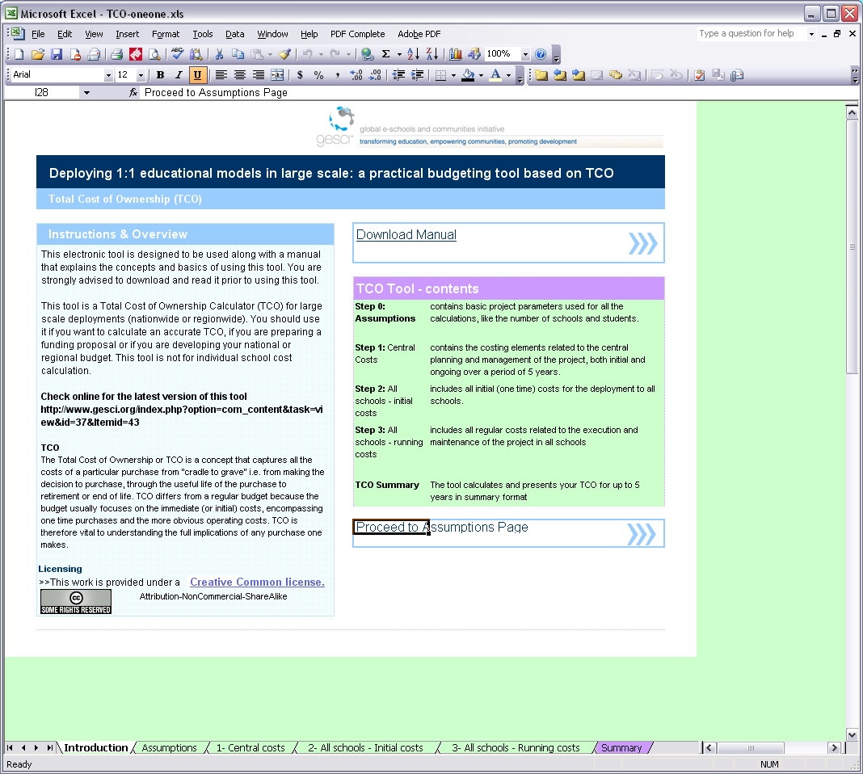
Before starting with this section please download and open the electronic spreadsheet available in several formats from GeSCIs website.

Tool Basics
  - The TCO electronic Tool is provided as a spreadsheet with different colored cells. The cells in green are cells that you have to fill-in with data. The cells in violet are automatic calculations and should not be modified.
  - The tool is divided into input and output sections. You will need to collect or careful consider all the information you require for the input sections to get a complete cost estimate from the tool.
  - The spreadsheet can be filled in any currency, as long as it is kept the same all over the spreadsheet. However, the “$” sign is used to represent cell containing amounts.
  - The tool will require you to collect and insert certain specific information about your project. You don’t have to have this information all at once since you can start using the spreadsheet to realize exactly what you need to collect. However, the tool will not give proper results until all the required information has been inserted. You can try changing certain parameters to visualize the totals under different scenarios.
  - Since there can be much variation between deployments, the tool is designed to be flexible and general enough to be applied to many different situations. If one particular field does not apply to your project, just leave it blank ($0).
  - Some costing categories, like for example teacher training, might appear duplicated in the spreadsheet. This is not an error, but rather allows for some components to be assigned to school level (decentralized model) and other to national level (centralized model) budgeting, or a combination of both.
The spreadsheet is divided into four data-entry worksheets:
- Assumptions: contains basic project parameters used for all the calculations, like the number of schools and students to be affected by it.
- 1 – Central: contains the costing elements related to the central planning and management of the project, both initial and ongoing over a period of 5 years.
- 2 – All schools - initial costs: includes all initial (one time) costs for the deployment to all schools.
- 3 – All schools - running costs: includes all regular costs related to the execution and maintenance of the project in all schools (with the exception of central costs). Includes monthly and annual costs.
Again, please note that these categories are not prescriptive to how costs are shared throughout the system. This is simply meant to separate central nation- and region-wide costs from costs that apply per each school deployment.
The results are provided in the last worksheet:
- Summary: provides the TCO results for initial and ongoing costs according to the deployment plan, including some averages

Step 0: Initial data
The first worksheet contains general information about the project and the deployment model, which will influence calculations all over the spreadsheet.
In this section you need to enter the data related to your project’s deployment, NOT the absolute national or regional totals.
Please start by entering the date and the name of the project at the top of the page.

Section 0.1: Overall National/regional context of the project
The initial data needed for the calculations are:
- Total number of schools: to be covered in the deployment, related to the deployment model. This is needed because some fixed costs, like servers, telecommunication infrastructure, are calculated on a per school basis.
- Total number of classrooms: related to the deployment model. This is because some costs like electricity or benches have to be considered per classroom.
- Number of students: affected by the deployment
- Number of teachers: affected by the deployment
- Number of administrative staff and Ministry of Education personnel: affected by this deployment
The following rows will automatically complete average calculations about the student/school, classroom/school, teachers/school and admin/school ratio. This will help in producing some average costs as well.
After this basic information, next you will complete information about the deployment model: how many devices will be assigned for each school, classroom, student, teacher, and admin staff? For example, in the case of true 1:1 deployments, add “1” in the column for students and teachers, meaning that there would be one device per every student and teacher, or “0.5” if one device will be shared by two students, for example. But this tool could also be used to calculate the TCO for computer labs models, where you could have for example 20 devices per school, or 0,05 per students, which is a PC every 20 students, and so on.
Then enter the expected life span of the devices in years, taking into consideration what the device vendor suggests and how the local conditions (weather, dust, heat) and usage could reduce this value. For example, in the case of OLPC XO, the vendor suggests this value should be 5 years, but it can probably be reduced to 3 or 4 years in real-life conditions.

Section 0.2: Roll Out schedule
Please complete what percentage of the schools you are planning to deploy to each year, according to your deployment plan, leaving 0% for the remaining years. The sum of the 5 columns/years must be 100%. For example, let’s say that you plan to cover 30% schools the first year, 50% the second, the remaining 20% the third. Insert “30%”, “50%”, “20%”, “0%”, and “0%”. When in doubt enter 100% of the schools the first year, otherwise the rest of the calculations will not work.
All the fields in this worksheet are mandatory and have to be filled-in in order for the calculations to work. Once you have filled in all this information, you can move into the next section.

Step 1: Central costs
A large scale project will require some central investments, like telecommunications infrastructure, Project Planning and National Infrastructure Setup, as well as some centralized management of some of the project’s areas, like teacher training, support and maintenance, etc. Sometimes a central management of telecommunication services like e-mail, web site hosting, etc as well.
- In this page you will have to fill in information about the central management areas of your project, covering a wide range of needs from nationwide infrastructure changes to curricula development and centralized training of trainers.
- At some stage of your planning you will have to decide which services you will centralize and which you will decentralize to region or even town level. This might not be so easy at the beginning, so if you are not sure of some of the fields leave them blank and you can fill them in later on, once you have filled-in more details about the school-related costs in the next 2 steps.
- The categories described here are needed to provide the management, support and control structure of the project. The values that you enter are then going to be averaged by school and by student to obtain national averages presented in the Summary worksheet.
- Costs are separated between initial setup costs and ongoing costs over a projected 5-year cycle.
- Some of the costs will be initial (one time) only, others would be regular costs and the value can change year by year. For each of the categories you can fill in the costs as initial or regular over the years, or leave blank if this variable does not apply to your project.
- Normally the items described in this page are paid with national funds, coming from different Ministries like Infrastructure, Telecommunications, etc.
- Some items may not be used in all deployments; especially in pilots and limited-scope projects. Some of these systems may already be in place (such as email or web servers) and the cost to adapt them may be lower than new systems.

1.1 Technology Platform:
The costs of setting up the central national infrastructure required to plan, deploy and maintain the project. This section should inspire deeper questions on the deployment plan – is the region/s being considered for a 1:1 program ready, and does the central educational authority for that region and/or the nation have the technical capacity to support such a deployment?. This is divided into three sub-sections: Central systems, National Infrastructure, and Educational Management.

1.1.1 Central Systems
What nation-wide systems should be in place to support a 1:1 project deployment? We suggest at the minimum two systems to provide technical support and guidance. Having a centralized system for maintenance that cannot be completed at the local level reduces long-term costs by extending the functional lifespan of the devices and optimizing the impact of expert personnel and spare/replacement part usage.
- Central Technical Services/Repair/Refurbishment center: According to your support model you might have a central national unit to provide high level or nationwide support, repairs, spare part distribution, refurbishment and equipment disposal, to handle laptop repair that cannot be completed at a more local level and to provide technical guidance to local repair efforts.
- Telecommunications broadcasting systems: Some method of communication (1-way broadcast or 2-way communication) will be required to connect the service center to the schools in the deployment. According to the telecommunications plan related to school’s connectivity, it might require some central infrastructure and services like radio or satellite broadcasting services.

1.1.2 National Infrastructure
Will the current infrastructure support a large quantity of laptop-like devices? Two important considerations are the electricity grid and a national telecommunications infrastructure. Many 1:1 devices have good battery life and do not require as much electricity as standard desktops, However, schools will need some ability to charge the devices if they are to be used all day at school as well as at home (where there may or may not be electricity available). Most 1:1 systems also employ some form of school server that stores online course materials, backs up the device content, and/or serves as a gateway to the Internet.
1:1 devices are powerful by themselves, but without a connection to the Internet, their power and impact is limited. If the nation or region has reliable telecommunications access (phone lines, cable, or even broadband-capable cell phone networks), other costs (such as per-school satellite connections) may be dramatically reduced.
- National telecommunications infrastructure: according to the telecommunications plan related for school’s connectivity, there might be some investment required in setting up shared infrastructure like a backbone, NAPs (Network Access point), etc. Costs related to connecting individual schools are considered in the next step.
- National electricity grid upgrade: in providing electricity for the schools there can be some organized effort in improving the electricity provision in general. Costs related to equipping or upgrading the individual schools are considered in the next step.

1.1.3 Educational Management
A school-system-wide software infrastructure enjoys many benefits of scale while at the same time assisting in management, monitoring and reporting. The Spreadsheet suggests a variety of software/service needs for the schools that are best provisioned centrally, such as email accounts for every teacher, a web host with customized space for each school’s blogs and public information, and course management system (CMS) to be used within schools. The school system as a whole may need to purchase, develop or customize other management software such as financial and educational management and information systems (EMIS), and other possible applications like a human resources system (HRIMS) and school administration tools, both of which may already exist in some form.

1.2 Content and Software, Applications
Every deployment should include some level of centrally acquired or created materials and software tools to assist in deployment. In situations where the Ministry of Education dictates nationwide curricula or standards, special effort should be made to create guides and lesson plans incorporating 1:1 device usage into existing curricula and lessons (how to use the laptop for a math lesson, how to "round-robin" write using the laptop, how to peer-edit, etc.) and demonstrations of ways to use 1:1 devices to teach existing national standards.
Other contents could include a "teacher's guide" and training session on classroom management with OLPCs (how to detect and prevent cheating, "cyber bullying", etc.) might win better teacher support for the device.
E-books and multimedia content are best acquired at a national level, as distribution can be bundled with the servers, the devices themselves, or via the telecommunications network. This allows the government to obtain better prices, and makes maintenance and content updating easier as well.
Also in this section you have to introduce the central cost of acquiring, developing or customizing, and maintaining software applications that you will need to run on the devices, servers, peripherals and online tools. This should include all subscription and licensing schemes adopted at national level.

1.3 Teacher training and teacher support
In addition to curricula guides and content, teacher training must also be a part of a sustainable and successful deployment. 1:1 devices can be pathbreaking tools, but at the same time, they enable a whole new level of intra-student communication and collaboration, which must be monitored and dealt with in new ways by teachers. According to your teacher professional development strategy you will include in this section the costs related to planning and executing centralized training schemes.
Training at the national level involves the creation of standards and training materials, as well as Training of Trainers, consultancy fees, and training center setup and/or rental. The scope and cost of the centralized training depends on your training model – is it designed to train all teachers, selected teachers who will then train their peers, or trainers who will then train teachers in other local facilities?

1.4 Maintenance and technical support
A national-level maintenance and technical support system – in some form – is vital to extending the lifecycle of deployed devices and reducing long-term equipment costs. Options to consider include having a central call-center / help desk, warehousing and distribution systems for spare/replacement parts.
National standards for authorized repairs procedures and would be helpful with or without a centralized repair facility. Lacking a central facility, additional guides, standards and documents as well as toolkits and spare parts need to be distributed among the schools.
According to your maintenance and technical support plan you can include in this section the centralized costs of maintaining a help desk center, user support structure and policies, call center, support via email/website/SMS, and development of technical standards and documents such as FAQs, instruction manuals, and guides.

1.5 Management, Monitoring and Reporting
Embedding reporting in the planning process eases setting and tracking goals. The spreadsheet is divided into three subsections to lay out a full array of management, monitoring and reporting funding needs: Policy and Implementation Planning, Setup of project management unit, and Monitoring, Evaluation and reporting

1.5.1 Policy and Implementation Planning
Any additional pilot and project planning costs should be included here, such as the cost of creating new government or educational policies to enable the 1:1 project.

1.5.2 Setup of project management unit
A project will require some Ministry of Education-level central office or staff assignment for management and oversight. This section includes the standard costs for such an office, some of which (e.g. connectivity and telephones) may have no per-unit costs to the Ministry. This unit may already exist in some form in many Ministries and not accrue any further specific costs.

1.5.3 Monitoring, Evaluation and reporting
Baseline data collection will need to be gathered, and follow-up data measuring against the same rubrics will also need tracking. Intra-ministry experts or external consultants can create a Monitoring and Evaluation (M&E) plan and tools to create a measurement rubric and evaluate the project against it.
For monitoring and evaluation you have to consider the costs associated with collecting baseline data, elaborating surveys, personnel, travel, supplies, equipment, communications, data processing, translation, recording, data analysis, etc.

Step 2: All schools, initial costs
Once the information about the central management unit has been filled in, you have to concentrate on Steps 2 and 3 which contain the direct school-related costs.
- In this page you will fill in the initial (one-time) expenses for all schools. This means that most of these costs are initial investments, capital expenses.
- You should only include direct costs related to the schools that are NOT included in the central structure costs, section 1.
- You should not include regular costs, either annual or monthly, like communications or electricity, as this will be included in Step 3.
- There is one expense per line. If a certain cost does not apply to your project, leave it blank. If you need to add additional expense sub-categories, just insert a line where needed. Use the Notes column to insert additional information about the cost components.
- The costs can be entered as a fixed cost, or a variable per unit (device) cost, per school, per classroom, per student, per teacher and/or per admin. To provide maximum flexibility you can fill in each cost as a combination of more than one of these fields, and the program will automatically calculate the sub-total. For example lets suppose that the import taxes are a fixed amount of $1000 and $1 per device, then you should fill in “$1000” under the “fixed cost” column and “$1” under the per unit column. The program will do the calculation of $1000+($1 multiplied per the total number of devices) as the total cost of the import taxes.

2.1 Deployment of technology platform

2.1.1 Equipment related
Direct acquisition cost (per device): This is the cost of each device paid to the vendor. This is normally the price FOB where it is manufactured.
Extra cost for teacher's device: in the case where the device for each teacher is slightly different from the students (i.e. more powerful, more storage, peripherals) then add the price difference here as a per teacher cost. For example if the standard device costs $200 and the teachers cost $ 300, as $100 here in the “per teacher” column.
Financing/administrative costs: This field can include financing costs, money exchange commissions and banking costs, international financial operations, loans and bids related to acquiring the equipment, fixed or converted to a per-device additional cost.
Transportation to country: This includes the costs of transportation, insurance, bureaucracy and paperwork necessary for the devices to arrive in the country. Normally can be converted to a fixed amount per device.
Import taxes: If taxes are not waived, this should include all taxes necessary to import and store the devices, like import, customs, inventory and storage taxes. In most countries, though, if the government is doing the acquisition then the products are tax-exempt, either because they are considered donations or through a specific decree/law.
Hardware, servers and networking equipment: most 1:1 models will require the school to have some IT infrastructure to support the individual devices’ communications. This item normally includes the acquisition of servers, server monitors and UPSs. This item might include local area networking equipment as well, like wireless access points, hubs, routers and firewalls. This item should not include software, which should be completed in the following section.
The type, size and number of servers needed will be related with server capacity and required functionalities, which can include some or all of the following functions:
- hosting of locally generated content and of educational content like e-books
- backup center for data and user storage
- connectivity gateway to Internet, web proxy and content filtering
- antivirus/antispam services
- mail server, web server, chat server, etc.
The rate of number of servers per users depends on the functionality and processing speed of the server, and on the functions provided. The individual specifications have to be determined during project planning and depend on a series of values. Estimations in the case of OLPC are about 1 server per every 120 students and one wireless access point for every 20 students.
Acquisition of peripherals and other support devices: some additional peripherals can be needed for the classrooms and schools, including printers, scanners, cameras, external hard disks, backup devices, disk drives, etc.
Other locally acquired items: includes items like extra batteries, a backpack for children to carry the devices in, USB memory sticks, etc.
Transportation to the distribution point: the cost of transporting equipment to the distribution point, for example MoE deposits if the equipment is going to be centrally deployed.

2.1.2 School Infrastructure
Civil works at schools: Includes the adaptations and repairs that will be needed at school level to provide an adequate environment for the machines to operate in the classrooms and the server room. It includes repairs and installations of flooring, ceiling, doors and windows, as needed. In order to estimate this value prefer refer to the “Estimating average values” section on page 34.
Security at schools: might include window bars, doors, server room security, door locks, alarms and security devices as needed.
Furniture at schools: Benches and tables as needed for classrooms, temporary storage for equipment when at school and furniture for server room (includes air conditioning if needed).
Electric installation at schools: (per classroom) Includes internal and external cabling, plugs, charging stations in the classrooms, multi-battery chargers, electric panels and security measures. For charging panels example, please refer to the picture on section 3.1
Alternative energy systems installation: For schools where no grid is available. It can include diesel generators, solar panels, wind generators, etc.
Local area network infrastructure: Cabling and infrastructure required connecting the wireless access points to the server room and Internet connectivity provision. Includes cables, connectors, etc
Internet connectivity set up costs: According to the type of connectivity, the initial costs to deploy the service (i.e. acquiring the antenna or modem, electrical setup, security setup, etc)
Other infrastructure at school: other items that might be needed at school level not detailed above.

2.1.3 Equipment set-up:
Devices testing, installation and inventory: All the costs associated with testing and setting up the machines with the software and configuration, as well as activating and registering serial numbers in a national database. Some countries choose to skip this step and do it directly at school level, while other do it centrally prior to its distribution.
Transportation to schools: According to the deployment model, schools might be responsible for getting their machines to their destination or the government has to send them. These costs might include storage, transport, and insurance, as well as packing and unpacking. Some countries use an existing structure with high capillarity to assist in the task of delivering the equipment, like the armed forces , police, or existing textbook distribution channels. See the section on page 34 for some suggestions on how to estimate this value.
Equipment installation and configuration: The costs of installing and configuring the server and local area network at school. Includes server installation, device installation, LAN set up, networking at school level (does no include the cost of LAN infrastructure described in section 2.1.2)
Device activation and assignment: The costs (through personnel time spent) in activating and assigning each individual device to its new owner. Is there a central list of users and assigned device IDs to be managed, or activation keys to be entered?

2.1.4 Equipment disposal:
Provision to dispose of the devices once their lifetime has ended. Costs are to be determined according to the disposal method.

2.2 Content and applications
Software and applications for the devices: this includes the setup costs for software licenses for the devices, including operating system licenses.
Server software: This includes the setup costs of software licenses for servers to operate, to be determined according to the specific tasks the server has to perform and to the server hardware. It normally includes the operating systems, antivirus, firewall, proxy server, content filtering, data storage and backup applications, etc.
Course management system: this includes administrative software for managing the school, hosting online course tools (content, exercises, quizzes, discussion lists, etc.) if any need to be acquired.
Security software: might include antivirus, antispam, anti-malware, etc for each of the devices and/or for the servers as well. Costs depend on the network setup and software systems used.
Didactic material and content in electronic format: Development, acquisition, translation, localization of educational software. If these are acquired centrally do not include them in this section, but in section 1 instead. Remember that this item should include only initial costs and not regular license renewal costs, which are included in section 3.2.

2.3 User training
Teacher training: Course planning, training material, initial trainings, support on a per-teacher basis. This can include costs like transportation, lodging, extra salaries, etc. Remember theses are initial costs, and do not include centrally-managed costs (section 1.3) nor regular ongoing teacher training Programmes (detailed in section 3.3). Refer to page 37 for suggestions on how to calculate these amounts.
Student training: As student training will normally be indirect, that is, through the teachers and often integrated within normal classroom time, this item normally considers the cost of the training material only, like CDs, printing booklets and copying digital material. This does not include the cost of developing content (normally considered in section 1.2) or of updating it each year (section 3.2).
Community awareness: includes costs related to planning and organizing awareness seminars with parents and the communities.

2.4 Maintenance and technical support
Support toolkits: standard equipment and tools provided to schools for machine maintenance and parts replacement, i.e. screwdrivers, cleaning kits, anti-static-discharge devices, and other basic tools.
Spare parts: according to the failure rate a certain number of spare parts have to be bought. Standard recommendations are of having about 5% of the total number of machines extra per year to replace broken, lost and stolen equipment, but this can change according to local conditions and quality of the equipment.
Preventive maintenance contracts: according to the maintenance model, you can have some cost incidences in setting up the preventive maintenance in each school (this does not include the monthly cost of maintenance, considered in category 3.4)

Step 3: All schools, running costs
- In this page you will fill in the regular expenses required for the project to operate in all the schools.
- The costs can be entered as a fixed cost, or a variable per unit (device) cost, per school, per classroom, per student, per teacher and/or per admin. See Section 2 for an explanation of how to distribute the costs in each column.
- The values are considered the same for the 5 years of duration of the project. In this version of the tool it is not possible to vary these values over the years, even though some costs like Internet connectivity probably could be reduced over the years (or the bandwidth increased).
- There is one expense per line. If a certain cost does not apply to your project, just leave it blank. If you need to add additional expense sub-categories, just add a line where needed.
- Note: Carefully estimating and provisioning for regular expenses can help in guaranteeing that the project is financially sustainable over the years.

3.1 Operation of technology platform
This section includes on-going or regular costs divided into monthly costs and annual costs. Monthly costs will be multiplied by 12 to obtain the totals.

3.1.1 Monthly costs:
Electricity: (per school per month) the electric bill of an average school (grid electricity). See section on page 35 for some suggestions on how to estimate energy consumption per school.
Connectivity costs: (per school per month) the monthly cost of the provision of the Internet connection, normally estimated on a per-school basis. This does not include connectivity set-up costs, which are estimated in section 2.1.2.
Alternative energy maintenance costs: According to the type of energy source this could mean that there would be a monthly expense of oil, fuel, gas, maintenance etc. This does not include energy systems set-up costs, which are estimated in section 2.12.
Consumables: ink, paper, blank CDs and DVDs, USB flashdrives, cleaning materials, etc. that are going to be provided or paid by the project. Note that many of the low-cost devices do not include optical media drives, and some do not readily support printing.

3.1.2 Annual costs:
- Provision for Furniture: at schools and general repairs needed each year, like replacing chairs and tables, etc.
- Equipment insurance: In the case the government wants to insure the equipment against theft or damage when at the school or outside. This item is desirable but also highly improbable as the costs to insure portable devices can be very high.

3.2 Content and applications
Software licenses: according to the software used in devices and servers, this includes the cost of license renewal, upgrades and updates on a yearly basis. This does not include licenses which are acquired or managed centrally, which are included in step 1.
Content licenses: according to the contents used, this includes the cost of educations content license renewal, upgrades and updates.
New educational software: annual investment in new software and content for devices and servers.

3.3 User training
Training of teachers: cost of continuous training, per year, including travel expenses, lodging, training material, salary incentives, etc. This is related to section 2.3, initial cost of user training. Refer to page 37 for guidance on calculating these costs.

3.4 Maintenance and technical support
Related to cost item 2.4, this includes the annual cost of maintenance and support.

3.4.1 Technical Support Model
This varies according to the devices and the support model selected. Some countries selected a very centralized model where the failing devices are sent to a large city to be repaired, in which case most of the costing is represented in the Central Costs Page. In other, there is a multi-tiered support structure where the problem is diagnosed at local level and the machines are repaired locally and only sent to the central lab in specific cases.

3.4.2 Preventive Maintenance
The same applies to maintenance models where the equipment is cleaned and verified regularly. Maintenance normally includes software updates, backups, equipment cleaning and preventive replacement of parts.
Regarding software installation in case of software failure, the easiest solution is probably to re-install software and start with a “clean” environment. But the student loses all personalization and probably also own content, unless a backup procedure is in place.
Backup of content: some procedure has to be defined for students and teachers data to be stored safely in a central location, which is backed up regularly as well.
Regarding server software upgrades/updates: occasionally (2 times a year?) the sever will have to be controlled, cleaned up, and software updates and patches installed. This can be done as part of the preventive maintenance.

3.4.3 Spare Parts
This is the investment in spare parts in order to quickly repair problems in the devices, servers and local area network infrastructure. In the case of OLPC XO, few parts of the devices can be repaired in a design choice to make a more robust device. However, most parts can be easily replaced, in which case each repair center will need a few spare parts in numbers related to the possible failure rate. Some parts (i.e. keyboards, pointing devices) might have to be replaced within the device lifecycle as part of preventive maintenance. Spare parts can be stored at school level, regional level and national level.

Step 4: Totals and Results page
The summary page provides you with the totals resulting from the information entered in the previous sections and the calculations related to it. Please make sure that all data required in the Assumptions pages has been entered in order for the calculations to work!
This page presents a total summary of the data entered in the previous pages:
1 – the central system,
2 – all schools initial data and
3 – all schools, running costs.
It then shows totals for the initial costs and the sum of the 5 years of recurring costs.

The last table presents average expenditures:
- the average initial investment per school and per student
- the TCO per device for initial investment vs. the pure acquisition cost, which shows how much money has to be invested initially, as some governments seem only to consider the acquisition cost.
- averages per school and per each student, considering the annual recurrent costs without the cost of maintaining the central structure
- averages per school and per each student, including the average of the central costs as well.
For such a large scale project it is considered that an error margin in the estimation of +/-30% is normal, though of course the values could be adjusted even more by using a more detailed analysis of each costing variable.
Having the values in a spreadsheet allows you to experience different costing alternatives, going back to the initial premises and changing variables like the number of schools or devices to see how the costs are then affected. In this way the project can be resized to fit the available budget. Also, you can change the roll out schedule to deploy to schools in more or in less years and see how the budget is affected.

Cost estimations recommendations
Of course estimating the exact amount for each of the individual items of this TCO can be a nightmare when one considers that we are talking about a project that can involve thousand of devices at country level.
For each of the specific cost categories you will probably have to enroll the help of experts in the matter that can provide you with estimates. Use the space provided for Notes to describe how the value was estimated.

In any case in this section we will provide you with some ideas on how to estimate some of these values.

Equipment transportation to school (section 2.1.3)
Estimating transportation to schools can be done as follows. Begin by establishing ranges of distance of the schools from the distribution point, for example: 10% of schools are in the 10-50 km range, 30% are in 51-120 range, etc. Then estimate the transportation cost per kilometer. By multiplying the cost per kilometer by the upper limit of each range and by the %, and then adding it all together and dividing by the total number of schools you will have the average national cost of transportation. Then add to the cost per schools the cost of personnel loading and unloading, and the insurance.

Equipment installation (section 2.1.3)
To estimate how much it will cost to install, configure and inventory a device or a server, do a few standard installations measuring how long it takes to do one device. There are methods to optimize time when installing multiple machines with the same content, like hard disk imaging/flashing, batch script creation, or slipstreamed installation media with specific software and content included. Include in this the time required to pack and unpack. Then get the cost per hour of a technician that has the needed qualifications for the task, and get the final cost per device by multiplying the cost per hour (or minute) by the number of hours (minutes) it takes for each device.

Content development (section 1.2)
This is probably the most difficult item to estimate, and we can say there is no rule of thumb. Costs may be roughly estimated by comparing them to the creation costs of other educational content and curricula for the country. We hope to offer more ideas in the next version of this tool.

Electricity costs (section 3.1.1)
To estimate the electric bill of an average school (grid electricity) you have to first estimate the individual consumption of the devices and the number of hours they will be on on a standard school day. This will give as a result the KW needed per day.
Item | How to estimate | Calculations
Devices | The amount each device consumes depends on the battery type and the activity the user does. It has been estimated that an OLPC XOs battery lasts 2-3 hours, and can be charged in 2 hours. According to this we estimate the consumption of each device at 8-11 watt-hours, a little more if it is being used while charged. | Multiply watt/hours per number of devices per hours charging each day (i.e. 4 hours on a school day).
Servers | Depending on the server type and monitor, it can consume between 60-200 Watt/hour | Multiply watt/hours per number of server per hours on each day (i.e. 8 hours on a school day).
Network Access points, hubs, routers | About 7 watt/hour | Multiply watt/hours per number of server per hours on each day (i.e. 8 hours on a school day).
Other related devices, like printers, modems, etc have to be included in the calculations as well | Their energy requirements vary according to the technology used, the vendor, and the amount of hours it has to be in use
Adding up the energy consumption for all the devices will give you the total Kw/day needs. Multiply by the number of work-days in a month (i.e. 22) and the price of the Kw in your country to obtain the cost of the energy per school per month in your region.
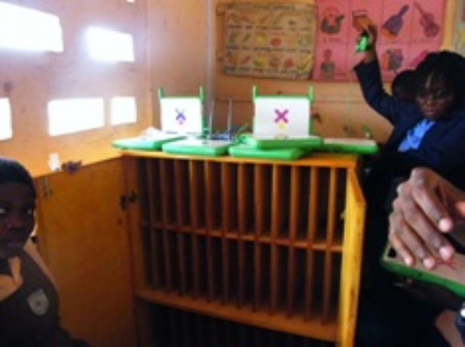Note about electricity and usage of OLPC in class: It has been observed in OLPC pilot project in Ghana where schools have electricity but most houses do not, that teachers follow this procedure to introduce the devices into everyday teaching: As soon as a child arrives to school he places his notebook in the charging station. After 2 hours, the teacher does some activity with the laptop for 1-2 hours. Then the laptops go back to being charged again so the child takes it home charged. For this purpose every classroom is provided with a charging panel at the back of the room.
Example:
Let’s consider a school in Ghana that has 120 OLPC devices. Energy consumption is: 120 devices X 8 watts X 2 hours a day = 1920 watt/hours; almost 2 Kw. Cost of Kw is US$ 0,25, so a school will be spending US$ 0,50 a day, or a total of US$ 11 a month (22 school days) for the electricity of the devices only.

Continuous Teacher training (Section 2.3 and 3.3)
To estimate teacher training first estimate how many days per year each teacher will get of training. Then estimate the average cost of a training day including transportation, lodging, training materials, instructor costs, food, extra salaries and expenses, etc. Multiply the average cost per day by the number of days in order to get a per teacher per year continuous training amount. For example, you can estimate that a training day costs, adding up all the components, $10 per teacher. If you plan to have 5 days of training a year this will be $50 per teacher per year.

We hope that you find these examples useful and that they help in estimating other complex costs included in the tool.

Conclusions
The exercise of working through a TCO calculation is useful not only for informing budgetary decisions, but also to examining the scope and feasibility of the project overall.

Filling out the spreadsheet can reveal gaps in project planning and unexpected expenditures. Carefully thinking through the recurring costs can help in guaranteeing the project’s sustainability and in assigning funds to make sure that these do not arrive unplanned to school headmasters and the communities that host the schools.

We highly recommend you review the other materials listed below in the Annex for further discussions on cost and implementation of 1:1 computing models.

The authors hope that you find this tool useful and welcome and comments, corrections and suggestion in order to improve future versions. Thank you.

Annex

Additional information and references
- For more information about the 1:1 educational model please refer to “1:1 Technologies/ Computing in the Developing World: Challenging the Digital Divide” by Mary Hooker, GeSCI: http://www.gesci.org/files/docman/1_to_1_Technologies_Computing_in_the_Developing_World_by_M._Hooker_GeSCI.doc
- For more information about other large scale deployment considerations, besides cost, please refer to “Practical guide to Pilot Projects and Large Scale Deployment of ICTs in the Education Sector - Guidelines on deploying information technology in schools at a regional or national level “ by Roxana Bassi, GeSCI, http://www.gesci.org/index.php?option=com_content&task=view&id=38&Itemid=44
- For basic information about educational & IT considerations, the system-wide model and deployment alternatives please refer to “Assessing Technology Options for Schools - Report on framework and tools” by Alex Twinomugisha and Roxana Bassi, GeSCI, http://www.gesci.org/index.php?option=com_content&task=view&id=37&Itemid=43
- “What is the real cost of OLPC?” article by Jon Camfield (2006) http://www.olpcnews.com/sales_talk/price/the_real_cost_of_the.html
- “A Report Card for OLPC” paper by Jon Camfield with Alex Kobulsky and Jake Paris (2007)
http://joncamfield.com/writing/Camfield_Report_Card_for_OLPC.pdf
- “Costing considerations (TCO) on deployment of OLPCs in Haiti” article by Jon Camfield http://www.olpcnews.com/implementation/plan/cost_of_olpc_in_haiti.html
- “Official deployment guide for large scale projects of OLPC devices” http://wiki.laptop.org/go/Deployment_Guide
- Article on costing considerations of OLPC Brazil http://www.olpcnews.com/sales_talk/price/the_real_cost_of_the.html
- IADB’s OLPC Pilot costing considerations in Haiti: http://idbdocs.iadb.org/wsdocs/getdocument.aspx?docnum=1364380
- “Planning for Sustainability: How to Keep Your ICT Project Running” by Schools Online – http://schoolsonline.org/resources/sustainability/index.htm
- UNESCO’s ICT in Education Toolkit http://www.ictinedtoolkit.org/usere/login.php
- GeSCI’s TCO page with manuals and tools http://www.gesci.org/index.php?option=com_content&task=view&id=37&Itemid=43
- “Affordable Computing for Schools in Developing Countries: A Total Cost of Ownership (TCO) Model for Education Officials” by VitalWave, June 2008, http://www.vitalwaveconsulting.com/pdf/Affordable_Computing_June08.pdf

For other deployment models please refer to GeSCI’s “Assessing Technology Options for Schools - Report on framework and tools” http://www.gesci.org/index.php?option=com_content&task=view&id=37&Itemid=43
For more information about the educational model please refer to “1:1 Technologies/ Computing in the Developing World: Challenging the Digital Divide” by Mary Hooker, GeSCI: http://www.gesci.org/files/docman/1_to_1_Technologies_Computing_in_the_Developing_World_by_M._Hooker_GeSCI.doc
OLPC website: http://laptop.org/
A list of low cost devices is maintened by InfoDev http://www.infodev.org/en/Publication.107.html
Download the updated spreadsheet and manual from http://www.gesci.org/index.php?option=com_content&task=view&id=37&Itemid=43
“Practical guide to Pilot Projects and Large Scale Deployment of ICTs in the Education Sector - Guidelines on deploying information technology in schools at a regional or national level “ by Roxana Bassi, GeSCI, http://www.gesci.org/index.php?option=com_content&task=view&id=38&Itemid=44
GeSCI’s TCO page. http://www.gesci.org/index.php?option=com_content&task=view&id=37&Itemid=43
For the Limited deployment plans, special care needs to be given to the selection of the schools so as to avoid appearing political. A transparent selection criteria is key (for example; schools which already have sufficient infrastructure, sufficient electrical capacity, or the largest school per district, or the poorest, or rural first, etc).
Most people would agree that these devices are for primary children, and that are better utilized when children already know how to read and write, so if a few classes have to be selected they are normally introduced to 4th-5th graders (9-10 years of age)
http://www.gesci.org/index.php?option=com_content&task=view&id=37&Itemid=43
XO life expectancy http://wiki.laptop.org/go/Green_Machine
OLPC server estimations http://wiki.laptop.org/go/Deployment_Guide/School_Server
XO battery specifications http://www.olpcnews.com/hardware/power_supply/olpc_power_boost_lifepo4.html

