Computer Tutorials for Teachers

A Beginner’s Introduction to Computers

Module 1

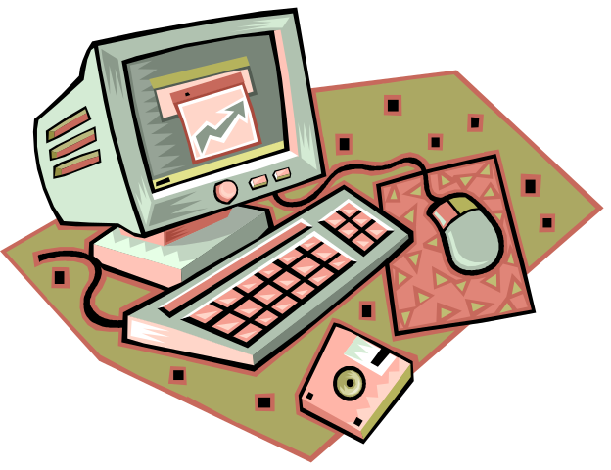

New Horizons for Primary Schools,
Educational Technology Intervention
Ministry of Education, Youth & Culture,
Caenwood Centre, 37 Arnold Road, Kingston 4. Jamaica.
Tel/Fax: (876) 967-5192, email: nhorizons@cwjamaica.com

Dear Colleagues,
Welcome.
It is a pleasure having you in this workshop. Your presence signals the fact that you are no longer asking the question – “Should computers be used in the classroom?” but instead you are now asking – “How can I use the computer in the classroom?”
These Tutorials have been designed to help teachers who are using computers for the first time to acquire the fundamental skills involved in using the computer and how to apply these skills in the context of the classroom.
On completion of these tutorials you will understand how this tool, the computer, can support you in your classroom and how you can introduce your students, directly or indirectly to these methodologies. The scope of this manual has been limited to what can be reasonably covered in a one-day workshop but you will always have this manual to practice your skills on your own or with a colleague, as proficiency is promoted by frequent reinforcement of skills learned.
Please encourage each other to build on, and grow beyond the skills learned in this tutorial and it is hoped that you will be motivated to go on to learn more advanced features of the computer and, in turn, help other teachers to provide meaningful and engaging learning experiences for their students.
Be assured that all your efforts will bear fruit when you incorporate computer-assisted instruction into your curriculum as you create new opportunities for you and your students.
You will undoubtedly touch the future even as you touch your own.
With best wishes,
Jean Beaumont
Educational Technology Specialist
New Horizons for Primary Schools

Table of Contents:

Getting started ………. …………………………………………….……………………… Page 4

What is a computer?
How do I get started?
What items do you have on your desk at work?
A look at the computer’s Desktop
Exploring files and folders on the Desktop

Illustrating with Computers ………………….………………………………………… Page 7

Learning to draw and paint with a mouse
Making different shapes and colouring them
Erasing, selecting and resizing objects
Saving your best work to a diskette

Writing with computers ……….………………………..……………… ………… Page 10

Using the computer keyboard to create text
Making changes to the text
- Add colours, change font size and style
Importing your picture from another program
- Import your drawing from the paint program to the writing or
word processing programme
Positioning and resizing your picture
Saving your work for later use

Activity Page ………....………………………………………………………………….. Page 12

Using Encarta Encyclopedia ………….………………………………….…………….. Page 13

How can I benefit from a Microsoft Encarta search?
How can my students benefit from Microsoft Encarta search?

Getting started

Searching and exploring topics using Microsoft Encarta

A Team Activity ……………..………………………………………………………..….. Page 15

Module 1 in the series of “New Horizons for Primary Schools Tutorials for Teachers”, has been designed for teachers who have never used a computer. It is hoped that at the end of this workshop, participants will be able to:
- Turn on, and ‘log off’ a computer.
- Describe a computer ‘desktop’.
- Know how to move around the desktop using a mouse.
- Begin to explore ways in which computers can be used to assist teachers in the classroom.
- Know how to use the mouse and drawing tools in “Paint” for illustrations
- Know how to use the ‘Help’ menu and follow on-screen instructions.
- Know how to write documents using a word processor and create simple teaching aids.
- Know how to make changes to or (format) a document.
- Know how to transfer information from one application to another.
- Know how to store information to a floppy disk.
- Conduct a research activity using “Microsoft Encarta”.

What is a computer?
A computer is an electronic devise that can store information (data) that has been placed in it, and in turn, this information can be manipulated to produce information whenever it is needed. Like all electronic devices, the computer needs to be plugged into an electrical outlet and turned on. It will take some time for the computer to get started, which is referred to as ‘booting up’ - just be patient and observe the various ways in which the computer checks its systems during the booting up process. Your computer is ready for use when you get a screen that looks like this one in Figure 1.

Figure 1
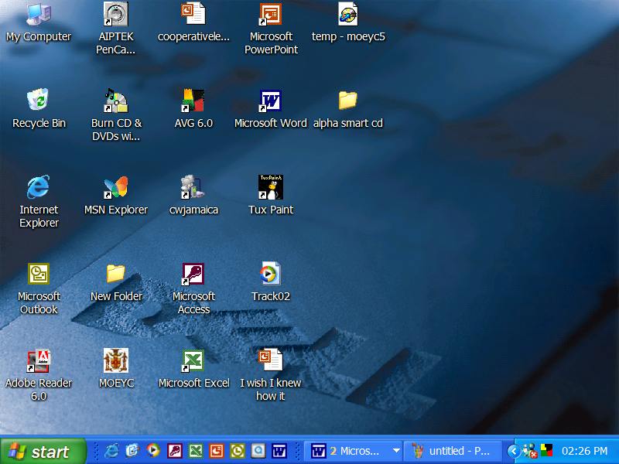
Icons
Folder
Start Button
Clock
Task Bar

This is what the computer desktop looks like. It shows the following:
- Pictures or Icons that will link you to programs and files that are frequently used.
- When you click the start button, it will open up more programs and files.
- The bar running the full length at the bottom of the desktop, beginning with the start button, is called the ‘task bar’.
- The task bar shows icons of frequently used applications and tasks that the user is presently working on.
- Notice the clock showing the time, in the bottom right hand corner.
- There is also a waste basket (Recycle Bin) for discarding work you no longer need.
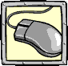
Go ahead and use your mouse to point, or move to any of the icons on your desktop. When you get your mouse directly on the icon, hold it very still and firmly click the left button on your mouse. Try clicking on at least two (2) icons.
Left button

Click on the start button, using the left mouse button and see what happens.
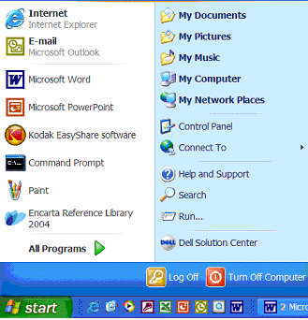
A pop-up’ menu appears showing different options. Slide your mouse to All Programs and click the left button.

All Programs

Opening a Program:
Click on the All Programs button and a menu with more applications will be available to you. Slide your mouse (don’t click yet) over to the right, following the arrow from All Programs and slide your mouse up to Accessories. Now, left click your mouse on Accessories and more applications will be available. Slide your mouse all the way down that menu of choices until you get to Paint. Now left click on Paint.

Illustrating with Computers:
The Paint program allows users to draw, paint and write using various tools that are manipulated by the mouse. You will get lots of practice using the mouse as you learn to create beautiful masterpieces.
Take a good look at the opening window of Paint. You will note that in addition to having a plain area (canvas) on which to work there are bars at the top of the page with words such as File, Edit, View, Image Colors and Help. This bar is called the Menu Bar because, within each of those words or menus, you will find many more operations that your computer can perform. Go ahead and left click on any of these menus in the Menu Bar. New choices or options will unfold – isn’t this fascinating?
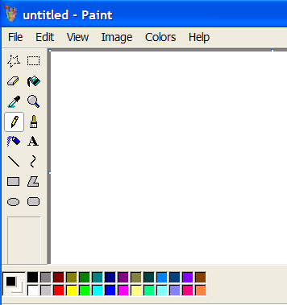
To the left of the screen there is the Tool Box where various drawing tools and icons are; and on the lower left hand corner there is a color box with a wide selection of colours. You will discover that every program on your computer has a Menu Bar, and on each Menu Bar there is a Help button that will guide users through every operation on a computer. This is your opportunity to use the Menu bar in Paint to discover what you can do in this progra.
Title Bar
Menu Bar
Help Menu
Tool Box

Color Box
Using the Help Menu:
Click on the Help menu, then select the Help Topics option and under the Contents tab select Paint. This option will reveal more options on the left, as seen in the figure below. To the right you will see the instructions. Select the option Create Pictures and let’s begin.
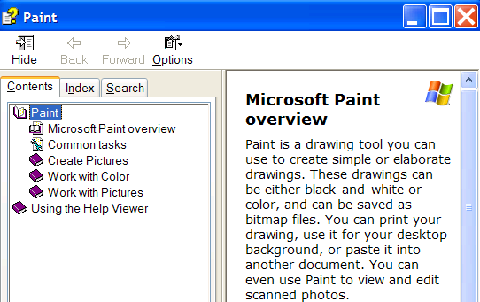
Options
Instructions

Let’s Paint:
The Paint program will show you step-by-step how to use the drawing tools on the left of the screen. When you have finished, go ahead and select the next tool and so on, until you are familiar with most of the tools in the paint program.
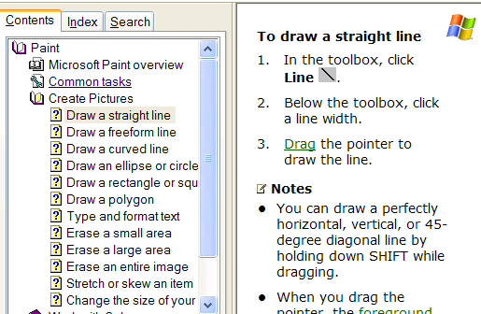
This is an example of the instructions given in Paint.

To draw a straight line
- In the toolbox, click Line .
- Below the toolbox, click a line width.
- Now point your mouse to the open canvas to draw the line.
- Continue experimenting with other drawing tools.

Notes
- You can draw a perfectly horizontal, vertical, or 45-degree diagonal line by holding down SHIFT while dragging.

Saving your best work to a diskette:
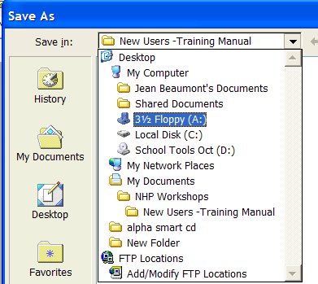
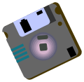
If you do not have a computer of your own, it is always best to save your work to a diskette so that you will always have it available when you need it. A floppy diskette, or an external memory disk, allows you to save almost 500 pages of a typed text, but if you have photos and other graphics, it will reduce your storage capacity considerably. To save a document, insert your diskette into the Floppy Drive or A Drive (always place the side with the circular disk facing down), select File in the Menu Bar and slide your mouse down to Save or Save As and click. A dialogue box will pop-up, click on 3 ½ Floppy (A:), and yet another dialogue box will appear, this time it will ask you to name the file you want to save. Look at the bottom of the dialogue box where is says “File name” and type the name of your file, then click on the save button that is to the right, and your work is now saved to a 3 ½ Floppy disk.
Save in
3 ½ Floppy (A:)

Congratulations!
Opening a Word Processing Document:

Go to the start button, click on it, click on All Programs, all the programs on your computer can now be seen. Look for Microsoft Word move your mouse into position and click on it. You are now in a writing program or a word processing program, with a clean sheet of paper on which to start writing. Look around this new writing environment, are there any similarities with the drawing and painting environment that you have been working in? What looks the same? Yes – There is a menu bar and space to complete your task!
In MS Word, the key board is used as this is the only way that you can input the letters you will need to write. Have a look at the key board – At the very top are some keys with F in front of numerals, these are called function keys however we will not be using them now. Just below the function keys is a row with numerals and below that are the letter keys. At the very bottom of the keyboard is a very long key, this is called the spacebar because it is used to create the space between words. On both sides of the key board you will find the shift key - when you hold this key down and type a letter, it will capitalize the letter. The Caps Lock key when pressed, will capitalize all letters until you press it again to remove this feature. On the lower right hand side of your keyboard are four (4) arrow keys which you will use to move around round your document. You already know how to use your mouse so you can use it to move around your document also.
Helpful Tips:
- To erase text or spaces to the right, press the delete key.
- To erase text or spaces to the left, press the backspace key.
- To move around your document you can use the mouse or the arrow keys at the bottom right-hand corner of the keyboard.
- To close a program, click on the X at the extreme right-hand corner of the screen. Keep clicking on these X’s until you close all programs.
- To turn off the computer, close all programs until you return to the Desktop then click on Start and follow the instructions given. The Computer will inform you when it is safe to turn off the power supply.

You are now ready to type your first sentence about your first experience with the computer. Try to use both hands, do not worry about your speed, you just need to concentrate on remembering where the letters and features are located on the keyboard. Remember to save on your diskette – the procedure is the same as in paint.
You are doing great – keep going!
Making changes to your Document or Formatting:
- Select the text you want to change by holding down your shift key and using your arrow keys simultaneously to highlight or select the entire area that you want to make bold. Now look for the icons in the tool bars that are below the menu bar and click on the one with B on it. Keep your highlight on and select the I - you will notice that the text changes to italics. These changes are called formatting a text.
- You can also make the selection by placing your mouse at the start of the area you want to highlight, click and hold the mouse button down and gently drag the mouse pointer across the area.

Change the font size of Text:
- Select the text you want to change.
- In the tool bar you will see Times New Roman which is a style of writing on the computer. To the right of this you will see a downward pointing triangle (arrow), click on this and you will have a choice of writing styles to choose from.

Change the colour of the Text:
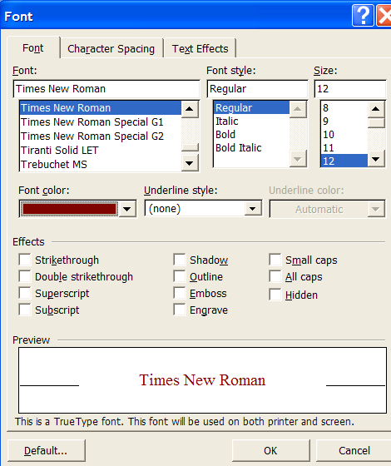
- Select the text you want to change. By now you would have observed that every time you want to make a change you have to select or highlight the area.

In the menu bar select Format + Font make your selection and click OK.
Font style
Select colours

Font size
Activities:

Create a teaching aid with computers using the Paint and Word Processing Programmes
Suggestions:
- Reading and Mathematics Flash cards
- Reading and Mathematics Friezes with Illustrations
- Story starters – a picture or a sentence
- Problem solving quizzes
- Task Cards of exercises to be completed in groups
You can think of many, many more ways to use the tools.

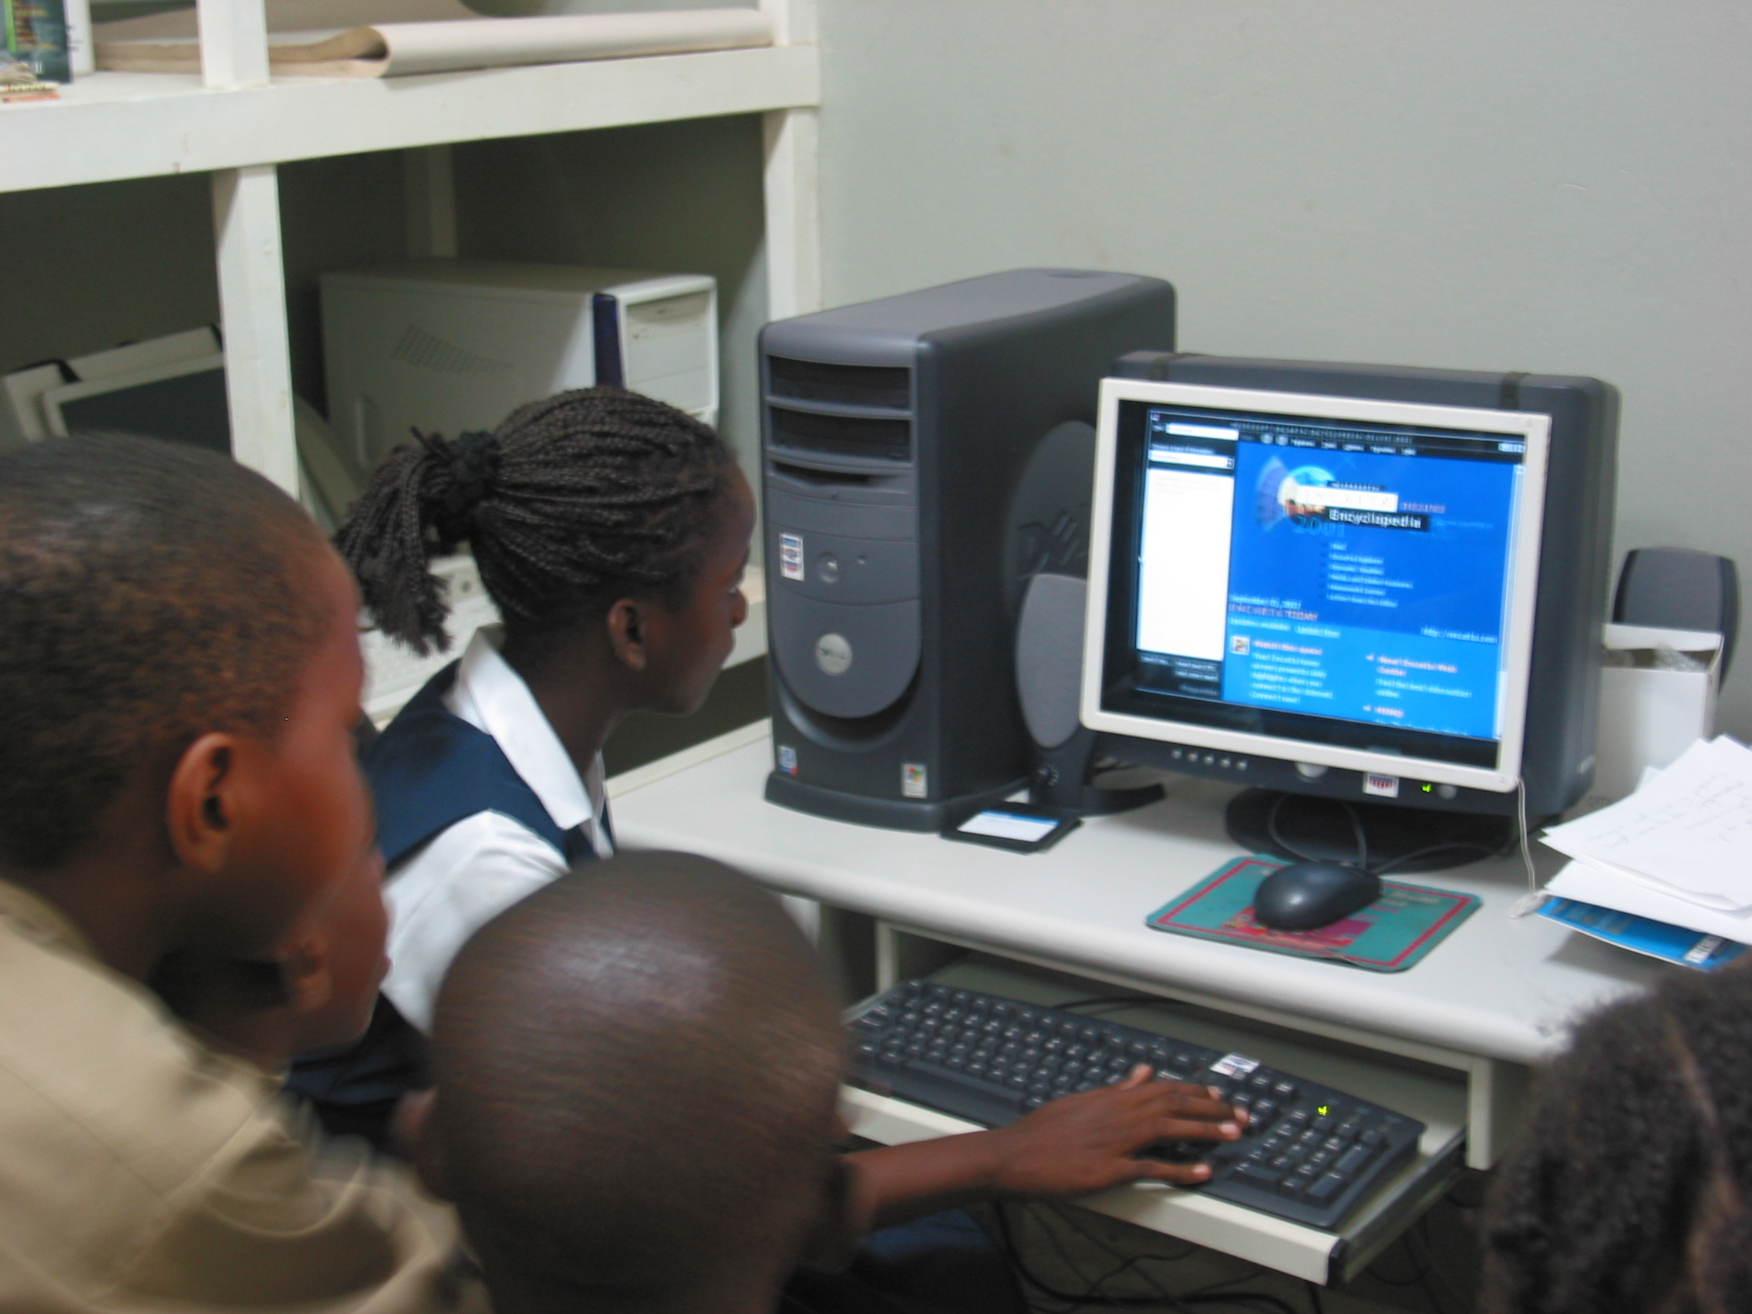

Using Microsoft Encarta

Microsoft Encarta is a digital encyclopaedia. You can search a huge collection of information in seconds. Encarta not only contains text, but also pictures, video and audio.

Doing a Search

- To find information in Encarta is easy. First you have to locate the ‘Find’ box in the upper left corner of the dialog box.

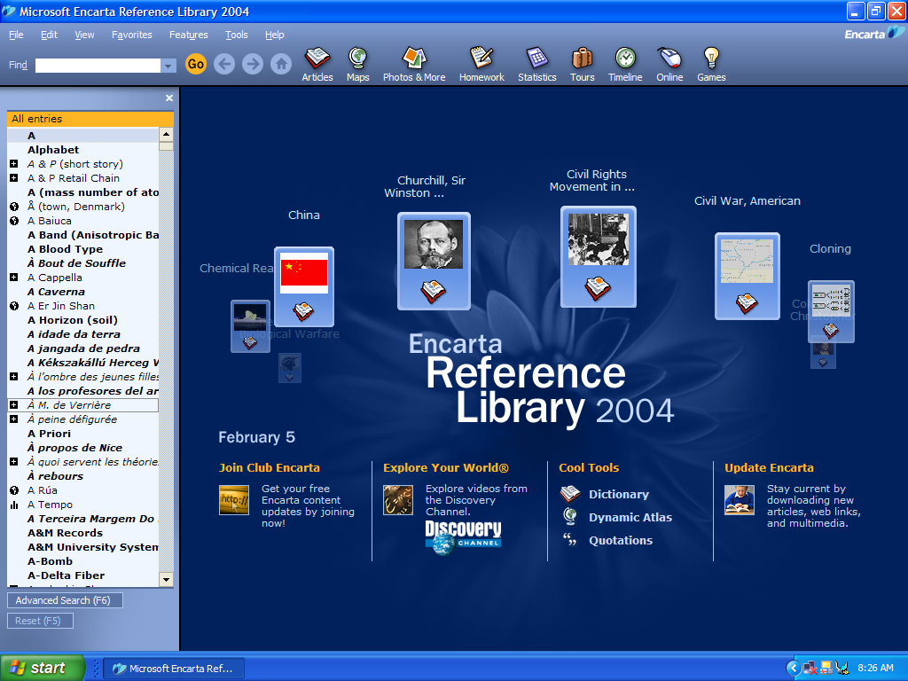
Find Dialog Box

2. Next, type in the word or phrase you wish to search for. Notice that as you type, a secondary list appears under the title ‘Quick Matches…’ The Quick Match provides a listing of similar or related items. You can scroll (click on the arrows to move up or down) through the list to review these matches.

You can make your selection by double-clicking on the desired item or by pressing the ENTER key.

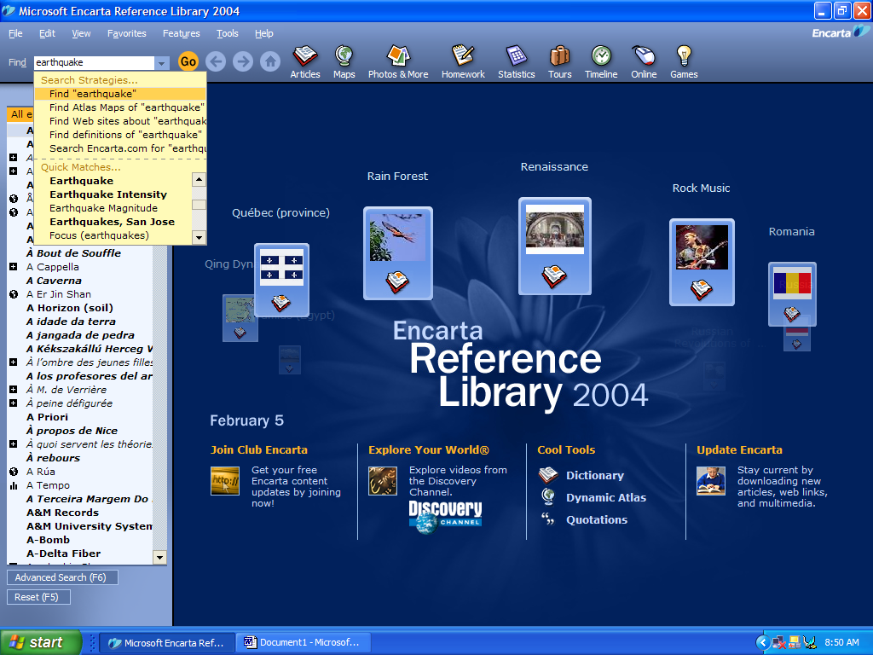
Quick Match List
3. Once you make your selection, in this case ‘earthquake’ has been typed in. Notice that the main discussion appears on the right portion of the Encarta window, and related matches appear on the left portion of the Encarta window. By pointing with your mouse and clicking on the item, more information appears about the selected items.

You can also point-and-click on the items in the left portion of the Encarta window. Please note that certain items in the ‘matches list’ have icons appearing to the left of the item. For instance, the world icon refers to maps. Thus, if you select the item ‘Earthquake Lake’ you will see a map. Other icons reference Quick Facts, Video, Sound, and Pictures.

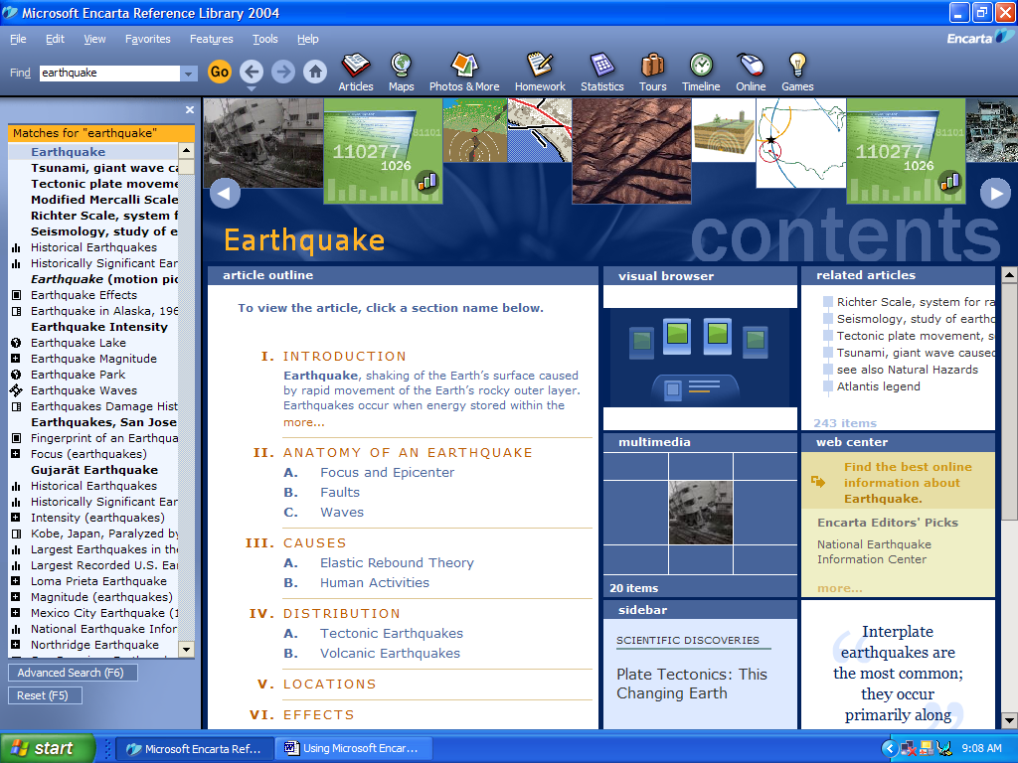
Map
Video

Activity:

Working in teams of two (2), select a topic and plan a mini lesson around that topic.

