Windows 95
Compatibility Tests

Compatibility Tests (CT)
- Audio Compatibility Tests (ACT)
- Block Compatibility Tests (BCT)
- Display Compatibility Tests (DCT)
- ISV Compatibility Tests (ISVCT)
- Modem Compatibility Tests (MCT)
- Network Compatibility Tests (NCT)
- Other Compatibility Tests (OCT)
- Plug and Play Compatibility Tests (PNPCT)
- Printer Compatibility Tests (PCT)
- System Compatibility Tests (SCT)
- Tape Compatibility Tests (TCT)

Copyright 1990, 1992, 1994 (c) Microsoft Corporation

November 29, 1994

Compatibility Tests - Introduction

Windows 95 Compatibility and the “Designed for Windows 95” logo
The Microsoft® Windows™ 95 operating system will introduce many new features that will make the PC easier, faster, and more powerful for the end-user. Among them are an improved graphical user interface, 32-bit technology, OLE, preemptive multitasking, better connectivity, and Plug and Play support.

Plug and Play (PnP) refers to the technology developed by leading hardware and software vendors to improve the ease of use, configuration and setup of personal computers. PnP allows users to add, change or remove hardware components while the computer automatically adapts to the changes.

Once the PC and peripherals are built to the specifications that enable them to take advantage of the technology in Windows 95, the next challenge is for PC hardware vendors to communicate the benefits that a user will experience by using that hardware with Windows 95. The Windows 95 Logo program is designed to meet that challenge. The “Designed for Microsoft Windows 95” Logo will help users easily identify PCs and peripherals that are designed specifically to work great with Windows 95. It will also help them identify software that offer equivalent benefits. The end result is that the user can use the Windows 95 Logo to help them mix and match PC hardware and software components, so that they can get the most out of their computers.

Compatibility Tests - Overview
In order for systems and peripherals to qualify for the “Designed for Microsoft Windows 95” logo they must pass the a suite of Compatibility Tests (CT) designed to ensure the system or devices compatibility with Windows 95. These CTs are expanded versions of the Windows 3.1 and the Windows NT HCTs, adapted for the specific needs of Windows 95. They test Plug and Play compliance as well as hardware, software and driver compatibility with Windows 95. The CT test suite consists of:

- Audio Compatibility Tests (ACT) for Sound Card Vendors
- Block Compatibility Tests (BCT) for Disk Drive/Controller Vendors
- Display Compatibility Tests (DCT) for Display Adapter and Monitor Vendors
- ISV Compatibility Tests (ISVCT) for Software Vendors
- Modem Compatibility Tests (MCT) for Modem Vendors
- Network Compatibility Tests (NCT) for Network Interface Card Vendors
- Other Compatibility Tests (OCT) for Joystick and Video Capture Card Vendors
- Plug and Play Compatibility Tests (PNPCT) for PnP ISA Card Vendors
- Printer Compatibility Tests (PCT) for Printer Vendors
- System Compatibility Tests (SCT) for PC Systems Vendors
- Tape Compatibility Tests (TCT) for Tape Backup Unit Vendors

How to get the most of the Compatibilty Tests
Preliminary CTs are available with the Beta releases of Windows 95, to help you test early and be sure that your machines and peripherals are on track to pass the final tests. All OEM’s and IHV’s should run these preliminary tests. SCT test results should be submitted to MCL (see SCT.DOC for details). Results of the tests for individual PC peripherals, such as display adapters, printers and modems should not be returned to MCL. These devices will follow a program similar to the certification program available today from MCL for Windows Logo Certification. Details of this program will be provided when available.

Windows 95 Beta Support
For reporting problems related to Windows 95 that are not CT results problems, please refer to the Windows 95 Beta Program Guide. This includes Windows 95 Operating System Bugs as well as Windows 95 CT Test bugs.

Please send any CT questions to Compuserve account 71034,3643.

Getting Started - Setting up the CT’s

Requirements
1. A computer system (PC) that meets the Microsoft Windows 95 minimum hardware requirements:
80386 or higher
Minimum of 4 MB of RAM
1.44 or 1.2 floppy drive
Harddisk with a minimum of 65 MB available before Windows 95 installation
VGA compatible graphics adapter supporting 640x480, 256 colors and higher
CD-ROM drive
Microsoft Mouse or compatible pointing device

2. Windows 95 installed on the system's hard drive and the Win 95 directory in the path.

3. Approximately 30 megabytes of free disk space on the hard disk drive prior to installation. Hard drive space will vary with components choosen.

4. General understanding of the Windows 95 user interface.

5. One high density floppy diskette for the 'A' drive which can be reformatted and used to send Wrap-Up results to Microsoft. Additionally a high density floppy diskette is needed for each floppy disk drive tested with the floppy disk test. These diskettes will be formatted by the tests.

CT Setup
1. Start Windows 95.
2. Double click to open “My Computer” icon.
3. Double click the drive containing the DDK CD-ROM.
4. Double click to open the CT directory.
5. Double click on the CTSETUP icon.
6. “Welcome to the CT Setup” appears - select “Continue”

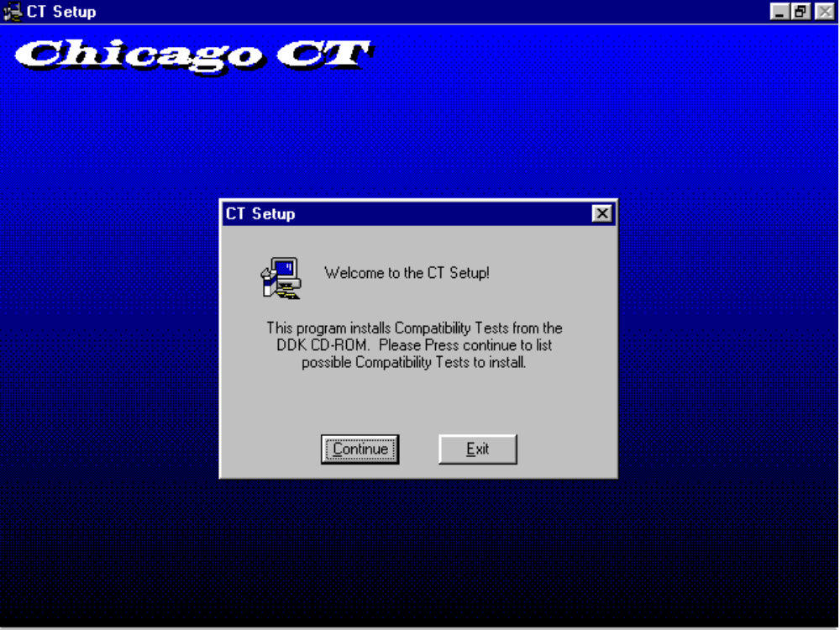

7. The next screen will give you choice of CT (Compatibility Test) suites to install:
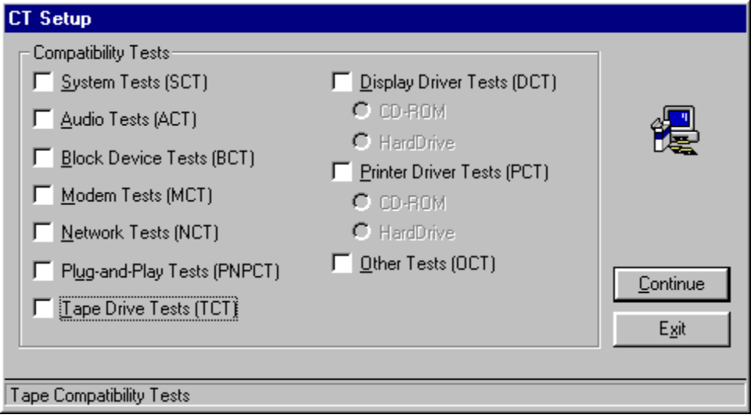
The SCT’s iclude tests or portions of tests from the ACT, BCT, MCT, NCT, PNPCT and TCT so selecting SCT will automatically select all of those suites.
The DCT and PCT may bie installed to a local ard drive or run directly from the DDK CD. The only difference is the amount of hard drive space used.

8. Choose a destination directory for the CTs:
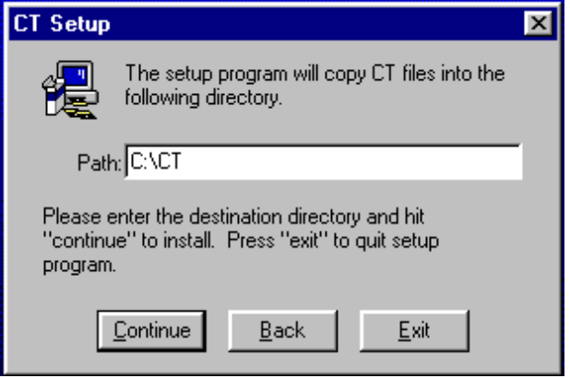

9. CT Setup will copy the CT files to your selected destination directory and create a subdirectory of the WINDOWS directory called CTLOGS.

10. CT Setup will create Folders and shortcuts for all the tests you chose to install

11. If you chose to install either the SCT, DCT or PCT and CT Setup detects an ISV application installed on the test machine that has a test, it will also install the ISV Applications Compatibility Test (ISVCT) for that particular application (see ISVCT.DOC for more information). You may also specify certain ISV tests to be installed.
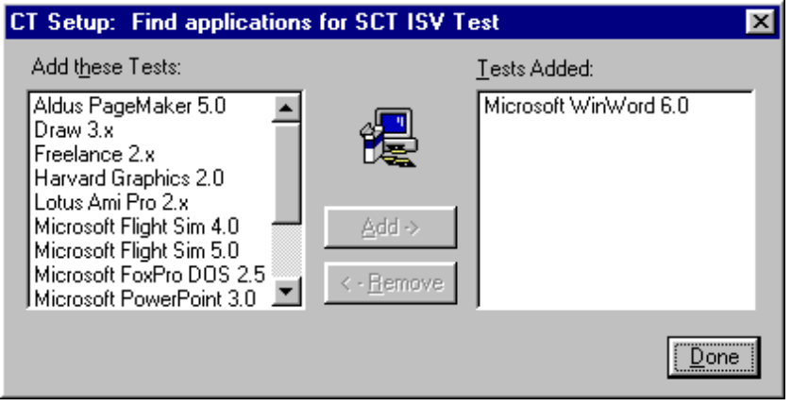
Note: The CT’s do not distribute any applications, only the means to test them. Select “Done” to finish selecting ISV tests.
12. A message informing you that CT Setup is complete will appear:
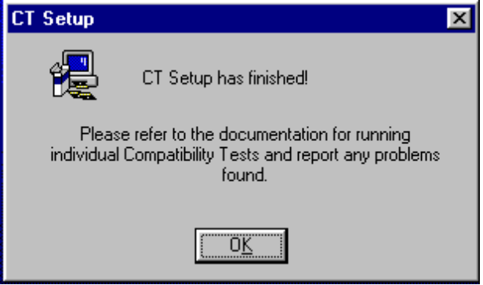
Select “OK” - and you are finished.

