This document contains two pages of Encapsulated PostScript images that were created in PaintBrush with various PostScript printers. The EPS files were created using level 2 printers.

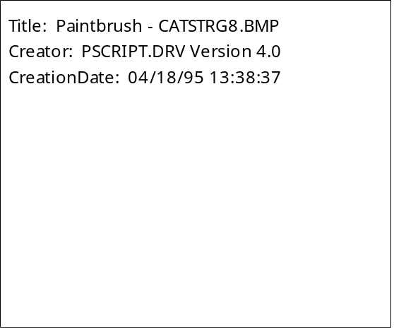 | <<== This EPS file was also created in PaintBrush with the IBM 4079 Color Jetprinter PS, default settings.
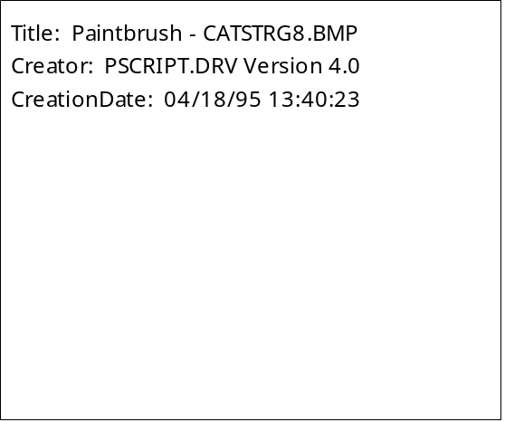 | <<== This EPS file was also created in PaintBrush with the IBM 4079 Color Jetprinter PS.  BMP Compression: ON  Halftone Frequency: 60  Halftone Angle: 33.3
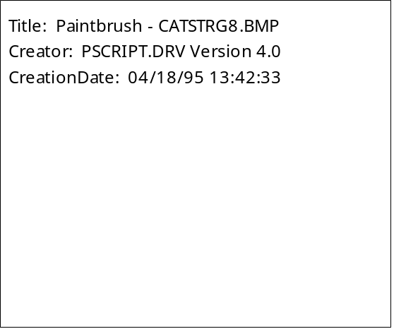 | <<== This EPS file was also created in PaintBrush with the IBM 4079 Color Jetprinter PS.  BMP Compression: ON  Image Color Matching: ON
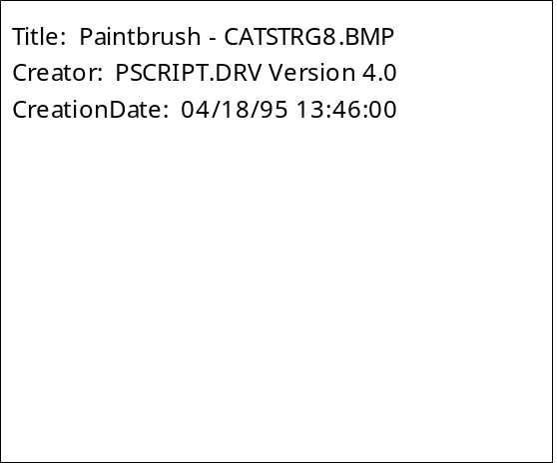 | <<== This EPS file was also created in PaintBrush with the IBM 4079 Color Jetprinter PS.  BMP Compression: ON  Image Color Matching: ON  Negative Image  Halftone Frequency: 60  Halftone Angle: 33.3
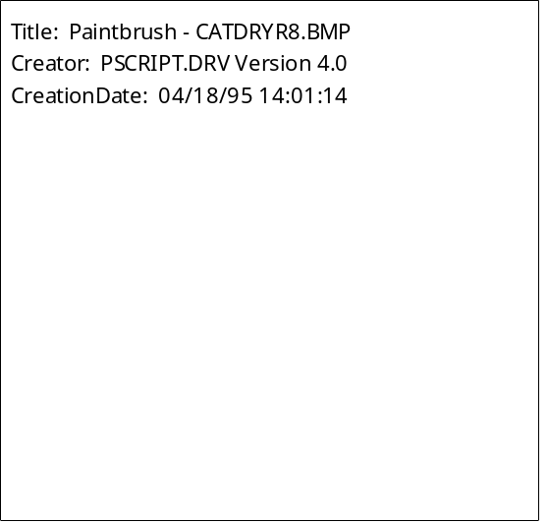 | <<== This EPS file was also created in PaintBrush with the HP LaserJet 4Si PS, default settings.
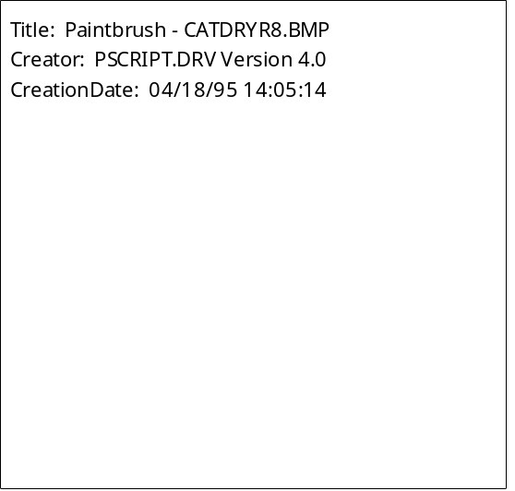 | <<== This EPS file was also created in PaintBrush with the HP LaserJet 4Si PS.  BMP Compression: OFF  Halftone Frequency: 85  Halftone Angle: 33.3  Negative Image
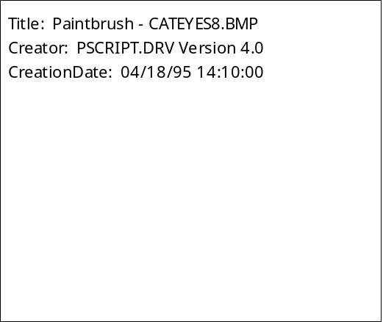 | <<== This EPS file was also created in PaintBrush with the HP DeskJet 1200C/PS.  Image Color Matching: OFF
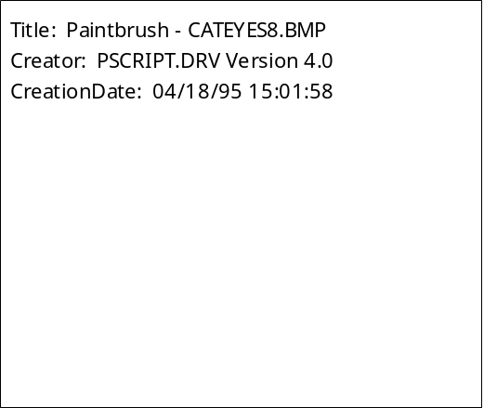 | <<== This EPS file was also created in PaintBrush with the HP DeskJet 1200C/PS.  Image Color Matching: ON  Halftone Frequency: 60  Halftone Angle: 33.3  Negative Image  BMP Compression: OFF  Language Level: 1

