DirectX Driver Setup
Preliminary specification

Important Note
The setup implementation on this Developer Release CD is not final. It implements the legacy behavior, but not the application callback mechanism. Some of the compatibility warnings you see will not be present in the beta 2 release. This specification reflects our current plans for DirectX setup. DirectX setup will be final by DirectX beta 2.

Objective
The goal of DirectX Driver Setup is to upgrade users with outdated drivers to the latest Microsoft-provided display and audio drivers. This needs to happen smoothly, without adversely affecting the user’s system. We need to upgrade older drivers whenever possible to prevent reduced performance and/or stability of all DirectX applications on that system.

General Description
DirectX 5.0 provides the application with more flexibility in deciding when to upgrade drivers and how to notify the user. It also makes driver installation setup safer by incorporating knowledge about existing drivers when deciding whether to recommend an upgrade.
DirectX Driver Setup utilizes a database of existing Microsoft-provided and third-party drivers created by Microsoft with the cooperation of our partner IHVs and OEMs. This database contains information about the upgradability of each driver, based on testing done at Microsoft and at other sites (see the March 1997 Windows Hardware Newsletter for more information on participating in this effort).
To allow the application to make decisions about driver installations and user interface, DirectX will make two passes through all of the installed drivers. The first pass will be a dry run, during which DirectX will not perform any upgrades. After the dry run the application can present UI to the user requesting that selections be made about driver upgrades. The second pass will be the action run, during which DirectX will actually install drivers if requested by the application.

Setup Algorithm Overview
- The application calls the main DirectX Setup function with a pointer to an application-provided callback.
- DirectX Setup performs a dry run: It steps through each existing driver and calls the application callback function with the driver’s upgrade information. The upgrade information will contain one of the following upgradability ratings:
- Upgrade is safe
Replacing the existing driver will not break any third-party apps.
- Upgrade is unknown
The existing driver is not contained in our database.
- Upgrade causes loss of functionality
Replacing the existing driver will break some third-party apps, but will allow GDI and DirectX apps to run normally.
- Upgrade causes failure
Replacing the existing driver will cause the system to be unusable.
- Upgrade is not necessary
The existing driver does not have a lower version number than the driver we’re installing, and it’s WHQL-certified. In other words, the existing driver is newer.
The upgrade information provided for each driver will also contain a string description of the driver for display to the user, as well as other information about potential functionality loss.
- DirectX Setup performs the action run: It steps through each driver and calls the application callback function with the driver’s upgradability status. The application’s callback function returns a code that instructs DirectX Setup to either upgrade or not upgrade the driver. If the application requests to upgrade an unknown driver, or a driver that causes loss of functionality, DirectX will display UI to warn the user of potential problems. An application will not be able to request an upgrade that causes failure. The user must run the standalone DirectX Setup utility to perform this (unrecommended) action.
- The main DirectX Setup function returns.

Setup Recommendations
Based on the upgradability rating of each driver, DirectX Setup will provide the app with a default action (i.e. the recommended action) to take. In most cases, the app may elect to take the default action or another one. Most ISVs are expected to simply take the default action in all cases. This minimizes user interaction and minimizes the risk of a system malfunction.

Upgradability rating | Replace existing driver | Don’t replace existing driver
Safe | Default. | Allowed.
Unknown | Allowed. Post warning to user:  See Unknown Upgrade Warning. | Default.
Causes loss of functionality | Allowed. Post warning to user:  See Functionality Loss Warning. | Default.
Causes failure | Not available. | Default.
Not necessary | Not available. | Default.

Setup Algorithm Flow Chart
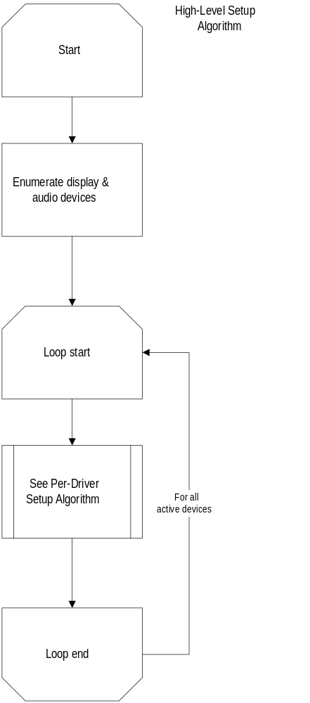

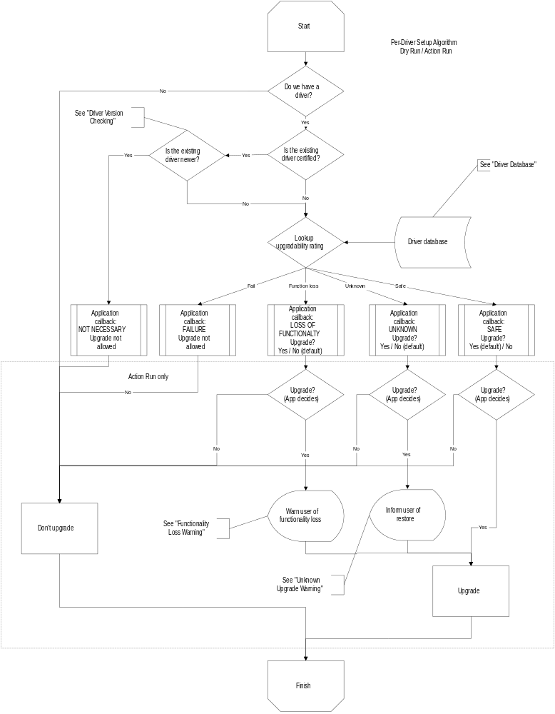

Driver Version Checking
[Display] The version of a display driver is defined as the version number of its .DRV file. We only use this file because it is the one file that gets signed by WHQL.
[Audio] The version of an audio driver is defined as the version number of the file. Audio drivers consist of only a single file.

Driver database
This database contains information about which drivers are safe to upgrade. The following display and audio drivers are considered safe:
- Microsoft-provided Windows 95 drivers
- Microsoft-provided DirectX drivers
In addition, other drivers will be listed based on testing of third-party drivers.
The database is contained in the .INF files, with drivers identified by filename and version number.

Safe Upgrade Message
Setup has found an updated version of this driver and can install it now for maximum performance and stability.

Unknown Upgrade Message
Setup does not recognize the existing driver for this device.
If you choose to install the new driver and later experience problems, you can restore the existing driver by running the DirectX Setup utility.

Functionality Loss Upgrade Message
Installing a new driver for this device may affect the following program(s):
<Program 1>
…
<Program n>
If you choose to install the new driver and later experience problems, you can restore the existing driver by running the DirectX Setup utility.

Fail Upgrade Message
Setup cannot upgrade the existing driver for this device.

Unnecessary Upgrade Message
The existing driver for this device does not need to be upgraded.

Unknown Upgrade Warning
Dialog title:
<Application name> Update
Dialog Text:
The following driver on your system has been upgraded:
<Driver string name>
If you experience problems later, you can restore the existing driver by running the DirectX Setup utility.

Functionality Loss Warning
Dialog title:
<Application name> Update
Dialog Text:
The following driver has been upgraded to the latest Microsoft-provided DirectX driver for maximum performance:
<Driver string name>
You should not experience any problems running this program or other standard Windows applications. However, the following program(s) may be affected:
<Program 1>
…
<Program n>
If you experience problems with any of the above program(s), restoring your previous driver may help. To restore your previous driver, run the DirectX Setup utility.

Backwards Compatibility
Applications that call previous versions of DirectX Setup will continue to function. The APIs that existed in DirectX versions 1-3.x will function the same as before, but will only upgrade in cases where the upgrade is safe.
The DirectXSetupSetCallback(…) function determines whether DirectXSetup(…) will invoke the new DirectX 5 setup behavior or the legacy DirectX 1-3 behavior. If the application does not call DirectXSetupSetCallback (as is the case with all legacy DirectX apps), DirectXSetup(…) will take on the legacy behavior. If the application does call DirectXSetupSetCallback (as will be the case with applications developed with DirectX 5 and above), DirectXSetup(…) will take on the new DirectX 5 behavior.

Optional Multiple Language Support for Drivers
Drivers will be contained in separate directories for each language, off of the main DirectX redist dir. Setup will only use language directories that are present. So, if an app vendor wishes to distribute only languages X and Y in his product, he only includes language X and Y directories in the redist of the game.

Deliverables

ISV redistributable
The ISV redistributable package will be for ISVs who wish to distribute DirectX with their titles. The package will contain the DirectX \redist dir with optional driver subdirectories, along with the dsetup*.dll files required for DirectX setup.

Web distribution
The web distribution will be an end-user download. It will be a set of Iexpress packages that each contain the runtime and the drivers for one language.

DirectX Setup Utility
The DirectX redistributable package will also contain a standalone executable (the “DirectX Setup Utility”) that provides all the functionality exposed by the DirectX Setup API calls. The standalone program will allow a user to manually install and uninstall display and audio device drivers. It will also provide the user with information about the current versions of their drivers and their WHQL qualification status. When an application calls DirectX Setup, DirectX Setup will create a “Microsoft DirectX” program group in Start à Programs. It will place a shortcut to the “DirectX Setup Utility” (dxsetup.exe) in the new folder.

Availability
This new setup package will be available in DirectX 5 beta 2. Beta 1 of DirectX included the same setup algorithm as DirectX 3. The CDGC Developer Release contains an interim implementation.

