Chapter 1
1.1 Objective
Overview
The Microsoft Windows NT Hardware Compatibility Test (HCT) kit provides a set of tests for verifying the compatibility of hardware systems with Windows NT. The HCT kit supports the following platforms:
u Intel x86 uniprocessor and symmetric multiprocessor (SMP)
u MIPS R4000 uniprocessor
u MIPS R44/4600 uniprocessor and SMP
u DEC Alpha AXP uniprocessor and SMP
u Power PC

By running the tests and returning the results, you can help Microsoft identify problems with the operating system and find possible incompatibilities between the system and your hardware.
The HCT Test Manager is a Microsoft Win32™ application that provides a simple way to launch the tests, keep track of test results, and return the results to Microsoft.
You can run many of the HCT tests under the HCT Test Manager, including all of the tests required for system qualification. These tests are described in Chapter 2, “System Hardware Compatibility Tests.” If you are an OEM, use these tests to qualify your system and return the results to Microsoft.
The tests described in Chapters 3 – 8 provide you with additional testing functions and debugging capabilities. Many of them provide their own interfaces. Use these tests to verify the operation of your hardware and driver combinations.
Microsoft maintains a Windows NT Hardware Compatibility List (HCL). If your Intel x86-based uniprocessor system passes the HCTs, and if you return the test results to Microsoft, your system can be included in the HCL. If you have a RISC-based machine or a multiprocessor machine that passes the HCTs, please contact your Microsoft account manager to find out how to submit your hardware and results for inclusion in the HCL.

Submit new hardware and driver combinations to the Microsoft Compatibility Labs (MCL) for inclusion on the HCL. For information about the MCL compatibility program, see Appendix A of this manual.
1.2 The Testing Procedure
The following sections lead you step-by-step through the testing procedure. The tests require you to:
1. Install Windows NT.
2. Install the HCTs.
3. Enter the system configuration.
4. Run the tests.
5. Return the results.

All tests automatically save results to disk. Some tests require manual interaction, but the tests automatically record manual selections that you make.
The Windows NT HCT kit includes information about submitting problem reports to Microsoft. You may encounter known problems or corrected problems, or both. In many cases, the Windows NT HCT group can determine the cause of the problem from the problem report alone, so please provide the most information possible in your initial problem report.
This report must include the hardware configuration together with peripherals, a debug log, and a detailed explanation of the steps required to reproduce the problem.
A test error or failure does not always indicate that your hardware is incompatible with Windows NT. The HCTs help Microsoft identify genuine incompatibilities and system failures. Each release of Windows NT includes enhanced HCTs that improve coverage.
For instructions on how to mail your HCT results directly to Microsoft Corporation, see Section 1.4.8, “Returning Final Results.”
1.3 Setting Up the HCTs

The following section lists the hardware system configuration you need to run the HCTs. It then leads you through the steps to install and setup the software.
1.3.1 Hardware Requirements
To install and run the HCTs on your hardware system, the system components must meet the following requirements.
Component | Requirement
CPU(s) | x86 uniprocessor or SMP  R4000 uniprocessor  R4400 uniprocessor or SMP  R4600 uniprocessor or SMP  Alpha AXP uniprocessor or SMP  Power PC
Memory | 12 MB RAM for x86 and 16 MB for RISC processors
Hard disk | 230 MB total on one or more physical drives (See Table 1.5 for a description of how to partition the hard disk during installation.)
CD-ROM | Windows NT – compatible recommended. To install the HCTs from a CD-ROM that is not supported by Windows NT, use the same setup method under Windows 3.x.
Floppy disk | 1.44 MB, 2.88 MB, or 1.2 MB
Video | Color monitor, VGA resolution (or higher if supported by Windows NT)

Some hardware port tests require loopback connectors. Tables 1.1 – 1.4 describe the connectors you may need.
Table 1.1 Connections for a Serial Loopback RS232C Connector

Connect this pin |  | To this pin
Tx | Rx
RTS | CTS, DCD (same as CD)
DTR | DSR, RI

Table 1.2 Connections for an IBM AT-Compatible with a 9-pin Connector

Connect this pin |  | To this pin
2 | 3
7 | 8 and 1
4 | 6 and 9
(5 is signal ground; leave it unconnected)

Table 1.3 Connections for PCs with a 25-pin Connector

Connect this pin |  | To this pin
2 | 3
4 | 5 and 8
20 | 6 and 22
(1 is frame ground; leave it unconnected)
(7 is signal ground; leave it unconnected)

Table 1.4 Connections for a Digiboard Serial 10-pin RJ-45 Loopback Connector

Connect this pin | To this pin
5 | 6
3 | 8 and 10
9 | 2 and 1

1.3.2 Installing Windows NT System Software
To install Windows NT system software, use the following guidelines:
u Refer to the provided Release Notes.
u When prompted for partitions and formats, set them up as shown in Table 1.5. You can skip partitioning and formatting if the partitions already match those in Table 1.5.
u Follow Windows NT installation instructions until you can start Windows NT and log on.
u Format the D partition (and any other test drives) using the following command (other drive letters may be substituted if they have all of the characteristics listed in Table 1.5):
format D: /fs:ntfs

Table 1.5 Partition Requirements for HCTs

Drive partition | File system format | Recommended size
C | FAT | 180 MB (for system, paging file, etc.)
D | NTFS | 25 MB

The HCT partition must have 50 MB of free space to run the System Stress test.

You may find it necessary to use the kernel debugger to debug system failures. You need an additional debugger machine running Windows NT and connected to your test system by a serial port. For instructions on how to set up and run the kernel debugger, see Appendix B.
Note

1.3.3 Installing HCT Software

Before installing or running these hardware compatibility tests, read the latest information about them in the file \HCT\README.TXT on the HCT CD-ROM disk.
Note
.
The HCT programs divide into several test groups that correspond to common hardware categories. One additional group contains the MS® Word for Windows™ files for this document. When you install the HCT software, you specify one or more of these groups.
The following table lists each test group, the approximate disk space necessary for installation of that group, and the chapters of this manual that contain information about tests in that group. See the first section of each chapter for a list of tests in each test group.
Test group | Required disk space | Description
System | 42 MB | Chapters 2 and 8
Multimedia | 8 MB | Chapters 3 and 6
NDIS Netcard | 7 MB | Chapter 5
Printer | 33 MB | Chapter 7
SCSI/Storage | 10 MB | Chapters 3 and 6
Video | 43 MB | Chapter 4
Documentation | 9 MB | All chapters

Some files are common to several groups, so the total disk space needed to install all groups may be less than the table indicates.
You use a graphical setup program to install these HCT groups, except for the NDIS group and the fault tolerance subgroup of SCSI/Storage. The following procedure guides you through the installation using the graphical setup program.

Û To install one or more HCT test groups
1. Insert the HCT CD-ROM disk into your CD-ROM drive.
2. From the Program Manager File menu, choose Run.
3. In the Command box, type
DriveLetter:\hct\setup.exe

where DriveLetter is the letter of the drive that contains the HCT CD-ROM.
4. Choose the OK button.
The Windows NT HCT Kit Installation dialog box appears, as shown in Figure 1.1.
5. In the Install To box, type the letter of the disk drive, followed by a colon (:), and the root directory where you want to install the tests (C:\HCT is the default).
6. Choose the Set Location button to update the Space Available box.
This box indicates the amount of free space on your selected disk.
7. Under Installation Options, select the HCT groups that you want to install.
For example, if you want to install only the tests you need to meet HCT system compatibility requirements, select the System group.
The space required for the selected test groups appears in the Space Required box.
8. Choose the Install button.
The setup program copies the selected tests to subdirectories of the root directory that you specify.
After copying the tests, the setup program creates a Program Manager group named “Windows NT HCTs” and a program item for the Test Manager in that group.

See Chapter 5, “NDIS Netcard Driver Tests,” and Section 3.2.3, “Fault Tolerance,” in Chapter 3 for instructions on how to install those tests manually using batch setup files.
Note

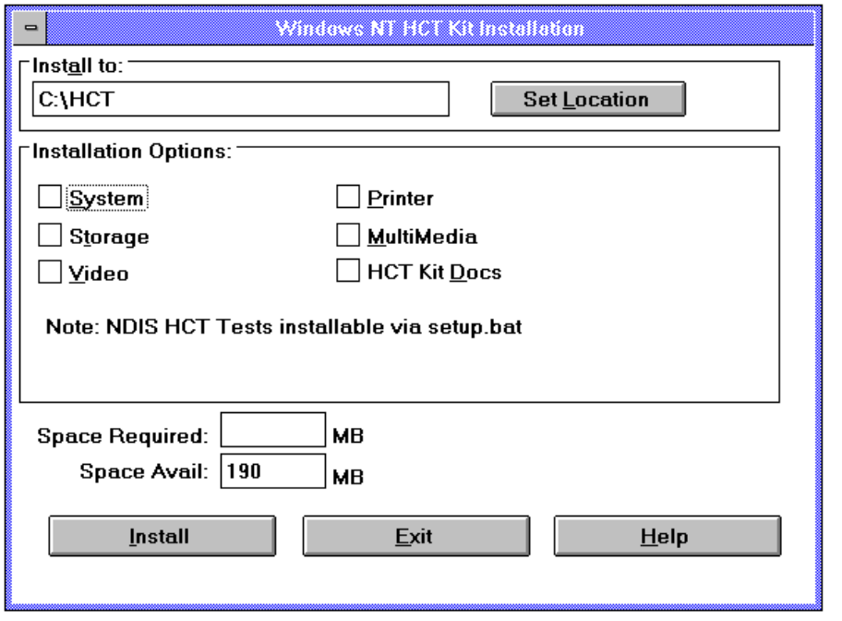
Figure 1.1 Windows NT HCT Kit Installation Dialog Box
In the Windows NT HCT Kit Installation dialog box, you can request help about the installation process by choosing the Help button.
You can quit the installation process at any time without installing tests by choosing the Exit button.
1.3.4 Completing the Configuration Worksheet
The first time you run the Test Manager, you need to provide information about your system hardware and software configuration. Table 1.6 shows the information you enter.
Each major section of the table corresponds to one configuration window. Many of the hardware configuration boxes are filled in automatically by the Test Manager.
For more information about entering configuration information, see Section 1.4.2, “Entering Configuration Information,” later in this chapter.

You must supply all requested information as completely and as accurately as possible. Microsoft uses this information to keep track of your machine’s configuration.
Note

Table 1.6 System Configuration Worksheet

Identification
Machine ID _______________________ | Product Name ___________________________

Install Information
Boot Media | Existing OS Configuration
_____ Setup Floppies | _____ None
_____ Boot Floppy + Setup CD | _____ MS-DOS
_____ Setup CD (R4X00) | _____ MS-DOS with LAN
_____ Setup CD (Alpha) | _____ MS Windows™ 3.1
_____ Custom MS-DOS + LAN Boot (x86) | _____ Windows 3.1 with LAN
_____ Existing Installed System | _____ OS/2 1.2, 1.3
Source for Setup Files | _____ OS/2 1.2, 1.3 w/ LM 2.1 Primary CD
_____ Floppies | _____ OS/2 1.2, 1.3 w/ LM 2.1 Backup CD
_____ CD | _____ OS/2 1.2, 1.3 w/ LM 2.1 Server
_____ LAN Share | _____ OS/2 1.2, 1.3 w/ LM 2.1 Workstation
_____ LAN Share + Machine Profile | _____ Windows NT
New OS Configuration | _____ Windows NT Advanced Server
_____ Windows NT AS for NT DC (Domain
Controller)
_____ Windows NT AS for NT Server
_____ Windows NT
_____ Maintenance Mode Setup
Record any install problems or comments:

Table 1.6 System Configuration Worksheet (continued)
General System Information
_____ MB RAM | _____ Cache | _____ # of Serial Ports | _____ # of Parallel Ports
Mouse |  | Keyboard
Manufacturer |  | Manufacturer
Model |  | Model
Number of Buttons |  | Style: _____ 84-key _____ 101/102-key
BIOS |  | Motherboard
Manufacturer |  | Manufacturer
Model |  | Model
Revision |  | Chip Set
Date |  | ROM BIOS
 |  | Bus Type
Shadowable? _____ Y _____ N

Processor Information
CPU | FPU
Manufacturer | Manufacturer
Model | Model
Speed (MHz) | Speed (MHz)
Step | Step
Number of Processors | Number of Processors

Video Information
Type | BIOS
Manufacturer | Manufacturer
Model | Model
Chip Set | Revision
KB RAM | Date
Resolution | Shadowable? _____ Y _____ N
Number of Colors

Table 1.6 System Configuration Worksheet (continued)
I/O Information
Adapters | Disks
Manufacturer/Model | Manufacturer/Model
Interface | Type
Bus | Fixed/Rem
Chip Set | Size (MB)
KB Cache
On Board? _____ Y _____ N
BIOS | Floppy Drives
Manufacturer | A B
Model | _____ 1.2 MB _____ 1.2 MB
Revision | _____ 1.44 MB _____ 1.44 MB
Date | _____ 2.88 MB _____ 2.88 MB
Shadowable? _____ Y _____ N

Network Adapter Information
Type ________________________
Manufacturer _________________
Model _______________________
Chipset ______________________
Bus _________________________

1.3.5 Preparing the Test Machine
After installing the HCT software, make sure that you have your test machine properly prepared to run the HCTs.
Û To prepare your test machine to run the system compatibility tests
1. Back up your hard disk partitions if they contain needed files.
Normally, you specify scratch partitions when running disk tests. If you specify partitions containing files, however, back up the files first.
2. Provide blank floppy disks and a loopback connector for running the tests. Check the Configuration section of each test description.

3. Verify that the FAT and NTFS hard disk partitions on which the disk tests are to run meet the minimum requirements listed in Table 1.5.
4. Reserve one floppy disk for recording test results.
For information about sending test results to Microsoft, see Section 1.4.8 later in this chapter.
5. To help debug any problems that might arise, connect a kernel debugger to each test machine. (This step is optional.)
See Appendix B for instructions about using the debugger.

1.4 The HCT Test Manager
The Test Manager is a 32-bit Windows application designed to run the compatibility tests and provide a quick summary of test results.
You start the majority of the HCT tests from the Test Manager. The exceptions are the NDIS Netcard Driver Test (Chapter 5), the Printer tests (Chapter 7), and several of the SCSI/Storage tests (Chapter 3), all of which you start from a command prompt session. See the appropriate chapter of this manual for information about those tests.
1.4.1 Starting the Test Manager
After you install the HCTs, the HCT Test Manager program icon resides in the Windows NT HCTs program group in the Windows NT Program Manager.
Û To start the Test Manager
1. Start Windows NT.
2. Switch to the Program Manager, and double-click the Windows NT HCTs group icon.
3. Double-click the Test Manager icon to start the testing program.

1.4.2 Entering Configuration Information
The first time you start the Test Manager it displays a series of windows which contain information boxes concerning the system ID, NT installation method, and hardware configuration. Many of these boxes are filled in automatically, but you need to provide additional information.
Each section of the worksheet shown in Table 1.6 corresponds to one of the windows described in the following sections.

1.4.2.1 Identification Window
This window requires you to provide a Machine ID and a Product Name.
The Machine ID is a name that you assign to your machine. Retain this name throughout the HCT program to help track the progress of your machine. The Machine ID must be fifteen characters or less and contain no spaces.
The Test Manager automatically completes the Machine ID field if you specified a machine name when you installed Windows NT or if you specified one at a later time.
The Product Name contains the manufacturer and model of the machine.

Type the marketed Product Name exactly as you want it to appear on the Windows NT HCL. It is very important that the product name you provide is the one under which the product is sold. If your system is already included on the HCL, verify that its name is correct. If the Product Name is incorrect, type the correct name and notify the HCT Group at Microsoft. For more information, see Section 1.4.8.
Note

You can later modify your entries for this window in the System Configuration window. From the View menu, choose the System Configuration command.
Choose the Continue button to move to the next window.
1.4.2.2 Install Information Window
The Install Information window provides feedback to Microsoft on the machine setup process. If you completed the System Configuration Worksheet (Table 1.6), the Install Information section of the worksheet contains the necessary information.
Select one option in each of the four categories listed to provide information about how you installed Windows NT. These categories are:
u Boot Media
Which method did you use to boot this machine to install Windows NT?
u Source for Setup Files
From where were the Windows NT system files installed?
u New OS Configuration
Which Windows NT configuration did you install?
u Existing OS Configuration
On what operating system did you install Windows NT?

Microsoft wants to expand its hardware coverage for setup testing and wants to know about any problems you find. Record them in the box at the bottom of the window.
You can return later to the Install Information window to modify your entries. From the View menu, choose the Install Information command.
Choose the Continue button to move to the next window.
1.4.2.3 System Configuration Window
The System Configuration window, shown in Figure 1.2, contains five buttons, each of which displays a dialog box. You must fill in all the information in each dialog box. Use the Tab key to move within each dialog box.
The System Configuration window also allows you to change the Machine ID and Product Name.
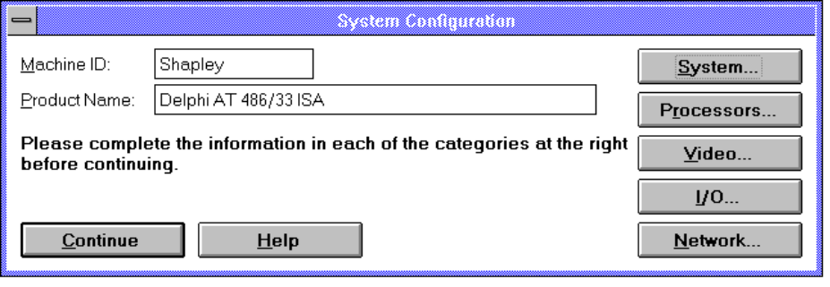
Figure 1.2 System Configuration Window
If you do not have all of the information necessary and must exit the Test Manager, choose Close from the Control-menu box (upper-left corner).
After you complete all five dialog boxes, choose the Continue button to return to the main Test Manager window. You can return later to the System Configuration window to modify your entries. From the View menu, choose the System Configuration command.
The five dialog boxes are described in the following sections.

It is important that you provide all requested information completely and accurately.
Note

General System Information

Enter details about the general configuration of the test machine.
Choose the Done button to return to the System Configuration window.

Processor Information
Enter details about the processors in the system. Multiprocessor support in Windows NT requires that all processors in the system be of exactly the same revision level. Enter the number of processors if you have more than one.
Choose the Done button to return to the System Configuration window.

Video Information
Enter information about the video subsystem that the machine uses.
Choose the Done button to return to the System Configuration window.

I/O Information
Enter information about all of the host bus adapters and hard disks in the machine. Use the list boxes to make your selections. You can enter up to eight adapters and up to eight hard disks.
Choose the Done button to return to the System Configuration window.

Network Adapter Information
Enter details about the model of the network interface card.
Choose the Done button to return to the System Configuration window.
1.4.3 Selecting the Tests
The Test Manager window is shown in Figure 1.3. It contains the following boxes:
u Available Tests
This box lists all the tests that you installed and which can be run under the Test Manager. Once a test is selected, it moves to the Selected Tests box. The Available Tests box also indicates the status of each test — Pass, Fail, or Not Run.
u Selected Tests
When you select a test, its name moves from the Available Tests box to this box. Tests are listed in the order you select them. This is also the order in which they execute.

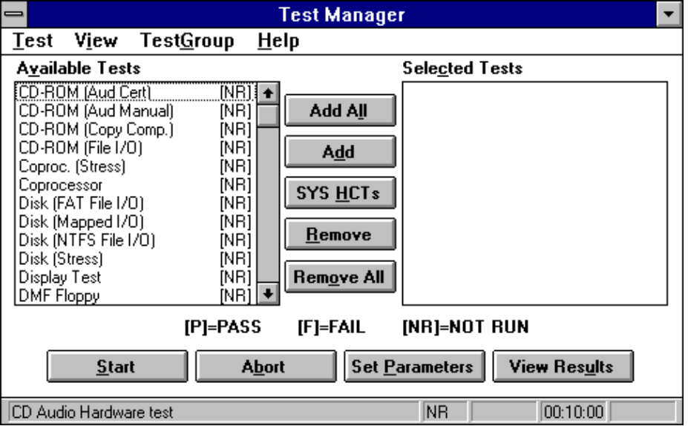
Figure 1.3 Test Manager Window
In the Test Manager window you select and remove tests to run, set parameters, start tests, and view results. The Available Tests box also indicates the status — either Pass, Fail, or Not Run — of each test.
Û To run a set of tests from the Test Manager window
1. Select the tests you want to run.
2. Set the parameters for each selected test.
3. Start the test run.
4. When the tests complete, view test results.

Û To select all available tests
• In the Test Manager window, choose the Add All button.
This moves all available tests to the Selected Tests box.

Û To select one or more available tests
• Double-click each test you want in the Available Tests box.
– Or –
Select each test by clicking once, and then choose the Add button to move the tests to the Selected Tests box.

Û To select only the tests necessary for system certification
• Choose the Sys HCTs button.

Û To remove a test
• In the Selected Tests box, select the test, and then choose the Remove button.

Û To remove all selected tests
• Choose the Remove All button.

You can also use the Test menu to select tests by category. System tests divide into Automatic, Manual, and Stress tests. Device tests divide into specific device categories.
The TestGroup menu allows you to save and load groups of frequently used tests. Select a group of tests, set the appropriate parameter settings, and then save that group to a file on disk using the Save Test Group File command on the TestGroup menu. Later, you can load the group of tests and parameters from the file using the Load Test Group File command.
You can run the tests individually or in groups, rather than running the entire set in a single session. If you select the manual tests first, you can then run the automated tests unattended.
If you are using the HCTs to include systems on the HCL, you need run only the system compatibility tests described in Chapter 2.
1.4.4 Setting Parameters
You need to set some parameters to ensure that the tests have access to the resources they need. If you don’t set the parameters properly, some tests fail. Read the appropriate sections of this manual to verify that you understand all parameters.
Parameters are automatically set correctly for most tests. In the Test Manager window, choose the Set Parameters button to review the parameters and make any necessary changes.
When you choose the Set Parameters button, a dialog box appears with the name and description of each selected test and a box for setting or changing test parameters. The Set Parameters dialog box is shown in Figure 1.4.

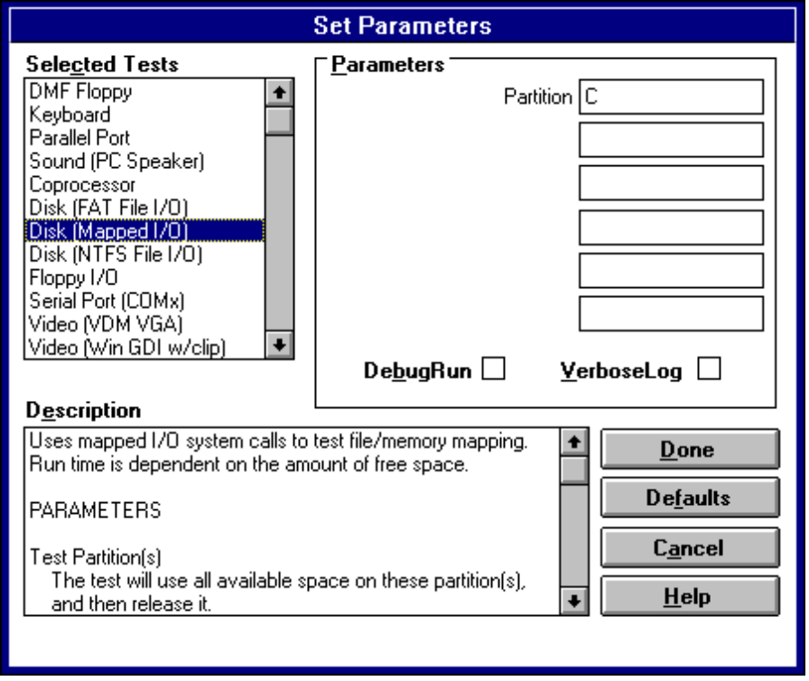
Figure 1.4 Set Parameters Dialog Box
To view or change test parameters, select the test name in the Selected Tests box. Each parameter required by that test appears in the Parameters box. To change a parameter, type a new value in the appropriate text box.
Some parameters accept a set of values, such as one or more disk partition names. If you want to include more than one value, type each value in a separate text box, as shown here:
FAT Test Partition | c:\
 | d:\

If you choose the Defaults button, the test parameters for all selected tests are set to their default values. (The test descriptions in the remainder of this manual show the boxes for required parameters with the default settings.)
When you've finished viewing or changing test parameters, choose the Done button.

1.4.4.1 DebugRun
Some tests provide for execution under a debugger. In this mode of operation, choosing the Start button in the Test Manager window causes a debug window to appear when the test starts. Use the debug window to control operation of the test. When the test completes, close the debug window to end the debugging session.
If a test can be executed under the debugger, the DebugRun button in the Set Parameters dialog box is available.
1.4.4.2 VerboseLog
All tests produce log files when they execute. You examine test log files by choosing the View Results button in the Test Manager window.
Some tests are capable of producing more extensive, or verbose, results. If a test can produce verbose logs, the VerboseLog button in the Set Parameters dialog box is available.

If you choose verbose logging, make certain that at least 2 MB of extra disk space is available for each test that is using verbose logging.
Note

1.4.5 Starting the Tests
Once you have set or verified the parameters for each test that you select, you can start the tests.
Û To start the HCTs
1. Plug in the serial loopback connector and insert blank floppy disks.
See Table 1.1 (and either Table 1.2 or Table 1.3) for connector specifications.
2. In the Test Manager window, choose the Start button.

The tests run one at a time, in the order in which the Selected Tests box displays them.
For manual tests, read the test description first, and then follow the on-screen instructions carefully. If a manual test fails, you are prompted to run it again. If it fails a second time, a FAIL result is logged, and the Test Manager runs the next test.
Richard: does
You may stop a test run before it ends by choosing the Abort button in the Test Manager window. (You cannot abort the System Stress test, however.)
Note

1.4.6 Viewing Test Results
The Test Results window appears when a test run finishes or is aborted. This window lists every selected test and its status — either Pass, Fail, or Not Run.
Verify that all tests ran and passed.
If a test fails, you can check the detailed results by selecting the test name in the Test Results window, and then choosing the Details button. This displays the test log file. Use the arrow keys to scroll through the log. To exit the log file, type q at the command prompt or press the esc key.
There is a separate log file for each test. The system always saves the log file from the last run of each test. If you rerun a test, the old log file is overwritten. When you are done, choose the OK button to return to the Test Manager window.

If the system crashes during a test run, look at the log file called LASTRUN.LOG in the \HCT directory. It contains a list of the tests that ran up to the point of the crash. This shows you which test was running when the system crashed. If you are using the kernel debugger, the debug machine also displays the name of the test that was running when the crash occurred.
Note

1.4.7 Qualifying for the HCL
To qualify for the HCL, your system must pass all the system compatibility tests. For a list of these tests, see Chapter 2.
Each system must pass its own set of HCTs. Each system with a different CPU, I/O adapters, or other hardware requires a separate test return.
1.4.8 Returning Final Results
When the tests are complete, log the results and return them to Microsoft.
Û To log and return the results
1. Insert a blank, formatted disk into drive A.
If you have a 1.44 MB, 3.5 -inch drive available, then the button for the 5.25-inch drive is unavailable. This forces the results to the 1.44 MB drive.
2. From the Test menu, choose Return Test Results.
If your testing is incomplete (some tests have not run or were not successful), a message box appears with a list of the incomplete tests. Choose Cancel to terminate Return Test Results, or choose Continue to ignore the incomplete condition.
3. Select the drive to receive the results.

4. Complete the usability survey as shown in Figure 1.5. Include clear, specific details of what you liked and did not like about the HCT kit.
5. Label the disk with your company name, machine ID, product name, and the date.
6. Mail the disk to:
Windows NT Hardware Compatibility Test
Microsoft Corporation
One Microsoft Way
Redmond, WA 98052-6399
USA
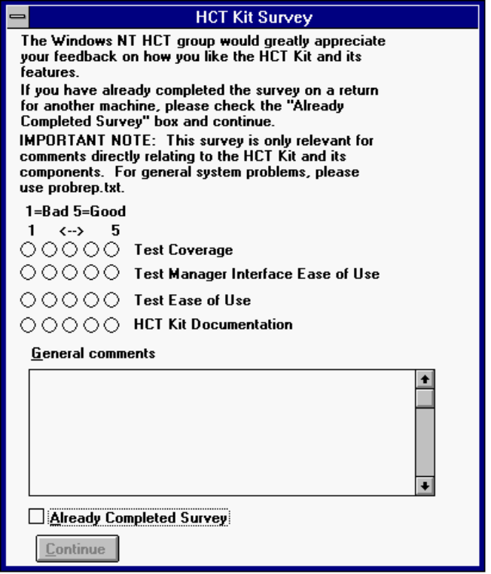
Figure 1.5 HCT Usability Survey

