Chapter 1
3.1 Overview
SCSI/Storage Tests
This chapter describes optional tests for checking storage device drivers. Some tests are designed specifically for SCSI miniport and device drivers, while others are more generic.
Some of the tests in this chapter run under the HCT Test Manager; others provide their own interfaces. For more information about the Test Manager, see Chapter 1, “Overview.”
The following tests are described in this chapter:
u CD-ROM (Copy Compare)
u CD-ROM (File I/O)
u Fault Tolerance
u Manual Drive Change
u Tape Backup/Restore
u Tape Functionality

Additional storage device tests are listed in the table below, along with the chapter in which each is described.
Test | Chapter
CD-ROM (CD Audio Manual) | Chapter 6
CD-ROM (CD Audio Cert) | Chapter 6
Disk (FAT File I/O) | Chapter 2
Disk (Mapped I/O) | Chapter 2
Disk (NTFS File I/O) | Chapter 2
Disk (Stress) | Chapter 2
DMF Floppy | Chapter 2
Floppy I/O | Chapter 2
To confirm system compatibility and qualify for the HCL, you need run only the tests listed in Chapter 2, “System Hardware Compatibility Tests.”

With the exception of the fault tolerance tests, install the SCSI/Storage tests by selecting the SCSI/Storage option during installation of the HCTs. For more information about installation, see Section 1.3, “Setting Up the HCTs,” in Chapter 1. For information about installing the fault tolerance tests, see Section 3.2.3, “Fault Tolerance,” later in this chapter.
Installation
3.2 Individual Test Descriptions
This section describes the purpose of each SCSI/Storage test and explains how to run it. For information about using the Test Manager, see Chapter 1.
3.2.1 CD-ROM (Copy Compare)
Type: | Automatic
Log filename: | cdtest.log
Processing time: | Approximately 20 minutes

This test uses XCOPY.EXE to copy and compare various amounts of data from a CD-ROM drive to a hard disk.

Parameters
Specify a CD-ROM drive and a hard disk.

Configuration
Insert the HCT or DDK CD-ROM in the CD-ROM drive being tested.
The target hard disk must have approximately 10 MB of disk space available.

Recommendations
Select the VerboseLog option if you want enhanced logfile information.
Good test coverage for a SCSI miniport driver includes testing between a CD-ROM drive and a hard disk connected to the same SCSI Host Bus Adapter. Another important case includes the hard drive and CD-ROM connected to different SCSI Host Bus Adapters.
If the test fails, check the log file for a list of files that do not match.
Û To verify that data copies correctly from a CD-ROM to a hard disk

1. Verify that you have a CD-ROM drive with an HCT or DDK CD-ROM disk inserted.
2. In the Test Manager window, choose the Set Parameters button.
3. In the Selected Tests box, select CD-ROM (Copy Compare).
4. Under Parameters, type the drive letter of the CD-ROM drive you want to test, including a trailing colon (:), and the drive letter of the target hard drive, including a trailing colon (:), as shown here:
CD-ROM Drive | f:
Hard Disk | e:

5. Choose the Done button to return to the Test Manager window, and start the test.

3.2.2 CD-ROM (File I/O)
Type: | Automatic
Log filename: | cdrom1.log
Processing time: | Approximately 1 hour

This test verifies that various API-level file I/O calls work on a CD-ROM file system.

Parameters
Specify the CD-ROM drive you want to test.

Configuration
This test requires one CD-ROM drive.
The HCT or the DDK CD-ROM must be inserted in the CD-ROM drive.

Recommendations
Select the VerboseLog option if you want enhanced logfile information.
Select the DebugRun option if you want to use the debugger.

Û To test file I/O calls on a CD-ROM
1. Verify that you have a CD-ROM drive with an HCT or DDK CD-ROM disk inserted.
2. In the Test Manager window, choose the Set Parameters button.
3. In the Selected Tests box, select CD-ROM (File I/O).
4. Under Parameters, type the drive letter of the CD-ROM drive you want to test, including a trailing colon (:), as shown here:
Test Drive | f:

5. Choose the Done button to return to the Test Manager window, and start the test.

3.2.3 Fault Tolerance
Type: | Automatic
Log filename: | See “Examining Test Results” at the end of this section.
Processing time: | Approximately 48 hours

The fault tolerance tests produce extensive I/O stress on SCSI host bus adapters. They use fault tolerance initialization with multiple target drive activity. You select the controllers to use, or you can let the fault tolerance tests determine the configuration. These tests include:
u Copy On Boot Mirror
u Extended Volume Set
u Fresh Mirror
u Simple Partition
u Stripe With Parity
u Stripe Without Parity
u Volume Set

Complete execution of the fault tolerance tests takes approximately 2 days.
The installation procedures described in Chapter 1 do not install the fault tolerance tests. The \hct\tests\ft directory on the HCT CD-ROM disk contains a special installation program.

Û To install the fault tolerance tests
1. Start a command prompt session, and change to the \hct\tests\ft directory on the HCT CD-ROM.
2. Type
install CPU DriveLetter:

where CPU is x86, MIPS, Alpha, or PPC
and
DriveLetter (followed by a colon) is the drive letter of the hard disk where you are installing the tests. You must type both parameters. There are no default values.

This procedure creates a directory named \ft on the specified drive and copies proper binaries for the specified CPU type.

Configuration
The test machine must have three disk drives, with at least 300 MB of unpartitioned free space on each drive, and must be running Windows NT Advanced Server.
The fault tolerance tests reboot the machine after altering the disk configuration. Because the machine reboots, the test must be able to log on automatically. Make sure you set the desired operating system for start up.
To enable automatic log on, start the tests under an account with no password. Since the tests run Disk Administrator, the account must also be a member of the Administrators group. The simplest options are to log on as Administrator and remove the password, or to create a local account and assign it to the Administrators group with no password.
To verify the default operating system for startup, switch to the Windows NT Control Panel and double-click the System icon. The operating system you want to use for testing should appear in the Startup box; a value of 30 seconds should appear in the Show List For box.

Û To run the fault tolerance tests
1. Start a command prompt session, change to the directory where you installed the program FTtest, and type
start fttest

The FTtest window appears, as shown in Figure 3.1.
2. From the Configuration menu, choose Open.
The Load Config File dialog box appears.
3. In the PathName box, type
.\hct.run

and choose the OK button.
This loads the default parameters for each test and moves configured tests into the Run List box.
4. In the FTtest window, choose the Edit Run button. (This step is optional.)
In each of the seven dialog boxes that appear successively, set test parameters. Choose the OK button to move to the next dialog box. When you finish with the final dialog box, choosing the OK button returns you to the FTtest window.
5. In the FTtest window, choose the Run button.
The Config Option dialog box appears.
6. In the Use Controllers box, select each appropriate disk controller.
This list applies only to the ‘Each Controller’ or the ‘Choose Controllers’ parameters specified in step 4. If you default to ‘Any Controller,’ the test uses the first disk controller(s) that meet all the other test requirements.
7. In the Language File box, type:
.\english.lan

8. Under Additional Options, select desired options for the test runs.
9. Choose the OK button to start the test run.
– Or –
Choose the Cancel button to return to the FTtest window.

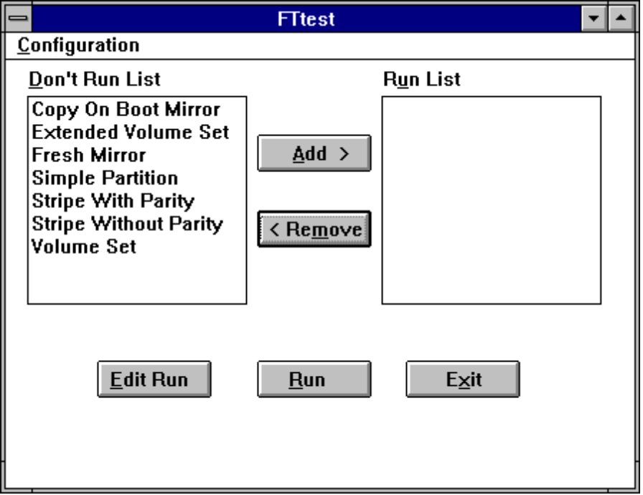
Figure 3.1 FTtest Window

Examining Test Results
The fault tolerance tests generate the following log files.
Log file | Test
cbtm.log | Copy On Boot Mirror
frshm.log | Fresh Mirror
part.log | Simple Partition
strwp.log | Stripe With Parity
strwop.log | Stripe Without Parity
VOLSET.log | Volume Set
EXTvol.log | Extended Volume Set

To produce a report from these log files, start a command prompt session and type
start getstats.cmd 351

where 351 represents the version number of Windows NT (in this case, version 3.51).

3.2.4 Manual Drive Change
Type: | Manual
Log filename: | Manual.log
Processing time: | Approximately 2 minutes

This test compares two removable media of the same type to verify that Windows NT detects media changes in that drive. Removable media include CD-ROM drives, floppy disk drives, and cartridge hard drives.

Parameters
Select a disk drive with removable media.

Configuration
Ensure that the root directory and label of the replacement media are different. Otherwise, the test fails. For example, testing two identical CD-ROM disks causes a failure.

Recommendations
Select the DebugRun option if you want to run with the debugger.
If the test fails, you can verify the results manually by switching to the File Manager and checking the directories on both media. If the File Manager shows a media change, run the test again.
Û To compare two removable media
1. Insert the first media into the test drive.
2. In the Test Manager window, choose the Set Parameters button.
3. In the Selected Tests box, select Manual Drive Change.
4. Under Parameters, type the drive letter of the test drive, including a trailing colon (:), as shown here:
Test Partition | a:

5. Choose the Done button to return to the Test Manager window, and start the test.

The test reads the current media in the drive, and then prompts for the insertion of a different media. The test compares the replacement media to the original media. If it determines that the original and replacement media are different, the test passes. Otherwise, the test fails. If you specify two or more drives, and the test for one drive fails, the report for the entire test is FAIL.

Always run this test in the foreground. If you perform any action that puts this test in the background, the test fails.
Note

3.2.5 Tape Backup/Restore
Type: | Automatic
Log filename: | bkuphct.log
Processing time: | Approximately 2 hours

This test checks the NTBACKUP utility. It first creates a tree of data files starting at the drive and path that you specify. Then it backs up the tree of files to the tape, restores the files, and compares the checksums of the original and restored file trees.
You can also specify up to four additional drive partitions. For these drives, the test backs up the entire partition and then verifies with the original files, without restoring the files.

Parameters
This test has the following three parameters:
u The partition and path in which the test creates data to be backed up. The default path is \TAPETREE.
u The number of MB to use for creating backup data. The default is 50 MB.
u The names of up to four optional, additional partitions to use for creating backup data.

Configuration
The test requires one tape drive and at least one hard disk drive. The disk drive must have at least 50 MB of free space.
Û To test the tape backup utility
1. Determine the amount of free space available on the hard disk that you want to receive the restored files.
2. In the Test Manager window, choose the Set Parameters button.
3. In the Selected Tests box, select Tape Backup/Restore.
4. Under Parameters, type the drive letter and path of the data drive (where the test creates the data to back up and to which the test restores the data) including a trailing colon (:), as shown here:
Data Drive:\Path | d:\tapetree

Do not specify an existing directory path.

5. Type the number of MB to use on the data drive, as shown here:
MB To Use on Data Drive | 50

6. Type drive letters for up to four backup drives (from which the test backs up the data), including a trailing colon (:), as shown here:
Addit. Backup Drv1 | e:

7. Choose the Done button to return to the Test Manager window, and start the test.

3.2.6 Tape Functionality
Type: | Automatic
Log filename: | TAPEAPI.log
Processing time: | Approximately 15 minutes

This test verifies that the functions of a tape drive are working correctly. First it queries the drive to determine its supported functionality. Then the test checks each reported function to confirm that it is fully supported.

Parameters
None.

Configuration
The test requires one tape drive with a tape loaded. The appropriate tape driver must also be installed.

Recommendations
Select the DebugRun option if you want to run with the debugger.
If the test fails, examine the log file. All tape operations are logged in Win32 API format.

3.2.6.1 Testing Methods
The following sections describe the methods used to test various functions
of the tape drive. To determine which of these functions is supported,
the test calls the GetTapeParameters API function to get the TAPE_GET_DRIVE_PARAMETERS structure. It then checks the
FeaturesLow and FeaturesHigh structure fields.

Block Mode Functionality

If TAPE_DRIVER_VARIABLE_BLOCK is set in FeaturesLow, the test sets the drive to variable block mode and writes several variable blocks. It then attempts to read back the blocks as smaller than, equal to, and larger than the size written.
If TAPE_DRIVER_SET_BLOCK_SIZE is set in FeaturesHigh, the test sets the block size to several different values. For each block size, it reads and writes several blocks. Block sizes tested include DefaultBlockSize, MinimumBlockSize, MaximumBlockSize, and several other sizes that may or may not be multiples of 512.

Positioning Functionality
First the test writes a set of data blocks to the tape. Each block has a unique pattern. Then, using each supported positioning method (as indicated in FeaturesHigh), the test moves the tape to different positions and checks the data pattern to determine whether the position is correct. The following positioning methods are tested:
u TAPE_DRIVE_LOGICAL_BLK
u TAPE_DRIVE_LOG_BLK_IMMED
u TAPE_DRIVE_ABSOLUTE_BLK
u TAPE_DRIVE_ABS_BLK_IMMED
u TAPE_DRIVE_RELATIVE_BLKS
u TAPE_DRIVE_REWIND_IMMEDIATE
u TAPE_DRIVE_END_OF_DATA
u TAPE_DRIVE_REVERSE_POSITION

Tape Mark Functionality
The test checks each type of supported tape mark (as indicated in FeaturesHigh). It writes several marks of each supported type on the tape, separated by data blocks containing unique patterns. If TAPE_DRIVE_WRITE_MARK_IMMED is set in FeaturesHigh, the test repeats with Immediate mode enabled. The following types of marks are tested:
u TAPE_DRIVE_WRITE_SHORT_FMKS
u TAPE_DRIVE_WRITE_LONG_FMKS
u TAPE_DRIVE_WRITE_FILEMARKS
u TAPE_DRIVE_WRITE_SETMARKS

Next, the test checks spacing to tape marks, using all supported spacing
methods (as indicated in FeaturesHigh). The test spaces to each tape mark and then reads the data pattern to see whether the position is correct. If TAPE_DRIVE_SPACE_IMMEDIATE is set in FeaturesHigh, the test repeats with Immediate mode enabled. The following types of spacing are tested:

u TAPE_DRIVE_SETMARKS
u TAPE_DRIVE_FILEMARKS
u TAPE_DRIVE_SEQUENTIAL_FMKS
u TAPE_DRIVE_SEQUENTIAL_SMKS

Erase Functionality
The test writes some data and then erases it. It uses the TAPE_DRIVE_ERASE_SHORT and TAPE_DRIVE_ERASE_LONG methods, if the drive supports them (as indicated in FeaturesLow).
If TAPE_DRIVE_ERASE_IMMEDIATE is set in FeaturesLow, the test repeats with Immediate mode enabled.
If TAPE_DRIVE_ERASE_BOP_ONLY is not set in FeaturesLow, the test erases in the middle of some data and then checks that the preceding data still exists.

Setting Features
The test attempts to enable and disable certain supported features (as indicated in FeaturesHigh). The only feature whose operation can be confirmed is TAPE_DRIVE_SET_REPORT_SMKS. For other features, the test only checks the ability to enable and disable them. The following features are checked:
u TAPE_DRIVE_SET_COMPRESSION
u TAPE_DRIVE_SET_ECC
u TAPE_DRIVE_SET_PADDING
u TAPE_DRIVE_SET_REPORT_SMKS

3.2.6.2 Calling Tape API Functions Manually
To assist you in debugging errors, you can call individual tape API functions manually.
Û To call individual tape API functions manually
1. At the command prompt, change to the directory containing the tape tests. For example:
cd \hct\tests\tape

2. To run the program DTAPE.EXE, type

dtape

When you type a question mark (?) at the command prompt, the program displays a list of all available operations, as shown in Figure 3.2.
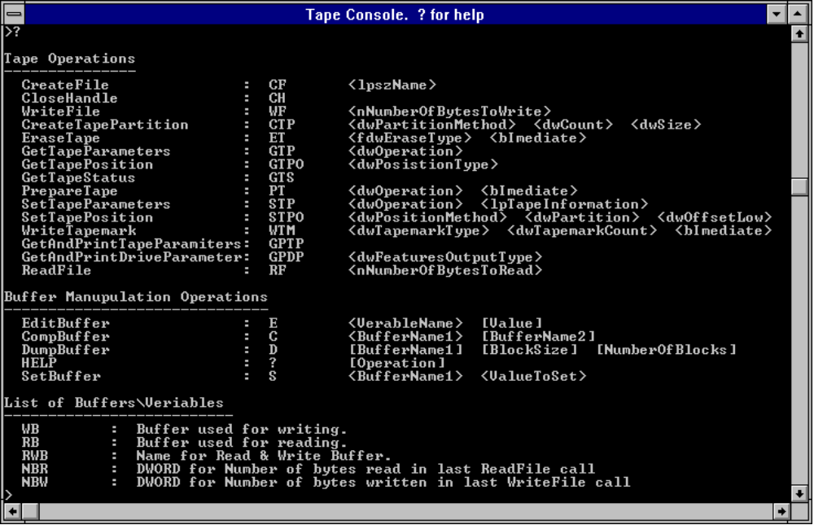
Figure 3.2 Tape Console Help Display
The tape API function help display is divided into the three sections, which are described in the following sections.

Tape Operations
This section shown in Figure 3.2 lists the available API functions. The name of each function is followed by a two-letter abbreviation and a list of parameters.
To call one of these functions, type the function abbreviation at the command prompt, followed by appropriate arguments. For example, to call the CreateFile function to open the first tape drive, type
cf \\.\tape0
You can obtain additional information about each API function parameter list by typing a question mark (?), followed by the function abbreviation. For example

? STP

displays information about the parameter list for SetTapeParameters.

Buffer Manipulation Operations
This section of the help display shows operations you can perform on a set of pre-defined buffers. These operations edit, compare, dump, and set the values of the buffers.

List of Buffers and Variables
This section lists a set of pre-defined buffers and variables. Use the commands in the Buffer Manipulation Operations section to view or modify the contents of these buffers and variables. The buffers are large enough to handle all tape operations.
For example, to write “5” to every byte of the write buffer, type
s wb 5

The following example shows how you can use the program to write a buffer to the beginning of the tape and then to read back the written data.
1. Before beginning any operations, open the tape drive. For example:
cf \\.\tape0

2. Fill the write buffer with bytes of the numeral 3:
s wb 3

3. Write 512 bytes to the tape, using the WriteFile API function:
wf 512

4. Rewind tape to beginning of write position (complete rewind):
stpo tape_rewind 0 0 0 0

5. To read the buffer back from the tape using the ReadFile API function, type
rf 512

6. To view the contents of the read buffer, type the dump command:
d rb

Type d several times to view the entire buffer.

