Chapter 1
6.1 Overview
Multimedia Tests
This chapter describes the optional tests for testing multimedia configurations. A subset of these tests runs under the HCT Test Manager; however, all of the multimedia tests are accessible through another user interface, the Multimedia Test Shell.
The following tests are described in this chapter:
u CD-ROM (CD Audio Manual)
u CD-ROM (CD Audio Cert)
u Multimedia (MIDI Input)
u Multimedia (MIDI Output)
u Multimedia (Wave Input)
u Multimedia (Wave Output)
u Multimedia (Wave Sanity)

Two additional tests can be used for multimedia testing. They are described in Chapter 3, “SCSI/Storage Tests.”
u CD-ROM (Copy Compare)
u CD-ROM (File I/O)

This chapter first describes most of the automated multimedia test scenarios available under the HCT Test Manager. It then describes the common user interface for the multimedia test applications, and concludes with a section on the individual test executables.
To install these tests, select the MultiMedia option during installation of the HCTs. For more information about installation, see Section 1.3, “Setting Up the HCTs,” in Chapter 1.
Installation
6.2 Individual Test Descriptions

Execute these tests from the Test Manager the first time you run them. If you prefer to run them individually, read Section 6.3, “Using the Multimedia Test Shell,” and Section 6.4, “Multimedia Test Executables,” before you begin.
6.2.1 CD-ROM (CD Audio Manual)
Type: | Manual
Log filename: | mcicdmnl.log
Processing time: | Approximately 5 minutes

The manual CD-Audio test uses the MCI interface to play CD audio tracks interactively. It verifies that the API return values correspond to the actual state of the CD-ROM device, and that the basic functions (playing, seeking, pausing, stopping, opening, and closing) are working.

Configuration
Insert a DDK or HCT CD-ROM in the drive used by MCI CD-Audio commands.
Connect either earphones or speakers to the audio output of your CD-ROM drive.
If you have more than one CD-ROM connected to your system, the test uses the default unit.
Û To change the default CD-ROM unit
1. Switch to the Windows NT Control Panel.
2. Click the Drivers icon.
3. In the Installed Drivers box, select [MCI] CD Audio.
4. Choose the Setup button.
5. Choose the drive letter of the new default unit.

Recommendations
The manual tests require you to respond to a series of Yes-or-No questions as you listen to the audio output and observe the log output on the screen. Yes is always considered the correct answer, and No is a failure. When the test asks whether something is visible or shown, the information is usually present in the last line logged in the test logging window.
The manual verification dialog boxes ask for track numbers. These numbers appear in the last line of messages in the main window, as shown in the following example:

mciSendStringW(0xblahbla1, 0xblahbla2, hex, 0x0) = 0
0xblahbla1 = 'status Alias1 position' [Unicode]
0xblahbla2 = '01:00:00:04' [Unicode]

In this case, '01:00:00:04' corresponds to the current TMSF position on the CD-ROM, where the track position is track 1 (the first group of digits in the number string).

Examining Test Results
Occasionally, CD-Audio tests fail when the behavior exhibited is actually satisfactory. Read the log files to determine whether failures are genuine problems or simply timing issues.
Test logging generally consists of the API function call and return value, the executed command, and the string return value for the command; these appear on three consecutive lines. Behavior of the different MCI commands is described in the manuals provided with the Microsoft Windows DDK and SDK. The log file contains enough information to make finding problems easy for someone familiar with MCI.

Logging is done after the API function is executed. If the system crashes in the middle of an MCI API function call, the lines for that command do not appear in the log.
Note

For manual verification of results, MCIERR_HARDWARE is sometimes an acceptable return value for file I/O operations.
6.2.2 CD-ROM (CD Audio Cert)
Type: | Automatic
Log filename: | mcicdfl.log
Processing time: | Approximately 10 minutes

The automatic CD-Audio test uses the MCI interface to play CD audio tracks automatically. It uses all functionality present in the MCI CD-Audio interface that affects the CD-ROM driver. Different operations are tried from different states. For example, seeking is done when the CD-ROM is playing, when it is stopped, and when it is paused. The mcicert.txt test script shows which commands are executed and what results are expected.

Configuration
These tests require you to insert a DDK or HCT CD-ROM in the drive used by MCI CD-Audio commands.

If you have more than one CD-ROM connected to your system, the test uses the default unit.
Û To change the default CD-ROM unit
1. Switch to the Windows NT Control Panel.
2. Click the Drivers icon.
3. In the Installed Drivers box, select [MCI] CD Audio.
4. Choose the Setup button.
5. Choose the name of the new default unit.

Recommendations
Make certain the HCT CD-ROM is in the CD-ROM drive. If you have problems, use MPlayer or CDPlayer to verify that the CD-ROM is visible as a CD-Audio device. You need not listen for audio output during this test.

Examining Test Results
Occasionally, CD-Audio tests fail when the behavior exhibited is actually satisfactory. Read through the log files and check to see whether failures are genuine problems or simply timing issues. For more information about these audio tests, see Section 6.2.1, “CD-ROM (CD Audio Manual),” earlier in this chapter.
6.2.3 Multimedia (MIDI Input)
Type: | Automatic
Log filename: | minddk.log
Processing time: | Approximately 3 minutes

The MIDI Input test simply exercises the MIDIIn... APIs. Driver writers should note the values returned to their software by MIDIInGetNumDevs and MIDIInGetDevCaps.
Use the MIDI Input test only on MIDI devices that have external MIDI-IN and MIDI-OUT ports.
The MIDIInAddBuffer recording test attempts to open both an input and an output device, and requires that the MIDI output be routed back into the MIDI input so the data can be recorded. If neither of these devices is present, the test case terminates.

If both of these devices are present, a 50K system-exclusive message is played and recorded into 5K buffers. After the message has played, the input buffers are compared with the original output buffer. If a discrepancy is found, the bytes that do not match (along with the 10 bytes that precede them) are logged, and buffer checking is terminated.

Configuration
All MIDI tests require that an appropriate driver be loaded and configured before the tests start. A dialog box appears if a driver is not installed.
A MIDI patch box must be cabled to the ports to provide a loopback. The tests fail if the loopback connection is not present.

This test is written for a synchronous driver. It does not work for an asynchronous driver.
Note

6.2.4 Multimedia (MIDI Output)
Type: | Manual
Log filename: | moutddk.log
Processing time: | Approximately 3 minutes

The MIDI Output test makes valid calls to each MIDIOut API, beginning with MIDIOutGetNumDevs and MIDIOutGetDevCaps. Pay close attention to the values returned in the MIDIOUTCAPS structure.
Minimum valid calls are made to MIDIOutOpen, MIDIOutPrepareHeader, and MIDIOutUnprepareHeader. All relevant values are logged, and no user interaction is required.
The test cases for MIDIOutShortMessage begin with two cases that send NoteOn messages ascending the chromatic scale. The second of these initial cases uses running status format. The next 21 cases send each valid MIDIOutShortMsg status byte with all valid combinations of data bytes. In some cases, such as NoteOn, this consists of 218 messages; in other cases, there is only one message, such as Active Sensing.
The upper limits for the channel and two data-byte arguments are logged to the test application window at the beginning of the test case. The first message for each channel is also logged to the window to give the operator an indication of the progress of the test.

Configuration
All MIDI tests require that an appropriate driver be loaded and configured before the tests begin. If a driver is not installed, a dialog box appears. These tests apply to both external MIDI ports and internal MIDI synthesizers. Make certain that you have a MIDI output device connected to your sound card.

Recommendations
Use mouttst.exe to test the transmission and recording of system-exclusive data. The test runs automatically until it reaches the last two test cases. These require answers to two questions while you listen to the MIDI output of your sound card; they use less than a minute of the test’s total running time. You can let the tests sit indefinitely before answering the questions in the message boxes.
These last two test cases turn on all notes on all channels, and then call MIDIOutReset for internal and external devices. The cases pass or fail depending on the operator’s response in the “Were all notes turned off?” message box.

Without an external MIDI device, case #30 logs a BADDEVICEID message but returns PASS.
Note

6.2.5 Waveform I/O Test Suite
The multimedia tests include a suite of three Waveform I/O tests. Specific information about the tests follows the general information about all three tests.

Configuration
All three tests require a properly installed and configured wave I/O device.
The tests also require a microphone and speakers (or headphones). Some tests require large amounts of input data (2 minutes or more), so it may be helpful to have a radio or CD player near your microphone.

Recommendations
The tests use Yes-or-No dialog boxes to query the user for information. This information is usually either a prompt to start playback or recording, or a query regarding what you heard.
Because of the way the application processes messages, it is important that the focus remain in the test application window. You obtain inconsistent results if you switch to another window.
The ESC key cancels the current test case even if the case has actually passed.

The waveOutGetDevCaps test verifies the capabilities of the driver with information from a file called wavedrv.ini. This file contains valid information for a SoundBlaster Pro, including volume changes. You can customize this file as required.

Examining Test Results
The log files provide more detail about each API function call. Each Wave API call is logged, including the parameters and return codes. For someone familiar with the Wave APIs, these log files provide information that simplifies finding problems.

Logging is done after the API function is executed. If the system crashes in the middle of an API function call, little or no information about that call appears in the log.
Note

6.2.5.1 Multimedia (Wave Input)
Type: | Manual
Log filename: | wavin.log
Processing time: | Approximately 5 minutes

The Wave Input test exercises most of the Wave Input API functions, and most of the verification is done automatically through API return values. Some tests require user interaction.
6.2.5.2 Multimedia (Wave Output)
Type: | Manual
Log filename: | wavout.log
Processing time: | Approximately 10 minutes

The Wave Output test exercises most of the Wave Output API functions, and most of the verification is done automatically through API return values. Some tests ask whether the user heard a specific sound, or whether the sound was interrupted.

6.2.5.3 Multimedia (Wave Sanity)
Type: | Manual
Log filename: | wavsc.log
Processing time: | Approximately 20 minutes

The Wave Sanity test runs a series of record and playback sanity checks. This test requires several minutes of audio input, so it may be helpful to have a radio or CD player near your microphone. The test asks you whether the recorded audio plays back correctly.
6.3 Using the Multimedia Test Shell
Besides running multimedia tests under the Test Manager, you can run them using the Multimedia Test Shell. This interface allows you to run the multimedia executable files directly. You can access more testing capabilities under the Test Shell than under the Test Manager.
This section documents the basic features of the Test Shell interface. The information in this section applies to all of the multimedia test applications.
The test applications are contained in four executable files. These files are:
u MCIGEN.EXE
u MINTST.EXE
u MOUTTST.EXE
u WAVETST.EXE

The tests are described in Section 6.4, “Multimedia Test Executables,” later in this chapter.
6.3.1 Starting Test Shell Applications
You can run Test Shell applications either interactively or automatically. If you run them interactively, you must use the Test Shell menus to set up and run the tests. If you run the tests automatically, test set-up information is loaded from profile files, either provided with the HCT kit or created by you.
6.3.1.1 Running a Test Shell Application Interactively
When you run a Test Shell application interactively, the Test Shell displays its main window and then waits for your input. Use the Test Shell menus described in the following sections to set up your testing configuration and then run the tests. You can save your configuration in a profile file for later use.

To start an application interactively, change to the multimedia subdirectory and then type the name of the application at the command prompt. For example, to start the MIDI input test application interactively, type:
cd \hct\tests\mm
mintst

6.3.1.2 Running a Test Shell Application Automatically
When you run a Test Shell application automatically, the application reads configuration information from a profile file and then runs the tests without your intervention. After the tests finish, the results are written in the log file MCICDFL.LOG. Within five lines of the end of the log file, a line reads PASS or FAIL.
To start an application automatically, change to the multimedia subdirectory and then type the name of the application at the command prompt. You must include the -g and -p qualifiers with the name of a profile file. The profile filename must include a period and backslash(.\). For example, to start the MCI interface test application with one of its profiles, type:
cd \hct\tests\mm
mcigen -g -p .\mcicdfl.pro

6.3.2 Using Test Shell Core Menus
Test Shell application menus consist of two core menus, a help menu, and additional custom menus for each test. The core menus are described in the following table:
File menu | Allows you to load and save profiles, and to exit the test application.
Test menu | Allows you to configure the tests correctly. You log characteristics, select test cases, and configure the environment using this menu.

Some test executables ignore the resource path and run modes that can be set with the Test menu.
Note

Section 6.4, “Multimedia Test Executables,” discusses the custom menus particular to each test application.

6.3.2.1 The File Menu
The File menu loads and saves profiles. A profile is a file that contains information on test-case selection, logfile options, and run-time parameters. One or more profiles has been generated for each test application, so you can test a set of functionality for a given driver without having to delve into the workings of the test.

Load Profile
The Load Profile command loads a profile. A dialog box appears in which you select the profile you want to load. The list of profiles includes those provided with the HCT kit and any you have created. After a profile is loaded, you run it by choosing the Run Tests command from the Test menu.

Save Profile, Save Profile As
The profiles provided with the multimedia test suite do not meet everyone’s needs. The Save Profile and Save Profile As commands allow you to save the state of the core menu options for a given test executable. If you do not save the profile, you must configure the custom options for that test application each time you run it.
To save a profile, first configure the options the way you want them using the commands on the Test menu. Then choose the Save Profile As command from the File menu and provide a profile filename. If you make changes to the options and want to update the profile in the current file, choose the Save Profile command instead.

Exit
To exit from a test application, choose the Exit command.
6.3.2.2 The Test Menu
The Test menu contains the commands to select and run different test cases from each test executable. These commands are discussed in detail below.

Set Input/Output Paths
Some tests read and/or write files. For example, wavetst.exe requires several .wav files and a data file that enumerates the characteristics of the wave device being tested.
The Set Input/Output Paths command on the Test menu opens a dialog box in which you specify the path to those files, as shown in Figure 6.1. The default value for the input and output path is the current working directory. To change the resource paths, type new paths in the text boxes and then choose the OK button.
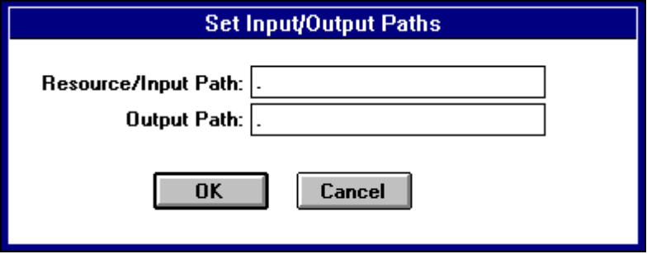

Figure 6.1 Set Input/Output Paths Dialog Box

Select Tests
The Select Tests command opens a large dialog box. The following illustration shows an example from a version of mcigen.exe.
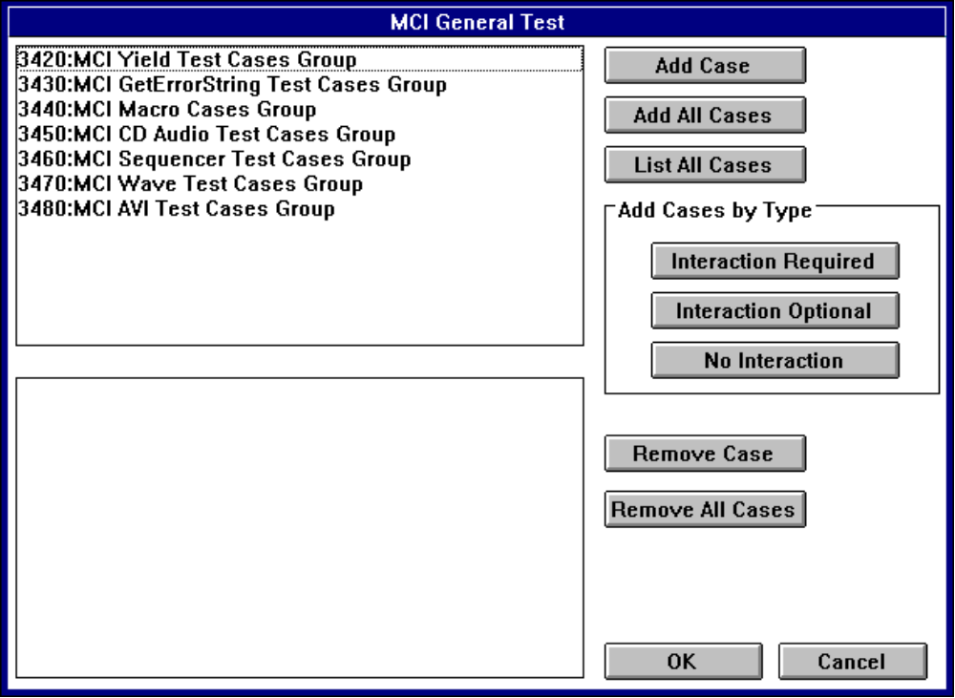
Figure 6.2 Select Tests Dialog Box for MCIGEN.EXE.

The most important elements of this dialog box are the two list boxes. The upper box lists the test groups or test cases. The lower box shows the selected tests in the order in which they run.
Test groups are logical, mutually exclusive collections of related test cases. For example, the test group #3480, shown in the preceding illustration, consists of almost 100 AVI test cases.
The List All Cases button is a toggle switch. Choosing it expands the list of available groups to the full list of available test cases, and changes the button label to List All Groups. Choosing the button again shrinks the list back to only the test group names.
To add a test case to the lower box, select the test case in the upper box, and then choose one of the buttons in the Add Cases by Type group. You can also double-click the test case in the upper box to add it to the lower box. Adding a test group copies all of the test cases in the group into the lower box.
To remove a test case from the lower box, select it and then choose the Remove Case button. You can also double-click the test case in the lower box to remove it.
The Add Cases by Type group contains three buttons. The Interaction Required button copies all test cases requiring user interaction from the upper box to the lower one. In this case, you must also set the verification mode to manual. To do this, choose the Set Run Parms command from the Test menu, and then select the Manual option.

Not setting manual verification mode for tests requiring interaction results in failure of those test cases.
Note

The Interaction Optional button adds all test cases that can be run with or without interaction. You can decide whether to run these tests in manual verification mode. However, results are more useful if these tests are run with manual verification.
Finally, the No Interaction button adds all test cases that do not require interaction to the lower box.

Run Tests
Choosing the Run Tests command from the Test menu starts test execution. Before choosing Run Tests, you must either load a valid profile, or configure the Set Input/Output Paths, Select Tests, Set Logging Configuration, and Set Run Configuration dialog boxes.

The only way to stop most of the test executables after they have started a test run is to use the Task Manager. You cannot size or minimize the test application window while it is running a test case, although you can perform such actions between test cases.

Set Logging
The Set Logging command allows you to specify the logging performed during a test run. Figure 6.3 shows the Set Logging Configuration dialog box.
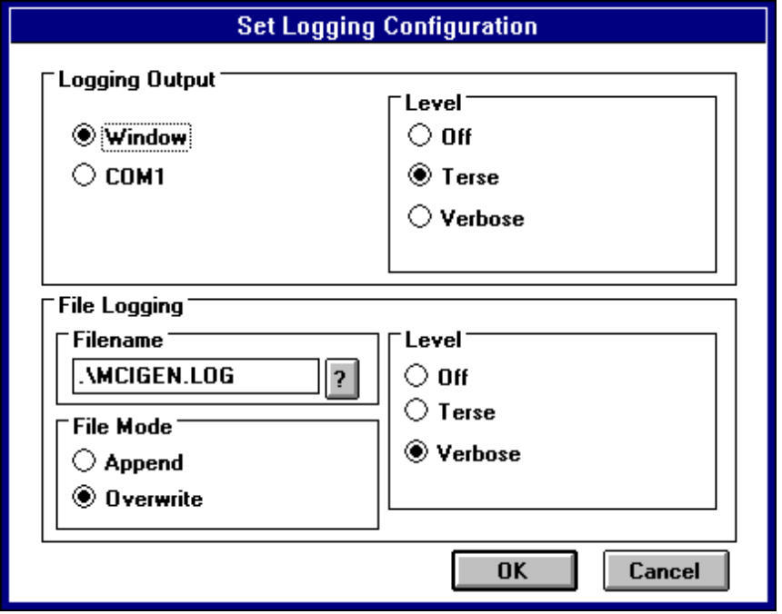
Figure 6.3 Set Logging Configuration Dialog Box
Logging can be directed to the test application window or to an output file. The option to log to COM1 is not valid in Windows NT.
There are three levels of test logging:
u Off, which results in absolutely no logging.
u Terse, which logs API failures, information required for verification, and PASS/FAIL for each test case.
u Verbose, which usually logs down to the API level.

The best policy is usually to use Terse for the test application window so that you know the progress of the tests, and to use Verbose for an output file so that you get the maximum amount of information to investigate any test failures.
The log file defaults to the name of the .EXE file with the extension .log. For example, the mcigen.exe default log file is mcigen.log. To select a new name for the log file, type the name in the Filename box, or choose the ‘?’ button next to the text box to open the common dialog box.
Note that the default file mode is Overwrite. Consequently, the log file resets to a zero-length file as soon as the Set Logging Configuration dialog box is closed with the OK button. Changing the file mode to Append adds the next set of results to the log file of the selected name, if such a file already exists.

Set Run Parms
The Set Run Parms command opens the Set Run Configuration dialog box shown in the following illustration.
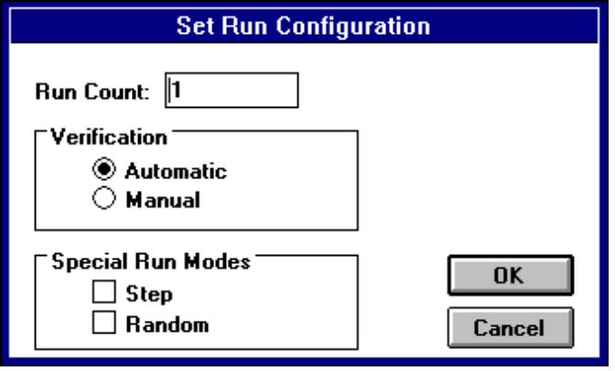
Figure 6.4 Set Run Configuration Dialog Box
Use this dialog box to set the verification mode and to specify how many times to run the test list specified in the Select Tests dialog box. A Run Count of 1 is the default. If you select test cases 20 – 30 for running and set the Run Count to 5, you generate a log that has the sequence of tests 20, 21... 29, 30, five times in a row.
The verification mode specifies whether you interact with the test executable for certain tests. Select Manual if you plan to be available to interact with the tests while they are running; otherwise select Automatic.

Setting automatic verification mode for a test case that requires manual verification results in failure of that test case.
Note

Unless you are using a profile for running the test, it is safer to select Manual verification. This does not force you to interact with a test that could otherwise verify its results automatically.
The special run modes are not valid in Windows NT.

Reset Logfile
The Reset Logfile command resets the log file named in the Set Logging Configuration dialog box to a zero-length file. No confirmation is given or required, so be certain you want to reset this option before choosing the command.

Reset Environment
The Reset Environment command resets each core menu option to its initial value. No confirmation is given or required, so be certain you want to reset these menus before choosing the command.
6.4 Multimedia Test Executables
The following four primary test application executables are included with the HCT/DDK multimedia test suite:
mcigen.exe | This is the MCI test executable used for testing CD-Audio drivers. You can also use it to test new MCI drivers.
mintst.exe | This is the MIDI input test executable used to verify the validity of drivers for external MIDI ports. Its results are valid only if a loopback for such a port exists.
mouttst.exe | This is the MIDI output test executable that works with both internal MIDI synthesizers and external MIDI ports.
wavetst.exe | This is the test for waveform audio input and output drivers. It is intended to test only drivers that work with PCM audio data. You can test input and output capabilities of waveform drivers separately.

Each of these executables has a set of support files that must be in the same directory as the test executable for valid results. Those files, and details on proper use of each executable, are discussed in the following sections. General information about the common interface elements for the different executables is provided in Section 6.3, “Using the Multimedia Test Shell.”

The easiest way to run these tests is through the Test Manager. For more information about this execution method, see Chapter 1, “Overview.”
Note

6.4.1 MCIGEN.EXE: MCI Test
Mcigen.exe is the executable for testing all MCI drivers shipped with Windows NT. Only two of the test cases are accessible through the Test Manager, but many more are available if MCIGEN is called directly. Running a test directly also allows you to specify different MCI driver and element names for testing, and even to execute tests you write yourself.
MCIGEN reads scripts that supply MCI command strings. It provides information about the expected string and API function return values. For more information about writing your own test scripts, see Section 6.4.1.2, “Writing and Using MCIGEN Scripts,” later in this section.
Note that MCIGEN ignores several of the core menu items. The only setting used from the Set Run Configuration dialog box is the run count. The Set Input/Output Paths information is not used. Consequently, all the files executed by MCIGEN must be in the directory from which the application is called.
Each of the four MCIGEN tests requires different files, as shown in the following table.
Test | Files required
AVIVideo | wndsurf1.avi, avimanl.txt, avisniff.txt, avitest.txt
CD-Audio | cdmanl.txt, cdsniff.txt, cdcert.txt, cdtest.txt
Sequencer | canyon.mid, seqmanl.txt, seqsniff.txt, seqtest.txt
WaveAudio | short.wav, medium.wav, long.wav, wavmanl.txt, wavsniff.txt, wavetest.txt

6.4.1.1 Setting MCIGEN Test Parameters
MCIGEN has a single custom menu item labeled Parameters! This command opens the Parameters dialog box, which contains various options for the executable, as shown in the following illustration.

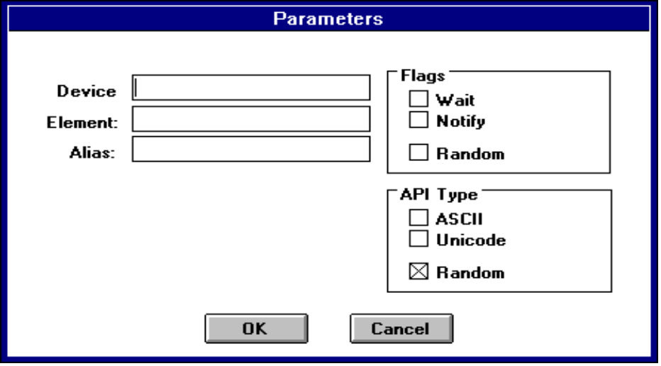
Figure 6.5 Parameters Dialog Box

If you leave a text box blank (except for the User-Supplied test case), a default value is selected when a given test case is run.
Note

There are three text boxes and two groups in the Parameters dialog box, described in the following table.
Use this field | To
Device | Enter a device name, such as CDAudio, WaveAudio, or AVIVideo. The value inserted in this field is used for any MCI Open commands requiring the type flag.
Element | Change the file used for MCI command interpreters that work with compound devices.
Alias | Change the alias used for the majority of operations. The default is Alias1.
Flags group | Select a flagging option. The Notify and Wait options specify whether the associated flag should be added to every MCI command executed.  The Random option specifies that each command has a 20 percent chance of having the Notify flag appended to it and a 20 percent chance of having the Wait flag appended to it.

Use this field | To
API Type group | Select a script version. The mciSendString routine has two variants, an ASCII version and a Unicode version. The MCIGEN test engine assumes that scripts and text box entries are ASCII, and converts them to Unicode only if the wide version of mciSendString is requested.  The Random option specifies that there is a 50 percent chance that the ASCII version of mciSendString is used for a given command, or else the Unicode version is used.

Changing any of the default settings in the Parameters dialog box invalidates the test run as a certification test. However, it does provide much more information about your driver’s performance.
Note

Suppose you have written a MIDI-synthesizer driver, and you want to see if it works under MCI with the MIDI file spam.mid rather than the default, canyon.mid. You open the Parameters dialog box, type spam.mid in the Element box, choose the OK button, and then run the appropriate sequencer tests.
For information about selecting and running test cases, see Section 6.3, “Using the Multimedia Test Shell.”
6.4.1.2 Writing and Using MCIGEN Scripts
One of the test cases you can select from the list of MCIGEN tests is the User-Supplied Test. This test looks for a text file named user.txt that is formatted as a test script and contains the line
TestCase TC_USER

preceding any of the script commands.
A test script is a long list of three-line records. For convenience, the three lines of a record are called the command, the return value, and the return string, respectively.
The first line of each record is an MCI command. The return value on the second line is zero if the command is expected to succeed, or an error name (such as MCIERR_OUTOFRANGE) that is the expected mciSendString return value. The return string on the third line is the expected value written into the lpszReturnString buffer supplied to mciSendString. If no string value is expected, a blank line is left in the script.

The following six lines are two valid records for a script:
Status canyon.mid position
0
45
Play canyon.mid from 20 to 10
MCIERR_OUTOFRANGE

The MCI Play command does not write anything into the string buffer, so the sixth line is blank.
MCIGEN allows the use of variables anywhere in a script. Variables are denoted by a valid C variable name with a percent sign (%) on either side. For example, %fish1% is a valid variable name, but %spam, spam?% is not. Variable names are case-insensitive. The three default variable values that can be supplied in the Parameters dialog box are shown in the following table:
%driver% | The string from the Device box
%element% | The string from the Element box
%alias% | The string from the Alias box

MCIGEN’s scripts are line-based, so each entry of a record is terminated by the end of a line. Certain characters in the first column of a line have a special effect, including those described in the following table.
Character | Effect
; | Comment operator. If encountered in the first column of a line, the line is ignored and the next line in the script is read in its place. Note that the comment operator is valid only in the first column of a script entry.
* | Wildcard operator. This operator is valid only in the first column of the return value, or at the end of the return string. The wildcard operator is used for the return value when you do not care whether a command succeeds or fails, such as a Close All command to make certain the MCI command shell is in a certain state.  The wildcard operator in the return string can be used only as the last character in the line. If the line has only one character, it is both the first and last character in the line. For example, if you specify '01:00:*', any return string beginning with '01:00:' is considered correct.
! | Log comment operator. This operator logs the string following it at the Terse level. This should be used to provide additional information or reminders in a log file. The Log comment operator is valid only between three-line records.

Character | Effect
? |  | Query operator. The query operator is valid only in the return-string field; it prints the text on the rest of the line as a Yes-or-No message box. The question should be phrased so that Yes is the correct answer. The message box is created after the command has been executed, and an answer of No is treated as a failure for returned string results.
= |  | Assignment operator. This operator is valid only in the return-string field of a record. It must be followed immediately by a variable name (denoted by a label enclosed by percent signs). The return string is treated as a success for that command, and the value of the return string is placed into the variable.

Wavetest.txt and wavemanl.txt provide samples that demonstrate how to use these special characters.
Û To write a script and execute it with MCIGEN
1. Copy the template usertemp.txt into the file user.txt.
2. Append a set of records to the template.
The last line in user.txt should be the return-string field of a valid record.
3. From the same directory as user.txt, run mcigen.exe using any element files your script needs.
You cannot omit this step, since MCIGEN ignores the resource path set with commands from the Test menu.
4. Choose Parameters! and then select the options you want, such as the element name used in your script.
5. From the Test menu, choose Set Logging, and then select the logging options you want for your test.
6. From the Test menu, choose Select Tests, and then select the User-Supplied Test entry.
7. From the Test menu, choose Run Tests.

6.4.2 MINTST.EXE: MIDI Input Test
The MIDI input test verifies that messages can be received correctly over the MIDI input port on the card being tested, and that the MIDI device interacts normally with the Multimedia API set. The MIDI device must be capable of producing and receiving external MIDI messages. You must connect a loopback connector so that messages sent through the MIDI OUT port are received into the MIDI IN port on the same card.

The MIDI Input test requires an additional file, mincb.dll. This file must be in the same directory as mintst.exe or in the current path. Mintst.exe does not function correctly without this DLL.
The MIDI input test has two custom menus, Input Drivers and Output Drivers. Each of these opens a dialog box in which you select one of the MIDI devices detected in your machine. If you run the MIDI tests from a command line rather than through the Test Manager, you must reselect the MIDI device to test from each of these dialog boxes, even if that device appears as the default in the dialog box.
Figure 6.6 shows the MIDI Input Drivers dialog box.
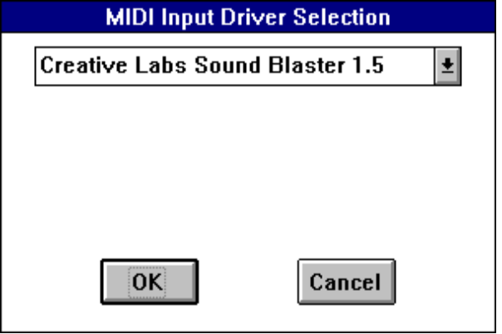
Figure 6.6 MIDI Input Drivers Dialog Box

Failure to explicitly select the input and output drivers results in invalid test results.
Caution

Û To run the MIDI input test with explicit driver selection
1. Start a command prompt session, change to the directory where you installed the multimedia HCTs, and run MINTST.EXE.
The executable must be in the directory where you installed the multimedia HCTs.
2. Choose the Input Drivers menu, and then select an input driver in the Input Driver Selection dialog box.
3. Choose the Output Drivers menu, and then select an output driver in the Output Driver Selection dialog box.
4. From the Test menu, choose Select Tests, and then select the test cases you want to run.
5. From the Test menu, choose Run Tests.

6.4.3 Mouttst.exe: MIDI Output Test
The MIDI output test verifies that an internal synthesizer works correctly, or that external MIDI messages are transmitted correctly from a MIDI-capable card, and that the MIDI device interacts normally with the Multimedia API set. In the case of external MIDI devices, the device must be able to receive and transmit external MIDI messages. A loopback connector must also be connected so that messages sent through the MIDI OUT port can be verified by the MIDI IN port on the same card.
The MIDI output test requires an additional file, moutcb.dll. This file must be in the same directory as mouttst.exe or in the current path. Mouttst.exe does not function correctly without this DLL.
The MIDI output test has two custom menus, Output Drivers and Input Drivers. Each of these opens a dialog box in which you select one of the MIDI devices detected in your machine. If you run the MIDI tests from a command line rather than through the Test Manager, you must reselect the MIDI device to test from each of these dialog boxes, even if that device appears as the default in the dialog box.

Failure to explicitly select the output driver results in invalid test results.
Caution

Û To run the MIDI output test with explicit driver selection
1. Start a command prompt session, change to the directory where you installed the multimedia HCTs, and run MOUTTST.EXE.
The executable must be in the directory where you installed the multimedia HCTs.
2. Choose the Output Drivers menu, and then select an output driver in the Output Driver Selection dialog box.
3. From the Test menu, choose Select Tests, and then select the test cases you want to run.
4. From the Test menu, choose Run Tests.

6.4.4 Wavetst.exe: WaveAudio Input and Output Test
WAVETST.EXE is a WaveAudio test application that verifies a PCM audio device driver is working correctly. It tests both the input and output capabilities of a given driver. Testing requires that a microphone and either speakers or headphones be connected to the sound device.

The WaveAudio tests require several files to work correctly. One file, wavcallb.dll, must be in the same directory as WaveAudio or be named in the path. The following files must be in the directory indicated in the resource path specified in the Set Input/Output Paths dialog box: short.wav, medium.wav, long.wav, and wavedrv.ini.
Wavedrv.ini contains information about the different wave audio devices. To take full advantage of the WaveAudio test suite, add an entry for your driver to the .ini file. The information contained in the .ini file corresponds to that which you expect to obtain from calls to the waveInGetDevCaps and waveOutGetDevCaps APIs.
WAVETST has two custom menus: Wave Input Device and Wave Output Device. Figure 6.7 shows a typical Wave Input Device menu.
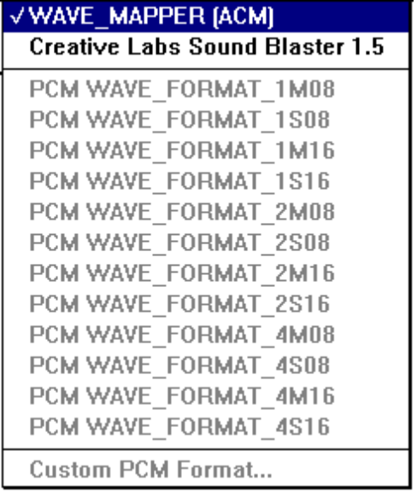
Figure 6.7 Wave Input Device Menu for WAVETST.EXE
This menu includes three sections, which are described in the following table.
Menu Section | Description
Driver Selection | This is the most important section of the menu. Tests are performed only for a driver that has a check mark next to it. Testing should be done for the driver you are testing, and not for the ACM.
Format Selection | The Format Selection section is considered information only, because the WAVETST application changes the selected format.
Custom Selection | This section is not used.

The WaveAudio test suite is interactive. This means that you must select the Manual option in the Set Run Configuration dialog box. Selecting the Automatic option generates inaccurate test results.
Before you run the WaveAudio test application, make certain you have added the correct entries to wavedrv.ini, and that you have connected the appropriate input and output peripherals to your WaveAudio device.
Û To run the WaveAudio test application
1. Start a command prompt session, change to the directory where you installed the multimedia HCTs, and run WAVETST.EXE.
2. From the Wave Input Device menu, select the correct input driver.
3. From the Wave Output Device menu, select the correct output driver.
4. From the Test menu, choose Set Input/Output Paths, and then type the appropriate paths.
5. From the Test menu, choose Set Run Parms, and then select the desired configuration parameters.
6. From the Test menu, choose Select Tests, and then select the tests you want to run.
7. From the Test menu, choose Set Logging, and then select the logging configuration you want.
8. From the Test menu, choose Run Tests.

