Overview of Microsoft® Windows™ 95
As the successor to Microsoft® MS-DOS®, Windows™ 3.1 and Windows™ for Workgroups 3.11, Windows 95 is the next major release of the standard operating system for the desktop and portable PC. There is something for everyone, whether it’s a more intuitive way to work, new capabilities like “surfing the information highway,” or better support for managing a 1,000 PC installation site.
The mission for Windows 95 is to go beyond making PCs easier to make them truly usable. This means a more intuitive and automatic PC that also integrates the latest technologies and offers superior responsiveness and stability. For end-users, this means an even easier, faster, and more powerful PC that is compatible with today’s existing software and hardware. And Windows 95 aims to make the upgrade and transition easy, without pain and without loss of performance or capability.
Windows 3.1 moved the PC platform forward by making PCs easier to use. Yet today’s customer problems highlight the need to significantly further the ease, power, and overall usefulness of the PC. Windows 95 goes beyond simple ease of use. It not only enables a new range of people to become PC users by making the PC dramatically easier to use, but also enables a wide new range of uses for the PC for existing users as follows:
- Windows 95 makes PCs even easier to use. Windows 3.1 put a friendly interface on top of MS-DOS to make common PC tasks easier. In Windows 95, the goal is to make those tasks more intuitive, or where possible, automatic. The addition and configuration of new hardware devices on the PC is one example. Windows 95 automatically loads the appropriate drivers, sets IRQs, and notifies applications of the new capabilities of the hardware device without any action by the user. A redesigned user interface, highlighted by the Windows Taskbar, makes computing more automatic for novices—usability tests show a ten-fold improvement over Windows 3.1 in time to complete certain common tasks such as starting an application—and makes the power of the PC more discoverable for intermediate and advanced users.
- Windows 95 is a faster and more powerful operating system. Ease on the surface requires power and speed at the core, and the modern, 32-bit architecture of Windows 95 meets these requirements. Freed from the limitations of MS-DOS, Windows 95 preemptively multitasks for better PC responsiveness—so users will no longer have to wait while the system copies files, for example—and also delivers increased robustness and protection for applications. Windows 95 also provides the foundation for a new generation of easier, more powerful multi-threaded 32-bit applications. And most importantly, Windows 95 delivers this power and robustness on today’s average PC platform while scaling well to take advantage of additional memory and CPU cycles.
- Windows 95 integrates network connectivity and manageability. Windows 3.1 gave end-users the power to better use their PCs, but it did not make the same strides for MIS organizations. Windows 95 addresses this deficiency by providing a system architecture that makes basic network connectivity easy by integrating high performance, 32-bit client support into the operating system—including a 32-bit client for Novell® NetWare®—and goes beyond simple connectivity by enabling the central management and control of the PC. Support for user profiles, policies, and the ability to utilize the existing NetWare or Windows NT namespace for user-level security makes it much easier for MIS organizations to administer and support large numbers of PCs within the corporation.
Windows 95 is more than the next generation of Windows—it is a catalyst that will move the PC industry to a higher level of usefulness for end-users. We expect the release of Windows 95 to spawn not only a new generation of PCs and peripherals that support Plug and Play, but a new generation of powerful, 32-bit Windows-based applications as well.
Even Easier
Windows 95 makes using your PC even easier by featuring a new, intuitive, user interface that greatly enhances the learnability, usability, and efficiency for users of all levels of expertise; support for using long filenames up to 255 characters, eliminating the difficulties posed by using cryptic 8.3 filenames; and simpler configuration of hardware devices through Plug and Play. Specifically for MIS users, Windows 95 features built-in integrated networking making it easy to connect to Microsoft Windows Networks such as Windows NT™ Server, and Novell NetWare, as well as other third-party networks; improved administration and manageability for PCs on the network running Windows 95 through mechanisms such as the centralized Registry, and user profiles allowing multiple users to use a single PC while preserving user preferences, as well as support for users to move to different PCs on the network and maintain their preferences; and the inclusion of backup agents making it easy to back up individual PCs on the network from a central location.
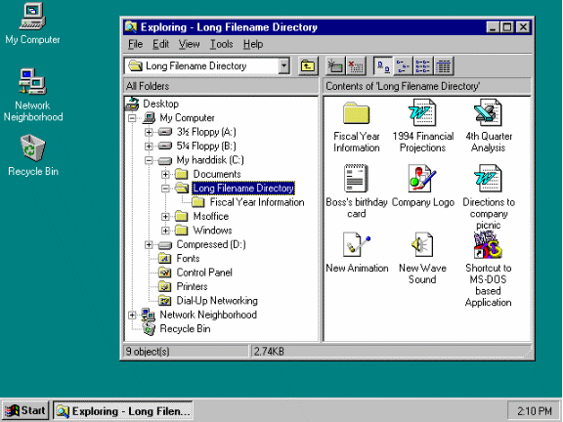
The Windows 95 User Interface Makes Using the PC Even Easier with the Task Bar, Start Button, and Explorer
The new user interface in Windows 95 is the result of thousands of hours of usability testing, and careful analysis of the types of activities that users perform. Windows 95 features a “desktop” on which users may place applications, documents, or shortcuts (links to information or resources), and which also serves as the location where users can access information on their computer (My Computer) or on the network (Network Neighborhood). The Info Center serves as a central location for storing electronic mail messages, sending and receiving Fax messages, and organizing other types of information. The Task Bar is the focal point of the user interface and provides easy access to Windows 95 operations through the Start button, or to easily switch between tasks that are running in the system. The Start Button on the Task Bar provides quick access to common operations such as starting applications or opening documents, changing settings on the computer, or finding information. The combination of the Task Bar and Start button operations makes it easy for both new users and experienced users to quickly and easily complete their tasks.
Faster and More Powerful
Another major area of concern for end-users is improving the efficiency and power with which they use Windows. Users care about getting their work done faster. They’d like to run more than one application or computer process at a time so they spend less time waiting on their PC. They’d like to be more effective without sacrificing system stability or performance. And perhaps most important of all, they’d like to escape the feeling that they take advantage of only a small fraction of what their PC can do. MIS users also want better integration between networking software and the operating system, and improved connectivity.
Windows 95 delivers benefits from new 32-bit subsystem components and operating system functionality to deliver improved performance, robustness, and functionality over Windows 3.1 and Windows for Workgroups 3.11. Under the hood, Windows 95 features a 32-bit preemptive operating system kernel providing true preemptive multitasking for 32-bit operating system components and 32-bit Windows-based applications; scalable system performance due to a new 32-bit dynamic disk and network cache; 32-bit subsystem components for areas such as disk I/O, networking, printing, communications, and multimedia—delivering improved performance and system responsiveness; more memory for running MS-DOS–based applications due to more functionality provided as Windows 32-bit device drivers, rather than through MS-DOS–based device drivers or TSRs. Support for a new generation of applications is provided through the Win32® application programming interface (API) that is shared in common with Windows NT, allowing a single application to run on a scalable computing platform to offer flexibility based on computing needs.
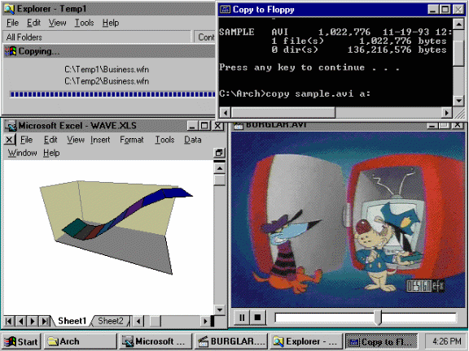
Windows 95 Delivers 32-bit Multitasking Power to Perform Multiple Operations Concurrently, Making You More Productive
Compatible
If an operating system upgrade requires new software, more memory, or new hardware, then the upgrade’s cost is far higher than just its purchase price. Unfortunately, users usually need to wait a substantial amount of time—usually until their next PC purchase—before benefiting from the latest technology. MIS organizations have had similar problems as those of end-users in terms of the cost to upgrade to a new operating system. Compatibility with today’s hardware and software is even more important, not only because of the larger scale of the upgrade, but because of compatibility problems with having differing operating system platforms within the organization. Having to support more than one platform only multiplies the problems MIS organizations face. MIS professionals worry about re-training users and about the need to migrate users to a new platform quickly, easily, and in an orderly way.
Windows 95 adds support for a new generation of applications and system services, while providing compatibility for drivers, software, and hardware that customers are using today. Compatibility is maintained for MS-DOS–based device drivers, MS-DOS–based applications, Windows–based device drivers, and Windows–based applications—this allows users to continue to use their existing software after installing Windows 95. In addition, users can expect the same or better performance from Windows 95 on a base computer platform of an Intel 80386DX with 4MB of RAM—Windows 95 requires no additional RAM to maintain performance. Windows 95 even adds functionality for running MS-DOS–based applications including a toolbar and the ability to run hardware-intensive applications like games that may not have run under Windows 3.1. MIS users will find that Windows 95 maintains compatibility with existing Windows 3.1-compatible networking software, and makes migration easy through the inclusion of Windows 3.1 Program Manager and File Manager to allow staging of training and deployment.
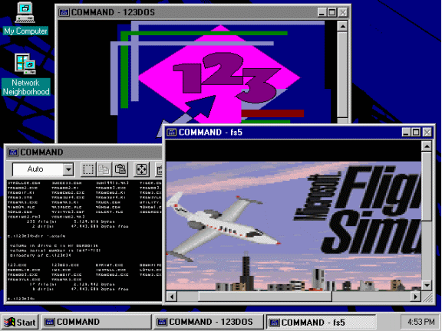
Windows 95 Provides Compatibility with Existing Device Drivers and Applications, While Supporting a New Generation of Applications

Where can I find more information about Windows 95?
Microsoft has established a number of easily accessible electronic distribution points for new whitepapers, press releases and other product-related information. Use the following electronic addresses to access further information:
On the Internet ftp.microsoft.com/peropsys/win_news On GEnie™ WINNEWS Download area in Windows RTC
On the Worldwide Web http://www.microsoft.com On Prodigy™ Jumpword WINNEWS
On CompuServe® GO WINNEWS On AOL Keyword WINNEWS
To subscribe to Microsoft’s WINNEWS Electronic Newsletter, send e-mail to enews@microsoft.nwnet.com with the words SUBSCRIBE WINNEWS as the only text in your message.
Microsoft, MS-DOS and Win32 are registered trademarks and Windows and Windows NT are trademarks of Microsoft Corporation. Novell and NetWare are registered trademarks of Novell, Inc. CompuServe is a registered trademark of CompuServe, Inc. Genie is a trademark of General Electric Corporation. Prodigy is a trademark of Prodigy Services Company.
1094 Part No. 098-57259 M

