Chapter 1
Remote Access
This chapter is a draft document. It may contain information that does not accurately represent the final version.
Note

Windows 95 includes several features designed especially for users who work on the road and at home. This chapter describes how to use Windows 95 tools to remotely access the network. It also describes how Windows 95 tools make it easier for users who have both portable and desktop computers to manage multiple configurations and to keep files between two computers synchronized.

Overview 22-2
In This Chapter
Installation Requirements 22-4
Installing Remote Access 22-4
Configuring the Dial-in Host 22-7
Using Remote Access to Connect to Windows 95 22-11
Connecting to Other Types of Servers 22-15
Making a Local Connection 22-33
Using Briefcase for File Synchronization 22-35
Using Deferred Printing 22-37
Using Remote Mail 22-37
Using Other Third-Party Dial-In Tools 22-37
Troubleshooting Remote Access 22-38

Overview
Windows 95 Remote Access features give mobile users complete workgroup computing capabilities, whether that means running a client-server application to access a customer database, downloading and browsing electronic mail, or accessing shared files. Remote Access is smoothly integrated into the Windows 95 user interface so it doesn’t appear to users that they are running a separate application. Establishing a remote connection works the same as establishing a connection in the office—the user simply double-clicks on the network object to connect. To read mail, the user double-clicks the Microsoft Exchange application icon and a remote connection is automatically established.
The Windows 95 Remote Access client component, like the rest of Windows 95 networking, allows you to dial-up amd connect to a broad set of servers and gateways, in addition to directly connecting to Windows 95 computers. Windows 95 Remote Access includes support for IPX, NetBEUI, and TCP/IP network protocols using industry-standard Point-to-Point Protocol (PPP) over the wire. Remote Access clients can alternately use Serial Line Interface Protocol (SLIP) instead of PPP for connections to older UNIX networks.
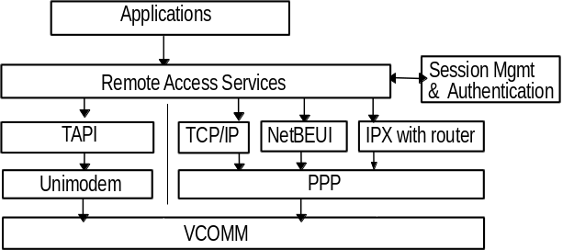

Because Remote Access is primarily an NDIS 3.1 network driver, it is important to note which protocols are bound to the Remote Access driver (PPPMAC.VXD). Different protocols, when used in combination with other Remote Access connection choices, affect which features you can use.
Notes

The Remote Access subsystem is network-independent and device-independent to enable universal connectivity. This means, for example, that Windows 95 supports ISDN boards, PBX modems, and so on. This capability is accomplished through service providers—software components that manage physical connections, and network traffic over the remote media. Windows 95 allows new types of dialing devices to be used simply by adding a new Telephony API (TAPI) service provider.
Remote Access uses the virtual communications driver, VCOMM, and TAPI with modem configuration extensions (MCX) and the Unimodem driver to initialize the modem, get device status, and dial the composed phone number.
The Windows 95 Remote Access server offers dial-in security on top of the usual share-level or user-level network security. With the ability to password-protect the dial-in process and implement callback authentication, remote access can be securely controlled. In addition, Windows 95 also supports third-party hardware solutions which add an extra degree of security on dial-in, and authentication protocols such as CHAP and SPAP. The Remote Access subsystem has an authentication provider that can be supplemented or replaced to provide custom security services. For instance, suppose the BrandX Company wants to provide its own custom services. That company can replace the Windows 95 authentication dynamic-link library (DLL) with its own to take advantage of BrandX-specific security features.
Remote access capabilities can be easily and effectively controlled. An administrator can disable dial-in support for particular users, or allow dial-in only to certain computers. In turn, the dial-in server can be set up to serve solely as a point-to-point connection, or also to route to the rest of the network. Windows 95 support for a variety of dial-in options makes the feature flexible and secure to manage.

Remote Access Connectivity Options
Windows 95 provides the ability to configure your computer as a Remote Access client or a dial-in host.
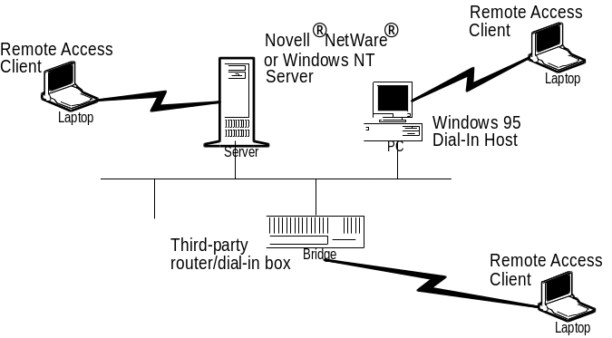
Remote access clients can access many different servers, including
- A Windows 95 computer configured for remote access server services.
- Windows NT 3.1 or higher, and Windows for Workgroups 3.11 Point-to-Point Remote Access Servers.
- Microsoft LAN Manager Remote Access Servers.
- Novell® IPXWAN (NetWare® Connect) servers.
- Shiva® LanRover and other dial-up routers.
- A connection using SLIP on a UNIX system.
- Other third-party PPP servers. Third parties will be able to add new-client support by providing a Setup program and hooking into the Windows 95 Remote Access architecture.
- A connection using PPP on a TCP/IP system.

Installation Requirements
To install Windows 95 Remote Access, you’ll need the following:

What do I need to use Remote Access?
- One or more compatible modems. (See the Hardware Compatibility List for a complete list of compatible modems. This list is available when you set up a modem with Windows 95 Setup.)
– Or –
A compatible serial or parallel null-modem cable for connecting two computers.
- Enough available hard disk space to install the Remote Access service. It currently requires about 2 to3 megabytes of free disk space to install the client, server, and administration portions of Remote Access.

Installing Remote Access
The quickest way to install and configure everything you need for Remote Access is to use the Remote Access wizard. You can use the Remote Access wizard to configure your computer as a Remote Access client or Remote Access server.
The wizard runs automatically the first time you double-click the Remote Access folder within Network Neighborhood. You can also run the Remote Access wizard later from within the Remote Access folder:

How do I run Remote Access wizard?
- To define a new Remote Access connection, double-click the New Connection icon.
- To define Remote Access dial-in server settings, click the Connections menu, then click Dial-In Options.

The following sections describe how to use Remote Access wizard to install Remote Access and set options for a Remote Access client or dial-in host.

Installing a Remote Access Client
Before installing the remote access services, you’ll want to ensure that you have properly installed a modem first. The Remote Access wizard prompts you to do so, or you can install it separately by using the Hardware Installation wizard.
To install Remote Access and define a new connection
1. Double-click Network Neighborhood.
2. Double-click the Remote Access folder icon.
3. Double-click the New Connection icon to run the Remote Access wizard.
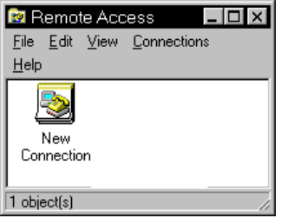
4. The Remote Access wizard will prompt you for the information needed to define a connection. In addition, if you haven’t yet set up the modem or added Remote Access to your networking configuration, the Remote Access wizard will lead you through these steps.
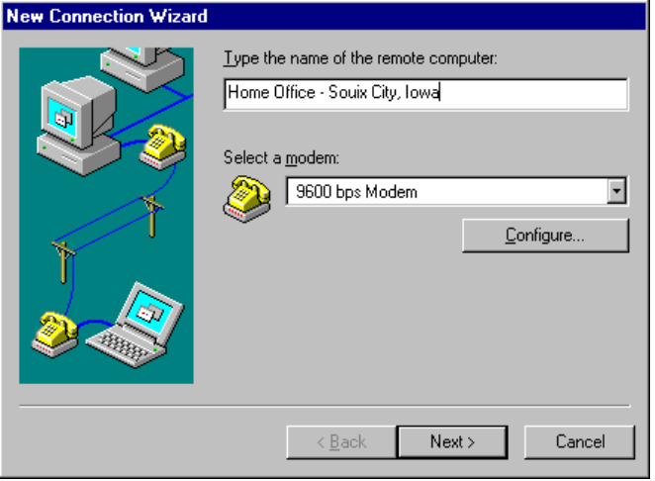

Remote Access wizard prompts you for the area code, telephone number, and country code that you want to call. You need to provide this information only once for each connection you define; you don’t need to type it each time you dial out. TAPI adjusts the dialing string to allow for country or area code changes as you travel.
Note

Installing the Windows 95 Remote Access Dial-In Server
Windows 95 allows one client at a time to dial in to the Remote Access. This connection can be either a point-to-point connection with access to local disk resources, or as a gateway to the entire network. The latter depends on which protocols you use, for example, TCP/IP protocol won’t route to the rest of the network on a Windows 95 Remote Access server computer.

How do I set up my computer so others can dial in?
The following steps describe how to configure a Remote Access server after the Remote Access wizard has been run once already.
To be provided: details on how this procedure differs on first instance of wizard
To configure your computer as a Remote Access server
1. From Network Neighborhood, double-click the Remote Access folder icon.
2. From the Connections menu, click Dial-In Options.
3. In the Dial-In Options dialog box, click Allow Caller Access.
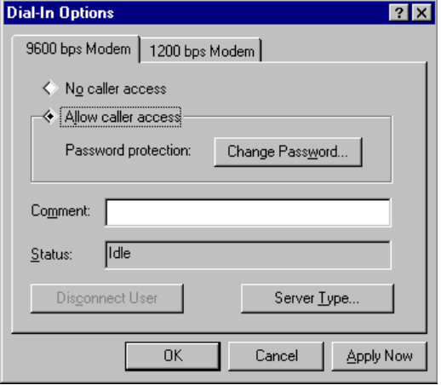
4. Click Change Password to define a call-in password for Remote Access clients, or, if using user-level security, set up the users who have access to this dial-in host. Click OK.
5. Click OK and the Remote Access dial-in host will be ready to answer incoming calls.

There will be an item added to the task bar that will be there while the server is ready to accept calls. To disable the dial-in host select the No Caller Access option from the Dial-In Options dialog box.

Remote Access can only use one modem at a time for dial-in support. You may have multiple modems installed, but only one modem can be selected to provide dial-in access at a time.
Note

Configuring a Windows 95 Computer as a Dial-in Server
Windows 95 can be configured as a dial-in server to support both a point to point connection to a particular computer, and a connection to the attached network.
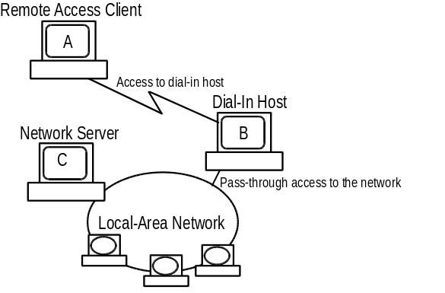
In this diagram, Computer A can access files shared on Computer B by means of the modem. When Computer B runs peer resource-sharing services for either Windows or NetWare networks, Computer A can also use other network resources.
For example, when Computer A and Computer C use the same client and server protocols, Computer A can also access files shared on Computer C.
After a Remote Access connection is made, the client computer acts just like any other computer on the network. Any restrictions the client has are the same client redirector and protocol limitations any other computer on the network has. That is, a Remote Access client running NetBEUI and TCP/IP can access all the same networking components that other local computers running NetBEUI and TCP/IP can access.
In the preceding diagram, assume the following:
- Computer A runs IPX and the Microsoft Client for NetWare Networks
- Computer B runs any redirector and the peer resource-sharing services for either Microsoft or Novell networks
- Computer C is a Novell NetWare file server

In this scenario, Computer A can “route” through Computer B with IPX, to access resources on the NetWare server, Computer C.
The decision to allow a remote client access to network resources is made at the protocol level (NetBEUI, IPX, or TCP/IP); it is not dependent on the redirector or server software installed on the client or dial-in host. For example, if the dial-in host is running the File and Print Services for NetWare, it does not mean that a remote client can only attach to NetWare servers. Instead, it means that the routing and gateway components on the dial-in server are active only when it is also acting as a server on the local area network.
Notice that a Windows 95 server cannot act as a gateway to the network for a dial-up computer running only the TCP/IP protocol because Windows 95 cannot serve as a router for TCP/IP. In these instances, you’ll want to use a dial-in server such as Windows NT Server or one of many third-party solutions. Information on protocol restrictions is provided later in the chapter.
Thus other than ensuring that the appropriate protocols and peer services are enabled, you only need to follow the steps of the Remote Access Server wizard which runs when you first double click on the remote access folder in Network Neighborhood. For more information about peer resource-sharing services, see Chapter 8, “Windows 95 on Microsoft Networks” and Chapter 9, “Windows 95 on NetWare Networks.”

Disabling Dial-in Host Support
Windows 95 can be set so that users cannot allow Remote Access into their Windows 95 computer. Use the System Policy Editor to create a policy file or to make direct changes to a computer’s dial-in support capabilities.
To disable dial-in support
1. Run the Systems Policy Editor.
2. Double-click the icon for the appropriate computer to open the policy file.
3. Click Network, and then click Remote Access. Check the Disable Dial-in box.
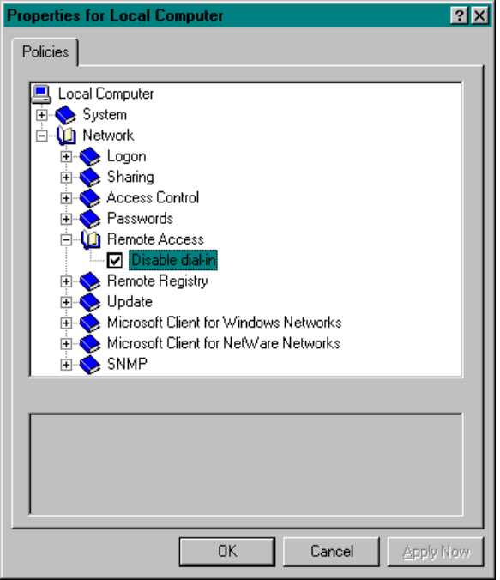
4. Click OK.
5. From the File menu, click Save.

The Dial-In Options menu option will still appear on the Remote Access Connections menu, but no dial-in option dialog box for setting up the dial-in server will appear. The user will not be able to allow remote clients to dial in to the network or to the local Windows 95 server.
For more information about implementing system policies, see Chapter 12, “System Management.”

Using Security with Remote Access
In addition to the standard share-level or user-level network security, Remote Access offers different levels of security to prevent unauthorized callers from gaining access to your network or local computer.
Think of it as doors to an office building and to the offices inside. You have a lock for the front door of the office. That is the Remote Access connection password or user list. The front door may lead to individual offices, and each office might or might not have a lock. This is the share-level or user-level account rights you specify for shared resources on a server computer.
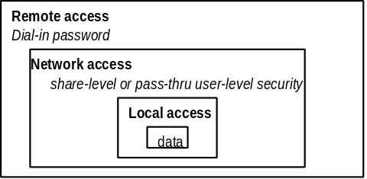
When the Remote Access server is part of a Windows NT or Novell NetWare network, it uses the same account database as a Windows NT Advanced Server or Novell NetWare server. This provides for easier administration, because users will log on with the accounts that they use while at the office. This ensures that users will have the same privileges and permissions they normally have.
When the Remote Access server is part of a Windows NT network, a user must have explicit Remote Access permission and a valid Windows NT account before using Remote Access. Then, when the user logs on, the following security measures are applied:
1. Windows 95 Remote Access authenticates the user to allow dial-in access. If the user is not authenticated, Windows 95 will not allow dial-in access to the server.
2. Windows NT validates the user’s logon name and password.

When the user tries to access a file, Windows NT ensures that the user has permission to access the file and ensures that the user is allowed to perform the discussed task.
To specify dial-in security on the Windows 95 client
To be provided: enabling encrypted password protection.

Defining Computer Profiles
As described in Chapter 12, “System Management,” the Windows 95 Registry contains per-configuration computer profiles for each computer. For example, you can define separate computer profiles for your computer — one for its docked configuration and one for its undocked configuration.
To define a new computer profile for your computer

How can I set up separate computer profiles for docked and undocked configurations?
1. From System Control Panel, open the Device Manager property sheet.
2. Choose Properties.
3. Edit the Profile Specific Settings.
To be provided: greater detail on how to best configure computer profile settings.

Using Remote Access to Connect
To create a new connection, click on the “Make New Connection” icon in the Remote Access folder in Network Neighborhood. Respond to the prompts displayed by the New Connection Wizard to define a particular connection.
To use a connection once it is defined
1. Double-click Network Neighborhood.
2. Double-click the Remote Access folder icon.
3. Double-click the icon for the connection you have defined. For example, the following illustration shows a defined connection named Home Office — Sioux City, Iowa.
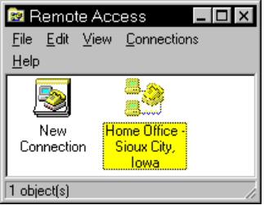
Notice that Remote Access connection definitions can be included as part of a user profile. Because of this, different users sharing the same computer can use separate dialing configurations. For more information about defining and using user profiles, see Chapter 12, “System Management.”
The configurations you set up for each connection are stored in the Registry’s Hkey_Current_User\RemoteAccess key.

Connection Types
There are three ways to connect to a dial-in server:
- Explicitly, by double-clicking an icon in the Remote Access folder.
- Implicitly, when a user tries to connect to a remote resource and Windows 95 responds by automatically activating the connection.
- By application initiation, when the application tries to connect to a remote resource and Windows 95 responds by automatically activating the connection.

After establishing or ending a connection, users do not need to reboot their computers or restart Windows 95. This is because Remote Access uses the dynamic, 32-bit, protected-mode network architecture of Windows 95.
Explicit, implicit, and application-initiated connection types are described in the following sections. Further information about the behind-the-scenes protocols and access negotiation is discussed later in this chapter.

Explicit Connections
Users make explicit connections when they double-click on a connection icon in the Remote Access folder. (An example of this is the icon that is created when you run Remote Access wizard to configure a Remote Access client.)
When the user creates an explicit connection in this way, Windows 95 prompts the user for a logon password. As Windows 95 makes the connection, it displays a status dialog box to report the progress of the connection.

Implicit Connections
Under certain conditions, users don’t have to make an explicit Remote Access connection — the tasks they are doing imply a connection is to be made and Windows 95 makes that connection automatically.
With Remote Access installed, Windows 95 automatically prompts the user to select a remote connection under the following circumstances:
- When a user tries to access a network resource and the computer is not connected to any network
- When a user or application specifies a Uniform Naming Convention (UNC) name (which uses the form \\servername\sharename) that can’t be accessed by means of the local area network
- When a user double-clicks a link that points to a remote network object
- When a user attempts to use a persistent network resource (also called an aliased drive)
- When an application attempts to connect to a named pipe or file (such as mail)
- When an application attempts to print to a remote network printer
- When a user reconnects to a remote OLE object

For example, if you specify that you want to use a file on \\Cool\Server and Windows 95 cannot find this shared directory on your network, you would see a prompt like this one:
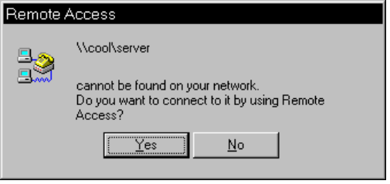
The connection that the user selects is used to start a Remote Access session. Remote Access retrieves the server information from the addresses stored in the Registry, if available. If the information is not available, the user is prompted to select a server from the connection definitions listed in the Remote Access folder or type information for a new server, as shown here:
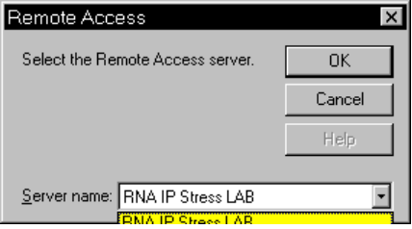
If the server is not a Remote Access server, Windows 95 marks this name as not accessible using Remote Access, so that it won’t attempt an automatic connection in the future.
Once the session is established, the network operation that initiated the connection is completed. Upon successful completion, Windows 95 remembers the connector the user chose so it can be used for future operations.
Implicit connections leaves a “ghost” mapping which reconnects when you need to use the resource. If you don’t need to use the resource, the connection remains inactive. Ghosting incorporates the idea of persistent network connections, whereby network connections are “remembered” so that the user doesn’t have to reconnect every network drive at every logon.

Application-Initiated Connections
Network applications use the Remote Access Session API to establish or disconnect a remote network connection. Applications can also retrieve information about a Remote Access session to perform tasks such as:
- Composing the correct phone number
- Initializing the correct device
- Dialing the device
- Starting authentication using the appropriate authentication module

As Remote Access tries to establish the connection, it reports the success or failure, and other details, such as connection speed, to the application.
For example, Microsoft Exchange takes advantage of the Remote Access APIs for connection to remote mail servers and to access Internet mail and news groups transparently.

Using Dial Helper to Change Dial-in Location Information
People who travel with their computers often need to dial in from different area codes and phone systems. In the past, this created extra work, with users having to remember and reconfigure calling numbers when traveling.
Remote Access is a TAPI-enabled application. This means that Remote Access can offload the work of matching the correct phone dialing string from the location to the TAPI components designed for that role. When you attempt a Remote Access connection, you have an option to use the Dial Helper.
With Dial Helper, you can specify area code, any special numbers needed to reach an outside line, and calling card information you may need for the connection number. The Windows 95 TAPI services will then automatically adjust the dial string it sends to your modem. For more information about using Dial Helper, see Chapter 18, “Modems and Communications Tools.”

Using Software and Hardware Compression to Transfer Data
To improve the throughput and lower the transfer times when using Remote Access, Windows supports dynamic compression of information when connected to another computer that also understands compression, for example, a computer running Windows 95 or Windows NT.
You can choose to use either software compression (specified through the Dial-In Options dialog box) or hardware compression. Software compression is performed by the Remote Access software; hardware compression is performed by the modem.

The software compression option is not available when connecting to a Windows NT 3.1 or Windows for Workgroups 3.1 PTP server.
Note

Hardware compression is available on most newer modems at higher connection speeds. For example, V.42bis is an industry standard which allows modems to do data compression on all the data sent through them “on the fly”.
When software compression is used on the connection, hardware compression should be disabled. The extra overhead is not efficient and software compression usually can achieve higher compression ratios with its larger pattern buffer and onboard memory.
When you use either type of compression on data that is already compressed, you won’t see any transfer time improvement. If the computer you are connecting to doesn’t support compression, these settings are ignored and data is sent uncompressed over the wire.

Connecting to Other Types of Servers
Remote Access automatically negotiates the connection protocol type of the dial-in server when dialing another host or when clients dial in to Windows 95. The features and benefits of each connection type are discussed in the following sections. The order of negotiation during a connection is as follows:
1. Point-to-Point Protocol (PPP)
2. Remote Access Server (RAS) for Windows NT 3.1, Windows for Workgroups 3.11, or LAN Manager
3. Novell NetWare Connect
4. Serial Line Interface Protocol (SLIP)

In most cases, you do not need to set a specific server type —Windows 95 will detect the server type you need to use and will use that one. However, to ensure full backward compatibility, you have the option of specifying a particular server type.
To specify a server type other than the default
1. From Network Neighborhood, double-click the Remote Access folder icon.
2. From the Connections menu, click Dial-In Options.
3. In the Dial-In Options dialog box, click Server Type.
4. Choose the server type you want to use from the list box. Click OK.
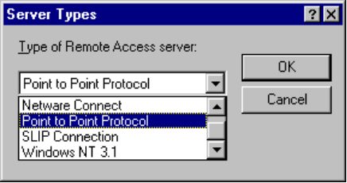

You may want to select an exact connection type to decrease the connection setup time. For example, suppose you know you want to establish a NetWare Connect connection. By default, Windows 95 does not attempt to use NetWare Connect until after PPP and RAS are processed, so you will have to wait 45 seconds or so until Windows 95 tries connecting with NetWare Connect. In this case, you can bypass those first checks and save 45 seconds on the connection setup by specifying the server type you want to use — NetWare Connect.

If users are having trouble making remote access connections, check to see if a specific server type was selected. When a specific connection type is selected, Windows 95 will not attempt to connect using any other server type.
Tip

Connecting to a Remote Windows NT Server
Connecting to a Windows NT 3.1 or 3.5 server is the same as connecting to a Windows 95 computer. All you need is the phone number of the Windows NT server when creating a connection and Windows 95 Remote Access negotiates the proper protocols and the connection type of the server. You don’t need to specify a default server type.

Windows NT 3.1 RAS
Windows NT 3.1 uses a Remote Access Server (RAS) connection type. RAS is a proprietary protocol, based on NetBEUI, that offers remote network connection over phone lines. It is a fast connection type, but does not allow for multiple protocols over the connection or much extensibility by Independent Software Vendors (ISVs).
RAS connections provide these basic services:
Service | Used by
Windows 95 Client Supports Connections to | Windows NT 3.1 and 3.5, Windows 95 Remote Access servers, Windows for Workgroups 3.11 PTP server, and LAN Manager servers
Windows 95 Supports Connections from | Windows NT 3.1 and 3.5, Windows 95 Remote Access clients, Windows for Workgroups 3.11, and LAN Manager clients
Novell NetWare Connectivity | Limited to file and print services, using gateway services for Netware on Windows NT 3.5
Internet Connectivity | None

The following table describes RAS connection protocol options for the Remote Access driver:
Protocols | NetBEUI | IPX | TCP/IP
Access as a Client | Y | N | N
Access as a Server | Y | N | N
Novell NetWare Connectivity | Y (to Windows NT server gateway) | N | N
Internet | N | N | N

When you use RAS connection protocol, make sure NetBEUI is bound to the Remote Access driver.
Note

Windows NT 3.5 RAS and PPP
There are many improvements to remote access in Windows NT 3.5, which make it both more robust and easier to use:
- Windows NT Server RAS handles up to 256 simultaneous connections. The Windows NT Workstation 3.5 is limited to one RAS connection at a time.
When accessing NetBIOS resources, the maximum number of simultaneous connections is 250. This is a limitation of the number of NetBIOS names that can be registered by a single system. When using Windows Sockets over TCP/IP or IPX, there will be no software limitations to the number of simultaneous connections that can be made to the RAS Server.
- PPP is supported in both the RAS client and server. PPP is an industry standard that allows Windows NT RAS to interoperate in a multiple-vendor network.
- RAS software compression is supported in Windows NT 3.5. This includes compression based on the new Microsoft DRVSPACE compression algorithm, and VJ compression for TCP/IP.
- RAS server architecture has been enhanced to support new features such as routing.
The basic service support for Windows NT 3.5 RAS and PPP is documented in “Using Point-to-Point Protocol for Remote Connections,” later in this chapter.

RAS Gateway and Routers
Windows NT 3.1 RAS server had the ability to act as a NetBIOS Gateway between NetBEUI and the other NetBIOS-compatible protocols installed on the Windows NT server. This allowed a RAS client that was only running NetBEUI to connect through the gateway to a remote server that might have been running TCP/IP or NWLink. Windows NT 3.5 enhances the RAS architecture by adding IP and IPX router capability. Windows NT 3.5 remote workstations can now run TCP/IP and IPX locally, and run Windows Sockets applications over their local TCP/IP and IPX protocols. For example, a remote client user now has the ability to access remote NetWare servers by using the Client Service for NetWare over IPX and Remote Access.
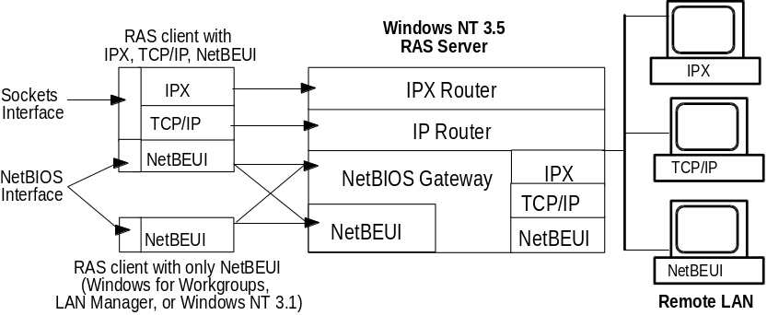
If the Windows NT 3.5 RAS server has a network adapter installed, the NetBIOS gateway and routers are enabled by default. Although this allows RAS clients to access resources on the remote network over all supported RAS protocols, there are limitations. By default, the RAS IPX and TCP/IP routers do not forward broadcast packets to the remote network because it reduces network traffic across the router. Because broadcast packets are the primary method of name resolution for these protocols, this limits a RAS client’s access to the remote network with these protocols. For example, a RAS Client using only the IPX protocol would have access to NetWare servers by means of the IPX RAS router but could not access a remote Windows NT server, even though it may be running the NWLink IPX/SPX-compatible protocol.

The only way that IPX clients can access remote NetBIOS resources is to enable the router to forward broadcast packets. While this is possible, it is much easier and more efficient to use the NetBEUI protocol to access NetBIOS resources. If the administrator does want to allow IPX RAS clients to access remote NetBIOS resources, a new Windows NT Registry value NetBIOSRouting with a type of REG_DWORD must be added under the following Registry key:
\Hkey_Local_Machine\System\CurrentControlSet\Services\NWlnkRip
\Parameters

0 = Do not forward Broadcasts (Default).
2 = Enables forwarding of NetBIOS packets from remote client to the LAN.
4 = Enables forwarding of NetBIOS packets from the LAN to the remote
ú client.
6 = Enables two-way forwarding of NetBIOS packets between remote clients
ú and LAN.

The location of this parameter was changed after the Windows NT manuals were printed. The manuals incorrectly state that the NetBIOSRouting parameter should be added to the IPXRouter key. This key does not exist.
Note

Protocols on the RAS Server
By default, IPX/SPX, TCP/IP, and NetBEUI are all supported protocols on Windows NT 3.5 RAS Server. (Windows NT 3.1 only allows for NetBEUI connections.) This allows RAS clients to use any combination of protocols to access remote resources. If needed, administrators can adjust these bindings to allow only certain protocols to be used over RAS. Configuration of the RAS protocols is done by means of the Network option in Remote Access Setup. (This option was labeled as Security in Windows NT 3.1.)
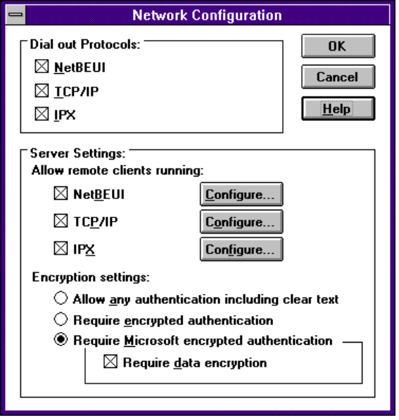
Each supported RAS protocol has its advantages and disadvantages. The easiest way to configure a Windows NT 3.5 RAS server is to enable all three supported protocols but some administrators may have reasons not to do this. For example, the remote network may not be running the NetBEUI protocol and, therefore, there would be no advantage to enabling NetBEUI on the RAS server. The following sections describe the advantages and disadvantages of each protocol and how to configure each protocol.

Using NetBEUI with RAS
Both Windows NT 3.1 and 3.5 allow remote clients to connect using the NetBEUI protocol. Clients running NetBIOS applications or needing to access NetBIOS resources on the remote network, such as file servers, should always use NetBEUI. The NetBEUI protocol is the fastest and most efficient transport to access NetBIOS resources and, with the RAS NetBIOS gateway functionality enabled, users have access to all remote NetBIOS resources even if they are not running NetBEUI.

If the remote network has computers running the NetBEUI protocol, NetBEUI should be used by RAS clients to access NetBIOS resources.
Rule of thumb

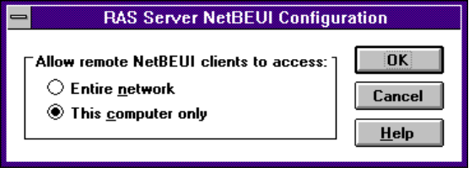

The only option to choose for the NetBEUI protocol is whether to enable the NetBIOS Gateway or not. Enabling the NetBIOS Gateway allows remote clients to access NetBIOS resources, such as the file and print servers, on any network to which Windows NT RAS server is attached.

Using TCP/IP with RAS
Windows NT 3.5 servers using PPP can provide TCP/IP access to the network for remote access clients.
It is possible for these clients to access a NetBIOS resource if the NetBIOS name can be resolved using the LMHOSTS file. Although this is possible, it is much easier and more efficient to use the NetBEUI protocol to access NetBIOS resources.
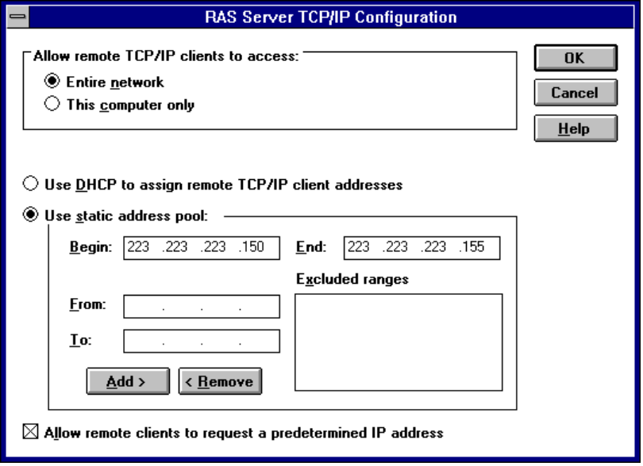
RAS clients using TCP/IP can do any of the following:

- Use a predetermined IP address
- Download their address from the RAS server
- Configure the RAS server to use DHCP to assign remote TCP/IP client addresses

For clients to download their IP address, a range of IP addresses must be set up on the RAS server. These addresses must be valid and not in use by the local subnet to which the RAS server belongs. If DHCP is used on the network, the range of addresses must be excluded on the DHCP server.
Enabling the Allow Remote TCP/IP Clients to Access option causes the RAS server to act as an IP router and allows TCP/IP users access to the entire network.

Using IPX with RAS
With PPP, Windows NT 3.5 can allow remote clients to connect and use the IPX protocol.
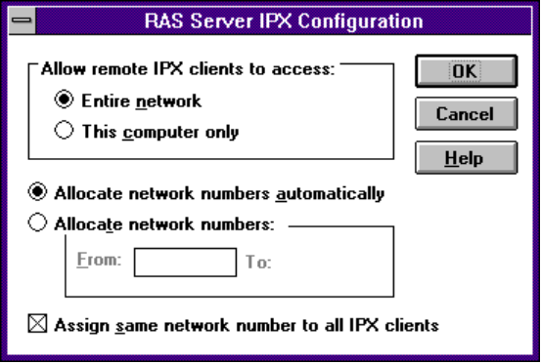
Server options for IPX include the ability to assign a static range of IPX network addresses for remote clients to use. This is helpful if an administrator wants to identify IPX clients by network number.
Enabling the Allow Remote IPX Clients to Access option causes the RAS server to act as an IPX router and allows IPX users access to the entire network. This does not allow access to NetBIOS resources unless the IPX router is configured to forward broadcast packets.

Connecting to NetWare Servers
Windows 95 Remote Access supports connecting to Novell NetWare resources in two ways:
- Connecting directly to a Novell NetWare Connect server
- Using a Windows 95 or Windows NT 3.5 computer as a gateway into a local area network, where NetWare servers are connected.

Notes
- NetWare Connect is a proprietary protocol and is the Novell solution for remote computing, which allows a Windows 95 client to dial in to a NetWare server. It also offers two other features — modem pooling and remote computer control. You can take advantage of these if you use the Novell NetWare Connect client software.
- Windows 95 can only act as a client for connecting to a NetWare Connect server. NetWare Connect clients themselves could not connect to a Windows 95 Remote Access server directly through dial-in.

The NetWare Connect connection type allows a Windows 95 client to directly connect to a NetWare Connect server and, with the right client redirector and protocols, connect to NetWare servers on the connected local area network.
No special configuration for Remote Access is needed when connecting to a NetWare Connect server. Remote Access detects and automatically negotiates the NetWare Connect protocol. However, you will need to use the Network Control Panel to make sure the IPX/SPX protocol and the Client Services for NetWare are bound to the Remote Access driver.

To decrease the connection setup time, you may want to select NetWare Connect as the connection type, so Remote Access doesn’t have to spend time first trying PPP and then RAS on the connection.
Tip

The following diagram shows how a remote access client can connect to a NetWare network:
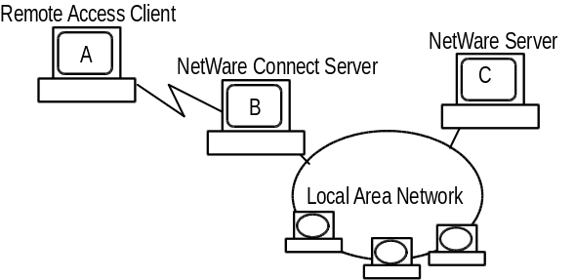
In this diagram, Computer A is a Remote Access client that dials in to a Novell NetWare Connect server, Computer B. Computer B can then route requests from Computer A through the network and to Computer C, the NetWare Server.
If you use Remote Access to access NetWare resources, you can access data remotely, but cannot control a computer remotely, as you can with the NetWare Connect client software supplied by Novell.
NetWare Connect connections provide these basic services:
Service | Used by
Windows 95 Supports Connections to | Novell NetWare Connect Servers
Windows 95 Supports Connections from | None
Novell NetWare Connectivity | Directly to the Novell NetWare product
Internet Connectivity | Depends on Novell NetWare features

The following table lists Novell NetWare Connect connection protocol options for the Remote Access driver:
Protocols | NetBEUI | IPX | TCP/IP
Access as a Client | N | Y | N
Access as a Server | N | N | N
Novell NetWare Connectivity | N | Y | N
Internet | N | Y | N

For this configuration, any Internet access must be provided by the Novell NetWare Connect server.
Note

Using Windows 95 or Windows NT Gateways to Connect to NetWare Servers
Remote Access itself can serve as a gateway to Novell NetWare servers, when used with the IPX/SPX protocol and the Microsoft Client for NetWare Networks.
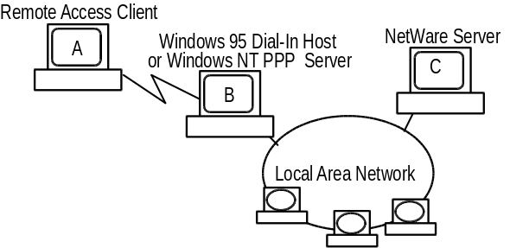
In this diagram, the Remote Access client, Computer A, automatically uses the PPP connection type to connect to the Windows 95 or Windows NT PPP server, Computer B. Computer B can then route the IPX packets to the network to connect to Computer C.

Using Point-to-Point Protocol for Remote Connections
When Windows 95 tries to establish a connection, it first tries to use PPP by default, since PPP offers the most flexibility in protocol choices.
The Point-to-Protocol Protocol (PPP) was designed to improve upon a more limited protocol called Serial Line Internet Protocol, or SLIP (discussed later in this chapter). PPP, specified in Request for Comments (RFC) 1331, is a proposed Internet standard. PPP was designed to define a standard encapsulation protocol for the transport of different Network Layer protocols (including, but not limited to, IP) across serial, point-to-point links. PPP also describes mechanisms for network protocol multiplexing, link configuration, link-quality testing, authentication, header compression, error detection, and link-option negotiation.
PPP provides a mechanism for transporting multi-protocol datagrams over point-to-point links. PPP addresses the limits of SLIP, using three main components:
- A method for encapsulating datagrams over serial links, based on the ISO High-level Data-Link Control (HDLC) protocol.
- A Link Control Protocol (LCP) for establishing, configuring, authenticating, and testing the data-link connection.
- A family of Network Control Protocols (NCPs) for establishing and configuring different Network Layer protocols.

PPP’s Data Link Layer is a slightly modified version of the High-level Data Link Control (HDLC) format extensively used by IBM and others for synchronous data transfer. HDLC was modified by adding a 16-bit protocol field that allows PPP to multiplex traffic for several network layers (NCPs). This encapsulation frame has a 16-bit checksum, but the size of this field can be negotiated. LCP is used to establish, configure, and test the integrity of the data-link connection. LCP allows for negotiating various parameters dynamically, including whether compression is enabled and which IP addresses will be used. Several NCPs have already been defined for major networking protocols including IP, IPX, DECNet™, OSI, and AppleTalk®.
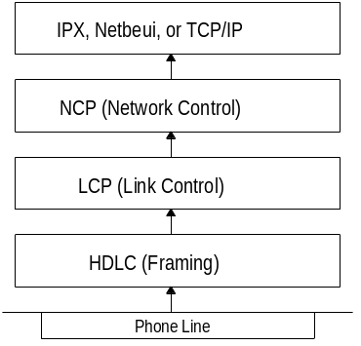
Aside from running several protocols over a single line, PPP provides well-defined link control negotiation with state diagrams for standard commands and responses. LCP also supports several schemes for authentication, link-quality monitoring, and compression. These features significantly ease the difficulties in debugging PPP connections, compared with debugging SLIP. However, some problems remain, since a serial line might be used for both remote logon and PPP use. While the promise of multiple protocols over a single line is enticing, few of the existing PPP implementations support more than a single NCP (usually IP). Vendors on some platforms (UnixWare and Novell NetWare, for example) have expressed plans to support IPX and IP in future versions.
At the Physical Layer, PPP is designed to work over any asynchronous or synchronous, dedicated or dial-up, full-duplex bit-serial circuit. It can employ any common serial communications protocol, including EIA-232-E (formerly, RS-232-C), EIA-422, EIA423, EIA-530, and CCITT V.24 and V. 35. PPP does not place any particular restriction on the type of signaling, type of transmission speed, or use of modem control signals.
PPP connections provide these basic services:

Service | Used by
Windows 95 Client Access to | Windows NT 3.5, Windows 95 Remote Access servers, Shiva LanRovers, other third-party PPP providers, and gateway connections to NetWare servers
Host Support for | Windows NT 3.5 and Windows 95 Remote Access clients; future clients possible
Novell NetWare Connectivity | Through Windows NT or Windows 95 IPX gateways
Internet Connectivity | Through third-party PPP Internet service providers

The following table shows PPP connection protocol options for the Remote Access driver:
Protocols | NetBEUI | IPX | TCP/IP
Access as a Client | Y | Y | Y
Access as a Server | Y | Y | N
Novell NetWare Connectivity | N | Y | N
Internet | N | Y | Y

When using PPP for remote access connections, consider the following:
- A client can communicate with the Windows 95 host computer it dialed in to only when using TCP/IP.
- A Windows 95 Remote Access dial-in host cannot provide access to Internet resources or any other IP server on the network that it makes available to a remote PPP client. Unlike Windows NT 3.5 server, there is no IP router built into Windows 95 to provide this service.
- Novell NetWare connectivity is available when using a Windows NT 3.5 Remote Access server or Windows 95 dial-in host as a connecting point into the local area network for a Novell server.
- If an Internet provider allows IPX connection to its resources, then that option is available to remote access clients. (However, few providers do so at this time.)

PPP Dial-In Sequence
When a user dials in to a PPP-compatible server, three things happen:
1. PPP framing defines how data is encapsulated before transmission on the wide area network. By providing a standard framing format, PPP ensures that various vendors’ remote access solutions can communicate and distinguish data packets from each other. PPP uses HDLC framing for serial, ISDN, and X.25 data transfer.
2. Link Control Protocol (LCP) is used to establish and configure link and framing parameters such as maximum frame size. During LCP, negotiation of authentication protocols occurs. Authentication protocols are used to determine what level security validation the Remote Access server can perform and what the server requires. The level of security that can be negotiated ranges from clear-text password authentication, to encrypted authentication, to callback security.
LCP can negotiate with any of these authentication protocols:
- Password Authentication Protocol (PAP) uses a two-way handshake for the peer to establish its identity. This handshake occurs only when the link is initially established. An identification and password pair is repeatedly sent by the peer to the authenticator until either the identification and password are verified or the connection is ended. Using PAP, passwords are sent over the circuit in text format, which offers no protection from playback.
- Shiva Password Authentication Protocol (SPAP) offers encryption of PAP passwords and Novell NetWare bindery access for user account information. When Windows 95 is set up for user-level security using a NetWare server account list, this is the security type used for Remote Access clients.
- Challenge-Handshake Authentication Protocol (CHAP) periodically verifies the identity of the peer, using a three-way handshake. This technique is done throughout the life of the connection. When established, the authenticator sends a challenge message to the peer. The peer responds with a value calculated using a one-way encryption. The authenticator then checks this response against its own calculation. If the values match, the authentication is acknowledged; otherwise, the connection is ended. CHAP provides protection against playback attack because the challenge value changes in every message. Since the password is never sent over the link, it is virtually impossible to learn it. CHAP allows different types of encryption algorithms to be used such as DES, MD4 (MS-CHAP), and MD5 (MD5-CHAP).
Windows 95 doesn’t support ongoing challenges with CHAP, but does implement full-blown MS-CHAP, as does Windows NT.
3. Negotiated Network Control Protocols (NCPs) are used to establish and configure different network protocol parameters which include negotiating protocol header compression, and compression control protocol. Which NCP is used depends on which protocol (NetBEUI, TCP/IP, or IPX) is being used to establish the RAS connection. NCPs supported in Windows 95 Remote Access PPP connections include the following:
- NetBIOS Frames Control Protocol (NBF CP) is used to configure, enable, and disable the NetBEUI protocol modules on both ends of the link. NBF CP is a Microsoft-proposed protocol for NetBEUI configuration. NBF CP is currently in “draft” status with the Internet Engineering Task Force (IETF). Windows 95 provides implementations for the current draft of NBF CP (as of March 1994).
- Internet Protocol Control Protocol (IPCP), defined in RFC 1332, is used to configure, enable, and disable IP Protocol modules at both ends of the link.
- Internet Packet eXchange Control Protocol (IPXCP), defined in RFC 1552, is used to configure, enable, and disable IPX protocol modules on both ends of the link. IPXCP is widely implemented by PPP vendors.

You can watch the different PPP layers set up by enabling the PPPLOG file. This file contains some of the basic layers and points of any Remote Access session, and is especially useful for monitoring PPP sessions. This file is created in the Windows directory.
To enable PPP logging
1. In Control Panel, double-click the Network Control Panel icon.
2. Select Remote Access Driver from the list of installed network components, then click Properties.
3. Click the Advanced Properties tab, and then choose Record a Log File from the Property list. Choose Yes from the Value list.
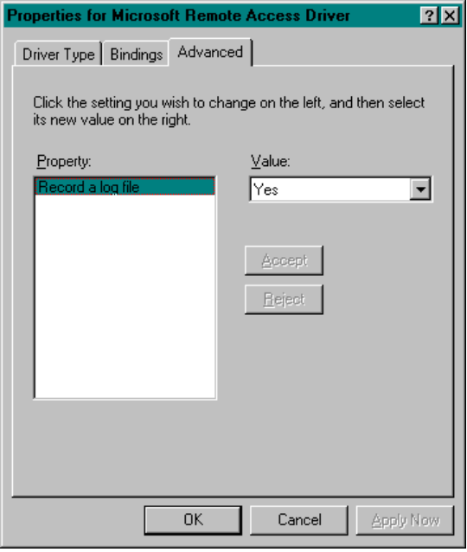
4. Click OK.

The following is sample content of a PPPLOG.TXT file:
09-01-1994 18:14:22 - Remote access driver log opened.

Sample PPPLOG.TXT
09-01-1994 18:14:22 - Server type is PPP (Point to Point Protocol).
09-01-1994 18:14:22 - CCP : Layer initialized.
09-01-1994 18:14:22 - NBFCP : Layer initialized.
09-01-1994 18:14:22 - FSA : Control protocol 2180 will not be
negotiated.
09-01-1994 18:14:22 - IPXCP : Layer initialized.
09-01-1994 18:14:22 - FSA : Encrypted Password required.
09-01-1994 18:14:22 - LCP : Layer initialized.
09-01-1994 18:14:22 - LCP : Will try to negotiate callback.
09-01-1994 18:14:22 - LCP : Layer started.
09-01-1994 18:14:22 - LCP : Received and accepted ACCM of 0.
09-01-1994 18:14:22 - LCP : Received and accepted authentication
protocol 23c2.
09-01-1994 18:14:22 - LCP : Received and accepted magic number 72fb.
09-01-1994 18:14:22 - LCP : Received and accepted protocol field
compression option.
09-01-1994 18:14:22 - LCP : Received and accepted address+control field
compression option.
09-01-1994 18:14:22 - LCP : Layer up.
09-01-1994 18:14:24 - IPXCP : Layer started.
09-01-1994 18:14:24 - NBFCP : Layer started.
09-01-1994 18:14:24 - CCP : Layer started.
09-01-1994 18:14:24 - FSA : Sending Protocol Reject for control
protocol 2180.
09-01-1994 18:14:26 - IPXCP : Accepted matching net number 34f0272b.
09-01-1994 18:14:26 - IPXCP : Received and accepted peer node number 0
0 0 0 0 1.
09-01-1994 18:14:26 - IPXCP : Layer up.
09-01-1994 18:14:26 - FSA : Sending Protocol Reject for control
protocol 2180.
09-01-1994 18:14:31 - NBFCP : Layer up.
09-01-1994 18:14:31 - CCP : Received and accepted compression value 1.
09-01-1994 18:14:31 - CCP : Layer up.
09-01-1994 18:14:31 - FSA : Last control protocol is up.
09-01-1994 18:52:49 - IPXCP : Layer down.
09-01-1994 18:52:49 - NBFCP : Layer down.
09-01-1994 18:52:49 - CCP : Layer down.
09-01-1994 18:52:49 - LCP : Layer down.
09-01-1994 18:52:49 - IPXCP : Layer terminated.
09-01-1994 18:52:49 - NBFCP : Layer terminated.
09-01-1994 18:52:49 - CCP : Layer terminated.
09-01-1994 18:52:49 - Remote access driver log closed.

Using Serial Line Interface Protocol for Remote Connections
Windows 95 supports Serial Line Internet Protocol (SLIP) for users on older UNIX® systems. SLIP is an industry standard (though not an official Internet standard) first developed in 1984 to support TCP/IP networking over low-speed serial interfaces in Berkeley UNIX. It is also included with Berkeley UNIX, Digital Equipment Corporation® Ultrix™
, Sun Microsystems® UNIX, and some TCP/IP implementations for PC-based systems. SLIP is an older standard than PPP, the protocol usually recommended for use with Windows 95. Windows 95 includes SLIP support for Remote Access because many companies have older UNIX systems configured as SLIP servers that are attached to the Internet.
Defined in RFC 1055, SLIP is designed for host-to-host, host-to-router, router-to-router, or workstation-to-host communications over asynchronous or synchronous, leased or dial-up serial lines. It is designed to operate at speeds from l200 bits per second (bps) to 19.2 kilobits per second (Kbps), but can be used at higher speeds.
SLIP connections provide these basic services:
Service | Used by
Windows 95 Client Supports Connections to | Internet SLIP providers
Windows 95 Supports Connections from | None
Novell NetWare Connectivity | None
Internet Connectivity | To Internet SLIP service providers

The following table shows SLIP connection protocol options for the Remote Access driver:
Protocols | NetBEUI | IPX | TCP/IP
Access as a Client | N | N | Y
Access as a Server | N | N | N
Novell NetWare Connectivity | N | N | N
Internet | N | N | Y

A SLIP server is not provided with Windows 95. SLIP is for dial-out only in Windows 95.
Note

SLIP is simple to implement and works well in many environments. However, its simplicity leaves it with a number of deficiencies, including:

- Addressing. SLIP does not provide any mechanism for hosts to communicate addressing information with each other; thus, each computer in a SLIP connection must know the other’s IP addresses for routing purposes. This means a feature such as DHCP is not available to a SLIP connection in Windows 95. The user is prompted for the IP address of the client every time a SLIP connection is attempted.
- Protocol identification. SLIP has no protocol-type field and, therefore, only a single protocol may be used over a SLIP connection. For example, if two hosts, running both TCP/IP and OSI, are connected over a SLIP connection, the multiple protocols cannot share one SLIP line. As an aside, although SLIP was designed for use with IP, SLIP frames do not have to contain an IP datagram; any higher-layer protocol information can be carried by SLIP. The restriction is that only a single Network Layer protocol may be used over a single SLIP line.
- Error correction and detection. SLIP provides no error-correction or error-detection mechanism. This deficiency is potentially expensive, in a protocol sense, for several reasons. First, SLIP will be used primarily over low-speed lines, so transmission time is an important consideration. Second, although IP will, in fact, detect bit errors, such errors are far more efficiently detected and corrected at lower protocol layers than at higher layers. Clearly, some form of error correction at the Physical Layer would add to the efficiency of the communication. Furthermore, some applications may ignore the TCP and IP checksums, assuming instead that the network has detected damaged packets before handing them up to higher layers.
- Compression. SLIP provides no mechanism for packet compression. Such mechanisms provide significant performance improvements, particularly since SLIP is associated with low-speed lines.

Making a Local Connection
You can use remote access to establish a local connection to transfer files quickly from a laptop to a desktop computer, or even set up a small, temporary two-computer network. To establish a local connection, you’ll need a null-modem serial or parallel cable to connect the two computers.

This capability is similar to that available with Interlink for MS-DOS 6.x, which allowed users to transfer data through the serial port between two personal computers.
Note

To make a local connection
1. Connect both computers with a null-modem serial or parallel cable.
2. On the server computer, select Direct Cable Connection from the Accessories programs folder.
3. When the Direct Cable Connection wizard displays, click Host. (When you follow this procedure again to set up the guest computer, click Guest instead.)
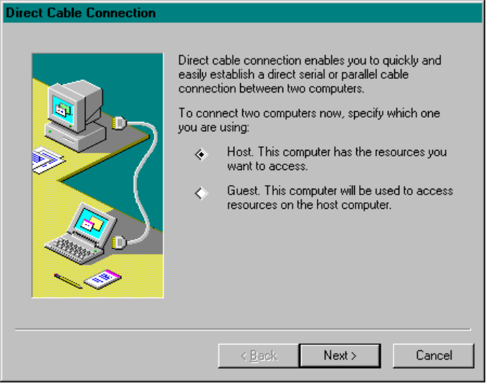
4. Specify the port to which the cable is connected on the local computer.
5. Next, you’ll be asked if you want to use password protection. If so, check the Use Password Protection box and specify a password.
Notice that you can’t set up user-level security choices when using Direct Cable Connection.
6. The host computer then displays a status message saying it is waiting for the guest computer to connect.
7. Repeat this procedure on the guest computer.

No new connection icon is added to the Remote Access folder after these steps. To set up the direct connection again, just select the Direct Cable Connection option in the Accessories folder and the last configuration you selected will be used.
Note

Using Briefcase for File Synchronization
Portable computer owners who also have a desktop computer constantly work to keep the most up-to-date files on the computer they are currently using. Windows 95 Briefcase minimizes this task by keeping track of the relationships between the files on the two computers.

How do I set up a Briefcase and synchronize files?
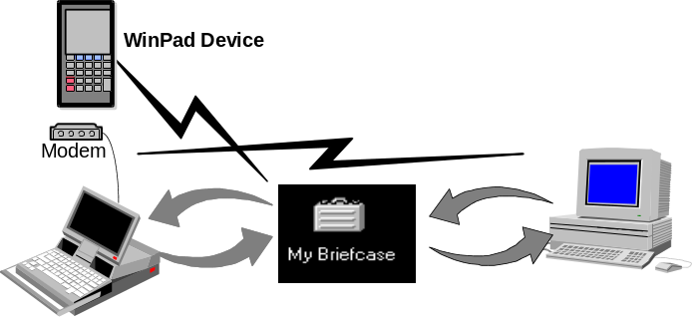
For example, a salesperson might need to collect data in certain files during a business trip. Later, it will be important for the files on that salesperson’s office computer to be synchronized with the files which were changed during the trip. Briefcase tracks and synchronizes the files.
With the Briefcase, a user can:
- Create a Briefcase folder.
- Add files to the Briefcase.
- Check the status of files in the Briefcase and their related files.
- Update related files, either individually or all at once.
- Split related files to maintain them separately.

The following shows a sample Briefcase which lists the contents and document status.
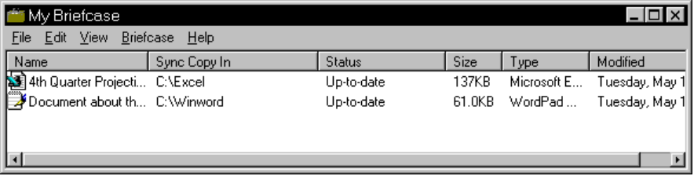
To create and configure a Briefcase

How can I use Briefcase to synchronize my files?
1. From the Start button, choose Programs, then choose Accessories, and then choose Create a Briefcase.
2. Specify whether you want the Briefcase placed on your desktop or in the root directory.
3. When the Briefcase is created, double-click its icon (from either the desktop or My Computer).
4. From My Computer or a network location, drag the files and directories you want to keep synchronized.

Unless you are the only person allowed to update network files, do not drag files from a network location and update them from your computer to the network server. To ensure that you do not inadvertently overwrite network files, make these files read-only.
Caution

Users can have as many briefcases as they want, with any name they want, with each briefcase containing hundreds of files.

Updating Files
When the user updates files using Briefcase, Windows 95 automatically replaces unmodified files with modified files. If both files have changed, Windows 95 calls the appropriate application (if available) to merge the disparate files.
To update files
1. Double-click the Briefcase icon.
2. Choose Update from the Briefcase menu.

When you open the Briefcase folder, you can check the status of any file in the Briefcase. You can also update files or split related files listed in the Briefcase.
Windows 95 provides a set of OLE interfaces that allow applications to bind reconciliation handlers to it, track the contents of the Briefcase, and define the outcome of any reconciliation on a class-by-class basis. For example, when both the file in the Briefcase and its synchronized copy outside have changed, Windows 95 calls the appropriate reconciliation handler to merge the two files. This could be handy when several users are simultaneously updating one large document.

Using Deferred Printing
To benefit users who work away from the office, the Windows 95 print subsystem supports for deferred printing. This capability allows users not connected to a printer to generate print jobs, which are stored on their local computers. This feature is handy for users working in a location away from the printer, and for users in the office who temporarily lose printer connections (because of network or printer problems. Users can create print jobs from Win16-based, Win32-based, or MS-DOS–based applications, and then print them on a physical printer upon reaching their home or office. Items not immediately printed are held in the print queue until the user reconnects to a printer.
See Also
Chapter 17, “Printing.”
To create a deferred print job
1. In the Printers folder, select Work Offline for the Object properties list.
2. Print to a printer. The printer will be dimmed in the Printer folder.
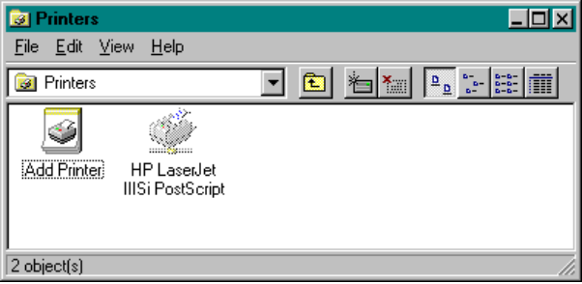
Jobs are stored in the queue until you set the printer to work online again.

Using Remote Mail
To be added:
- Examples for using remote mail
- How Microsoft Exchange client takes the most advantage of the limited transfer speeds of a phone line
- Discussion of property sheet settings

Using Other Third-Party Dial-In Tools
To be added:
- Information about how to connect to Shiva Remote Access Servers
- Additional security using third-party hardware

Troubleshooting Remote Access

I can’t access the Remote Access server.
1. From Network Neighborhood, double-click the Remote Access folder to run the Remote Access wizard and configure a new connection.
2. Use the new connection to try accessing the server again.

My modem is dialing out, but is not connecting or being answered.
1. Check the modem configuration and be sure the correct one has been selected.
2. Check the TAPI setup to see that all parameters, such as access codes, area code, and country code are setup correctly.
3. Try using Online Connection or the old version of Terminal, and use standard Windows 3.x Terminal troubleshooting steps.
4. Try choosing the driver for generic modem.
5. If yours is an external modem, check the cable and make sure that all is connected correctly.
6. If yours is an internal modem with a non-standard IRQ selection, use Device Manager to check the IRQ setting for the COM port and change it, if necessary.

My computer is configured as a Remote Access server, but you want to dial out.
1. From the Dial-In Options dialog box, change the selection to No Caller Access and click OK.
2. Now try to dial out.

The Remote Access server is not answering incoming calls.
1. Turn off Caller Access and shut down the computer.
2. Turn the computer’s power off to reset the COM port.
3. If the modem is external, turn off the modem.
4. Turn the computer power back on and reconfigure the Remote Access server, and then try again.
5. If these steps fail, turn off Dial-In Access and see if either terminal can manually answer the incoming call.
6. If yours is an external modem, check the cable and make sure that all is connected correctly.
7. If yours is an internal modem with a non-standard IRQ selection, use Device Manager to check the IRQ setting for the COM port and change it, if necessary.
8. On the user’s computer, try choosing the driver for generic modem, and then retry step 4.

