Chapter 1
This chapter provides detailed information about server-based setup, which includes installing Windows 95 source files on a server, plus preparing for and installing Windows 95 to run as a shared copy on a client computer. This Chapter also presents information about customizing Windows 95 installations and using logon scripts for automatic mandatory installation of Windows 95.
Network Setup

Network Setup (NETSETUP.EXE and related files) is available only on the Windows 95 compact disc. You cannot run Network Setup from the Windows 95 floppy distribution disks.
Important

Network Setup Overview 4-2
In This Chapter
Planning for Shared Installations 4-4
Task 1: Copying Windows 95 Files to a Server 4-8
Task 2: Creating Home Directories for Shared Installations 4-16
Task 3: Installing Windows 95 for Shared Installations 4-19
Technical Issues for Shared Installations 4-22
Customizing Windows 95 4-31
Setting Up Push Installations 4-36

Chapter 3, “Introduction to Windows 95 Setup,” for a description of the requirements and various Setup options, plus a description of the basic installation steps
See Also
Chapter 5, “Setup Technical Issues,” for details about Windows 95 Setup and system startup processes
Appendix C, “Windows 95 .INF Files,” for a detailed description of the format for statements used to customize Windows 95 in setup scripts
Appendix D, “MSBATCH.INF and Sample Setup Scripts,” for a detailed description of the settings that can be defined in setup scripts

Network Setup Overview
The purpose of the Network Setup program is to prepare everything to run Windows 95 Setup (SETUP.EXE) on network client computers. To support Network Setup, Windows 95 includes many improvements over support previously provided in Windows version 3.1 or Windows for Workgroups. Windows 95 provides new and better support for installing and running a shared copy of Windows 95 from a server, including support for the following kinds of shared installations:
- Computers that start from the local hard disk and then run a shared copy of Windows 95 from the server.
- Computers with single floppy drives that start locally from a floppy disk and then connect to a server to run a shared copy of Windows 95.
- Diskless workstations that remote-boot (sometimes called RIPL or remote IPL) from Novell® NetWare® version 3.x and 4.0 servers and run a shared copy of Windows 95. This option is available only for diskless workstations on Novell NetWare 3.x or 4.x networks.

After installing Windows 95 source files on a server, administrators can create and manage one or more home directories for shared installations. Home directories contain the specific configuration information for the client computers.
Administrators can also use Network Setup to create setup batch scripts to make it easy to automate all kinds of installations, as described in “Customizing Windows 95” later in this chapter. As part of the process of creating setup scripts, Network Setup uses the System Policy Editor user interface so that you can predefine installation settings. You can also edit the resulting setup batch scripts to customize Windows 95 Setup for your site.
To install Windows 95 source files on the network and set up batch scripts
- Run Network Setup (NETSETUP.EXE) under Windows 95, and follow the instructions to do the following:
- Copy the Windows 95 source files onto the server, as described in “Task 1: Copying Windows 95 Files to a Server” later in this chapter.
- Optionally, for shared installations, create home directories for running a shared copy of Windows 95 from a server, as described in “Task 2: Creating Home Directories for Shared Installations” later in this chapter.
- Create and run setup batch scripts for automated installation on client computers, as described in “Task 3: Installing Windows 95 for Shared Installations” later in this chapter.

To set up a computer from network source files to run Windows 95 from the local hard disk
- Run Windows 95 Setup as described in Chapter 3, “Introduction to Windows 95 Setup,” specifying the server name as the distribution source and, optionally, the filename for a setup batch script.

- Run Windows 95 Setup as described in “Task 3: Installing Windows 95 for Shared Installations” later in this chapter.
To set up a computer to run a shared copy of Windows 95 from the network

Network Setup can only be run from a computer that is currently running Windows 95 or Windows NT. You cannot run Network Setup from Windows 3.1, Windows for Workgroups, or MS-DOS.
Important
If you want to use Network Setup to create setup batch scripts or to create home directories for running shared copies of Windows 95, you must run Network Setup under Windows 95. If you run Network Setup under the Windows NT operating system, you can only use this program to install the Windows 95 source files in a shared directory.

Installing Network Setup on the Administrator’s Computer
NETSETUP.EXE replaces setup /a, which was used in Windows 3.x and Windows for Workgroups for administrative setup.
The files that make up Network Setup are uncompressed files in the \NETADMIN directory on the Windows 95 compact disc. The required files for Network Setup are the following:
NETSETUP.ADM NETSETUP.EXE
NETSETUP.DLL NETSETUP.INF
Network Setup is not installed automatically with Windows 95. (The System Policy Editor, which is required for creating setup batch scripts, is installed with Windows 95 if you choose to install the Network Administration component as part of Setup.)
A network administrator can install Network Setup on a local computer running Windows 95. To do this, insert the Windows 95 compact disc and make the CD-ROM drive the active drive. Switch to the \NETADMIN directory, and then type copy netsetup.* c: at the MS-DOS Prompt.

The following illustration summarizes the main tasks that are performed with Network Setup, as described in this chapter.
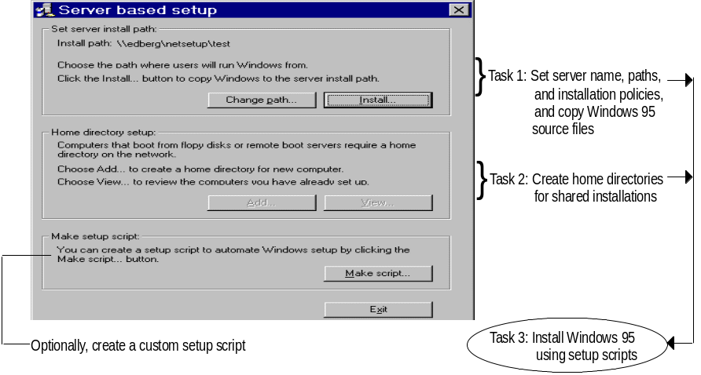

Planning for Shared Installations
This section provides some guidelines and summary information for planning the installation process for computers that will run a shared copy of Windows 95 (referred to as “shared installations” in this chapter). This information supplements that planning and implementation information presented in Part 1 of the Resource Kit.
Preparing to use Windows 95 on networks where users will run shared copies of Windows 95 includes several planning tasks:
- Planning for shared vs. private components
- Planning the requirements for shared installations, including the memory and hardware requirements for servers, the number of servers required, and the memory requirements for client computers in various configurations
- Planning setup scripts for running Windows 95 Setup on client computers

This section includes information and guidelines for decision making and planning related to server-based setup for running shared copies of Windows 95.

Planning for Shared vs. Private Components
This section provides guidelines for placing files and configuring server and client computers for running a shared copy of Windows 95 on the network.
Running a shared copy of Windows 95 reduces the hardware requirements for the network computers and provides network administrators with a centralized location for managing users’ system configurations. The trade-offs that guide decision making for such system configuration relate to reliability, maintainability, and performance. You must define where users on the network will operate, within the range for separating shared versus private files:
- The most private configuration: All Windows 95 executable files and applications are stored on the local hard disk and run locally. Swap files and TEMP files are also located on the local hard disk. The network is used only to store commonly used data.
Typically, such standalone computers are used for personal workstations, laptop computers that occasionally connect to the network, and workgroups that only share data (not software).
- The most shared configuration: All Windows 95 executables and applications run from the network. All data is saved on the network. Swap files and TEMP directories are placed on network drives.
Typically, such shared installations are used where there may be roving users who need to access various computers for tasks such as point-of-sale data-entry. Shared installations are also typically used on enterprise networks with many thousands of similar computers.

The benefits of a standalone installation include the following:
- Performance is faster
- The user can customize the system
- The system can start and continue running whether or not the server is available
- Less network traffic is generated

The benefits of a shared installation include the following:
- Easier to customize and manage multiple desktops
- More secure (each user has to log onto the network to use the computer)
- Easier to upgrade, especially for multiple computers
- Safer for novice users, because access to system files is controlled
- Requires less local computer power and other lower system requirements

Obviously, an entirely shared configuration makes it easy for the administrator to maintain the system and also requires less local disk space. However, a shared configuration also means more network traffic and requires larger servers.
Additional detailed information to be provided.

Planning the Requirements for Shared Installations
To be provided.

Server Requirements for Shared Installations
Network Setup operates on one server at a time. You specify a particular server where Windows 95 files will be installed, and you also specify where related home directories will be created for running a shared copy of Windows 95.
However, the home directories do not need to be created on the same server where the Windows 95 files are installed. In fact, to balance the network load, you may prefer to designate specific servers to maintain the Windows 95 source files, and other servers to contain the home directories and logon scripts.
This section provides some basic guidelines for deciding the number of servers, the hardware requirements, and other server specifications to support client computers running shared copies of Windows 95.
To be provided.

Workstation Requirements for Shared Installations
To be provided.
Memory Requirements for Running Windows 95
 |  | Third-party real-mode network clients
Windows 95 location | Microsoft¹ | NETX | VLM | Other
Local hard disk, local Windows 95
Local hard disk boot, Windows 95 on a server
Floppy boot, Windows 95 on a server
Remote boot, Windows 95 on a server
¹ Microsoft 32-bit, protected-mode network client (either Client for Windows Networks or Client for NetWare Networks)

Planning Setup Scripts for Shared Installations
You can create default and custom setup batch scripts that predefine the settings for Windows 95 Setup. You will probably choose to use batch scripts at your site if you are installing Windows 95 on more than five computers. You will want to take advantage of the ease of use, manageability, and time savings that setup scripts provide.

Before users can run setup batch scripts to install Windows 95, the network administrator needs to do the following:
1. Install the Windows 95 source files in a shared directory, as described in “Task 1: Copying Windows 95 Files to a Server” later in this chapter, and create home directories for users, as described in “Task 2: “Creating Home Directories for Shared Installations” later in this chapter.
2. Create one or more automated setup batch scripts (MSBATCH.INF and variations), as described in “Task 1: Copying Windows 95 Files to a Server” and “Customizing Windows 95” later in this chapter.
3. Optionally, create policy files, user profiles, user restrictions, and the WRKGRP.INI file, as described in “Customizing Windows 95” later in this chapter.
4. Optionally, create logon scripts for mandatory automated setup, as described in “Setting Up Push Installations” later in this chapter.

The tasks for planning setup scripts, customizing Windows 95, and using push installations apply for both standalone and shared installations. Most information about these planning activities can be found in Chapter 1: and in “Customizing Windows 95” later in this chapter.
Note

After you have completed these preliminary tasks, then users can log onto the network and run Windows 95 Setup by specifying the batch file that contains the appropriate installation information or, optionally, by way of logon scripts.
Additional detailed information to be provided.

Task 1:
Copying Windows 95 Files to a Server
To place the Windows 95 source files on a server, you must run Network Setup, the server-based setup program. This was formerly setup /a in Windows 3.x and Windows for Workgroups.

These procedures are the only steps you need to complete if you want to install Windows 95 source files on a server for standalone installations that will run Windows 95 from their local hard disks.
Note

The server where you install Windows 95 sources files for shared installations can be a server on a NetWare or Windows NT network or a server on one of these other networks: Artisoft® LANtastic® 5.x, Banyan® VINES® 5.52, Digital® Equipment Corporation (DEC™) Pathworks™ 4.x, IBM® OS/2® LanServer 1.2 or greater, Novell NetWare 3x or 4x, or SunSelect PC-NFS® 5.0. For more information, see “Technical Issues for Shared Installations” later in this chapter.
To get ready to copy Windows 95 source files onto a NetWare server
1. On the network administrator’s computer, log onto the NetWare file server.
This should be a network computer that can run as a standalone computer and is used only by support personnel for network maintenance. Make sure you log on with security privileges that allow you to create directories and copy files.
2. On the administrator’s computer, run castoff all to make sure that server-to-workstation or workstation-to-workstation messages do not affect Network Setup.

To run Network Setup
1. Run Windows 95 or Windows NT.

If you plan to use Network Setup to create setup scripts and user directories, you must run Windows 95.
Important

2. Insert the Windows 95 compact disc in the CD-ROM drive, make sure that it is the active drive.
For example, at the command prompt, type f: if the F drive is the CD-ROM drive, or switch to that drive in Windows Explorer or Network Neighborhood.
3. Switch to the \NETADMIN directory.
4. At the command prompt, type netsetup and press Enter.
– Or –
In Windows Explorer, double-click NETSETUP.EXE.
The Server-Based Setup dialog box appears so that you can begin installing source files and other tasks.
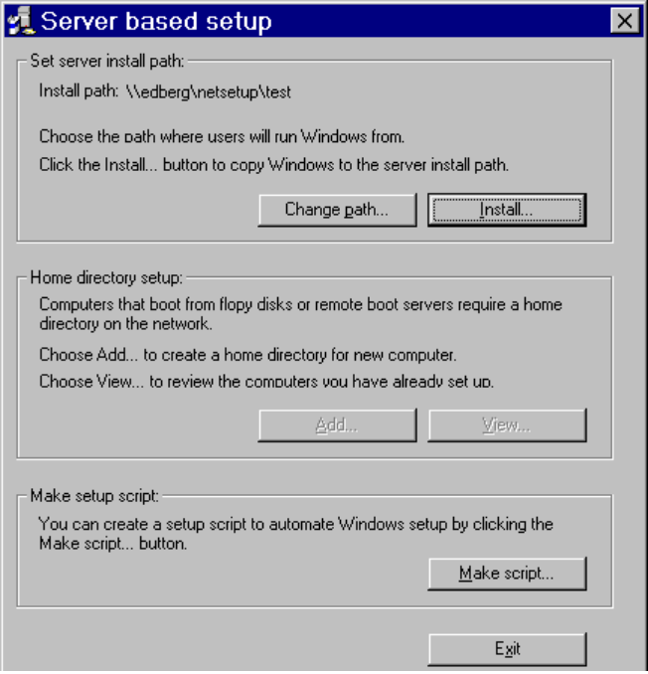

The following procedure summarizes the steps for server-based setup.
To install Windows 95 source files on a server
1. In the Server-Based Setup dialog box, click the Change Path button and specify the server path in the Source Path dialog box.
2. Click the OK button. Network Setup presents a dialog box (as described in the following sections) so that you can complete these actions:
- Set the server path where the source files are to be installed.
- Specify whether you want to create a default setup script, and then define the settings in the script, if you choose to create one.
- Specify how users can install Windows 95 from the server — on a local hard disk. as a shared copy, or as user’s choice.
- Install Windows 95 source files in the shared directory you specify, using the same directory structure as described Chapter 5, “Setup Technical Issues.”

The following sections provide details about the steps required to set up the server.

Selecting the Server
The first Server-Based Setup dialog box is used to specify a particular server, and to manage how users can set up Windows 95 from that server.
You cannot choose the Make Script, Add, or View buttons if you are running Network Setup from Windows NT
In the Server-Based Setup dialog box, the Server Path box shows the name of the selected server. If you are running Network Setup from a directory where Windows 95 is already installed, this shows that path. Otherwise, this box displays the mapped drive or a Uniform Naming Convention (UNC) path to another network location that you specify.
To change the server path
1. Use your preferred method to connect to the server where you will install the Windows 95 source files. Then run Network Setup.
2. In the Server-Based Setup dialog box, click the Change Path button if you need to specify a path to the server where you want to install Windows 95 source files.
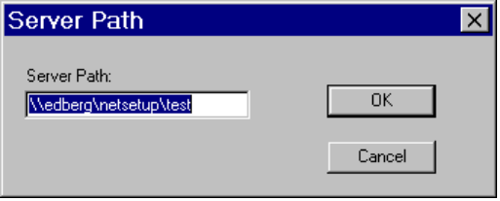
3. Type the drive letter for a mapped drive or the Uniform Naming Convention (UNC) path to the server you want. Then click OK.
For example, if the server where you want to install the files is named NWSVR1, type:
\\nwsvr1

If you are running Windows 95 with a NetWare client installed, you can use NetWare syntax to specify a NetWare server.

If the directory does not already exist, Network Setup asks if you want to create the directory, and then completes this action if you confirm the message.
If you have insufficient privileges for connecting to or creating a directory on the specified server, a message warns you. You can specify another server or quit Network Setup and log on under an account that has sufficient privileges on the specified server.
When Network Setup is set to a new path, it looks for the Registry file (NETSETUP.POL) that it uses to keep track of computers that have been set up. When you use Network Setup to create a home directory, an entry is added to the file. (No entry is added when a user runs Windows 95 Setup from that shared directory.)

Setting the Destination Path and Installation Policy
After you set the server name, you can install the Windows 95 source files on that server. You must specify the source and destination paths and set the installation policy for users who will install Windows 95 from this server. Optionally, you can specify that a default setup script should be created.
To set the destination path and installation policy for a specified server
1. In the first Server-Based Setup dialog box, click the Install button.
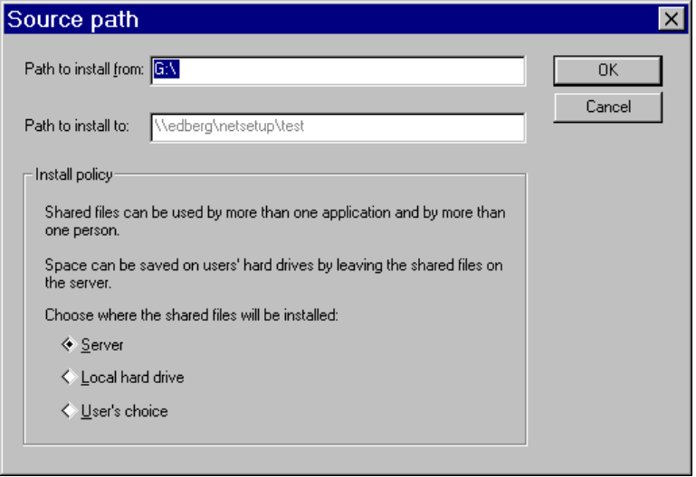
2. In the Path To Install From box of the Source Path dialog box, type the path for the source of the Windows 95 distribution files.
This is the path to the CD-ROM drive that contains the Windows 95 compact disc, the first time you install the source files.
If you are subsequently installing source files on other servers, you can specify the path to a shared directory that contains the Windows 95 source files.
3. In the Path To Install To box, type a path to the directory where the files will be installed.
This must be the directory on the previously specified server where you want to copy the source files. (Network Setup will create the directory if it does not already exist on the server.)

In either of these boxes, you can either type a drive and directory path or specify a UNC path name.
Note

4. Select an installation policy option as described in the following table, and then click OK to continue to the next part of server-based setup.
Network Setup displays the Create Default dialog box, as described in the following section.

The installation policy options specify whether users running Windows 95 Setup from this server are installing Windows 95 to run from their local hard disks or are preparing to run a shared copy of Windows 95 from the server, as described in the following list.
Installation policy option | Resulting installation capability
Server | Allows only shared installation of Windows 95 (shared Windows 95 files are stored on this server). Select this option if the source files on this server are to be used by client computers to run a shared copy of Windows 95.
Local Hard Disk | Allows only standalone installation on a local hard disk. Select this option if the source files on this server are to be used only to set up Windows 95 to run from local hard disks of client computers.
User’s Choice | Allows either shared installation or standalone local installation.

Network Setup stores the settings made in this dialog box in the MSBATCH.INF file it creates as part of the server-based setup process.

Creating a Default Setup Script
Network Setup can automatically create a default setup script. Network Setup stores the setup options you specify in an MSBATCH.INF file, together with the Windows 95 source files on the server. This default setup script can be used to install Windows 95 on individual computers, or it can be used as a template to create other versions of the setup script.

This section summarizes the procedural steps related to creating a default script while installing Windows 95 source files on a server. For information about making a script based on choosing the Make Script button in the Server-Based Setup dialog box, see “Customizing Windows 95” later in this chapter.
Note

If you are running Network Setup under Windows 95, when you click OK in the Install Server dialog box after specifying the destination path and installation policy option, Network Setup automatically prompts you to specify whether a default setup batch script should be created. If you choose to create a default script, it will be saved as MSBATCH.INF on the server.

You cannot create a setup script if you are running Network Setup under Windows NT.
Note

Your decision about whether to create a default setup script depends on the following:
- Most basically, whether you want to control installation settings for users who install Windows 95 from this server.
- Whether you want to use the default settings to create custom scripts.
- Whether you previously created the setup script to be used and do not require a new default script.

To continue with server-based setup without creating a default script
- In the Source Path dialog box, click OK. Then, in the Create Default dialog box, click the Don’t Create Default button to begin installing Windows 95 source files on the server.

To create a default script for automating Windows 95 Setup
1. In the Source Path dialog box, click OK.
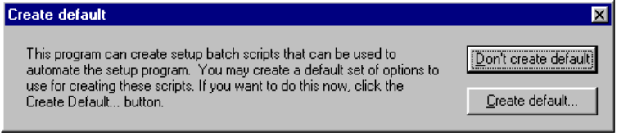
2. In the Create Default dialog box, click the Create Default button.
3. Network Setup displays the Policies page (the same one you see when you run System Policy Editor) for creating an MSBATCH.INF file that contains the specific configuration settings.
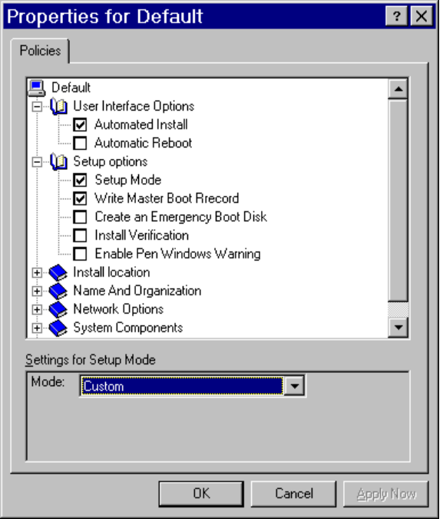

Although Network Setup uses the System Policy Editor user interface, this procedure does not create system policies. Only a setup batch script is created.
Note

For information about using System Policy Editor while creating a setup script, see the context-sensitive Help. For information about the specific settings saved in the MSBATCH.INF file on the server, see Appendix D, “MSBATCH.INF and Sample Setup Scripts.” See also “Customizing Windows 95” later in this chapter.

Installing Files on the Server
After Network Setup has the input it needs, it installs Windows 95 source files on the specified server, performing the following tasks:
- Copies Windows 95 to the server using the same hierarchical directory structure used when files are copied to the hard disk, as summarized in the following.
- Generates a default setup script (MSBATCH.INF) on the server, based on the default computer settings. This script is used whenever users run Windows 95 Setup from the shared directory on the server without specifying a particular setup script.

When Network Setup is finished, the server should have the following directory structure (rather than the flat directory structure created by the Windows 3.x setup /a command):
To be provided: directory structure

Task 2:
Creating Home Directories for Shared Installations
When you run Windows 95 Setup to create a shared installation on a client computer, information is stored in a home directory for the client computer. The home directory contains the following kinds of configuration information:
- Appropriate initialization and configuration files (including WIN.INI and SYSTEM.INI)
- The version of WIN.COM to be used to run Windows 95 by computers using that configuration
- SYSTEM.DAT and USER.DAT files that make up the Registry for the shared installation
- Files that define the Desktop, Start menu directories, and other programs
- The spool directory for printing

Task 2 in server-based setup using Network Setup involves creating home directories. You can set up the home directory for a single computer or specify the filename of a text file that you created previously to define home directories for multiple computer names.
To create a text file that defines multiple home directories
1. Create a text file that contains a list of computer names and the related location of the home directory that will contain computer-specific files for Windows 95.
The entry for each home directory in this text file should appear on a separate line, in the following format:
computername,\\UNC_server_name\directory

For example:
acct1,\\nwsvr1\netsetup\group1
acct2,\\nwsvr1\netsetyo\group2

2. Save the file in text-only (ASCII) format, using any filename and storing it in any shared directory.

Using a home directory is optional unless the user will be installing Windows 95 for a floppy-only computer or a remoteboot workstation.
Note

To create one or more home directories
1. In the Server-Based Setup dialog box, click the Add button.
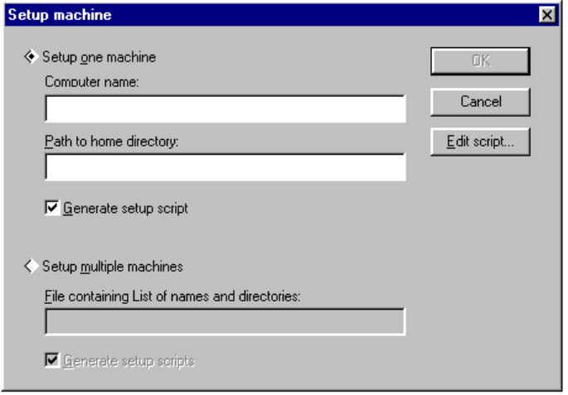
2. In the Setup Machine dialog box, click an option to select the mode for installing Windows 95 on computers from the currently specified server.
- If you want to add a single computer to the current server, click Setup One Machine. Then specify the name of the computer and the path to its home directory.
- If you want to add home directories in a batch, click Setup Multiple Machines. Then type the path and filename of the text file that contains the list of computer names and home directories. (This is the text file created in the previous procedure.)
In this case, you can type the name of a directory on the current server or type the UNC path name to a directory on another server.
3. If you want Network Setup to generate a setup batch script based on the values set in this dialog box, check the related Generate Setup Script check box.
A setup script for each computer will be generated based on the default script created in Task 1, as described “Creating a Default Setup Script” earlier in this chapter
4. After you have specified all options for home directories, click OK.

After Network Setup creates the specified home directories, it stores the setup batch script in the home directory, if you specify that a script should be created.
You can see a list of the home directories that have been created for the currently selected server.
To view home directories for the current server
- In the Server-Based Setup dialog box, click the View button.
When you are done viewing home directories, click the Close button to return to the Server-Based Setup dialog box.
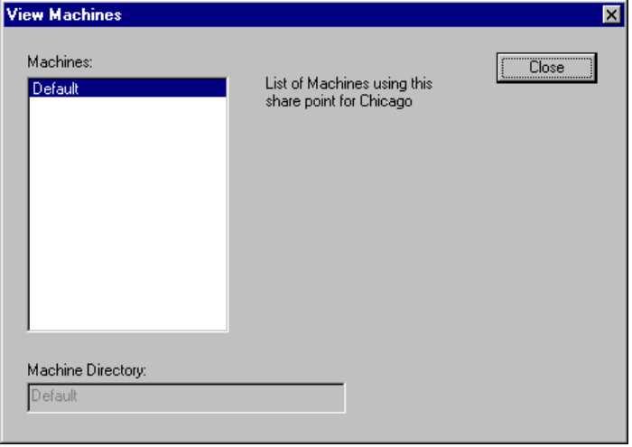

Task 3:
Installing Windows 95 for Shared Installations
Setup batch scripts can be used to install Windows 95 on the hard disk of a standalone computer, or to set up client computers to run a shared copy of Windows 95 from a server.
The setup script itself tells Windows 95 Setup what kind of installation is allowed, based on the installation policy specified by the administrator and stored in the script. The script can force a standalone installation or a shared installation, or allow either. If the script is set to allow either, Setup asks the user to specify the type of installation the user wants.
This section provides specific information for using setup scripts to set up a shared installation of Windows 95 on client computers.
Network Setup supports creating a shared installation of Windows 95 for the following kinds of systems:
- Remoteboot workstations
- Computers with a single floppy disk drive
- Computers with local hard disk drives

To configure each computer and complete the installation process, each computer starting from a hard disk or a floppy disk must run Windows 95 Setup. For remoteboot workstations, run Windows 95 Setup once for each class of similarly configured computers. Similar computers can then use the same source files and home directory to run Windows 95.
As described in Task 2, for shared installations the administrator can use MSBATCH.INF (the default setup script stored on the server) plus a list of computer names and home directories to generate a setup script for each computer. This results in a setup script for each client computer. The administrator can also create custom setup scripts using the MSBATCH.INF format, as described in “Customizing Windows 95” later in this chapter.
Whatever method is used to create setup scripts, the scripts can be used in logon scripts for push installations. Also, by archiving the batch script, the network administrator can quickly run Setup again for a particular computer, if a catastrophic failure occurs (for example, if the Registry becomes corrupted).
After you create the MSBATCH.INF file with appropriate settings, the location of the appropriate MSBATCH.INF file is specified as a command-line parameter when running Windows 95 Setup.
You can use these basic approaches for installing Windows 95 with setup scripts:
- Run Windows 95 Setup with a setup batch script from the command line after connecting to the server, as described in this section.
- Use a logon script to run Setup with a setup batch script, automatically installing Windows 95 when each user logs on, as described in “Setting Up Push Installations” later in this chapter.
- Use Microsoft System Management Service (SMS) or other third-party network management software to run Windows 95 Setup with a setup batch script.

To run Windows 95 Setup using a setup script
1. Log onto the network, running the existing network client software.
The client computer must already be connected to the network to run Windows 95 Setup from the shared directory.
2. Connect to the server that contains the Windows 95 source files.
3. At the command line, run Windows 95 Setup by specifying the batch file with the installation settings, using this syntax:
setup msbatch.inf

For example, type setup e:\wfwbatch.inf to run Setup using an .INF file named WFWBATCH.INF on drive E. Or, to use a script in the SCRIPTS directory on a server named NWSVR1, you could type setup \\nwsvr1\scripts\myscript.inf.

When you run Windows 95 Setup in this way, Setup takes all settings from the custom script and ignores the default script completely. After copying files, Windows 95 Setup restarts the computer and begins the Run-Once setup operations (printer setup, group conversions, and so on). When the Run-Once operations are finished, Windows 95 is completely installed.
When the user quits Windows 95 Setup at this point, Setup writes all changes to the Registry. The user can restart the computer and log on with the usual logon name and password.
The network administrator can automate this entire process by providing each user with a floppy disk that contains the necessary files for starting the computer, connecting to the network, and running Windows 95 Setup with a setup batch script.

To customize Windows 95 Setup, you define settings in the setup batch script, rather than make changes to .INF files (as was done when customizing Windows 3.x). The format for the file used to customize Windows 95 Setup is described in Appendix D, “MSBATCH.INF and Sample Setup Scripts.”
Note

How Windows 95 Setup Runs with a Setup Batch Script
When Windows 95 Setup runs with a setup script, Setup performs the following for both standalone and shared installations:
- Looks for MSBATCH.INF in the current directory. If this file is found, Setup knows it is running from a server.
- Runs detection and configures the hardware, storing the configuration in the home directory.
- Prompts the user to specify or change any settings that are not defined in the setup script.
- Copies the settings in MSBATCH.INF to be used by Control Panel and the Run-Once process in Setup.

For shared installations, Setup performs the following additional tasks:
- Prompts the user for the path to the home directory, if it isn’t specified in the script.
- Sets the home and shared directories in the Registry.
- Formats the startup disk and then copies files to the startup disk.
- If a protected-mode network client will be used, Setup configures the network for transition from the real-mode network, using settings from the setup script or by prompting the user.

Technical Issues for Shared Installations
Computers that run a shared copy of Windows 95 from a server can connect to network resources using the Map Network Drive dialog box, Open and Save As dialog boxes, and other methods that were commonly used in Windows 3.x. Also, computers can share resources such as printers and directories when protected-mode network support is installed, such as Microsoft Client for NetWare Networks.

For earlier versions of Windows, network administrators created a server share with the complete Windows distribution (shared files) on it. Then, by running Windows Setup on each client, the administrator installed the real-mode network client software and configuration files specific to a computer, usually storing these configuration files in a directory on the network.
Note
To run a shared copy of the operating system, Windows 95 uses the shared files on the server, startup files, plus the configuration files in the home directory.

There are some basic differences between installing Windows 95 to run a shared copy over the network, and running Windows 95 from a local hard disk on a computer that is connected to the network:
- No hard disk is required for shared installations.
- Network logon is required before running Windows 95 on shared installations, because network connectivity is required before Windows 95 can run over the network. This can be a general logon, rather than specific user logon.
- Because most of the Windows 95 files are located on the server for shared installations, the Windows 95 components must be loaded across the network before they can run, which increases network traffic.
- Home directories are required for remoteboot workstations and computers started from a floppy disk running a shared copy of Windows 95 from a server. For shared installations:
- On a remoteboot workstation, the home directory is created on the server. The network adapter is considered the boot device, and the real-mode operating system files are stored with the disk image in the home directory.
- On a computer started from a floppy disk, the home directory is on the startup disk.
- On a computer with a hard disk running shared Windows 95, the home directory is optional and can be on the local hard disk.

Networking Support for Shared Installations
First access to the network must occur in real mode. After Windows 95 is loaded, the protected-mode drivers take over if the computer is configured to use a protected-mode client such as Client for NetWare Networks.
Also, a real-mode version of the IPX/SPX or NetBEUI protocol is required to connect to the network. Not all supported protocols allow Windows 95 to connect to the network in real mode. For example, the Microsoft TCP/IP protocol in Windows 95 runs only in protected mode, so the computer must have IPX/SPX or NetBEUI protocols loaded to make the real-mode connection to the network. After the system loads and switches to protected mode, then Microsoft TCP/IP can be used.
For Microsoft networks, both NDIS 3.1 and NDIS 2.x network adapter card drivers are required. You can also use your existing NDIS 2.x or ODI drivers for third-party network support.
The startup disk contains a real-mode network that connects to the server. The real-mode software is small enough to fit on a floppy disk. This allows Windows 95 to start from a hard disk, floppy disk, or a remoteboot disk image in the case of a diskless workstation.
Client computers can run a shared copy of Windows 95 from a server using real-mode network software other than the Microsoft real-mode network software when protected-mode network support is not available. The following networks have been tested and shown to support running a shared copy of Windows 95 from a server:
- Artisoft LANtastic 5.x
- Banyan VINES 5.52
- DEC Pathworks 4.x
- IBM OS/2 LanServer 1.2 or greater
- Novell NetWare Workstation Shell 3.x and 4.0
- SunSelect PC-NFS 5.0

For additional information about running Windows 95 with a specific network, see Chapter 10, “Windows 95 on Other Networks”
Network clients running a shared installation of Windows 95 can use protected-mode network software by making a transition from the Microsoft real-mode network to Client for Windows Networks or Client for NetWare Networks. Network clients that don’t use the Microsoft real-mode network clients cannot use protected-mode network clients (such as Client for Windows Networks or Client for NetWare Networks) to connect to the shared installation.

Setting Configuration Information for Shared Installations
The configuration information in setup scripts for shared installations includes adding entries to CONFIG.SYS and AUTOEXEC.BAT. For shared installations on all remoteboot client computers, the following line is also added to AUTOEXEC.BAT so that it points to the correct source for COMMAND.COM:
@set compspec=bootdrv:\command.com

where bootdrv is the startup disk. On a computer started from a floppy disk, bootdrv is usually drive C. On a computer started from a floppy disk, bootdrv is drive A. On a remoteboot workstation, bootdrv is the RAM drive on the server.
The following sections describe the specific configuration changes made, depending on the type of computer that is set up for a shared installation.

Configuring a Computer that Starts from a Hard Disk
For a computer using a Microsoft network client, NETSTART.BAT is set up as follows for a shared installation on a computer with a local hard disk:
snapshot.exe /r
net start redir /v
net logon user password /y
net remote

where redir is either basic or nwredir.
For Client for NetWare Networks, NETSTART.BAT is as follows:
snapshot.exe /r
net start redir /v
net use \\server\directory
net remote

To be provided: example AUTOEXEC.BAT
Setup creates the home directory unless it already exists, and copies appropriate files into those directories. The following files are copied to the home directory:
- All initialization files, including WIN.INI and SYSTEM.INI
- SYSTEM.DAT and USER.DAT (must be in the home directory for user profiles to work)
- WIN.COM

Because all Windows 95 source files are on the server, Setup does not need to copy Windows 95 locally as it does for a standalone installation. The File Copy step in Setup should only copy about 2 megabytes (MB) of files.

Configuring a Computer that Starts from a Floppy Disk
Running shared copies of Windows 95 on client computers started from a floppy disk differs from computers started from a hard disk in that client computer must be able to start Windows 95 and access the shared Windows 95 home directories give limited file space on the floppy disk. Setup handles this problem by creating a mini-Registry on the floppy disk.
To be provided: sample AUTOEXEC.BAT

Configuring a Remoteboot Workstation
Windows 95 can be installed on remoteboot workstations that start from Novell NetWare 3.x and 4.0 servers. Remoteboot workstations contain a Remote Boot PROM that queries the network for instructions, creates a RAM drive, copies a disk image from the server to the RAM drive, and continues booting from the RAM drive. Windows 95 Setup creates this disk image.
When you run Windows 95 Setup on a remoteboot workstation, a mini-Registry is created and copied to the startup disk, which is a RAM drive. When Setup is finished, it creates a file containing a disk image of the RAM drive on the server.
Windows 95 Setup assumes that the destination directory is the root of the RAM drive, and copies files to it just as in the installations from a floppy disk only. In addition to the usual files, Setup copies IO.SYS, RPLBOOT.SYS, BOOTDRV.COM, and NWRPLTRM to the root directory.
For remoteboot workstations, Setup adds the following line to CONFIG.SYS to create the RAM drive:
DEVICE=A:\RAMDRIVE.SYS ramdrv: 1440

where ramdrv is the drive letter to assign to the RAM disk (the first available non-local drive).
For remoteboot workstations, the following lines must be added to AUTOEXEC.BAT:
@MKDIR ramdrv:\
@COPY A:\ ramdrv:\
@SET COMPSPEC=bootdrv:\COMMAND.COM

To be provided: sample AUTOEXEC.BAT

Creating the Disk Image for a Remoteboot Workstation
Novell specifies that to allow a remoteboot workstation to start from a Novell NetWare server, the following actions must be completed.
1. Create a boot disk, and then create a disk image file using the boot disk.
Windows 95 Setup installs a new disk image file, as described later in this section.
2. Copy the remoteboot files to the server.
3. Create a BOOTCONF.SYS file.
4. Install the Enhanced Remote Boot PROM on the network adapter card.
5. Install the network adapter card in the remoteboot workstation.
6. Connect the remoteboot workstation to the network.

This section describes how Windows 95 Setup installs a new disk image file. It also provides information to help you create BOOTCONF.SYS file to support remoteboot workstations running a shared copy of Windows 95 from a NetWare server. For more information, see the Novell publication Installing Enhanced Remote Boot PROMs on Novell Ethernet Network Interface Cards. To obtain this document, contact your NetWare vendor.
When Windows 95 Setup is finished, it automatically runs RPLIMAGE, a utility that creates a file on the server. This file contains a disk image of the RAM drive for the remoteboot workstation.
You can enter the boot image filename plus the workstation’s network address and node address in the BOOTCONF.SYS file on the NetWare server that is the repository for boot image files. BOOTCONF.SYS is stored in the SYS:LOGIN directory of the server, and is a text file that contains one record for each remoteboot workstation or group of workstations. Multiple workstations can be specified by using wild cards or question marks within the network address.
The following shows the format for each record in BOOTCONF.SYS. The parameters are defined later in this section.
0x[network_address,]node_address = image_filename.sys [ack] [frame=ff] [gns] [noack] [nogns] [noprotect] [notro] [protect] [ps=server] [tro] [wait time=sss]

Each record ends in a CR/LF character.
The NetWare server that contains the boot image files should have Novell RIPL.NLM loaded and bound to the appropriate network card. The following procedures summarize this process.
To load RPL on a NetWare 3.x or 4.x server
1. At the command prompt, type load rpl
2. Then type the following:
bind rpl to board [ack] [frame=ff] [gns], [nodefault], [protect], [ps=server], [tro], [wait time=sss]

To load RPL on a NetWare 2.x server
1. At the command prompt, type load rpl
2. Then type bind rpl to board
NetWare version 2.x does not accept parameters.
3. Restart the server to load the VAP.

The parameters for BOOTCONF.SYS records and for binding RPL are not case-sensitive. The parameters can be entered in any order, and can be separated by either blanks or commas. The following table briefly defines these parameters. For more information, see your Novell documentation on BOOTCONF.SYS.
Novell NetWare Parameters for BOOTCONF.SYS and BIND Commands
Parameter | Description
ack | Requires a per-frame acknowledgment so slower workstations can pace RPL, when it sends frames in burst mode.
bind board | Binds RPL to a board configured for 802.2 frames. The board can be specified by the name of the network adapter board number.
frame=ff | Configures RBOOT to use the following frame types: 802.2 (default), EII (Ethernet_II), or snap.
gns | Causes the workstation to use a Get Nearest Server request after RBOOT is downloaded. Use this parameter when the workstation should find a server other than the one containing RPL.
nodefault | Causes RPL to ignore remoteboot requests when the node address is not in BOOTCONF.SYS.
nogns | Overrides gns.
noprotect | Overrides protect specified with BIND.
notro | Overrides tro with BIND.
protect | Adjusts memory size in BIOS data area to reflect the amount of memory used by RBOOT, reducing available memory by 12K. Do  not use unless absolutely necessary.
ps=server | Specifies that RBOOT attach to a preferred server other than the server where RPL is located.
Parameter | Description
tro | Causes bootstrap program to perform This Ring Only Count Of 3 on all broadcast frames. Used in source routing environments.
wait time=sss | Specifies how many seconds (0000 to 665535) the workstation waits before selecting a Disk Image Name automatically, when multiple names are specified in BOOTCONF.SYS.

Windows 95 supports the following remoteboot PROMs for Novell:
- To be provided.

Startup Process for Shared Installations
The following briefly summarizes the startup process for a computer that starts from a floppy or hard disk to run a shared copy of Windows 95 from a server.
- IO.SYS starts and reads the Registry to determine whether the computer is running Windows 95 over the network.
- COMMAND.COM executes AUTOEXEC.BAT and NETSTART.BAT, which starts the network.
- If the network is configured to log on users in real mode, it asks for a user name and password, and then logs on the user. If the network is configured to log on users in protected mode, the network uses a generic user name.
- The network connects to the shared Windows directory and connects to the home directory using the path stored in SYSTEM.DAT, then sets an environment variable to HomeDir\SYSTEM.DAT.
- IO.SYS starts Windows 95.
- If the computer is running a protected-mode Microsoft network client, the real-mode network transitions to the protected-mode network.

For a general description of the Windows 95 startup process, see Chapter 5, “Setup Technical Issues.”

Startup Disks for Shared Installations
The full copy of the Registry for a shared installation exists on the network in the home directory. For shared installations that are not remoteboot workstations, Windows 95 Setup creates a startup floppy disk by modifying the boot sector and copying IO.SYS. For shared installations on computers with hard disks, Setup modifies the startup disk for Windows 95 by changing the boot sector and copying new IO.SYS, COMMAND.COM, and MSDOS.SYS files. The following files are copied.
Files on Startup Disk for Shared Installations on Hard-Disk Computers
COMMAND.COM  HIMEM.SYS  IFSHLP.SYS  IO.SYS  MSDOS.SYS | NDISHLP.SYS  NET.EXE  NET.MSG  NETH.MSG  NETSTART.BAT | PROTMAN.DOS  PROTMAN.EXE  RAMDRIVE.SYS  SNAPSHOT.EXE  NDIS 2.x driver

The following table lists the files on the startup disk for a computer with only a floppy-disk drive running a shared copy of Windows 95 from a server.
Files on Startup Disk for Shared Installations on Floppy-Disk Computers
AUTOEXEC.BAT  CONFIG.SYS  COMMAND.COM  HIMEM.SYS  IFSHLP.SYS  IO.SYS | MSDOS.SYS NDISHLP.SYS  NET.EXE  NET.MSG  NETH.MSG  NETSTART.BAT | PROTMAN.DOS  PROTMAN.EXE  RAMDRIVE.SYS  SNAPSHOT.EXE  NDIS 2 network card driver

For remoteboot workstations, Windows 95 Setup copies the same files to the home directory as are copied in the case of floppy-disk computers. In addition, Setup also copies the files listed in the following table.
Additional Startup Files for Remoteboot Installations
BOOTDRV.COM | NWRPLTRM.COM | RPLBOOT.SYS

The following notes apply for startup disks for shared installations:
- The contents of the startup disk fit on a 1.2 MB floppy.
- A startup floppy disk can be removed with no problems after Windows 95 starts.
- One startup disk can be used for similar computers (computers with the same kinds of network cards and settings). It is especially true that the same configuration can be used to run shared Windows 95 on remote workstations with similar hardware configurations.
- The startup disk can be marked read-only. The software on the startup disk does not require writing information to the startup disk.
- Files shared by clients are marked read-only.

File Organization for Shared Installations
Windows 95 files for a shared installation are stored in the locations described in the following table.
File location | Description
Startup disk | Contains all the real-mode software necessary to start the computer and connect to the shared Windows directory. This can be a local hard disk, a floppy disk, or a remoteboot disk image stored on a server. For computers that start from a floppy disk or from a remoteboot server, there is a small copy of the computer’s SYSTEM.DAT file on the startup disk that contains the information needed by IO.SYS and the real-mode network. After connecting to the home directory, Windows 95 uses the full Registry stored there.
Home directory | Contains files specific to a particular computer. The home directory can exist on any network shared resource.
Shared installation directory | A central shared directory on a server that contains all the shared Windows 95 files. This directory is always marked read-only.

Other Notes on Shared Installations

MS-DOS Mode is disabled for shared installations.
When the user starts a program that runs in MS-DOS Mode, Windows 95 shuts down and exits back to MS-DOS to run the program. When the program quits, Windows 95 starts again. This mode is available as a last resort mode for compatibility with existing software. Computers that run a shared version of Windows 95 lose their network when Windows 95 exits. Because of the related problems, MS-DOS Mode is not available for computers running Windows 95 over the network. When a user tries to run a program in this mode, Windows 95 warns that the mode has been disabled.

Hot docking for Plug and Play network adapters is not supported for shared installations.
When Windows 95 starts over the network, real-mode drivers control the network adapter card. If the network card is a Plug and Play card, the driver is responsible for setting the computer to the active state. Computers that run over the network do not support hot Plug and Play disconnects, because the operating system is on the network.

Fail-Safe Startup for network computers always runs configuration files.
To perform a Fail-Safe Startup on a network computer, the network must be started. Thus, IO.SYS always runs AUTOEXEC.BAT, CONFIG.SYS, and NETSTART.BAT, even in a Fail-Safe Startup. This allows the network computer to detect the semaphores in the home directory that describe how and when to perform a Fail-Safe Startup.

Swap files for shared installations have special considerations.
- The swap file is stored on the local hard disk for a client computer that starts from the hard disk.
- The swap file is stored in the home directory for a client computer that starts from a floppy disk and runs protected-mode network software.
Client computers that start from a floppy disk and run real-mode network software do not have a swap file.

Customizing Windows 95
When users install Windows 95 from source files on a server, there are several options that the administrator has for ensuring that a custom version of Windows 95 is installed. These options include the following:
- Creating custom MSBATCH.INF files. The custom setup scripts contain predefined settings for all the options that can be specified during Setup, and can contain instructions for installing additional software.
- Defining WKGRP.INI files to control users’ choices for workgroups to join on the network.
- Creating user profiles and system policies to restrict users’ abilities to change the system configuration.
- To be provided: other customizing options for Windows 95 installation.

The following sections provide details for each of these customization options.

Customizing Windows 95 with Setup Scripts
You can specify custom settings for Windows 95 installations by creating a custom file in MSBATCH.INF format and using this setup script for installation. The default setup script is stored with the source files on the server. Custom setup scripts can be stored in user’s home directories.
There are two ways to create a custom setup script:
- Use Network Setup to specify custom settings
- Edit an existing file in MSBATCH format to specify custom settings

These methods are described in the following sections.
To be provided: editing an MSBATCH file for a customized Windows 95 installation.

Using Network Setup to Create Custom Setup Scripts
To create a custom setup script using Network Setup
1. In the Server-Based Setup dialog box, click the Make Script button.
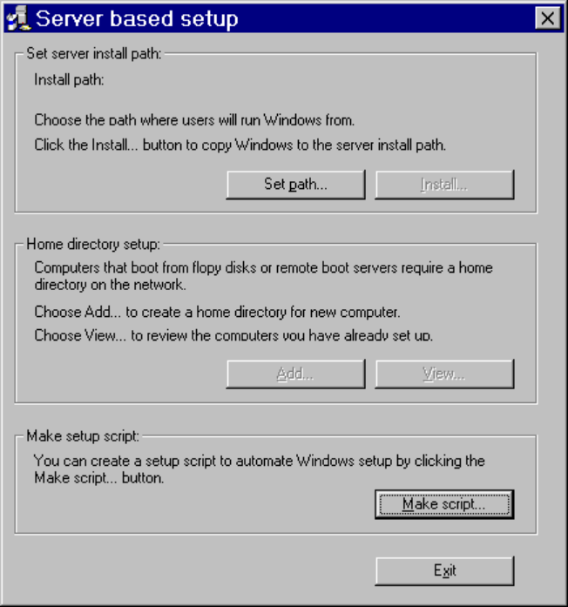
2. In the Save As dialog box, specify the filename for this setup script, and specify the path where the script is to be stored, and then click OK.
3. Use the Policies page (which resembles the System Policy Editor user interface) to specify custom settings, as described in the following procedures.

Details to be provided.
For a description of each of the specific settings that can be defined using Network Setup, see the description of policy settings in Chapter 12, “System Management.”

Editing MSBATCH.INF for Custom Settings
To be provided.

Using WRKGRP.INI Files
Windows 95 Setup can recognize an initialization file named WRKGRP.INI that administrators can use to specify a list of valid workgroups that users can choose to join. You can use WRKGRP.INI to help reduce the proliferation of workgroup names at your site, and to control the workgroup choices that users can make. The WKGRP.INI file is stored in the shared Windows directory on the server that contains the Windows 95 source files.
Windows 95 Setup maps the workgroup to the proper logon domain, preferred server, and other values to values defined in WRKGRP.INI, and stores these values in the Registry. The same values are used to control the related options available in Network Control Panel. The WRKGRP.INI file contains the following sections.
Section | Description
[Options] | Specifies the recognized options for using WRKGRP.INI.
[Workgroups] | Contains a list of workgroups from which the user can choose.

In Windows 95, for each workgroup, administrators can specify the domain, preferred server, and so on, that everyone in a workgroup will join, depending on the network providers used. The entry that defines the network providers for each workgroup has the following format in the [Workgroups] section:
workgroup_name=mapping1,mapping2,mapping3,...
By default in Windows 95, workgroups can be mapped to both Windows NT domains and NetWare preferred servers. (This is because Windows 95 includes network providers for these two networks.) For example:
MktMain=MktDom1,master1

This example specifies that the workgroup named MktMain has these two mappings: MktDom1 is the logon domain for the Windows NT network, and Master1 is the preferred server for the NetWare network.
Administrators can specify the 32-bit, protected-mode network providers that can be mapped for a workgroup by setting the Mapping= parameter in the [options] section of WRKGRP.INI. For example, if the network uses two network providers (MSNP32 for Microsoft networks and NWNP32 for NetWare networks), the following is defined in WRKGRP.INI:
[Options]
Mapping=MSNP32,NWNP32

If you use an additional network provider at your site, you can specify it by adding the network provider filename to the comma-separated list of Mapping= values. The Mapping= line specifies which network provider is related to a mapping and, the Registry key where it is stored, because the locations of domains, preferred servers, and so on, are stored under the network provider’s key in the Registry. For example, domain names are stored in the following key:
Hkey_Local_Machine\System\CurrentControlSet\Services
\MSNP32\NetworkProvider\AuthenticatingAgent

You can also specify a default mapping for workgroups that do not have an explicit mapping. This allows you to use an existing WRKGRP.INI created for Windows for Workgroups 3.11, and add one line to take advantage of Windows 95 functionality.
If a WRKGRP.INI exists, the Workgroup field in Windows 95 Setup and Network Control Panel shows all the workgroups listed in WRKGRP.INI. Users can choose a workgroup from the list or type one in. If Required=true in WRKGRP.INI, the user must choose from the list.
In WRKGRP.INI, ForceMapping= controls whether mapped values can be changed in the Windows 95 user interface. For example, if ForceMapping=true and the user selects a workgroup that is mapped to a domain, the Logon Domain box in Network Control Panel and in the logon dialog box is not available for the user to change.
Network Control Panel always saves these parameters directly to the Registry, so canceling Network Control Panel doesn’t cancel related settings.

When Windows 95 Setup finds the WRKGRP.INI file in the Windows 95 source files, it copies the file to the shared Windows directory.
Note

The format of the Windows 95 WRKGRP.INI is described in the following table.
WRKGRP.INI Settings
Section or entry | Description
[options] section:
ANSI=true | false | Specifies whether the workgroups need to be converted from an OEM character set to ANSI. Default is false.
Required=true | false | Specifies whether users can type their own workgroup name or forces them to choose from those listed.
ForceMapping=true | false | Specifies whether users can change values that are set by a mapping.
Mapping=NP1, NP2, NP3,...  (comma-separate list of network providers) | Specifies a comma-separated list of the network providers to which workgroups can be mapped. Also specifies the order in which values will be listed in the [Workgroups] section. Implicitly, this specifies where in the registry to store settings. This parameter is optional. By default, workgroups map to domain, preferred server.
Default=NP1 default,NP2 default, NP3 default,... | Specifies the default mapping for workgroups listed in the [Workgroups] section that don’t have a mapping defined. This allows administrators to add a single line to existing Windows for Workgroups WRKGRP.INI files to get minimal mapping functionality. The format is the same as for specifying a mapping in [Workgroups].
[Workgroups] section¹:
workgroup= | Specifies a workgroup that users can choose and its mappings will automatically be defined in the order specified in Mapping=. There can be a workgroup= entry in the file for every workgroup that users can choose.
¹ Each name of a workgroup must be followed by an equal sign (=) for the workgroup name to be interpreted correctly.

Restricting User Actions with Profiles and Policy Files
You can predefine settings in user profiles and system policy files to control user actions. For example:
- You can enforce a mandatory desktop configuration by installing a mandatory user profile (USER.MAN) in users’ home directories. (On NetWare networks, this is the MAIL directory for each user.)
- You can control the user’s security privileges, network access, and desktop configuration if you install a master system policy file on the logon server. This is the PUBLIC directory on a NetWare server or the NETLOGON directory on the primary domain controller for a Windows NT domain.

To take advantage of these features in Windows 95, you must define the user profile and system policy settings to be used. Then place these files in the appropriate directories before users run Windows 95 Setup. When users first log on to Windows 95, the profiles and policies will be used automatically.
To be provided: details for creating and placing master files.
For information about creating and using user profiles and system policy files, see Chapter 12, “System Management.”

Setting Up Push Installations
You can take advantage of batch scripts to set up an automated, mandatory installation scheme for installing Windows 95 on multiple computers. This is a new feature that will help you to easily install Windows 95 throughout the enterprise. We believe that you will want to use this method if you are responsible for installing Windows 95 on more than 50 computers.
After you set up the base files on one or more servers and create setup batch scripts, you can perform push installations in three ways:
- Use a logon script to run Setup with a setup batch script, automatically installing Windows 95 when each user logs on. Details are provided in the following section.
- Use Microsoft System Management Service (SMS) to run Windows 95 Setup with a setup batch script as a mandatory job, as described in “Using Microsoft SMS for Push Installation” later in this chapter.
- Use your third-party network management software to automatically install Windows 95 based on the setup scripts you created. Refer to the documentation for your network management software for information about performing remote installation of software.
To be provided: a list of other tools that can be used for push installations.

The following sections describe how to use logon scripts and Microsoft SMS for push installations.

Using Logon Scripts for Push Installation
This section describes how to prepare for and run Windows 95 Setup automatically from logon scripts, using the Windows 95 source files installed on a server.
A push installation uses Windows 95 Setup with a MSBATCH.INF file, plus components of the server on a NetWare or Windows NT network (the logon script and utility for managing user accounts). These are the basic steps for preparing to use push installations:
1. Install a shared copy of Windows 95 on the server, as described in “Task 1: Copying Windows 95 Source Files to a Server” earlier in this chapter.
2. Create the setup batch files for Windows 95 Setup to use and store these files in the appropriate directories on the server.
3. Create the logon scripts to start the installation process.
4. Create the user accounts to activate the logon scripts.

A push installation begins when the user logs onto the client computer. These cases are described here for pushing installation from logon scripts:
- From a Windows for Workgroups computer. This includes special steps that are described in the following section.
- From a computer running MS-DOS with a real-mode network client that supports logon scripts.
- From a computer running Windows 3.1 with a real-mode network client that supports logon scripts.

Preparing for Push Installations with Real-Mode Network Clients
If the real-mode network client used on a computer supports running logon scripts, you can use logon scripts to push installation of Windows 95 on that computer.
Push installation from logon scripts can be used on MS-DOS – based computers, including computers running Windows 3.x, for the following real-mode network clients, which support running logon scripts:
- Windows for Workgroups real-mode network
- Windows for Workgroups Add-On for MS-DOS
- LAN Manager 2.x real-mode network client
- Novell NetWare 3.x real-mode network client (NETX)

If the client computer is running on a Microsoft network, the real-mode network client for Windows for Workgroups or Windows 3.1 requires the following to run logon scripts:
- The line net start full in the logon script.
- The entry lmlogon=1 in the [network] section of SYSTEM.INI.

Essentially, the full network redirector must be loaded and the user must be validated for network logon, for push installations to be started from a logon script.
To use push installation from logon scripts to upgrade Windows 3.1 or Windows for Workgroups, the administrator must create a STARTUP.GRP file that contains the command line for starting Windows 95 Setup, as described in the following section.

Preparing a STARTUP.GRP File
If you will be upgrading computers that are currently running Windows 3.1 or Windows for Workgroups, you must create a special Startup group that is used just once to run the logon script.
The use of the Startup group is only mandatory when the user is running Windows for Workgroups 3.11 with logon validated performed by Windows NT Server. In this scenario, the user starts Windows for Workgroups, which loads the protected-mode protocols and processes the logon script. The login script runs in a DOS VM, and Windows 95 Setup cannot usually run in that way. Using a modified STARTUP.GRP file with a pointer to SETUP.EXE causes Setup to run as a Windows-based application.
Computers running a shared copy of Windows for Workgroups from NetWare servers usually use the server for logon validation, logon scripts, and the shared setup of Windows 95. In this scenario, the client computer running MS-DOS, Windows 3.1, or Windows for Workgroups uses the ODI real mode drivers, which are loaded and run in MS-DOS; therefore, Windows 95 Setup can be included in the NetWare logon script in the usual way. This is primarily used for MS-DOS users who must run Setup from the command prompt.
Windows 3.1 or Windows for Workgroup users can use the logon script method as described earlier or use the STARTUP.GRP method to run Setup from within Windows. The latter scenario is the preferred method for upgrading to Windows 95 if Windows 3.x is already installed on the computer.
The STARTUP.GRP method is also required if a computer running Windows for Workgroups is running real-mode ODI drivers and also loading protected-mode drivers to access a Windows NT Server where the Windows 95 installation source files are stored’
You must create the Startup group on a computer running Windows for Workgroups or Windows 3.1. In Windows NT Server, for example, the Startup group is contained in the Registry. Even if it is exported to a .GRP file. it cannot be correctly recognized by any versions of Microsoft Windows.
To prepare for push installations to upgrade earlier versions of Windows
1. Run Windows 3.1 or Windows for Workgroups on a computer.
2. If the Startup groups is not present, use the File New command in Program Manager to create a Windows for Workgroups Startup group.
If the computer already has a startup group, create a new group named UPGRADE.GRP.
3. In either the Startup group or Upgrade group, use the File New command to create an Upgrade icon that contains the following command line:
source_drive:setup source_drive:msbatch.inf

For example:
k:\setup k:\msbatch.inf

Specify the same source drive used in the logon script statements, as described in the following sections on preparing the server for push installations.
4. Copy the STARTUP.GRP (or UPGRADE.GRP) file to the shared directory on the server that contains the Windows 95 source files.
5. Delete the group or icon that you just create, so that it is no longer stored on the computer where you are working.

Setting Up a NetWare Server for Push Installations
To prepare the server for push installations
1. Run Network Setup, and install the Windows 95 source files in the shared directory on the NetWare server. For example, on the server named NWSERVER, copy the files to a directory named DISTSHARE.
You will need about 70 MB free on this drive. For more information about server requirements, see “Planning for Shared Installations” earlier in this chapter.
2. Modify the MSBATCH.INF file to meet your installation requirements, and copy it into the directory that contains the Windows 95 source files (NWSERVER/DISTSHARE, in the example in the previous step).
For more information, see Appendix D, “MSBATCH.INF and Sample Setup Scripts.”

This example always refers to the MSBATCH.INF file, though the filename is arbitrary, and can be any ASCII text file containing valid settings.
Note

3. On the NetWare server, create a user account named Upgrade and specify upgrade1 as the password. Also, set the types of options for this account as described in the following list.
- Allow user to change password = NO
- Force Periodic Password Changes = NO

This example uses a common upgrade account rather than changing every user’s logon script. This avoids activating the Setup process again after Windows 95 has been installed. You can use other utilities that avoid this problem.
Note

4. Assign the Upgrade user account to the preferred server that users have access to.
5. Create a logon script and assign it to the Upgrade user. The logon script must be placed in the appropriate directory on the server where users will log on.
The logon script for client computers running MS-DOS or Windows 3.1 must contain the following entries:
attach nwserver/sys: ;or volume name where MSBATCH.INF is stored
map source_drive:nwserver/volume
source_drive:setup source_drive:msbatch.inf

If this logon script will be used to upgrade computers that are currently running Windows for Workgroups, the logon script must contain the following lines.
attach nwserver/sys: ;or volume name where MSBATCH.INF is stored
map source_drive:nwserver/volume
rename windowsdir\startup.grp *.sav
copy path\startup.grp user_windows\startup.grp

Where:
- source_drive is the same drive letter as specified in the Startup group
- nwserver/DistShare specifies the NetWare server that contains the Windows 95 source files
- WindowsDir is the relative path to the user’s Windows directory
- Path is the path to the Startup group file
- User_Windows is the relative path to the user’s Windows directory that will contain STARTUP.GRP. Use the relative drive and directory designation ( . ) instead of hard-coding the Windows directory (for example, C:\WINDOWS).
For information about creating the STARTUP.GRP file, see “Preparing a STARTUP.GRP File” earlier in this section.

For example, for a computer running Windows for Workgroups, the logon script could be similar to the following:
attach nwserver1/win95
map k:nwserver1/win95
rename .\startup.grp *.sav
copy nwserver/scripts\startup.grp .\startup.grp

For a computer running MS-DOS or Windows 3.1 with a real-mode network client, the logon script could be similar to the following:
attach nwserver1/win95
map k:nwserver1/win95
k:setup k:msbatch.inf

Setting Up a Windows NT Server for Push Installations
To prepare the server for push installations
1. Run Network Setup, and install the Windows 95 source files in the shared directory on the Windows NT Server.
You will need about 70 MB free on this drive. For more information about server requirements, see “Planning for Shared Installations” earlier in this chapter.
For example, on the Windows NT Server named \\NTSERVER, create a shared directory named \DISTSHARE.
2. Modify the MSBATCH.INF file to meet your installation requirements, and copy it into the Windows 95 source directory (\\NTSERVER\DISTSHARE, in the example in the previous step).
For more information, see Appendix D, “MSBATCH.INF and Sample Setup Scripts.”

This example always refers to the MSBATCH.INF file, though the filename is arbitrary, and can be any ASCII text file containing valid settings.
Note

3. On the Windows NT Server 3.5 computer, create a user account named Upgrade and specify upgrade as the password.

This example uses a common upgrade account rather than changing every user’s logon script. This avoids activating the Setup process again after Windows 95 has been installed. You can use other utilities that avoid this problem.
Note

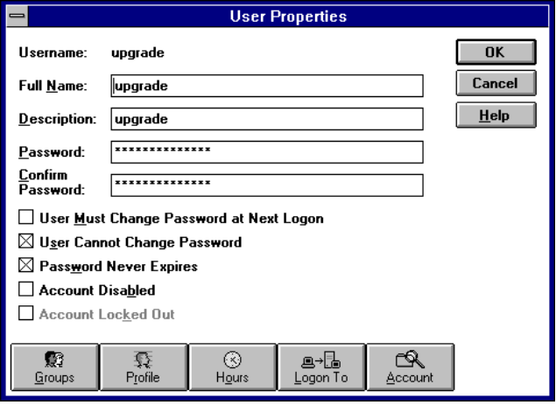
User Properties dialog box in Windows NT
4. In User Manager for Domains, make sure the following options are checked:
- User Cannot Change Password
- Password Never Expires
5. Assign the Upgrade user account to the corporate domain your employees have access to.
By default, the user account is assigned to the domain that you used to logged on. If you use multiple domains, create the Upgrade user account for each domain.
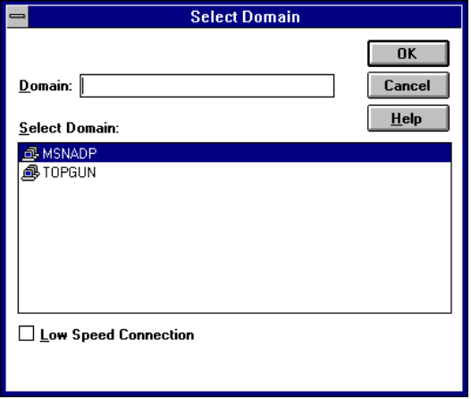
Select Domain dialog box in Windows NT
6. Create a logon script and assign it to the Upgrade user. The logon script must be placed in the appropriate directory on the computer running Windows NT Server:
winnt\system32\repl\input\scripts

The logon script for client computers running MS-DOS or Windows 3.1 must contain the following entries:
net use source_drive \\ntserver\distshare
source_drive:setup source_drive:msbatch.inf

If this logon script will be used to upgrade computers that are currently running Windows for Workgroups, the logon script must contain the following lines.
net use source_drive \\ntserver\distshare
rename windowsdir\startup.grp *.sav
copy path\startup.grp user_windows\startup.grp

Where:
- source_drive maps a drive letter for the server containing the source files. This must be the same drive letter as specified in the STARTUP.GRP file. For information about specifying. Check the lastdrive= setting in CONFIG.SYS to make sure that the drive letter specified on the above command line is a valid logical drive letter. If it is not, the network connection will not be made, and the Setup process will fail.
- \\ntserver\DistShare specifies the Windows NT computer that contains the Windows 95 source files.
- WindowsDir is the relative path to the user’s Windows directory.
- Path is the path to the Startup group file.
- User_Windows is the relative path to the user’s Windows directory that will contain STARTUP.GRP. Use the relative drive and directory designation ( . ) instead of hard-coding the Windows directory (for example, C:\WINDOWS). Do not use the WinDir environment variable, because WinDir is not an accessible environment variable in the script.
For information about creating the STARTUP.GRP file for Windows 3.1 or Windows for Workgroups, see “Preparing a STARTUP.GRP File” earlier in this section.

For example, for a computer running Windows for Workgroups, the logon script could be similar to the following:
net use k: \\ntserver\distshare
rename .\startup.grp *.sav
copy \winnt\system32\repl\input\scripts\startup.grp .\startup.grp

For a computer running MS-DOS or Windows 3.1 with a real-mode network client, the logon script could be similar to the following:
net start full
net use k: \\ntserver\distshare
k:setup k:msbatch.inf

Running Logon Scripts for Push Installations
To run a login script for a push installation
- Tell users to log onto the network using the Upgrade user account and the user password.
When a user logs on, the Windows 95 installation process begins automatically, using the settings in the MSBATCH.INF specified in the logon script.

After copying files, Windows 95 restarts the computer and begins the Run-Once operations (group conversions, and so on). When the Run-Once operations are finished, Windows 95 is completely installed.
When the user quits Windows 95 at this point, Setup writes all changes to the Registry. The user can restart the system and log on using the usual logon name and password.

Using Microsoft SMS for Push Installation
Microsoft System Management Server (SMS) is a set of Windows NT services that allow a system administrator to manage network computers remotely. This includes the following:
- Collecting an inventory of the computers and software on the network
- Distributing software
- Troubleshooting hardware and software problems
- Installing, configuring, and managing Windows 95

For more information about the Microsoft System Management Server, see Chapter 12, “System Management.”

