Chapter 1
Computers running Windows 95 can communicate with other computers running Windows 95, Windows for Workgroups, Windows NT, and LAN Manager on Microsoft networks. This chapter presents procedures and technical information for using Windows 95 on Microsoft networks.
Windows 95 on Microsoft Networks

Windows 95 and Microsoft Networking Overview 8-2
In This Chapter
Installing Client for Windows Networks 8-7
Configuring Client for Windows Networks 8-8
Logging onto Microsoft Networks 8-11
Using Logon Scripts with Microsoft Networking 8-12
Browsing on Microsoft Networks 8-13
File and Printer Sharing for Windows Networks 8-18
Running Windows 95 with Windows NT Server 8-23
Running Windows 95 in a Mixed Microsoft Network Environment 8-25
Technical Issues for Microsoft Networks 8-26
Troubleshooting Windows 95 on Microsoft Networks 8-34

Chapter 3, “Introduction to Windows 95 Setup,” for a description of how to install networking support for Windows 95
See Also
Chapter 7, “Network Technical Issues,” for a description of how the networking components in Windows 95 work together and technical discussions of network protocols, adapter cards, and other topics
Chapter 22, “Remote Access,” for information about setting up and using remote access capabilities with Microsoft networks

Windows 95 and Microsoft Networking Overview
Microsoft Client for Windows Networks is the 32-bit, protected-mode network client that provides the redirector and other software components for Microsoft networking. Client for Windows Networks also supports limited interoperability with other Microsoft-compatible server message block-based (SMB) servers such as IBM® LAN Server, DEC™ Pathworks™, AT&T® StarLAN, and LAN Manager for UNIX® Systems local area network software.
Computers running Client for Windows Networks can also take advantage of peer networking capabilities with File and Printer Sharing for Windows Networks (the Windows 95 SMB-based server, VSERVER.VXD), which supports all networking products that use the SMB-based file sharing protocol. With peer resource sharing, users can access shared file and printer resources on the network and can share local resources with other users on the network. Technical issues related to this feature are described later in this chapter.
The following describes the key features in the Windows 95 Client for Windows Networks.
Robustness and reliability. The client is designed for operation in a protected-mode multitasking environment and is more reliable than real-mode components.
32-bit, protected-mode implementation. The network provider and network client (redirector) together with NDIS 3.1 protocol and network adapter card drivers are implemented as 32-bit, protected-mode virtual device drivers (VxDs) and dynamic-link libraries (DLLs) to provide greater performance without the overhead of switching and buffering in real mode. Because the components run in protected mode, they use no conventional memory.
Auto-reconnect feature. If the network connection to a server is lost, Windows 95 attempts to reconnect in the background. If the server is restored to the network, the connection is reestablished automatically.
Client side caching. The redirector in Client for Windows Networks is implemented as a file system driver and shares the common cache (VCACHE) used by all Windows 95 file system drivers. Files read across the network are copied to the RAM cache and are made available to applications much faster than they would be rereading the file across the network. For a given file request, the cache is checked for the needed data before checking the network.
Plug and Play awareness. Client for Windows Networks responds to Plug and Play events and can load or unload when prompted by a Plug and Play event.
Full integration into the Windows 95 user interface shell. Client for Windows Networks supports key Windows 95 features such as long filenames and Point and Print support. Users access all networking features using the Windows 95 user interface, including Network Neighborhood and the Map Network Drive dialog box.
Provides direct connectivity and NetBIOS support. Client for Windows Networks can use any of the network protocols (IPX/SPX-compatible, Microsoft TCP/IP or NetBEUI). This client can also use IPX over NetBIOS or TCP/IP over NetBIOS for applications that require NetBIOS support.

Installing Client for Windows Networks
In Windows 95, Client for Windows Networks provides the redirector (VREDIR.VXD) to support all Microsoft networking products that use the SMB file sharing protocol. This includes support for connecting computers running LAN Manager, Windows NT, Windows for Workgroups, Workgroup Add-on for MS-DOS networking software for PCs running MS-DOS, and Windows 95.
Because Windows 95 network redirectors are implemented as file system drivers, Client for Windows Networks provides mechanisms for locating, opening, reading, writing, and deleting files, submitting print jobs, and making available application services such as named pipes and mailslots.
If a previous Microsoft network is running when Windows 95 Setup is started, then Client for Windows Networks is installed automatically, as described in Chapter 3, “Introduction to Windows 95 Setup.” You can add Client for Windows Networks after Setup in addition to other network clients that may be running, or if network hardware is added to the computer.
To install Client for Windows Networks
1. In the Network Control Panel, click the Configuration tab, and then click the Add button.
2. In the Select Network Component Type window, select Client, and click the Add button.
3. In the Select Device window, select Microsoft from the Manufacturers list on the left, and then select Client for Windows Networks in the Models list of on the right.
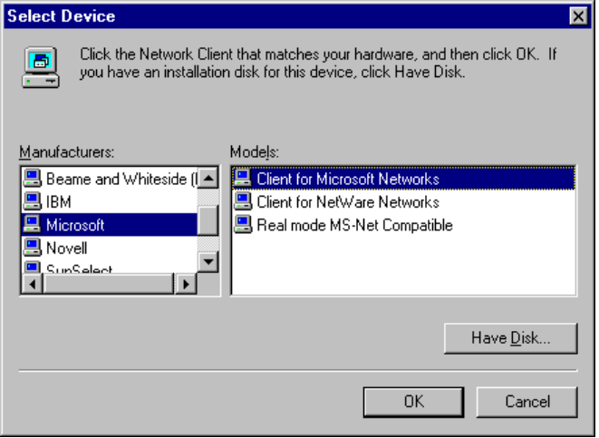
4. Click OK, and click OK again to close Network Control Panel. Then restart the computer.

Configuring Client for Windows Networks
Configuring Client for Windows Networks consists of specifying three options:
- Whether Client for Windows Networks is the primary network client
- Whether users can log onto a Windows NT domain for pass-through security validation
- Whether persistent connections to network drives will be validated when the user logs onto Windows 95

The following sections describe the options and how to configure the network client.

Configuring the Primary Network Client
Setting Client for Windows Networks as the primary network client means the following:
- For this computer, logon scripts run from a Windows NT Server computer.
- Users must be authenticated by a Windows NT Server domain controller to log onto the network.
- The Microsoft network can be used to download system policies and user profiles.

To make Client for NetWare Networks the primary network client
1. In the Network Control Panel, click the Configuration tab.
2. In the Primary Client list, select Client for NetWare Networks, and then click the Apply Now button.

Configuring Logon and Reconnection Options
The Client for Windows Networks property sheet allows you to specify Microsoft Windows NT validation and network resource connection options. This section describes how to configure these options.
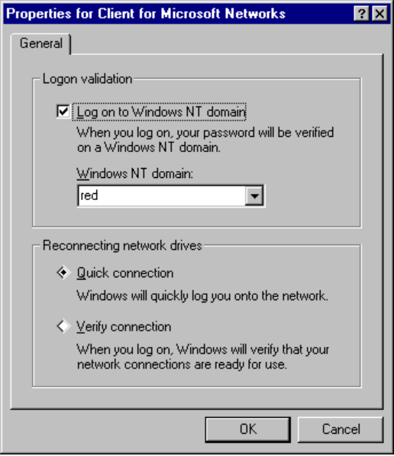
Logon Validation automatically validates the user on the specified Windows NT domain during the process of logging onto Windows 95. If logon validation is required on your network and this option is not configured, you will not be able to access most network resources. If this option is configured and you (or another user) does not provide a correct password, you may not notice anything about Windows 95 operation, except that you won’t have access to network resources.

In Windows 95, currently you cannot use password validation to control access to resources on the local computer.
Note

To configure logon validation for Client for Windows Networks
1. On the Configuration property sheet in the Network Control Panel, click the Properties button.
2. On the General property sheet, check the Logon To Windows NT Domain option if you want to automatically log onto a Windows NT domain when starting Windows 95.
If you do not want to log onto a domain when starting Windows 95, make sure this option is cleared.
3. If you select logon validation, you must also specify the domain to be used for validation by typing or selecting a server, or domain name in the Windows NT Server or Domain box.
You can specify the name of a Windows NT Advanced Server 3.1 or Windows NT Server 3.5 domain controller or specify the Windows NT domain name where you have a user account.

The user’s user name and password must be specified in a user account on the specified server or domain for logon validation to work.
Note
Also, Windows 95 does not support using a LAN Manager domain controller as a security provider.

You can also specify whether you want to automatically establish a connection for each persistent connection or verify whether to reestablish connections at system startup.
To configure how persistent connections are restored for Client for Windows Networks
- On the General property sheet for Client for Windows Networks, click Quick Connect if you want to log onto the network without establishing a session for each persistent network connection.
– Or –
Click Verify Connect if you want Windows 95 to verify each persistent network connection at startup by establishing a session for each persistent connection.

Quick Connect works in essentially the same way that Ghosted Connections worked under Windows for Workgroups 3.11. That is, Windows 95 initializes data structures for mapping local drives and local printer ports to network resources, but does not physically attach to the network resource until the user tries to access the resource.
When you use Quick Connect (which is the default), Windows 95 can start up and return control of the user interface faster than if the physical connections are actually made. Because your computer may not be physically attached to the resource when you click a drive icon (for example, in My Computer), you might see a slight delay before the directory for the network drive is displayed. This delay is balanced against a possibly long startup time, depending on the number of persistent network connections you maintained.

Logging onto Microsoft Networks
There can be two levels of logon validation on Microsoft networks:
- Log onto Windows 95 using a user name and password
- Log onto a Windows NT domain when logon validation is enabled, as described in “Configuring Client for Windows Networks.”

This section provides an overview and technical information related to logging onto Windows 95.
Windows 95 provides a single unified logon prompt. This prompt allows the user to log onto Windows 95 (which unlocks the .PWL file that caches encrypted passwords) and to all networks at the same time. The first time a user starts Windows 95, there are two separate logon prompts if logon validation is enabled—one for the system and one for the domain. If the two passwords are not changed, the second logon prompt for the domain is not displayed again.
To log onto Windows 95 when logon validation is enabled
- When the Enter Network Password dialog box appears after starting Windows 95 for the first time, specify the user name and password, plus the name of the Windows NT domain that contains the related user account.
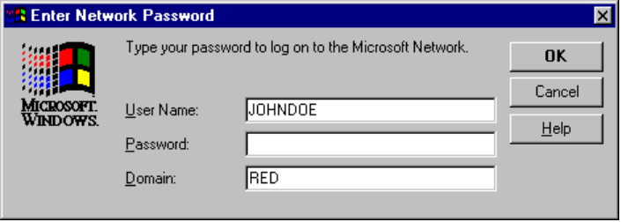
The next time this computer is started, Windows 95 displays the name of the last user who logged on and the domain name used for validation. If the same user is logging on again, only the password needs to be entered. If another user is logging on, that user’s unique user name and password must be entered.

The network administrator can enforce requirements for logon validation by defining system policies. For information, see Chapter 12, “System Management.”
Note

In the following example, User1 on a computer running Windows 95 is connecting to a Windows 95 shared resource protected by user-level security. This user has logged onto the Windows NT domain and has been validated by the domain controller.
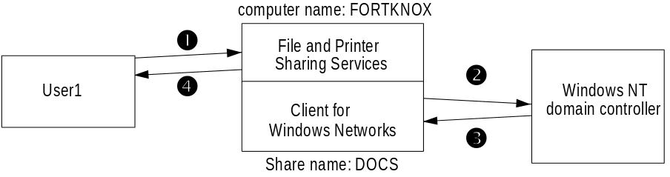
In this illustration, these steps are followed:
1. User1 requests access to the shared resource \\FORTKNOX\DOCS by using the Map Network Drive dialog box or net use command. This resource is protected with user-level security.
2. The computer named FORTKNOX, which is running File and Printer Sharing for Windows Networks, asks the Windows NT domain controller if User1 has logged onto the domain and been validated.
3. The domain controller replies to the request with a positive answer and also sends a list of groups to which User1 belongs. Windows 95 checks the Access Control List (ACL) for the shared resource and verifies that User1 has been granted individual access or belongs to a group that has been given access.
- If the user has not logged onto the domain, the system asks the user for the password, and then continues with verification if the correct password is provided.
- If User1 does not have individual access rights or does not belong to a group that has access, an access-denied error message appears.
- If User1 has been granted individual access or belongs to a group that has access, Windows 95 sends a successful connection reply back to User1.

Using Logon Scripts with Microsoft Networking
To be provided.
For details about using logon scripts for push installation of Windows 95 on Windows NT networks, see Chapter 4, “Network Setup.”

Browsing on Microsoft Networks
With the Windows 95 user interface, users can browse network resources to access information or connect to resources available on the network. Users can find network resources by scrolling through a list of available workgroups, a list of available computers in a given workgroup, and a list of available resources on a given computer. The Windows 95 browsing scheme for Microsoft networks is based on the scheme currently used for Windows NT and Windows for Workgroups, as described later in this section.
This section provides information on these topics:
- Network Neighborhood overview, with information on using this tool for finding and connecting to shared resources on the network
- Connecting to drive and printer resources in Windows 95
- Browsing with the net view command, showing how you can find and connect to resources on the network from the command prompt

For technical notes on how browsing works in Windows 95, see “Technical Issues for Microsoft Networks” later in this chapter.

Network Neighborhood Overview
The Network Neighborhood interface is the primary means by which users can browse the network. For information about what happens internally when Network Neighborhood is used to browse multiple networks, see the description of the Multiple Provider Router in Chapter 7, “Network Technical Issues.”
To use Network Neighborhood
1. Double-click the Network Neighborhood on the desktop.
When you open the Network Neighborhood, you can see workgroups and domains on your network, and the servers to which you are connected. You can double-click any of these computers to access their resources.
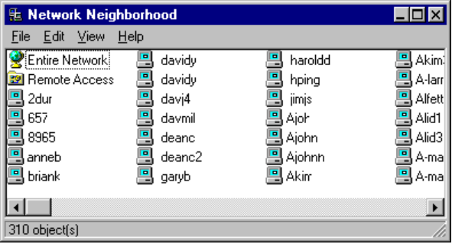
2. Double-click the Entire Network icon.
A list appears, showing all the Microsoft network domains and workgroups on your network. If you have both Client for Windows Networks and Client for NetWare Networks installed, the list of NetWare servers is at the end of the list of workgroups and domains in the Entire Network window.
3. Double-click any resource in the Entire Neighborhood window to access that resource.
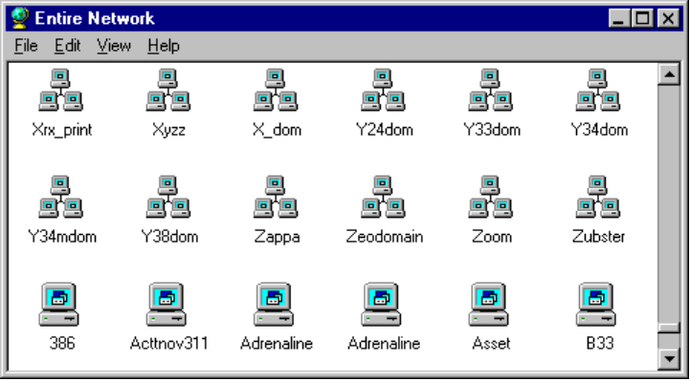
Right-click a server icon to see a context menu that shows what you can do with that server.
These icons represent workgroups or domains.
These icons represent servers or other computers running File and Printer Sharing for Windows.
In both the Network Neighborhood and Entire Network views, you can access shared resources on a server without having to map a network drive. Browsing and connecting to the resource consist of a single step.

Connecting to Drive and Printer Resources
This section presents the following topics:
- Making drive connections on Microsoft networks
- Making printer connections on Microsoft networks

Making Drive Connections on Microsoft Networks
The toolbar available in every window includes the Map Network Drive button (as shown in the margin), which displays the Map Network Drive dialog box.

In this dialog box, you can type the name of a Microsoft network server and shared directory using the Uniform Naming Convention (UNC). For example, to connect to the server CORP and the shared directory DOCS, the UNC name to specify is \\CORP\DOCS.
You can make any drive mapping persistent (that is, stored and automatically reconnected at startup) by checking the Reconnect At Logon check box in any Map Network Drive dialog box.
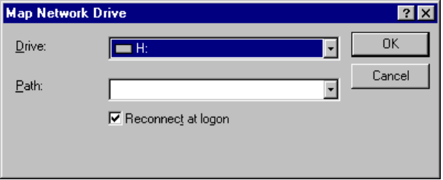
To make a network connection persistent, click the Reconnect At Logon option so it is checked.
Windows 95 also supports the mapping of a Microsoft network drive resource using the net use command from the command line, as described in Appendix A, “Summary of Command-Line Commands.”

Making Printer Connections on Microsoft Networks
Shared printer resources on Microsoft networks can be specified
during the installation of a new printer using the UNC syntax of \\servername\print_share_name or using the Point and Print method
for installing a printer driver.
See Also
Chapter 17, “Printing,” for more information about Point and Print
For example, for the shared printer named HP_III on the server CORP, the network path in UNC syntax is \\CORP\HP_III.
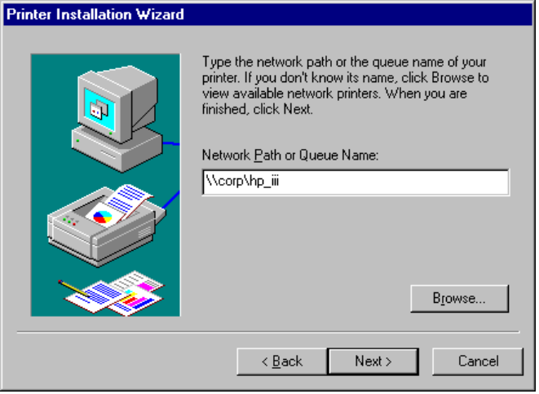

Browsing with the Net View Command
Browsing network resources at the MS-DOS prompt is handled by the real-mode networking components. The net view command is used to request a list of computers present in a given workgroup. Unlike a browsing request from one of the Windows 95 user interface components such as Network Neighborhood, the net view command requests a list of computers directly from the master browse server.
To display a list of computers in your workgroup that share resources
- At the command prompt, type net view and press Enter.

The following summarizes the syntax for the net view command.
net view [\\computername]
Net View Syntax
– Or –
net view [/workgroup:workgroupname]
computername
Net View Parameters
Specifies the name of the computer which has shared resources you want to see listed.
/workgroup
Specifies that you want to view the names of the computers in another workgroup that share resources.
workgroupname
Specifies the name of the workgroup which has computer names you want to view.

Tip for Using the Net View Command
The net view command is a valuable troubleshooting tool if you suspect the browse list maintained by a backup browse server is incomplete or inaccurate. You can use the net view command to get the list of known computers directly from the master browse server. The request is not handled by a backup browse server.
If the list of computers returned from the request by a master browse server is inaccurate, you could reset this computer by exiting Windows 95 to request that a new master browse server be designated for the workgroup.

File and Printer Sharing for Windows Networks
File and Printer Sharing for Windows Networks is the Windows 95 SMB server (VSERVER.VXD), which supports all Microsoft networking products that use the SMB file-sharing protocol. File and Printer Sharing for Windows Networks is a 32-bit, protected-mode network component based on the SMB file-sharing protocol and can work with Windows for Workgroups, Windows NT, LAN Manager, LAN Manager for UNIX, AT&T StarLAN, IBM LAN Server, 3Com® 3+ Open® and 3+ Share®, and DEC Pathworks. Windows 95 enhances the features of Windows for Workgroups peer services to provide administrative control over whether server services are enabled and what specific resources can be shared with which users.
This section presents the following topics:
- File and printer sharing overview
- Installing peer resource sharing services for Windows networks
- Configuring peer resource sharing services for Windows networks

File and Printer Sharing Overview
Windows 95 supports share-level security similar to the security provided with Windows for Workgroups. This level of security associates a password with a shared disk directory or printer. Share-level security for peer resource sharing can be implemented in a Windows 95-only peer-to-peer network or on a network supported by Windows NT or other Microsoft Windows network-compatible servers.
Windows 95 also supports user-level security by linking directly to a Windows NT domain for user account validation (or using a NetWare server, if running a NetWare-compatible network client). For network administrators, the user account list is centrally controlled at the Windows NT domain controller. For users on a Windows network, it is only possible to share a resource with users with accounts in the Windows NT account database. Users can also be assigned specified access rights for particular resources. For specific information about using and managing security, see Chapter 11, “Security.”
Although Client for Windows Networks (VREDIR.VXD) and File and Printer Sharing for Windows Networks (VSERVER.VXD) are separate network processes, they share connection information and pass requests to each other when validating a user-level security request.
When a user requests access to a shared resource under user-level security, File and Printer Sharing for Windows Networks checks for the user’s logon name against the list of user accounts maintained on the domain controller. If this is a valid user logon, Windows 95 then checks whether this user has access privileges for this resource. If the user has access privileges, then the connection is established.
Using the NetWatcher tool, a network administrator can remotely monitor connections to any resource on any computer running File and Printer Sharing for Windows Networks (provided the Microsoft Remote Registry service has been installed for that computer). The network administrator can disconnect users and change access rights for users on a particular computer. By default, remote administration is limited to user accounts with Administrator privilege. For more information, see Chapter 12, “System Management.”

Installing File and Printer Sharing for Windows Networks
If you choose the Custom Setup option in Windows 95 Setup, you can specify that File and Printer Sharing for Windows Networks be installed with Windows 95. Otherwise, you can add the service later using the Network Control Panel.
The administrator can control whether this service is installed by default during Setup or restrict users’ ability to install this service by specifying options in setup scripts, as described in Chapter 4, “Network Setup.” The administrator can also restrict access using system policies, as described in Chapter 12, “System Management.”
To install File and Printer Sharing for Windows Networks
- In Network Control Panel, click Enable File And Printer Sharing on the Configuration property sheet.
– Or –
1. In the Network Control Panel, click the Add button.
2. In the Select Network Component Type window, select Service and click the Add button.
3. In the Select Device window, select Microsoft from the Manufacturers list, and then select File and Printer Sharing For Windows Networks in the Models list.
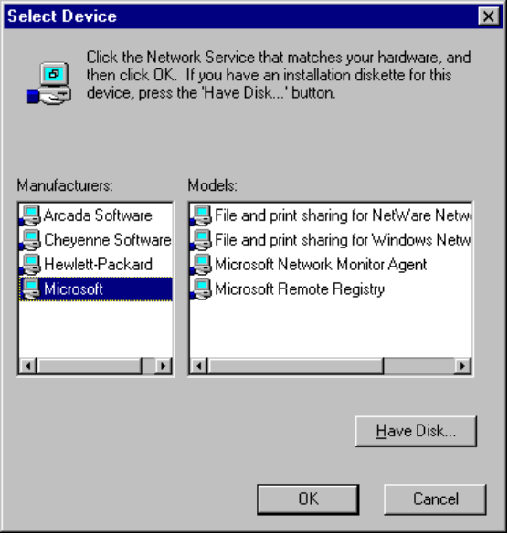

Configuring File and Printer Sharing for Windows Networks
The default configuration settings for File and Printer Sharing are correct for most installations. You should only need to change these settings in the following circumstances.
- To be provided: scenarios for changing these properties.

Use the Network Control Panel to configure the Browse Master and LMAnnounce parameters for the peer resource sharing service. For more information about the Windows 95 browse service that is affected by these parameters, see “Browsing on Microsoft Networks” later in this chapter.
For information about configuring security on the Access Control property sheet, see Chapter 11, “Security.”
To configure File and Printer Sharing for Windows Networks
1. In the Network Control Panel, click the Configuration tab.
2. Select File and Printer Sharing for Windows Networks, and then click the Properties button.
3. On the Advanced properties sheet, set values for BrowseMaster and LMAnnounce parameters, as described in the following procedures.
4. Click OK, and then click OK in the Network Control Panel. Then restart the computer.
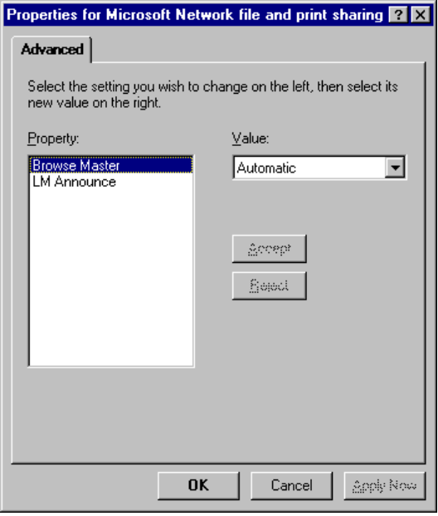
To specify Browse Master settings
1. Select Browse Master in the Property list in the Advanced property sheet for File and Printer Sharing for Windows Networks.
2. Select a setting in the Value list, as described in the following table.
Option | Description
Yes | Specifies that this computer is to be used to maintain the browse list for computers in your workgroup. This increases the likelihood that this computer will become the browse master in your workgroup.
No | Specifies that this computer is never used to maintain the browse list. Use this setting if the computer has little free memory or is connected by a slow link (such as a dial-in connection), or if other conditions create special performance problems.
Automatic | Specifies that this computer will maintain the browse list if Windows 95 determines that it is necessary. The default.

At least one computer in the workgroup must have the value of Automatic or Yes for this parameter to ensure the browse list is available to network computers. This parameter is the equivalent of the MaintainServerList= entry in the [network] section of SYSTEM.INI in Windows for Workgroups 3.11.

The LMAnnounce property controls whether a computer running File and Printer Sharing for Windows Networks is visible to LAN Manager 2.x clients.
To specify LMAnnounce settings
1. Select LMAnnounce in the Property list in the Advanced property sheet for File and Printer Sharing for Windows Networks.
2. Select a setting in the Value list, as described in the following table.
Option | Meaning
Yes | Specifies that you want this computer to announce its presence to other Microsoft networking computers in the workgroup. This value must be set to Yes if other computers in your workgroup need to see this computer when browsing the network.
No | Specifies that you do not want this computer to broadcast its presence to other computers in the workgroup. Setting this value to No minimizes the level of network traffic. Other users can still connect to this computer by specifying its UNC name in a Map Network Drive dialog box, but the computer will not appear in browse lists.  This value should be No if there is no LAN Manager 2.x domain on your network.

This parameter is the equivalent of the LMAnnounce= entry in the [network] section of SYSTEM.INI in Windows for Workgroups 3.11.
A LAN Manager 2.x domain is known by browse servers in a workgroup only if at least one computer running Windows 95 (or Windows NT in the domain) is a member of that LAN Manager 2.x domain.
To make a Windows networking computer a member of a LAN Manager 2.x domain
- Set the workgroup name for the computer to be the same as the LAN Manager 2.x domain name.

Running Windows 95 with Windows NT Server
Microsoft Windows NT Server networks provide both client-server and peer networking with user-level security using a domain structure. You can run Windows 95 on a Windows NT network, and you can install Windows 95 for dual-booting on Windows NT 3.1 and Windows NT 3.5 computers.
The following chapters present additional details related to Windows 95 on Windows NT networks:
- Chapter 4, “Network Setup,” for information about setting up a Windows NT Server with Windows 95 source files for shared and local installation
- Chapter 5, “Setup Technical Issues,” for installing and removing Windows 95 as a dual-boot operating system with Windows NT
- Chapter 7, “Network Technical Issues,” for a description of the support available through Windows NT for DHCP and WINS servers
- Chapter 11, “Security,” for a detailed description of user-level security in Windows 95 using Windows NT for pass-through validation
- Chapter 15, “Disks and File Systems,” for information about how long filenames are resolved when Windows 95 is running on a Windows NT network

Details about the following notes are provided in Chapter 4, “Network Setup”:
- Windows 95 and Windows NT versions 3.1 or 3.5 can be installed on the same computer, but should not be installed in the same directory.
- If you installed Windows NT in the same directory as Windows 3.1 or Windows for Workgroups, you cannot be upgraded to Windows 95. You must install Windows 95 in a new directory.
- You cannot run Windows 95 Setup from within Windows NT 3.1.
- If your computer has any NTFS (Windows NT file system) partitions, these are not available from within Windows 95. Therefore, any data or programs on those partitions cannot be seen or accessed from Windows 95.

The Microsoft Windows NT Server operating system is the high-end member of the family of Microsoft Windows operating systems, providing a powerful, reliable, and scaleable operating system to support the demands of client-server computing.
Windows NT Server provides the ideal platform for the server backbone in a mixed-network environment. It is especially versatile and powerful for enterprise networks made up of LANs that use a variety of network types and require dial-in support for network access.
Windows NT Server is designed to support complex business applications with the following features:
- Networking and workgroup support. Windows NT Server provides built-in
file and printer sharing capabilities for workgroup computing, and an open network system interface that includes built-in support for IPX/SPX, TCP/IP, NetBEUI, and other transports. Windows NT Server provides administrative tools for controlling network services, auditing system events, changing hardware configuration and system performance, managing and backing up disks, and more. Windows NT also provides robust support for server-based and client-server applications.
- Interoperability. Windows NT Server also provides easy interoperability. It is compatible with networks such as Windows 95, Banyan® VINES®, Novell® NetWare®, UNIX®, LAN Manager 2.x, and Microsoft Windows for Workgroups. Windows NT Server can immediately add value to your current network environment without disruption. Even though networks and interoperability are complicated, a Windows NT network is easy to use and reliable, with automatic configuration provided, wherever possible, and remote administration ensured for most administration tasks.
- A single network logon. Users can access network resources, including client-server applications, using one user account and one password per user.
- Centralized management of user accounts. The administrator can work from
a single computer across divisions, departments, and workgroups.
- Advanced data protection features. These include disk mirroring, disk striping with parity (RAID 5), and uninterruptible power supply support.
- Remote Access Service. Users can access network resources, whether off-site, traveling, or working at home. Users can dial in over asynchronous telephone lines or Integrated Services Digital Network (ISDN) lines to access the network from computers running Windows 95, MS-DOS, Windows for Workgroups, or Windows NT operating systems. Windows NT RAS also supports X.25 networks.
- Access to Apple® Macintosh® resources. When Services for Apple Macintosh is installed on a Windows NT Server, Macintoshes and PCs can work together to share files, printers, and client-server applications. Macintosh users can access Windows NT Server just like any other AppleShare® server.

Running Windows 95 in a Mixed Microsoft Network Environment
This section presents some technical notes for consideration if your network includes computers running earlier versions of Microsoft networking products in addition to computers running Windows 95 and Windows NT.

Running Windows 95 in a Mixed Environment with LAN Manager
Windows 95 and Windows NT can both be installed as upgrades for all versions of LAN Manager and O2/S LAN Server. Microsoft recommends that you upgrade such servers, rather than maintaining these legacy systems on your network.
A workgroup in Windows 95 is analogous to a LAN Manager domain in that it’s a logical grouping of workstations. However, a workgroup in Windows 95 does not share any of the advanced security features offered as part of a LAN Manager domain. Windows 95 does not support using a LAN Manager domain controller as a security provider, so only share-level security can be used for computers running Windows 95 on LAN Manager networks.
To ensure that computers running Windows 95 can see LAN Manager servers
- Make sure that at least one computer running Windows 95 on the network sets its workgroup name to the name of the LAN Manager domain.

Once a computer running Windows 95 is a member of the LAN Manager domain, this computer can distribute the names of LAN Manager servers in that domain to other computers running Windows 95 on the network. The configuration must be duplicated for each LAN Manager domain to support viewing LAN Manager servers by all computers running Windows 95.
To ensure that LAN Manager workstations can see Windows 95 computers that are running File and Printer Sharing Services for Windows Networks
- Set the LMAnnounce property to Yes on the computer running Windows 95, as described in “Configuring File and Printer Sharing for Windows Networks” earlier in this chapter.

This setting ensures that the computer running Windows 95 peer resource sharing services announces its presence to LAN Manager workstations and servers. Notice that by default, the LMAnnounce property is set to No to reduce broadcast traffic on the network.

Running Windows 95 in a Mixed Environment with Windows for Workgroups
To be provided.

Technical Issues for Microsoft Networks
This section presents the following technical notes:
- Client for Windows Networks architecture
- Network browsing technical notes

Client for Windows Networks Architecture
Windows 95 provides a 32-bit protected mode file system driver (VREDIR.VXD) to support all Microsoft networking products that use the SMB file sharing protocol. Microsoft networking products includes LAN Manager, Windows NT, Windows for Workgroups 3.x, Workgroup Add-on for MS-DOS, and Windows 95.
Network products from other vendors using the Microsoft Network standard are also supported, such as LAN Manager, IBM LAN Server, and 3Com 3+ Open.
The following illustration shows the basic architecture for Client for Windows Networks.
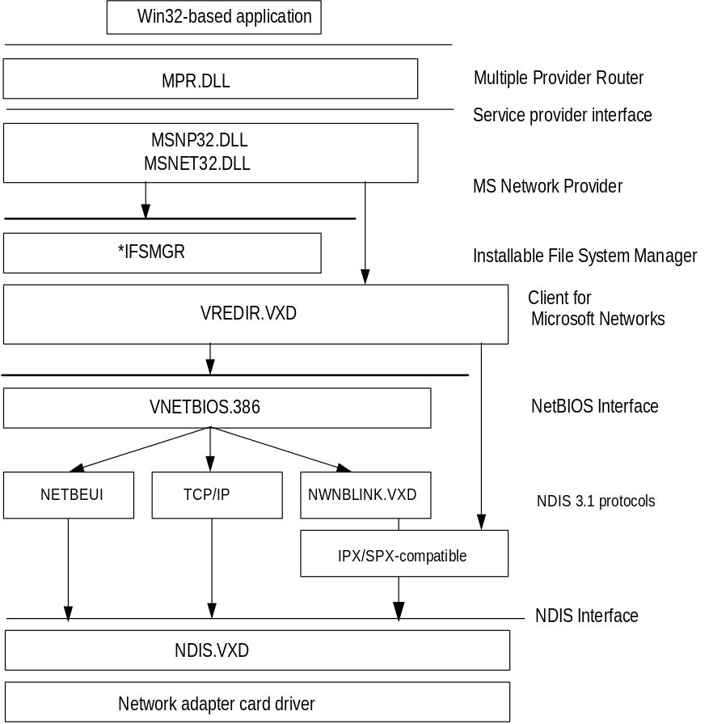
Windows 95 architecture for Windows networking
NetBIOS interface. Client for Windows Networks supports connectivity over any NDIS protocol that supports a NetBIOS interface and is accessible through VNETBIOS.386. The protected-mode protocols shipped with Windows 95 that support a NetBIOS interface are:
- NetBEUI using NETBEUI.VXD.
- NetBIOS over TCP/IP using VNBT.VXD and the TCP/IP components, VTCP.VXD and VIP.VXD.
- NetBIOS over IPX/SPX using NWNBLINK.VXD and NWLINK3VXD.

IPX/SPX connectivity. Client for Windows Networks also supports connectivity over IPX/SPX using NWLINK.VXD without the NetBIOS interface.
For specific information about the architecture for the network provider with Microsoft networks, see Chapter 7, “Network Technical Issues.”

Network Browsing Technical Notes
The Windows 95 browse service attempts to minimize the network traffic related to browsing activity, while also providing an implementation that scales well to support both small and large networks.
This section describes how the browse service designates browse servers and maintains the browse list.

Designating a Browse Server
The Windows 95 browse service uses the concept of a master browse server and a backup browse server to maintain the browse list. There is only one master browse server for a given Windows 95 workgroup for each protocol used in the workgroup; however, there may be one or more backup browse servers for each protocol for a given workgroup.
The master browse server is responsible for maintaining the master list of workgroups, domains, and computers in a given workgroup. To minimize the network traffic that the master browse server may be subjected to when handling browsing services, backup browse servers can be designated in a workgroup to help offload some query requests. Usually there is one browse server for every 15 computers assigned to a given workgroup.
When Windows 95 is started on a computer, the computer first checks to see if a master browse server is already present for the given workgroup. If a master browse server doesn’t exist, the computer starts an election to serve as the master browse server for the workgroup.
If a master browse server already exists, Windows 95 detects the number of computers in the workgroup, and the number of browse servers present. If the number of computers in the workgroup exceeds the defined ratio of browse servers to computers in a workgroup, an additional computer in the workgroup may become a backup browse server.
The Browse Master parameter in the Advanced property sheet for File and Printer Sharing for Windows Networks provides a mechanism to control the designation of computers that can become browse servers in a workgroup. If this parameter is set to Automatic, the master browser can designate that computer as a backup browse server when needed.

Building the Browse List
In Windows 95, the browse service maintains an up-to-date list of domains, workgroups, and computers, and provides this list to applications when requested.
- If a Windows 95 user requests a list of computers in a workgroup, the browse service on the local computer randomly chooses one of the browse servers it is aware of and requests the list of workgroups and computers.
- If a user selects a workgroup to which the computer does not belong, Windows 95 requests a list of computers defined in the selected workgroup from a browse server in the selected workgroup.

The selected browse server also sends a list of other workgroups it knows about, that are defined on the network, along with a list of computers in the workgroup to which the user belongs.
The browse list is displayed in the Map Network Drive and Connect Network Printer dialog boxes, or anywhere that Windows 95 presents lists of resources that can be browsed. The browse list can also be displayed using the net view command (described earlier in this chapter). The list can contain the names of domains, workgroups, and computers running the peer resource sharing service, including the following:
- Computers running Windows 95, Windows for Workgroups, and Windows NT Workstation
- Workgroup Add-On for MS-DOS servers
- Workgroups defined in Windows 95, Windows for Workgroups, and Windows NT
- Windows NT Server domains and servers
- LAN Manager 2.x domains and servers

Adding New Computers to the Browse List
When a computer running Windows 95 is started on the network, it announces itself to the master browse server for its workgroup, and the master browse server adds that computer to the list of available computers in the workgroup. The master browse server then notifies backup browse servers that a change to the browse list is available. The backup browse servers then request the new information to update their local browse lists. Notice that it may take as long as 15 minutes before a backup browse server receives an updated browse list, so a new computer on the network may not show up in a user’s request for a browse list until this time has elapsed.

Removing Computers from the Browse List
When a computer running Windows 95 shuts down properly (that is, when a user shuts down Windows 95 rather than powering off the computer or restarting the computer without exiting), the system sends an announcement to the master browse server to inform it that the computer is shutting down. The master browse server then notifies backup browse servers that a change to the browse list is available. The backup browse servers request the changes to the browse list.
If a user turns off the computer or starts the computer without shutting down, the computer does not get a chance to send a message to the master browse server informing it that Windows 95 is shutting down. If the master browse server does not receive notification that the Windows 95 has shut down, the computer name may continue to appear in the browse list until the name entry times out, which can take up to 45 minutes.

Miscellaneous Technical Notes on Browsing
- The Windows 95 browser has been updated to support browsing across TCP/IP subnetworks. To take advantage of this, the network must use a WINS server or you must use #DOM entries in LMHOSTS files. For information about creating LMHOSTS files, see Appendix H, “HOSTS and LMHOSTS Files for Windows 95.”
- Microsoft LAN Manager-compatible networks such as IBM LAN Server and Microsoft LAN Manager for UNIX support browsing of servers and shares using the Windows 95 user interface or net view.
- DEC Pathworks is an example of a Microsoft LAN Manager-compatible network that does not support browsing. AT&T StarLAN is an example of a Microsoft Network-compatible network that is not based on Microsoft LAN Manager and that does not support remote browsing of servers and shares. These servers do not show up in the Network Neighborhood, but with Windows 95, users can still access the servers and shares through a network connection dialog box.
- When a known slow network connection is used (for example, the remote access driver), Windows 95 is automatically configured not to designate that computer to be a browse server for the network connection. The SlowLanas= parameter in the Registry identifies the network LANA numbers for which the local computer will not serve as a browse master. However, the user can still request a list of available workgroups and computers on the network across the slow network connection.

Troubleshooting Windows 95 on Microsoft Networks
This section presents troubleshooting tips for these topics:
- Troubleshooting Client for Windows Networks
- Troubleshooting File and Printer Sharing for Windows Networks
- Troubleshooting logon validation on Windows NT networks
- Troubleshooting Windows 95 running with other Microsoft Network clients

For general network troubleshooting steps, see Chapter 7, “Network Technical Issues.”

Troubleshooting Client for Windows Networks
To be provided.

The system appears to stall when attempting to browse a workgroup.
When attempting to browse a workgroup in which the browse master or backup fails to respond correctly, the system may appear to be stalled, when in fact the browse attempt will eventually time out.

Troubleshooting File and Printer Sharing for Windows Networks
To be provided.

Troubleshooting Logon Validation on Windows NT Networks
To be provided.

Windows 95 client cannot access Windows NT security provider using pass-through security.
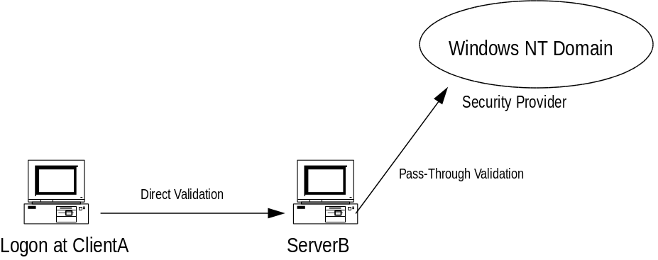
If ClientA cannot access ServerB using pass-through security to a Windows NT domain controller, find the security provider used on the computer running File and Printer Sharing for Windows Networks. See if ClientA can be validated by the security provider directly without going through the computer running File and Printer Sharing for Windows Networks.
- If successful, verify that ClientA is on the access control list for the shared resource. Remove ClientA from the list of users and then add it back.
- If unsuccessful, reconfigure ServerB to another security provider that can validate ClientA.

Troubleshooting Windows 95 with Other Microsoft Network Clients
To be provided.

