Chapter 1
This chapter presents information for logging onto Windows 95 and browisng resources on Novell® NetWare® networks.
Logon and Browsing on NetWare Networks

Using Logon Scripts with NetWare 10-2
In This Chapter
Browsing on NetWare Networks 10-3

Chapter 8, “Windows 95 on NetWare Networks,” for information about configuring the network client
See Also

Using Logon Scripts with NetWare
This section provides guidelines for running logon scripts with Windows 95 on NetWare networks.

How do I run logon scripts with Windows 95 on NetWare networks?
The issues related to running logon scripts depends on whether the computer is configured with Client for NetWare Networks or uses a Novell-supplied network client.

Running Logon Scripts with Client for NetWare Networks
The Windows 95 logon script processor runs NetWare 3.x system and user logon scripts, using commands in these scripts, such as MAP and CAPTURE, to makes global changes to the system environment. For example, a script might include a PATH statement to specify search drives or SET statements.
Windows 95 cannot make TSRs available globally. If TSRs are run in the logon script, Windows 95 warns users that the TSRs will be removed from memory and advises users to contact their network administrator. TSRs are loaded in a DOS VM that is shut down after the logon script is processed. If a TSR needs to be run for an application such as DOSNP, the application should be loaded using AUTOEXEC.BAT, STARTNET.BAT, or WINSTART.BAT. Otherwise, you must use the real-mode Novell-supplied client (NETX or VLM) and log on before running Windows 95.
Computers running Client for NetWare Networks can run logon scripts that do not include real-mode TSRs. Any commands can go in a Win32-based logon script except TSRs.
Remember that you can make persistent connections (using the same drive letter each time) to NetWare volumes and directories by using the Windows 95 user interface. Using persistent connections eliminates the need for some NetWare MAP commands in logon scripts.
Client for NetWare Networks differs from NETX and VLM in that it does not map the first network drive to the logon directory of the preferred server. All subsequent connections to NetWare servers must be made in the Windows 95 user interface.
Additional information to be provided.

Running Logon Scripts with Novell-Supplied Clients
If you use VLM or NETX, you should log onto the NetWare server before running Windows 95. If you do not log on before running Windows 95 and instead log onto a DOS VM, then all the drive mappings created by the logon scripts will be local to that VM and will not show up in the My Computer window.

Browsing on NetWare Networks
The Windows 95 user interface includes support for browsing and connecting to network resources on Novell NetWare and other networks. This support is the same whether you use Client for NetWare Networks or the Novell-supplied NETX or VLM client.
After you connect to a NetWare volume or a computer running File and Printer Sharing for NetWare Networks, you can drag and drop directories and files to move and copy them between your computer and the NetWare server or the shared resource.
This section contains the following topics:
- Using Network Neighborhood on NetWare networks
- Logging in to a NetWare server for browsing
- Making drive connections to NetWare servers
- Making connections at the command prompt
- Connecting to NetWare resources through Windows NT
- Technical issues for browsing NetWare networks

For information about making printer connections, see Chapter 19, “Printing.”

Using Network Neighborhood on NetWare Networks
Network Neighborhood is the primary means by which you can browse the network. When you open Network Neighborhood:
- All the NetWare bindery-based servers that your computer is connected to are displayed.
- Clicking the Entire Network icon displays a list of all NetWare servers on the network. You can view the contents of a server without having to map a network drive.
If your computer has both Client for Windows Networks and Client for NetWare Networks installed, the list of NetWare servers is at the beginning of the list of workgroups or domains in the Entire Network window.
- In both Network Neighborhood and Entire Network views, you can open a server to access its contents without having to map a network drive.
- You will be asked for security information, if necessary, and you can choose to save your password so that you will not have to type it the next time.


The toolbar on every window includes the Map Drive button that you can use to specify the name of a NetWare server and volume (or directory).
In Windows 95, drive mappings are limited to the available drive letters. However, Windows 95 supports unlimited UNC connections.
To connect to a NetWare drive in Network Neighborhood
1. In Network Neighborhood, click the Map Drive button on the toolbar.
2. In the Drive box of the Map Network Drive dialog box, the first free drive letter appears. You can accept the displayed drive letter for the connection or select another.
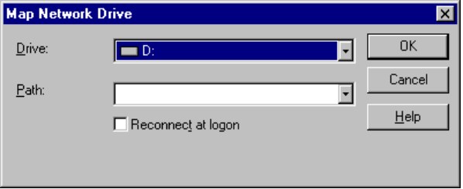
3. In the Path box, if you have connected to the volume or directory before, select the path from the list displayed. The Path box displays the previous ten paths.
– Or –
In the Path box, select or type a network path using either uniform naming convention (UNC) or NetWare syntax. Be sure to preface the server name with two backslashes (\\) if you use UNC path names. For example, if you want to connect to the server CORP, volume DOCS, directory WORD, subdirectory Q1:
- The UNC name is \\CORP\DOCS\WORD\Q1.
- The NetWare name is CORP/DOCS:WORD\Q1. (In the NetWare environment, “/” and “\” are treated the same.)
4. Click OK.

The NetWare server validates your user name and password before it displays directories in a NetWare volume you select. If the NetWare server cannot validate your credentials, Windows 95 displays the Enter Network Credentials dialog box.
You can use the context menu for a NetWare server to show everything you can do with the related server, volume, or directory.
To view the context menu for a NetWare server
- In Network Neighborhood, right-click a NetWare server.

The following shows information about the context menu for a NetWare Server.
Context command | Meaning
Open | To be provided.
Explore | To be provided.
Global Who Am I | To be provided.
Who Am I | Specifies whether the user is logged in or attached to the server; if a user is logged in and the computer is attached, specifies that user’s name.
Logout | Logs the user off the server.
Attach As | Presents a dialog box for typing a password to log onto the server, as described in “Logging into a NetWare Server for Browsing” later in this section.
Map Network Drive | Lets the user map a network drive to a drive letter.
Create Shortcut | Creates a shortcut on the desktop for the selected server
Properties | Shows the properties for the server.  Notice that listing the properties of a NetWare server creates an attachment without logging in, thereby using up one of the allowable connections to the server.

Using Lightweight Connections
A 20-user Novell server allows only 20 concurrent connections. Users who list properties for a Novell server create an attachment without logging on, using one of the allowable connections. If all the connections are used, then NETX and VLM, will be unable to find the server if it is the preferred server during a LOGIN or ATTACH procedure in system startup. Client for NetWare Networks merely replaces one of the “not logged in” connections with the name of the user that logged in.
To view the number of current connections to a Novell server
- Type load monitor at the NetWare server console prompt to monitor the number of active connections under Connection Information from the Available Options menu.
If there are Windows 95 computers getting properties on the server, you will see a number of “not logged in” active connections. For example:
Active Connections
------------------
1 NOT-LOGGED-IN
2 NOT-LOGGED-IN
3 NOT-LOGGED-IN
4 JOHNDOE
5 NOT-LOGGED-IN
6 NOT-LOGGED-IN

Logging into a NetWare Server for Browsing
To log onto a NetWare server
1. Right-click a NetWare server in Network Neighborhood.
2. In the context menu, click Attach As.
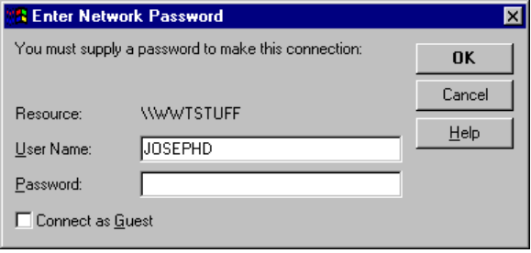
3. Confirm that the correct user name is specified, type your password, and then click OK.

Windows 95 does not support the NetWare 4.0 naming convention of \\\nwserver_sys\directory path\filename.ext where \\\nwserver_sys is the name of the NDS server volume object.
Note

Printing to NetWare Network Print Queues
You can print to NetWare print queues by connecting to the print queue in Print Manager or by using the copy command at the command prompt.

Windows 95 does not support the NetWare 4.x naming convention of \\\nw_queue_name where nw_queue_name is the name of the NDS print queue object.
Note

Despooling a NetWare Print Queue with Windows 95
Windows 95 Resource Kit utilities include a Win32-based PSERVER capability that can despool print jobs from NetWare print queues to printers on computers running Windows 95. This means that a NetWare server queue can be served by a printer attached to a computer running Client for NetWare Networks. The benefits include the following:
- The print queues can all be managed centrally from the NetWare server, so users print to one queue.
- Queues can be designated specifically for printers attached to a computer running Client for NetWare Networks.

For information about configuring and using this capability, see Chapter 19, “Printing.”

Using Commands to Connect to NetWare Servers
You can use the net commands at the command prompt or in logon scripts to manage connections.
To get help on the command-line networking commands
See Also
Appendix A, “Command-Line Commands Summary” for a list of net commands
- At the command prompt, type net /?

The following brief procedures show built-in Windows 95 commands that can be used at the command prompt or in scripts to manage resource connections.
To view NetWare servers
- Use net view
For example:
D:\WIN\COMMAND>net view
NetWare Servers
----------------------------
\\386
\\SHRIKE
\\WRK

To view volumes on a server
- Use net view \\servername
For example:
D:\Win\Command>net view \\shrike
Shared resources at \\shrike
Sharename Type Comment
----------------------------------
SYS Disk
PUBLIC Disk

The net view command creates an attachment without logging in. Viewing a NetWare server or a computer running File and Printer Sharing for NetWare Networks does not show print queues. However, viewing a computer running File and Printer Sharing for Windows Networks shows both drive and printer shares.
Use the network parameter, to specify the volumes on the particular network you want to view. For example:
net view \\nwserver_name /network:nw
To create a drive connection
- Use net use drive: \\servername\volume
For example:
D:\Win\Command>net use l: \\shrike\sys
The password is invalid for \\shrike\SYS.
Enter user name for server SHRIKE:joed
Enter the password for user JoeD on server SHRIKE:

The net use command is equivalent to MAP drive:=servername\volume:\ and maps to the root of the volume only.
T
To use the next available drive letter when connecting to the volume, replace the drive letter with an asterisk (*).
Tip

To delete a drive connection
- Use net use drive: /d
For example:
D:\WIN\COMMAND>net use l: /d

The /d switch and the NetWare command MAP DEL drive are equivalent.
To create a print connection
- Use net use port: \\servername\queuename
For example:
D:\WIN\COMMAND>net use lpt3: \\shrike\pscript1

This is equivalent to CAPTURE l=port S=servername Q=queuename.
To delete a print connection
- Use net use port: /d
For example:
D:\WIN\COMMAND>net use lpt3: /d

This is equivalent to ENDCAP L=port#.
The net command in Windows 95 does not support the following:
- The functionality of the NetWare MAP ROOT command or search drive mappings.
- Any of the command line options of the CAPTURE command except the equivalents shown in the table for specifying port, server name, and queue name. To use specific CAPTURE options, use the Novell CAPTURE command.
- The functionality of the Novell NetWare print job designations (the J=jobname parameter for the CAPTURE command).

You can still use the NetWare commands SLIST (instead of net view), MAP (instead of net use), or CAPTURE (instead of net use to connect to a printer).
Note

Using Windows NT to Connect to NetWare Servers
If your site includes both a Novell NetWare network and a Windows NT Server network, computers using Microsoft networking will need to communicate and share resources with the NetWare network.
For clients of the Microsoft network that need access to NetWare resources but cannot use multiple protocols, you can configure a Windows NT Server computer as a file or print gateway. A gateway is also useful for Microsoft networking clients that are using Microsoft Remote Access Service, or on networks on which you want to limit IPX/SPX traffic or on which you are migrating to the Transport Control Protocol/Internet Protocol (TCP/IP). A gateway on a Windows NT Server computer can connect to NetWare resources and share them with clients of the Microsoft network.
Windows NT Gateway Service for NetWare provides access to NetWare servers for Microsoft network client computers that are not running NetWare client software. Windows NT Gateway Service for NetWare acts as a translator between the server message block (SMB) protocol used by the Windows NT network and the NetWare core protocol (NCP) used by the NetWare network. Administrators can control which users can establish a gateway and the resources that are shared over the gateway.
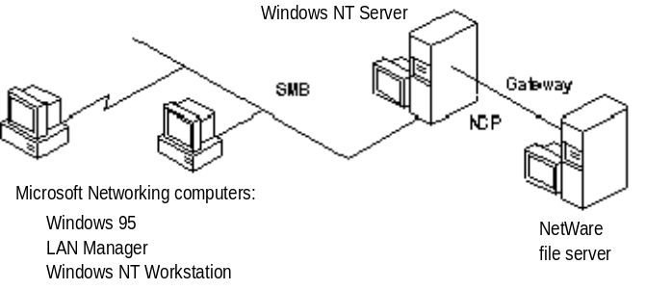
All file access over the gateway is done by sharing drives that are redirected to NetWare volumes or directories. The file gateway uses a NetWare account on the Windows NT Server computer to create a validated connection to the NetWare server. This connection appears on the Windows NT Server computer as a redirected drive. When the administrator shares the redirected drive, it becomes like any other shared resource on the Windows NT Server computer.
A print gateway functions much like the file gateway: when you have enabled the Gateway Service on a Windows NT Server computer, the NetWare printer appears on the Windows NT network like any other shared printer. Print jobs sent to the print gateway are redirected to the corresponding NetWare print queue. Microsoft networking clients can connect to the shared NetWare print queue as they would to any Windows NT printer. For example, if the print queue is shared on a Windows NT Server computer named WIN_NT under the share name HP4SI, users can specify \\win_nt\hp4si in the Connect To Printer dialog box. Users can also browse for the printer, which is listed by its uniform naming convention (UNC) name in the Shared Printers box.
A gateway enabled on a Windows NT Server computer seamlessly integrates the Microsoft network with file and print resources on the NetWare network. Because requests from Microsoft networking clients are being processed through the Windows NT Server, access over the gateway is slower than direct access from the client to the NetWare network. For Windows 95 networking clients that require frequent access to NetWare resources, Client for NetWare Networks is a better solution.
For information about setting up a Windows NT Server computer with Gateway Service for NetWare, see Windows NT Server Services for NetWare Networks in the Windows NT Server 3.5 documentation set.

