Chapter 1
For the past year, multimedia titles have been one of the fastest-growing segments of the software industry. A large and increasing number of the personal computers being sold come with the equipment that makes great multimedia applications possible — notably CD-ROM drives, sound subsystems, system power, and local-bus video.
Multimedia
Installing Windows 95 gives users an immediate multimedia upgrade. Windows 95 includes built-in support for multimedia. Its streamlined architectures for digital video, digital audio, MIDI, and file handling subsystems allow for very high-quality sound, video, and animation effects.
The 32-bit Windows 95 architecture provides for vastly improved multimedia performance from computers, so Windows 95 multimedia titles can include digital video and sound that is bigger and bolder than ever before.

Multimedia Architecture 14-2
In This Chapter
Recording, Editing, and Playing Audio 14-12
Playing and Recording Digital Video 14-18
Using Digital Video Over Networks 14-20
Customizing CDs with AutoPlay 14-20
Buying a Multimedia Computer 14-21
Troubleshooting Multimedia 14-23

Multimedia Architecture
Because Windows 95 is a 32-bit multitasking operating system, multimedia applications run more smoothly than with previous versions of Windows. Multimedia authors can write programs that use multiple threads, which help to avoid problems such as jerky animation, sound clips that halt during a game or video, and long waits between interactive sequences while the next sequence of data is loaded. The multitasking capabilities of Windows 95 also allow authors to use the computer for other tasks, even when a huge compression operation is under way.
The streamlined Windows 95 architecture for digital video, digital audio, MIDI, and the file handling subsystem means:
- Users can enjoy smoother-playing applications and games that have richer sound, animation, and color.
- Authors can add more advanced and varied effects in their titles and can work more efficiently to create titles.
- Media professionals can use Windows 95 for studio-quality development of sound and video.

The following is a simplified view that shows the key components in Windows 95 for capturing, editing, and playing back multimedia applications.
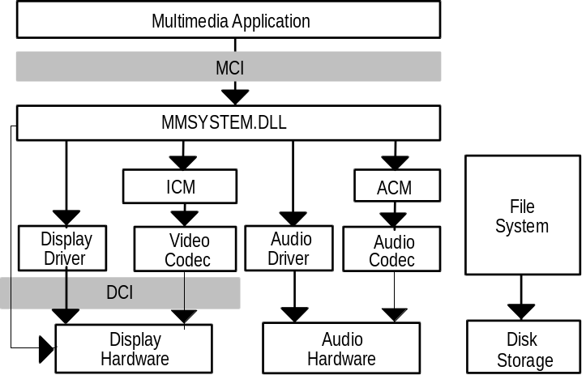
The next several sections describe these key components.

Media Control Interface
The Media Control Interface (MCI) provides Windows 95 applications with device-independent capabilities for controlling media devices such as audio hardware, video disc players, and animation players. This interface works with MCI device drivers to interpret and run MCI commands such as pause, play, and stop.
MCI provides a generic set of core commands for a broad range of media devices. For example, MCI uses the same command to begin playback of a waveform audio file, a video disc track, and an animation sequence. MCI also provides extended commands for using particular device types with unique capabilities, such as using a frame-based time format for animation. For more information about MCI drivers and commands, see the Microsoft Windows 95 Device Driver Kit.

Multimedia Files
When an application requests that the multimedia subsystem play back a multimedia title, the file system retrieves the file to be processed by the subsystem. Most often, multimedia files are maintained in one of the following formats:
Format | Corresponding filename extension
Digital video format | .AVI
Audio format | .WAV
MIDI format | .MID

Multimedia files are stored on a compact disc, a local hard drive, a network file server, or another storage medium. The playback quality is constrained by the amount of data that the storage medium can supply to the file system continuously.
A multimedia data stream (such as an .AVI file) generally contains multiple components, such as digital video data, audio data, text, and perhaps other data (such as hot-spot information, additional audio tracks, and so forth). As multimedia information is read from the CD-ROM drive, the multimedia subsystem determines what the data stream contains, and then separates and routes the data accordingly.

CD-ROM File System
The trend toward faster CD-ROM drives (double-speed and triple-speed) is a very good thing for multimedia computing. To get the best possible performance from these new devices, Windows 95 includes a new, 32-bit, CD-ROM file system (CDFS) for reading files from CD-ROM drives as quickly and efficiently as possible.
Faster reading of CD-ROM data helps to make video and audio playback from
CD-ROM drives look and sound better. This is an important component of the overall performance enhancements to multimedia in Windows 95.
In addition, CDFS reads data asynchronously, so that users see much smoother playback of CD-ROM data.
Windows 95 also extends its support for CD-ROM to drives that read XA-encoded disks, such as Kodak® PhotoCD and Video CDs.

CDFS replaces the Windows version 3.1 MSCDEX driver. For more information about MSCDEX, see the Microsoft Windows Resource Kit version 3.1 and the Microsoft Windows for Workgroups Resource Kit version 3.1.
Note

MMSYSTEM, Device Mappers, and Device Drivers
MMSYSTEM.DLL is the central component in the multimedia subsystem. This component provides services for capturing, editing, and playing back video, audio, and image data.
When an application sends a call to play a multimedia file, MMSYSTEM works with device mappers to determine which hardware devices are capable of fulfilling the request. For MIDI and WAVE device types, Windows 95 supports separate device mappers. The device mapper selects the device to perform the action needed and passes the information to its corresponding device driver. (For more information about device mappers and device drivers, see Chapter 13, “Devices” and Chapter 24, “Windows 95 Architecture.”)

Compression Managers
Digitized full-color graphics, animation, and sound each take a lot of storage space. Therefore, in most cases, digital video and digital audio are stored in a compressed form. As a result, before it can be seen or heard, this data must be decompressed. Unless there is hardware support available on the graphics adapter or sound card for all or part of the decompression work, this work is handled by components called compression managers.
The multimedia subsystem includes two compression managers, one for audio and one for video and image data, which, in turn, work with various technologies called codecs, for compressing and decompressing specific types of data. (Codec is short for compression/decompression.) These two components act as extensions of MMSYSTEM and are installed as mappers.

Audio Compression Manager
Audio Compression Manager (ACM) uses audio codecs to compress and decompress audio data. The ACM also provides support for filtering audio data. In its role as mapper, the ACM uses the driver interface mapper hooks for WAVE devices to decode or encode WAVE data before passing the data to or from the specified device driver.

Image Compression Manager
Image Compression Manager (ICM) uses video codecs to compress, decompress, and filter video data. Its functions are similar to those of the ACM. The ICM acts as the intermediary between the application and the video codec driver, which actually compresses and decompresses individual frames of data.

Codecs
The multimedia subsystem allows installable codecs (compression/decompression system). Windows 95 ships with a set of useful software-only codecs for both video and audio, but you are not limited only to these tools. As new codecs become available for particular audio and digital video needs, they can be added to the multimedia subsystem. For example, you may want to install Motion JPEG, a useful codec for multimedia authoring, if you have a capture card with JPEG support.
To install a codec
1. From the Start button, choose Settings, and then click Control Panel.
2. Double-click the Add New Hardware icon to start the Hardware Installation Wizard.
3. In the second panel, click Install A Specific Device, and then Sound, Video, and Game Controllers from the list. Click the Next button.
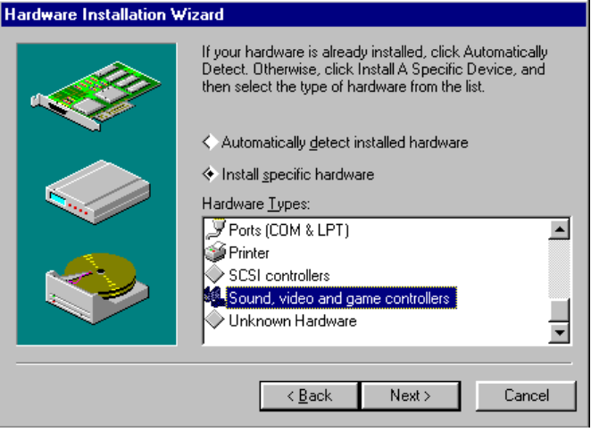
4. Select Microsoft from the Manufacturers list, and then choose a codec from the Models list.

To configure a codec
1. From the Start button, choose Settings, and then click Control Panel.
2. Double-click the Multimedia icon.
3. From the Advanced property sheet, click the plus sign next to Video Compression Codecs to see a list of video codecs you can install. Click the plus sign next to Audio Compression Codecs to see a list of audio codecs.
4. Click the codec you want to configure, and then click the Properties button.
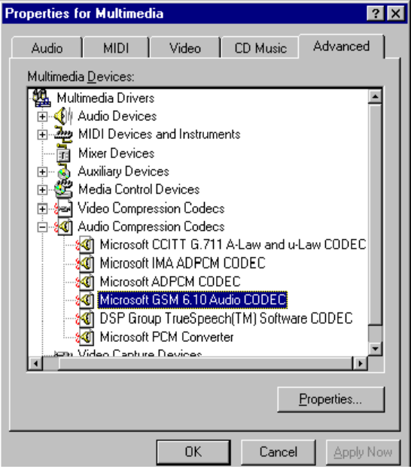
5. Use the property sheet to configure options for the codec. For example, the following shows the property sheet for the GSM codec.
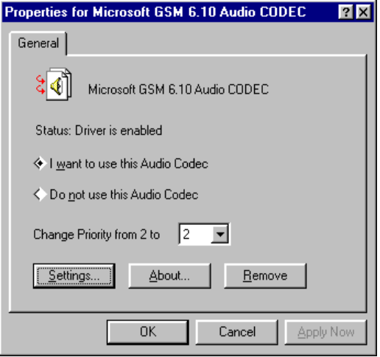
6. For certain codecs, you’ll be able to define compression and decompression rates. Click Settings (if available) to do this. A dialog box such as the following appears. Use the drop-down lists to choose the compression and decompression rates.
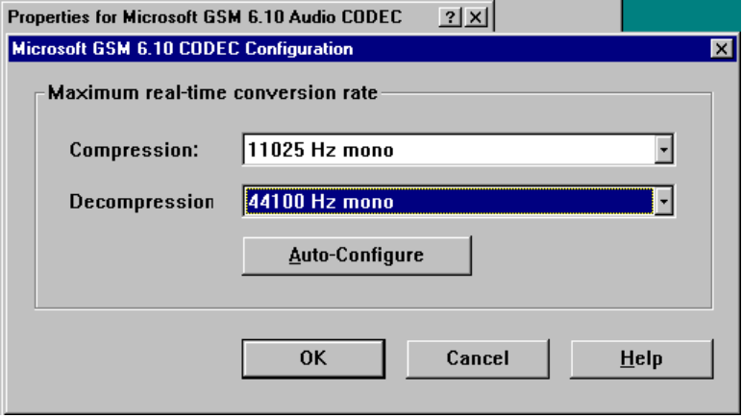
You can click the Auto-Configure button to let Windows 95 determine best-fit compression and decompression rates for your computer. When you do this, it leaves half of the system resources free for other processes to use. This is a handy option to choose if you want to use your computer to do other tasks while you compress data.

Audio Codecs
Full CD-quality, uncompressed stereo audio contains a lot of data — about 176K for every second of sound. An entire CD-ROM can contain only a little over an hour of music. Windows 95 includes both music and voice-oriented sound codecs. Music-oriented codecs (such as IMA ADPCM or Microsoft ADPCM) are included to allow close to CD-quality sound to be compressed to about one-quarter of its original size. Voice-oriented codecs (such as Truespeech™ or GSM) are included to allow very efficient compression of voice data.
Windows 95 includes support for the following sound codecs:
Codec | Description
DSP Group, Inc. Truespeech | Offers good compression for voice-oriented sound, but is not a good option for non-voice sound. Truespeech offers a better decompression rate than GSM, the other voice-oriented codec provided with Windows 95. This makes Truespeech a good option for users who want to record notes in their documents or spreadsheets, store voice mail on their computers, and so on. Truespeech does not offer real-time compression rates, but does offer real-time decompression rates, making this codec a good alternative for use with modems and networks.

Codec | Description
Microsoft GSM 6.10 Audio | Offers real-time compression (so long as the hardware is fast enough to support it), making this codec a good option for recording voice with Sound Recorder. GSM is the codec which conforms to the European Telecommunications Standards Institute — Groupe Special Mobile recommendation 6.10. GSM allows you to select from among a range of sampling rates.
Microsoft CCIT G.711 A-Law and u-Law | Provided for compatibility with telephony standards for Europe and North America. This codec is supported by many hardware configurations and offers a 2-to-1 compression ratio (from 16 bits to 8 bits per sample).
IMA ADPCM | Defined by the Interactive Multimedia Association for multiple hardware platforms; similar to Microsoft ADPCM. Offers real-time compression.
Microsoft ADPCM | Offers both real-time and non-real–time compression. When authors choose the latter option, the compression process takes longer but authors can create better-sounding audio files. Microsoft ADPCM is the codec used for Microsoft Encarta™ multimedia encyclopedia and other CD-based publications.
Microsoft PCM converter | Included for use with Sound Blaster™ and other 8-bit sound cards. With this codec, 8-bit cards can play 16-bit samples. Likewise, you can use this converter to play a sample at one megahertz rate on a card that supports another rate.

Video Codecs
Full-color video, which requires 3 bytes per pixel, at 640x480 resolution equals nearly 1 megabyte (MB) of digital data per frame. This means that a developer could easily use up 1 gigabyte (GB) of hard disk space by storing less than one minute of uncompressed digital video information.
Windows 95 includes support for the following video codecs:
Codec | Description
Cinepak | Licensed from Supermac, provides good-looking video quality with good playback performance, typically 320x240 images at 15 frames per second or better. Compression times are very long, typically 12 to 16 hours for 10 minutes of finished video. Cinepak is a common video codec for CD-ROM titles for both Windows and the Macintosh. It is the codec used on Microsoft® Dinosaurs and Cinemania®.
Indeo | Developed by Intel, offers good video quality and playback performance, and faster compression. Intel sells an inexpensive video capture adapter with built-in hardware compression for real-time capture and compression.

Codec | Description
Microsoft Run-Length Encoding (RLE) | Intended for compressing clean graphic images such as bitmaps and animating bar charts. It has a low CPU overhead, but does not handle rapid, complex scene changes well.
Microsoft Video 1 | Compresses data quickly, has a low CPU overhead, and is good for full motion, moderate quality video.

You can also install other video and image codecs such as JPEG for image data and Motion JPEG for video data.

MPEG
MPEG (which stands for Motion Pictures Experts Group) is a popular codec for squeezing full-screen, VHS-quality digital video into a small data stream so that it can be played from a CD-ROM drive.

What is MPEG?
Together with the Open Computer MPEG Consortium, Microsoft has defined an industry standard for MPEG board and chip makers that want to ship MPEG devices for Windows 95. This standard allows applications to incorporate MPEG video without worrying about precisely which vendor’s MPEG device is present to decompress it.
MPEG is a computationally intense and thorough way of compressing data. It allows for VHS-quality (that is, 640x480, 30 frames-per-second) digital video playback at very low data rates. A double-speed CD-ROM would be sufficient for playback of this quality of video.

If you intend to use MPEG, make sure that your CD-ROM driver supports Mode 2. This is because much of the MPEG content on the market today is encoded using Mode 2, in a format called XA.
Tip

The following is a sample listing of MPEG products which are currently available or soon to be available:
- C-Cube Microsystems CL450 MPEG 1 video decoder chip (currently available)
- C-Cube Microsystems CL9100 multimode MPEG video decoder chip (currently available)
- Jazz Multimedia Jakarta video graphics accelerator (scheduled to be available in September 1994)
- S3 Incorporated Vision/Va video accelerator chip (scheduled to be available in the fourth quarter of 1994)

- SGS Thomson Sti4510 audio decoder chip (scheduled to be available in October 1994)
- Sigma Designs RealMagic Series PC enhancement card with video (sound optional) and multimedia kit (currently available)
- Tseng Labs VIPeR video image processor chip (currently available)

If you intend to use Motion JPEG to capture digital video, look for a multimedia system with a sustainable hard disk I/O rate of 3 MB per second to support JPEG’s real-time compression rate. For example, if you want to capture full-color (3 bytes), 640x480-resolution video at a rate of 30 frames per second, the resulting data stream is 27 MB per second. A Motion JPEG data-capture card provides real-time compression of data at a ratio of about 10 to 1, meaning that instead of 27 MB of data per second, the system generates 2.7 MB of compressed data per second. Thus, if your hard disk I/O can sustain a transfer rate of 3 MB per second, it can easily accommodate data at the rate it is compressed by the Motion JPEG data-capture card.
Tip

Display Control Interface
The Display Control Interface (DCI) is a new display driver interface created jointly by Microsoft and Intel. DCI-compliant drivers provide a fast, direct way for games and digital video in windows to write to the video frame buffer. It also enables digital video playback to take advantage of several specific kinds of hardware support included on advanced graphics adapters. For example, with the stretching hardware feature, users can scale up the size of a digital video clip with virtually no additional CPU. Color space-conversion support in hardware can reduce the amount of work a codec must perform by up to 30 percent, allowing substantially better video playback.
DCI enables video cards to include hardware features, such as the following, for improved video playback:
- Stretching hardware. With this feature included on the video card, the CPU needs to do no additional work to make the video appear bigger. It simply passes the same number of pixels to the video card and the video hardware adjusts the size of the image. Notice that the card manufacturer must supply a level-2 DCI driver with the card to take advantage of stretching.
- Color space conversion, or YUV-to-RGB conversion. This is a method of color management that provides for better video playback.

Computer monitors display colors in combinations of red, green, and blue (RGB), but the human eye perceives colors differently. For example, most people perceive red more strongly than blue, and most perceive a difference in brightness more readily than a difference in hue. The YUV color standard is based on this understanding of color perception. In the compression process, RGB color is translated to YUV, then compressed. During decompression at playback, the reverse happens. If the video card contains a chip with this conversion capability, a lot of CPU time is saved. This way, you can play much bigger and more colorful videos at a faster frame rate.
- Double buffering. This means including more memory on the video card to allow for video techniques such as page flipping. Instead of having one memory space on your video hardware to draw a frame or an image, there would be two. The first might be the one currently used for display on the screen. Meanwhile, the second would be used to draw the next frame in a sequence before it is displayed. This advanced processing makes videos and game animation play back very smoothly.
- Chroma key. This facilitates the merging of video data streams, so that a particular color can be treated as “transparent” in the merge operation.
- Overlay. This speeds display of partly concealed objects.
- Asynchronous drawing. This, along with double buffering, provides a faster method for “drawing” into off-screen memory space.

For more information about DCI and creating DCI drivers, see the DCI Level 2 Specification. This specification is available through the Microsoft Developer Network (call 1-800-759-5474; or, from outside the U.S. and Canada,
call (402) 691-0173).

Support for Multimedia Devices
Windows 95 includes built-in support for common multimedia authoring devices such as laser discs and video tape recorders (VTRs). This makes it easy to set up a system for “step capture,” a process in which the author captures digital video data one frame at a time, usually to be compressed later. This is a slow process, but it is absolutely the best way to get the best possible quality of digital video.
Frame-accurate control of the VTR is also important for recording broadcast-quality special effects to use in commercials, movies, television programs, music videos, and the like.
Windows 95 provides videocassette recorder (VCR) control services through the MCI VISCA device driver, which is based on the MCI command set for VCRs. This device driver is used with a video capture or overlay card to control SONY® VISCA-compatible videotape recorders, such as the CVD-1000 Vdeck. The VISCA-compatible driver controls the parts of the VCR, including the tape transport, channel tuners, and VCR input and output channels.
To play the contents of a videotape on your computer, you must connect the video and audio outputs from your VCR to the video capture or overlay card of your computer, and to the audio inputs of your computer. You might also need to install an MCI digital-video device driver.

Plug and Play Support Benefits for Multimedia Users
The Windows 95 Plug and Play standard makes the prospect of adding a new multimedia device to a computer considerably less daunting. Just plug in a Plug and Play-compliant sound card and (literally) it plays. In fact, Windows 95 even makes the prospect of installing old multimedia devices less daunting — Windows 95 includes tools that make it vastly easier to identify and resolve conflicts between legacy devices that are not Plug and Play-compliant. Windows 95 includes built-in drivers for the most popular sound cards to make this process as painless as possible. Plug and Play substantially reduces the cost of installing and supporting multimedia devices.

Recording, Editing, and Playing Audio
Windows 95 multimedia services provide extensible, device-independent audio support. Windows 95 features services for sound control, and for waveform, MIDI, and mixer devices.

To use Windows 95 sound capabilities, you must have a sound card installed.
Note

With audio support in Windows 95, you can:
- Use the Sound Control Panel to assign sound clips to play each time a specific event occurs.
- Use CD Player to play audio CDs while you work.
- Use Sound Recorder to record sound.
- Use built-in Windows 95 OLE support to copy or link audio clips in other documents, as described in Chapter 16, “Application Support.”

Assigning Sounds to Common Actions
You can use the Sound Control Panel to assign waveform sounds to actions such as opening an application or exiting Windows.
To assign a sound to an event
1. From Start, choose Settings, and then click Control Panel.
2. Double-click the Sound Events icon to display Properties for Sound Events.
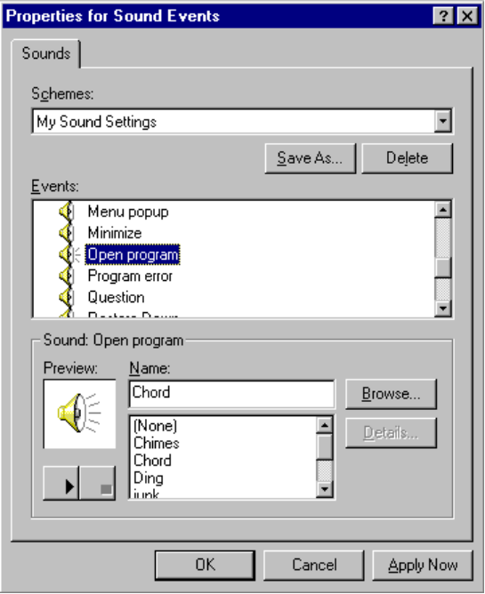
3. Click the event you want to associate with a sound, and then click the sound. Repeat for other events and sounds.
4. To save your choices as a new sound scheme, select the name of the scheme from the Schemes list, and then click Save As.

Playing Audio CDs
Windows 95 includes a versatile tool called CD Player so that you can play audio CDs while you work. CD Player works in the same way as a standard CD player. Its controls look like those of a regular CD player, and it supports many of the same features you find in advanced CD players, such as random play and programmable playback order. With CD Player, you can save programs so that you don’t have to recreate your play list each time you pop in a CD.
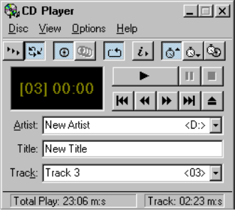
To play a CD
1. Place the CD in the CD-ROM drive.
2. From the Start button, choose Programs, then choose Accessories, choose Multimedia, and click CD Player.
3. In CD Player, click the Play button.

To define a play list for your CD
1. From Disc, select Edit Play List.
2. Use the Add and Remove buttons to specify the play list.
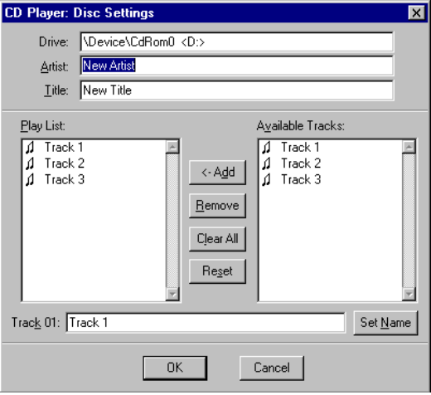

You can also use this dialog box to maintain a list of what’s on the CD by typing the name of the artist, title, and songs in the Artist, Title, and Play List fields.
Note

Windows 95 Support for MIDI
MIDI is used as a development tool for musicians. Virtually all advanced music equipment today supports MIDI, and MIDI offers a convenient way to control the equipment very precisely.
MIDI is like the electronic equivalent of sheet music. In real life, there are two ways you can listen to a piece of music. One way is to buy a CD that contains a lot of data about a specific recording of a particular performance of that piece of music with all of the instruments and parts predefined. This method requires no interpretation at all — it’s straightforward playback. A way to use less data to listen to the same piece of music is to buy the sheet music and have someone play it. This method requires very little data but, depending on the quality of the instruments and the interpreter (for example, the piano player), you may get a good or bad version of that piece of music.
MIDI works in very much the same way. Sound cards that support MIDI sound synthesis are able to take a MIDI data stream and produce sound according to the digital sheet music instructions that they receive.
One of the early challenges for MIDI was that it was, in a way, too flexible. Any instrument can be “connected” to any MIDI channel, so that a “sequence” (song) written for a piano might accidentally end up being played on a tuba. Now, MIDI authors can refer to the General MIDI Specification to request particular instruments and sounds. This specification is an industry standard that defines how MIDI should be used and is supported by Microsoft and most MIDI sound card manufacturers.
Windows 95 comes with the best-ever implementation of MIDI from Microsoft, including a new technology called polymessage MIDI support. This technology is used in advanced sound cards to play very complex MIDI sequences with light CPU use. Support for this technology allows Windows 95 to communicate multiple MIDI instructions simultaneously within a single interrupt. The result of this change is that playing MIDI files now requires even less computing power than it did before, and allows developers to process MIDI instructions, graphics, and other data even more successfully.
To play a MIDI sound file
1. From the Start button, choose Programs, then choose Accessories, choose Multimedia, and click Media Player.
2. From the Device menu, click Microsoft MCI MIDI Sequencer.
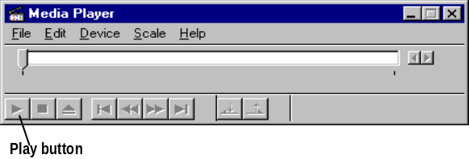
3. From the dialog box that displays, choose the file you want to play.
4. Click the Play button.

Recording Sound
If you have a microphone connected to your computer, you can record sound using Sound Recorder.

You must use a real-mode compression codec with Sound Recorder. If you use the GSM codec, you can turn on voice compression when recording so that your file is compressed in real-time.
Note

To record sound from a microphone
1. From the Start button, choose Programs, then choose Accessories, choose Multimedia, and click Sound Recorder.
2. Click the microphone button and record.
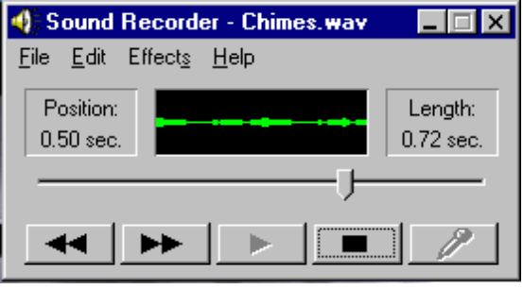
3. Click the Stop button to end recording.
4. From the File menu, click Save As and type a filename for this .WAV file.

You can also record sound from a CD player or other component that you connect to your sound card’s Line In.
To record sound from Line In
1. Use the Volume Control tool to turn on Line In and turn off the microphone input. (See the following section for information on how to do this.)
2. From Sound Recorder, click the microphone button and record.

Controlling Audio Input Levels
Windows 95 also includes a Volume Control tool that provides audio line routing services to manage the different audio lines installed on a computer system. An audio line is made of one or more channels of audio waveform data coming from one origin or system resource. For example, a stereo audio line has two data channels, yet is considered a single line. Each audio line also has zero or more mixer controls associated with it. A mixer control can take on a number of different characteristics, such as controlling volume, depending on the characteristics of the associated audio line.
The number of lines you can mix using Volume Control depends on the number of audio source lines your computer has, and whether you are using Volume Control for input or output. The following shows the Media Control tool for a computer with four audio source lines:
Control | Description
Vol | Controls the audio levels from all sources, including wave sound, MIDI sound, sound from Line In, and so on. The master control switch for your system.
Line | Controls sound from Line In. (Or, in the case of playback, this controls output to the speakers.)
Wave | Controls wave sound.
Synth | Controls MIDI sound.

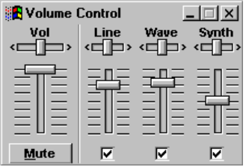
The vertical slider bars control the right and left speaker balance. The horizontal slider bars control the volume level.
For the master volume control, click the Mute button at the bottom of the volume control to mute all sound. (When you do this, its name changes to Unmute.) Click the Unmute button to restore sound. (The name will change back to Mute.)
For individual controls, when the check box at the bottom of the Line, Wave, or Synth control is checked, this control is not muted. When the check box is cleared, the control is muted.
To mix sound from two or more audio input lines
1. From Start, choose Programs, then choose Accessories, choose Multimedia, and click Volume Control.
2. If only the master control (Vol) is displayed, right-click the icon in the upper-left corner of the Volume Control window and choose Expand.
3. Check the check boxes for the audio input lines from which you want to receive sound; clear the others.
4. Adjust the volume and balance on each input line that you have checked.

To set recording controls
1. From Volume Control, right-click the icon in the upper-left corner of the Volume Control window, and choose Recording Controls.
2. Click the option button for the input source you want to use for recording.

Playing and Recording Digital Video
Windows 95 video services provide the resources for capturing video clips, compressing the content, and controlling playback.

Windows 95 provides the software to support video playback. Additional software and hardware are needed to capture and compress digital video.
Note

Displaying digital video involves moving and processing huge streams of data continuously and efficiently.
In the past, the process of displaying digital video has relied on a series of 16-bit systems — from reading data from the disk, to decompressing the video data, to displaying it on the screen. One key design goal of Windows 95 was to upgrade this architecture to 32 bits, and with this upgrade, the difference is dramatic. For multimedia users, installing Windows 95 will be the quickest and cheapest multimedia upgrade available. Without adding any hardware, Windows 95 users can display bigger, smoother, and more colorful digital video than ever before.
It’s also important to notice that Windows 95 multimedia is fully compatible with 16-bit multimedia titles. Early testing has shown that the 32-bit improvements in file access speed and stream handling results in performance gains, even for 16-bit multimedia applications — the biggest gains, of course, will be realized in the new generation of 32-bit titles that will be designed for Windows 95.

Playing a Video Clip
Through its new 32-bit Device-Independent Bitmap (DIB) engine, Windows 95 substantially improves the speed at which graphics are drawn to the screen.
You can use Media Player to play existing video and animation files.
To play a video file
1. From the Start button, click Programs, then click Accessories, and then click Media Player.
2. From the File menu, click Open and type the name of the video file.
3. Click the Play button.

Instead of having separate windows for Media Player and for the video clip, you can combine them.
To add Media Player controls to the bottom of the video playback window
- Double-click the Media Player window title bar. A window similar to the following results:
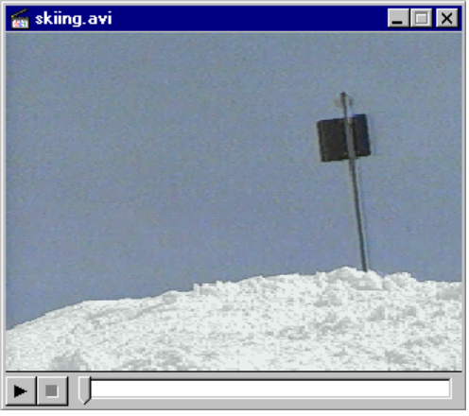

To separate the two windows again

- Double-click the video playback window title bar.

To tell in what format an existing video clip was authored, you can run Media Player, then select Configure from the Device menu. The information in the Information Frame tells you about the format.
Tip

Using Digital Video Over Networks
To be provided:
- Continuous data stream
- LANS, mostly “packet switches”
- Video OK if the net isn’t busy or if you have a network that guarantees continuous data stream (for example, ATM or Isochronous Ethernet)

Customizing CDs with AutoPlay
In various ways, titles and games that run off a CD-ROM drive run differently from other applications. First, the way to start a CD-ROM program differs from a hard disk-based application — you first have to open the drawer, choose the right disk, and place it in the CD-ROM drive. Then you can run it like any other program — assuming, of course, that you can find the icon you created when you first installed the program. A second difference between CD-ROM products and hard disk-based applications is that CD-ROM products may be used less regularly.
If the CD-ROM is a title, and you’ve never run it before, then the act of putting it in the drive means that you intend to install the program. If you already have installed the title, then the act of inserting the disk means that you intend to run it.
Windows 95 includes a feature called AutoPlay that allows software developers to make their products easier for customers to install and run. When you put a disk into a CD-ROM drive, Windows 95 automatically looks for a file called AUTORUN.INF. If this file exists, then Windows 95 opens it and follows the instructions AUTORUN.INF contains.
This new feature will make the setup instructions for a Windows 95-based multimedia game or title incredibly easy:
- To play _________, insert the disk in your CD-ROM drive.

That’s all there is to it.
To be provided:
- Example of how you can use Autoplay to customize CD functionality for CDs pressed in-house
- Details of AUTORUN.INF structure

Buying a Multimedia Computer
When you’re ready to purchase a great multimedia system, there are lots of features to try out and compare. The following list provides a few guidelines for what to look for in a great multimedia system. The next few sections provide more specifics for overall sound components, MIDI components, mixing capabilities, and video components.
- Balance beats horsepower. Multimedia playback places heavy demands on many parts of the system, from the CD-ROM (for reading data) to the hard disk (for writing data) to the CPU (for decompressing) to the video and audio subsystems (for playing). A fast CPU does not guarantee a great playback system. In fact, multimedia playback on most of today’s high-end PCs is not constrained by the CPU.
- Local-bus video is indispensable. Without local-bus video, a PC will not be able to keep up with the amount of video data that consumer multimedia titles and games released in 1995 will want to display continuously. Preferably, your system should include a PCI bus.
This is required for TrueColor support. Look for a 24-bit display monitor.
- Double-speed CD-ROM or better. Titles in 1995 will be written assuming double-speed data rate. (Double-speed means that the drive reads data from the CD-ROM at a rate of about 300K per second.) This is the rate needed to have a good-looking 320x240 digital video clip playing at a reasonable frame rate with no undue image compression. (Compression causes the image to be somewhat grainier. At extreme compression, for example, an image of a person might look instead like a bunch of blocks.)
- SVGA (800x600) or better with 16-bit color. Because multimedia applications use a lot of colors, and tend to compete for access to the system palette, it’s important to have support for more than 256 colors. Consider the challenge of a multimedia presentation that includes a digital video clip of an underwater scene on a slide with a smooth-shaded maroon background. There aren’t enough colors in a 256-color palette to make both the slide background and the underwater scene look good.
- 16-bit audio. The installed base of sound cards that can interpret MIDI is now large enough to be tempting to game and title developers. Not all sound systems are equal — some sound great (16-bit with sampled sounds), and some sound like Star Trek reruns.

What to Look for in a Great PC Sound System
Here are some key features to look for when you want to purchase a multimedia computer with great sound support:
- Although you can use an 8-bit sound card with Windows 95, the quality will not be great. Instead, choose a sound card with 16-bit digital-to-analog converter for playback, and for developers, 16-bit analog-to-digital converter for recording.
- Look for a CD-ROM drive with double-speed or triple-speed capabilities and “multisession” support.
- Look for a system that supports stereo sound and 8, 11, 22, and 44 kilohertz (kHz) waveforms. CD-quality sound uses 44 kHz. The 11 and 22 kHz waveforms are fractions of 44 and often used for compressed wave forms meant to save CPU processing. The 8 kHz waveform is used for a new capability in Windows 95 called Truespeech compression. It is also used for Telephony and voice coding.
- Developer’s systems should also include support for 48 kHz for higher-quality sound and full-duplex support to record and play sound at the same time.

What to Look for in a Great PC MIDI System
We recommend that sound cards for both consumer and developer systems be able to support the following:
- General MIDI support. General MIDI refers to a system of assigning numbers to each kind of instrument, so that instrument 12 on one computer is the same as instrument 12 on all others.
- Polyphony, which means the ability to play multiple sounds at the same time. Consumer systems should include 16-voice polyphony; developer systems should include at least 20-voice polyphony. Support for more concurrent sounds means a fuller-sounding playback.
- Polymessage MIDI. This is a very efficient new capability included in Windows 95, whereby a sound card receives and batch-processes multiple MIDI messages (such as Note On and Note Off). This is useful because many things happen simultaneously in music. By building polymessaging sound support into your sound subsystem, you liberate your CPU from managing those messages individually. This offers virtually flawless playback, even when the CPU is being heavily taxed by large-frame video playback, for example.
- Sampled sound rather than waveform synthesis. Waveform synthesis uses a mathematical approximation of a sound, such as a piano. Sampled sound is an actual recording of the piano, and sounds much better. (MIDI really shows the difference in quality between sound cards.)
- Standard MIDI port. Consumers and developers use this port to plug in MIDI devices such as piano-style keyboards or joysticks.

What to Look for in Mixing Capabilities
A good multimedia system for either a user or a developer should have mixing capabilities. Look for the following features:
- The mixer should mix input from four sources (WAV, MIDI, Redbook, AUX) and present the output as a stereo, line-level audio signal at the back panel of the computer. Each input should have at least a 3-bit volume control (8 steps) with a logarithmic taper.
- Make sure that all sources are sourced with -10 dB (consumer line level 1 milliwatt into 600 ohms, 0 dB), and without attenuation. This will ensure that the mixer will not clip, meaning that if a sound peaks, the audio clicks instead of playing that sound. It also ensures that the mixer will output between 0 dB and +3 dB.
- It’s very helpful to find a system which has individual audio source and master digital volume control registers and extra line-level audio sources.

Troubleshooting Multimedia
This section provides suggestions for solving problems related to playing .WAV files and MIDI files.

My multimedia device isn’t working right.
1. From the System Control Panel, click the Device Manager tab.
2. Click on the Media Devices icon, then click Wave, and then click the device that seems to have the problem.
3. Click Properties to view any messages about problems that Windows 95 has detected for this device.

Can't play .WAV files.
When Media Player is unable to play .WAV files, it is commonly due to one or more of the following problems:
- The sound card is not installed properly.
- A .WAV driver is not installed.

Before attempting any complicated troubleshooting, shut down and then turn off the computer. Then restart Windows 95 to see if the system functions correctly.
Note

To make sure the sound card is properly installed
1. Make sure the sound card does not conflict with other hardware.
2. Verify Port and IRQ settings.

If the sound card also supports digitized sound and wave files, then the card is properly installed if .WAV files can be played.
Note

To make sure the WAV driver is installed
1. If you start Sound Recorder and there is no Wave driver installed, you will receive an error message telling you so. If you do not receive an error message, you can assume that the Wave driver is installed.
2. If Sound Recorder says that there is no Wave driver installed, check to see if the Wave driver is listed under Multimedia in the Control Panel. If the sound card is Sound Blaster-compatible, try using the Sound Blaster driver that ships with Windows 95. If the correct driver for the type of sound card being used is not listed, you may try using the Windows 3.1 drivers for the specific card.

Can't play MIDI files.
When Media Player is unable to play MIDI files, it is commonly due to one or more of the following problems:
- The sound card is not installed properly.
- A MIDI driver is not installed.

Before attempting any complicated troubleshooting, end your Windows 95 session and turn off the computer. Then turn it back on and see if the system functions correctly.
Note

To make sure the sound card is properly installed
1. Make sure the sound card does not conflict with other hardware.
2. Verify Port and IRQ settings.

If the sound card also supports digitized sound and wave files, then the card is properly installed if sound files can be played.
Note

To make sure the MIDI driver is installed
- Use the Hardware Installation Wizard to detect your hardware. This wizard will let you know if you have any hardware for which the appropriate driver is not yet installed.

My PC seems to be dropping frames or is jerky when it plays back video.
- Make sure the appropriate video driver is installed for the video card you are using. (Use the New Devices Wizard to check its configuration.)
- Check to see if MSCDEX is installed on your computer. If it is, remove it. This has been replaced by the improved Windows 95 CD file system.
- Consider replacing your current video card with one that includes a local bus.

