Chapter 1
Disks and File Systems
This chapter is a draft document. It may contain information that does not accurately represent the final version.
Note

This chapter presents information about the Windows 95 installable file systems, including the new 32-bit file allocation table (VFAT) file system. It also describes long filenames and how you can use them locally and on various network configurations. This chapter also describes how you can use the following utilities to manage disks and data:
- Fdisk, to partition disks
- Format, to format disks
- DriveSpace, to compress data and free space on disk drives
- Disk Defragmenter, to defragment information on a disk
- ScanDisk, to analyze and repair disks

Windows 95 File System Overview 17-2
In This Chapter
Using Long Filenames 17-3
Partitioning Hard Disks 17-8
Disk Compression and Windows 95 17-17
Disk Management Overview 17-24
Defragmenting Disks 17-26
Using ScanDisk 17-28
Troubleshooting Disk and File System Problems 17-30

Chapter 5, “Devices,” for information about disk device drivers
See Also
Chapter 26, “Windows 95 Architecture,” for information about the architecture of the Windows 95 file system

Windows 95 File System Overview
With the Windows 95 Installable File System, multiple file systems can coexist on the computer. Windows 95 includes the following file systems:
VFAT. In Windows 95, the 32-bit virtual File Allocation Table file system is the primary file system and cannot be disabled. VFAT can use 32-bit protected-mode drivers or 16-bit real-mode drivers. Actual allocation on disk is still 12-bit or 16-bit (which depends on the size of the volume), so FAT on the disk uses the same structure as previous versions of this file system. VFAT handles all hard disk drive requests, including SCSI. VFAT was first introduced in Windows for Workgroups version 3.11 as an optional FAT file system that processed file I/O in protected mode. VFAT uses 32-bit code for all file access for hard-disk volumes that allow 32-bit disk access.
CDFS. The virtual CD-ROM file system has the same responsibilities for a CD-ROM device as VFAT has for a standard hard disk. If a CD-ROM device is detected, the CDFS driver loads dynamically. When CDFS is installed, the standard disk type-specific device and Disk SCSI translator are replaced with CD-ROM versions. The CDFS driver is a protected-mode version of MSCDEX.EXE, providing the interface from the CD-ROM device to the operating system, as described in Chapter 14, “Multimedia.”
Network redirectors. A network redirector such as SMB or NCP accesses the network file system. Windows 95 supports multiple network redirectors simultaneously, as described in Chapter 7, “Network Technical Issues.”
All these file systems support long filenames, as described later in this chapter, and can use the protected-mode cache (VCACHE) for read-ahead and (for VFAT) lazy-write throughput.
Third-party vendors might also implement file systems. For example, a vendor might provide a file system that allows a computer running Windows 95 to connect to a different operating system (for example, Macintosh® or UNIX®) to share files.
The Installable File System Manager receives all INT 21 calls and determines which file system driver should receive the call to process it. The Installable File System Manager uses a real-mode stub named IFSHLP.SYS to send INT21 calls back to the Installable File System Manager.
File system drivers manage the high-level I/O requests from applications. The file system driver processes requests from applications and initiates low-level I/O requests through the I/O Supervisor.
Protected-mode disk compression is not integrated into the file system, but is supported by a separate VxD. Windows 95 supports disk compression software created for earlier versions of MS-DOS, using their real-mode driver loaded from CONFIG.SYS.

Using Long Filenames
For MS-DOS version 6.22 and earlier, filenames cannot exceed eight characters and filename extensions cannot exceed three characters in length (“8.3 filenames”). The period character (.) could be used only to separate the filename from the filename extension. These 8.3 filename constraints are gone in Windows 95.
For all Windows 95 file systems, users can specify filenames that are up to 255 characters long and can contain more than one period. These long filenames are any names that exceed 8.3 characters in length or contain any lowercase character or any character that is not legal in the 8.3 namespace.
The following sections describe how automatically generated aliases are used to maintain compatibility with file systems that use only 8.3 filenames and describe the VFAT file system structure for supporting long filenames.

How do I use long filenames?

Maintaining Compatibility with Automatic Aliases
For every long filename, an alias entry is automatically generated that complies with the 8.3 filename rules for backward compatibility. This alias entry uses an algorithm which takes the first eight characters as the base filename and the last three characters for the extension.
For the filename to comply with the 8.3 filename rules, it must use only the valid characters for an alias and it must be all uppercase. Short filenames are converted to uppercase by the Installable File System Manager before being passed to the file system driver.

At this writing, the method for automatically generating 8.3 filename aliases has not yet been made final for Windows 95.
Note

File System Details for Long Filenames
Any physical file on a VFAT file system is logically associated with two names: the filename and its alias. The alias is in the standard 8.3 filename format and can be generated automatically.
Valid characters for MS-DOS 8.3 filenames (and aliases) can be any combination of letters A – Z and digits 0 – 9, a blank (ASCII 20H), ASCII characters greater than 127, and the following special characters:
$ % ' - _ @ ~ ` ! ( ) ^ # &

The following additional characters are valid in long filenames, but are invalid in alias names:
+ , ; = [ ]

The following rules also apply for Windows 95 file systems:
- Maximum filename component length is 256 characters, including NULL.
- Maximum path length is 260 characters, including NULL (compared to 80 characters for a short name).
- The OEM character set can be specified by an application if the application is written for that character set.
- The long-filename directory entries use the Unicode character set to store the names.

When a file is created, it logically has both a long filename and an alias. The filename and the alias are the same if the filename meets 8.3-filename rules (that is, if it contains only valid characters for an alias and it is all uppercase). Short names are converted to uppercase by the Installable File System Manager before being passed to the file system driver.
This implies that a filename using only valid characters for an alias and following the 8.3-filename format is still not the same as the alias name if it contains lowercase characters. However, in this case the alias is the uppercase version of the filename. For example, if the long filename of a file is Examples.Txt, its alias is EXAMPLES.TXT. The case is preserved in the filename.

Searches in the Windows 95 file system are not case-sensitive. So a search of the form examples.txt or Examples.Txt will find the same files.
Note

If the filename does not comply with 8.3-filename rules in format or in the characters used, then an alias is generated automatically. Automatically generated aliases are composed of the basis-name and an optional numeric tail. So the filename ThisIsALongFileName is associated with the automatically generated alias THISISAL. Neither the user nor an application can control the name created by the automatic alias process. Related issues are discussed in the following sections.

Long Filenames and Root Directory Entries
Usually, it is best to store files in a directory below the root directory. This is especially true for files with long filenames. Files with long filenames use more directory entries than files with 8.3 filenames. Because the number of entries in the root is limited to 512, the root directory can fill up with fewer files if long filenames are used.
Notice that typing the command mkdir Examples creates a long filename directory entry that contains the name Examples to preserve the case, plus an 8.3 alias entry with the name EXAMPLES for compatibility. In this example, two directory entries are used.

Long Filenames and Network Compatibility
Like Windows for Workgroups, Windows 95 can access files on HPFS or NTFS partitions from remote drives. However, there is currently no support for adding either of these file systems as another installable file system running in Windows 95. So Windows 95 cannot access either a HPFS or NTFS partition on a local disk drive.
The following describes interoperability exceptions for other file systems. The following sections provide details about long filename support on various networks.

How do I support long filenames with Novell NetWare or other file systems?
NTFS. The Windows NT file system supports long filenames, but includes architecture for security that Windows 95 does not use. Also, Windows NT 3.1 doesn’t recognize long filenames on FAT drives and removes them; however, Windows NT 3.5 supports long filenames on FAT drives. Additional details to be provided regarding compatibility between Windows NT 3.5 and Windows 95 long filenames.
HPFS. To be provided.
CDFS. Long filenames are supported on CDFS volumes.

NetWare Using the OS/2 Namespace
Computers running Windows 95 can see long filenames on NetWare 3.x and 4.x volumes that have been configured to use the OS/2 namespace, which emulates an HPFS volume.
Filenames on NetWare HPFS-emulation volumes have a maximum filename length of 254 characters and use the 8.3 truncation on the first instance of the filename. For example:
longfilenameold.tst --> longfile.tst
longfilenamenew.tst --> longfil0.tst

To enable long filenames on a NetWare volume
1. Enter the following lines at the NetWare server console prompt:
load os2
add name space os2 to volume sys

2. Then add the following line to the STARTUP.CNF file:
load os2

3. Shut down the file server. Then copy the file OS2.NAM from the distribution disks or compact disc to the same disk and directory that contains SERVER.EXE.
4. Restart the NetWare file server.

Long Filenames with Windows 95 Protected-Mode Clients
Windows 95 protected-mode network clients (Client for Windows Network and Client for NetWare Networks) include long-filename support. If the network server that the computer is connected to supports long filenames, then Windows 95 can read, create, and copy local long-filename files on the network share. On some servers, the length of filenames, restricted characters, and the algorithm for creating 8.3 filenames from long filenames may differ from Windows 95.
Long filenames on computers running File and Printer Sharing are fully supported and can be viewed on computers using protected-mode Windows 95 network clients. Real-mode Windows 95 clients can only see the 8.3 filename aliases.
If Windows 95 has been configured with File and Printer Sharing for NetWare, any MS-DOS – based NetWare clients using NETX or VLM will see the 8.3 filename. Computers using Client for NetWare Networks can see long filenames.

Older Microsoft or Microsoft-compatible clients (for example, LAN Manager, Workgroup Connection for MS-DOS, Windows for Workgroups, and so on) cannot use shared folders with long filenames. These older network clients may have problems connecting to and using a shared directory with a long filename as the directory name. Having a short share name does not correct this problem.
Note

Windows NT 3.5 with HPFS, NTFS, and Long Filename-over-FAT Volumes
In Windows NT 3.5, file and directory names on the FAT file system are no longer restricted to the 8.3 naming convention. Instead, file and directory naming rules are similar to those of NTFS: names can be up to 255 characters with support for uppercase and lowercase. This capability is supported both within File Manager and at the command prompt.
Long filenames on shared Windows NT 3.5 partitions using HPFS, NTFS, and long filename-over-FAT are fully supported and viewable by protected-mode Windows 95 network clients. Real-mode network clients can only see the 8.3 filename aliases.
Windows NT 3.5 HPFS partitions use 8.3 truncation on the first instance of the filename. For example:
longfilenameold.tst --> longfile.tst
longfilenamenew.tst --> longfil0.tst

Windows NT 3.5 NTFS partitions use 8.3 truncation on the first instance of the filename. For example:
longfilenameold.tst --> longfi~1.tst
longfilenamenew.tst --> longfi~2.tst

Windows NT 3.5 partitions using long filenames-over-FAT use 8.3 truncation on the first instance of the filename. For example:
longfilenameold.tst --> longfile.tst
longfilenamenew.tst --> longfi~1.tst

Windows NT 3.5 computers can see Windows 95 long filenames. Windows NT 3.5 supports local long filenames on FAT volumes and is aware of the long filename-over-FAT file scheme used by Windows 95. Therefore, on a computer with dual-boot capabilities for Windows NT 3.5 and Windows 95, long filenames on local FAT volumes can be seen by both operating systems.

Long Filenames and Application Compatibility
MS-DOS – based applications configured to run in MS-DOS Mode use only the real-mode FAT file system, so long filenames created in a Windows environment are not visible when the system exits to MS-DOS Mode, although the long filenames themselves are physically present on the media. Only the 8.3 alias names are visible.
The same principle applies for any down-level FAT file system when floppy media containing long filenames is transported to them. (Down-level file systems are systems that support the earlier MS-DOS FAT file system, such as MS-DOS 6.0, Windows 3.1, OS/2 2.11, Windows NT 3.1, and so on.) On down-level file systems, only the 8.3 alias name is visible on the floppy, even if it contains long filenames created on Windows 95.
Some applications and utilities will not work with the new directory entries for long filenames. If you need to use such applications and utilities, you can turn off support for long filenames during Windows 95 Setup if you choose the Custom Setup option. (Administrators who create custom setup scripts for automated installation can control this selection, as described in Chapter 4, “Network Setup.”)
To disable support for long filenames while installing Windows 95
1. In the Advanced Options dialog box in Custom Setup, click the Change button.
2. In the File System Compatibility dialog box, click the option named No, I Do Not Want To Use New File System Features. Then click OK.

If you later decide that you want to be able to use long filenames, you must reinstall Windows 95.

Partitioning Hard Disks
This section describes how to use the Fdisk program to configure a hard disk. For example, if you want to combine several partitions into one large partition, you must use Fdisk; there is no method for automatically combining partitions.

If you are using certain types of partitions, such as those created by Disk Manager, SpeedStor, Priam®, or Everex™ partitioning programs, which replace the BIOS in interactions between MS-DOS and the hard-disk controller, do not repartition the hard disk by using Fdisk. Instead, use the same disk-partitioning program you originally used to partition the disk. For example, if you use SpeedStor on a computer that has more than 1024 cylinders, do not carry out the following procedures.
Caution
To determine whether you have a partition created using one of these disk-partitioning programs, search for the following files: DMDRVR.BIN (Disk Manager), SSTOR.SYS (SpeedStor), HARDRIVE.SYS (Priam), and EVDISK.SYS (Everex). Usually, you will find device= entries that load these files in CONFIG.SYS. If you need help repartitioning the hard disk or are unsure whether the BIOS is being replaced, contact the manufacturer of the original disk-partitioning program.

To configure a hard disk, you must do the following:
- Back up the files on the hard disk
- Repartition the hard disk by using Fdisk
- Format the hard disk
- Restore the backed-up files

The procedures for repartitioning and formatting are described in the following sections.

Partitioning Drives with Fdisk
If you want to repartition a hard disk into one large drive, you must first delete all existing partitions and logical drives, and then create a new primary partition and make it active. You can also repartition a hard disk so that it has more than one drive.
To configure a hard disk by using Fdisk, complete these tasks:
- Delete MS-DOS partitions, logical drives, the extended MS-DOS partition, and the primary MS-DOS partition
- Create a new primary MS-DOS partition
- Create an extended partition and logical drives, if you want any

If you use Fdisk to repartition a hard disk, all the files on the original partitions will be deleted. Be sure to back up all data files on a partition before using Fdisk.
Caution

To start Fdisk
1. At the command prompt, type fdisk.
If you are starting Fdisk from a startup disk, make sure the disk is in drive A, and then restart the computer by pressing CTRL+ALT+DEL. Then type the following at the command prompt:
a:fdisk
The Fdisk Options screen appears, where you can choose to create a partition or logical drive, set the active partition, delete a partition or logical drive, or display partition information.
Each Fdisk screen displays a Current Fixed Disk Drive line, followed by a number. If the computer has only one hard (fixed) disk drive, the number is always 1. If the computer has more than one hard disk drive, the number shows which disk Fdisk is currently working with. The first hard disk drive on the computer is 1, the second is 2, and so on. The Current Fixed Disk Drive line refers only to physical disk drives.
If the computer has two or more hard disks, Fdisk displays a fifth option on the Fdisk Options screen, named Change Current Fixed Disk Drive. You can switch to another disk drive by choosing this option. Changing the current hard disk drive while using Fdisk doesn’t change the current drive when you return to the command prompt.
2. To determine what partitions are on the computer, press 4, and then press ENTER.
The Display Partition Information screen appears, showing the status, type, volume label, size, file system, and percent of used space for the selected disk drive.
3. If the computer has logical drives, press ENTER to see logical drive information.

If you installed a third-party disk-compression program, Fdisk displays the uncompressed, not the compressed, size of the drives. Also, Fdisk might not display information about all the drives that the third-party disk-compression program or the network using.
Note

Deleting Partitions and Logical Drives
You can use Fdisk to delete partitions before creating a new primary partition. You must delete partitions in the following order:
- Delete any non–MS-DOS partitions
- Delete the logical drives in the extended MS-DOS partition, if any
- Delete the extended MS-DOS partition, if any
- Delete the primary MS-DOS partition

Back up your files before deleting partitions.
Important
If you have a non–MS-DOS partition on a hard disk, copy the data files on the partition to floppy disks or a network drive, to back them up. For more information, see the documentation that came with your non–MS-DOS operating system or your third-party disk-partitioning program.

To delete a partition or logical drive
1. From the Fdisk Options screen, press 3, and then press ENTER. The Delete DOS Partition Or Logical DOS Drive screen appears.
2. Press the number as shown on the screen for the kind of partition you want to delete, and then press ENTER.
3. Follow the directions on the screen, and repeat the steps for deleting any additional partitions or logical drives.

Deleting Logical Drives
If Fdisk cannot delete a certain non–MS-DOS partition, quit Fdisk, delete the non–MS-DOS partition by using the software used to create it, and then restart Fdisk.
Note

Creating a Primary MS-DOS Partition
After you have deleted a primary MS-DOS partition, you can create a new primary MS-DOS partition.
To create a primary MS-DOS partition
1. In the Fdisk Options screen, press ENTER. The Create DOS Partition or Logical DOS Drive screen appears.
2. Press ENTER. The Create Primary DOS Partition screen appears.
3. If you want the partition to be the maximum size, press ENTER. Then insert a startup disk in drive A, and press any key.
If you don’t want the partition to be the maximum size, press n, and then press ENTER. Another Create Primary DOS Partition screen appears.
4. Follow the instructions on-screen to specify the partition size you want, and then press ENTER.
You can specify the partition size as a percentage of disk space or in megabytes of disk space. If you specify a percentage of disk space, include a percent (%) sign after the number.
5. Press ESC to return to the Fdisk Options screen, then follow the instructions on-screen to make the primary MS-DOS partition active, and then return to the Fdisk Options screen.
If you want to create an extended partition, continue with the following procedure.
If you don’t want to create an extended partition, press ESC to quit Fdisk. Then insert a startup disk in drive A, and press any key.

Creating an Extended MS-DOS Partition and Logical Drives
If you have not allocated all the space on a disk drive to the primary MS-DOS partition, you can create an extended MS-DOS partition and logical drives.
To create an extended MS-DOS partition and logical drives
1. In the Fdisk Options screen, press ENTER.
2. Press 2, and then press ENTER. The Create Extended DOS Partition screen appears.
3. Type the partition size you want as a percentage of disk space or in megabytes of disk space, and then press ENTER.
4. Press ESC. The Create Logical DOS Drive(s) in the Extended DOS Partition screen appears.
5. Type the logical drive size you want as a percentage of disk space or in megabytes of disk space, and then press ENTER.
6. If you want to create another logical drive, repeat step 5.
7. When you finish creating logical drives, press ESC and quit Fdisk.
8. Insert a startup disk in drive A, and then press any key.

Assigning Drive Letters
To assign a drive letter to a shared folder

1. In My Computer or Network Neighborhood, click the Map Network Drive tool on the tool bar.
2. Click the Path box, and then type the path to the resource you want. For example:
\\computername\foldername
If a password is required, Windows 95 prompts you to type one.

Tip
- To select a resource you have mapped before, click the arrow to the right of the Path box to display the list of recently mapped resources, and then click the one you want.
- If the tool bar is not visible, click the View menu, and then click Toolbar.

Partitioning Removable Media
Whenever a removable media device is present, the new Windows 95 volume tracker is enabled to ensure that the correct media is in the device and to detect and report improper media removal or insertion.
The volume tracker keeps track of removable media in two ways:
- On non – write-protected floppy disks, the volume tracker writes a unique ID in the disk’s FAT header. This ID is different from the volume serial number.
- On write-protected floppy disks, the volume tracker caches each disk’s label, serial number, and BIOS parameter block.

Windows 95 supports existing removable media with MS-DOS – compatible partitions, which are usually created using third-party Fdisk utilities. As with previous versions of MS-DOS, Fdisk for Windows 95 can be used to create partitions on INT 13-based removable media, as described later in this chapter.

Identifying Volumes on Removable Media
Windows 95 does not perform volume tracking based on the volume serial number, because all removable media do not have serial numbers or may have duplicate serial numbers, as with bulk-formatted floppy disks. Therefore, the file system driver must assign unique serial numbers to removable media the first time there is a request to mount the specific media, unless unique numbers have already been written to the media. These unique numbers identify the media for volume tracking.
For volume tracking with NEC floppy-disk change detection, if the system detects a change line on a volume, the change line is used for subsequent I/O requests to the media.

Assigning Drive Letters for Removable Media
You can control the number of drive letters that will be reserved for each of the removable media drive during system initialization.
To reserve drive letters for removable media
1. To be provided.

If the MaxRemovableDrivePartition entry is not present in the Registry, the number of drive letters to be assigned is based on the number of partitions on the media present when the system starts. If no media is present at startup, Windows 95 reserves one drive letter for each of the removable media.
To support variable-sized disks and partitions, the I/O Supervisor recalculates the disk geometry every time a media change is detected. If you insert media with more partitions than specified in the MaxRemovableDrivePartition entry, a message warns you that some partitions on the media are not accessible in the current configuration and prompts you to increase the value of MaxRemovableDrivePartition.

Disk Compression and Windows 95
With Windows 95 DriveSpace, you can manage drives compressed with DriveSpace or DoubleSpace. (You can even have drives of both compression types on your computer.) You can also use DriveSpace to change the size or estimated compression ratio of a DriveSpace or DoubleSpace drive.
This section presents these topics:
- Overview of compressed volume files and host drives
- Using DriveSpace for Disk Compression

The Registry can reside on compressed drives.
Note
The swap file can reside on a compressed drive if a protected-mode driver controls the compressed drive.

Overview of Compressed Volume Files and Host Drives
A compressed drive is not a real disk drive, although to most programs, it appears to be. Instead, a compressed drive exists on the hard disk as a compressed volume file (CVF). A CVF is a file with Read-Only, Hidden, and System attributes, which contains a compressed drive. Each CVF is located on an uncompressed drive, which is referred to as the CVF’s host drive. A CVF is stored in the root directory of its host drive and has a filename such as DRVSPACE.000 or DBLSPACE.000.
Most CVFs can store more data than the space they use on their host drives; for example, a typical CVF might use 100 MB of space on its host drive but contain 200 MB of compressed data. DriveSpace assigns a drive letter to the compressed volume so that you can use it as a disk drive and can access the files it contains. The host drive will have a separate drive letter, though it may be hidden.
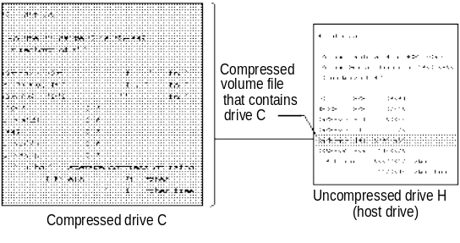

Do not tamper with a CVF. If you do, you might lose all the files on the compressed drive.
Caution

This illustration shows the relationship between a compressed drive, a CVF, and a host drive in two drives: drive C, which is compressed, and drive H, which is uncompressed. The dir /c command has been carried out on compressed drive C. This command lists the files in the current directory and displays the compression ratio of each file. Drive C contains several directories and the COMMAND.COM, AUTOEXEC.BAT, and CONFIG.SYS files.
The dir /a command has been carried out on drive H. This command lists the files in the current directory, including any files that have the Hidden attribute. Drive H contains several files, including the compressed volume file for drive C, DRVSPACE.000.
Compressed drive C is contained in the compressed volume file DRVSPACE.000, which is located on uncompressed drive H. Drive C’s compressed volume file uses a substantial amount of space on drive H. However, drive C provides far more storage capacity than the space it uses on drive H.

Using DriveSpace for Disk Compression
Using DriveSpace, you can compress and uncompress data on floppy disks, removable-media drives, or hard disk drives. DriveSpace frees space on disks by compressing the data that is on them. The first time you use DriveSpace to compress data or space on a drive, the disk will have 50 to 100 percent more free space than it did before.

Tip for Swap Files on Compressed Drives
Windows 95 allows you to store a swap file on a DriveSpace or DoubleSpace drive. DriveSpace marks the swap file as uncompressible and, to reduce the risk of fragmentation, places the swap file as the last file in the sector heap. (Locating the file there also allows for room to grow.)
If you want to change the size of the drive and DriveSpace or a defragmentation utility detects a swap file at the end of the sector heap, you will be prompted to restart the computer. Likewise, if you try to change the size of a drive that was mounted with a real-mode DriveSpace or DoubleSpace driver, you may be prompted to restart the computer so that the drive can be remounted under Windows 95.

When you choose to compress a drive, the drive you specify is compressed and contains more free space than it did before. You can use the compressed drive just as you did before you compressed it. In addition, DriveSpace creates a new uncompressed drive, called the host drive, where it stores the CVF. If the host drive is large enough, you can also use it to store files that must remain uncompressed.

DriveSpace can create a virtual drive of up to 512 MB. If your disk is very large, you may not be able to compress it as a single volume.
Note

Alternately, on an uncompressed drive that is part of a non-removable hard disk, you can create a new compressed drive from its free space. After compression, you’ll notice that the uncompressed drive contains less free space than it did before. This space is now being used by the new compressed drive, which is stored in a hidden file with a filename such as DBLSPACE.001.
Consider this scenario: Suppose you have a 200 MB hard disk with 100 MB of data on it. Uncompressed, this disk has 100 MB of free space. You can increase the amount of disk space in two ways:

What’s the difference between compressing a drive and creating a new compressed drive?
- If you compress this drive, DriveSpace compresses both the data and the free space on the disk. Then, because DriveSpace reports file sizes of compressed files as though they were uncompressed, you will see that the disk is now a 400 MB disk with 100 MB of data and 300 MB of free space.
- If you instead create a new compressed drive from the hard disk’s free space, DriveSpace will report that you have two drives, one with 200 MB of free space and the other with 100 MB of data (and no free space).

While the option to compress a drive provides more usable space, the process takes longer than creating a new compressed drive, because it compresses both the data and the free space on the drive. Creating a new compressed drive involves compressing the free space only.

Before you use DriveSpace to compress a drive, you should back up the files on drive you want to compress.
Important

For information about using the command-line equivalent commands for DriveSpace, see Appendix A, “Command-Line Commands Summary.”
To compress a drive
1. From the Start button, choose Programs, then choose Accessories, and then choose System Tools. Click DriveSpace.
2. In the Disk Compression window, click the drive you want to compress.
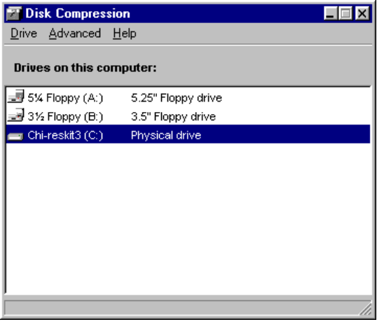
3. Use options on the Advanced menu if you want to do any of the following:
- Change the amount of free space to be left on the host drive.
- Change the drive letter assigned to the host drive.
- Make the host drive visible. (In most cases, the host drive is hidden by default.)
4. From the Drive menu, click Compress.
Windows 95 displays the Compress a Drive dialog box, listing the drive it is about to compress.
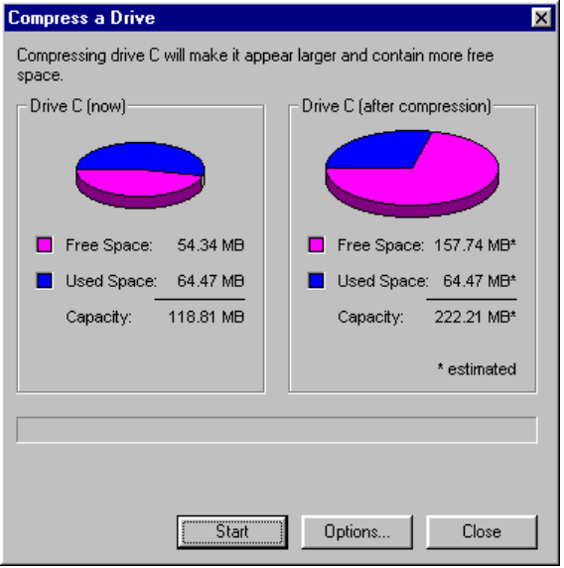
5. Click Options if you want to specify the drive letter free space available for the host drive, and whether the host will be hidden.
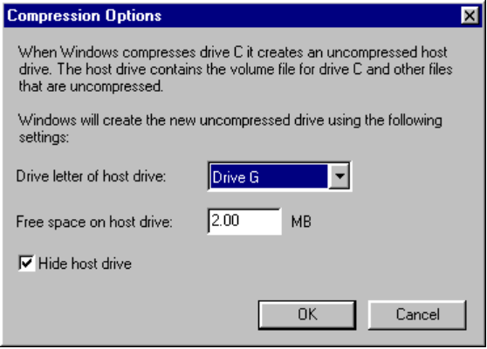

By default, DriveSpace hides the host if the amount of free space is less than 20 MB. You can clear the Hide Host Drive check box to make this drive visible.
Note

Make modifications in the Compression Options dialog box, and then click OK.
6. Click Start to continue.
7. DriveSpace prompts you to back up your files. If you want to back them up at this time, click Back Up Files.
8. Click Compress Now to continue.
9. As the compression progresses, DriveSpace displays a status bar.
DriveSpace checks the drive for disk errors, and then defragments and compresses the drive. This process can take from several minutes to several hours, depending on the speed of the hard disk and processor and the amount of data the hard disk contains. Because DriveSpace checks and rechecks the validity of the data as it compresses files, the process is very safe. In fact, if the compression process is accidentally interrupted (for example, by a power outage), DriveSpace will recover and continue without losing any data.
If any files are open on the drive, DriveSpace will prompt you to close them. For drives that always have opened files (such as the drive containing Windows 95 or the drive containing a swap file), DriveSpace will restart the computer, using a limited version of Windows in place of Windows 95 while it compresses the drive. After compression, your computer will restart again, this time with Windows 95.
10. When the compression is completed, DriveSpace Setup shows how much free space is available on the drive. Click OK.
DriveSpace prompts you to restart your computer again.

Do not tamper with the hidden files on the new host drive. If you change or delete these files, you might lose all the files on the drive you compressed.
Caution

To create a new compressed drive
1. From the Advanced menu, click Create Empty.
2. To be provided.

To uncompress a drive
1. From the Drive menu, click Uncompress.
2. To be provided.

Using DriveSpace with Floppy Disks
You can use DriveSpace to increase the storage capacity of floppy disks. After compressing a floppy disk, you can use it to store data or to transfer data from one computer to another if both computers must be using DriveSpace. After DriveSpace finishes compressing the floppy disk:
- The floppy disk contains more free space than it did before. You use the floppy disk just as you did before you compressed it, except that if you change floppy disks or restart the computer, you must remount the floppy disk. (The process to mount volumes is automatic after DriveSpace drivers are loaded on your system, which happens when you use DriveSpace to compress a drive or to explicitly enable Automounting.)
- The computer has a new drive letter (usually hidden by default). This new drive letter represents the compressed floppy disk’s host drive, which contains the floppy disk’s CVF. Both the new drive letter and the original drive letter are associated with the same physical floppy disk drive.

In general, you use a compressed floppy disk just as you do an uncompressed floppy disk.
By default, DriveSpace automatically mounts a compressed floppy disk when
you try to use that disk. This makes it possible to use the disk as if it were an uncompressed floppy disk.
If you rarely use compressed floppy disks, you might want to disable the Automounting feature to save memory. When Automounting is enabled, it uses about 4K of memory.
To disable Automounting
1. From the Advanced menu, click Options.
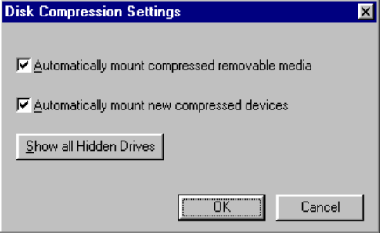
2. Clear the Automatically Mount... option.

Before it is mounted, a compressed floppy disk appears nearly full. If you have turned off the Enable Automounting option and if you change to the floppy disk drive and carry out the dir command, the system usually lists one file: a text file named READTHIS.TXT, which briefly explains how to mount the floppy disk. The dir command usually reports that the floppy disk contains almost no free space, because most of the space is used by the CVF. The CVF is a file usually named DBLSPACE.000 with Hidden, Read-Only, and System attributes.
Note

When Automounting is disabled, you can still use compressed floppy disks, but you must mount them yourself.
To mount a compressed floppy disk
1. Insert the compressed floppy disk in a drive.
2. In the Disk Compression window, click the drive you want to mount.
3. From the Advanced menu, click Mount.

The compressed floppy disk remains mounted and the files on it remain available until you change floppy disks or restart the computer.

Changing Free Space and the Estimated Compression Ratio of a Compressed Drive
On an uncompressed drive, free space indicates how much additional data you can store on that drive. For example, if a drive has 2 megabytes (MB) of free space, you can expect to fit 2 MB of data on it. However, the free space on a compressed drive is only an estimate of how much data you can fit on that drive.
When you store a file on a compressed drive, DriveSpace compresses the file so that it takes up as little space as possible. Some files can be compressed more than others; for example, a bitmap file can be compressed much more than a program file. DriveSpace cannot detect the compressibility of files you haven’t stored yet, so it can only estimate a compressed drive’s free space.
DriveSpace estimates a drive’s free space by using the estimated compression ratio, which you can set to specify the compressibility of the files you plan to store. For example, if the estimated compression ratio is 3 to 1, DriveSpace calculates the drive’s free space based on the assumption that each file you will store can be compressed to one-third its original size.
Usually, the best compression estimate to use is the actual compression ratio for the files already stored on the drive. Sometimes you might want to reset the estimated compression ratio of each drive to match that drive’s actual compression ratio.
You might want to change the estimated compression ratio if it differs greatly from the actual compressibility of the files you plan to store. For example, if you plan to store extremely compressible files, such as bitmap files, you might want to specify a higher estimated compression ratio. Or, if you plan to store files that will not compress much further, you might specify a lower ratio.
Changing a drive’s estimated compression ratio does not affect how much DriveSpace actually compresses the files on that drive; it changes only the way DriveSpace estimates the free space on the compressed drive.
To change the estimated compression
1. From the Advanced menu, click Change Ratio.
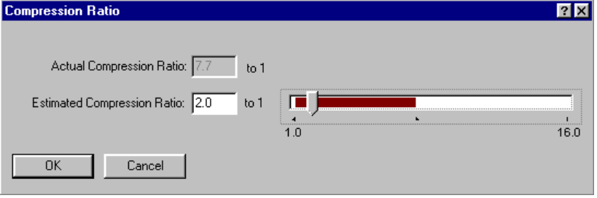
2. Type a new ratio in the Estimated Compression Ratio box. Click OK.

You can also adjust the amount of free space for a compressed drive or its host drive. When you increase free space on a compressed drive, you decrease it on its host, and vice versa.
To change the amount of free space on a drive
1. From the Drive menu, click Adjust Free Space.
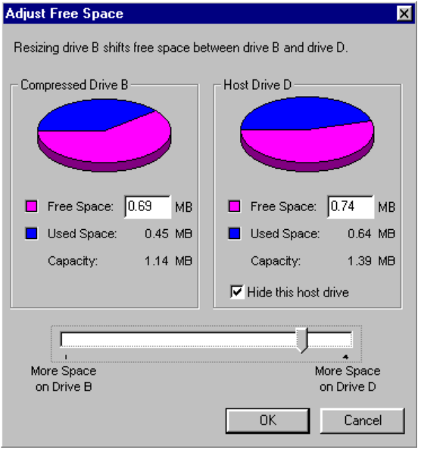
2. Using either the right or left Free Space field, or the slider bar, adjust the amount of free space available on the compressed and host drives. Click OK.

Disk Management Overview
Windows 95 includes several tools that you can use to manage and protect your data and improve the performance of your computer. To keep your computer in good working order, use these programs on a regular basis. To determine which tasks are necessary to manage your computer, consider the following.
To ensure that | Do this | For details, see
Files aren’t lost if the hard disk fails | Run backup or a network backup agent | Chapter 12, “System Management”
The computer can access files quickly and efficiently | Defragment the hard disk | “Defragmenting Disks” later in this chapter
Files are stored correctly, lost clusters aren’t taking up space on a disk, or that the hard disk is not damaged | Run ScanDisk | “Using ScanDisk” later in this chapter

The routine for managing a computer’s hard disks should include automatically running ScanDisk when starting the computer to check the integrity of the hard disk, backing up files once a week, and occasionally using the Disk Defragmenter to defragment the hard disk. No matter what your computer management plan, carry it out at regular intervals.

For best results, do not run other programs while running either Disk Defragmenter or ScanDisk. Although you can use your computer for other tasks while running either of these utilities, each time you write to the disk, the utility automatically reinitiates itself to work with the current view of the disk.
Note

To be provided: information for maintaining compatibility with earlier utilities.

Tip for Volume Locking for Disk Utilities
Windows 95 provides volume locking APIs that applications such as disk utilities can use to control direct disk access when the computer uses the Windows 95 32-bit file system. (In Windows for Workgroups 3.11, VFAT generated an error whenever a disk utility tried to access the drive in protected mode.)
Disk utilities usually make absolute INT 25 and INT 26 disk calls, which do not require file system drivers. Instead of calling INT 21 and INT 13 to access the disk, the application calls INT 25 for reads and INT 26 for writes.
When an application is going to change the disk structure (such as a disk utility preparing to defragment the disk), it should use the volume locking APIs to lock that volume or drive before making any disk calls, so that no other application can write to that volume and interfere with its operations. When the application has completed its work, it must unlock the volume before the system can resume normal operation.
If a utility does not use volume locking before it attempts to read from or write to the disk, Windows 95 returns an error and causes it to fail. All utilities included with Windows 95, such as Defrag and ScanDisk, use volume locking.

Defragmenting Disks
Over time, as programs read from and write to the hard disk, information that is stored on the disk can become fragmented. Fragmentation occurs when a file is stored in discontiguous sectors on a disk. Fragmentation doesn’t affect the validity of the information — the files are still complete when they are opened. But it takes much longer for the computer to read and write fragmented files than it does to read and write unfragmented files.

How do I defragment a hard disk?
To improve file access time, you can defragment your uncompressed FAT drives and compressed DriveSpace or DoubleSpace drives.

The Disk Defragmenter will not work with third-party compressed drives (such as those compressed with Stacker or SuperStor), read-only drives, locked drives, network drives, FFS drives, or drives created with ASSIGN, SUBST, or JOIN.
Note

To defragment a disk drive
1. From the Start button, choose Programs, then choose Accessories, and then choose System Tools. Click Disk Defragmenter.
2. In the Select Drive dialog box, specify the drive that requires defragmentation and click OK.
3. The Disk Defragmenter displays a dialog box telling you whether defragmentation is recommended for your disk or not. If your disk has low fragmentation, the Disk Defragmenter will not recommend defragmentation.
4. Click the Advanced button if you want to do any of the following:
- Specify a defragmentation method (all files and free space, files only, or free space only). Depending on how badly defragmented the disk is, you can reduce the amount of time required to defragment a disk by choosing to defragment only files or only free space.
- Choose to defragment hidden files or compressed volume files.
- Save optimization preferences each time you use Disk Defragmenter.
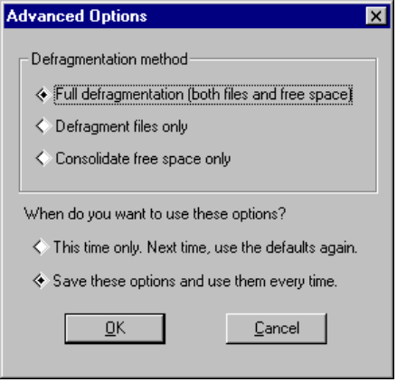
5. In the Advanced Options dialog box, select the required defragment options and click OK.

For quickest performance, minimize the Disk Defragmenter window while the utility is running. (Showing details while the Disk Defragmenter runs causes it to take long.)
Tip

6. Click Defragment Now or Defragment Anyway to continue.

To see defragmentation information for a particular drive, right-click that drive’s icon, then click Properties. The Tools property sheet shows the number of days since the last complete defragmentation process ran on the drive. You can also run Disk Defragmenter from this property sheet.
Tip

You can also use the command-line equivalent command, defrag, in a batch file. For more information about this command, see Appendix A, “Summary of Command-Line Commands.”

Using ScanDisk
ScanDisk is a full-featured disk analysis and repair program. It is designed to work on both uncompressed drives and DriveSpace or DoubleSpace compressed drives. ScanDisk checks and fixes problems in the following areas:
- File allocation table (FAT)
- Long filenames
- File system structure (lost clusters, cross-linked files)
- Directory tree structure
- Physical surface of the drive (bad sectors)
- DriveSpace or DoubleSpace volume header, volume file structure, compression structure, and volume signatures

ScanDisk can find and fix errors on the following types of drives:
- Hard disk drives
- Floppy disk drives
- RAM drives
- Memory cards

ScanDisk cannot find or fix errors on CD-ROM drives, network drives, or drives created by using ASSIGN, SUBST, JOIN, or INTERLNK.
Note

ScanDisk can check and repair mounted DriveSpace or DoubleSpace drives and unmounted CVFs. If you run ScanDisk on a mounted or unmounted compressed drive, by default, ScanDisk will check the host (physical) drive first. In general, you should allow it to do so, since an error on the host drive could cause problems with the compressed drive.

Consider putting ScanDisk in the Startup folder to run it each time you start your computer.
Tip

To run ScanDisk
1. From the Start button, choose Programs, then choose Accessories, and then choose System Tools. Click ScanDisk.
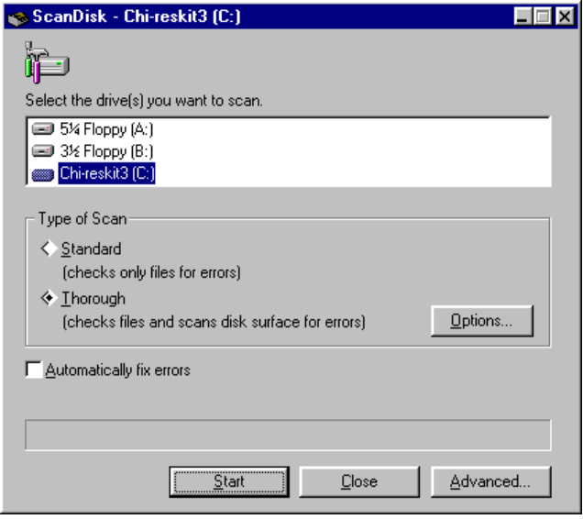
2. Select the drive or drives you want to analyze or repair.
3. Click the Options button if you want to specify which areas of the disk to check or which type of processing to perform.
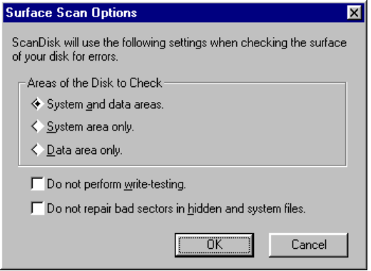
Select the options you want to use and click OK.
4. Click Start to continue.

ScanDisk begins checking the first selected drive. If ScanDisk finds any problems, it displays a dialog box explaining the problem.

You can also run ScanDisk from a drive’s Tools property sheet. To do so, right-click that drive’s icon, click Properties, and then click the Tools tab. Run ScanDisk from this property sheet.
Tip

You can also use the command-line equivalent command, scandisk, in a batch file. For more information about this command, see Appendix A, “Summary of Command-Line Commands.”

Troubleshooting Disk and File System Problems
To be provided.

Troubleshooting Long Filenames
You might experience some problems with long filenames when transferring files between down-level file systems, running file searches, or using certain disk utilities.

Summary of Long-Filename Troubleshooting Tips
- Long filenames can cause problems for some disk utilities. Be sure to use disk utilities that are long filename-aware.
- Using a down-level file system command (such as copy or rename) rather than the Windows 95 equivalent will destroy a long filename.
- Because the root directory is limited to 512 entries, the root directory can be filled with fewer files that have long filenames, because each name takes more than one entry in the directory.

The following will help you find and solve problems that might occur with long filenames.

An operation on a long filename changed the alias name.
In particular, operations such as copy, backup, and restore might change the 8.3 alias name associated with the file. For example, if a file with the name LongFileName is associated with an alias LONGFI~2, and this file is copied to a different directory using the following:
copy LongFileName \TMP\LongFileName

then the alias associated with this file can become LONGFILE, if such an alias is not present in the target directory. The long filename is preserved in this case.

An operation on the 8.3 alias name destroyed the long filename.
In particular, operations such as copy, edit, backup, and restore using older versions of utilities that do not support long filenames can destroy the long filename associated with the file that is operated upon. For example, if a file with the name LongFileName.Txt is associated with an alias LONGFI~1.TXT, and this file is copied to a different directory using an older version of copy that is not aware of long filenames, then:
oldcopy LONGFI~1.TXT \TMP\LONGFI~1.TXT

causes the destination file in the target directory to be associated only with the filename and alias of LONGFI~1.TXT. The destination file will not have the filename LongFileName.Txt. A similar problem can occur on older versions of backup and restore. If you back up the entire computer using an old version of a backup utility that does not support long filenames and then restore it, all the long filenames in the system will be lost. Notice that the alias (which will also be the newer filename) and the data of the file are preserved.
A user who chooses to use only filenames that comply with the 8.3-filename rules (ignoring case) will not see these idiosyncrasies.

Searching for a filename gives unexpected results.
Searches for filenames apply to both the filename and its alias, because the system presents a single unified namespace so that the single physical view of the file is preserved. However, if the result of the search shows only the filename, it could be confusing.
If you perform a wildcard search using a disk utility that is not long filename-aware, the results may be unexpected. For example, using the following four files, a search that uses dir *jun* results in listing all the files.
Departmental Budget. June 1993  Departmental Organization.Fiscal Year 1993.June  Department Assets List as of June.1993  Department Employee Assets.June.1993 | DEPTBDGT.JUN  DEPART~1.JUN  DEPARTME.199  DEPART~1.199

Searching with dir *.jun would result in only the following two files being listed.
Departmental Budget. June 1993  Departmental Organization.Fiscal Year 1993.June | DEPTBDGT.JUN  DEPART~1.JUN

Searching with dir *.jun* results in the following three files being listed.
Departmental Budget. June 1993  Department Assets List as of June.1993  Department Employee Assets.June.1993 | DEPTBDGT.JUN  DEPARTME.199  DEPART~1.199

As another example, you might have a set of files in a directory, where the filenames and aliases are as follows:
Long filename | Alias
LongFileName | LONGFI~1
MyFile | MYFILE
Problems.Txt | PROBLEMS.TXT
AnotherFile | ANOTHERF
File-1 | FILE-1

In this example, searching for dir *1 results in the following:
LONGFI~1 123 08-11-93 15:26 LongFileName
FILE-1 352 08-11-93 16:01 File-1

Notice that DIR displays the alias first for compatibility with the older DIR format. However, a utility that is aware of long filenames and that displays only the filename will display both the files LongFileName and File-1. This can be confusing, because the file LongFileName does not have the number 1 as part of the name (which was specified in the search criteria). The file matches the search pattern, because its alias contains the number 1.
Long filenames preserve the case of the name. So typing mkdir examples at the command prompt actually creates an entry named examples and an alias of EXAMPLES. However, searches are not case-sensitive.
The period character (.) is just another character in a long filename, but a filename starting with a period is not allowed. So a filename can have multiple periods as part of the name, as long as it does not start with a period. For example, MyFile.081293.Document is a valid filename, though its alias will probably be MYFILE08.DOC, because the first three characters after the last period in the filename are used as the extension for the alias. Previously, the DIR command appended the characters .* (period with asterisk) to the search pattern if no extensions were specified. In Windows 95, the DIR command appends the .* characters, only if no extensions are specified as part of the search pattern (as before) and the search pattern does not end with an * character. The end effect of the DIR command should be what you would expect.

Long filenames cannot be seen or created on the computer.
If Windows 95 is installed on the computer without long filename support, you cannot see or use long filenames. This installation option should only be used if you use a utility that requires an exact duplicate of the Windows 3.x files.
To install long filename support, you must reinstall Windows 95, and do not disable long filename support.

The long filename was lost after the file was edited on another computer.
Down-level file systems are not aware of the long filename extensions to the FAT file system. If you take a floppy disk containing files with long filenames to a down-level system, only the 8.3 alias name is visible on that system. If you take the floppy disk back to a computer running Windows 95, the long filename is visible.
If you copy the file from the floppy to the hard disk on the down-level system, the long filename associated with the file is not copied over. This is not a problem on the down-level system, because it cannot see the long filename anyway. However, if you edit the file on the down-level system, and then save a new copy back on the floppy disk, the long filename associated with the file is lost. If you subsequently take this floppy disk back to the computer running Windows 95, only the alias name is associated with the file, because the down-level system was not aware of and could not preserve the long filename.

A disk utility reports a disk error but there is no error on the disk.
Disk utilities that are not revised for VFAT will unexpectedly find values in fields that were once reserved for MS-DOS. In previous versions of MS-DOS and Windows, these reserved entries were zero.
Some disk utilities, especially disk repair and checking utilities, might display errors about the disk because of the usage of these reserved entries, though there are no real errors on the disk. In the worst case, a disk repair utility could destroy all these entries since it mistakenly thinks they are corrupted entries. The end result of destroying these entries is different for the long entry case and the alias entry case. In the long entry case, the long filename is lost, but the alias (8.3 name) and the data in the file are still present, making it difficult to find the file, without the associated long filename. In the case of a destroyed alias entry, the alias and the data will also be lost, because crucial information about the file (apart from the name) is also lost. For this reason, Windows 95 warns you about potential dangers related to running the most popular disk utilities.
A disk utility that checks for directory entry coherence should only check the valid entries. Specifically reserved locations should either not be checked for zero values or such checks should be combined with MS-DOS version checks. Otherwise, the utility will malfunction when the entries are extended by using the reserved locations.
The following describes the behavior of certain disk utilities with regard to long filenames.
Utility | Behavior with long filenames
ScanDisk | The default for ScanDisk is not to check for the Volume-Label attribute. Therefore, even the MS-DOS 6.2x version of ScanDisk will not be alarmed by a long entry with its unusual attribute. If the user wants earlier versions of ScanDisk to check for the Volume-Label attribute, the WINDISK.INI should include the entry:  CheckVolLabel=ON
Norton Disk Doctor (NDD) | In a long entry, the first cluster is 0. However, the File Size field (the last four bytes) will have values in them for the 12th and 13th characters in that entry’s set. NDD will try to overwrite the file size area with zeroes.
DiskFix | This utility has the same behavior as NDD regarding the first cluster and File Size fields. In addition, if some of the 10 reserved bytes are nonzero, DiskFix completely erases the entry.

Troubleshooting Other File System Problems
To be provided.

Troubleshooting Disk Space Problems

Do not run any disk utilities which are not specifically designed for Windows 95.
Caution

There is too little disk space.
- Check the TEMP variable.
- Check the disk space on the TEMP drive.
- Check the swap file size.
- Check for lost allocation units. (ScanDisk refers to these as lost file fragments.)

The following procedures describe how to check these items.
To check the TEMP variable
1. Use the SET command at an MS-DOS prompt to display the TEMP variable.
2. Verify the TEMP variable points to a valid drive.
– Or –
1. Shut down and restart the system.
2. Press Shift+F5 at the Starting Windows message to use Fail-Safe Startup to start at the real-mode command line.
3. Run MSD from the Windows COMMAND directory.

To verify the TEMP drive has free space
- In Windows Explorer, right-click a drive icon, and when the menu appears, click Properties.
The display will default to the General property sheet which contains graphical and numeric displays of user and available disk space.
– Or –
1. Shut down and restart the system.
2. Press Shift+F5 at the Starting Windows message to use Fail-Safe Startup to start at the real-mode command line.
3. Run ScanDisk from the Windows COMMAND directory.

To check the virtual memory allocation on disk
1. In System Control Panel, click the Virtual Memory button
2. Check the text in the Hard disk box. The box will contain the drive which is being used for the swap file and the amount of remaining free space on the drive.
3. You may want to set or reduce the maximum size of the swap file to free up additional space for other temporary files (such as spooled metafiles to a printer).
4. You may want to specify a different drive for the swap file or for the TEMP variable, if insufficient free disk space is available on this drive.
5. You may want to keep at least 2 to 10 MB of disk space free on the TEMP drive (or more if large print jobs are being done, especially when using PostScript®).

To check for lost allocation units
1. In Explorer, right-click a drive icon, and when the menu appears, click Properties.
2. Click the Tools tab.
3. In the Check For Damage box, click the Check Now button.
– Or –
1. Shut down and restart the system
2. Press Shift+F5 at the Starting Windows message to use Fail-Safe Startup to start at the real-mode command line.
3. Run ScanDisk from the Windows COMMAND directory.

All lost allocation units will be detected by ScanDisk, and you will be prompted to recover them for use.

Troubleshooting Compressed Drives

Disk errors occur on a compressed drive.
- Run the ScanDisk program on that drive.

