Chapter 1
With Windows 95, printing is even faster and easier than before. This chapter describes the improvements made to this printing system over the Windows 3.1 printing system. It also explains how to set up printers with Windows 95.
Printing

Improved Printing in Windows 95 19-2
In This Chapter
Windows 95 Print Subsystem 19-2
Installing a Printer 19-11
Sharing a Printer 19-13
Connecting to a Remote Printer 19-14
Using Point and Print 19-14
Printing Documents 19-16
Using a NetWare Print Server 19-17
Spooling Print Jobs from a NetWare Print Server 19-18
Printing Flowcharts 19-21
Troubleshooting 19-24

Improved Printing in Windows 95
Windows 95 includes several significant improvements for printing over
Windows version 3.1. These include:
- A new 32-bit print subsystem. The Windows 95 print subsystem is compatible with the Windows NT 3.1 print subsystem including monitors which facilitate bidirectional communications with printers.
- Quicker “return to application” time. Background spooling and the use of enhanced metafile (EMF) spooling can significantly decrease the time it takes to return control to the application, depending on job content.
- Better conflict resolution. Spooling from MS-DOS – based applications solves conflicts when multiple MS-DOS – based application or MS-DOS – based and MS-Windows-based applications are trying to print at the same time.
- “Point and Print” support. Windows 95 provides “hands-free” printer installation. Additionally, users can Point and Print to Windows 95, Windows NT, and Novell® NetWare®-based printers.
- Improved network printer connections. Uniform Naming Convention (UNC) connections are used whenever possible to eliminate the need for LPT port redirection.

Windows 95 Print Subsystem
In Windows 3.1, print spooling functionality was handled by Print Manager and was supported by code in several different Windows-based components. In Windows 95, the print spooler is implemented as a series of 32-bit virtual device drivers and DLLs, and consolidates the spooler functionality into a single architecture.
The new spooler provides smooth background printing. In Windows 3.1, Print Manager passed a fixed amount of information to the printer, whether the printer was ready to receive it or not. If the printer wasn’t ready to receive more data, the Windows 3.1 system was suspended until the printer was ready. Unlike Print Manager, the Windows 95 spooler passes data to the printer only when the printer is ready to receive more information, by using background thread processing. This helps to reduce what often seemed like “jerkiness” when printing documents with Windows 3.1 Print Manager.
The new spooler provides quick “return to application” time and smooth background printing. This spooler is much more powerful and flexible. It allows the user to select printer attributes on a per-printer basis, instead of requiring global printing attributes as in Windows 3.1. For example, each printer can have a different separator page and the option of printing directly, versus printing by means of a queue.
The following diagram illustrates how Windows 95 prints documents.
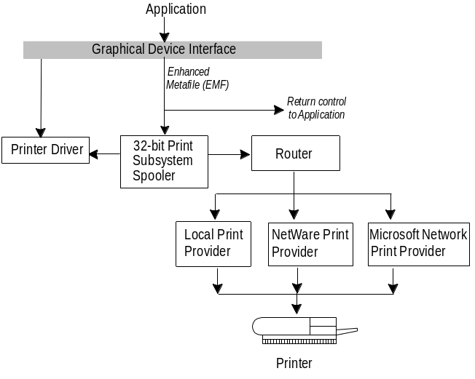

For flow diagrams showing specific printer configurations with Windows 95 as a client to other networks, see the “Printing Flowcharts” section later in this chapter.
Note

Enhanced Metafile Spooling
Many changes to Windows 95 affect printing. The most noticeable of these is that all output to non-PostScript® printers spool enhanced metafiles, instead of raw printer data as they currently do in Windows 3.1. When you direct an application to print, it will print more quickly (as much as twice as fast) and enable you to resume work much more quickly.
As shown in the following diagram, when printing from Windows–based applications, Windows 95 spools enhanced metafiles (EMF) rather than raw printer data to ensure quick return to application time. When spooled, the EMF information is interpreted in the background, and output is then sent to the printer.
EMF information is generated by the graphical device interface and is spooled, instead of the raw printer data being generated by the printer driver. For example, if a document contains a solid black rectangle, the EMF would contain a command to draw a rectangle with the given dimensions, fill it in with a solid color, using the color black. After the EMF is created, control is returned to the user, and the EMF is interpreted in the background on a 32-bit print subsystem spooler thread and sent to the printer driver. This results in control being returned to the user in significantly less time than having to wait for the print calls to be fully interpreted by the printer driver directly.
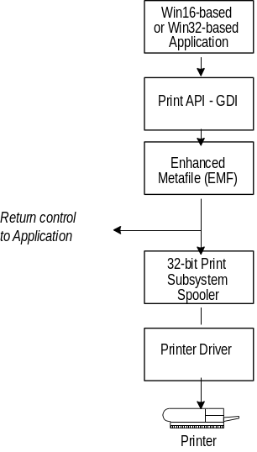

If you have problems printing, you might want to disable enhanced metafile spooling to determine if it is causing the problem. Enhanced metafile spooling is enabled by default for all non-PostScript printers.
Tip

To disable enhanced metafile spooling
1. From the Start menu, choose Settings, and then click Printers.
2. Right-click the icon for your printer.
3. From the context menu that displays, click Properties and click the Detail tab. Then click Spool Settings.
4. In the Spool Settings dialog box, select RAW from the Spool Data Format drop-down list box. Click OK.
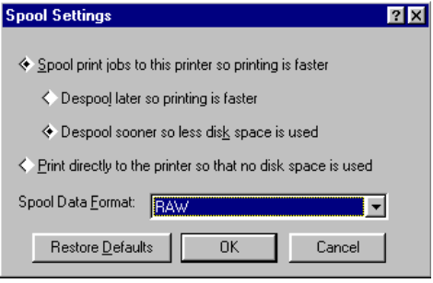

Plug and Play Support for Printers

One of the key features for Windows 95 that makes managing a computer much easier is Plug and Play support. A Plug and Play-compliant printer reports information about itself to Windows 95, namely, a manufacturer name and printer model. The manufacturer plus the model make up the Device ID for the printer.
In addition, the printer may also provide information about class, description, and compatible identification.
The following table describes these key values:
Key | Description
Manufacturer | The names of the hardware vendor for the printer.
Model | The model name for the printer.
Class | Describes the type of device; namely, “Printer”.  The purpose of this keyword is to differentiate printers from network adapters, attached hard drives, and other peripherals.
Description | A brief description of the device that the manufacturer would like the user to see when prompted for the disk containing a driver, for example, Hewlett-Packard LaserJet® 4P, Tektronix® Phaser™ II SDX Thermal Wax Transfer Color Printer.
Compatible ID | Contains one or more model names of other device drivers that may be for that printer, in order of preference. The purpose of this field is to allow compatible device drivers to be installed, if a driver for the exact model being used is not available.

Windows 95 stores the information provided by each printer in the Registry.
Windows 95 also offers auto-detection of devices. At startup, Windows 95 queries all devices attached to a parallel port and tries to obtain a device ID (that is, the manufacturer and model) of the device. When this ID is found, and no device driver is yet installed, Windows 95 tries to install it, either from the hard disk or by prompting the user for a disk.
Similarly, when a user connects to a network printer that is not yet installed on the user’s computer, Windows 95 automatically tries to detect which driver to install. If the printer is connected to a computer running Windows 95, the driver is copied from the server to the user’s computer.

Printer .INF Files
Windows 95 uses a new .INF format for printer installation. Although the previous OEMSETUP.INF file format is still supported for compatibility with previous versions of Windows, the new format offers added functionality, including supports for installation of print subsystem components such as the print driver and port monitor.
Windows 95 searches for a corresponding .INF file to match the manufacturer and model. If found, Windows 95 automatically installs the device driver listed there. If the automatic ID and compatible ID are available, Windows 95 also uses these to identify a matching .INF file.

Bidirectional Communication Support
Windows 95 detects Plug and Play-compliant printers that return device ID values (as described in the IEEE 1284 specification) through bidirectional parallel communication. This feature is of benefit to applications because they can use it to query the printer directly to find out about its physical attributes.
Bidirectional communication allows for:
- Accurate identification of attached devices
- Improved ease of use when installing new components
- Optimized performance by enabling intelligent communication between host and peripheral
- Dynamic event notification in real time

One of the immediate benefits of bidirectional communication is being able to initially configure device driver settings on the server without user intervention. The printer driver can automatically determine how much memory the printer has, what device fonts are available, and so on.
Bidirectional communication also allows printers to send unsolicited messages to Windows 95 and to applications. For example, the printer might send an “out of paper” or “printer offline” message. Bidirectional communication enables much more detailed status reporting on a wider variety of information such as toner low, detailed paper jam information, maintenance needs, and so on.

Printer Driver Support
As with other devices, Windows 95 offers a device driver model that makes it easier for printer manufacturers to create drivers for their printers. The Windows 95 device driver model includes two parts, a universal driver and a mini-driver. Windows 95 provides the universal printer driver which communicates with other parts of the operating system and includes information pertinent to all printers. The mini-driver written by the printer manufacturer communicates with this universal driver and with the printer itself.

Mini-drivers written for Windows 95 will also work with the Windows NT 3.5 universal printer driver.
Note

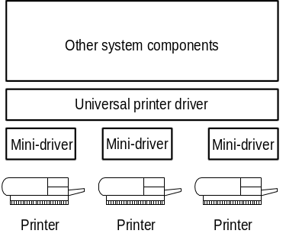

Universal Printer Driver
The Windows 95 universal printer driver supports mainstream page description languages, including HP® PCL®, Epson® ESC P/2, Canon® CaPSL, Lexmark PPDS, monochrome HP GL/2, as well as most of the older dot matrix technologies. Almost all non-PostScript printer drivers shipped with Windows 95 will be based on Universal Driver Technology.
The universal printer driver has full support for device-resident Intellifont and TrueType® scaleable device fonts. It also supports downloading of TrueType outlines to PCL printers with TrueType rasterizers.
The universal printer driver includes the following:
- Full 600 dots per inch (dpi) support. Changes allow future expandability to higher resolutions.
- Support for downloading TrueType outlines to PCL printers with TrueType rasterizers. Enhancements offer support for downloading unbound TrueType outlines and of character sets with more than 256 characters.
- Monochrome HP GL/2 support, providing full LaserJet® 4 functionality.
- Generic Text support using TTY.DRV.
- Support for ESC P/2 raster graphics directly through the universal driver, rather than mini-drivers.
- Easy-to-use property sheets for configuring printer driver settings.

PostScript Mini-Driver
Windows 95 also provides a PostScript mini-driver, which Microsoft developed by working closely with Adobe. This mini-driver offers the following:
- PostScript Level 2 support. This feature is automatically enabled for printers reporting as Level 2 from their PPD.
- Additional support for image color matching (ICM). The PostScript driver allows the server to offload ICM to the PostScript processor to improve performance. This flexibility allows you to take advantage of color raster enhancements on either the printer or the server.
- Control over output data format. The PostScript mini-driver supports ctrl+d handling, Binary Communications Protocol (BCM) and Tagged Binary Communications Protocol (TBCP), and pure binary (8-bit) channels (AppleTalk).
- Support for version 4.2 PPD files. These are then converted to driver-readable format. WPD files are still supported for compatibility.
- Tracking of PostScript virtual memory availability in the printer. This allows you to print more complex documents than you could with Windows 3.1. However, if you encounter problems where the printer prints a message about being unable to print due to lack of available virtual memory in the printer, you can work around this problem by changing the PostScript options settings from Optimize for Speed to Optimize for Portability.
- Easy-to-use property sheets for configuring printer driver settings.
- Support for installable device options, as described in the .PPD file, through the user interface.

Extended Capabilities Port Support
Support for Extended Capabilities Port (ECP), as described by the IEEE 1284 specification, is included in Windows 95.
To enable ECP support in Windows 95
1. Consult your computer (or add-in card) manual to determine the interrupt request (IRQ) and direct memory access (DMA) settings selected for each of the ECP ports you want to use. You’ll need this information to enable ECP support.
2. From the Start button, choose Settings, and then click Control Panel.
3. Double-click the System Control Panel icon.
4. Click the Device Manager tab.
5. Click Ports (COM & LPT), and then select the Extended Capabilities Port entry. (Notice that you will only see this entry if an Extended Capabilities port was detected in your computer. If you have multiple ECP ports, you will have to repeat Steps 7 and 11 to configure each port’s DMA and IRQ values.)
6. Click the Properties button from the dialog box.
7. In the General property sheet, click the Change Driver button in the Driver Information box.
8. From the dialog box that displays next, you can select from Printer Port and ECP Parallel Port. (Notice that you will only see this entry if an Extended Capabilities port was detected in your computer. Otherwise, you must choose Show All devices to see both entries.) Choose ECP Parallel Port and then click OK from the Select Device dialog box.
9. Click the Resources tab, then click Manual Based On to see control for Interrupt Request (IRQ) and Direct Memory Access (DMA) settings. Type the values you noted during step 1 of this procedure.
10. Click OK to close the dialog box, and then choose Current, when prompted if you want to use new or current files.
11. Restart Windows 95 when prompted. After restarting, you can take advantage of the ECP-specific capabilities of the port.

Improved Printing Support for MS-DOS–based Applications
With Windows 3.1, users printing from MS-DOS – based applications could not take advantage of the Windows-based spooling functionality offered by Print Manager, and encountered device contention issues when trying to print from
MS-DOS – based applications at the same time as printing from Windows-based applications.
Windows 95 addresses the print issues in Windows 3.1 by incorporating the functionality for an MS-DOS – based application to spool directly to the 32-bit Windows 95 print spooler. This support is integrated into a print spooler virtual device, which takes the output destined for a printer port and first places it in the Windows 95 print spooler before sending the data to the printer. This functionality works with all existing MS-DOS – based applications, and results in quicker “return to application,” through the use of the spooling mechanism. While MS-DOS – based applications do not benefit from EMF spooling (which is supported only for printing from Windows-based applications), users won’t encounter device contention issues, and will instead experience smoother background printing and improved printing performance in Windows 95. The print spooling functionality for use with
MS-DOS – based applications is automatically installed and configured. Handling is transparent to the user.

Support for Deferred Printing
To benefit users who work away from the office and from printers, the Windows 95 print subsystem also features support for deferred printing. This capability allows users not connected to a printer to generate print jobs, which are stored on their local computers for later printing. This feature is handy for users working in a location away from the printer, and for users in the office who temporarily lose printer connections because of network or printer problems, for example. Users can create print jobs from Win16-based or Win32-based applications, or MS-DOS – based applications while on the road, and then print on a physical printer upon reaching their home or office. Items not immediately printed are held in the print queue until the user reconnects to a printer.
For more information about using deferred printing, see Chapter 24, “Remote Access.”

Image Color Matching Support
Windows 95 includes image color matching (ICM) support, enabling applications to offer better consistency between the color of images displayed on the screen and the color of images generated by an output device.
Using technology licensed from Kodak, Windows 95 includes image color matching (ICM) support for display and printer drivers. ICM provides consistent, predictable color rendering from input, through monitor preview, to output. Applications that use ICM functionality enable portability of color information across applications, manipulating the graphic information, across users, to provide consistent use of colors, and across platforms, allowing color information to be easily moved to different systems where the ICM technology has been implemented.
Because Windows 95 includes ICM support as part of the operating system, application vendors can integrate ICM functionality into their applications, and thus take advantage of this new system service. To provide support for device-independent color matching, colors used in applications are tied to international (CIE-based) colorimetric standards, rather than in device-dependent form to specific hardware devices. The operating system will then do the appropriate color transformations to map the device-independent color representations to the colors supported by the physical device.
The key to ICM support is the use of a profile, which represents the color properties of a monitor, printer, or scanner device. The profile format used by the ICM support in Windows 95, is the result of an industry consortium called InterColor 3.0 and is made up of many industry hardware vendors (including Kodak, Microsoft, Apple Computer, Sun Microsystems, and Silicon Graphics, among others) and industry standard-setting bodies. The InterColor efforts provide for a consistent cross-platform color standardization process that will result in industry-wide standards for defining ICM properties of output and display devices.

Installing a Printer
Installing a printer is quick and easy. Everything you need, whether you are installing a local or remote printer, manipulating a print job, or managing a printer, is all conveniently located in one place — the Printers folder.
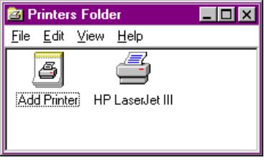
To set up a new printer
1. From the Start menu, choose Settings, and then click Printers.
2. From the Printers folder, double-click the Add Printer icon. The Printer Installation Wizard leads you though the process of setting up and configuring a printer.

Some printers take advantage of the built-in bidirectional communications ability and initially configure device driver settings such as available fonts and the amount of installed memory, without any user intervention.

Installing a Local Printer
It’s much easier to find the correct printer to install with the New Device Installation Wizard which groups printer models by manufacturer. When you select a printer manufacturer on the left side of the dialog box, the list of available printer models is displayed on the right. Choose the printer you want to install by either double-clicking on the model or by selecting the model and clicking OK.
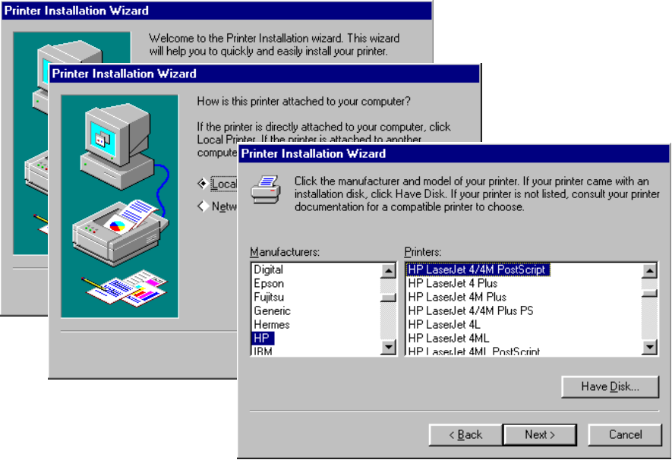
If the printer you are installing is not Plug and Play-compliant, the wizard prompts you for the port that you want to use with your printer. Next, you can choose to configure that port if necessary, as in the case of COM ports, where you may need to select the appropriate baud rate.
Next, the wizard prompts you for a “friendly” printer name — one that people, not just computers, will find useful. For example, if you plan to share this printer with others on your network, it’s a good idea to have the printer name reflect information users may need to know in order to use this printer properly, such as its physical location.
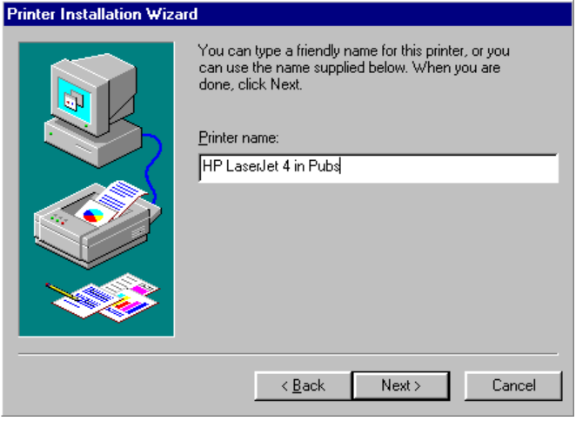
When you click Finish, the system begins copying the necessary files. If you already have all of the files needed to install the printer, you can either use the files you already have or you can choose to install new files. You can install new files from your Windows 95 floppy disks or CD, from a disk supplied by your manufacturer, or from a location on your network.
When installation is complete, you can print a test page to ensure that the printer is functioning properly.

Sharing a Printer
To share a locally installed printer with other people

How do I share my printer?
1. From the Printers folder, right-click the icon of the printer you want to share.
2. From the context menu, click Sharing.
3. From the Sharing property sheet, specify the options you want.

For details about sharing resources, see Chapter 13, “Security.”

You can use WinPopup to send a message from a printer that a print job is done. The Microsoft network must be running first. For information about how to use WinPopup, from the Help menu in WinPopup, click Help Topics.
Tip

Connecting to a Remote Printer
The easiest way to set up a remote printer is to simply print to it! Windows 95 supports Point and Print to any Windows 95 printer and to printers managed by NetWare or another network server.

Point and Print is fully supported only for computers running Windows 95 and partially supported for NetWare servers in this beta release.
Note

Whether you find the printer in Windows Explorer, drag a printer onto your desktop, or drop a document onto a remote printer, Windows 95 automatically tries to install the printer for you. Depending on the type of server to which the printer is connected, Windows 95 may be able to completely install the printer correctly without asking you any questions at all.
If the print server you’re using doesn’t support Point and Print, you can use the New Device Installation Wizard to select the printer you want to install. The only difference between setting up a remote printer and a local printer, using the New Device Installation Wizard, is that you will need to specify the name of the print server.
You can use a shared printer just as you would a locally installed printer. Print either an open document by selecting Print from the File menu and specifying a network printer or an unopened document by dragging and dropping it on the printer you want to use.

Using Point and Print
Windows 95 offers a new capability called Point and Print. Point and Print allows you to:
- Install the driver for a printer over the network automatically. To do this, drag the network printer icon from the server’s shared resource window to the Printer window or to the desktop.
- Print to a networked printer. To do this, drop a document on the icon of the network printer you want — Windows 95 determines the printer name and automatically loads the driver across the network to the local hard disk and configures the printer on the user’s system.

The files needed to set up a Point and Print network printer are the printer drivers specified in the Windows 95 .INF files.
When you want to install a new remote printer, Windows 95 makes intelligent choices to install all necessary components and properly configure the print device without any user intervention. What information is available and how Windows 95 determines the correct information depends on which print provider is used and how much information the provider can determine about the print device.
Point and Print functionality means Windows 95 attempts to identify the printer you want to install and to copy the driver and any printer-specific information from either the server or an alternate location on the network. If some of the information is not available, Setup prompts you for any missing information or, if the printer driver is not found locally, for a location of the printer driver.
When you install a local printer under Windows 95, all of the information about the installed printer is stored in the Windows 95 Registry. If you are using the print sharing capabilities built into either of the Windows 95 peer servers, you don’t need to do anything other than share your printer and grant appropriate sharing permissions to configure Point and Print. When a user wants to set up and connect to your printer, the client computer asks for information about the installed printer from the server and the server responds with the appropriate information. The printer driver is also copied from the server and installed on the local computer.

Enabling Point and Print with User-Level Security
On a computer running Windows 95 and using pass-through user-level security, there are some additional steps you must take to enable Point and Print support.
To enable point and print with user-level security
1. From Windows Explorer, locate the Windows SYSTEM directory.
2. Right-click the SYSTEM directory icon. From the context menu, click Properties.
3. Click the Sharing tab and then click Add.
4. Add all users who are supposed to be able to access your printer with read-only access. Click OK.

It is not necessary to share the directory, just add the permissions.
Note

5. Windows 95 will offer to share the directory after you add the permissions. Click No.

Printing Documents
Printing a document is simple. If the document is open, from the File menu, click Print. If the document is not open, drag and drop the document onto either a locally installed printer or a network printer.
To view documents waiting to be printed, open the Printers folder and double-click the appropriate printer. This displays the print queue containing print jobs. If you have administrative privileges for the printer, you can manipulate print jobs remotely.
To change printer settings, double-click the printer in the Printers folder. Then from the Printer menu, click Properties. The settings you can change depend on the type of printer you have.

For easy access to your printer, use your right mouse button to drag the printer’s icon from the Printers folder to the desktop, and then click Shortcut on the popup menu that displays. Then you can quickly print a document by dragging the document’s icon onto the printer icon.
Tip

Printing to a Network Printer
With the Microsoft network clients or other third-party networks supporting Uniform Naming Convention (UNC) paths, you no longer need a physical redirection to a printer to print. Instead, as soon as you double-click the installed network printer or drop a document onto a network printer in your Printers folder, the connection is automatically made for you.

You can quickly locate a printer on a particular server by choosing Run from the Start button, and typing the server name (for example, \\myserver). You will be logged onto the server and prompted for a password, if needed. Then a Windows Explorer window will be displayed.
Tip

If you use a network client that does not support UNC connections, or if you need to have a physical redirection to support printing from a particular application, you can still make a connection to a printer by using the appropriate network commands (such as net use lpt1: \\server\printer or capture lpt1:).

Using a NetWare Print Server
If you are using the Client for NetWare Networks and are logged onto a server for which you have administrative privileges, you can configure a NetWare server to store Point and Print information in the NetWare Bindery.
To configure the NetWare server to store Point and Print information
1. Right-click a print queue on a NetWare server. From the context menu, click Point and Print Setup, and then click Set Printer Model.
2. In the Select dialog box, click the printer manufacturer from the left pane and the model from the right. Click OK.
3. Right-click the NetWare printer queue again and, from the context menu, click Set Driver Path.
4. Type the UNC path (in the form \\server\volume\directory) for the driver files. For example:
\\NOVSVR\SYS\DRIVERS\EPSON24

5. Copy the appropriate files (from MSPRINT.INF) to the printer path.

To use Point and Print to connect to a NetWare printer
1. From Network Neighborhood, double-click the NetWare server icon.
2. Drag and drop the print queue from the NetWare server window to your Printer Folders window, as shown here:
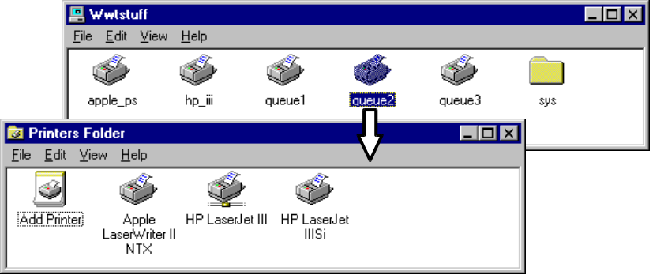
3. Follow the online instructions. The New Device Installation Wizard will prompt you to type a name for this printer.
Windows 95 automatically copies the files for the printer driver (including .DRV, .DLL, .HLP, and other files, as needed) to the Windows SYSTEM directory.

Spooling Print Jobs from a NetWare Print Server
Windows 95 includes a Win32-based PSERVER capability, which can despool print jobs from NetWare queues to printers connected to computers running Windows 95. This means that a NetWare server (running NetWare version 2.1 or later) queue can direct print jobs to a printer attached to a computer running Windows 95 with the Client for NetWare Networks.
You can use Microsoft Print Server for NetWare (MSPSRV.EXE) to take advantage of this capability. Notice that you must also set up Client for NetWare Networks to use Microsoft Print Server for NetWare. However, you do not need to run File and Print Sharing Services for NetWare.
While a normal PSERVER must be a dedicated computer and can spool jobs to as many as 16 printers, the computer running Windows 95 with Microsoft Print Server for NetWare can despool jobs from the NetWare print queue while it performs other tasks. The computer running Windows 95 can direct jobs to one printer.
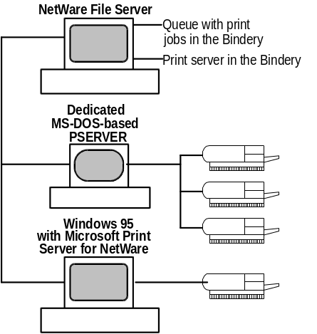
When Microsoft Print Server for NetWare is set up, it will try to log onto the NetWare File Server for which it is managing the queue. It can service one queue for printing to a single printer, locally attached to the computer running Windows 95.
Print Server for NetWare is not dedicated — it runs in the background, using no resource except for data packet polling at a set interval. This means it won’t interfere with other things the user wants to do. (This is a configurable setting.)
Before you set up Microsoft Print Server for NetWare, check the NetWare print server and the MS-DOS computer configured as the PSERVER to make sure they are both working correctly. If you see the following message, you will know that the NetWare print server isn’t configured correctly:
Cannot determine print queue name.

Microsoft Print Server for NetWare uses the queue management services (QMS) API for queue services. It logs onto the NetWare print server, attaches to the print queue, and gets a handle. Then it polls the NetWare print server and receives a header which includes information about how to complete the print job. For example, the header might include information about whether to use a banner, how many copies to print, and other information about printing the job. Next, Microsoft Print Server for NetWare reads data from the job in the queue and uses Win32-based calls to print to the printer. When the job is printed, it returns a call to the NetWare print server.
To enable the Microsoft Print Server for NetWare
1. Right-click the printer to which the NetWare print queue will direct jobs. Then click Properties.
2. From the Printer Server property sheet, click Enable Microsoft Print Server for NetWare.
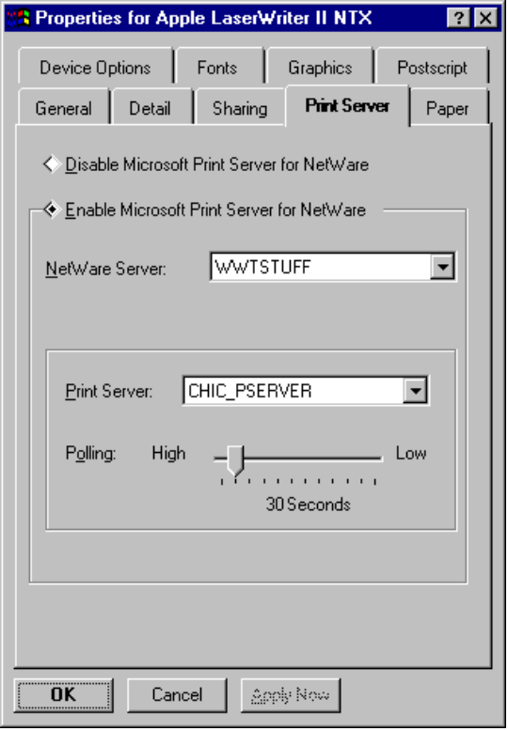
3. Select the NetWare server on which the queue resides from the drop-down list box.

You must have access to this server; only those NetWare servers to which you have access are listed.
Note

When a NetWare server is selected, the available print server appears in the Print Server drop-down list.
4. As appropriate, adjust the time interval for polling the print queue. This setting can be adjusted as high as 15 seconds for maximum print server performance, or as low as 3 minutes for increased local performance. The default is 30 seconds.

For more information about connecting to printers on NetWare networks, see Chapter 9, “File and Printer Sharing on NetWare Networks.”

Printing Flowcharts
The following flowcharts show which system components are used when you print in the following scenarios:
- Printing to a directly connected printer
- Printing to a printer on a Microsoft 32-bit network
- Printing to a NetWare printer using Client for NetWare Networks
- Printing to a NetWare printer using a real-mode Novell-supplied client
- Printing to a printer managed by a Microsoft 16-bit network

Printing in Windows 95
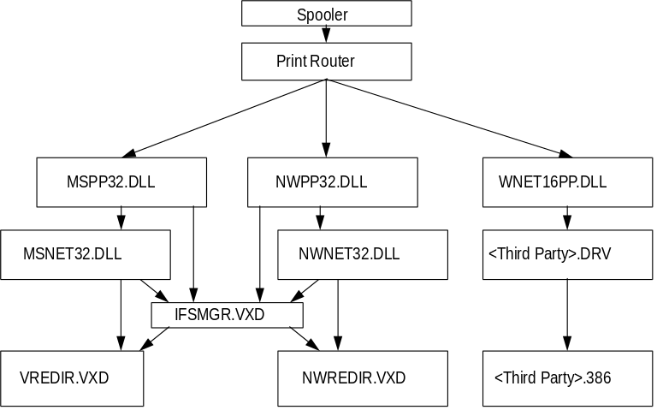

Printing Using Microsoft 32-bit Networks
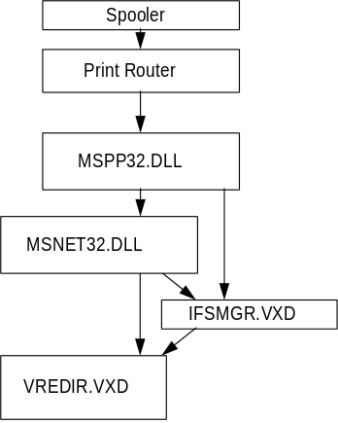

Printing Using Client for NetWare Networks
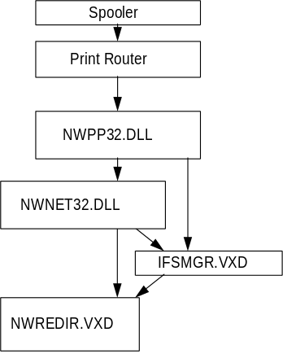

Printing Using Real-Mode NetWare-Supplied Client
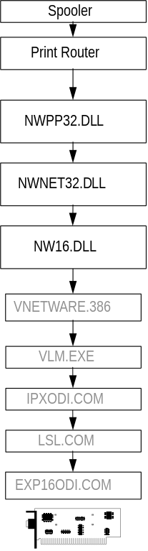

Printing Using Microsoft 16-bit Networks
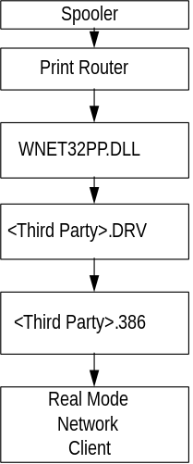

Troubleshooting
Windows 95 provides an online Print Troubleshooter. Use this tool first to try to solve printing problems you may have. Refer to the following tips for additional help.
To use the online Print Troubleshooter
1. Press F1 to start Windows 95 Help.
2. From Printing Options, select the Print Troubleshooter.
3. Click on the answers that apply and try the suggested steps to fix the problem. Print Troubleshooter provides a series of questions.

I can’t print to a local printer.
- Check the cable to the printer.
- Make sure there is enough paper and there is no paper jam.
- Check for any printer cartridge or toner problem.
- Check printer, make sure it is plugged in, turned on, and is online (most printers have an Online light indicator on the front panel).

1. Can you print using a different application?
Yes: Check the failing application’s configuration, reinstall the application, or do both.
No:
- Check the printer driver.
- Click on the Printers folder.
- Select Print.
- From the Printers menu, select Properties.
- Make sure the names match.
2. Can you print using a different printer driver?
Yes: Check the version, and either reinstall the driver, upgrade the driver, or do both.
No: Check printing from real mode.
3. Can you print from real mode (Shift F5)?
Yes: Temporarily rename SYSTEM.DAT to SYSTEM.ORG and copy SYSTEM.NEW to SYSTEM.DAT, and restart Windows 95. Then reinstall the printer driver, and retry the printing operation.
No: Check the computer.
4. Is the problem specific to this computer? (Try the same printing operation on a different computer to check.)
No: The problem is system-specific. Further configuration analysis, reinstallation of system software, or both may be needed.
- Check disk space in the TEMP drive.
- Check Printer Settings.
- Make sure the settings match print hardware and configuration.

I can’t print to a network printer.
- Check to see that the application is configured to use the printer you want to use.
- Check the printer and network cables.
- Check printer for paper jams, and so forth.
- Check to be sure you’re using the correct printer driver.
- Check system configuration options.

An error message displays when I drag a network printer to my local Printers folder.
When installing a network printer by dragging a shared printer object from a network server to the Printers folder on a local computer, you may see the message:
Printer Setup - Invalid Network Path

If you are confident that the printer path is valid:
- Select Use This Path and continue with the installation.

I’m having trouble with printing and fonts.
1. Try printing a different document to determine if the error is specific to that document.
2. Try printing with a different application to determine if the problem is application-specific.
3. If you can, try printing to a different printer to see if the problem is printer-specific.
4. Check free disk space, and make sure you have at least a few megabytes free. To free space, be sure to delete any temporary files from the TEMP directory.
5. Verify the size and date of the printer driver and support files. Also verify that you are using the correct driver for the printer.
6. If you are using UNIDRV or DeskJet®, use the printer’s property sheets to disable Enhanced Metafile spooling. Then try printing again.
7. Print to a file and then copy the file to a port to see if the driver is creating the correct output. This will determine if the spooler is causing the problem or if the driver is failing. For example:
copy test.prn /b lpt1:

8. If the printer supports multiple input formats, try a different input format. For example, on an HP LaserJet IIISi printer, use a PostScript driver instead of UNIDRV, or vice versa. On an HP 550c, try a monochrome driver (UNIDRV-based), instead of the color driver.
9. Try to print with a different mini-driver, such as the Generic/TTY mini-driver. Or, for a PostScript printer, use a generic .PPD file.
10. If you have a second printer cable, replace the one currently connected to your printer.
11. If you can, try printing the same job using Windows 3.1.
12. Try using a different code path. Windows 95 has three code bases for printing: UNIDRV, PostScript, and DeskJet color. (The HP Plotter driver is also another separate driver.) Generic/TTY is now a mini-driver with UNIDRV.
By using different code paths with the printers in the following list, you can possibly isolate the problem to one specific printer or determine whether it is global with all UNIDRV.DLLs.
Printer type | Alternate code paths
Laser (three main languages) | HP PCL (Hewlett-Packard), CaPSL (Canon), PPDS (Lexmark)
Ink-jet | Color, Mono
Dot matrix | 9-Pin Mono, 24-Pin Mono, 9-Pin Color, 24-Pin Color
Epson line | ESC P/2 Mono, ESC P/2 Color
PostScript | Color, Mono
HP DeskJet color | 550C

The graphics output quality is bad.
1. Turn the Enhanced Metafile spooling option on and off.
2. Try printing to a PostScript driver (if this prints correctly, then there is a problem with UNIDRV.DLL).
3. If PostScript fails, there’s either a problem with GDI (for fonts) or with the application. If it’s an application problem, try printing another file or from another application.
4. If you are printing a long document or several documents, the spooler might be printing one page over another. Try printing shorter jobs, or fewer jobs at a time.
5. Try steps for general printing problems above.

The printer is printing rotated fonts.
1. The problem may be printer-related. If so, it’s probably because the printer can only print 180-degree and 90-degree rotation, but not odd-degree rotations. Redefine the degrees of rotation for the image.
2. If the problem is at the GDI level, try specifying Print TrueType as Graphics.
3. The problem may also be font-related. Try using another character set. Or, download TrueType fonts to the printer and try again.

The printer is printing overlapping fonts.
1. The problem may be resolution-dependent; try different resolutions, using the same printer. If a higher or lower print resolution works, the printer driver is probably at fault. Try using another printer driver.
2. If the problem persists with more than one printer driver, the problem is likely to be at the GDI level. Try specifying Print TrueType as Graphics.

The printer is printing fonts in different formats.
1. If strikeout or underlined text prints incorrectly, try a different application with the same font.
2. Print in a different orientation (that is, if landscape, change to portrait or vice versa).
3. Try specifying Print TrueType as Graphics.

The printer is clipping fonts or images.
1. Recheck the printable region by running a print test from the printer. (Usually, there is a test button on the printer; press this to run a test.) Adjust the paper orientation if you can.
2. On a laser printer, try specifying Print TrueType as Graphics.
3. Check printer memory. If the image is large, you may need more memory.

The printer is printing distorted fonts, or it is not printing some sections of the document.
1. Print preview to see if GDI is correctly drawing the fonts.
2. Change the font size to see if the problem recurs with a larger or smaller size font.
3. Reformat the text or job to a different font to see if the original font is corrupted or bad.
4. Cut and paste the font into another application to try to reproduce it. If you can reproduce it, the bug is global.
5. Load a PostScript driver and select Download as True Type. If the job prints correctly, the problem was with the printer driver or UNIDRV.DLL. Otherwise, the problem is probably in the GDI.
6. On a laser printer, specify Print TrueType as Graphics.
7. Check printer memory. If the image is large, you may need more memory.

I’m having trouble with the spooler.
Windows 95 has two levels of spooling available to UNIDRV and DeskJet, and one level of spooling for PostScript. UNIDRV and DeskJet have the option to use Enhanced Metafile (EMF) spooling. A metafile contains a list of GDI commands which are played back to print the job. Windows 95 spools to the \TEMP directory.
In general, follow these guidelines:
- Always delete spool jobs (with the filename extension .SPL) from the Windows SYSTEM\SPOOL\PRINTERS directory, if a job does not output.
- Check your \TEMP directory and delete all .TMP files, and then restart the computer before testing again.
- Check to make sure that you have free hard disk space. Depending upon what you are printing, you should have a minimum of 30 MB of free hard disk space on the computer for printing.
- Printing with EMF=ON works in the background.
- Printing with EMF=OFF works in the foreground.
- All printing is sent out as RAW data when going to direct ports or over the network. EMF playback despools the EMF file before the print job is sent.

An error message may display, but be hidden behind other windows, when you print from a Win32-based application. Press alt+tab to bring this message box to the foreground of your desktop. The message should tell what is causing the printing error.
Note

