Chapter 1
Windows 95 has the built-in ability to send and receive electronic mail and faxes. Through the Microsoft Exchange client, you can:
Electronic Mail and Information Exchange
- Read and send mail using the Windows 95 mail capabilities or another mail system that you may choose to add.
- Send and receive faxes electronically, using a fax modem supported by the Microsoft At Work Fax software, which is included in Windows 95.
- Easily move messages and documents between folders and other documents. Like the other parts of Windows 95, Microsoft Exchange supports compound documents, including the ability to embed other documents in mail messages.
- Use custom views and filters to organize messages and documents.

Windows 95 Messaging Components 21-2
In This Chapter
Windows 95 Messaging Subsystem 21-3
Installing the Microsoft Exchange Client 21-6
Setting Up a Windows 95 Mail Postoffice 21-8
Setting Up Microsoft Exchange for a User 21-11
Viewing Messages 21-18
Using Microsoft Exchange Remotely 21-25
Customizing Microsoft Exchange 21-30
Upgrading to a Full Microsoft Mail Postoffice 21-39
Upgrading to Microsoft Exchange Server 21-41
Microsoft Mail Gateways 21-42
Troubleshooting Microsoft Exchange and Mail 21-48

Windows 95 Messaging Components
The Windows 95 Messaging Subsystem consists of a number of components:
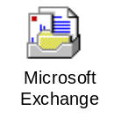
The Microsoft Exchange client. An advanced, extensible messaging and workgroup client that is built directly into Windows 95. It can be the front-end to any electronic mail or information system that has appropriate Messaging API (MAPI) drivers — including Microsoft Mail. Microsoft Exchange works equally well, whether connected over the local-area network, or by way of a dial-up Remote Access connection. The Microsoft Exchange client includes an OLE 2.0-compatible rich-text editor used for composing and reading messages, and powerful custom views, searching, and filtering capabilities.
Personal Address Book. A common address book that contains not only electronic mail addresses, but friendly names, phone and fax numbers, mailing addresses, and other personal contact information. Through the open MAPI interfaces, it is accessible from a wide variety of applications. The Windows 95 Personal Address Book can store addresses for multiple electronic mail systems at the same time.
Personal Information Store (.PST). A sophisticated local database, so that users can store messages, forms, documents, and other information in a common place. Its rich organizing capabilities include using long filenames, plus sorting and filtering on various fields of the stored objects. Users can create and save any number of custom views on the information in their personal store. Personal Information Store also functions as the user’s local mailbox — including a universal inbox and outbox that work with any connected messaging system.
MAPI 1.0. The core system components that connect the Viewer and other applications to the various information services.
Microsoft Mail Workgroup Postoffice. A workgroup edition of the Microsoft Mail Server is included with Windows 95. In a workgroup, one user’s computer typically hosts the postoffice, and the other users access that postoffice to send and receive mail. The Windows 95 workgroup postoffice provides the same feature set as the full Microsoft Mail Server, with the following exceptions:
- Limited to a single postoffice. No routing is provided between multiple postoffices.
- No access to Microsoft Mail gateways.
- Simplified administration tools (for example, support for system-wide groups and import/export capabilities are not included).

Microsoft Mail Drivers. A set of MAPI drivers used by Microsoft Exchange to work with either the workgroup postoffice built into Windows 95, or a full Microsoft Mail postoffice (acquired separately).
Microsoft Internet Mail drivers. A set of MAPI drivers which let the Microsoft Exchange client send and receive mail directly on the Internet, using the built-in TCP/IP and PPP communication protocols provided with Windows 95.
Microsoft At Work Fax Drivers. A set of MAPI drivers used by Microsoft Exchange to send and receive electronic faxes just like electronic mail. Faxes are received in the same universal inbox as your mail, and the same address book is used for both mail and fax recipients.

Windows 95 Messaging Subsystem
The Windows 95 Messaging subsystem architecture provides power and flexibility while the details of its design remain virtually invisible to the user. The subsystem provides an abstraction layer between user tools and applications, and various message delivery components (called MAPI drivers), including drivers for mail delivery and fax delivery.
The core of the messaging subsystem is a Messaging API (MAPI) layer. With MAPI, the subsystem enables you to create mix-and-match messaging applications that can each access multiple messaging systems. Electronic messaging can be used for all types of communication, not just for person-to-person mail. You can use the messaging capabilities of Windows 95 to send electronic faxes and access online services and the Internet. Corporations can use the same messaging system for scheduling, forms routing, order processing, and project management. Likewise, two processes on two different computers can cooperate with each other by exchanging messages over a messaging system.
The Messaging subsystem divides messaging components into four types:
- Messaging client applications
- MAPI core
- MAPI drivers
- Messaging systems

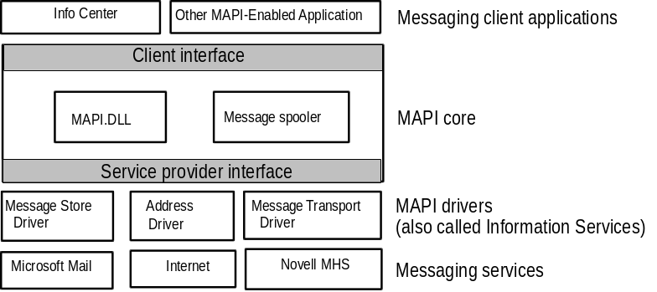

This model provides the flexibility to construct custom messaging environments using the appropriate components.
For example, messaging client applications that use MAPI can communicate with different underlying messaging systems, such as Microsoft Mail, Internet, and Novell MHS, as long as the appropriate MAPI drivers are installed. MAPI can manage multiple service drivers simultaneously, so clients can call for services from two or more messaging systems using the same code, making it extremely efficient and providing a single, unified interface.
Windows 95 contains the modules for three separate Messaging APIs: Simple MAPI, Extended MAPI, and Common Messaging Calls or CMC.
Simple MAPI contains 12 basic messaging functions. Its main purpose is for use in messaging-aware applications. These are applications with a main function, which is usually something completely separate from messaging, such as graphing or word processing, but which contain messaging features as well. This added messaging capability enables users to send their documents to others directly from the application, without stopping to run a separate mail application. Simple MAPI allows applications to send and receive messages, access address books, and attach and embed objects using OLE.
Extended MAPI is designed for full-blown messaging applications. This module provides advanced function calls for mail applications, workflow development, and forms distribution and management. It includes Simple MAPI, and provides the tools to access and manipulate message stores and address books through the Service Provider Interface.
Common Messaging Calls is an API layer defined by the XAPIA (X.400 API Association) which also allows applications to use advanced functions to gain messaging capabilities. The difference between CMC and MAPI is that MAPI works only under Windows-based operating systems. CMC is designed to be platform-independent. Simple MAPI and CMC calls are functionally equivalent, but if you are developing an cross-platform messaging application, you should use CMC. As mentioned before, Windows 95 supports all of these APIs natively.

Messaging Clients
Messaging client applications communicate with MAPI drivers through the MAPI core. The client layer interacts with the MAPI core to gain access to MAPI-compliant service drivers. Each MAPI driver interacts with a specific underlying messaging service, such as Microsoft Mail.
Messaging client applications can be divided into three general categories:
- Messaging-aware applications. These include messaging functions as an added but not required feature, supporting the application’s main purpose. An example of a messaging-aware application is Microsoft® Word, which can add messaging functions by adding a Send Message command to its File menu.
- Messaging-enabled applications. These require some form of messaging functionality in order to meet the application’s main purpose. Examples of messaging-enabled applications are the Microsoft Exchange client, Microsoft Mail, and cc:Mail.
- Messaging-based workgroup applications. These are more complex types of applications which go beyond basic electronic mail. They require full access to all the messaging services, including the message store, address book, and message transport functions. An example of this type of application is Microsoft Schedule+.

For information about creating a messaging client, see the Windows 95 Software Development Kit.

MAPI Core
The MAPI core consists of several DLLs and the message spooler. Its function is to coordinate MAPI-compatible client applications with MAPI-compatible service drivers. The subsystem includes two major functional interfaces — the client interface and the service driver interface.

MAPI Drivers
MAPI defines three basic driver types:
- Message store drivers supply message storage, organization, and retrieval facilities for a messaging system.
- Address book drivers supply message addressing and distribution list facilities to the messaging client.
- Messaging transport drivers move messages between messaging clients.

MAPI supports all these messaging services with a message spooler to queue outgoing messages and route incoming messages to the proper message store folder.
A messaging service driver can include multiple message stores, address books, and transport drivers, but MAPI selects between message store and messaging transport drivers as necessary and merges the address books presented to it, so the client application sees one combined address book interface.

Third-party mail vendors can add or replace MAPI drivers to enable the Microsoft Exchange client to work with their mail systems.
Note

Microsoft Exchange Universal Inbox
Microsoft Exchange offers you the ability to maintain a single universal inbox for all messages you receive. In addition to mail messages from other Windows 95 users, you can receive messages from the following other sources, each using a corresponding MAPI driver:
- Other Microsoft Mail clients
- Microsoft At Work Fax
- Microsoft Online Services
- Other mail back-ends such as Novell MHS, Internet, or CompuServe

Information Services
Information services are a logical collection of one or more drivers that comprise a single messaging subsystem service. Examples of these services in Windows 95 include Microsoft Mail, Microsoft At Work Fax, Internet Mail, Personal Information Store, and Personal Address Book.

Installing the Microsoft Exchange Client
The easiest way to install Microsoft Exchange is to choose it when you run Windows 95 Setup.

You must select Windows 95 “Custom” setup in order to install Microsoft Exchange and the rest of the Messaging System. If you didn’t choose to install Microsoft Exchange at setup, you can do it afterward.
Note

To set up Microsoft Exchange after you run Setup
- To be added (use App Install from Control Panel)

Other Installation Considerations
When you install Microsoft Exchange, most of the configuration for the Windows 95 mail client is already done. However, there are a few simple choices yet to make:
- Decide the location of your postoffice and specify the mail server name on the client. You specify the mail server when you create a messaging profile, as described later in this chapter.

Within a Windows 95 network (assuming you have not upgraded your postoffice to a full Microsoft Mail postoffice), you can only send mail to people sharing your same Windows 95 workgroup postoffice. Therefore, it is important to decide where you, as the administrator, will place the postoffice before users begin using Microsoft Exchange.
Important

- Decide if you will need to use Remote Access with mail. If you do, you can create a separate messaging profile for your Remote Access connections. For more information, see the “Using Microsoft Exchange Remotely” later in this chapter.
- Decide if you want to access other messaging or information systems in addition to the built-in Windows 95 MS Mail postoffice.
If you want to communicate with other postoffices or gateways, you can upgrade your Windows 95 postoffice, which is a limited edition of the Microsoft Mail 3.2 postoffice, to a full version of that product. With Microsoft Mail 3.2, you will also receive client software for Windows 3.1, Macintosh, OS/2, and Windows NT clients. For more information, see “Upgrading to a Full Microsoft Mail Postoffice” later in this chapter.
In addition, if you want to send and receive mail on the Internet, you can use the Internet Mail driver included with Windows 95. If you do not have a direct LAN connection to the Internet, you will also need a modem and phone line, and an Internet account, for dial-up access. For details, see Chapter 23, “Internet Access.”

Setting Up a Windows 95 Mail Postoffice
The first time you start Microsoft Exchange on your computer, you’ll be asked to either identify the location of your postoffice or let Microsoft Exchange create a new postoffice on your computer.
Setting up the postoffice is simple when you use the Workgroup Postoffice Control Panel. This tool directs you through each step needed to install and configure a mail postoffice for your workgroup.
If you upgraded from Windows for Workgroups to Windows 95, your workgroup postoffice is retained for use with Windows 95. The mail postoffice for Windows for Workgroups and for Windows 95 is identical, so any users using Windows for Workgroups can still share your postoffice.

Create only one postoffice for your workgroup, or your users will not be able to send mail to each other.
Important

The Windows 95 postoffice — a workgroup edition of the Microsoft Mail 3.2 postoffice — is a temporary message store. As a limited edition of the Microsoft Mail 3.2 postoffice, the Windows 95 postoffice can’t exchange messages with other Microsoft Mail postoffices. To do this, you must upgrade your postoffice to a full Microsoft Mail 3.2 postoffice.
The postoffice holds a message until the recipient’s workstation retrieves it. When it is retrieved, the message is removed from the postoffice.
Mail is efficient because it stores only one copy of each mail message, even when a message is addressed to multiple recipients. A message sent to multiple recipients has a reference count in it. The count is decremented each time a recipient retrieves the message, and the message itself is removed when the reference count drops to 0.
The postoffice can reside on any computer in the workgroup. For best results, of course, the computer should have ample hard disk space to contain message files. The server should also be accessible at all times to users. That is, the postoffice directory must be shared and the computer must be turned on so that users can access the shared postoffice. Finally, the mail server should have more than the minimum memory configuration. Sharing does take some system resources, and it would be unwise to place the postoffice on a slow computer with little memory.

You should allow approximately 2 MB of storage on the mail server to start. As the mail system is used, the amount of space it requires grows based on the number of users and the size of the messages and attachments being stored. For more than 20 users, consider using a dedicated computer as a mail server.
Tip

The Postoffice Directory Structure
The postoffice, as shown in the following figure, is simply a directory structure.
All subdirectories must be present for the Mail system to function correctly. The following is a list of what’s in each directory of the Mail postoffice:
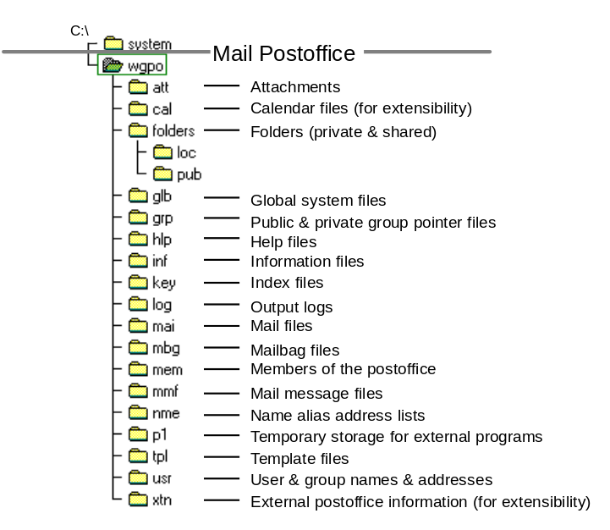
WGPO Subdirectory | Description
ATT | Contains encrypted file attachments.
FOLDERS | Contains shared and private folders (with a filename extension of .FLD) for use by MS-DOS workstations. (Windows for Workgroups workstations’ folders are in their .MMF files on the workstations.)
GLB | Contains global system files for Mail. These files contain local user logon information and control files to generate mail files.
INF  TPL | These two subdirectories contain file information relating to postoffice-defined templates. INF contains information files and TPL contains templates. ADMIN.INF and ADMIN.TPL contain template information for local postoffice users.
KEY | Includes index files that contain pointers to header records in the mailbag (.MBG) files.

WGPO Subdirectory | Description
MAI | Stores mail messages in encrypted form until the recipients’ workstations retrieve them.
MBG | Contains mail headers that point to the mail (.MAI) files. For each file in this directory, there is a matching index (.KEY) file.
MEM | Contains a list of the postoffice’s members.
NME | Contains pointer files for the name alias address lists. ADMIN.NME and ADMINSHD.NME list members of the postoffice address list.
GRP  LOG  MMF  USR  XTN | These subdirectories are useful only if you decide to upgrade to a multi-postoffice configuration. This can be done with the Microsoft Mail Extensions for Windows 95. In that case, USR is used to list user names and group names for the other network and XTN is used to list other external information.

Configuring the Microsoft Mail Information Service

Which Service Delivers Which Types of Addresses?
Occasionally users want a piece of mail addressed to a Windows 95 user to be handled by a non-Windows 95 messaging system, such as a fax gateway. For example, a user on the road may want to send faxes through a personal fax modem inside the computer, but have faxes be sent through the corporate fax gateway while they’re in the office on the LAN.
Enabling delivery by address type is a feature of the Microsoft Mail information service that allows it to reject a message that it would ordinarily handle so that this message can be passed on to another messaging resource that will deliver it in a more economical way.
To configure whether electronic mail of a particular address type will be delivered by Microsoft Mail (usually through a corporate gateway), or passed on to a local service (such as a local fax modem)
1. From Microsoft Exchange, select the Tools Options menu.
2. Click the Services tab.
3. On the Service page, double-click the Microsoft Mail service.
4. Click the Delivery tab.
5. On the Delivery page, click the “Address Type” button, where it says “Enable Delivery To:”.
6. Click the check box for each address type of message which you would like Microsoft Mail to deliver (if you have a corporate gateway available).
7. For example, if you would rather deliver faxes using a MS Mail corporate fax gateway, instead of a personal fax modem, click the check box.

More details to be provided.

Maintaining the Workgroup Postoffice
The workgroup postoffice administrator is responsible for creating and managing the postoffice. The only difference between the administrator and other Mail users is that the administrator can perform the following tasks:
- Back up the postoffice, which should be done on a regular basis
- Add users to the postoffice
- Change user information, including forgotten passwords
- Check the status of shared folders

The workgroup postoffice manager library, WGPOADMN.DLL, is the software component that supports administrative functions such as adding or deleting users and changing passwords.
For more information about performing administrative tasks, see online Help for use of the Workgroup Postoffice Control Panel.

Moving the Windows 95 Workgroup Postoffice
To be provided.

Setting Up Microsoft Exchange for a User
The Windows Messaging Subsystem maintains one or more separate configuration profiles for each user. A configuration profile is a set of preferences listing the messaging services and associated options you want to use.
A Configuration Wizard runs automatically the first time you open Microsoft Exchange. This wizard leads you through the steps needed to create a messaging profile. During this process, you will specify the location of your postoffice and your user name and password. The wizard will create a mailbox and personal address book for you. Information about your postoffice, name, password, information store, and address book are all included in your profile.
Upgrading from Windows for Workgroups Mail or the Microsoft Mail 3.2 Windows client is automated. When Windows 95 is installed in the directory formerly used by Windows or Windows for Workgroups, Microsoft Exchange reads any existing MSMAIL.INI file to determine what mail files to delete and copy. All .MMF files are automatically converted to a .PST format, the format readable by mail in Windows 95.

How do I upgrade from Windows for Workgroups or Microsoft Mail client?
Additional information about related issues to be provided.

Configuring Profiles
Using MS Exchange profiles allows several users, each with an individual set of preferences, to share the same computer to send and receive mail. Also, a single user can easily switch between multiple configurations (for example, one for remote access and one for on-site access). In addition, if a user is accessing multiple messaging services -- a profile can securely cache any required passwords, allowing for a single logon to multiple mail systems.
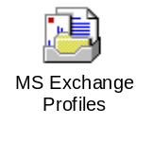
The following illustration shows four profiles for three people sharing the same computer. One person has two profiles — one for use on the road and one for the office.
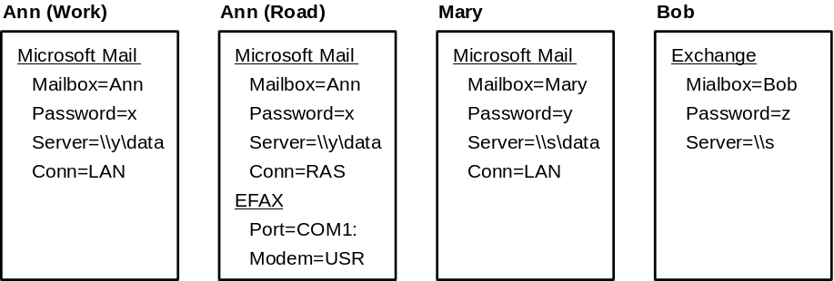
Most Windows 95 mail settings are stored in a messaging profile. However, so that other users can access the information, some settings are stored elsewhere.
If you share your computer with another user, or if you use one messaging profile for the office and another for at home or on the road, you can select the profile you want to use.
To view messaging profiles for your computer
- From Control Panel, double-click the MS Exchange Profiles icon. The MS Exchange Profiles dialog box displays the names of all the profiles defined on your computer.
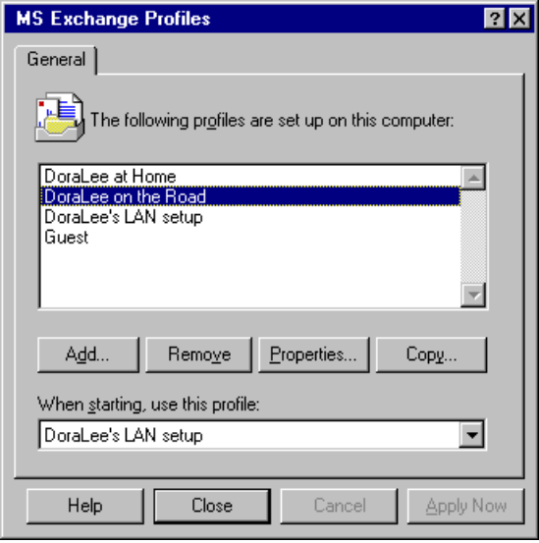

To use another profile (if more than one is defined)
1. In Microsoft Excahnge, from the Tools menu, choose Options.
2. From the At Startup field, click Choose Profile to Open.
– Or –
Click Automatically Open Default Profile and specify the profile name.
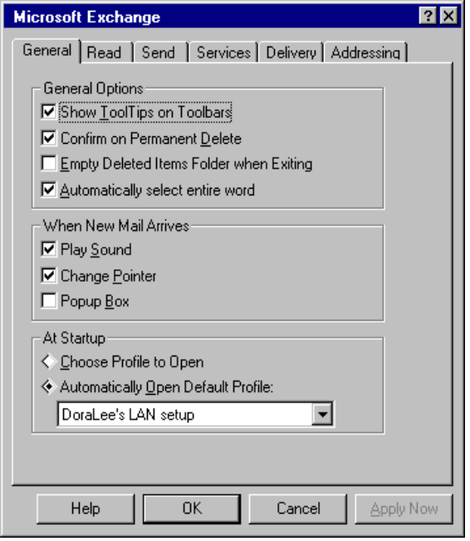

To change your password

This procedure is for changing your mailbox password on the built-in Microsoft Mail postoffice. If you are using the Microsoft Exchange client with another electronic mail system, the exact procedure will vary.
Note

1. From Control Panel, double-click the MS Exchange Profiles icon. The MS Exchange Profiles dialog box displays the names of all the profiles defined on your computer.
2. Select your profile and click Properties.
3. From the list of Information Services on the property sheet, choose Microsoft Mail and click Properties. This displays the Microsoft Mail dialog box.
4. Click the Logon tab, then click Change Mailbox Password.
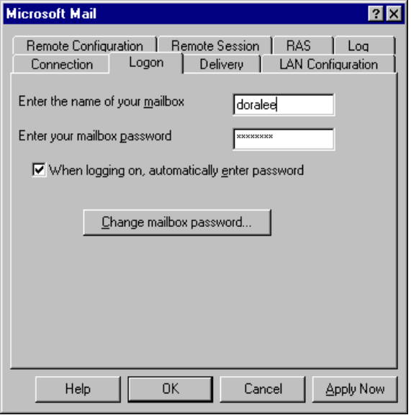
5. Type the old password. Then type your new password in both the New Password and Confirm Password text boxes. Click OK.
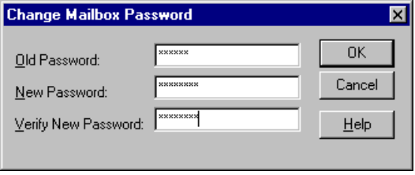

To create a new messaging profile
- From Control Panel, double-click the MS Exchange Profiles icon. The MS Exchange Profiles dialog box displays the names of all the profiles defined on your computer.
- Click Add. This starts the Microsoft Exchange Configuration Wizard, which leads you through the steps to create a profile.
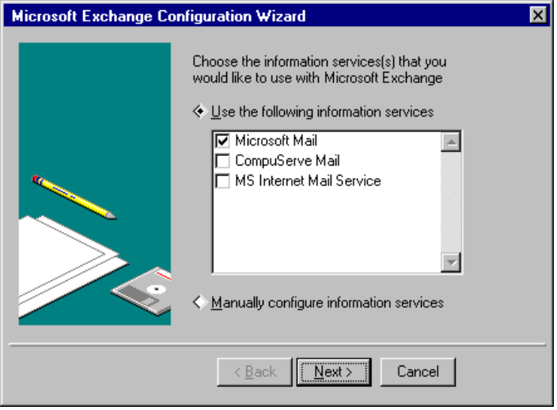

Adding Information Services to an Existing Messaging Profile
Through Microsoft Exchange, you can access multiple information services such as Microsoft Mail, Microsoft At Work Fax, Internet Mail, and other third-party services such as CompuServe. Each information service that you are able to access is listed in your messaging profile.
To edit a profile
1. From Control Panel, double-click the MS Exchange Profiles icon. You will see a list of the existing profiles.
2. Select the profile that you wish to edit.
3. Select the Properties button. The following dialog box displays:
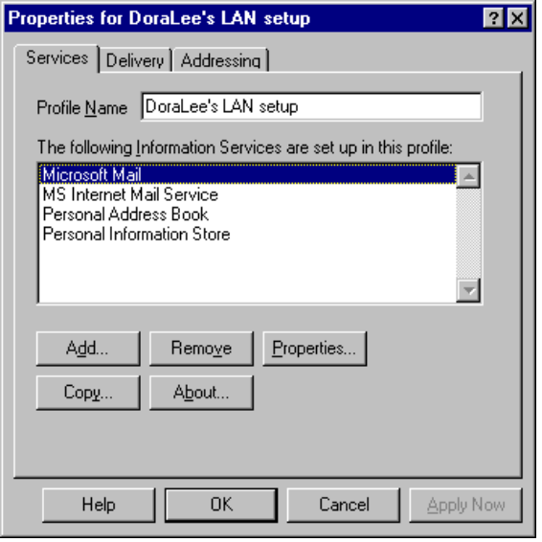
4. Click Add and specify the information service you want to add.
The service you select determines what specific DLL is loaded when Microsoft Exchange is started. For example, if the Microsoft Mail service is added, the MSFS32.DLL file is copied to the Windows SYSTEM directory. (To find out which DLL is loaded for a service, click the name of that service, then click About.)
Many services will then prompt you for any required configuration information.
5. If you want to configure a service manually, click the name of a service, then click Properties.

When you’re troubleshooting Windows 95 mail issues, remove additional information service drivers (except Personal Address Book and Personal Information Store) and add back each information service, one at a time.
Tip

Using Address Books
The address book is used to define the destination of electronic messages. With it, users can select recipients while composing a message, create and modify lists of recipients, and modify directories of user names. Each user maintains an address book. In addition, other address books associated with particular information services may also be available. For example, Microsoft Mail users can use a postoffice address book which is maintained on the workgroup mail server. Users can download copies of any of these public address books.
Messaging services typically include one or more server-based address books, maintained centrally by the network manager, and one or more user-specific lists, known as Personal Address Books (PABs). Often users use multiple address books at once. The default when using the built-in Microsoft Mail postoffice in Windows 95 is two address books: a Personal Address Book (PAB) and a Post Office Address List, maintained by the postoffice administrator.
To specify the address book you want to use
1. You can select between the available address books from either the Compose Message address fields, or from the Browse Mode Address Book (shown in the following).
2. From the Show Names From... list, click the address book you want to use as your default.
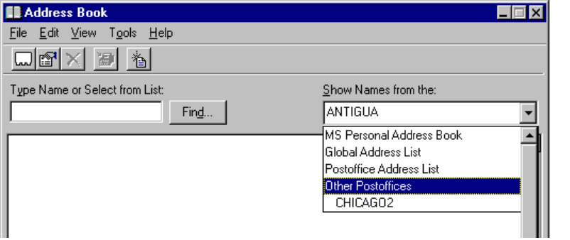

Viewing Messages
The Microsoft Exchange client provides a number of flexible ways to view and manage electronic mail messages and other information. There are several ways to start Microsoft Exchange.

How do I use the Microsoft Exchange client?
To start the Microsoft Exchange client
- Double-click the Microsoft Exchange icon. Click on the Inbox folder inside your Mailbox to read any new electronic mail.

Other ways to start the Microsoft Exchange client
- From the Start menu on the Windows 95 Taskbar select Programs, then select Open Inbox. This will take you directly into your Microsoft Exchange inbox.
- If you have new mail waiting, you are notified by an envelope icon on the Windows 95 task bar. Double-clicking this icon will take you directly into your Inbox.

Sorting Messages
By default, when you first use Microsoft Exchange, you’ll see messages arranged by these fields: From (sender’s name), Subject, and Received (date and time). You can reorganize the way you view the contents of a single folder or all your folders by redefining the view you use.
You can sort and organize messages in several different ways:
- You can create a series of folders to keep groups of messages in each.
- You can sort messages within a folder by category, such as the message subject title, the sender’s name, and so on.
- You can redefine which columns of information you want to see for each message.
- You can group messages by category and by subcategory.
- You can define filters to list only specific types of messages.
- You can combine all of your organizational features into a view, which you can save, and later apply at any time.

The following sections provide procedures for sorting messages.

Sorting Messages into Folders
To move a message to another folder
- Drag the message to the new folder.
– Or –
- Select the message, and choose Move Item or Copy Item from the File menu, and then specify the destination folder.
– Or–
- Right-click the message and select Move Item or Copy Item, and then specify the destination folder.

When you use a double-pane view, drag the message from the right pane to a folder in the left pane.
To sort messages in a folder
1. From the View menu, click Sort.
2. From the Sort Items By list, select the field to sort on. Click OK.
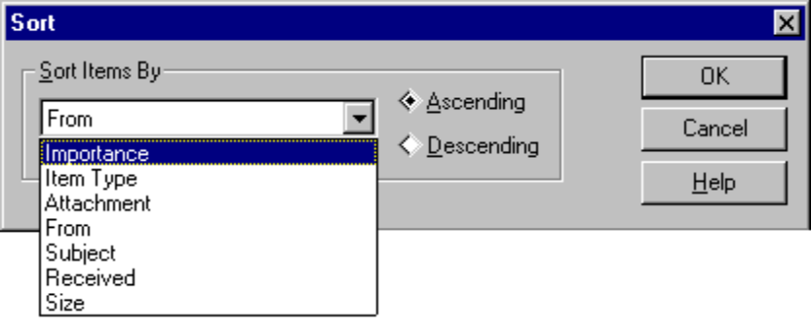
– Or –
Click on the field name at the top of the messages. For example, click the Subject bar to sort by subject.

Customizing the Microsoft Exchange Columns
To view additional information about your messages
1. From the View menu, click Columns.
2. Use the Add and Remove buttons to specify the columns you want displayed.
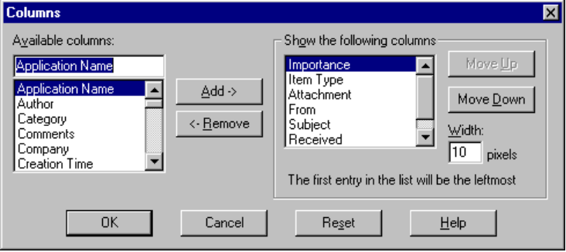

You can use the New View dialog box to define a new view. You can also arrange the contents of your messages folder the way you want it, and then give the new view a name.

Grouping Messages
You can arrange your messages in a hierarchy by defining how they will be grouped. For example, the following illustration shows a folder with messages grouped hierarchically by Subject. This is referred to as a categorized view. The “+” to the left of the subject name indicates that this category can be expanded or collapsed to reveal its contents.
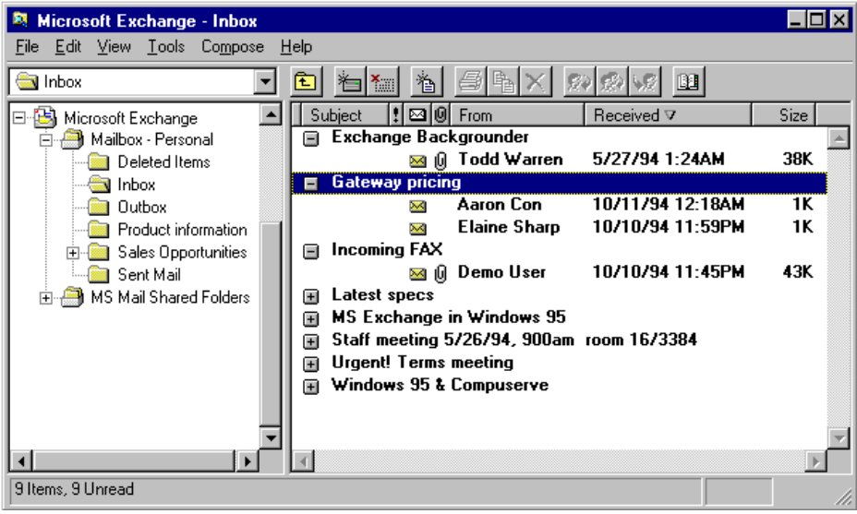
To define how messages will be grouped
1. From the View menu, click Group By.
2. From the lists, select fields by which you would like your messages grouped. You can specify up to four levels of hierarchy.
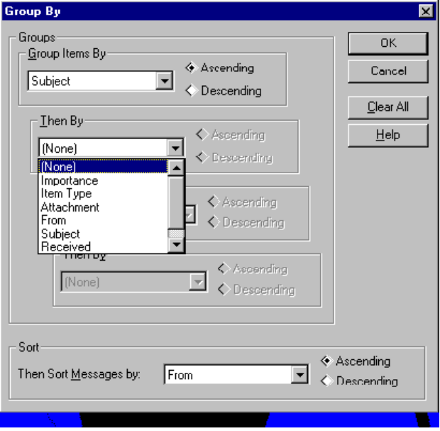
3. Use the Sorted By field to specify which field you want to sort on.
4. Click OK.

Filtering Messages
A filter lists only those messages which meet a certain set of criteria. For example, you can define a filter to show all of the messages from AnnM, or all the messages on which you were listed on the “Cc” line.
To define a filter
1. From the View menu, click Filter.
2. Specify the criteria you want to use to filter messages.
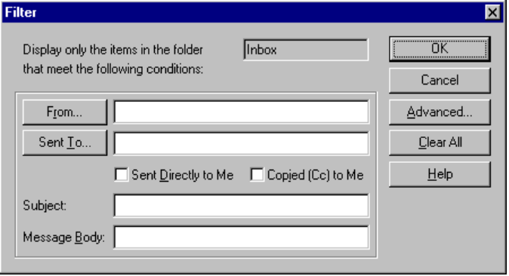
3. Click Advanced to filter by size, date, importance, or sensitivity. You can also use this dialog box to filter unread messages, messages with attachments, or messages that do not meet the criteria you specified.
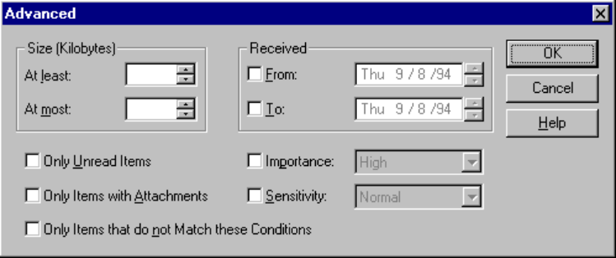
4. When you’re finished defining the filtering method, click OK.

Creating Custom Views
Once you create an organization that suits the way you work, you can save it as a view. You can also switch from among predefined views, to see information about your messages in a variety of ways.
To switch to another predefined view
1. From the View menu, click Folder View or Common View.
2. Click the name of the view you want to use.

To define a custom view
1. Organize the folder to show information the way that you want it.
2. From the View menu, click Define View.
3. Click Current View.
4. Click New and type a name for the view.
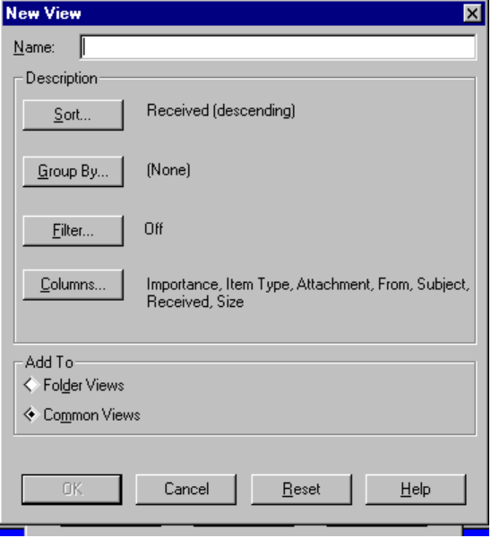
5. Click either Folder View (for use with the current folder) or Common Views (for use with any folder). Click OK.

When you choose to sort messages by subject, Microsoft Exchange ignores “FW:” and “RE:” in the subject line, and groups all messages on the same topic together.
Note

Using Message Finders
A message finder is a separate window that works in the same way as a filter to find messages that meet a particular set of criteria. When set up, a finder can run continuously, alerting you when matching messages arrive.
To display a message finder window
- From the Tools menu, click Find.
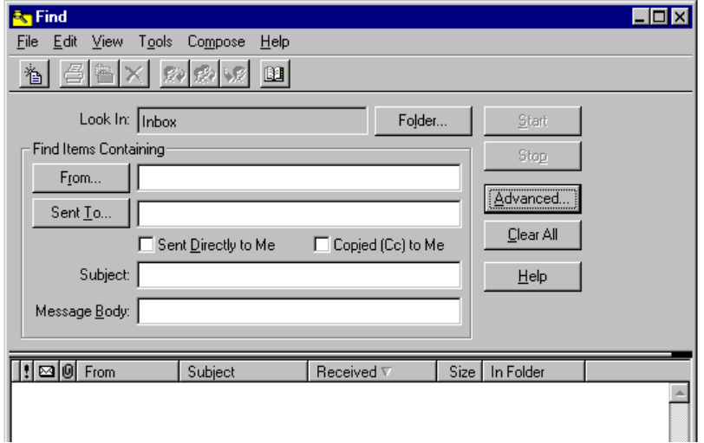

More details to be provided.

Using Message Links
To be provided.

Working with Documents
You can use the built-in OLE capabilities of Windows 95 to drag messages to drives, folders, or documents. You can also drag documents into messages.
- If you drag a message from a Microsoft Exchange folder to the icon for drive C or another drive, or a directory on your disk, Windows 95 will save it as a .MSG file.
- If you drag files into Microsoft Exchange folders, you can use the Custom Views and Group By options to organize them.

You can use Microsoft Exchange folders as an alternate way to store and sort files. Consider creating a hierarchy of folders, perhaps with separate views, to store and categorize files which would create a personalized document library. Microsoft Exchange folders allow you to create more elaborate and customized views than are possible in the regular Windows 95 file system.
Tip

All Microsoft Office products, such as Microsoft Word for Windows™ and Microsoft Excel, include Summary Info dialog boxes, as shown below. The fields listed in this dialog box and their values are maintained with the document as OLE properties. When you drag one of these documents into a Microsoft Exchange folder, these OLE document properties automatically become available as fields in the folder. You can add these fields to the columns you wish to view, or you can sort, filter, and search on these fields (in addition to the normal messaging properties).
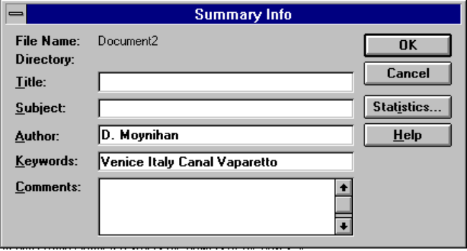
This capability is supported by the Personal Information Store in Windows 95. In addition, some server-based information stores, such as Microsoft Exchange Server, also support shared or replicated sets of folders to let large groups of people easily share documents and messages, and create rich views on them.

Using Electronic Mail Remotely
The Microsoft Exchange client is designed to provide the benefits of remote mail, without requiring any additional client software, or a special gateway to dial-in to. Remote or mobile users can easily send and receive electronic mail using the following features:
- Remote Preview electronic mail lUsing the built-in Microsoft Mail drivers, Microsoft Exchange users can dial in to their network and preview just the headers of their new mail messages. That is, they can see who has sent them new mail, what the subject is, how large the message is, and the estimated time it will take to download that message.
- Selective Download electronic mail After the headers are retrieved, user;s can mark which messages they’d like to download, and which messages should be deleted without downloading. Users can either stay on the line after getting the headers, or make another call later to download their selected messages.
- Remote Network Access electronic mail Rather than using a specialized electronic mail gateway for remote mail, Microsoft Exchange relies on the standard Remote Access that’s built into Windows 95. Users can dial into another computer running Windows 95, Windows NT Server, or a third-party remote access server — such as a Shiva™ LanRover™. Remote electronic mail then becomes protocol-independent, since Windows 95 Remote Access supports standard network protocols such as TCP/IP, IPX, and NetBEUI.
- Offline use electronic mail Microsoft Exchange users can compose mail while offline, that is, while they’re not connected to a network. Download new messages at the airport, read your mail and compose replies while on the airplane, and then send your responses automatically the next time you dial in from the hotel. Messages are queued up in the outbox until the next time you’re connected to the appropriate mail service.
- Scheduled Connections electronic mail Users can dial-in as needed to retrieve mail remotely, or they can set up scheduled connections to dial in at a specific time, or on a regular basis (for example, if the user is on a permanently remote machine).
- A Good TAPI Application electronic mail Microsoft Exchange uses the Windows 95 TAPI facilities to dial and retrieve mail remotely. This allows for effective sharing of modem resources between applications. For example, you can set your modem to listen for incoming faxes, but still make a call to get your electronic mail — TAPI handles the resource management between applications. Microsoft Exchange also uses the TAPI Dial Helper feature to easily handle multiple locations, hotel dialing prefixes, and credit card calls.

When you specify that you want to use mail remotely, you can dial into access your mail messages. For users to take advantage of this capability, administrators need to provide dial-in access to the postoffice for all remote users. For more information, see Chapter 24, “Remote Access.”
Note

To configure Microsoft Exchange for Remote Access

This procedure describes the use of remote electronic mail for the built-in Microsoft Mail service in Windows 95. Other mail services may also have remote functionality (for example, CompuServe). Their configuration procedures may be different.
Note

1. From Control Panel, double-click the MS Exchange Profiles icon. The Messaging Profiles dialog box displays the names of all the profiles defined on your computer.
2. Either modify your primary profile for remote use, or copy it to a second profile for use only with remote access.
3. Click your desired profile to modify, and then click Properties.
4. From the Properties dialog box, choose Microsoft Mail and click Edit. This displays the Microsoft Mail dialog box.
5. Click the Connection tab. Click “Remote using a modem and RAS”.
6. Click the Remote Configuration tab and check “Use Remote Preview”.
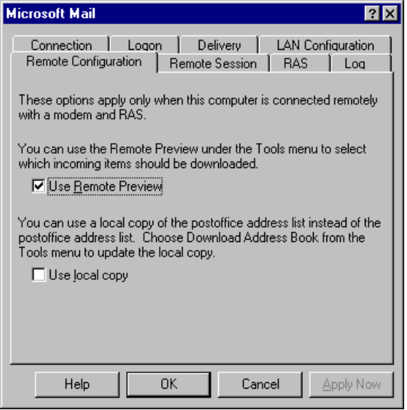
7. Click the Remote Session tab and check the appropriate boxes to specify under what conditions you want to automatically start the Remote Access service. Also specify when Remote Access should be automatically ended.
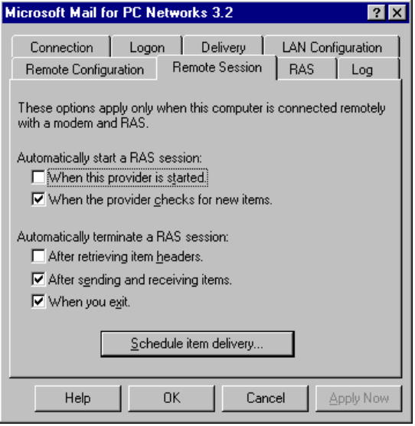
8. Click the RAS tab and specify the Remote Access Service connection to be used when you start a Remote Access session.
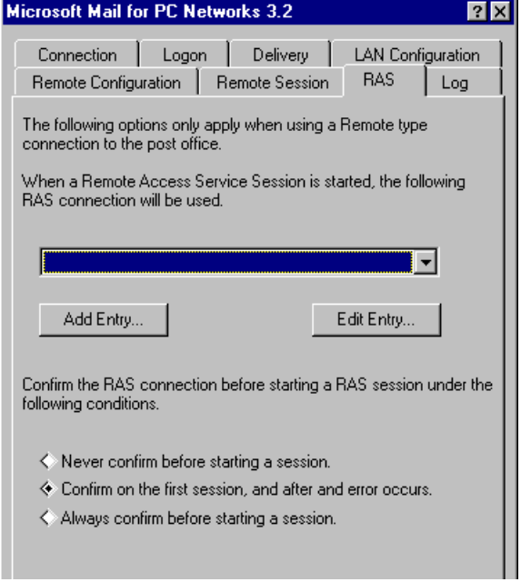

To move the message store between desktop and portable computers
To be added.

Defining Scheduled Sessions
A scheduled session is a session initiated through Remote Access that can be scheduled to occur at a specific date and time, or other interval in the future. Through a scheduled session, you can perform a series of up to 16 scheduled events, including these:
- Perform a session at a specific date and time.
- Perform a session every x interval.
- Perform a session at specific time on specific days of the week.

Scenarios to be added.
Remote Access scheduled session events are stored in the messaging profile.
To define a scheduled session
1. From Control Panel, double-click the MS Exchange Profiles icon. The MS Exchange Profiles dialog box displays the names of all the profiles defined on your computer.
2. Click your profile, and then click Properties.
3. From the Properties dialog box, choose Microsoft Mail and click Properties. This displays the Microsoft Mail dialog box.
4. Click the Remote Session tab.
5. Click the Schedule Item Delivery button.
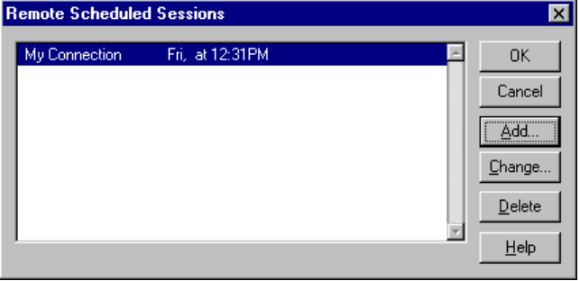
6. Click Add and specify the time at which you want to schedule a session.
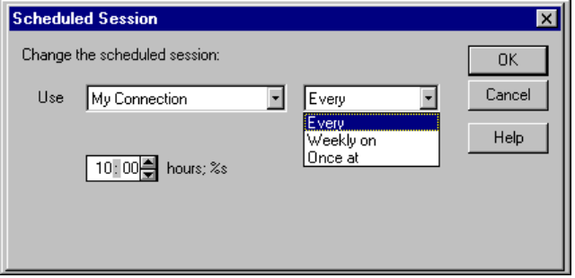
Notice that if you click Weekly On, the dialog box contents change so you can specify a date and time:
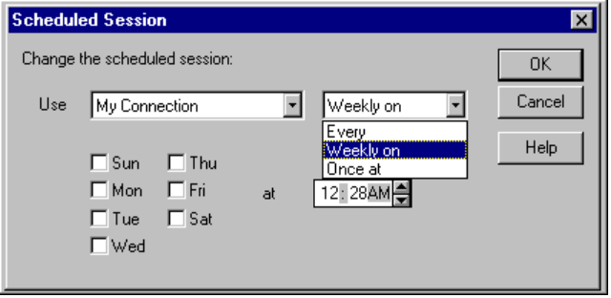

Customizing Microsoft Exchange
You can use several features to customize the way the Microsoft Exchange client works for a particular user on a computer running Windows 95:
- Custom commands are commands you add to Microsoft Exchange menus.
- Custom message types enable you to define and install customized forms.
- Custom menus enable you to add a menu name to the Microsoft Exchange menu bar. You can use these menus to group custom commands and messages under a single, distinctive menu item.

You can install custom commands, message types, and menus for use by a single user on an individual computer or on a network file server to be shared by many users. The following sections describe how to use these features to customize the Microsoft Exchange.
In addition, developers can use MAPI functions to add mail-enabled features to other Windows-based applications and to create MAPI drivers. For more information, see the Microsoft Messaging Application Programmer’s Interface Developer’s Guide.

Custom Commands
You can add custom functions to your Microsoft Exchange menus with custom commands which you add to a menu to perform a unique function tailored to your needs.
There is also a second type of custom command not associated with any menu, which can be set to run whenever the user starts Microsoft Exchange, ends Microsoft Exchange, or receives a new message.
A custom command is usually implemented in a dynamic-link library (DLL). Any executable code — including batch files or applications — can be run from a custom command. Here are some examples of how custom commands can be used to tailor mail for specific needs:
- Display a window that contains information specific to the user’s line of work, such as a parts list or a list of stock quotations.
- Query a database without leaving Microsoft Exchange.
- Launch another application and open a specific file. For example, users can create a command to open a MEMOS.TXT file in WordPad.

Installing Custom Commands
You can install custom commands on the local computer for use by a single user or centrally on the server to be shared by all users. Installing the command on the server eases installation and administrative tasks, and saves space on other users’ hard disks.
When installed, these custom commands can appear to users as built-in features. You can install up to 1000 custom commands in Microsoft Exchange. If you install several custom commands, you can add separator bars between groups of commands to help organize the menu’s appearance.
To install custom commands for a user on an individual computer, you need to modify the Registry on that computer for each custom command and supply the appropriate DLLs. To install custom commands for everyone who uses a particular server, you need to modify the Registry for each user, modify the SHARED32.INI file on the server, and add the DLLs to the server.

Typically, the Setup program that installs the custom commands automatically modifies entries in your computer’s Registry and in the server’s SHARED32.INI file. The information in the following sections is for your reference if you need to make the modifications yourself.
Note

Starting Separate Applications
Microsoft Exchange recognizes custom commands that are implemented as DLLs. A custom command can launch an application. The DLL can pass information about the command to the application when it starts.
Although Microsoft Exchange always calls a DLL, the DLL can pass information to an application by using OLE, command-line parameters, or a disk file. If the called application is already running, the DLL transfers information most efficiently using OLE. If the DLL uses a disk file, take care so that multiple temporary files are not added to the user’s disk. The application that implements the custom command runs independently of Microsoft Exchange.

Installing a Custom Command for a Single User
To install a custom command for a single user on an individual computer
1. Copy the DLL for the custom command to the Windows SYSTEM directory of your hard drive.
2. Add a custom command entry to the Registry on your computer in Hkey_Current_User\Software\Microsoft\Microsoft Exchange\Custom Commands.
3. Quit Microsoft Exchange if it is running, and then restart it. Microsoft Exchange rereads your Registry and adds the custom command.

Installing a Custom Command on a Server
If you have a custom command that you want to make available to multiple users, you can install the command on a server instead of in each user’s Registry. When you create a new custom command, you must include a SharedExtensionsDir entry in this key in each user’s Registry:
Hkey_Current_User\Software\Microsoft\Windows Messaging Subsystem

This entry instructs Microsoft Exchange to check the server’s SHARED32.INI file for custom command entries.
Microsoft Exchange finds the SharedExtensionsDir entry in the user’s Registry, and then reads entries for custom commands in SHARED32.INI before returning to the user’s Registry to read any custom command entries there. For example in the following figure, Microsoft Exchange reads the SharedExtensionsDir entry in the user’s Registry first. Then it reads the entries in the [Custom Commands] section of SHARED32.INI (in this case, the lines labeled tagA= and tagB=). After reading all of the custom command entries in SHARED32.INI, Microsoft Exchange reads entries in the key of the user’s Registry (in this case, the entries labeled tag1 and tag2):
Hkey_Current_User\Software\Microsoft\Windows Messaging Subsystem
\Custom Commands

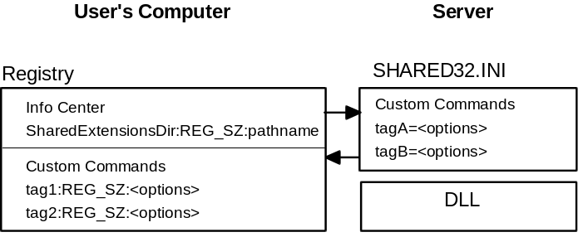
The directory on the server specified by SharedExtensionsDir in the Registry contains the SHARED32.INI file and the DLLs that implement shared custom commands.
Microsoft Exchange can check a server for custom commands and custom messages in one of two ways:
- When you use a dynamic connection to the server
- When you manually connect to the server before starting Microsoft Exchange

The syntax you use with the SharedExtensionsDir entry in the Registry reflects the way you choose to connect. The SharedExtensionsDir entry uses the following syntax:
SharedExtensionsDir:REG_SZ:\\server\share\pathname [password]

– Or –
SharedExtensionsDir:REG_SZ:pathname

When you want to dynamically connect to the server’s shared disk, use the \\server\share\pathname option with SharedExtensionsDir. Use the pathname option with SharedExtensionsDir to point to a manual connection to the server’s shared disk.
To install a shared custom command
1. Create a shared Microsoft Exchange extensions directory on the server.
2. Copy the custom command DLL to the shared extensions directory.
3. A sample SHARED32.INI file is included on the Windows 95 Resource Kit disks. Copy this file to the shared extensions directory.
4. Add custom command entries to the [Custom Commands] section of the SHARED32.INI file on the server, using this syntax:
tag=Mail version; menu; name; position; DLL name; command;
event map; status text; Help file; Help context
Notice that this is a single command line in SHARED32.INI. Don’t add any carriage returns even if line-wrapping occurs.
Values are defined in the following table.
Value | Definition
tag | The descriptive identifier for the command.
version | The version of mail with which the custom command is compatible. The Windows 95 mail client is compatible with version 3.2.
menu | The name of the menu where the custom command is to be added, such as File or Help.
name | The command name that is to appear on the menu. You may include an ampersand just before the letter that is to serve as an ALT+ key accelerator.
position | The zero-relative position within its menu where the command is to appear. A value of -1 places the command at the end of the menu.
DLL name | The name or path of the DLL where the custom command resides. This entry can be followed optionally by a comma and the ordinal of the entry point to call (default is ,1).
command | The command string passed as one of the parameters to the DLL entry point for the command.
event map | A sequence of up to 16 digits identifying the Microsoft Exchange events that the custom command supports. Each can be 0 or 1 to indicate if the DLL is to be called for a specific event. Currently three events are defined; the rest are reserved and must be zero (or this whole section can be empty):  The first digit means Microsoft Exchange startup.  The second digit means Microsoft Exchange exit.  The third digit means the arrival of a new message.
status text | Text to be displayed in the Microsoft Exchange status bar when the user moves the cursor to the command in the menu.
Help file | Windows 95 Help file to be started when the user presses F1 while the command is selected. The specified filename is passed to the Windows 95 Help program. Optional.
Help context | Value passed to the Windows 95 Help program along with the Help file name. Use -1 (Help file index) if there is no specific entry in the Help file for this command. Optional.  There is one special token that may appear within certain fields:
<ExtsDir> | Value expands to the value of SharedExtensionsDir in the user’s Registry. Used to refer to DLLs that are installed in a shared extensions directory on the network. Valid for the DLL name, command, and Help file subfields.

5. In the Registry on your computer, add a SharedExtensionsDir entry to reference the shared extensions directory in the following key:
Hkey_Current_User\Software\Microsoft\Windows Messaging Subsystem

6. If you have chosen the manual connection method, make the necessary network connection using File Manager.
7. Quit Microsoft Exchange if it is running, and then restart it.
Microsoft Exchange rereads your Registry and adds the shared custom command to the specified menu.
8. Test the shared custom command.
9. When the custom command works successfully on your computer, modify each user’s Registry to have access to the shared extensions directory. (See step 5.)

Custom Message Types
A custom message type is a special type (or class) of message for delivery between two or more message recipients or mail-enabled applications. A custom message type can define a particular way to perform standard mail operations such as composing, replying to, and forwarding messages. Custom message types can define a message’s appearance and content, or the behavior of the forms displayed to the user when sending, reading, and replying to messages of that type.
Most custom message types are received in your inbox in the same way as standard mail and fax messages. A second kind of custom message type doesn’t appear in the inbox when it arrives and yet is available to other mail-enabled applications. This allows mail-enabled applications to define their own message classes.
Custom message types have many similarities to custom commands. Like custom commands, a command for composing a custom message type can be added to a Mail menu. When the user chooses this command, the custom message type DLL displays a dialog box or form that enables the user to compose a message of the corresponding type. These dialog boxes or forms can include features specific to the message type.
You can install up to 1000 custom message types in Microsoft Exchange.
When a custom-type message arrives in a mail folder, it can appear in the message list in the same way as other standard mail messages. But when read or replied to, the custom dialog boxes or forms associated with the message type can be displayed in place of the standard read or reply form. You can also design a custom message type that doesn’t appear in the user’s inbox when it arrives and yet is available to other mail-enabled applications.

If a custom message type is delivered to a user who does not have that custom message type installed, the message is treated as a standard message type.
Note

Custom message types can provide special messaging functionality such as the following:
- Messages that are composed or read using a special form.
- Messages accessed by the user through an application other than Microsoft Exchange.
- Messages that are preaddressed to a particular recipient.
- Messages that are used to order parts or services or to describe an event. The dialog boxes displayed when the user composes these types of messages can include special structured fields specific to the purpose of the message.
- Messages that help route workflow events.
- Messages that are specific to group scheduling.
- Messages that enable some game, such as chess, to be played between two Microsoft Exchange users.

Installing Custom Message Types
Installing a custom message type is similar to installing a custom command. Just like custom commands, you can install custom message types on an individual computer or on the server as shared custom message types. Typically, though, you’ll install them as shared custom message types because you’ll want both sending and receiving parties to take advantage of the custom message type.
When you install custom message types on an individual computer, you must modify the Registry on that computer by adding a custom message type entry in this key:
Hkey_Current_User\Software\Microsoft\Windows Messaging Subsystem
\Custom Messages

For shared custom message types, you must add a custom message type entry to the server’s SHARED32.INI file. Then, on each workstation using the shared custom message type, you must add a SharedExtensionsDir entry in the Microsoft Exchange subkey Registry. As with custom commands, when Microsoft Exchange sees this entry in the Registry, it reads SHARED32.INI for custom message type entries before reading custom message type entries in the Registry.

Installing Custom Message Types on a Server
To install a shared custom message type on the server, follow these steps:
1. Create a shared Microsoft Exchange extensions directory on the server.
2. Copy the SHARED32.INI file and custom message type DLL (or .EXE file) to the shared extensions directory.
3. Add custom message type declarations to the [Custom Messages] section of the SHARED32.INI file on the server, using this syntax:
MessageClassName= Mail version; menu name; command name;
command position; ExtsDir DLL name; ExtsDir command string;
operation map; status text; ExtsDir Help file name; Help context;

Notice that this is a single command line in SHARED32.INI. Do not add any carriage returns even if line-wrapping occurs.
Values are defined in the following table.
Value | Definition
class | A string uniquely identifying the message type. Microsoft Exchange places this string in messages and calls custom message DLLs based on its value.
Mail version | The version of Mail with which the custom message is compatible. The Windows 95 mail client is compatible with version 3.2.
menu name | The name of the menu where the custom command for the message type is to be added, such as File or Mail.
command name | The command name that is to appear on the menu. As usual, you may include an ampersand just before the letter that is to serve as an ALT+ key accelerator.
command position | The zero-relative position within its menu at which the command is to appear. A value of -1 places the command at the end of the menu.
ExtsDir DLL name | The name or path of the DLL in which the custom message resides.
ExtsDir command string | The command string passed as one of the parameters to the DLL entry point for the command.
operation map | A sequence of up to 16 digits. Each can be 0, 1, or 2. 0 indicates that Microsoft Exchange is to perform its standard operation on the custom message. 1 indicates that the DLL is to be called to handle the operation. 2 indicates that the operation is to be completely disabled. Currently eight operations are defined; the rest are reserved and must be zero. In the following list, 0 is the leftmost digit:
 | 0 Compose (menu command defined in this entry)
 | 1 File.Open
Value | Definition
 | 2 Mail.Reply
 | 3 Mail.Reply to All
 | 4 Mail.Forward
 | 5 File.Print
 | 6 File.Save as
 | 7 Arrival of new mail
status text | Text to be displayed in the Microsoft Exchange status bar when the user moves the cursor to the command in the menu.
ExtsDir Help file name | The Windows 95 Help file to be invoked when the user presses F1 while the command is selected. The specified filename is passed to the Windows 95 Help program. Optional.
Help context | Value passed to the Windows 95 Help program along with the Help file name. Use -1 (Help file index) if there is no specific entry in the Help file for this command. Optional.
 | There is one special token that may appear within certain fields:
<ExtsDir> | Value expands to the value of SharedExtensionsDir in the user’s Registry. Used to refer to DLLs that are installed in a shared extensions directory on the network. Valid for the DLL name, command, and Help file subfields.

4. In the Registry on your computer, add a SharedExtensionsDir entry to reference the shared extensions directory in the following key:
Hkey_Current_User\Software\Microsoft\Windows Messaging Subsystem

5. If you have chosen the manual connection method, make the necessary network connection using Network Neighborhood.
6. Quit Microsoft Exchange if it is running, and then restart it.
Microsoft Exchange rereads your Registry and adds the shared custom message to the specified menu.
7. Restart Microsoft Exchange and test the shared custom message type.
8. When the custom message type works successfully on your computer, modify each user’s Registry to have access to the shared extensions directory. (See step 4.)

Custom Menus
You can add menu items to the Mail menu bar by putting custom menu entries in the Custom Menus section of your Registry or in the [Custom Menus] section of SHARED32.INI (in the directory specified by the SharedExtensionsDir entry in your Registry). SHARED32.INI is examined first.
Each entry specifies a menu name to be added to the Microsoft Exchange menu bar. You may use these menus to group custom commands or messages under a single menu item. A description of the custom menu entry format for SHARED32.INI follows. Each entry must occupy a single line. Many subfields are optional. For information on how to add equivalent entries to your Registry, see __________________(to be provided).
tag=version;name;name to follow;status text

For example,
tools=3.0;&Tools;Window;Useful development toys
Values are defined in the following table.
Value | Definition
tag | The menu to someone reading the .INI file (serves no other purpose).
version | The version of Mail with which the command is compatible. The Windows 95 mail client is compatible with version 3.2.
name | The menu name to be added to the menu bar. As usual, you may include an ampersand just before the letter that is to serve as an ALT+ key accelerator.
name to follow | The name of an existing menu. The new menu will be added directly before it.
status text | Text to be displayed in the Microsoft Exchange status bar when the user moves the cursor to the menu.

Upgrading to a Full Microsoft Mail Postoffice
With Windows 95, you can support all the users in your workgroup on a single postoffice. Performance will vary depending on your postoffice computer, but for best results, no more than 100 users should be supported by this postoffice. If your organization grows larger, you can upgrade your postoffice to a full Microsoft Mail 3.2 postoffice by installing the Microsoft Mail Post Office Upgrade product.
The Windows 95 and Microsoft Mail 3.2 postoffices are identical, except for the following:

How is mail in Windows 95 different from Microsoft Mail 3.2?
- No executable files or Help files are in the workgroup postoffice structure. Microsoft Mail 3.2 does include these files in its postoffice.
- The postoffice in Windows 95 doesn’t support connections to external postoffices or gateways.
- Default ADMIN.TPL and ADMIN.INF files are created to add the predefined extended user information in the workgroup postoffice structure.
- Microsoft Mail 3.2 includes an ADMIN account not created in Windows 95 mail.
- Microsoft Mail 3.2 includes an administration utility that is used to administer and configure the postoffice. The ADMIN.EXE program can be used to configure and administer a postoffice from any workstation on the network.
- Microsoft Mail 3.2 includes support files for external postoffice mail transfer through a network or modem. Windows 95 mail does not.

The Microsoft Exchcnage client offers a number of features not available in the Microsoft Mail 3.2 Windows client:
- Rich text electronic mail, including full use of fonts, colors, bullets, and so on; uses drag and drop text editing; supports Find/Replace
- Full OLE 2 support, including Visual Editing, and cross-application drag and drop
- Built-in remote mail capability; doesn’t require a separate “remote” product; uses TAPI and Remote Network Access to support all common modems and network protocols
- Fully integrated with Windows 95 file system; simply drag messages out to hard drive directories, or drag files into your mail folders.
- Customizable toolbar with Tooltips™ and right-click “shortcut” menus to commonly used tasks
- Blind Carbon Copy (BCC:)
- Intelligent message replies; reply text is automatically indented and rendered with your personal font or color; better tracking of who made which comments
- Connection to multiple mailbox files simultaneously
- Custom Views on any folder to define the columns, and select the sorting, filtering, and categorization
- Integration with Windows 95 registry to use Master Password logon

You can upgrade your Windows 95 postoffice to a full Microsoft Mail 3.2 postoffice by using the Microsoft Mail Post Office Upgrade product. The Extensions package includes software, documentation, and licensing to extend the connectivity of your workgroup. It includes the following software components:

How do I set up a Windows 95 workgroup mail server to route mail between two or more post offices?
- Software to upgrade your workgroup postoffice to a full Microsoft Mail 3.2 postoffice.
- Additional server software:
- Advanced administration tools, including tools for routing, directory synchronization, network group names, user access privileges, mail log files, and deleting old mail and old Mail accounts).
- The Message Transfer Agent (External) component, which provides the process to connect postoffices (with physical or asynchronous link) and the platform for remote access.
- Windows 3.1, MS-DOS, Macintosh®, and OS/2® Mail client software for people on your network who may not use Windows 95.

Extending Mail Access With MAPI Drivers
A MAPI driver is like a personal gateway. You specify all of the connection and addressing settings needed to communicate with the network on the other end.
Windows 95 includes several MAPI drivers you can use to connect your Microsoft Exchange client software with other mail server back-end products:
- The Microsoft Mail MAPI driver connects to Microsoft Mail 3.2 postoffices that you may have on a Windows NT or Novell NetWare server, and the built-in Windows 95 workgroup postoffice. See the previous sections for details on configuring and using the Microsoft Exchange client with a Microsoft Mail Post Office.
- With the Internet Mail MAPI driver, you can send and receive mail directly on the Internet or other SMTP-based networks. It supports SMTP and POP3 protocols over Windows 95’s built-in TCP/IP and PPP support.
- With Microsoft At Work Fax, you can send and receive electronic faxes as if they were mail messages. For more information, see Chapter 22, “At Work Fax.”
- The CompuServe Mail MAPI driver allows you to send and receive mail using the CompuServe information system. It supports Windows 95 TAPI for dialing directly into CompuServe.

In addition, you will be able to add a Microsoft Exchange MAPI driver to connect your Windows 95 Microsoft Exchange clients to the next-generation Microsoft Exchange Server, a client/server messaging system that runs on Windows NT Server.
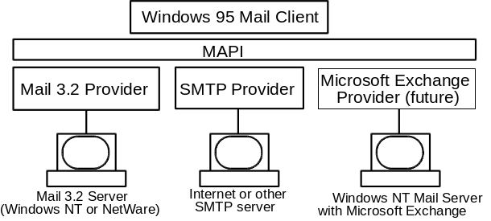
The Microsoft Mail driver is described in detail in the preceding sections, and the Microsoft At Work Fax driver is described in detail in Chapter 22. The next section describes using and configuring the other MAPI drivers:

Using the Internet Mail drivers
To be added.

Using the CompuServe Mail drivers
To be added.

Upgrading to Microsoft Exchange Server
Microsoft has announced a next-generation client-server messaging system known as Microsoft Exchange Server. Expected to be available in 1995, Microsoft Exchange Server provides advanced electronic mail, scheduling, groupware applications, and custom application development capabilities. Microsoft Exchange Server includes MAPI drivers that allow the Windows 95 Microsoft Exchange client to access much more than just mail messages. For example, when the Microsoft Exchange is connected to an Exchange Server, you can access replicated “public folder” databases, create custom forms and shared documents, schedule meetings with others, manage your time and tasks, and create custom electronic forms for use in your business.
Contact your Microsoft representative for more information on Microsoft Exchange Server.

Microsoft Mail Gateways
Almost all large organizations have multiple electronic messaging systems. In your organization, you may need to communicate with workgroups or organizations using electronic mail systems other than Windows 95 mail, such as cc:Mail™, HP® Openmail, or IBM® PROFS®. Microsoft offers a complete line of advanced gateways which provide reliable and sophisticated connectivity between Microsoft Mail for PC Networks and virtually any other electronic mail system within your organization.
Gateways ensure that messages always get across to their intended recipients. Addressing messages remains an easy process because people using other mail systems will be listed in your Microsoft Mail global address list — all you need to know is the name of the person you need to communicate with.

How do I communicate with other existing mail systems?
Microsoft offers gateways for the following:
X.400 | IBM PROFS | SNADS
SMTP | MHS | AT&T Easylink™
MCI MAIL | Fax

Microsoft gateways support key features such as messaging backboning and message encapsulation.
- Messaging backboning lets organizations leverage their existing messaging resources by using these systems as high-performance bridges — or messaging backbones — between multiple Microsoft Mail sites.
- Message encapsulation in Microsoft gateways makes it possible for users to place graphics, charts, sound, and video objects directly in their mail messages for richer communication. Moreover, these complex messages can be sent across messaging backbones between distant sites without any loss of data integrity.

To connect a workgroup postoffice to another workgroup postoffice, you can purchase Microsoft Mail Postoffice Upgrade for each postoffice. To connect to another message system, such as X.400 or SMTP, you’ll need to install both Microsoft Mail Postoffice Upgrade plus the appropriate gateway software.
Each message system can connect to the workgroup postoffice by using one or more specific gateways. The following table is a partial list of the Microsoft gateways needed for various message systems. If you use one of the message systems listed in this table, you need to purchase the appropriate gateway.
Message system | Microsoft Mail gateway
ARCOM 400 Swiss PTT | X.400
AT&T® Easylink | X.400
AT&T Mail | X.400 or AT&T Gateway
Atlas 400 | X.400 (NF mark from Afnor)
Banyan® Mail | MHS or X.400
Beyond Mail | MHS
cc:Mail™ | X.400, MHS, SMTP, or Office Vision
CompuServe® | SMTP or MHS
The Coordinator | MHS
Data General® CEO | X.400
DaVinci™ | MHS
DEC® All-In-1® | X.400, PROFS, SNADS, or SMTP
Message system | Microsoft Mail gateway
DEC VMS Mail | X.400 or SNADS
Dutch® PTT | X.400
Envoy 100/Gemdes | X.400
Fax | Fax
Fischer International EMC2 | X.400 or SNADS
Gold 400 UK | X.400
Higgins | MHS
IBM® AS/400® Office | SNADS, or through PROFS Distribution Manager, if you have a VM host
IBM System 36 | PROFS/OV
IBM CMS NOTES | PROFS
IBM DISOSS | SNADS
IBM OfficeVision MVS | SNADS, or through PROFS Distribution Manager, if you have a VM host
IBM PROFS® | PROFS
Infonet® | X.400
Internet | SMTP
Lotus® Notes® | MHS, or the MS Mail-Notes Gateway by Corporate Software
Microsoft® Mail for AppleTalk® | Microsoft Mail connection
NCR® Corporation | X.400, or in some cases, the AT&T Gateway
Novell® NetWare® | MHS
Retix® | X.400
Soft-Switch™ Central | SNADS
Sprint TeleMail | X.400
Telebox 400 German PTT | X.400
Touch | X.400
Unisys® | X.400
UNIX® SMTP | SMTP¹
UUCP | SMTP²
Verimation Memo | SNADS
WANG® Office | MHS, X.400, or PROFS
¹SMTP is a part of TCP/IP, not a part of UNIX. You can also have SMTP origination to a VAX or IBM host.
²Requires connectivity to an SMTP host which acts as a router to UUCP.

The following sections summarize the features and benefits of Microsoft gateway products.

Microsoft Gateway to Fax
Using Microsoft Gateway to Fax, you can send several types of items — such as electronic mail messages, text files, and graphic attachments — in a single fax. You can use this product to transmit attachments in any of three different formats: ASCII (text), black and white .PCX, or .DCX (graphics).
You can view incoming fax messages, scaling it anywhere from one-eighth to full-sized view. You can also rotate pages 90 or 180 degrees.
Microsoft Gateway to Fax offers easy setup and administration. It also features improved error reporting and support for the high performance GammaFax board, in addition to the Intel SatisFAXtion and Connection Coprocessor boards.
This product features attachment file type verification before transmitting outgoing faxes, ensuring they are in a format supported by the fax board (ASCII, .PCX, or .DCX). If they are not, the message is returned to the sender.

Microsoft Mail Gateway to MHS
MHS is a messaging system commonly found in Novell NetWare networks.
With Microsoft Mail Gateway to MHS, users can route mail between Microsoft Mail postoffices or sites using MHS. Encapsulation technology preserves the following across the MHS backbone:
- Address information
- OLE objects
- Binary file attachments

Using Microsoft Mail Gateway to MHS, you can address mail routed to MHS mail users in a familiar Microsoft Mail format. You can also add individual MHS users to the Microsoft Mail Personal Address Book.
Like Microsoft Mail, you can send or receive an unlimited number of attachments in one message and you can receive any type of text or binary files as attachments in Microsoft Mail.
No system administration resources are needed to address MHS users and add them to personal address lists. In addition, Microsoft Mail Gateway for MHS offers full error-logging support for MHS activity.
Microsoft Mail Gateway to MHS is compatible with most popular MHS mail systems, including Da Vinci Systems Mail version 1.8, The Coordinator version II, Lotus cc:Mail version 3.2, and any fully MHS 1.5-compatible system, such as Novell Global Messaging.

Microsoft Mail Gateway to X.400
Microsoft Mail Gateway to X.400 offers transparent backboning using an X.400 network. It links geographically dispersed local-area networks into a single mail network. It connects local-area networks, mainframes, minicomputers, and microcomputers with X.400. This gateway uses the X.400 gateway to connect to an unlimited number of message transfer agents (MTAs) and functions as a relay between them. This gateway also provides X.400 over an 802.x LAN.
With Microsoft Mail Gateway to X.400, OSI LAN connectivity eliminates the need for costly additional software, hardware, or communication lines. It supports multiple simultaneous active sessions for higher overall throughput and accepts up to two incoming calls while sending a message. It also accepts local-area and wide-area network connections simultaneously for more flexibility.
This gateway uses encapsulation, or “tunneling,” to exchange messages containing text, multimedia objects, binary files, and directories with other Microsoft Mail users across X.400 backbones without losing information or data integrity.
Administrators can configure and maintain Gateway to X.400 more easily with a new full-screen utility, which can be used to view and print log files and configuration parameters. They can also use the Advanced Address Mapping feature to assign users arbitrarily — even multiple X.400 addresses — without shutting down the gateway.
Users can create a new address simply by filling out the address template provided. They can also read friendly names on mail from other X.400 systems instead of lengthy X.400 O/R addresses. X.400 addresses can be added to the Microsoft Personal Address Book.
Microsoft Mail Gateway to X.400 complies with international X.400 standards in the following ways:
- Acting as a fully functional CCITT 1984 X.400 MTA and being able to communicate with 1988-compliant MTAs
- Supporting NIST, ENV 41202 (A/311) X.400 profiles
- Conforming to OSTC
- Having Afnor Certification

The gateway offers the following bodypart support:
- Supports bodypart 0 (IA5), including translation tables for Norwegian, German, and Swedish, in addition to standard International Reference Version (IRV), for improved interoperability between European X.400 systems.
- Supports bodypart 5 (T.61/Teletex), for extended character support.
- Includes new bodypart 13 support (ISO 6937), to seamlessly carry text in attached files with accented characters not supported through the standard IA5 text character set.
- Supports binary attachments using bodypart 14, so attachments can be sent to other systems without losing any information.

Microsoft Mail Gateway to SMTP
With Microsoft Mail Gateway to SMTP, users can send and receive Simple Mail Transfer Protocol (SMTP) messages as easily as Microsoft Mail.
This gateway is easy to maintain. Administrators can use the standard Microsoft Mail administration program to control access to the gateway and to use the full-traffic and error-logging support, to isolate problems and optimize routing. Global directory synchronization provided by the product can reduce directory maintenance by automatically updating Microsoft Mail directories with user addresses from other electronic mail systems in the organization.
You can link Microsoft Mail systems transparently using SMTP. Encapsulation lets users send mail messages containing text, binary files, multimedia objects, and directory updates over a messaging backbone without any loss of data integrity. This gateway automatically encapsulates all binary file attachments and messages with extended characters.
Microsoft Mail Gateway to SMTP supports the following major standards:
- TCP/IP
- RFC 821 Simple Mail Transfer Protocol (SMTP)
- RFC 822 ARPA Internet text messaging standard
- Incoming and outgoing encapsulated attachments
- RFC 1154 Encoding Header Field for Internet Messages

Microsoft Mail IBM PROFS and OfficeVision Gateway
With this gateway, PROFS and OfficeVision users send mail to Microsoft Mail users using standard PROFS and OfficeVision, or CMS NOTE addressing formats. Users on PROFS and OfficeVision systems can respond to a message from either system using the Reply option and receive automatic acknowledgment of registered mail delivery.
This gateway provides flexible and reliable architecture to improve connectivity. A mainframe component creates a virtual machine (VM) and identifier for the Remote Spooling Communication Subsystem (RSCS). A standard Network Job Entry (NJE) RSCS link connects Mail to the VM. Multiple LANs can be connected to single or multiple VM nodes.
The gateway offers transparent exchange of scheduling information which saves administration time. When PROFS and OfficeVision users receive meeting requests from Microsoft Schedule+ users , these appear as familiar PROFS and OfficeVision meeting requests. When Schedule+ users receive PROFS and OfficeVision meeting notes, they are delivered in familiar Schedule+ format. Free and busy times of PROFS and Office Vision users can be periodically downloaded to the LAN for scheduling purposes.
Extensive file support between systems helps mainframe and PC users work together more effectively. VM users can send files to Microsoft Mail users using SENDFILE, DISK DUMP, PUNCH, and PRINT formats. In addition, Microsoft Mail attachments appear as files in the VM user’s Virtual READER.
This gateway is easy to administer and troubleshoot. With its Generic Routing Facility (GRF), all Microsoft Mail users appear to PROFS and OfficeVision users as if they are on a single VM node. (The ability to define a VM node per Microsoft Mail postoffice still exists, even if GRF is being used.) Using message size restrictions, administrators can limit the size of messages transmitted.
The Distribution Manager option adds document-exchange features and links Microsoft Mail to a variety of host systems. It offers the ability to exchange messages and documents with other messaging systems that use the Document Interchange Architecture (ZIP packet protocol), such as OfficeVision/MVS™, OfficeVision/400™, PS/CICS, System/36, remote PROFS and OfficeVision using DISOSS, and (through gateways) DEC® All-In-1™, WANG® Office, and Verimation Memo.

Troubleshooting Microsoft Exchange and Mail

I need to recreate the Windows 95 mail initialization procedure.
1. Rerun Windows 95 Setup.
2. Select the Custom Setup option and choose to install Microsoft Exchange.

I want to change the Postoffice location for the mail client.
1. From the Tools menu, click Options for Microsoft Exchange.
2. Click the Services tab and double-click Microsoft Mail.
3. Click the Connection tab and type the new path.

More troubleshooting tips to be added.

