Chapter 1
This chapter presents specific information about the architecture for the networking components in Windows 95.
Windows 95 Network Architecture

Windows 95 Network Architecture Overview 27-2
In This Chapter
Multiple Network Support 27-7
Architecture for Network Protocols 27-21
IPC and Windows 95 27-22

Chapter 26, “Windows 95 Architecture,” for details abotu the basic architecture for Windows 95
See Also
Chapter 8, “Windows 95 on NetWare Networks,” for details about the architecture for Microsoft Client for NetWare Networks and for Novell-supplied network clients with Windows 95

Windows 95 Network Architecture Overview
Windows 95 provides multiple, simultaneous connections to a variety of networks (Windows NT, Novell® NetWare®, and others) and a variety of resources (files, programs, printers, host systems, mail systems) over most popular media (Ethernet, Token Ring, X.25, ISDN) from most any location (office, home, hotel).
Windows 95 networking capabilities are implemented using a high-performance, reliable, and open architecture based on the Windows Open Services Architecture (WOSA) specification. This approach provides users with a consistent interface to different services on the front end, while giving system administrators the flexibility to mix and match multiple services on the back end.

OSI Reference Model and Windows 95 Architecture
The modular networking architecture of Windows 95 is based on two industry standard models for a layered networking architecture, namely the International Standards Organization (ISO) model for computer networking, called the Open Systems Interconnect (OSI) model and the Institute of Electrical and Electronic Engineers (IEEE) 802 model. Windows NT and Windows for Workgroups are likewise designed according to these standard models. The ISO and IEEE 802 models define a modular approach to networking, with each layer responsible for some discrete aspect of the networking process.
The OSI Reference Model describes the flow of data in a network, from lowest layer (the physical connections) up to the user’s applications. Data going to and from the network is passed layer to layer. Each layer is able to communicate with the next highest and next lowest layers. This way, each layer is written as an efficient, streamlined software component. When a layer receives a packet of information, it simply checks the destination address, and if its own address is not there, passes the packet to the next layer.
When two computers communicate on a network, the software at each layer on one computer assumes it is communicating with the same layer on the other computer. For example, the Transport Layer of one computer communicates with the Transport layer on the other computer. The Transport Layer on the first computer has no regard for how the communication actually passes through the lower layers of the first computer, across the physical media, and then up through the lower layers of the second computer.
The OSI Reference Model includes seven layers, as shown in the following figure.

7  Application Layer | — Represents the level at which user applications access network services. This layer represents the services that directly support the user applications such as software for file transfers, database access, and electronic mail.
6  Presentation Layer | — Translates data from the Application Layer into an intermediary format. This layer also manages security issues by providing services such as data encryption, and compresses data so that fewer bits need to be transferred on the network.
5  Session Layer | — Allows two applications on different computers to establish, use, and end a session. This layer establishes dialog control between the two computers in a session, regulating which side transmits, plus when and how long it transmits.
4  Transport Layer | — Handles error recognition and recovery. It also repackages long messages when necessary into small packets for transmission and, at the receiving end, rebuilds packets into the original message. The receiving Transport Layer also sends receipt acknowledgments.
3  Network Layer | — Addresses messages and translates logical addresses and names into physical addresses. It also determines the route from the source to the destination computer and manages traffic problems, such as switching, routing, and controlling the congestion of data packets.
2  Data Link Layer | — Packages raw bits from the Physical Layer into frames (logical, structured packets for data). This layer is responsible for transferring frames from one computer to another, without errors. After sending a frame, it waits for an acknowledgment from the receiving computer.
1  Physical Layer | — Transmits bits from one computer to another and regulates the transmission of a stream of bits over a physical medium. This layer defines how the cable is attached to the network adapter card and what transmission technique is used to send data over the cable.

The following diagram shows the layered components that make up the Windows 95 networking model.
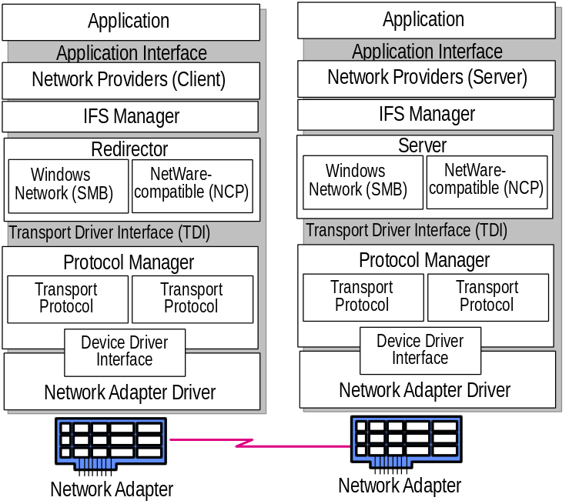
Layers in the Windows 95 networking model
The following sections describe these elements of the Windows 95 network architecture:
- Redirectors and Installable File System Manager
- Transport Driver Interface (TDI) and Protocol Manager

The following discussions present the Windows 95 architecture for other layers in the networking model:
- The Application layer and network providers in Windows 95 are described in “Multiple Network Support” later in this chapter.
- The architecture for each network protocol is described in the section for that protocol later in this chapter.
- The device driver interface and network adapter drivers are described in Chapter 11, “Network Technical Issues.”

Redirectors and Installable File System Manager
A network redirector provides mechanisms to locate, open, read, write, and delete files and submit print jobs, and makes available application services such as named pipes and mail slots. When an application needs to send or receive data from a remote device, it begins by sending a call to the redirector. The redirector provides the functionality of the application and presentation layers of the OSI model. The redirector maps local names into network devices and decides whether the application needs access to a local or remote device.
The redirectors are included in the Windows 95 network client software as the following file system drivers:
- In Microsoft Client for Windows Networks (VREDIR.VXD), the redirector supports all Microsoft networking products, which use the Server Message Block (SMB) file-sharing protocol.
- In Microsoft Client for NetWare Networks (NWREDIR.VXD), the redirector supports NetWare networking products, which use the NetWare Core Protocol (NCP) file-sharing protocol.

Windows 95 also supports network redirectors from other network vendors.
Because each redirector is implemented in Windows 95 as a file system driver, the redirector is managed by the Installable File System (IFS) Manager. The IFS Manager controls file I/O transfers for all the installable file systems in Windows 95.
The Windows 95 redirector formats an application’s request into data packet SMBs and submits the packet to the Transport Driver Interface. The NetWare redirector formats requests into NCP packets. The data packet is passed by the protocol to the Protocol Manager.
The Windows 95 server side at this layer of the networking model supports peer resource sharing. Windows 95 provides two server services for peer networking:
- File and Printer Sharing for Windows Networks (the Windows 95 SMB-based server, VSERVER.VXD), which supports resource sharing among all computers on the network that use the SMB file sharing protocol.
- File and Printer Sharing for NetWare Networks (the Windows 95 NCP-based server, NWSERVER.VXD), which supports resource sharing among all computers on the network that use the NCP file sharing protocol.

TDI and Protocol Manager
To communicate with a network device, the redirector makes a call using the Transport Driver Interface to the protocol by passing a data packet to the Protocol Manager. The protocol and the network adapter driver add the equivalent of headers and footers to the packet, and the network adapter driver places the packet on the network itself. This interface provides a uniform set of commands for requesting the lower-level network services. It provides interaction with the network in the same way that the BIOS provides for interaction to local hardware.
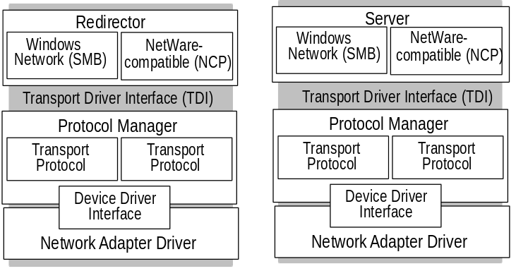

Transport Driver Interface
For communication between the Session and Transport layers of the OSI Reference Model, Microsoft developed and supports the Transport Driver Interface (TDI). On a computer running Windows 95, the server and redirector processes communicate with protocols through the TDI. Like NDIS (as described in Chapter 11, “Network Technical Issues”), TDI makes networking on Windows 95 more versatile by making it possible for different protocols and upper-level networking components to communicate using a common interface. Different protocols that conform to TDI can work with different upper-level components that also support TDI. When a redirector or server makes a call to a protocol, it uses the TDI for the call and thus does not have to know anything about the protocols being used.
The TDI support in Windows 95 means that alternate protocols or even alternate redirectors or servers written by other network vendors that conform to TDI, will work with Windows 95. Using TDI enables Windows 95 to overcome limitations of LAN Manager 2.x. For example, TDI imposes no limit on the number of workstations that can connect to a server, although LAN Manager 2.x was limited to 254 workstation connections for each of the server’s network adapter cards.
The Transport Driver Interface supports interprocess communications (IPC) mechanisms used in distributed computing, as described in “IPC and Windows 95” later in this chapter.

Protocol Manager
The Protocol Manager is responsible for sending information to the appropriate protocol. The protocol, in turn, manages both the quality of service and the accuracy of information. It provides a network message standard used to translate messages into information that the system recognizes.
Windows 95 can accommodate multiple protocols on a single computer and is designed to be protocol-independent, so it works the same, regardless of the protocol being used. For information about using NetBEUI, IPX/SPX, and TCP/IP with Windows 95, see Chapter 11, “Network Technical Issues.”

Multiple Network Support
Enterprise networks are often a conglomeration of many different types of networks and are becoming more interconnected all the time. Companies are linking their Windows-based computers to multiple PC-based network servers, mainframes and mini-computer host systems, UNIX® computers, and even a variety of services such as the Internet. The desktop operating system must meet this challenge and provide support for the disparate connectivity needs on the network.
The Windows 95 modular Network Provider Interface, as described later in this section, supports concurrent communication with several different networks. For example, a user’s computer can have connections to computers running Windows 95 peer resource-sharing services, to servers for Windows NT and NetWare networks, and to the Internet, all at the same time.
In addition to the Windows 95 network client and peer sharing components, Windows 95 supports the following network clients from other vendors:
- Artisoft® LANtastic® version 5.0 and greater
- Banyan® VINES® version 5.52 and greater
- Beame and Whiteside BW-NFS 3.0c and greater
- DEC™ Pathworks™ version 4.1 and greater (installed as a protocol)
- DEC Pathworks version 5.0 and greater (installed as a protocol)
- Novell® NetWare® version 3.11 and greater
- SunSelect PC-NFS® version 5.0 and greater
- TCS® 10-Net version 4.1 or greater

Most network clients can be installed along with any Microsoft networking component. Windows 95 does not include the supporting files for these networks; you must obtain them from the network vendor. For information about using these network clients and the required supporting files, see Chapter 12, “Windows 95 On Other Networks.”
Windows 95 does include the support necessary to work with networking components from other network vendors. The network software should be installed and running before installing Windows 95, so that Windows 95 Setup can detect the network and install support for it by default. You can check this on the Network Options page during Custom Setup.
Multiple network support in Windows 95 consists of these components, as described in the following sections:
- Win32 WinNet API
- Multiple provider router
- Service provider interface
- Network providers (including the WinNet16 interface)

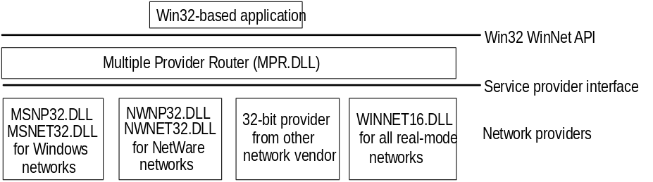
Components of multiple network support in Windows 95

Win32 WinNet Interface for Applications
The Win32 WinNet interface in Windows 95 provides an application programming interface (API), that software developers can use to create single versions of applications that run unmodified on different networks. The Win32 WinNet interface is the successor to the WinNet16 interface introduced in Windows 3.0 and enhanced in Windows 3.1.
The WinNet interface is set of network-independent APIs implemented by a driver supplied by the network vendor. In Windows 95, the expanded WinNet API set includes the following:
- Support for the Win32 WinNet APIs as defined in Windows NT. This set of functions and the other Win32 APIs provide all the commonly used capabilities required by applications.
- An interface that allows browsing of network resources (network directories, printers, and other network resources). This includes consistent handling of authentication requirements across multiple networks and support for the NetWare server security model.
- Backward compatibility with Windows for Workgroups 3.11 and support for networking using the Windows 3.1-based architecture (that is, a network that uses a WinNet16 network driver).

Multiple Provider Router
The Multiple Provider Router in Windows 95 exports the Win32 WinNet APIs to applications. It provides seamless access to network services and resources, and it supports a way to access a single WinNet16 network driver. It routes incoming network requests to the appropriate network provider, using the same interface whether one or more network providers are installed.
Features common to all networks are implemented once in the Multiple Provider Router, which reduces the code base for each network provider and ensures common behavior between networks. For example, network providers do not implement persistent connections — this feature is implemented in the Multiple Provider Router and is entirely transparent to a network provider.

Service Provider Interface
Windows 95 uses an open, modular service provider interface (SPI) to allow multiple 32-bit network providers to be installed in Windows 95 simultaneously. The service provider interface is a single, well defined set of APIs used by Windows 95 to request network services to browse servers, connect to and disconnect from servers, send a print job, and so on. The service provider interface is below the Win32 WinNet API in the networking model, and provides the needed network services to honor a Windows 95 request for network-specific services. This model is similar to the Windows 95 design for various device driver interfaces: a well-defined set of interfaces used by the operating system, with services provided by a device driver (often written by a third party) to honor requests. These requests are then passed to the network providers.
The service provider interface enables Microsoft or any other network provider to integrate varied network services seamlessly into Windows 95. The service provider interface ensures that all supported networks are identically accessed and managed through the Windows 95 Network Neighborhood and other user interface components.
The service provider interface consists of two parts, the service provider API and the network providers, as described in the following section.

Network Providers
Windows 95 uses an open, modular network provider interface (NPI) to allow multiple network support simultaneously in Windows 95. Key benefits of the network provider interface architecture are the following:
- An open interface allows any network vendor to supply tightly integrated support for its network servers for Windows 95.
- Identical access and management through the Windows 95 user interface components, including Network Neighborhood and Network Control Panel.

The network provider interface consists of two parts—the network provider API and the network providers. The network provider API calls are used by applications to request network services. When Windows 95 receives a network provider call, it passes the call to the appropriate network provider, which then supplies the requested network service.
The network provider is a network-specific device driver that implements the service provider interface call from the Multiple Provider Router. The functions provided include authenticating users when they access a network server, managing passwords, adding or removing connections to a server, and browsing network resources.
Windows 95 includes the following network providers:
- MSNW32.DLL and MSNET32.DLL, for Microsoft networks
- NWNP32.DLL and NWNET32.DLL, for NetWare networks
- A network provider to support at most one WinNet16 driver (WINNET16.DLL)

Windows 95 also supports any number of other 32-bit network providers and a single 16-bit network provider that uses WinNet16 driver. Such network providers must be supplied by other network vendors.
The Windows 95 system logon is an example of a network service provided by the network provider interface. Each network provider can provide a unique logon dialog box to suit the needs of its network server security model. Once the logon is validated by the requested server, this is passed back to Windows 95. Windows 95 can then use this password as the master key password to unlock any system or network resource linked to the master key password validation. In this way, Windows 95 can accommodate the various ways that network servers provide their services, yet still offer a consistent user interface.
The following summarizes the internal processes when, for example, a user double-clicks the Entire Network icon in Network Neighborhood:
1. The Windows 95 user interface generates a Win32-based network API call to enumerate the network.
2. The Multiple Provider Router receives the API call and submits a service provider interface call to all the available network providers.
3. Each network provider browses its individual networks and returns the list to the Windows 95 shell, which displays all the networks and their hierarchies in the Entire Network window.

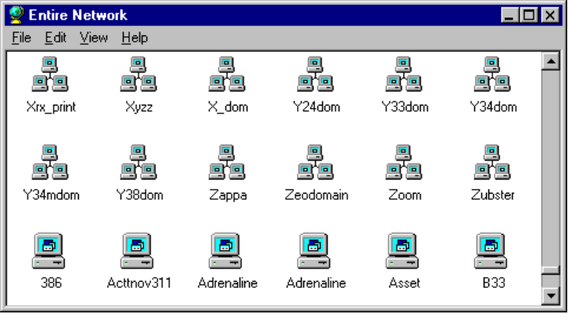
This is an example of the list of workgroups and computers available in Network Neighborhood.
Because of network provider support in Windows 95, users can specify server name strings in a drive connection dialog box using the syntax to which they are accustomed. A network provider knows how to correctly interpret the syntax of its own server name strings. The server name string is the syntax used by a particular network operating system to specify a shared disk resource. Microsoft network-compatible networks use the Uniform Naming Convention (UNC), which appears as the following:
\\server_name\share_name

However, NetWare servers are usually specified as follows on NetWare networks:
server_name/volume_name:directory_name

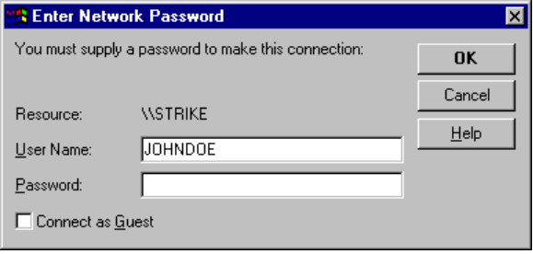
This example shows the dialog box for logging onto a Novell NetWare 3.x server, including an option to log on as Guest.
Because the network provider knows how to interpret server name strings, users who are accustomed to using the NetWare server syntax can type such server names wherever required in Windows 95 to access NetWare server resources. The Windows 95 user interface and the net command also support UNC names for connecting to NetWare resources.

Network Provider for NetWare Networks
The network provider that supports NetWare networks (NWNP32.DLL and its support library, NWNET32.DLL) provides access to NCP-based NetWare network resources using, for example, Windows Explorer, Network Neighborhood, Control Panel, and other Win32-based applications.
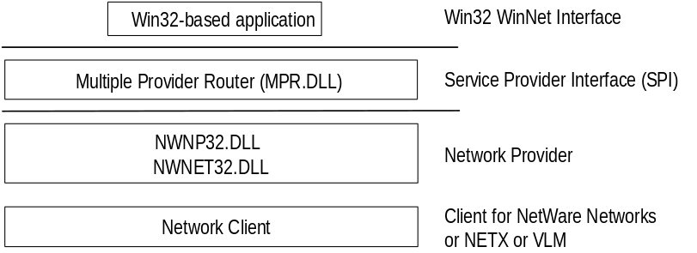
Basic architecture for network provider for the NetWare networks
The network provider supports these functions on NetWare networks:
- Browsing of NetWare networks
Bindery-based NetWare networks (versions 2.15 and above, 3.x, and 4.x with bindery emulation) use a Server-Volume-Directory hierarchy.
- Logging on to and off a NetWare network, providing dialog boxes for network login, and performing attachments to bindery-based servers.
- Adding and removing connections, allowing remote drive and printer connections using the NetWare format (server/volume:) and the UNC connections to NCP-based network resources (mapped drive or printer port, and UNC \\server\share).

Network Provider for Microsoft Networks
The network provider that supports Microsoft networks (MSNP32.DLL) provides access to SMB-based Microsoft network resources using the Windows 95 user interface (such as Windows Explorer, Network Neighborhood, and Control Panel) and other 32-bit Windows applications.
MSNET32.DLL is the Microsoft 32-bit network API support library for MSNP32.DLL. Together MSNP32.DLL and MSNET32.DLL provide the Microsoft network-specific dialog boxes (such as the Windows NT domain logon dialog box) and code to resolve a service provider interface call from the Multiple Provider Router to a call to VREDIR (Client for Windows Networks).
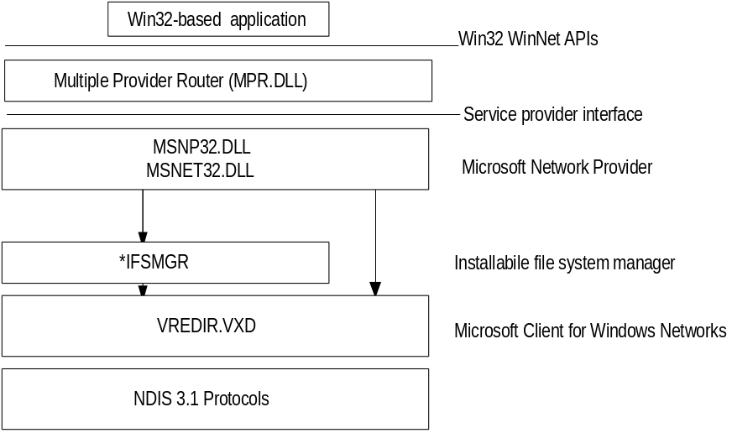
Windows 95 architecture for the network provider for Windows networks
Notice that there are two arrows, one going through IFS Manager and one going directly to Client for Windows Networks (VREDIR.VXD).
- When a network request is for file I/O or printer output, the call is submitted to the IFS Interface.
- When a network request is not based on file I/O or printer output (browsing functions, connection functions, or server logons), the call is sent to VREDIR.VXD.

The network provider supports these functions in Windows networks:
- Browsing Microsoft networks
Microsoft networks use either a Workgroup-Computer-Share hierarchy when dealing with Windows for Workgroups or Windows 95 networks, or a Domain-Computer-Share hierarchy when dealing with LAN Manager or Windows NT Server networks.
- Logging onto and off a Windows NT domain
The Microsoft network provider provides authentication services for validation by a Windows NT domain controller, plus the ability to change the domain password.
- Adding or removing connections
The Microsoft network provider allows remote drive and printer connections and UNC connections to SMB-based network resources.

WinNet16 Interface
The WinNet16 interface (WINNET16.DLL) is the earlier set of network-independent APIs introduced with Windows 3.0 and enhanced in Windows 3.1. WinNet16 provides simple functionality such as connecting to a drive letter or redirecting a printer port to a network printer. Windows 95 provides support for using a single WinNet16 driver.
If a network vendor provides a WinNet16 network driver developed for Windows 3.1 and has not written a 32-bit network provider and file system driver for Windows 95, using the WinNet16 interface and WINNET16.DLL is the only way to support that network in Windows 95. The WinNet16 driver that currently works with Windows 3.1 can be used without modification under Windows 95, using the WINNET16.DLL.
If Windows 95 Setup detects a Windows 3.x installation that uses a WinNet16 network driver and there is no 32-bit network provider available, Windows 95 Setup keeps the 16-bit network driver in place and provides network functionality with the 16-bit network driver installed as the primary network. For example, if Artisoft LANtastic 5.x is detected, then Windows 95 Setup installs the existing LANTASTI.DRV and LANTASTI.386 drivers.
The following diagram shows an example of a Windows-based LANtastic network utility using the WinNet16 interface. For specific details for various types of other networks in a similar configuration, see Chapter 12, “Windows 95 on Other Networks.”
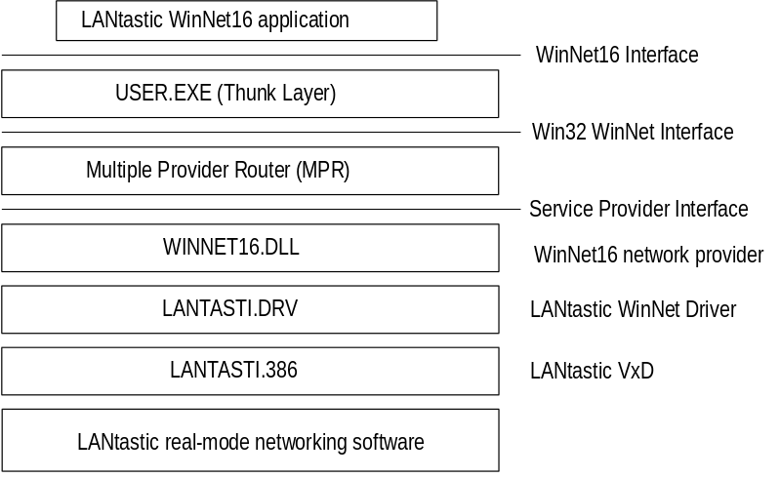
This example shows a Windows-based network utility from another network vendor using the WinNet16 interface.

Multiple Network Example
In the following example, the user has installed two Windows 95 network clients (Client for Windows Networks and Client for NetWare Networks) and also has installed Banyan VINES support using a WinNet16 driver.
Banyan VINES uses the StreetTalk™ syntax to specify server names, as follows:
file service@group@organization

In trying to resolve the request to connect to Docs@Marketing@Corp from a network drive connection dialog box in Windows 95, the Multiple Provider Router submits the request to all installed network providers. WINNET16.DLL receives the call and passes it on to VINES.DRV, which submits the drive connection request to the Banyan real-mode networking software through VVINESD.386.
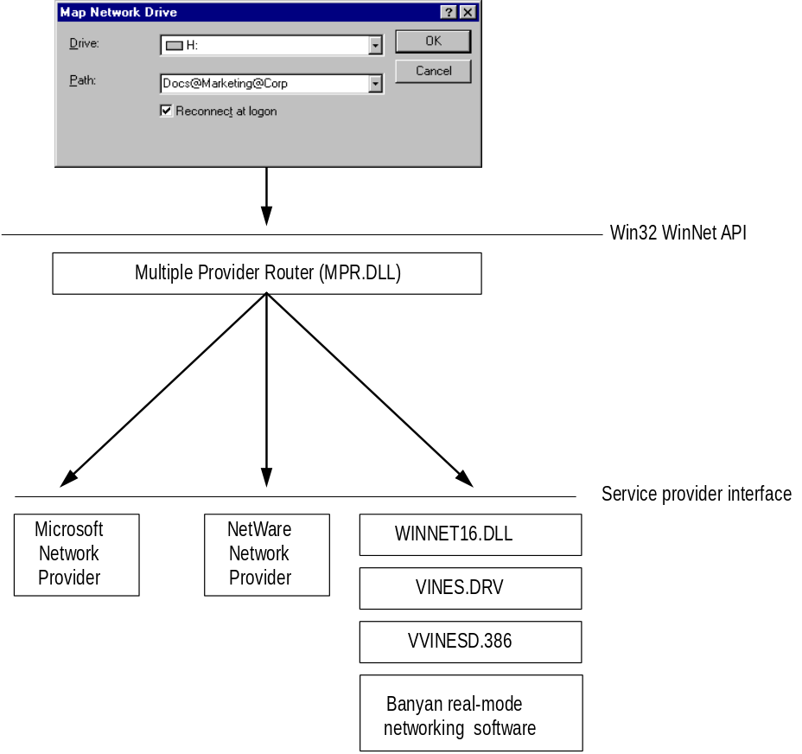
This example shows a network drive connection request with multiple networks installed.

Client for Windows Networks Architecture
Windows 95 provides a 32-bit protected mode file system driver (VREDIR.VXD) to support all Microsoft networking products that use the SMB file sharing protocol. Microsoft networking products includes LAN Manager, Windows NT, Windows for Workgroups 3.x, Workgroup Add-On for MS-DOS, and Windows 95.
Network products from other vendors using the Microsoft Network standard are also supported, such as LAN Manager, IBM LAN Server, and 3Com 3+ Open.
The following illustration shows the basic architecture for Client for Windows Networks.
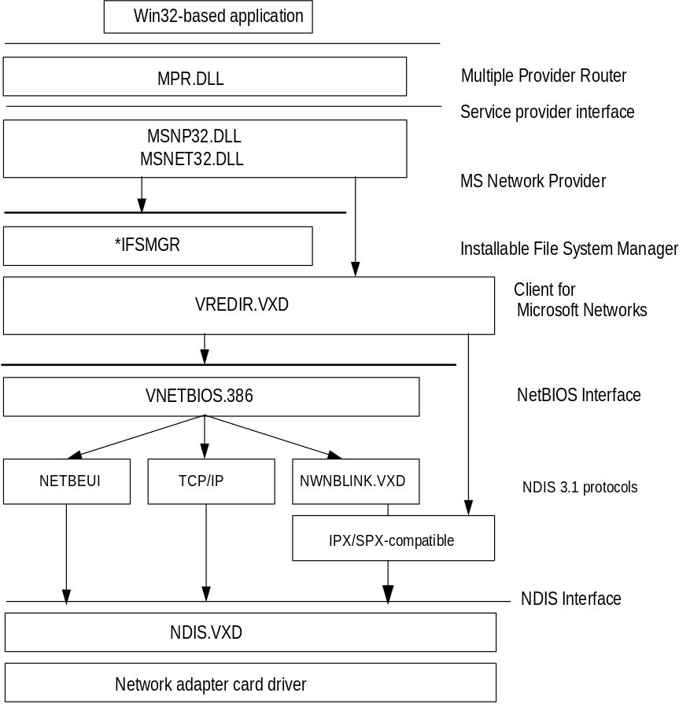
Windows 95 architecture for Windows networking
NetBIOS interface. Client for Windows Networks supports connectivity over any NDIS protocol that supports a NetBIOS interface and is accessible through VNETBIOS.386. The protected-mode protocols shipped with Windows 95 that support a NetBIOS interface are:
- NetBEUI using NETBEUI.VXD.
- NetBIOS over TCP/IP using VNBT.VXD and the TCP/IP components, VTCP.VXD and VIP.VXD.
- NetBIOS over IPX/SPX using NWNBLINK.VXD and NWLINK3VXD.

IPX/SPX connectivity. Client for Windows Networks also supports connectivity over IPX/SPX using NWLINK.VXD without the NetBIOS interface.

MS-NET – Compatible Client Architecture

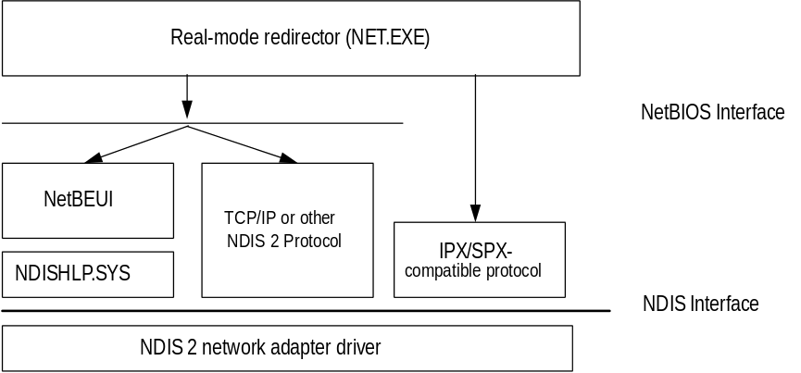
Windows 95 architecture for the real-mode MS-NET – Compatible Client
Real-mode redirector. The network client supports making drive and print connections, plus named pipes, mailslots APIs, and the ability to log onto a Windows NT domain.
Protocols. The real-mode redirector can work over any NDIS real-mode protocols that support a NetBIOS interface, including NetBEUI and TCP/IP. The real-mode MS-NET – Compatible Client does not support connectivity over real-mode DLC. (DLC does not support a NetBIOS interface, so the redirector cannot use DLC directly.)
IPX connectivity. The redirector supports direct connectivity using the IPX/SPX-compatible protocol provided with Windows 95. NetBIOS over IPX is not required.
The real-mode MS-NET – Compatible Client uses real-mode NDIS 2 protocols for NetBEUI and IPX/SPX, and network adapter card drivers use PROTOCOL.INI to store values.

Architecture for Network Protocols

Architecture for IPX/SPX-Compatible Protocol
The Microsoft IPX/SPX-compatible protocol uses the NWNBLINK.VXD module to support computers that use NetBIOS over IPX and to support the NetBIOS programming interface.
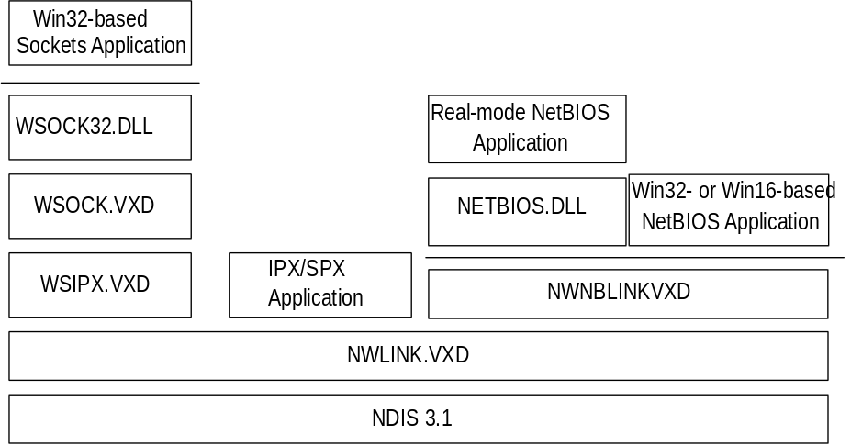
Windows 95 architecture for IPX/SPX-compatible protocol
The Microsoft IPX/SPX-compatible protocol is NDIS 3.1-compliant, allowing computers running Windows 95 to communicate over a routable IPX-compatible protocol. This protocol can use Novell NetWare servers configured as routers (and other IPX routers) to transfer its packets across LANs to access resources on other computers running Windows 95.
The IPX/SPX-compatible protocol is a 32-bit, protected-mode protocol that is Plug and Play-compliant. With the IPX/SPX-compatible protocol, it is not necessary to load the Novell VIPX.386 driver.

Architecture for NetBEUI Protocol
The NetBEUI protocol is implemented as both a real-mode and protected-mode protocol. The NetBEUI module, NETBEUI.VXD, is accessible through the NetBIOS interface.
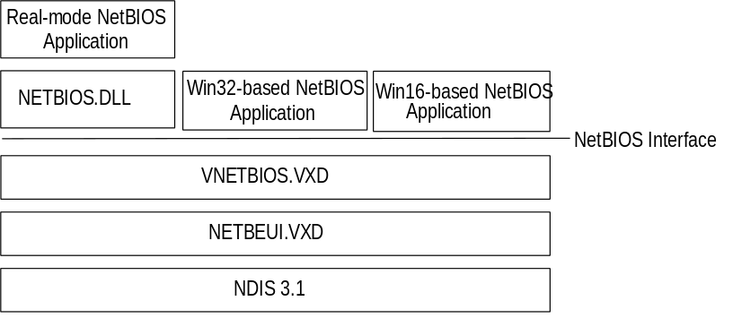
Windows 95 architecture for NetBEUI protocol

Architecture for Microsoft TCP/IP Protocol
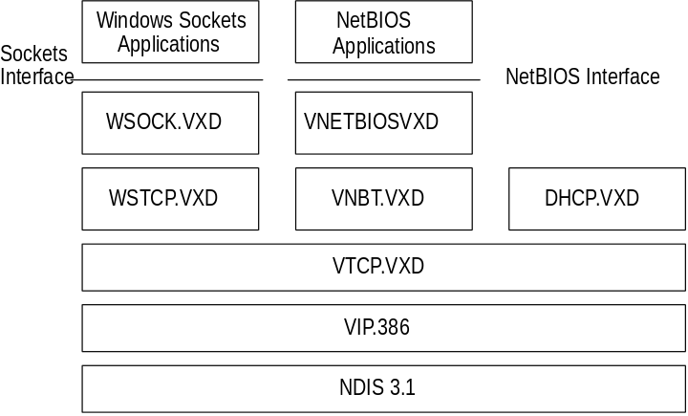
Windows 95 architecture for Microsoft TCP/IP

IPC and Windows 95
The goal in distributed computing is to divide the computing task into two parts. The first part runs on the client computer. This may not take a great deal of computing power but may require a lot of network bandwidth (operations such as screen graphics, mouse movements, and keyboard actions). The other part of the process requires large amounts of data, number crunching, or specialized hardware (operations such as database lookups and updates, or mainframe data access).
In some cases, distributed computing may provide the distribution of a complex task. One computer can work on a complex math problem that would take a month to complete. But with distributed computing, 50 computers could work on the math problem simultaneously so it could be completed in a less than a day.
Central-to-distributed computing is a connection between the client and the server at a process-to-process level that allows data to flow in both directions. Such interprocess communication is direct communication between processes on two different stations without using the file system.
The following interprocess communication (IPC) mechanisms are provided by Windows 95.
NetBIOS. Provides backward compatibility with existing NetBIOS applications. NetBIOS provides a protocol-independent way of creating sessions, datagrams, and name resolution and management over multiple protocols. NetBIOS is supported by all three protocols in Windows 95.
Windows Sockets. A Windows implementation of the widely used Berkeley sockets programming interface. Windows Sockets was originally designed as a vendor independent way of accessing datagram and session services over TCP/IP and has been extended in Windows 95 to support TCP/IP and IPX/SPX.
Named pipes. Provides backward compatibility with existing LAN Manager installations and applications.
Mailslots. Provides backward compatibility with existing LAN Manager installations and applications.
Remote Procedure Calls (RPCs). Compatible with the Open Software Foundation (OSF) Data Communication Exchange (DCE) specification for remote procedure calls.
The following sections provide details about these IPC implementations in Windows 95.

NetBIOS
Although TDI is the interface in Windows 95 for communication between protocols and upper-level software such as the redirector and server service, NetBIOS is also supported. NetBIOS is provided as an additional driver and DLL, and enables Windows 95 to be compatible with NetBIOS applications and to run software that specifically requires NetBIOS. The NetBIOS software is used only for these situations.
NetBIOS defines the interface between the redirector and the protocol layers. SMBs are passed to components at the OSI Transport Layer using the NetBIOS interface. The NetBIOS interface is a set of function calls that allow an application (such as the redirector in the Windows 95 protected-mode network client) to use the services of a Transport-layer service provider. The NetBEUI protocol driver is an example of such a service provider. The protocol driver contains the actual program code that implements the service requested by the NetBIOS “command” or API call. The NetBIOS specification also defines a protocol that can be implemented by a protocol driver to provide the services requested by applications using the NetBIOS interface (the interface between the Windows 95 redirector and one or more protocol drivers).
Many network applications use NetBIOS to send commands to the protocol driver. As long as a protocol driver recognizes NetBIOS commands issued by an application, that protocol driver can be used with any NetBIOS application. The NetBIOS interface in Windows 95 is supported by all three protocols shipped with Windows 95.
- VNETBIOS.386 implements the NetBIOS interface for 32-bit and 16-bit Windows-based applications so that computers running Windows 95 can concurrently run network-aware Windows-based and MS-DOS – based applications that use NetBIOS to communicate.
- NETBIOS.DLL provides support for backward compatibility with real-mode NetBIOS applications that call INT 5Ch.

The architecture for NetBIOS over the various protocols is described with the respective protocols earlier in this chapter.

Windows Sockets
Windows Sockets is a Windows implementation of the widely used UC Berkeley Sockets API, the de facto standard for TCP/IP networking. Non-NetBIOS applications must be written to the sockets interface to access Microsoft TCP/IP protocols. Applications written to the sockets interface include FTP, SNMP, and the NetBIOS name service.
Windows Sockets in Windows 95 is a protocol-independent networking API tailored for use by programmers using the Windows family of products. Windows Sockets is a public specification that aims to do the following:
- Provide a familiar networking API to programmers using Windows or UNIX
- Offer binary compatibility between heterogeneous Windows-based TCP/IP stack and utility vendors
- Support both connection-oriented and connectionless protocols

Sockets have these benefits over a NetBIOS protocol:
- Less overhead. Non-NetBIOS native protocols like TCP/IP and IPX/SPX require a NetBIOS interface and mapping layer. This extra NetBIOS software adds more processing time and also adds a header to the data frame sent on the wire. A good example is NetBIOS over TCP/IP. When the NetBIOS interface is used, a NetBIOS header is added to the frame before the TCP and IP headers. Stations running just native TCP/IP cannot see this frame. When sockets are used, the frame is sent using native TCP/IP without the addition of a NetBIOS header.
- Portability. A sockets-based network application on one system can communicate with any other computer that supports sockets.

In TCP/IP, the Internetwork Address is the IP address of the station and the software process address is the port number. Source and destination IP address and port numbers are fields in the TCP/IP packet structure. In IPX/SPX, the Internetwork Address is the combination of the IPX Network ID and the media access control (MAC) address of the network adapter card, and the software process address is the IPX Socket number. Source network, destination network, node, and socket numbers are fields in the IPX/SPX packet structure.

IPX Sockets are not the same as Windows Sockets. Novell uses the term “socket” to identify the individual software process address.
Note

For a bidirectional path, a Windows Sockets application specifies the following, depending on the protocol.
Protocol | Source socket | Destination socket
TCP/IP bi-directional path | IP address and port number of the source | IP address and port number of the destination
IPX/SPX bi-directional path | Network ID, MAC address of the network adapter card, IPX socket number | Network ID, MAC address of the network adapter card, IPX socket number

The following table describes the supporting files for 16-bit and 32-bit Windows Sockets over TCP/IP and 32-bit Windows Sockets over IPX/SPX.
Windows Sockets Supporting Files
File | Description | Comment
WINSOCK.DLL | 16-bit Windows Sockets | Provides backward compatibility with existing 16-bit TCP/IP Windows Sockets applications such as PING
WSOCK.VXD | Virtualized Windows Sockets | Supports 16-bit Windows Sockets and 32-bit TCP/IP and IPX/SPX Windows Sockets
WSTCP.VXD | Windows Sockets over TCP/IP¹ | Supports 16-bit Windows Sockets and 32-bit TCP/IP Windows Sockets
WSOCK32.DLL | 32-bit Windows Socket | Supports 32-bit TCP/IP Windows Socket applications such as TELNET and 32-bit IPX/SPX Windows Socket applications
WSIPX.VXD | Windows Sockets over IPX/SPX² | Supports 32-bit IPX/SPX Windows Sockets
¹ TCP/IP sockets are STREAMS-based over TCP and datagram-based over UDP.
² IPX/SPX sockets are STREAMS-based over SPX and datagram-based over IPX.

Most users will use programs that comply with Windows Sockets, such as FTP or TELNET. If you are interested in developing a Windows Sockets 1.1 application, specifications for Windows Sockets are available on the Internet from ftp.microsoft.com, on CompuServe® in the MSL library, and in the Microsoft Win32® Software Developers Kit.
To get a copy of the Windows Sockets specification using anonymous FTP
1. Make sure you have write permission in your current working directory.
2. Start ftp and connect to ftp.microsoft.com (or 198.105.232.1).
3. Log on as anonymous.
4. Type your electronic mail address for the password.
5. Type cd \advsys\winsock\spec11 and press ENTER.
6. Use the dir command to see the list of available file types. If you want binary data such as in the Microsoft Word version, type bin and press ENTER.
7. Determine the file with the format you want [for example, ASCII (.TXT), PostScript® (.PS), or Microsoft Word (.DOC)], and then type get winsock.ext where ext is the format that you want, such as winsock.doc for the Microsoft Word version.

To get a copy of the Windows Sockets specification from CompuServe
1. Type go msl and press ENTER.
2. Browse using the keywords windows sockets.
3. Choose the file with the format you want [ASCII (.TXT), PostScript (.PS), or Microsoft Word for Windows (.DOC)], and then type get winsock.ext.

There is also an electronic mailing list designed for discussion of Windows Sockets programming.
To subscribe to the Windows Sockets mailing list
- Send electronic mail to listserv@sunsite.unc.edu with a message body that contains subscribe winsock user’s-email-address.
You can use the same procedure to subscribe to two mailing lists called winsock-hackers and winsock-users.

Client-Side Named Pipes
As with Windows for Workgroups 3.11, Windows 95 supports client-side named pipes for other networks such as NetWare and VINES. Server-side named pipes are not supported.
VREDIR in Client for Windows Networks makes the Named Pipes API available for applications that use named pipes for IPC. However, VREDIR does not provide named pipes support for other networks such as Novell NetWare and Banyan VINES. A user who needs Novell NetWare or Banyan VINES named-pipes support must use the real-mode TSRs and network components provided by Novell or Banyan.
Named pipes provide an easy-to-access conduit for a one-to-one, reliable, connection-oriented data transfer between two processes. These two processes are normally differentiated as a client process and a server process. The term “server” as applied to the server process in a named-pipe application does not refer to the “server service” that is a component of the network operating system, although the server service may be (but is not necessarily) involved in making the pipe available to other stations.
- The named-pipe server process creates the pipe and manages access to it. The resources that make up the pipe are owned by the server process and physically exist on the station where the server process is running.
- The named-pipe client process uses the services of the underlying network protocols to access the remote pipe resources.

Although named pipes are usually used bidirectionally, the pipe can be configured to allow communication in only one direction, such as from server to client.
A common use for named pipes is in client-server applications based on SQL. The SQL client application can be run on the computer running Windows 95 with Microsoft Client for Windows Networks. The SQL server application, however, must be set up on a LAN Manager, Windows NT, or other named-pipes server computer.

Mailslots
Mailslot APIs in Windows 95 and Windows NT are a subset of the APIs in Microsoft OS/2 LAN Manager. VREDIR in Client for Windows Networks makes the Mailslots API available for applications that use mailslots for interprocess communication.
A mailslot is similar to a named pipe except that named pipes can only be used for one-to-one communication. Mailslots can be used for one-to-one, one-to-many, many-to-one, or many-to-many communication. A mailslot can be created on any network station. When a message is sent to a mailslot, the sending application specifies in the mailslot message structure whether the message is to be sent using first-class or second-class delivery.
First class delivery is a session-oriented, guaranteed data transfer for one-to-one or one-to-many communication. Messages designated as first-class delivery can only be sent to a mailslot that was created on a server.
Second class delivery is a datagram, non-guaranteed data transfer for one-to-one, many-to-one, one-to-many, and many-to-many communication. Messages designated as second-class delivery can be sent to a mailslot that was created on any station, or even on multiple stations, if the message size is 400 bytes or less.
Windows 95 and Windows NT implement only second-class mailslots, which are most useful for identifying other computers or services on a network and for wide-scale identification of a service. Windows 95 uses second-class mailslots for WinPopup messages and browsing.

Remote Procedure Calls
Much of the original design work for an RPC facility was started by Sun Microsystems®. This work was continued by the Open Software Foundation (OSF) as part of the overall Data Communication Exchange (DCE) standard. The Microsoft RPC facility is compatible (but not compliant) with the OSF/DCE-standard RPC. (Compliance in this case means starting with the OSF source code and building on it.) The Microsoft RPC facility is completely interoperable with other DCE-based RPC systems such as those for HP and IBM AIX® systems.
The RPC mechanism is unique because it uses other IPC mechanisms to establish communications between the client and the server. RPC can use named pipes, NetBIOS, or Windows Sockets to communicate with remote systems.
RPC is based on the concepts used for creating structured programs, which can be viewed as having a “backbone” to which a series of “ribs” can be attached. The backbone is the mainstream logic of the program, which should rarely change. The ribs are the procedures that the backbone calls on to do work or perform functions.
In traditional programs, these ribs are statically linked. By using DLLs, structured programs can dynamically link the ribs. With DLLs, the procedure code and the backbone code are in different modules. The DLL can thus be modified or updated without changes to the backbone. RPC means that the backbone and the ribs can exist on different computers, a feature which is important for distributed applications.
As shown in the following, Windows 95 provides RPC client support over the NetBIOS, named pipes, and Windows Sockets interfaces.
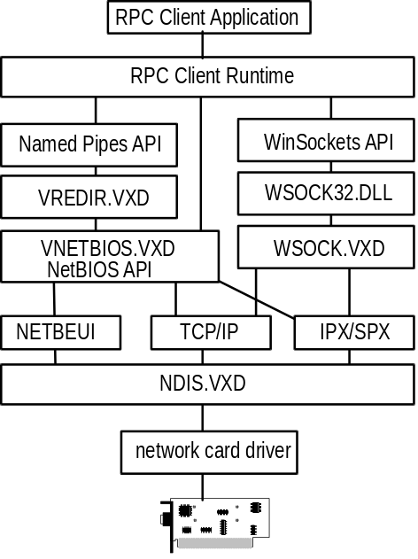
RPC client support in Windows 95
The following diagram shows how Windows 95 provides RPC server support over NetBIOS and Windows Sockets. There is no server support for RPC over named pipes. With a named-pipes RPC application, the named-pipes client can be run on the computer running Windows 95 but the named-pipes server must be set up on a LAN Manager server or Windows NT computer.
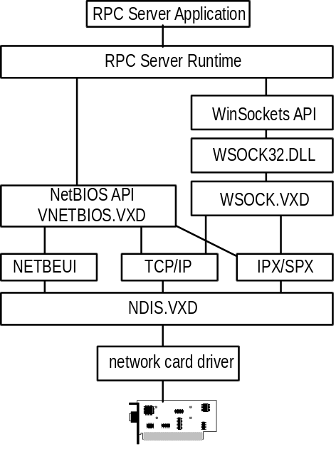
RPC server support in Windows 95

