Chapter 1
This chapter presents detailed information for configuring and integrating Windows 95 on Novell® NetWare® networks.
Windows 95 on NetWare Networks

For complete information on setting up master source files for Windows 95 on a NetWare server, see Chapter 4, “Server-based Setup for Windows 95.”
Important

Overview of Windows 95 and NetWare Compatibility 8-2
In This Chapter
Configuring NetWare Servers to Support Windows 95 8-10
Using Microsoft Client for NetWare Networks 8-12
Using a Novell NetWare Client 8-27
Technical Issues for Windows 95 on NetWare Networks 8-48
Troubleshooting Windows 95 on NetWare Networks 8-49

Chapter 11, “Network Technical Issues,” for details about multiple network support, configuring network adapter cards and protocols, and general networking troubleshooting tips
See Also
Appendix E, “Network Configuration Settings,” for typical configuration settings for computers running Windows 95 on NetWare networks
For more information on configuring Novell-supplied components and running NetWare utilities, consult your NetWare documentation

Overview of Windows 95 and NetWare Compatibility
Windows 95 runs on NetWare workstations that use Novell NetWare 2.15 and above, 3.x, and 4.x servers. You have several choices for the networking client to use with Windows 95 on NetWare workstations, as described later in this section:
- The new 32-bit, protected-mode Microsoft Client for NetWare Networks
- Novell NetWare 3.x real-mode networking client (NETX)
- Novell NetWare 4.x real-mode networking client (VLM)

In the Windows 95 Resource Kit for NetWare, “NETX” is the name of the Novell NetWare workstation shell for NetWare version 3.x; VLM is used to refer to the NetWare workstation shell for version 4.x.
Note

Whichever client you choose, you can use the built-in features and commands in Windows 95 to perform most common network operation and administration tasks. Windows 95 also supports the 16-bit NetWare 3.x command-line utilities for both users and administrators, and supports most 16-bit utilities for NetWare 4.x.
Windows 95 provides complete 32-bit, protected-mode software for running on Novell NetWare networks, including a network client (sometimes called the redirector or requestor), an IPX/SPX-compatible protocol, and administrative tools. Using the Microsoft Client for NetWare Networks client in Windows 95, users can access NetWare server services, browse and connect to NetWare servers, and queue print jobs using the Windows 95 network user interface or Novell NetWare utilities.
The following sections describe the different features available, depending on whether you choose to run Windows 95 using the Microsoft Client for NetWare Networks or using a Novell-supplied NETX or VLM client.
Whichever client you use, the following features are available in Windows 95 to support computers running on NetWare networks:
Automatic setup for Windows 95 on workstations. This includes preparing for automatic installation and customizing Windows 95 as part of installation, as well as setting up to run Windows 95 from a local hard disk or running a shared network copy from a server. For information, see Chapter 4, “Server-Based Setup for Windows 95.”
Remote boot from a NetWare server. This includes support for booting diskless workstations and floppy-disk startup for running a shared network copy of Windows 95. For information about remote boot workstations and shared installations, see Chapter 4, “Server-Based Setup for Windows 95.”
Full integration in the Windows 95 user interface. You can use the graphical Windows 95 unified user logon and password caching to log onto a NetWare 2.15 and above, 3.x, or 4.x bindery. Users can access NetWare server resources using Network Neighborhood or through common network-connection dialog boxes such as the Open or Save As dialog boxes. Logon for Windows 95 is linked to a NetWare bindery-based server, which logs the user on to the computer running Windows 95. For details, see Chapter 10, “Logon and Browsing on NetWare Networks.”
Long filenames. Computers running Windows 95 can recognize and use long filenames on NetWare 3.x and 4.x volumes that have been configured to use the OS/2 namespace, which emulates an HPFS volume. For more information, see “Configuring NetWare Servers to Support Windows 95” later in this chapter.
Printing to NetWare print queues using Point and Print. A computer configured with any client for NetWare networks can be configured to print to a NetWare print queue. (The utilities provided with the Windows 95 Resource Kit also include a Win32-based PSERVER capability that can despool print jobs from NetWare print queues to printers connected to computers running Microsoft Client for NetWare Networks.) For details, see Chapter 19, “Printing.”
Backup agents for Cheyenne ARCserve and Arcada Backup Exec. Notice, however, that Windows 95 does not support backup that is compatible with TSA. For information about setting up network backup agents, see Chapter 14, “System Management.”
Agent for Simple Network Management Protocols (SNMP). You can use a server service such as HP® Open View to manage workstations remotely. For information about remote administration, see Chapter 14, “System Management.”
Remote network access. Windows 95 supports several protocols, including IPX/SPX and PPP. For information about remote access protocols and connection types, see Chapter 24, “Remote Access.”

Choosing Microsoft Client for NetWare Networks
If you are installing Windows 95 to run on a NetWare network, Microsoft recommends that you use the Microsoft Client for NetWare Networks, which provides a 32-bit protected-mode redirector. Client for NetWare Networks can be installed to coexist with Client for Windows Networks, or it can be used as the sole network support for Windows 95. For technical information about these optional configurations, see “Using Microsoft Client for NetWare Networks” later in this chapter.
Using Client for NetWare Networks provides the following benefits.
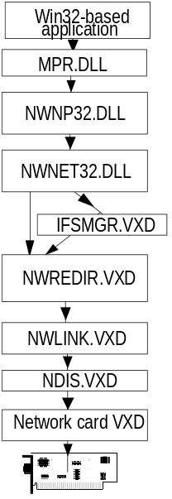
A high-performance, robust system using no conventional memory. Client for NetWare Networks uses only 32-bit protocols, drivers, and supporting files. This client runs in protected mode and is designed to be used in a multitasking environment. This new client provides the robust performance available for any protected-mode component in Windows 95 and uses no MS-DOS conventional memory space. On large block transfers over the network, Client for NetWare Networks is up to 200 percent faster than Windows 3.x with the VLM shell. For most network operations that are a mix of reading and writing, Client for NetWare Networks is 50 to 200 percent faster, depending upon the I/O mix.
Interoperation and login with Novell NetWare 2.15, 3.x, and 4.x servers. This includes support for running NetWare logon scripts that do not include real-mode TSRs. Client for NetWare Networks can access NetWare 2.15 and above, 3.x servers (which are bindery-based), and NetWare 4.x servers using bindery emulation.
Complete Plug and Play support. You can use hot docking on a computer that has a PCMCIA network adapter card, and you can use warm docking on a computer with a network adapter card that has an NDIS 3.1 driver. If you disconnect the network cable from a computer running Windows 95 with Plug and Play components, the system continues to function. With most real-mode network clients, this causes the system to stall.
Client-side caching for network information. Because the Client for NetWare Networks redirector is a file system driver, it uses the same 32-bit cache used by all Windows 95 file system drivers, so it can cache network data for quick access.
Automatic reconnection for lost server connections. Client for NetWare Networks can reconnect with a server after detecting the loss of a NetWare Core Protocol (NCP) connection. When servers become available again, Windows 95 reconnects automatically and then rebuilds the user’s environment, including connection status, drive mappings, and printer connections. (Novell-supplied AUTO.VLM only reconnects servers.)
Support for all documented MS-DOS APIs defined by Novell. This includes support for all NetWare 3.x APIs defined in the Novell NetWare Client SDK. NetWare-aware applications that use only these documented APIs are compatible with Client for NetWare Networks. For more information, see “Client for NetWare Networks Technical Issues” later in this chapter.
Support for packet-burst protocol for faster transfer of network information. Client for NetWare Networks supports burst-mode NCPs, a sliding window implementation.
Large Internetwork Packet (LIP) protocol support. LIP works to increase the speed of data transmission when communication occurs through a router. Previously, if a server identified a router between itself and the client, packet size was set to 576 bytes (including 64 bytes of header information). Using LIP, the client and server can negotiate the packet size used when communication occurs through a router. With LIP, the packets can be set to a maximum of 4202 bytes, based on the maximum physical packet size of the server. LIP is enabled between computers running Client for NetWare Networks and NetWare 3.12 – 4.x servers or any computer running Microsoft File and Printer Sharing for NetWare Networks.
You might choose not to use Client for NetWare Networks in these cases:

When should I not use Client for NetWare Networks?
- If you run any NetWare TSR programs, you should use NETX or VLM.
- If you want to take advantage of NetWare NCP Packet Signature for enhanced protection of servers and client computers using NCP, then you must use VLM, because Client for NetWare Networks does not support this feature.
- If your site needs to use NetWare IP, you should use NETX or VLM. Client for NetWare Networks does not support NetWare IP, and you cannot use Microsoft TCP/IP to communicate with NetWare IP.
- If you use 3270 emulators that rely on DOS-helper TSRs or need 3270 emulation for applications in MS-DOS sessions, you should use NETX or VLM.
- If your site needs to use NetWare Directory Services (NDS), you should use VLM. Microsoft Client for NetWare Networks does not support this feature.
- If you are using custom VLM components such as PNW, you should use VLM.

Choosing a Novell-Supplied NetWare Client
Windows 95 can be installed to use Client for Windows Networks in conjunction with a NETX or VLM client, or the Novell-supplied network client can be used as the sole network support in Windows 95. For technical information about these optional configurations, see “Using a Novell NetWare Client” later in this chapter.
Windows 95 provides new and improved support over Windows 3.x when you are using NetWare clients supplied by Novell. These improvements include the following.
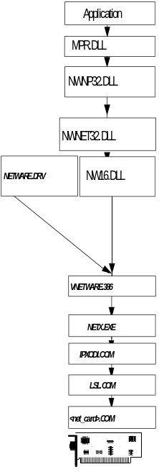
Improved network adapter card driver support. Windows 95 networking components can be installed to work with Open Datalink Interface (ODI) network adapter card drivers. This is the preferred configuration if you use a Novell-supplied NetWare client, and is also supported with Client for NetWare Networks. You can install Windows 95 to run with the IPX monolithic protocol stack (IPX.COM), although it is strongly recommended that you upgrade to a newer NetWare version using ODI drivers. Windows 95 can also run on NetWare networks using ARCNet® network adapter cards.
Protected-mode IPX/SPX-compatible protocol. You can use the new Microsoft implementation of this protocol for network connectivity to other computers running the IPX/SPX protocol with Windows 95, Windows NT, or MS-DOS operating systems. Windows 95 also provides protected-mode NetBIOS over IPX for communicating with other NetBIOS-compliant applications, providing better performance and reduced network traffic. Alternatively, you can use the real-mode Novell-supplied driver, NETBIOS.EXE.
Compatibility with NDS, NetWare IP, NCP packet signatures, 3270 emulators, TSRs, and NetWare logon scripts. Users can run native NetWare services and commands without special configuration changes in Windows 95.
You might choose not to use the Novell-supplied client and instead use Client for NetWare Networks in these cases:

When should I use Client for NetWare Networks instead of a Novell-supplied network client?
- You want the performance advantages of 32-bit, protected-mode network clients and network adapter card drivers, including complete Plug and Play support.
- You want to take advantage of the Windows 95 unified logon and user interface for navigating the network, plus the Windows 95 network management tools.
- You want to take advantage of long filenames, client-side caching, automatic reconnections, and other performance enhancements provided in Client for NetWare Networks.

Preparing for Windows 95 on NetWare Networks
Administrators responsible for moving a large existing installation to Windows 95 don’t have the luxury of simply loading the new software on their personal computers, experimenting with desktop settings and driver configurations, and then resuming everyday activities.
Instead, if you are administering an existing NetWare network, the move to Windows 95 will be an incremental series of planning, testing, and gradually implementing Windows 95 on many computers on the network. Typically, the administrator will take several months to complete these tasks:
1. Install Windows 95 on a single workstation, and experiment with various configuration alternatives, including the following:
- Windows 95 protected-mode network client vs. Novell real-mode client
- Protected-mode NDIS 3.1-compliant network card adapter drivers vs. real-mode Open Datalink Interface (ODI) drivers
- Protected-mode IPX/SPX-compatible protocol vs. existing IPX
- Using a sole client vs. adding Client for Windows Networks
This task includes experimenting with using typical applications for your site, such as working over the network to assess the performance, reliability, and robustness provided by Windows 95.
2. Conduct an inventory per-user, per-computer, and per-workgroup. This is needed to build an implementation strategy, as summarized in Chapter 1.
3. Test the selected configuration of network clients, protocols, and drivers on a small network.
4. Create default user profiles and set up batch scripts for automatic installation, based on the inventory and implementation strategy.
5. Test automatic installation on a small network.
6. Prepare and implement the incremental strategy for rollout on the larger network.

Testing Windows 95 on NetWare Workstations
This section provides steps for testing three alternate Windows 95 installations, in preparation for developing a rollout strategy for the enterprise:
- Windows 95 installed over an existing 16-bit, Novell-supplied workstation client, using ODI drivers.
- Windows 95 added to an existing Windows 3.x-and-NetWare installation, using Client for NetWare Networks and protected-mode networking support components.
- Windows 95 as a new installation using all protected-mode components, including both Client for NetWare Networks and Client for Windows Networks, plus peer resource sharing support.

The steps described here are variations of the basic testing strategy for Windows 95. For listings of typical configuration files for each installation option, see Appendix E, “Network Configuration Settings.”

Testing Windows 95 with the NETX Real-Mode Client on ODI Drivers
To be provided.

Testing Windows 95 with Client for NetWare Networks on NDIS Drivers
To be provided.

Testing a New Installation with Protected-Mode Networking
To be provided.

Setting Up Windows 95 for NetWare Networks: an Overview

Windows 95 does not include any Novell NetWare components. For information on obtaining updates for the latest versions of the Novell-supplied files, see “Using a Novell NetWare Client” later in this chapter.
Note

Windows 95 Setup automatically detects the hardware on a computer and also detects any network software that is running when you start the Setup program. For details about how detection works in Windows 95 Setup, see Chapter 6, “Setup Technical Issues.”
To support Novell NetWare integration with Windows 95, the computer on which you are installing Windows 95 should be properly configured to connect to a NetWare server, and the NetWare network should be running when you start Windows 95 Setup. This requires that the computer be configured with either an ODI driver (recommended) or the monolithic IPX drive, in addition to either a NetWare 3.x or 4.x workstation shell to access resources on a NetWare server.
Windows 95 Setup detects whether a Novell NetWare workstation shell is running on the computer by looking for NET*.COM, the alias for several versions of the NetWare workstation shell. Windows 95 must find at least version 3.26 of NET*.COM to automatically configure networking for NetWare networks.
During the detection phase, Windows 95 Setup also tries to determine whether the computer is using real-mode TSRs that cannot be replaced (such as DOSNP.COM, TCP/IP client software, or 3720 emulators). Windows 95 Setup can detect the programs in the following list, and takes the appropriate action for configuring the computer in each case.
Software detected | Action
Btrieve® | Leaves the real-mode networking client, network card adapter, and protocol in place.
LAN Workplace® | Leaves the real-mode networking client, network card adapter, and protocol in place.
Personal NetWare | No action.
Novell NetBIOS TSR | Installs the Microsoft IPX/SPX-compatible protocol.

Windows 95 Setup copies relevant configuration settings from NET.CFG (the Novell NetWare configuration file) to the Registry and automatically configures settings for network adapter cards and protocols required to support computers running Windows 95 on NetWare networks. The specific issues for configuring drivers and protocols depend on whether you are using Client for NetWare Networks or a Novell-supplied workstation shell, as described later in this chapter.
For information about network adapter cards and about installing, configuring, and using specific protocols, see Chapter 11, “Network Technical Issues.” For configuration details related to the specific network client you are using, see “Configuring Microsoft Client for NetWare Networks” or “Configuring Windows 95 for Novell NetWare Clients” later in this chapter.

Configuring NetWare Servers to Support Windows 95
This section contains the following topics:
- Installing Windows 95 source files on NetWare servers
- Automating Setup for NetWare workstations
- Supporting long filenames on NetWare servers

Installing Windows 95 Source Files on NetWare Servers
The Windows 95 source files can be placed on a NetWare server to be used as source files for installing Windows 95 locally on NetWare workstations, or to be used as a shared copy for running Windows 95 across the network. To create a directory structure and place the Windows 95 source files on a server, you must run Network Setup, the administrative setup program. (This is roughly equivalent to setup /a in Windows 3.x and Windows for Workgroups.)
To set up Windows 95 source files on a NetWare server
1. On the network administrator’s computer, log on to the NetWare file server.
This should be a network computer that can run as a standalone computer and that is used only by support personnel for network maintenance. Make sure you log on with security privileges that allow you to create directories and copy files to the file server.
2. On the administrator’s computer, run castoff all to make sure that server-to-workstation or workstation-to-workstation messages do not affect Network Setup.
3. Follow the procedures for copying Windows 95 source files to a server in Chapter 4, “Server-Based Setup for Windows 95.”

Automating Setup for NetWare Workstations
You can create automatic installation procedures for installing Windows 95 on multiple workstations. The steps include the following:
- Creating setup scripts for NetWare networks
- Configuring user and computer settings for batch setup of specific NetWare workstation configurations
- Creating logon scripts to set up NetWare workstations

For a complete description of the basic procedures for preparing and managing automatic installation of Windows 95 on multiple computers, see Chapter 4, “Server-Based Setup for Windows 95.”

Supporting Long Filenames on NetWare Servers
Computers running Windows 95 can use long filenames on NetWare 3.x and 4.x volumes that have been configured to use the OS/2 namespace, which emulates an HPFS volume. Filenames on NetWare HPFS-emulation volumes have a maximum filename length of 254 characters and use the 8.3 truncation on the first instance of the filename. For example:
longfilenameold.tst --> longfile.tst
longfilenamenew.tst --> longfil0.tst

To enable long filenames on a NetWare volume
1. Type the following lines at the NetWare server console prompt:
load os2
add name space os2 to volume sys

2. Then add the following line to the STARTUP.CNF file:
load os2

3. Shut down the file server. Then copy the file OS2.NAM from the distribution disks or compact disc to the same disk and directory that contains SERVER.EXE.
4. Restart the NetWare file server.

Using Microsoft Client for NetWare Networks
In Windows 95, Client for NetWare Networks provides full NetWare 3.x client functionality. This robust 32-bit client software runs in protected mode, supports automatic reconnection, takes advantage of caching, and uses no conventional memory. Client for NetWare Networks also supports long filenames and is Plug and Play-aware, which means that it can be loaded and unloaded dynamically.
Microsoft Client for NetWare Networks supports most documented NetWare 3.x APIs, so you can access the NetWare resources that you can access with NetWare NETX or VLM clients, except for NDS. For information about exceptions, see “Client for NetWare Networks Technical Issues” at the end of this section.
This section contains the following topics:
- Configuring Client for NetWare Networks
- Managing connections with Client for NetWare Networks
- Client for NetWare Networks technical issues

The redirector in Client for NetWare Networks (NWREDIR) is a file system driver that supports the NCP file sharing protocol for NetWare 2.15 and above, NetWare 3.x, and NetWare 4.x. Client for NetWare Networks also supports Microsoft File and Printer Sharing for NetWare Networks (NWSERVER, the NCP server provided with Windows 95).
Note
For the architectural details of this configuration, see “Client for NetWare Networks Technical Issues” at the end of this section.

Configuring Microsoft Client for NetWare Networks
When using Client for NetWare Networks, you do not need to load any Novell-supplied drivers or components. This client runs with the Microsoft IPX/SPX-compatible protocol and NDIS-compliant, protected-mode drivers, which Windows 95 Setup installs automatically when you select this client.
Client for NetWare Networks does not access the settings in NET.CFG. Windows 95 Setup moves any relevant NET.CFG settings to the Registry during installation. You can configure these settings when you run Windows 95 Setup or change these settings later using the Network Control Panel. You can also configure the network adapter card driver and the IPX/SPX-compatible protocol, as described in Chapter 11, “Network Technical Issues.”
If you did not install Client for NetWare Networks during Windows 95 Setup, you can switch to this client any time after Windows 95 is installed on your computer, as described in the following procedure.

To quickly display the Network property sheets without opening Control Panel, right-click the Network Neighborhood icon on the desktop. Then click Properties on the context menu.
Tip

To use Client for NetWare Networks
1. In the Network Control Panel, click the Configuration tab.
2. Select the currently installed NetWare Workstation Shell client, and click the Remove button.
3. Click the Add button, click Client, and then click the Add button.
4. In the Select dialog box, click Microsoft in the Manufacturers list, and then click Client for NetWare Networks in the Models list.
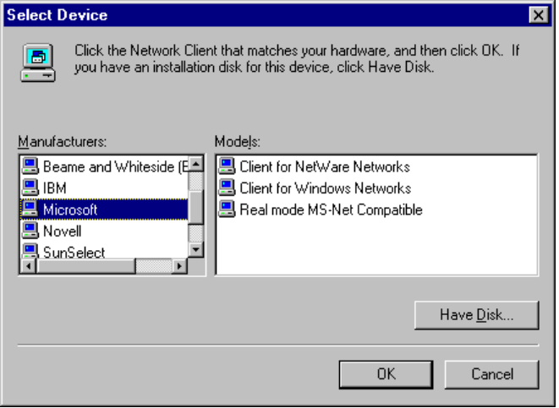
5. Click OK, and then click OK in the Network property sheet. Then shut down and restart the computer.

When you install Client for NetWare Networks, Windows 95 Setup adds the value lastdrive=32 to the parameters for the network client in the Registry. This value makes room for entries in a table to store drive information. For a Microsoft Network, the last drive would be set to Z (or 26), but NetWare allows six additional entries in its drive table. The extra drives are used only by NetWare-aware applications; the drives are not available to users.
Note

Configuring Network Adapter Card Drivers for Client for NetWare Networks
When you install Client for NetWare Networks, a 32-bit, protected-mode, NDIS 3.1 compliant network adapter card driver is also installed automatically. If you instead configured Client for NetWare Networks to use ODI drivers, you can switch to the protected-mode drivers at any time.

How to do I configure the correct network adapter card driver to use with Client for NetWare Networks?
Although it is possible to run Client for NetWare Networks over ODI drivers, Microsoft recommends that you install a 32-bit protected-mode network adapter card driver to take advantage of the performance improvements offered by these drivers, as described in Chapter 11, “Network Technical Issues.”

If you are running Client for NetWare Networks as the primary and only network, you may have to install the 32-bit, protected-mode network adapter card driver before you can install the network client.
Note

To switch to a 32-bit, protected-mode network adapter card driver
1. In the Network Control Panel, click the Configuration tab.
2. Select the network adapter card, and then click the Properties button.
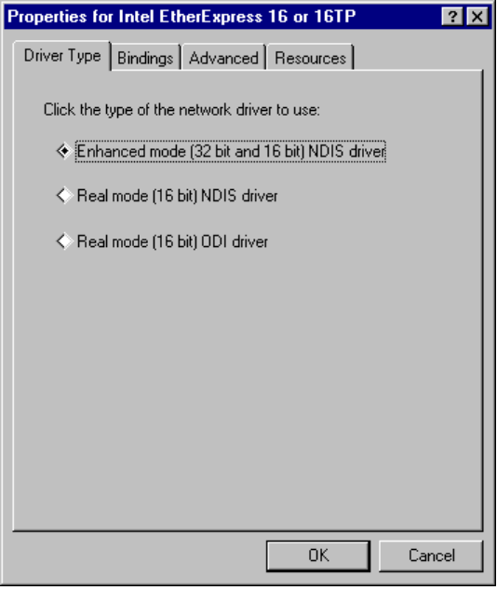
3. On the properties sheet for the adapter, click the Driver Type tab.
4. Click the option titled Enhanced Mode (32 Bit And 16 Bit) NDIS Driver.
5. Click OK, and then click OK on the Network properties sheet. Then shut down and restart the computer.

For more technical information about using NDIS network adapter cards, see Chapter 11, “Network Technical Issues.”
If you want to use your current ODI driver instead of the Windows 95 NDIS network adapter card driver, you can select that driver using the Network Control Panel.
To use ODI drivers with Client for NetWare Networks
- Follow steps #1 – #3 in the previous procedure. Then click the Real Mode (16-bit) ODI Driver option, and click OK.

If Windows 95 Setup installs Client for NetWare Networks to work with existing ODI drivers, the following drivers are used to support NetWare connectivity:
- Windows 95 drivers: MSODISUP.VXD, NDIS.VXD, NWLINK.VXD, NWNBLINK.VXD, NWNET32.DLL, NWNP32.DLL, NWREDIR.VXD, ODIHLP.EXE, and VNETBIOS.VXD
MSODISUP.VXD is the ODI support layer that maps NDIS 3.1 protocols to an ODI driver, and ODIHLP.EXE is the real-mode stub that allows LSL to complete its binding process in real mode (similar to NDISHLP.SYS).
- Novell-supplied drivers: LSL.COM and a network adapter card driver such as NE2000.COM
To be provided: list of other Novell-supplied files.

For more information about using ODI drivers, see “Configuring Windows 95 with ODI Drivers” later in this chapter.

Setting Options for Client for NetWare Networks
This section, and following sections, describe the procedures for configuring Client for NetWare Networks, including the following topics:
- Specifying whether Client for NetWare Networks is the primary client
- Specifying the preferred server
- Specifying the first network drive
- Specifying the search mode if the current drive is a network drive

Setting Client for NetWare Networks as the primary network client means the following:
- For this computer, logon scripts will run from a NetWare server.
- Users must be authenticated by a NetWare server to log onto the network.
- The NetWare network will be used to download policies and user profiles.

To make Client for NetWare Networks the primary network client
1. In the Network Control Panel, click the Configuration tab.
2. In the Primary Client list select Client for NetWare Networks, and then click the Apply Now button.

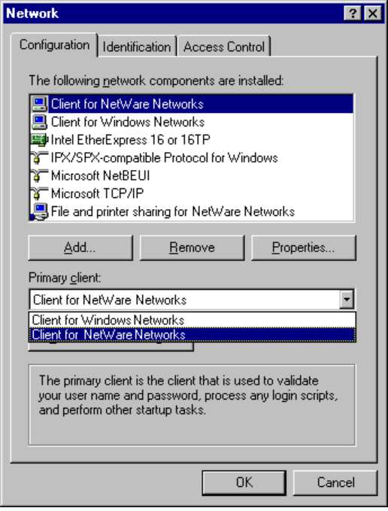
To configure Client for NetWare Networks
1. On the Configuration sheet for Network properties, select Client for NetWare Networks, and then click the Properties button.
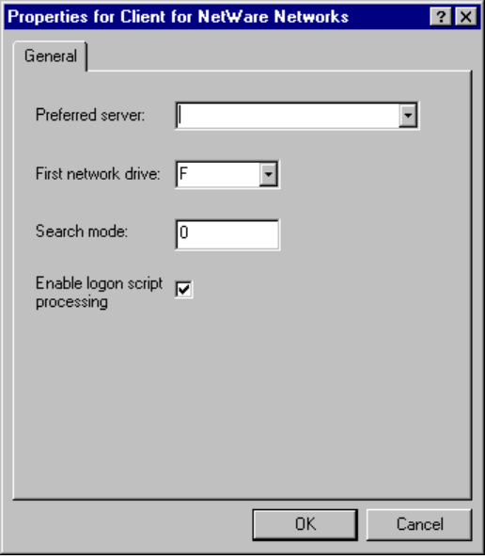
2. On the General sheet, set values for the configuration options, as described in the following table.
Property | Meaning
Preferred Server | Designates the server that appears in the logon dialog box when Windows 95 starts. This server name is required to access policy files and profiles. For more information, see “Selecting a Preferred Server for Client for NetWare Networks” later in this section.
First Network Drive | Specifies the first connection for Client for NetWare Networks.
Search Mode | Helps determine how an application, such as a NetWare utility like SYSCON, can use the search drives to search for auxiliary files. For more information, see “Setting the Search Mode for Client for NetWare Networks” later in this section.
Enable Logon Script Processing | Specifies whether users on this computer can use NetWare logon scripts during system startup.

Selecting a Preferred Server for Client for NetWare Networks
You need to specify a preferred NetWare server, so that Windows 95 knows where to find profiles and policy files. You can change the preferred NetWare server at any time.
Based on the value specified for the preferred NetWare server, Client for NetWare Networks attempts to connect to that server rather than the first server that responds to the Get Nearest Server broadcast. Client for NetWare Networks also attempts a number of server connections in case the client computer can’t establish a connection with the specified server.

The following procedure shows how to select a preferred server if you are running Client for NetWare Networks. If you use a NETX or VLM client, you can configure these settings using NET.CFG settings or using the /ps option in STARTNET.BAT, AUTOEXEC.BAT, or wherever you run NETX or VLM.
Note

To specify a preferred NetWare server for Client for NetWare Networks
1. In the Network property sheet, click the Configuration tab.
2. Select Client for NetWare Networks, and click the Properties button.
3. In the Select Preferred Server box on the General sheet, select a server from the list provided, or type the name of a NetWare server directly into the box.
The name you type is the NetWare server that appears automatically in the logon dialog box.
4. Click OK. If your password on the NetWare server is different from that on the computer running Windows 95, enter your NetWare password at the prompt, and then click OK.

The next time you log on, Windows 95 connects to the specified NetWare server.

The Preferred Server setting is for the computer, not for individual users.
Note

Setting the Search Mode for Client for NetWare Networks
Many applications, when started, also open a number of other files (such as overlay files and data files) that are used as application resources. The Search Mode option for Client for NetWare Networks determines when applications can look in your NetWare search drives to find these auxiliary files.
The Search Mode option has five possible settings: Modes 1, 2, 3, 5, and 7. (Modes 4 and 6 are not currently used.) Each mode specifies a different way of using search drives, as described in the following table. MS-DOS always looks in a specific path (if specified in the application), and then in the default directory, regardless of which search mode you specify. You may need to read your application documentation to determine whether the application only reads its auxiliary files, or reads and writes to them.
Mode | Meaning
1 | Uses the default search mode. When you use this setting, Client for NetWare Networks will look in the search drives only when no path is specified in the application and after the default directory has been searched.
2 | Causes Client for NetWare Networks not to look in any search drives to find auxiliary files. The application will behave as if you were running it on a standalone computer (without networking). If the application has a defined directory path for searching and opening files, the application searches for the files in that path. NetWare refers to this mode as “Do not search.”
3 | The same as Mode 1, except that if the application has no defined directory path to search and open files, Client for NetWare Networks will look in the search drives only if the open request is a read-only request. NetWare calls this “Search on Read-Only opens with no path.”
5 | Causes Client for NetWare Networks to always look in the search drives, even if the application specifies a path. NetWare refers to this mode as “Search on all opens.”
7 | The same as Mode 5, except that Client for NetWare Networks will look in the search drives only if the open request is a read-only request. NetWare calls this mode “Search on all Read-Only opens.”

The search mode applies to all applications, so you should select the mode that works for most of your programs. The table below shows when the Search Mode option allows Client for NetWare Networks to use the search drives, according to whether a path is specified in the application and whether the open request is a read-only request or a read-write request.
Drive Search Allowed Based on Specified Search Mode
 | No application path |  |  |  |  | Application path specified
Mode | Read-Only | Read-Write |  |  | Read-Only |  | Read-Write
1 | • | • |  |  | — |  | —
2 | — | — |  |  | — |  | —
3 | • | — |  |  | — |  | —
5 | • | • |  |  | • |  | •
7 | • | — |  |  | • |  | —

Validating a NetWare Account for Client for NetWare Networks
Each user must have an account on the NetWare server before being able to use its files, applications, or print queues. The NetWare server account contains user credentials (user names and passwords).

Tip for Passwords on Windows 95 and NetWare Servers
Windows 95 automatically supplies the user name and password used when you logged onto Windows 95 as the credentials it sends to the NetWare server. You are asked to supply your user name and password on the NetWare server only if they are different from those on the computer running Windows 95. Therefore, you may want to keep your user name and password the same on both the Windows 95 and NetWare network.
Administrators may want to recommend this tip to users, because maintaining the same user name and password also makes it easier for network administrators to coordinate user accounts.
For information about using a master password, see Chapter 14, “System Management.”

To change your password on a NetWare server
1. In Network Neighborhood, click the Map Drive button on the toolbar, and connect to the NetWare server’s SYS volume.
– Or –
Right-click Network Neighborhood, and click Map Network Drive.
–Or–
At the command prompt, use the net use command to connect to the NetWare server’s SYS volume. For example, for a server name NWSVR2, you would type net use * \\nwsvr2\sys
2. At the command prompt, change to the drive for the NetWare server, and then make the PUBLIC directory the current directory. For example, type n: and then type cd \public.

If you want to change your password on more than one server, connect to all affected servers before running the setpass command.
Note

3. At the command prompt, type the setpass command. If the server on which you want to change your password is different from the one on the current drive, type setpass and the server name.
For example, to change your password on the server named NWSERVE1, type:
setpass nwserve1

4. When you are prompted, type your old password, then the new password, and then retype the new password to confirm it.
5. If you are connected to other NetWare servers that also use your old password, these servers are listed, and you are asked if you want to change your password on these servers as well.
To change the additional passwords, press Y.
–Or–
To leave the passwords as they are, press N.

Managing Connections with Client for NetWare Networks
With Client for NetWare Networks, there is no real-mode logon before Windows 95 starts, just the single, unified logon prompt for Windows 95 that allows users to log on to the system and to all networks at the same time. The first time a user starts Windows 95, there are two separate logon prompts — one for Windows 95 and one for the NetWare preferred server. As long as the two passwords do not change, the second logon prompt is not displayed again.
Client for NetWare Networks is also different from NETX and VLM because it does not map the first network drive to the logon directory of the preferred server as do NETX and VLM. All subsequent connections to NetWare servers must be made in the Windows 95 user interface.

Connecting to NetWare Resources with Client for NetWare Networks
With Client for NetWare Networks, you can manage connections to the NetWare network using Network Neighborhood and common network-connection dialog boxes such as the Open and Save dialog boxes (the same techniques as used for Microsoft networks).
To connect to NetWare resources with Client for NetWare Networks
- Click the Map Drive button in Network Neighborhood, and complete the information in the Map Drive dialog box.
– Or –
Right-click Network Neighborhood, click Map Network Drive, and complete the dialog box.
– Or –
Use the net use command at the command prompt.

For details, see Chapter 10, “Logon and Browsing on NetWare Networks.” In addition, Client for NetWare Networks can connect to and use the shared resources of computers running peer resource sharing services, as described in Chapter 9, “File and Printer Sharing on NetWare Networks.”
With Client for NetWare Networks, you can define persistent connections (which use the same drive letter each time the computer starts) to NetWare volumes and directories. Using persistent connections eliminates the need for NetWare MAP commands in logon scripts. You simply indicate, when you create network connections, that they are to be restablished.

In Windows 95, persistent connections are restored to the same drive letters each time.
Note

To use persistent connections
- Check the Reconnect At Logon box when making connections using Network Neighborhood or using any file or print connection dialog box.
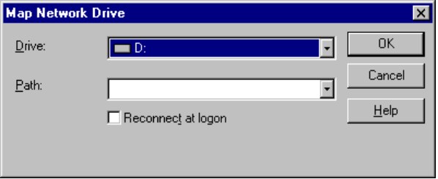

You can also view and manage active connections with the Windows 95 net use command. For example, the net use command can be used to do the following:
- Perform the same functions as the NetWare ATTACH and MAP utilities.
For example, net use *1 *2 *3 and the NetWare logon script entry
MAP *1 *2 *3 are equivalent.
- Supply similar functionality to the CAPTURE utility for printing when MS-DOS–based and Windows-based applications require printing to a specific port.

By typing the net use command without parameters, you can list the current network connections. For example:
Status  ------ | Local  ----- | Remote  ------ | Network  -------
— | E: | \\NW4\SYS | NetWare
OK | F: | \\WINDOWS\DROOT | Microsoft
— | H: | \\NETWARE40\THOR\APPS | NetWare

The Windows 95 net view command can be used to perform the same function as the NETX SLIST or VLM NLIST SERVER commands.

Using Windows 95 Tools with Client for NetWare Networks
Windows 95 includes 32-bit, protected-mode graphical tools for configuration management that provide many of the functions traditionally provided through logon scripts. These include the following:
- Network Neighborhood for establishing and maintaining persistent connections and for the same functionality as the NetWare ATTACH, LOGIN, and LOGOUT utilities
- Print folder for connecting to NetWare print queues
- Command-line commands, such as net use, for managing connections

With Windows 95, you can use system policies to define options such as who can or cannot share resources or configure system components. You can also use user profiles to define desktop settings and security settings. For information, see Chapter 14, “System Management.”

Running NetWare Utilities with Client for NetWare Networks
In addition to the 32-bit, protected-mode graphical tools built into Windows 95, you can use the 16-bit command-line utilities provided with NetWare for managing and sharing resources.
With Microsoft Client for NetWare Networks, you can run all NetWare 3.x utilities that reside on the NetWare server, such as SYSCON. You can run most NetWare 4.x utilities when you are using Client for NetWare Networks, except those that require NDS, such as NWADMIN, CX, and NETADMIN.

How do I run NetWare utilities with Client for NetWare Networks?
To run NetWare 3.x utilities in Windows 95
1. Map a drive to the volume containing the NetWare utilities by using any of the methods described earlier in this section.
Make this a persistent connection by clicking the Reconnect At Logon box.
2. From the Start button, choose Programs, then click MS-DOS Prompt to start an MS-DOS session.
3. Switch to the mapped network drive.
4. Run the utilities in the usual way.

You cannot use the VLM NWUSER utility when running Client for NetWare Networks.
Note

Client for NetWare Networks Technical Issues
This section presents some technical topics you should be aware of when using Client for NetWare Networks. These topics include the following:
- Client for NetWare Networks configuration notes
- The architecture for using Client for NetWare Networks with Client for Windows Networks
- The architecture for using Client for NetWare Networks as the sole client
- NetWare API support in Client for NetWare Networks

Client for NetWare Networks Configuration Notes
Some configuration notes for Client for NetWare Networks:
- Client for NetWare Networks is always bound only to the IPX/SPX-compatible protocol for Windows. This is the only protocol this network client can use. If you require an additional protocol, such as TCP/IP, you must install an additional network client, such as Microsoft Client for Windows Networks.
- Windows 95 automatically provides a real-mode network client for use in emergency startup and recovery situations. It is not a full-featured, robust NetWare client and, therefore, does not support features such as long filenames, automatic reconnection to servers, and the packet-burst (burst-mode) protocol.
- With Client for NetWare Networks, you cannot map drives for individual VM sessions; drive mappings are always global. This is the equivalent of the behavior formerly specified by the SYSTEM.INI setting NWShareHandles=True.

Using Client for NetWare Networks with Client for Windows Network
If you install Client for NetWare Networks, you can also install Client for Windows Networks plus File and Printer Sharing for Windows Networks, as described in Chapter 27, “Windows 95 Network Architecture.”
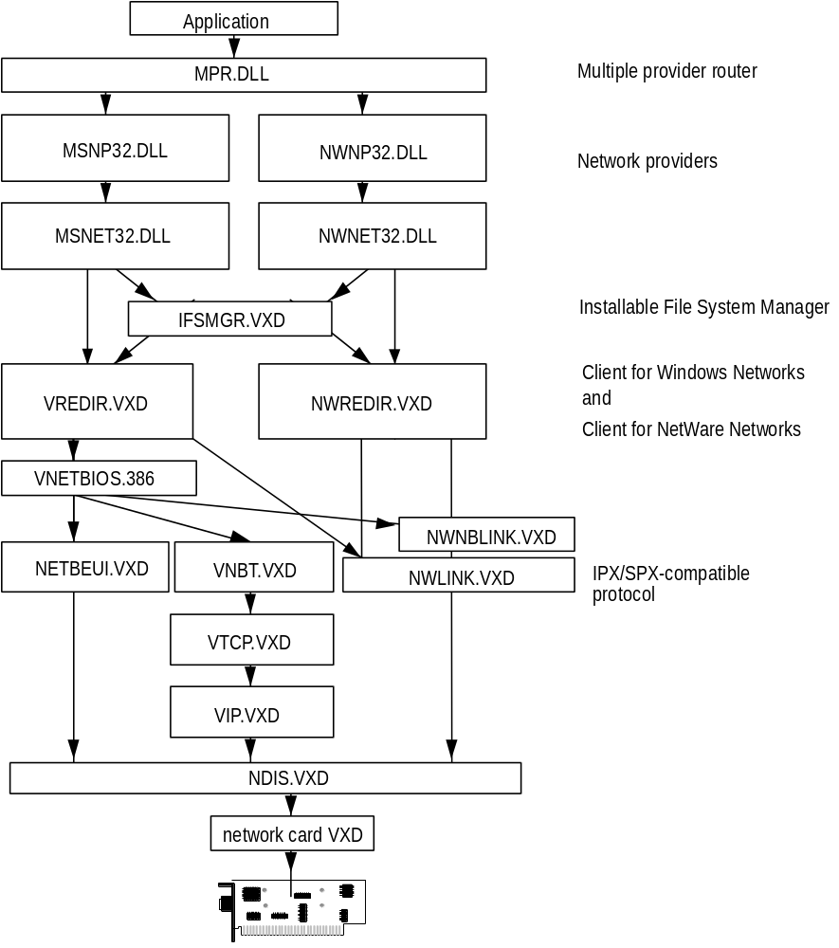
Architecture for Client for NetWare Networks with Client for Windows Networks

Using Client for NetWare Networks as the Sole Client
You can use just Client for NetWare Networks in an environment where all that is needed is a 32-bit client to connect to existing NetWare servers (for example, if there is no need for the SMB-based peer resource sharing services provided by File and Printer Sharing for Windows Networks).
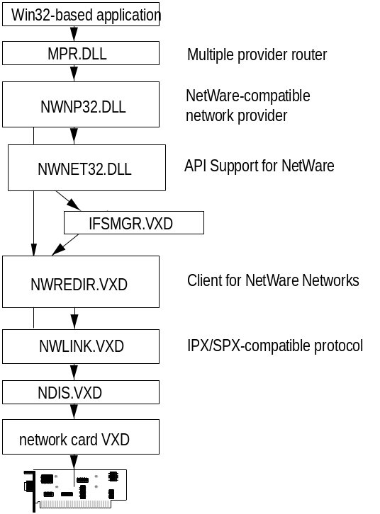
Architecture for Client for NetWare Networks as the sole client

NetWare API Support in Client for NetWare Networks
Client for NetWare Networks includes built-in support for MS-DOS – based APIs defined by Novell for NetWare 3.x.
MS-DOS – based APIs for NetWare
API for MS-DOS | Use
INT21H | Used by applications for NetWare information, bindery services, and so on
INT64 | Used by applications to submit IPX/SPX requests
INT7A | Used for the ECB interface (used by NETX to submits NCPs)

Client for NetWare Networks supports all known and documented
MS-DOS – based API calls. If problems occur with applications that make proprietary or undocumented API calls, then you should use a real-mode Novell-supplied client.
Note

The Windows 3.x APIs for NetWare consist of a series of DLLs provided by Novell with the version 3.x WinNet16 driver for the new VLM client. The 16-bit Novell-supplied DLLs for Windows can run with Client for NetWare Networks. This ensures that Windows-based applications and utilities that are NetWare-aware will run with Microsoft Client for NetWare Networks.
The NetWare DLLs are described in the following list.
API for Windows | Use
NWCALLS.DLL | APIs for NCP communication between the file server and the client computer
NWGDI.DLL | NetWare Graphical Device Interface
NWIPXSPX.DLL | APIs for IPX/SPX communication
NWLOCALE.DLL | APIs for localization of applications
NWNET.DLL | Network API support for NDS
NWPSRV.DLL | Print server services APIs

These Novell-supplied DLLs are not provided with Windows 95. They are provided by Novell with NetWare versions 3.12 and 4.x, and are updated on CompuServe and other electronic forums. As of this writing, WINUP9.EXE is the latest update available.

Using a Novell NetWare Client
Windows 95 can run with the NetWare NETX and VLM clients. If you choose to run Windows 95 with this configuration, you should continue to load the necessary MS-DOS – based TSR programs using AUTOEXEC.BAT or STARTNET.BAT. You should also make sure that you still have the necessary Novell-supplied files for Windows 95 support, which can be obtained from Novell. The process of setting up Windows 95 with a Novell NetWare client includes the following general tasks:
- Specifying the client to be used for networking
- Ensuring the correct network adapter card driver selection
- Ensuring the correct versions of support files are installed

Novell-supplied components for using the NetWare client with Windows 95 require that you log onto the appropriate NetWare server before starting Windows 95. You should not log on to a NetWare server from within Windows 95.
Caution

This section describes these specific activities in the following topics:
- Setting up Windows 95 with a Novell-supplied NetWare client
- Configuring Windows 95 for Novell NetWare clients
- NETX technical issues
- VLM technical issues

Setting Up Windows 95 with a Novell-Supplied NetWare Client

The Novell-supplied NetWare client software, including network adapter card drivers, must be loaded and you must be able to successfully connect and use resources on a NetWare server when you install Windows 95. This will help to ensure Windows 95 can properly detect the configuration for successful installation of Windows 95 on Novell-supplied drivers.
Important
Also, if you currently use IPX.COM, you should upgrade to later versions of NetWare that use ODI drivers before installing Windows 95. For information about using ODI drivers versus monolithic IPX.COM with the Novell NetWare client, see “Configuring Windows 95 for Novell NetWare Clients” later in this chapter.

The following sections describe how to install Windows 95 to work with a Novell NetWare client in more detail, including these specific topics:

How do I configure Windows 95 to work with my existing Novell NetWare client?
- Installing Windows 95 with a Novell NetWare client
- Required NetWare support files for Windows 95
- Obtaining current NetWare clients and support files

For specific information about your Novell-supplied workstation shell, see “NETX Technical Issues” or “VLM Technical Issues” later in this chapter.

Installing Windows 95 with a Novell NetWare Client
This section presents these procedures for installing Windows 95 to run with a Novell-supplied client, depending on various installation situations:
- Selecting Novell-supplied NetWare client support during Windows 95 Setup
- Installing Client for Windows Networks in addition to a Novell-supplied NetWare client
- Returning to the NETX client from Client for NetWare Networks
- Adding support for NETX if no network is running when Windows 95 is installed

For all of these procedures, you must also ensure that you have the correct versions of supporting Novell-supplied files. For information, see “Obtaining Current NetWare Clients and Support Files” later in this section.

The method for installing VLM support is different, as described in “VLM Technical Issues” later in this section.
Note
Also note, if the NetWare client software is not running at the time Windows 95 is installed, you must configure Windows 95 after Setup to work in conjunction with the NetWare client software.

To select Novell-supplied NETX client support during Windows 95 Setup
1. Install and run the NETX client under MS-DOS, Windows 3.1, or Windows for Workgroups.
2. Run Windows 95 Setup, click Custom Setup, and then click Network Options.
3. Click the Add button, select Client, and then click the Add button.
4. Select Novell in the Manufacturers list, and select Workstation Shell 3.X [NETX] in the Models list.
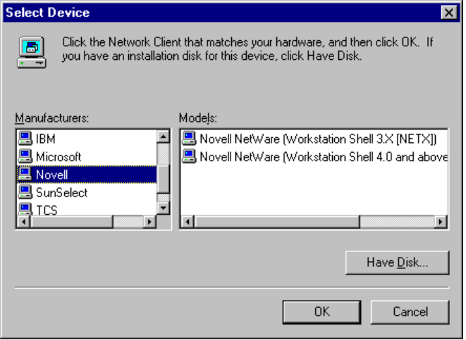
5. Click OK, and then click the Close button.
6. If you want to use only the NETX client, you do not need to specify settings for your network adapter card driver or protocols. However, Setup does add support for the ODI adapter and IPXODI automatically.
If you want to also use Client for Windows Networks, follow the steps in the next procedure.
7. Click OK and continue with Windows 95 Setup.

To install Client for Windows Networks in addition to a Novell NetWare client
1. In the Network Options dialog box, click the Add button, select Client, and then click the Add button.
2. Select Microsoft in the Manufacturers list, and select Client for Windows Networks in the Models list. Click OK, and then click OK in the Network Options dialog box.

You cannot install Client for Windows Networks as an additional networking client if you are installing Windows 95 to run with an IPX monolithic configuration.
Note

To determine whether the correct adapter driver is installed
1. In the Network Control Panel, click the Configuration tab.
2. Select the network adapter card, and click the Properties button.
3. Click the Driver Type tab.
4. Make sure the Real Mode (16 bit) ODI driver is selected, and then click OK.
5. If you must specify a different driver type, shut down and restart the computer after you finish selecting the driver.

Switching Back to NETX from Client for NetWare Networks
If you install the protected-mode Client for NetWare Networks and later decide to return to your original Novell NetWare NETX configuration, follow these steps. For details about adding or returning to VLM, see “VLM Technical Issues” later in this section.
To return to NETX after installing Client for NetWare Networks
1. In the Network Control Panel, click the Configuration tab.
2. Select the IPX/SPX-compatible protocol, and click the Delete button.
3. Click the Add button, select Client, and then click the Add button.
4. Select Novell in the Manufacturers list, and select Workstation Shell 3.X [NETX] in the Models list, and then click OK.
Windows 95 automatically installs IPXODI support.
5. On the Configuration sheet, select the network adapter card, and click the Properties button.
6. Click the Driver Type tab, select the Real Mode (16 bit) ODI driver, and then click OK.
7. Click OK on the Network properties sheet, and provide a disk or a location for any files that Windows 95 requests to complete the installation.
8. Shut down and restart the computer.

Obtaining Current NetWare Clients and Support Files
If your computer is not configured with the necessary NetWare client software, or if you don’t have the support files that Windows 95 Setup requires to properly configure your computer, several sources are available for these files.
For a list of required files for NETX, see “Required NETX Support Files for Windows 95” later in this chapter.

Obtain and use the latest available version of Novell-supplied driver files.
Important

To obtain current NetWare software files
- Check with your NetWare network administrator or your local Novell representative to see if the latest client files are available locally.
– Or –
Check the Novell Files forum on CompuServe by typing go novfiles at a system prompt. Novell posts the latest revisions of NetWare client software and drivers on this forum. Alternatively, check the Novell Library forum by typing go novlib at a system prompt.

Typically, you will find the following files on the Novell Files forum. As of this writing, WINUP9.EXE is the latest update available.
Novell-supplied file | Description
DOSUP*.EXE | Contains updated MS-DOS client files. For DOSUP9.EXE, this file includes NetWare workstation shells version 3.32 (NETX.EXE, EMSNETX.EXE, XMSNETX.EXE, and BNETX.EXE), compatible with MS-DOS 3.0 and above, and with Windows 3.0 and 3.1. This file also includes shells for MS-DOS 6.x. support for both ODI and monolithic IPX, plus Packet Burst, NetBIOS, and other MS-DOS client files.
WINUP*.EXE | Contains updated Windows 3.x client files. For WINUP9.EXE, this file includes the NetWare Driver Set version 2.02 for Windows 3.0 and 3.1 and related files, including support for IPX/SPX.

Configuring Windows 95 for Novell NetWare Clients
This section presents some technical information related to the network adapter card drivers used when configuring Windows 95 to run on NetWare networks. The topics include the following:
- Configuring Windows 95 with ODI drivers
- Setting network card options in NET.CFG
- Configuring Windows 95 for monolithic IPX
- Configuring Windows 95 with ARCNet network adapters
- Setting other NET.CFG options

NET.CFG, the Novell NetWare configuration file, is an ASCII text file that consists of left-justified section headings and settings within the section that are indented with a space, a combination of spaces, or a tab. For information about the format and contents of NET.CFG, consult your NetWare documentation.
Note

Configuring Windows 95 with ODI Drivers
The Open Datalink Interface (ODI) specification was defined by Novell Corporation and Apple Computer Corporation to provide a protocol and a consistent API for communicating with a network adapter card driver, and to support the use of multiple protocols by a network adapter card driver.

How do I use ODI drivers with Windows 95?

To ensure the most flexibility in Windows 95 for other protocol support along with NetWare integration, Microsoft recommends that you use ODI drivers when running Windows 95 on NetWare networks. Novell also recommends using ODI-based client software rather than monolithic IPX drivers.
Tip

ODI consists of the following components.
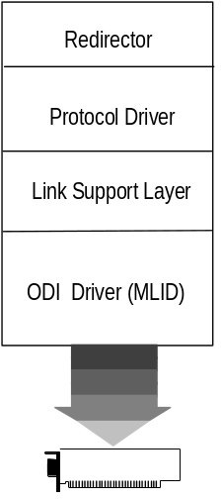
An ODI-compliant version of the IPX/SPX protocol. This component provides the network protocol for communicating between a NetWare client and a NetWare server. On a computer running Windows 95, this can be the Microsoft IPX/SPX-compatible protocol or Novell-supplied IPXODI.COM. For more details, see Chapter 11, “Network Technical Issues.”
The Link Support Layer (LSL). LSL, provided in the Novell-supplied LSL.COM file, provides a foundation for network adapter card drivers to communicate with multiple protocol drivers, and for protocol drivers to communicate with multiple network adapter card drivers.
The ODI driver. Also called the Multiple Link Interface Driver (MLID), the ODI-compliant network adapter card driver is created by the adapter card manufacturer. This component usually identifies the name of the supported adapter in the filename, such as NE2000.COM for the Novell NE-2000 card, 3c5x9.COM for the 3Com® Etherlink III® card, and EXP16ODI.COM for the Intel EtherExpress™ 16 card. Windows 95 supports using such drivers, but these drivers are not included with Windows 95.
A computer using ODI and the IPX/SPX protocol has entries for these Novell-supplied files in its AUTOEXEC.BAT before Windows 95 is installed: LSL.COM, IPXODI.COM, NETX.EXE, and a network adapter card driver such as NE2000.COM.
If you choose to keep Novell-supplied drivers when installing Windows 95 on a NetWare network, the following drivers are used.
- Windows 95 drivers: VNETBIOS.VXD, ODIHLP.EXE, and MSODISUP.VXD
Windows 95 can also provide supporting files to virtualize any IPX driver, or it can replace Novell-supplied VIPX or IPXODI files for either real mode or protected mode.
- Novell-supplied drivers: IPXODI.COM, LSL.COM, NETWARE.DRV, NETWARE.HLP, NETX.EXE, NWPOPUP.EXE, VIPX.386, VNETWARE.386, and a network adapter card driver such as NE2000.COM
If you are using the NetWare 4.x client software, use version 4.0 or above of the NETX.VLM, and version 1.02 or above of the other VLM client support files.

Tips for Installing Windows 95 with ODI Drivers
- Before you install Windows 95 on a computer, the real-mode IPXODI network must be configured and working properly using your Novell-supplied installation program. Test to confirm that there are no errors when loading the Novell-supplied files LSL.COM, IPXODI.COM, the ODI driver, and NETX.EXE or when accessing resources on NetWare servers. If the Novell-supplied ODI drivers are installed and running on the computer when Windows 95 is installed, Windows 95 Setup detects that ODI drivers are used, automatically identifies the network adapter card, and configures Windows 95 to run with the ODI drivers.
- If Windows 95 Setup cannot identify the ODI driver being used, you may have to manually configure the network adapter card driver. In this case, choose the appropriate IPXODI support driver to match the type of network adapter card used. For example, if the computer uses an Ethernet adapter, you should choose Generic ODI Driver from Generic Drivers.
- When Windows 95 is installed with ODI drivers, and the MS-Net – compatible client is installed, by default Windows 95 Setup also installs the Microsoft 32-bit, IPX/SPX-compatible protocol, NetBIOS service provider support, and NetBEUI protocol.

Setting Network Card Options in NET.CFG
Because an ODI computer can have multiple ODI drivers and multiple protocols loaded and bound, ODI uses NET.CFG to identify the network adapter card, protocol configuration, and binding information.
Monolithic IPX does not require a settings file because there is only one protocol and one network adapter card driver that are bound together in a specific way. The IPX.COM file contains the network adapter card configuration information, including the interrupt and base memory address used by the card.
If NET.CFG is not present, the ODI driver assumes a default configuration. When only the Novell-supplied IPXODI driver is loaded, the default binding is to the first ODI driver loaded.
Network adapter card configuration information is contained in a Link Driver section in NET.CFG, where you can specify the network adapter card’s interrupt, I/O address, memory address, frame types, and protocols.

The LSL driver loads and initializes information contained in NET.CFG, which should reside in the same directory as LSL.COM and the Novell-supplied NETX.EXE network client.
Note

Fox example, the following shows NET.CFG entries for an SMC Ethercard Plus Elite 16:
show dots=on
file handles=60
preferred server=NW_311
Link Driver SMC8000
int 5
port 240
mem D000
Frame Ethernet_802.3

The following table describes selected information commonly found in NET.CFG under the Link Driver section. For information not found in NET.CFG, default settings for the network adapter card are assumed.
NET.CFG parameter | Description
DMA | DMA channel number. Can assign up to two DMA channels by designating them DMA #1 x and DMA #2 y.
FRAME | Alternate MAC layer frame encapsulations for the network adapter. The default is ETHERNET_802.2 if not specified. Frame types are:  ETHERNET_802.3 ETHERNET_SNAP  ETHERNET_802.2 TOKEN_RING  ETHERNET_II TOKEN_RING_SNAP
INT | IRQ number. Can assign up to two IRQs by designating them IRQ #1 x and IRQ #2 y.
MEM | Memory address in upper memory area (UMA). Can assign up to two UMA addresses by designating them MEM #1 x and MEM #2 y.
NODE ADDRESS | New 12-digit MAC address assigned to the network adapter card.
PORT | I/O port address. Can assign up to two I/O port addresses by designating them PORT #1 x and PORT #2 y.
PROTOCOL | Protocols to be used with ODI drivers. You do not need to specify this in NET.CFG if NETX is only running IPX and no other protocol. If other protocols are running, you must specify the protocol, protocol ID, and the frame type.
SLOT | Network adapter card slot number (MCA, EISA).

Configuring Windows 95 for Monolithic IPX
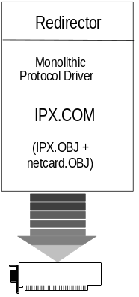
Although the monolithic IPX legacy configuration is supported in Windows 95, Novell recommends that the ODI client software be used instead of dedicated IPX drivers. Microsoft also strongly recommends upgrading to ODI drivers and using the 32-bit protected-mode software for a computer running Windows 95 on NetWare networks.
Caution
If you want to install Windows 95 with monolithic support, all networking components must be installed and working before you install Windows 95.
If you want to use Client for NetWare, you must first upgrade your Novell-supplied networking software to a recent version of the ODI client software.
Using monolithic IPX can cause various problems.

The monolithic implementation of the IPX protocol, IPX.COM, includes a single driver file that contains both the IPX/SPX protocol stack and the network adapter card driver for communicating with the network adapter card. IPX.COM must be configured for each individual computer based on the individual network adapter card and its hardware configuration (IRQ, I/O address, RAM address in the upper memory area, and DMA channel). IPX.COM is generated from the IPX.OBJ file and a particular network adapter card driver file (net_card.OBJ) using the NetWare SHGEN or WSGEN programs.
Remember that this is not a recommended configuration. If you must use Windows 95 on monolithic IPX, then configure the real-mode monolithic IPX network and verify that it is working properly before installing Windows 95. Test to confirm that there are no errors when loading IPX.COM and NETX.EXE or when accessing resources on NetWare servers.
After Windows 95 is installed on a monolithic IPX configuration, the required drivers include the following files, which must all be supplied by Novell: IPX.COM, NETWARE.DRV, NETWARE.HLP, NETX.EXE, VNETWARE.386, and VIPX.386.

Configuring Windows 95 with ARCNet Network Adapters
Windows 95 supports connectivity to Novell NetWare servers as well as other computers running Windows 95 over an ARCNet network. When you configure Windows 95 to support NetWare integration over ARCNet, NetBIOS over IPX is used to support Windows 95 peer resource sharing services. You cannot use real-mode IPX without NetBIOS on ARCNet network adapters. This is true whether you are using a monolithic IPX driver or an ODI ARCNet driver.
If the ARCNet driver and NetWare workstation shell are running when Windows 95 is installed, Windows 95 Setup detects the configuration and automatically installs the proper components. However, if you are using a generic ARCNet driver or if Windows 95 is unable to detect that you are using an ARCNet driver, you may have to manually configure Windows 95 to run on a ARCNet configuration. You will also need to install the ODI ARCNet Support transport with NetBIOS to support peer resource sharing services over an ARCNet network card. If Windows 95 Setup can detect your configuration properly, this network protocol is installed automatically for an ODI ARCNet driver.
This is similar to configuring Windows 95 to run with a monolithic IPX driver, except that Novell-supplied ODI drivers are used. The drivers used in this configuration include the following files, which must all be supplied by Novell: SMC8000.COM (ODI driver), LSL.COM, IPXODI.COM, NETWARE.DRV, NETX.EXE, VNETWARE.386, and VIPX.386.

Setting Other NET.CFG Options
NET.CFG is responsible for configuring of the network environment for the client, and is used to configure custom parameters for NETX, IPX, NetBIOS, or the general NetWare environment. To configure any options, edit NET.CFG as described in your NetWare documentation.
NetWare began using SHELL.CFG as the configuration file name with monolithic IPX and is now using NET.CFG for ODI. NET.CFG is the preferred file to use and has some specific uses for ODI, as described in “Setting Network Card Options in NET.CFG” earlier in this chapter.
- Neither SHELL.CFG nor NET.CFG is required for a NetWare client computer. If these files do not exist, default settings are used.
- If both SHELL.CFG and NET.CFG exist, both are processed (first SHELL.CFG, then NET.CFG). Any NET.CFG settings duplicated from SHELL.CFG are ignored.
- If you are using ODI drivers, the Novell-supplied LSL.COM file uses information from NET.CFG to configure the ODI driver before the NETX workstation shell does. LSL will look for the NET.CFG in the current directory or in the same directory as NETX.EXE. To override this default behavior, run NETX.EXE (or the IPX protocol driver) with the /c=drive:path\filename command-line switch, which loads only the single .CFG file specified. For example:
NETX /c=d:\netstuff\net.cfg

LSL must find the proper NET.CFG file. To verify that you do not have more than one NET.CFG file present on your computer, type dir \net.cfg /s at the command prompt (or from the Start button, click Find and search for NET.CFG).
Note

NETX Technical Issues
This section describes specific issues related to using the Novell-supplied NetWare 3.x client software along with Windows 95. The following topics are included:
- The architectural model for NETX with Microsoft Client for Windows Networks
- The architectural model for NETX as the sole client
- Specifying the LastDrive= parameter
- Setting Show Dots and file access limits

Using NETX with Client for Windows Networks
When running NETX with Windows 95, you keep all the same functionality that you had when running with MS-DOS or Windows 3.x. You also gain the additional features described in “Overview of Windows 95 and NetWare Compatibility” earlier in this chapter.
If you are using NETX as the network client, you might also choose to install the 32-bit, protected-mode Client for Windows Networks if you want to connect to other Microsoft network computers, such as computers running Windows 95, Windows for Workgroups 3.x, LAN Manager, or Windows NT.
When you run the NetWare NETX client with Windows 95 in this configuration, you should continue to load the necessary Novell-supplied client components and MS-DOS – based TSR programs (LSL, ODI driver, IPXODI, and NETX) in AUTOEXEC.BAT or STARTNET.BAT, just as you did with MS-DOS or Windows 3.1. Windows 95 Setup will automatically add the configuration lines.
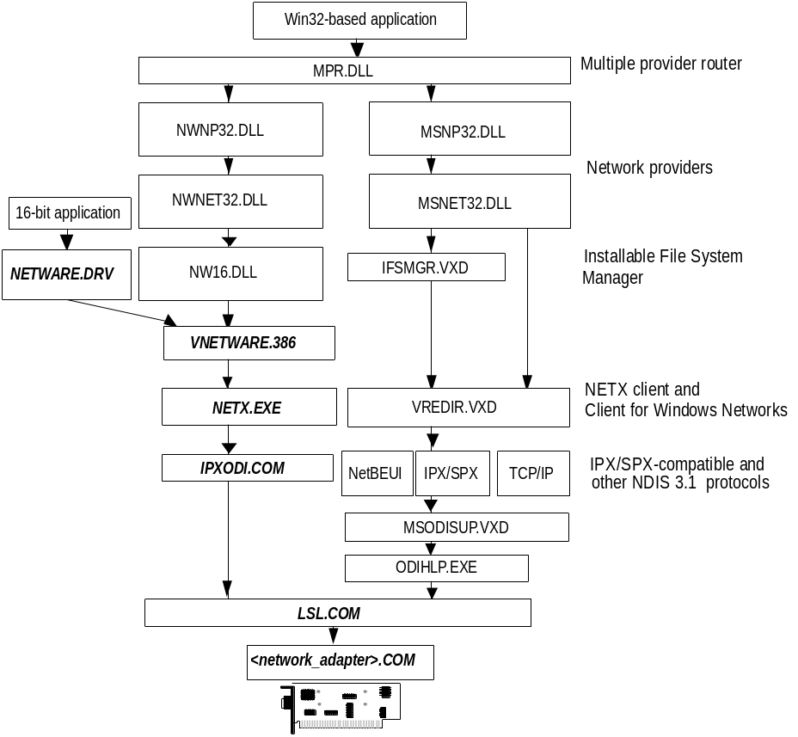
Architecture for Novell-supplied NETX with Client for Windows Networks
Components shown in bold are supplied by Novell.
In this configuration, NETWARE.DRV is installed and loaded only for applications that call it directly. Because this driver is not used by Windows 95, all access to NetWare resources is by using the Windows 95 user interface, not the NETWARE.DRV dialog boxes provided by Novell. NW16.DLL translates 32-bit network calls to 16-bit network calls that can be passed to VNETWARE.386.

You cannot install Client for Windows Networks as an additional networking client if you are using the IPX monolithic configuration.
Note

Using NETX as the Sole Client
This configuration is for the user who must run the NETX client because the IPX monolithic configuration is used, application incompatibilities have been experienced, or there is a need to use NetWare TSRs. If you choose this configuration, you cannot connect to other computers that are running Windows 95, Windows for Workgroups 3.x, LAN Manager, or Windows NT (unless, of course, these computers are also running a NetWare-compatible network client).
To use only NETX client support, use the Network Control Panel to remove Client for NetWare Networks and Client for Windows Networks, if either of these clients is installed. Then add the Novell NetWare (Workstation Shell 3.X [NETX]) client, as described in “Installing Windows 95 with a Novell NetWare Client” earlier in this chapter.
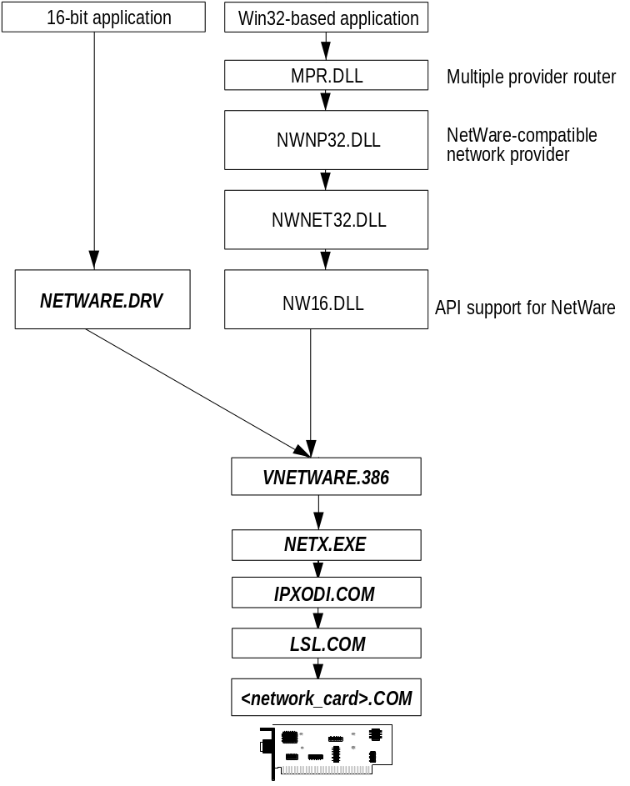
Architecture for Novell-supplied NETX as the sole client
Components shown in bold are supplied by Novell.

Required NETX Support Files for Windows 95
In addition to the base Novell-supplied NetWare client software required to communicate with a NetWare server, which consists of the NetWare redirector and IPX protocol, some additional NetWare support files are necessary for the Novell-supplied components to work properly in the Windows 95 environment. The required NetWare files provided by Novell are shown in the following list.
Novell-supplied file | Description
NETWARE.DRV NETWARE.HLP | Windows network driver and associated help file to provide access to network redirector functionality from Windows 95.
NWPOPUP.EXE | NetWare messaging utility. Used to receive messages and alerts from a NetWare server.
VNETWARE.386 | Virtual device driver providing virtualization services for the NetWare redirector in the Windows 95 environment and across VMs.
VIPX.386 | Virtual device driver providing virtualization services for NetWare IPX protocol for Windows 95 environment and across VMs.

When Windows 95 is configured to support a Novell NetWare client, Setup checks to see if these files are in the Windows directory. If the files are not in the Windows directory, Setup asks for a disk or network drive location for these files.

Setting the LastDrive Parameter for NETX
Windows 95 uses the LastDrive= entry in the Registry (or CONFIG.SYS) to allocate enough storage space in the internal memory structures to recognize drive letters for devices through the given value for this entry. For example, a setting of LastDrive=Z tells Windows 95 to recognize drive letters from A to Z.
Windows 95 uses all drive letters up to the letter assigned as the last drive. NetWare servers use all the drive letters. For example, if LastDrive=P is specified, you can assign drive letters D through P (assuming drive C is the only physical hard disk drive in the system). In this same example, NetWare will begin mapping NetWare volumes with Q.

Setting Show Dots and File Access Limits
A NetWare file server does not include the directory entries dot (.) and double dot (..) as MS-DOS and Windows 95 do. However, the NetWare workstation shell version 3.01 or later can emulate these entries when applications attempt to list the files in a directory.
To turn on the Show Dots feature
- If you have problems listing files or deleting directories, add the following line to the beginning of NET.CFG:
show dots=on

By default, NetWare allows you access to only 40 files at a time. When you are running applications under Windows 95, you can exceed this limit rather quickly. If you do, you might see unexpected error messages.
To increase the file access limit
1. Add the following line to the beginning of NET.CFG:
file handles=60

2. Add the following to CONFIG.SYS for the local computer:
files=60

VLM Technical Issues
VLM stands for Virtual Loadable Module, the network client provided with Novell NetWare versions 4.x. You should choose to run VLM rather than Client for NetWare Networks in these cases:
- If you need NetWare Directory Services (NDS) support. When using VLM, you can access NDS using NWUSER and the WinNet16 dialog boxes.
- If you experience incompatibilities in a NetWare-aware application.
- If you must use any NetWare TSR for which there is no replacement built in to Windows 95.

When you run the VLM client with Windows 95, the behavior of the NetWare workstation shell is the same as it is with MS-DOS or Windows 3.1. You should still load the Novell-supplied client components and TSR programs, and log on from AUTOEXEC.BAT or STARTNET.BAT. Logon scripts also work in the same way as in MS-DOS and Windows 3.1. After Windows 95 starts, you can use the Windows 95 user interface to make drive and printer connections, or you can run NetWare utilities by running MS-DOS prompt and entering commands at the command prompt.

Installing Windows 95 with the VLM client requires special steps. For information, see the steps later in this section.
Note

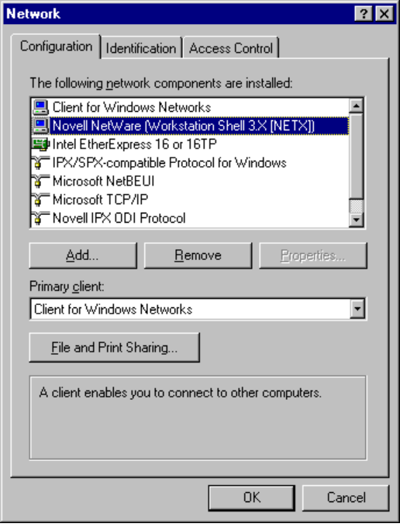
This section describes specific issues related to using the Novell-supplied NetWare 4.x client software along with Windows 95. The following topics are included:
- The architectural model and procedures for setting up VLM with Client for Windows Networks
- The architectural model for VLM as the sole client
- Specifying the LastDrive= parameter for VLM

Using VLM with Client for Windows Networks
If you are using VLM as the network client, you might also choose to install the 32-bit, protected-mode Client for Windows Networks if you want to connect to other Microsoft network computers, such as computers running Windows 95, Windows for Workgroups 3.x, LAN Manager, or Windows NT. The following illustration describes this configuration.
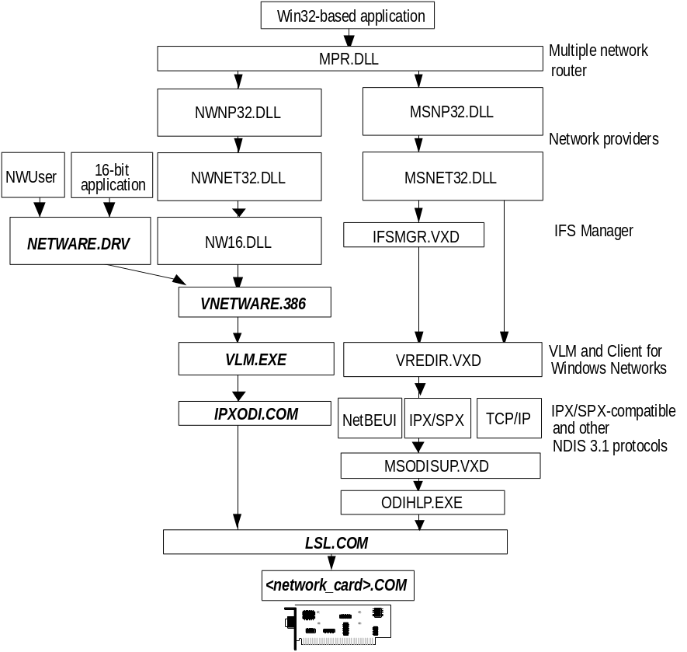
Architecture for Novell-supplied VLM with Client for NetWare Networks
Components shown in bold are supplied by Novell.
In this configuration, NETWARE.DRV is installed and loaded only for applications that call it directly. It is not used by Windows 95. All access to NetWare resources is through the Windows 95 user interface, not the NETWARE.DRV dialog boxes. The NWUSER utility calls NETWARE.DRV directly, to bring up the central NetWare Version 3.0 WinNet16 dialog box.
Because the Novell-supplied VLM installation program installs Windows support, there is a certain order that you must follow to set things up properly for Windows 95. Follow the instructions under the procedure in this section that most closely describes your configuration.

Windows 95 Setup tries to detect VLM by looking for an NLS directory. If NLS is present, it begins the process of installing Windows 95 for VLM. If the NLS directory is not present, Setup asks you to first install VLM using the Novell installation program. Then you can continue with Windows 95 Setup.
Note

If you already run VLM with Windows 3.x and install Windows 95 over Windows 3.x
1. Run Windows 95 Setup.
2. During Setup, choose support for Novell NetWare 4.0, as described in “Installing Windows 95 with a Novell NetWare Client” earlier in this chapter.
– Or –
1. After Setup, in the Network Control Panel, click the Add button, select Client and click the Add button.
2. In the Select dialog box, select Novell in the Manufacturers list, and select the Novell NetWare (Workstation Shell 4.0 and above [VLM]) option in the Models list.
3. If you want to install Client for Windows Networks at this time, you can repeat the steps in this dialog box to install it.
4. Click OK, and then shut down and restart the computer.
5. Use your Novell NetWare software to configure the client.

If you already run VLM with Windows 3.1 and install Windows 95 in a new directory
– Or –
If you are running VLM with MS-DOS
1. Run Windows 95 Setup.
Setup will partially configure Windows 95, then prompt you to reinstall VLM using the Novell-supplied installation program.
2. When you reinstall VLM, respond Yes to installation of Windows support. Specify the name of the directory where Windows 95 is installed.
3. Run Windows 95. In the Network Control Panel, select support for Novell NetWare 4.0, as described in the previous procedure. You can also install Client for Windows Networks at this time.
4. Shut down and restart the computer.

Using VLM as the Sole Client
This configuration can be used if you do not need to connect to other computers that are running Windows 95, Windows for Workgroups 3.x, LAN Manager, or Windows NT. (Of course, you can connect to a Microsoft Network computer that is also running a NetWare-compatible client such as Client for NetWare Networks.)
To get VLM client support, you must add the Novell NetWare (Workstation Shell 4.0 and above [VLM]) client using the Network Control Panel, as described earlier in this section. With this configuration, you will see only VLM listed in the Network Control Panel. No network adapter card or protocol will be listed.
The following illustration summarizes this configuration.
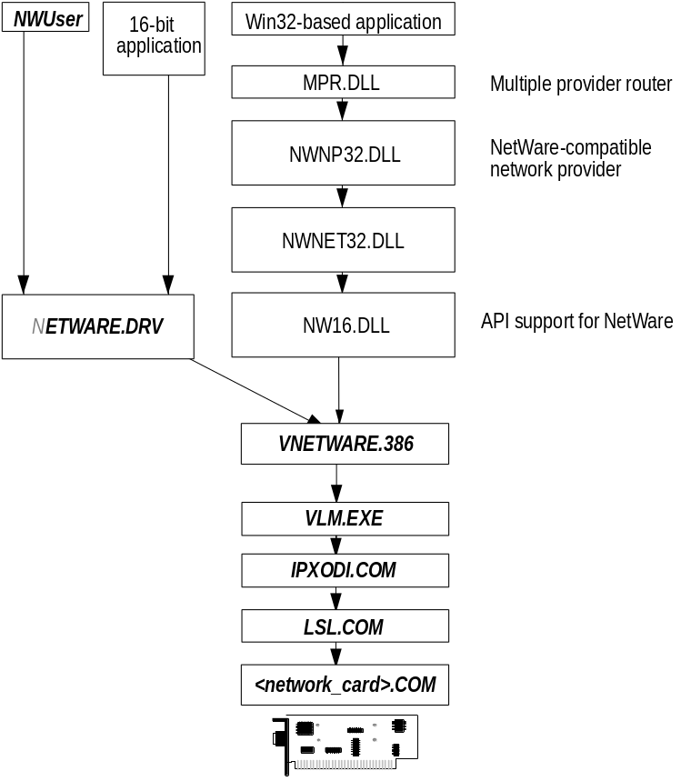
Architecture for Novell-supplied VLM as the sole client.
Components show in bold are supplied by Novell.

Setting the LastDrive Parameter for VLM
Windows 95 uses the LastDrive= entry in the Registry to allocate enough storage space in the internal memory structures to recognize drive letters for devices through the given value for this entry. For example, a setting of LastDrive=Z tells Windows 95 to recognize drive letters from A to Z.
The Novell-supplied NetWare 4.x redirector handles the LastDrive= entry the same way that Windows 95 does. That is, both the NetWare 4.x redirector and Windows 95 allow drive letters to be used to connect to redirected network drives up through the drive letter specified by the LastDrive= entry. By default, Windows 95 sets the entry to read LastDrive=Z when the NetWare 4.x workstation shell is selected as the additional network.
The NetWare 4.x redirector uses the First Network Drive= entry in the NET.CFG file to identify the first network drive that can be mapped. For more information on this setting, consult your NetWare documentation.

Technical Issues for Windows 95 on NetWare Networks
This section contains the following topics:
- Hardware issues for Windows 95 on NetWare networks
- Software issues for Windows 95 on NetWare networks
- User-level security issues on NetWare networks

Hardware Notes for Windows 95 on NetWare Networks
Routers: To be provided.
Bridges: To be provided.

Software Notes for Windows 95 on NetWare Networks
To be provided.

Using Microsoft IPX/SPX-Compatible Protocols on NetWare Networks
The Microsoft 32-bit IPX/SPX-compatible protocol is an NDIS 3.1-compliant, routable protocol that conforms to the IPX specification, which requires routable datagram packets. This protocol can use Novell NetWare servers configured as routers (and other IPX routers) to transfer its packets across LANs to access resources on other computers running Windows 95.
The IPX/SPX-compatible protocol is a 32-bit, protected-mode protocol that is Plug and Play-aware. With the Microsoft IPX/SPX-compatible protocol, it is not necessary to load the Novell-supplied VIPX.386 driver.

You can install both protected-mode and real-mode IPX drivers on the same adapter running ODI or NDIS. Notice, however, that you cannot install or use the IPX/SPX-compatible protocol to run over an IPX monolithic configuration.
Note

The Microsoft IPX/SPX-compatible protocol is installed automatically if you install Client for NetWare Networks. However, if you configure Windows 95 to maintain the existing NetWare client and protocol software, you can later try using the protected-mode protocol provided with Windows 95. For details about installing and configuring IPX/SPX-compatible protocol and NetBIOS over IPX, see Chapter 11, “Network Technical Issues.”

Using Microsoft TCP/IP on NetWare Networks
Client for NetWare Networks does not support NetWare IP. The protected-mode network client can use only the IPX/SPX-compatible protocol.
Microsoft TCP/IP is fully compliant with the standard RFCs specifying TCP/IP. NetWare IP uses other protocol implementations for IP functionality, so that the two protocol suites cannot communicate with each other.
Although Microsoft TCP/IP cannot be used as the supporting protocol for Client for NetWare Networks or for Novell-supplied networking clients, Microsoft TCP/IP can be installed to support other networking clients on the same computer. Use this configuration when TCP/IP-based communications are used on the internetwork.

User-Level Security Notes on NetWare Networks
- Windows 95 does not support the use of NetWare domains or the distributed name server called NetWare Naming Service (NNS). NNS is installed as an add-on product that is supported by NetWare 3.x servers. NNS uses a domain model for NetWare servers by grouping them and distributing the domain’s account list to all servers in the domain.

Troubleshooting Windows 95 on NetWare Networks
This troubleshooting section includes these topics:
- Overview for troubleshooting Windows 95 on NetWare
- Troubleshooting problems with Client for NetWare Networks
- Troubleshooting Windows 95 using Novell NetWare clients

Overview for Troubleshooting Windows 95 on NetWare
This section presents some checklists for information gathering and general troubleshooting steps, and guidelines for determining whether the problem is with Windows 95 or NetWare.
For general troubleshooting tips, see Chapter 7, “Troubleshooting Setup and System Startup.” For general tips on troubleshooting networking problems, see Chapter 11, “Network Technical Issues.”

Information for Troubleshooting NetWare Problems
Gather this information when attempting to troubleshoot a NetWare computer with problems running under Windows 95.

General information for troubleshooting Windows 95 on NetWare
1. Verify that NetWare was working successfully before Windows 95 was installed.
2. Verify that the user is logging in to the NetWare server before running Windows 95.
3. If the user is running a shared copy of Windows 95, verify that the home directory and the shared Windows directory are the first two items in the search path.
4. Gather configuration information about the following:
- Current contents of CONFIG.SYS, AUTOEXEC.BAT, and NET.CFG (or Registry values if using Client for NetWare Networks).
- Other equipment in the computer, including hard disk controller, video adapter, I/O boards, and other hardware controller cards.
- Network adapter card configuration.
Get IRQ, I/O base address, base memory address, and DMA settings, and check for known device conflicts. (For monolithic configurations, run ipx i to get information on adapter driver and hardware configuration.)
For a monolithic configuration, verify that the configuration does not use the /o# switch on IPX.COM or the config option= statement in NET.CFG (or SHELL.CFG for monolithic IPX).
For an ODI-based configuration, find the appropriate NET.CFG and check the Link Driver section of the ODI driver.
5. Check all levels where TSRs can be loaded, including the following:
AUTOEXEC.BAT | System logon script
CONFIG.SYS | User logon script
WINSTART.BAT | NetWare network MENU system

Information to verify when troubleshooting Windows 95 using NETX or VLM
1. Check the version numbers of all Novell-supplied NetWare workstation shell components, including IPX, NETX, VLM, LSL, IPXODI, and the ODI driver file. Make sure the latest versions are being used.
To get the version number for the Novell-supplied software you are using, run driver_name i or driver_name ? at the command prompt. For example, type netx i to get the version number for the Novell-supplied NET*.COM or NET*.EXE file.
If you are not using the latest software, upgrade as described in “Obtaining Current NetWare Clients and Support Files” earlier in this chapter.
2. Check for multiple instances of the NetWare files, specifically the ODI driver and NET.CFG. Use the Network button in MSD to verify which one is being used by LSL.
For information about using MSD, see Chapter 7, “Troubleshooting Setup and System Startup.”
If there are multiple instances, remove all but the most recent version.
3. Verify that IPXODI is binding to the network adapter card, using the same settings as the NET.CFG and the same [link driver ODI_driver] name. (The link driver line will usually match.)
If IPXODI is not bound to the network adapter card, correct the entries in NET.CFG to correct this problem.

General Troubleshooting Guidelines for Windows 95 on NetWare Networks
1. Does the problem occur on all client computers?
Yes: May be a network or server configuration issue.
No: What is common to the client computers having a problem?
2. Does the problem occur for different users logged in at a particular computer?
Yes: May be a computer-specific issue.
No: What is common to the users having the problem?
3. Does the problem occur when logged in as a Supervisor?
No: Problem is related to NetWare rights: Trustee or Directory Rights.
4. Has it ever worked?
Yes: What is different about the configuration now and when it worked?
5. Does the network function properly outside of Windows 95?
See the following section for troubleshooting Windows 95 on NetWare networks.

Troubleshooting Windows 95 on NetWare Networks
To determine if the problem is between the NetWare network software and Windows 95 when the two are integrated, try the following:
- If NetWare was running successfully before you added or installed Windows 95 and now it’s not, then remove the changes to the NetWare environment made by Windows 95 and see if NetWare runs successfully again.
- If Windows 95 is running successfully, but NetWare is not, then verify the integrity of the NetWare components in the Network Control Panel. Check the file sizes and dates and look for multiple instances of the Novell-supplied drivers to help isolate the problem.
- If the two networks were working together, and now are not, start at the lowest level with NetWare only. Make sure it is booting and logging in to the servers correctly at MS-DOS before installing Windows 95.

Troubleshooting Client for NetWare Networks Problems
This section discusses some common problems that might occur while installing, configuring, or using Microsoft Client for NetWare Networks.

No network is available after Windows 95 starts.
Verify that Client for NetWare Networks is installed. Use the Network Control Panel to view a list of installed clients, protocols, and services.
Make sure that you did not replace the VxD that Windows 95 uses (NWREDIR) with the original Novell-supplied NetWare VxD.

Servers can’t be found.
You may not be able to see NetWare servers if you are using an incorrect frame type for the servers. To verify that you are using the correct frame type for the server, use the Network Control Panel to see the frame type you have set for your adapter card.
Client for NetWare Networks supports NetWare 4.x bindery emulation. Be sure
that the bindery context you set for your NetWare server directory includes the Windows 95 users who should have access to the servers. You can view and set your bindery context on NetWare 4.x servers by loading the SERVMAN NetWare loadable module (NLM) and then viewing and setting the SET BINDERY CONTEXT parameter. Or, you can type set at the command prompt to view
the Miscellaneous SET parameters. For more information, see your NetWare 4.x server documentation.

Client for NetWare Networks asks for a password at each logon.
Client for NetWare Networks prompts for a password for your preferred server after you log on to Windows 95 because the user name and password for your NetWare preferred server differs from your Windows 95 password. If you don’t want to be prompted for your preferred server password, make your NetWare preferred server and Windows 95 passwords the same. To synchronize your user credentials on your computer and any NetWare servers you are connected to, change the password.

Access to NetWare servers is denied.
By default, Client for NetWare Networks uses the credentials provided for preferred server authentication to access other NetWare servers. To see files on NetWare servers for which you have access, synchronize your credentials on all the NetWare servers. You can synchronize your credentials on NetWare servers using the setpass command at the command prompt, or you can change the password on your computer and simultaneously synchronize your credentials on all NetWare servers to which you are connected.

No print queues are visible when you choose a NetWare server in Print Manager.
Your credentials on the server do not match those on your preferred server. By default, Client for NetWare Networks uses your preferred server credentials to access the print queue server.
If you do not see any print queues, verify that you can see NetWare servers in Network Neighborhood. Also, on the server side, make sure that the server is working properly and that the queue is shared.
To see the print queues on NetWare servers to which you have access, you must have an authenticated connection to the server. Synchronize your credentials on
all the NetWare servers using the setpass command at the command prompt. Or change your password on the computer running Windows 95 and then synchronize your credentials on all NetWare servers to which you are connected.
For more information about printing, see Chapter 19, “Printing.”

NetWare MAP utility fails with a memory allocation error.
If the NetWare MAP utility fails with a memory allocation error, the default environment for 16-bit programs is too small to accommodate the mapping table created by the NetWare MAP utility.
You need to designate COMMAND.COM as the permanent command interpreter for the MS-DOS Prompt and reset the default environment size allocated to the window. An environment of 4096 bytes is large enough to accommodate the NetWare utility, the mapping table, and the command interpreter.
To make these changes to the environment, include this command in CONFIG.SYS:
shell=%systemroot%\system32\command.com /e:4096

This command causes COMMAND.COM to be the command interpreter for the window as long as it remains open or until you issue another shell command, and
it permanently allocates 4096 bytes to programs you run in the window.

Troubleshooting Windows 95 Using Novell NetWare Clients
Additional information to be provided.

During startup, LSL reports that it has already been loaded.
If you configure Windows 95 to use a Novell-supplied NetWare workstation shell with Client for Windows Networks and set the driver type to ODI, Windows 95 Setup adds lines to NETSTART.BAT to start the ODI drivers. But it does not remove the same lines in the STARTNET.BAT file that the Novell NetWare installer created. This causes LSL to report that it is already loaded. The network should function completely. You can manually remove command lines from STARTNET.BAT for the Novell-supplied LSL.COM file and the ODI driver.

Cannot attach to the NetWare file server after installing Windows 95.
Verify the frame type being used by the NetWare server. If the NetWare server is using a different frame type from the one configured for the computer running Windows 95, and if there is not a PROTOCOL entry in the NET.CFG, the user cannot see the server. The Novell-supplied IPXODI protocol binds only to the first logical board, which is the first frame type in the link driver ODI_driver section in NET.CFG.
To correct this problem, manually edit NET.CFG so that the correct frame type is first in the link driver ODI_driver section. Or use the Network Control Panel to configure the IPX/SPX-compatible transport to change the frame type.

Can see other computers running Windows 95, but cannot see the NetWare server.
1. Verify that all four frame types are listed in NET.CFG. You should see the following indented with a space or a tab character under the link driver ODI_driver section:
FRAME ETHERNET_802.3
FRAME ETHERNET_802.2
FRAME ETHERNET_II
FRAME ETHERNET_SNAP
2. Verify that the correct NET.CFG is being processed by LSL.COM. To do this, check the local drive for the existence of other NET.CFG files. There should only be one, and it should be in the same directory as the NetWare driver files. If you are loading these files from AUTOEXEC.BAT or another batch file, modify the batch file to change to this directory, run the necessary ODI drivers, and change back to the directory you want. This ensures that the current directory is the same as the location of the LSL.COM file when it is being loaded.
3. Verify that you are running the very latest version of the Novell-supplied ODI drivers and support files. Check with your network adapter card manufacturer to determine whether a newer ODI driver is available.

Verify that both client computers are running the same protocols. If the client computers are on different sides of a router, make sure that the IPX/SPX-compatible protocol or the IPX/SPX-compatible protocol with NetBIOS is being used on both computers.

Cannot see NetWare servers or other computers running Windows 95.
To determine if it is an ODI driver issue, configure Windows 95 to use the NDIS drivers, if available, and see if the client computers are able to communicate using these drivers. If so, it is possible that the ODI driver or the ODI support files need to be updated to newer versions. Or switch permanently to Windows 95 NDIS drivers.

Cannot access the logon drive after installing Windows 95.
A common misconception is that users must log onto their NetWare server using the drive letter F. However, this is not true. For a client computer using the NETX workstation shell, the NetWare logon drive is the next drive letter available after the LastDrive= statement in the Registry. When installing support for Novell NetWare, Windows 95 Setup updates the LastDrive= statement and sets it to the letter P. This sets the logon drive to Q. You can alter the LastDrive= statement to change the logon drive, but you must leave enough drives before the LastDrive= that Windows 95 can use for its own connections.

