Chapter 1
This chapter presents information for using the Windows 95 built-in peer resource sharing service called Microsoft File and Printer Resource Sharing for NetWare Networks.
File and Printer Sharing on NetWare Networks
This chapter contains the following topics in relation to File and Printer Sharing for NetWare Networks:
- Configuring the browsing preference for file and printer sharing
- Using bindery emulation for pass-through security
- Connecting to NetWare volumes and files
- Using NetWare utilities for file and printer sharing

Overview of File and Printer Sharing for NetWare Networks 9-2
In This Chapter
Configuring the Browsing Preference for Peer Sharing on NetWare Networks 9-3
Using Bindery Emulation for Pass-Through Security 9-7
Using NetWare Utilities with File and Printer Sharing for NetWare Networks 9-8
Technical Issues for File and Printer Sharing for NetWare Networks 9-8
Troubleshooting File and Printer Sharing for NetWare Networks 9-9

Chapter 11, “Network Technical Issues,” for details about configuring network adapter cards and protocols, and general networking troubleshooting tips
See Also
Chapter 10, “Logon and Browsing on NetWare Networks,” for a general discussion of browsing when you are using Novell NetWare clients
Chapter 13, “Security,” for information about setting up and using user-level security with File and Printer Sharing for NetWare Networks

Overview of File and Printer Sharing for NetWare Networks
Microsoft File and Printer Sharing for NetWare Networks (NWSERVER) is a 32-bit, protected-mode networking component that allows users to share directories, printers, and CD-ROM drives on computers running Windows 95 with other users on the network. File and Printer Sharing for NetWare Networks works in concert with existing NetWare servers to add complementary peer resource sharing services.
A computer configured with File and Printer Sharing for NetWare Networks uses the NCP file sharing protocol to share resources with MS-DOS – based Novell NetWare computers, computers running Windows NT, and computers that have Client for NetWare Networks installed.

How do I use peer resource sharing services on NetWare networks?
Similar to File and Printer Sharing for Windows Networks (which is an SMB-based peer resource sharing service), File and Printer Sharing for NetWare Networks supports long filenames and is Plug and Play-aware. This new implementation differs from peer resource sharing in Windows for Workgroups 3.1x in two fundamental ways:
- File and Printer Sharing for NetWare Networks uses the NCP protocol instead of the SMB protocol. This means that any NetWare client (Client for NetWare Networks, NetWare NETX, or NetWare VLM) can connect to a computer running File and Printer Sharing for NetWare Networks.
- File and Printer Sharing for NetWare Networks uses user-level security. Access to a shared resource is based on the user’s identity, instead of being based on a password associated with that resource. The user database for verifying user identity is the bindery on a specified NetWare server.

File and Printer Sharing for NetWare Networks requires that the computer also use Client for NetWare Networks, rather than Novell-supplied client software.
Note
Also, File and Printer Sharing for NetWare Networks cannot run at the same time as SMB-based File and Printer Sharing for Windows Networks.

Administrative control over File and Printer Sharing for NetWare Networks is coupled with the printer sharing control — the option controlling the user’s ability to both share a local printer. If the administrator has specified that print sharing is not allowed, File and Printer Sharing for NetWare Networks cannot load and the related options are not available.
For information about setting up and using user-level security with File and Printer Sharing for NetWare Networks, see Chapter 13, “Security.” For a general discussion of browsing when you are using Novell NetWare clients, see Chapter 10, “Logon and Browsing on NetWare Networks.”

The network administrator can use System Policy Editor to turn off peer resource sharing services for specific users. For information, see Chapter 14, “System Management.” This option can also be specified in setup scripts for custom Windows 95 installations.
Tip

Configuring the Browsing Preference for Peer Sharing on NetWare Networks
After you install File and Printer Sharing for NetWare Networks, you need to choose the method that computers browsing on the network will use to find this computer. You can browse using two options:
- Browse Master, used by workgroups on Microsoft Networks.
- Service Advertising Protocol (SAP, the NetWare broadcasting protocol), used by Novell NetWare 2.15 and above, 3.x, and 4.x servers to advertise their presence on the network.

To specify the browsing preference
1. In the Network Control Panel, select File and Printer Sharing for NetWare Networks, and then click the Properties button.
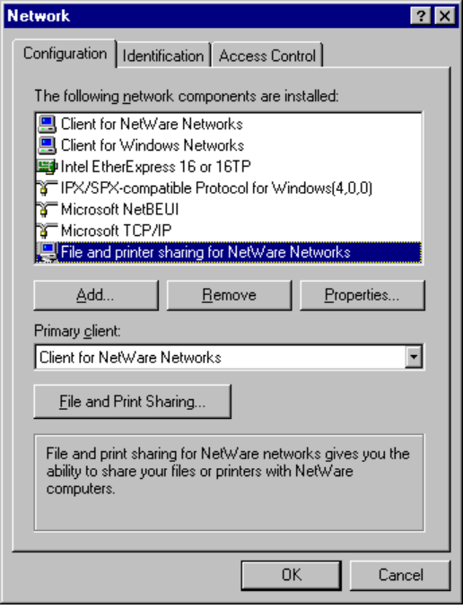
2. Click the Advanced tab, and select a browse option.
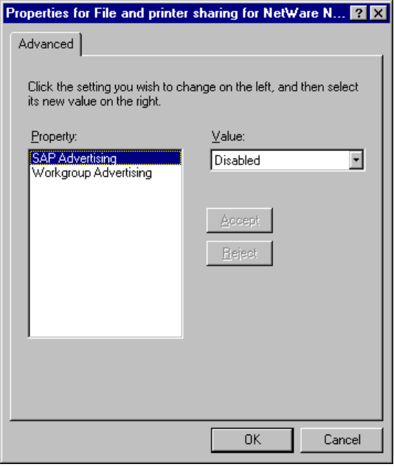
3. Details on Browse Master and SAP Browsing to be provided.
By default, computers running File and Printer Sharing for NetWare Networks are placed in and browsed by workgroup. You can use the Identification property sheet in the Network Control Panel to specify the workgroup and computer name for the computer. Each workgroup must have a designated Browse Master at all times that keeps track of the name and address for each computer in the workgroup.
To set up a computer as the Browse Master
1. On the File And Printer Sharing properties sheet, click the Advanced tab, and select Browse Master.
2. In the Values list, select Preferred.
Select Disabled if you do not want this computer to be elected Browse Master.

SAP browsing has a theoretical limit of 7000 systems for browsing, and a practical limit of about 1500 systems. Therefore, SAP browsing will not work in a peer networking environment that consists of a larger number of computers. For a large peer network, use Browse Master.
Note

Although computers that use SAP Browsing appear in the list of NetWare servers, you cannot use them in all the same ways that you use NetWare servers.
- When using NETX, you cannot log onto a computer running Windows 95, although you can attach to one and map drives to its directories.
- When using VLM, you cannot log onto a computer running Windows 95 at the command line, but you can run a login /ns command, and use the Login button in the NWUSER utility.
- If you run SYSCON on a NetWare server, you can change the server to one of the computers running Windows 95. However, the computer running Windows 95 does not have a bindery, so when you display all the users (or groups) in SYSCON, you will see the user list (or group list) from the NetWare server that was selected to participate in user-level security.
- If you run VOLINFO on a NetWare server, you can select one of the computers running Windows 95 and display its volume information (if you are attached to it). This shows all the available shared disk resources for the computer running Windows 95.
- To be provided: FILER example.

In Windows 95, you can do the same things to computers running File and Printer Sharing for NetWare Networks as you can to any other network resource. For example, when you open the icon to view its contents, you will see only shared resources that you have rights to see. You can also create a link to the computer or map a drive to its shared directories, and so on.
How a computer running File and Printer Sharing for NetWare Networks appears in Network Neighborhood depends on whether it has been configured for Browse Master browsing or SAP browsing.
- If the computer is configured to use a Browse Master, it appears in the workgroup to which it belongs.
- If the computer is configured for SAP Browsing, it appears after the list of workgroups in the Entire Network window, with the other Novell NetWare servers on the network.

Each computer configured with File and Printer Sharing for NetWare Networks must log onto the NetWare server providing security, to get access to the bindery. One constant connection to that server is needed for each computer configured with File and Printer Sharing for NetWare Networks.
Note
If a connection already exists, Windows 95 uses that connection and only makes a new connection when required.
NetWare is sold in user packs (such as 10-user or 25-user packs) that limit the number of concurrent connections. So, for example, for a NetWare 3.x 20-user server, only 20 computers configured with File and Printer Sharing for NetWare Networks can maintain a connection at the same time.

Using Bindery Emulation for Pass-Through Security
File and Printer Sharing for NetWare Networks grants access to printers and folders on a per-user basis, which requires the name of the server to retrieve the names of users on a network. For NetWare 2.15 and above and 3.x servers, all the information for users, groups, passwords, and rights is stored in a database on the server called the bindery. NetWare 4.x servers can appear to have a bindery using bindery emulation, which is enabled by default. Windows 95 can use the bindery of one NetWare server.
Usually, companies have multiple NetWare servers for different departments, and individual users log onto a different server by department. Problems occur when the list of accounts differs between NetWare servers. For example, AnnieP and YusufM log onto the SALES server, and KrisI is on the R&D server. AnnieP can only select one server for pass-through validation, so she must select the SALES server, because that’s where this account is located for logon. She can grant access to YusufM, but not to KrisI.
To ensure all users have the required server access
- Make sure that one NetWare server on the network has the accounts for all users or all servers, and then make that server the security provider for every computer configured with File and Printer Sharing for NetWare Networks.

If server access is not properly set, the message “The pass-through server has not been specified” appears each time the computer is started.

Using NetWare Utilities with File and Printer Sharing for NetWare Networks

This section presents comments and issues related to using specific NetWare utilities on a computer running File and Printer Sharing for NetWare Networks.
NetWare command | Comment
ATTACH | Use SAP Browsing, or use the new Windows 95 ATTACH program to view and connect to NetWare servers.
CAPTURE | To be provided.
ENDCAP | To be provided.
FLAG | To be provided.
FLAGDIR | To be provided.
LOGIN | Using the LOGIN utility is not recommended to create an attachment to a computer configured with File and Printer Sharing for NetWare Networks. Use the ATTACH utility instead.
MAP variations | To be provided.  Drive maps in Windows 95 are global to all sessions.
RIGHTS | To be provided.
SLIST (NLIST on VLM) | To be provided.
VOLINFO | To be provided.

Technical Issues for File and Printer Sharing for NetWare Networks
When File and Printer Sharing for NetWare Networks is installed, Client for NetWare Networks (NWREDIR.VXD) is used to get NetWare server connection information and to enable user-level security based on a NetWare server’s user accounts.
The following illustration shows the supporting files for File and Printer Sharing for NetWare Networks in the Windows 95 networking architecture.
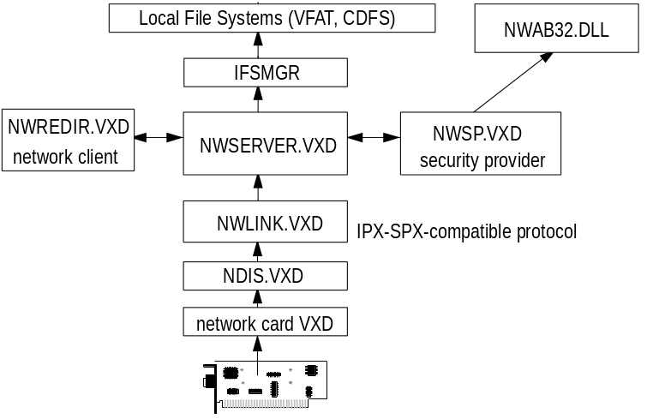
Architecture for File and Printer Sharing for NetWare Networks
In this configuration, the NetWare Security Provider (NWSP.VXD) assists in validating user access when sharing a resource. The network component NWAB32.DLL translates the account lists from the NetWare server and provides the Add Users dialog box for selecting which users get access rights.

User-Level Security Notes on NetWare Networks
- Windows 95 does not support the use of NetWare domains or the distributed name server called NetWare Naming Service (NNS). NNS is installed as an add-on product that is supported by NetWare 3.x servers. NNS uses a domain model for NetWare servers by grouping them and distributing the domain’s account list to all servers in the domain.

Troubleshooting File and Printer Sharing for NetWare Networks
To be provided.

