“Entity Proxy” – A design pattern and implementation framework for developing highly scalable Windows DNA Applications

White Paper
Abstract
This document will present an informal design pattern and implementation framework that has been specifically designed for multi-tier, multi-user and distributed applications, where the business operations or logic developers utilize high-level languages like Visual Basic or Java. Emphasis has been placed on the scalability and reusability of both design and implementation and on developer approachability. A full set of performance benchmark results is presented together with a discussion of the implementation.

© 1999 Microsoft Corporation. All rights reserved.
The information contained in this document represents the current view of Microsoft Corporation on the issues discussed as of the date of publication. Because Microsoft must respond to changing market conditions, it should not be interpreted to be a commitment on the part of Microsoft, and Microsoft cannot guarantee the accuracy of any information presented after the date of publication.
This white paper is for informational purposes only. MICROSOFT MAKES NO WARRANTIES, EXPRESS OR IMPLIED, IN THIS DOCUMENT.
Microsoft, Active Directory, MSN, Win32, Windows, the Windows logo and Windows NT are either registered trademarks or trademarks of Microsoft Corporation in the United States and/or other countries.
Other product and company names mentioned herein may be the trademarks of their respective owners.
Microsoft Corporation • One Microsoft Way • Redmond, WA 98052-6399 • USA
1999

Introduction 1

Contents
Distributed, multi-tier applications 1
Scalability 1
Implementation 1
Microsoft Windows DNA 2
Investment Yields Results 3
The Design Pattern 4
Data Entities 5
Business Operations Proxy 5
Business Operations Component 5
Entity Proxy 5
Data Proxy 6
Extensions to the pattern 6
The Entity Proxy Implementation Framework 7
Overview 7
Windows 2000 7
Entity Proxy Components 7
Data Entity (DataServices.Entity) 7
IEntity Interface (DataServices.Entity, default interface) 8
IEntityData Interface (DataServices.IEntityData) 8
Entity Metadata 10
Data Proxy (DataServices.Proxy) 11
Resultset (DataServices.Resultset) 12
Dynamic Collection (DataServices.Dynamic) 13
Implementation Technologies 14
Overview 14
ODBC API 14
Visual C++ and the Active Template Library 14
Standard COM Interfaces 14
IMarshal 14
IPersistStream 14
Collection 14
Use of Memory 15
Scalability Testing 16
Hardware 16
System Setup 16
The application 16
Transaction 17
Results 20
Summary / Conclusion 22
Appendix 1: The EPGen Tool 23
Overview 23
Screenshot – the EPGen tool in use 23
Visual Basic Code 23
T/SQL Stored Procedures 24
Appendix 2: Usage Scenarios 25
Overview 25
Scenario 1 – Sending a textual SQL command to the database. 25
Scenario 2 - Read a single business entity from the database 25
Scenario 3 – Read a business entity, make a change and save the results back 26
Scenario 4 – Lookup an entity in the database where no Load stored procedure exists, and/or there will be more than a single entity returned 28
Scenario 5 – Query for many results / entities 29
Scenario 6 – Insert a new business entity into the database 29
For more information 31

Distributed, multi-tier applications

Introduction
Distributed, multi-tier applications have a set of characteristics that make design and implementation significantly more challenging than for traditional monolithic or Client/Server applications. Applications in the modern enterprise have to support multiple users, perhaps these users are on different sites, and even require different mechanisms to access the application functionality (typically, internet or client/server). This distributed and multi-user requirement shapes an application in ways that focus on the server for reliability and scalability. The design, and implementation must be multi-tier, and client agnostic since the application will actually be deployed into this physical configuration.
Good design (even “correct” design) is even more important with distributed, multi-tier applications than ever before where focus is trained on client independence, business oriented access to, and manipulation of, data.
Each tier in a multi-tier application has a different “ideal” working environment. The client, for example, is heavily influenced by the user’s way of working. In addition client developers are used to an object oriented style of interface onto business operations. The middle tier and database are best suited to transactional work, where the server resources are shared between many simultaneous clients. Each transaction should have a very short lifetime, deal with a minimal amount of state and leave few, or ideally no, artefacts on the middle tier server.

Scalability
Scalability, vitally important to multi-user applications, is all too easy to fail to achieve; problems can occur in both design and implementation that yield undesirable consequences in terms of application scalability. Architects can influence scalability through careful and informed design and appropriate implementation technology choices. This scalability, which can be thought of almost as a currency, can be “spent” in a number of ways:
- Implementing the business operations logic – the actual application logic
- Provide business operation developers with some “headroom” to get code written quickly without thinking constantly of the most scalable case
- Cater for peak load situations, since a system should not be run at its peak for normal operating conditions.

Implementation technologies can have an enormous effect on the scalability of an application. Research and papers published by Robert Barnes et al. clearly show where the tradeoffs can be made – pitching ease of development against performance and scalability.

Implementation
Those involved in building a solution will have a clear set of requirements when it comes to implementation. High developer productivity will always be a project requirement, not just the ability to get functionality implemented, but also that the code written is reliable and free from unexpected behaviour. Technology familiarity, approachability and availability are also great benefits in terms of developer productivity, and cost reduction for training etc. These requirements are contributing to a significant uptake in the use of very high-level languages (like Visual Basic and Java) for the implementation of server based business operations logic.

Microsoft Windows DNA
Windows Distributed interNet Applications (DNA) is an architectural framework for building modern, scalable, multi-tier distributed computing solutions that can be delivered over any network.

Current mainstream technologies, in support of high level languages, have been designed to be extremely flexible and all-powerful regardless of the structure or deisgn of the application. The result, with implementations like ADO are a highly powerful, flexible and generic set of data access components, with no specific optmisations. Determining the “best” way to use these generic technologies for each application type can be a significant undertaking in it own right.
Robert Barnes et al. work has clearly demonstrated that the more specific the data access technology the higher the performance and scalability. The ideal might be a set of generic technologies that are targeted at distributed applications and use the most scalable technologies available. Since design is a significant factor in achieving scalability and performance (to a lesser extent) any implementation should be accompanied by a design pattern or guide. The Entity Proxy Model is an informal design pattern and implementation framework targeted specifically at Windows DNA applications. Primarily the typical business application core has been targeted; providing each tier in the architecture with an implementation that maps to and provides for the specific characteristics of that tier.

Developing a scalable and robust system will always require some investment, at all stages of development, including design and implementation.

Investment Yields Results
Design will always have application specific areas, but there will invariably be large areas where design reuse can take place between distinct applications and also within one larger application. These common areas once proved and validated can be described in terms of a design pattern that a development team can make use of and even be trained on. It is at this point that a simple “way of working” can become a published and recognised, though not necessarily formal, design pattern.
Development organisations will invariably develop their own patterns that follow specific guidelines and formats and possibly fit in with existing implementation frameworks. However with scalable systems it is of great advantage to have a starting point that is known to scale and function reliably.
In order to achieve the maximum scalability from a given set of hardware, additional investment will often be required, in the implementation of key elements of the design pattern. As has already been pointed out, the choice of implementation technology will have a significant impact on the performance and scalability of the application.
Framework
& Coding
Investment
Transaction Throughput
Technology
OK
RAD, Generic, simple Technologies

“Best practice” use of generic technologies
Good
Excellent
Hand crafted C++ and DB code
Very Good
Investment in key, reusable components
Figure 1: Investment vs. Performance & Scalability
Generally the kind of investment that is required is of a fairly low-level nature. The creation of generic components that utilise highly scalable data access technologies whilst still presenting a component based interface to business operations developers would seem an ideal candidate. The Microsoft Solutions Framework describes a team structure that segregates a number of technically skilled developers into a “factory” sub-team whose sole task is to produce re-usable components – ideal for this investment requirement.
Design patterns generally develop over time as applications are created and best practices identified. However there are situations where the ability to acquire best practices is more cost effective than a traditional trial-and-error method.

The Design Pattern

The Entity Proxy pattern follows the current thinking in Windows DNA application design – clearly separating the business operations from the business data and client. Reusability is a key driver for design patterns, it therefore focuses on the core requirements of a distributed application, including optimising for the disconnected, “optimistic” case, the movement of objects between tiers and object / relational mapping. These areas typically present architects and developers with some significant challenges.

This model can be thought of as laying out a path for the developer / architect that is known to scale. Indeed the description of some elements, like the Business Operations Object appear to force the developer to adhere to the ideal conditions of this inherantly transactional component. This is simply a result of it being a critical factor in achieving scalability in the middle tier of a Windows DNA applcation.

The Entity Proxy pattern identifies a number of key elements in a multi-tier application:

- Client (information presentation and acquisition)
- Business Operations Proxy (value validation, OO / Transaction mapping and operation request management)
- Business Operations Object (application logic, business data manipulation)
- Data Entity (used to represent the raw data of a business entity)
- Entity Proxy (provides “intelligence” to the raw business data in the Data Entity)
- Data Proxy (tuned database access)
- Database

The model functions through the movement of Data Entities between the client and the database. These entities pass between tiers of the application through Proxies that provide business intelligence to the raw data in the data entity. This intelligence, in the case of the Business Operations Proxy will take the form of validation and ensuring that operation requests are well formed.

Figure 2: The Entity Proxy Model
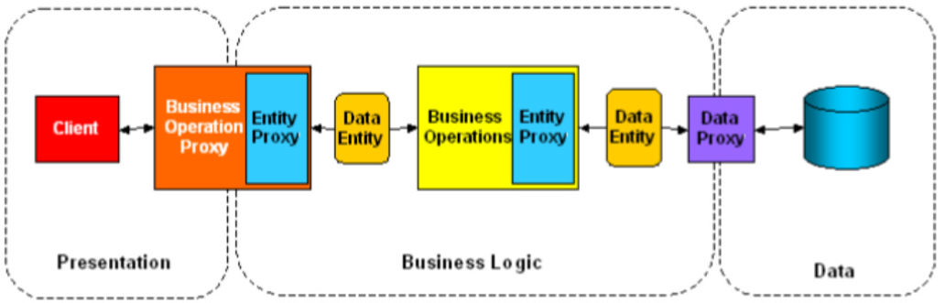

Data Entities
Data Entities, which present the developer with a simple collection-like interface for access to data, carry data sets throughout the application. In addition to automatically carrying the data that forms part of an application’s inter-tier communications, Data Entities implement the object persistence logic that is required to provide Load, Insert, Update, Delete commands, formatted from the internal state of the Entity. The Data Proxy (described later) will make use of this logic to execute entity-based database commands.

Business Operations Proxy
The Business Operations Proxy is the client developer’s view on the application through which all application functions will be exposed. Ideally, the client developer would be presented with a straightforward and OO style interface that exposes properties and methods e.g. a Customer would have properties for customer attributes and methods for customer manipulation i.e. load, save, find etc. The data is packaged into a Data Entity and passed onto the relevant Business Operations component as part of an operation request – typically a simple method call.

Business Operations Component
The Business Operations component implements business logic (operations, functions or transformations that are applied to business data). It does not define the data upon which its services operate.
A Method call into a Business Operations component, its Data Entity, and any other parameters will make up a well-formed request. If the operation is transacted, this request will carry with it everything that is required by the business operation component to fulfil the request (clearly the Business Operations component can gather additional data from other server based data sources). Once the operation is complete the Business Operation component will be deactivated in the standard MTS/COM+ way. Any state that is to be retained will either need to go back to the client as return / output values (or perhaps via a Data Entity managed by the Business Operations Proxy), or be persisted safely in the database. For Windows 2000 these are components that are “configured” i.e. they are placed within a COM+ application on the application server. Generally these components will participate in a COM+ automatic transaction. Using Microsoft Transaction Server (MTS) terminology, these components would be placed into an MTS managed package.

Entity Proxy
The Entity Proxy is implemented to provide intelligence to the Data Entity. Functionality provided may vary for client and server operations. At the client, this would tend to be code-driven validation like number ranges, data ranges, formats etc. rather than data driven (i.e. those validations that may require a cascade of database accesses in order to establish validity). For both client and server, functions provided would include the preparation of Data Entities that represent a business entity (e.g. a Customer, an Order etc.). This preparation would include assigning the appropriate metadata to a Data Entity (e.g. stored procedures that the Data Proxy will use to read/update/delete/insert the data for the entity). Also it may be necessary to create a new Data Entity that has just default data and metadata for a Business Operation to populate. There may also be instances where the metadata that the Data Proxy can retrieve from the database is inappropriate for the application (perhaps the field names in the database have been automatically generated, and are not human meaningful or even readable). This object-relational mapping can usually be deferred to the stored procedures that manipulate the database on behalf of an entity, however if necessary this could be implemented in the Entity Proxy. There are other ways in which this mapping could take place, including an extension to, or modification of the Data Proxy. However the most straightforward solution would be to have field names that are meaningful, if this is not possible then implement stored procedures that map to/from meaningful names.

Data Proxy
Like the Data Entity, the Data Proxy has been designed and optimised for multi-tier / disconnected / optimistic operations. It has specific functions for the manipulation of Data Entities: Load, Update, Delete, Insert etc. together with mechanisms for working with query resultsets and for passing textual commands directly to the data source.

Extensions to the pattern
Clearly there will always be application requirements that are not catered for in any design pattern. Elements such as the object relational mapping, briefly discussed earlier can present interesting issues if access to the database, its schema or stored procedures is not possible.
The implementation framework, detailed in the next section, is designed to operate against Microsoft SQL Server 7.0, a change in the database back end would require changes to both Data Entity and Data Proxy implementations.

Overview

The Entity Proxy Implementation Framework
Scalability has already been identified as a primary requirement in Windows DNA applications, particularly when they are destined for the Internet or large Intranet. The Entity Proxy model can be implemented using ADO, for example. It provides all of the required functionality (e.g.. data access, and resultset marshalling). Appropriate use of ADO achieves significant throughput (see the Results section). However a specific implementation that works towards maximizing the available machine resource needs a more optimal implementation. The implementation presented here is targeted at using SQL Server as its data store.
The primary requirement for this Entity Proxy implementation framework is scalability, this is evident in the SQL Server implementation’s choice of technologies (ODBC API, C++, ATL). However usability and approachability are also key goals, as a result the implementation is presented as a series of COM components that a developer can make use of in their choice of language (VB, C++, Java, Script / ASP etc.). The developer simply utilizes the framework’s collection-like interface to access data, without having to deal with the complexities of the powerful ODBC API.

Windows 2000
The implementation presented here was written and tested (for both functionality and scalability) on Windows 2000 Release Candidate 1. However, the core functionality of the code should function without change on Windows NT 4.0 (with SP4 or later) and Microsoft Transaction Server – however this configuration has not been tested.

Entity Proxy Components
The two principal components of the implementation framework are the Data Entity (typelibrary name and PROGID DataServices.Entity) and the Data Proxy (DataServices.Proxy). As their name suggests they are data related, each having a specific task: Data Entities (and Resultsets of Data Entities) carry data sets throughout the application (including being automatically marshalled by value across tiers). The Data Proxy provides a mechanism for Data Entities to interact with a data store (SQL Server in the current implementation). A secondary component the Dynamic Collection (DataServices.Dynamic) can be used as a generic, Visual Basic compatible, collection that also has the ability to be marshaled by value (it implements the IMarshal and IPersistStream interfaces).

Data Entity (DataServices.Entity)
The Data Entity is a data container, that maintains the raw data and metadata that represent a business entity (e.g. a Customer, an Order, a Product etc.). The data logic that is required to Retrieve, Insert, Update and Delete an entity’s data is also handled by the Data Entity. In the SQL Server implementation this logic takes the form of four stored procedure names, the parameters for which are generated by the Data Entity at the point where database communication is requested by the Data Proxy.
The Data Entity implements two interfaces, one of which is designed to be used by the application developer who is simply making use of the entity (IEntity), the other (IEntityData) is designed for use by a developer who needs to manipulate both entity data and metadata.

IEntity Interface (DataServices.Entity, default interface)
Method / Property | Action / Item
Item([in] VARIANT* Index, [out, retval] VARIANT* pvarRet); | Given an index, returns an item in the structure
Count([out, retval] long* pi4); | Returns number of items in structure
_NewEnum([out, retval] IUnknown** ppunk); | Return an enumerator for this entity
EditMode([in] ColEditModeEnum newVal); | The EditMode represents the current state of the entity data
Key(long Index, [in] BSTR newVal); | The name of a field in the entity
Field([in] VARIANT *Index, [out, retval] VARIANT *pVal);  Field([in] VARIANT *Index, [in] VARIANT *pVal); | Entity Data Item
Recordset([in] _Recordset* newVal); | Assign an ADO record to an entity

IEntityData Interface (DataServices.IEntityData)
Method / Property | Action / Item
Item([in] VARIANT* Index, [out, retval] VARIANT* pvarRet); | Given an index, returns an item in the structure
Add([in] VARIANT* Item, [in, optional] VARIANT* Key, [in, optional] VARIANT* Before, [in, optional] VARIANT* After); | Adds an item to the structure
Count([out, retval] long* pi4); | Returns number of items in structure
Remove([in] VARIANT* Index); | Removes an item from the structure
_NewEnum([out, retval] IUnknown** ppunk); | Return an enumerator for this entity
Initialize(long Size); | Initialize the structure to a given size
EditMode([in] ColEditModeEnum newVal); | The EditMode represents the current state of the entity data
Key(long Index, [in] BSTR newVal); | The name of a field in the entity
Insert([in] long Index, [in] BSTR Key, [in] VARIANT *pVal); | Insert a metadata item into the entity
Field([in] VARIANT *Index, [out, retval] VARIANT *pVal);  Field([in] VARIANT *Index, [in] VARIANT *pVal); | Entity Data Item
Recordset([in] _Recordset* newVal); | Assign an ADO record to an entity
UpdateCommand([out, retval] BSTR *pVal); | Retrieve the internal UpdateCommand for this entity
ReadCommand([out, retval] BSTR *pVal); | Retrieve the internal ReadCommand for this entity
UpdateStoredProcedure([in] BSTR newVal);  UpdateStoredProcedure ([out, retval] BSTR *pVal); | Stored procedure used for storing entity data to the database
ReadStoredProcedure([in] BSTR newVal);  ReadStoredProcedure ([out, retval] BSTR *pVal); | Stored procedure used for reading an entity from the database
KeyField([in] BSTR newVal);  KeyField ([out, retval] BSTR *pVal); | The database primary key field for this entity
Append(VARIANT *pItem, VARIANT *pKey); | Append and item to the entity
DeleteStoredProcedure([out, retval] BSTR *pVal);  DeleteStoredProcedure ([in] BSTR newVal); | Stored procedure used for deleting an entity from the database
DeleteCommand([out, retval] BSTR *pVal); | Retrieve the internal DeleteCommand for this entity
InsertStoredProcedure([out, retval] BSTR *pVal);  InsertStoredProcedure ([in] BSTR newVal); | Stored procedure used for inserting an entity into the database
InsertCommand([out, retval] BSTR *pVal); | Retrieve the internal InsertCommand for this entity

Entity Metadata
Each Data Entity carries the raw data that makes up a business entity. In addition to the data, a certain of metadata is also maintained.

- Field datatypes
- Stored Procedures (Load, Update, Delete, Insert)
- Entity Status (edited, deleted etc.)

Automatic Construction
The datatype metadata is built from database resultset schema in the majority of cases. However if necessary (and often desired in order to minimize database access) the metadata can be built programmatically. One of the primary uses for manual metadata creation will be fore the Insert or AddNew case (see the Usage Scenarios section for details).

Programatic Construction
Manually the developer can construct the metadata using code similar to the following:

Dim entity as IEntityData

Set entity = New DataServices.Entity
' Initialize the entity with the appropriate number of fields
enitity.Initialize 5

' Add a placeholder to the entity (for each field) ready for the data
entity.Insert 1, "OrderID", 0
entity.Insert 2, "ProductID", 0
entity.Insert 3, "UnitPrice", 0#
entity.Insert 4, "Quantity", 0
entity.Insert 5, "Discount", 0#

' Intially the entity is marked as being in Add mode.
entity.EditMode = colEditAdd
' Assign the names of the entity's stored procedures.
entity.ReadStoredProcedure = "spOrderDetailsLoad"
entity.UpdateStoredProcedure = "spOrderDetailsUpdate"
entity.DeleteStoredProcedure = "spOrderDetailsDelete"
entity.InsertStoredProcedure = "spOrderDetailsInsert"
entity.KeyField = "OrderID"

Once the metadata is in place the Data Entity will maintain run-time type safety by not allowing any other type, than the metadata dictates, to be assigned to the field. The most efficient method of creating new entities is to manually create the metadata as shown above, the alternative would incur a database access to gather a resultset and its associated schema. However, the developer can use the EPGen tool to automatically generate the entity creation code and typical stored procedures and for an existing table or view in a data source.

Data Proxy (DataServices.Proxy)

The Data Proxy is desgined to provide very high performance (with very high scalability characteristics) access to the underlying data source. The “IDataProxy” interface provides methods specific to dealing with Data Entities (Retrieve, Insert, Update, Delete, Query, Lookup etc.) for which it will use, or populate, the private metadata of the Data Entity in order to perform the requested operation. In addition methods for simply sending a textual command to the database are supported, as well as some simplistic support for the use of ADO for database operations.

Note that the methods that return either a Data Entity or a Resultset of Data Entities have optional parameters that specify stored procedure names. These stored procedures will be used if the developers requests that the entity be inserted, updated, deleted at some future time.

Method / Property | Action / Item
Execute([in] BSTR SQLString, [out, retval] long *Result) | Execute a SQL String as fast as possible, if a result is requested (i.e. a non-null value is passed in for the Result parameter), then the first row of the first column in the resultset is returned as a long.
ManualConstruct([in] BSTR ConstructString); | Construct the DB connection using the provided connection string e.g."DSN=Northwind;UID=sa;PWD="
EntityUpdate([in]IEntityData *Entity, [out, retval] long *Result); | Update the database using a given entity as it's source
EntityLoad([in] BSTR ReadStoredProc, [in] BSTR UpdateStoredProc, [in] BSTR DeleteStoredProc, [in] BSTR InsertStoredProc, [in] BSTR KeyField, [in] VARIANT KeyValue, [out, optional] long *Result, [out, retval] IEntityData **Entity); | Load an entity from the database. Entity metadata is built from the resultset schema information.
EntityQuery([in]BSTR SQLString, [out, optional] long * Result, [in, optional] BSTR ReadStoredProc, [in, optional] BSTR UpdateStoredProc, [in, optional] BSTR DeleteStoredProc, [in, optional] BSTR InsertStoredProc, [in, optional] BSTR KeyField, [out, retval] IResultset **Resultset); | Query for a collection of entities. The results are returned in a DataServices.Resultset.
EntityRead([in] IEntityData *Entity, [out, retval] long *Results); | Retrieve an entity's data from the database. Metadata is not built from resultset schema. i.e. the correct metadata must already exist.
EntityLookup([in]BSTR SQLString, [out, optional] long * Result, [in, optional] BSTR ReadStoredProc, [in, optional] BSTR UpdateStoredProc, [in, optional] BSTR DeleteStoredProc, [in, optional] BSTR InsertStoredProc, [in, optional] BSTR KeyField, [out, retval] IEntityData **Entity); | Lookup entities - first found is returned. Use NextEntity for subsequent entities.
NextEntity([out, retval] IEntityData **Entity); | Retrieve the next entity from the current lookup set
LookupFree(); | Free up resources used in the current entity lookup
EntityDelete([in] IEntityData *Entity, [out, retval] long *Result); | Delete the entity from the database
EntityInsert(IEntityData *Entity, [out, retval] long *Result); | Insert into the database using a given entity as it's source
NextResultset([out, optional] long * Result, [out, retval] IResultset **Resultset); | Retrieve the next Resultset for the current query. This may be used if a query or stored procedure returns multiple resultsets.
NextLookup([out, optional] long *Result, [out, retval] IEntityData **Entity); | Retrieve the first entity of the next set of results for the current lookup. This may be used if a query or stored procedure returns multiple resultsets.
RSQuery([in] BSTR QueryText, [out, optional] VARIANT *Result, [out, retval] _Recordset ** Recordset); | Query for an ADO Recordset and SP return value (int) - read only and disconnected
RSQueryRW([in] BSTR QueryText, [out, optional] VARIANT *Result, [out, retval] _Recordset **rs); | Query for an ADO Recordset and SP return value (int) - read/write and disconnected
RSUpdate(_Recordset *rs); | Update the database using the given ADO recordset as a source

Resultset (DataServices.Resultset)
The Resultset is a very simple collection that is read-only once created by the Data Proxy and can only contain instances of Data Entities.
Method / Property | Action / Item
Record (long nIndex, [out, retval] IEntityData **pVal); | Given an index, returns an entity item in the resultset
Count([out, retval] long* pi4); | Returns number of items in the resultset
_NewEnum([out, retval] IUnknown** ppunk); | Return an enumerator for this resultset

Dynamic Collection (DataServices.Dynamic)
The Dynamic collection is a generic, Visual Basic compatible collection that is both high performance and can be marshalled by value. The collection can have other object instances placed in it, and if they are themselves persistable (implement IPersistStream) then they will be marshalled by value along with the collection.

Method / Property | Action / Item
Item([in] VARIANT* Index, [out, retval] VARIANT* pvarRet); | Given an index, returns an item in the collection
Add([in] VARIANT* Item, [in, optional] VARIANT* Key, [in, optional] VARIANT* Before, [in, optional] VARIANT* After); | Adds an item to the collection
Count([out, retval] long* pi4); | Returns number of items in collection
Remove([in] VARIANT* Index); | Removes an item from the collection
_NewEnum([out, retval] IUnknown** ppunk); | Return an enumerator for this collection

Overview

Implementation Technologies
Implementation technologies were chosen according to two priorities:
- Performance and Scalability
- Approachability of exposed interfaces

The decision process was very simple: internally to the implementation use the technologies and techniques that would achieve the most performance and scalability, however the exposed interface must be simple, but powerful, and extensible enough to cope with the majority of Windows DNA application scenarios.

ODBC API
The research conducted by Robert Barnes et al, clearly show that the ODBC API is currently the fastest and most scalable data access mechanism available for Microsoft SQL Server. For this reason ODBC API was chosen for all database access within the Entity Proxy implementation. In summary, data being retrieved from the database is bound using SQLBindCol, rather than SQLGetData. While SQLBindCol requires the ODBC driver to allocate memory for the binding information it was found that the performance of a single call to SQLFetch and the automatic binding was better than many calls to SQLGetData. Single value returns (as in IDataProxy::Execute) use SQLGetData.

Visual C++ and the Active Template Library
Visual C++ and the Active Template Library provide the potential for the fastest code of all the tools in Visual Studio. It also provides the flexibility to achieve the most efficient and scalable use of memory and other system services.

Standard COM Interfaces

IMarshal
IMarshal is implemented by DataServices.Entity, DataServices.Resultset and DataServices.Dynamic to marshal-by-value the internal data and metadata across machine and apartment boundaries.

IPersistStream
Nearly identical in implementation to IMarshal, implementing IPersisStream allows objects to be persisted easily into MSMQ message bodies and used with Strutured Storage.

Collection
The collection interface implemented by DataServices.Dynamic (and a derivative of which is implemented by DataServices.Entity) is the same as the one implemented by the standard Visual Basic collection object. However the DataServices.Dynamic collection has the advantage that it is highly scalable in the way it uses memory, and it implements both IMarshal and IPersistStream for marshal-by-value behaviour. Any object that has been placed in the collection will have it’s IPersistStream implementaion delegated to by the collection to marshal-by-value or persist it’s state.

Use of Memory
Use of memory in a server environment is a critical element in achieving scalability. There are a number of ways of minimizing heap access, some of which will involve the use of static or automatically allocated memory so that there is only one single heap allocation for an entire object instance. The limitations of this are clear – a decision must be made at compile-time as to the size of the memory to be allocated. The DataServices components use a fixed-length allocator scheme that allows an object to dynamically allocate memory depending on the size of metadata reported by the database or requested by the developer but minimizing the number of actual heap allocations that take place. A full discussion of fixed length allocators are outside the scope of this paper. However their usage dramatically reduces the amount of heap traffic and so reduces the serialization that can occur when accessing a single heap.

Scalability Testing

Hardware
Scalability was tested utilising the Microsoft Windows DNA Performance Tuning Kit on the following hardware:

- Application Server
Compaq Proliant 7000
4 x 200MHz Pentium Pro
1.2 Gb RAM
38Gb Disk (Arranged in 2 hardware striped arrays of 4 x 4.8 Gb disks each)
100 Mbit Ethernet
Windows 2000 Advanced Server RC1

- Database Server
Compaq Proliant 7000
4 x 200MHz Pentium Pro
640 Mb RAM
72 Gb Data Disk (4 x 18Gb hardware striped array)
19.2 Gb Log Disk (4 x 4.8 Gb hardware striped array)
4.8 Gb System Disk
4.8 Gb DTC Log Disk
Windows 2000 Advanced Server RC1
SQL Server 7.0

- Clients
Compaq Professional Workstation
2 x 200MHz Pentium Pro
64 Mb RAM
Windows 2000 Professional RC1

System Setup
The SQL Server had one dedicated RAID disk array for the database, and one for the database log. The single DTC (only one DTC was used for both application and database servers) was housed on the database server and had a dedicated disk for its log (though the activity of this log appeared negligible). Log activity, as expected, was the highest, but never accounting for more than 20% of disk time.

The application
The application was an OLTP style order entry system with requests being made from a large number of simultaneous clients. The back-end database was an expanded version of Northwind (300Mb in size at the start of the test). Since the focus of this test was the middle tier and the scalability of the design pattern and its framework implementation the fact that the database could be accommodated 100% in the database server memory was not a concern. At no point during the final test was the SQL Database Server a bottleneck.

Transaction
The transaction consisted of the following:

- Read a random customer
- Read a random product (the assumption here is that the customer detail has some influencing preference that affects the product choice).
- Create a new entry in the orders table (using details from the customer)
- Create a new entry in the order details table (using details from the new order and the product).

Tests were conducted by calling SQL stored procedures using “a sequence of typical ADO steps” and also using the entity/proxy implementation.

Think Time
Think time for each user was chosen using the Windows DNA Performance tuning kit’s “exponential” setting with times ranging between 20 and 60 seconds.

ADO Operation Code
In the ADO implementation, ADO parameter objects were not used for the final tests, however they were used in an earlier, interim, test and no appreciable difference in scalability was evident – this makes sense, since it would be a SQL Server processing penalty to send the commands through to the database as text as we did, not a middle tier one (where ultimately the ADO bottleneck appeared).

Dim rsCustomer As New ADODB.Recordset
Dim rsProduct As New ADODB.Recordset
Dim rsOrder As New ADODB.Recordset
Dim cmd As New ADODB.Command

cmd.ActiveConnection = "Provider=SQLOLEDB.1;Password=;Persist Security Info=True;User ID=kmpdf;Initial Catalog=Northwind;Data Source=SCALELABDB"

cmd.CommandType = adCmdText
cmd.CommandText = "EXEC spCustomerLoad @CustomerID = '" & ChooseCustomer(CLng(m_random1 * 90) + 1) & "'"
rsCustomer.CursorLocation = adUseClient
rsCustomer.CursorType = adOpenStatic
rsCustomer.LockType = adLockReadOnly
rsCustomer.Open cmd

cmd.CommandText = "EXEC spProductLoad @ProductID = " & (CLng(m_random2 * 76) + 1)
rsProduct.CursorLocation = adUseClient
rsProduct.CursorType = adOpenStatic
rsProduct.LockType = adLockReadOnly
rsProduct.Open cmd

cmd.CommandText = "EXEC spOrderUpdate @OrderID = 0, @CustomerID = """ & rsCustomer!CustomerID & """, @EmployeeID = 3, @OrderDate = ""July 23 1999"", @RequiredDate = ""July 23 1999"", @ShippedDate = ""July 23 1999"", @ShipVia = 1, @Freight = ""17.52"", @ShipName = """ & rsCustomer!ContactName & """, @ShipAddress = """ & rsCustomer!Address & """, @ShipCity = """ & rsCustomer!City & """, @ShipRegion = ' ', @ShipPostalCode = """ & rsCustomer!PostalCode & """, @ShipCountry = """ & rsCustomer!Country & """"
rsOrder.CursorLocation = adUseClient
rsOrder.CursorType = adOpenStatic
rsOrder.LockType = adLockReadOnly
rsOrder.Open cmd

cmd.CommandText = "EXEC spOrderDetailsUpdate @OrderID = " & rsOrder.Fields(0) & ", @ProductID = " & rsProduct!ProductID & ", @UnitPrice = " & rsProduct!UnitPrice & ", @Quantity = 1, @Discount = 0"
cmd.Execute

Entity / Proxy Operation Code

Dim proxy As New DataServices.proxy
Dim customer As IEntityData
Dim order As IEntityData
Dim orderitem As IEntityData
Dim product As IEntityData

proxy.ManualConstruct "DSN=Northwind;uid=kmpdf;PWD="

Set customer = proxy.EntityLoad("spCustomerLoad", "spCustomerUpdate", "spCustomerDelete", "cpCustomerInsert", "CustomerID", ChooseCustomer(CLng(m_random1 * 90) + 1))
Set product = proxy.EntityLoad("spProductLoad", "spProductUpdate", "spProductDelete", "spProductInsert", "ProductID", CLng(m_random2 * 76) + 1)
CreateNewOrder order, sErr

order!CustomerID = customer!CustomerID
order!EmployeeID = 3
order!ShipVia = 1
order!Freight = 17.52
order!ShipName = customer!ContactName
order!ShipAddress = customer!Address
order!ShipCity = customer!City
order!ShipRegion = customer!Region
order!ShipPostalCode = customer!PostalCode
order!ShipCountry = customer!Country

CreateNewOrderItem orderitem, sErr

orderitem!OrderID = proxy.EntityUpdate(order)
orderitem!ProductID = product!ProductID
orderitem!UnitPrice = product!UnitPrice
orderitem!Quantity = 1
orderitem!Discount = 0

proxy.EntityUpdate(orderitem)

The graphs show the performance of the ADO code secions (shown above) vs. the code sections that use the Entity Proxy implementation framework. The design of both applications was identical, based on the Entity Proxy Model. Care was taken to assertain the most performant usage of ADO.

Results

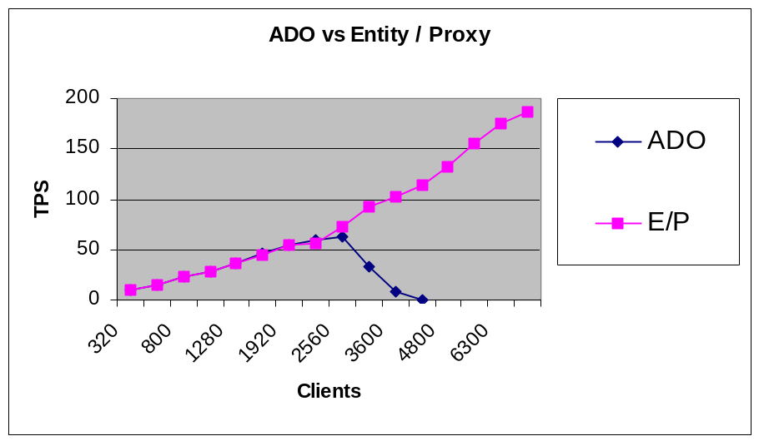
Graph 1: Shows ADO code results vs. Entity/Proxy results

The sharp drop off in the number of valid transactions per second (TPS) shown in the graph above is in fact the transactions that returned to the “user” within the two second allowed time period. The number of transactions actually processed by the system in both the ADO and Entity Proxy cases actually flattened after their peaks. For the Entity Proxy tests the available clients were exhausted before the full test could be completed. However the behaviour of the middle tier server had almost identical characteristics in terms of CPU usage etc. at it’s peak as that at the peak of the ADO test. The prediction is that the results for Entity Proxy would model those of ADO, but clearly scaled by about 2.5 to 3 times.

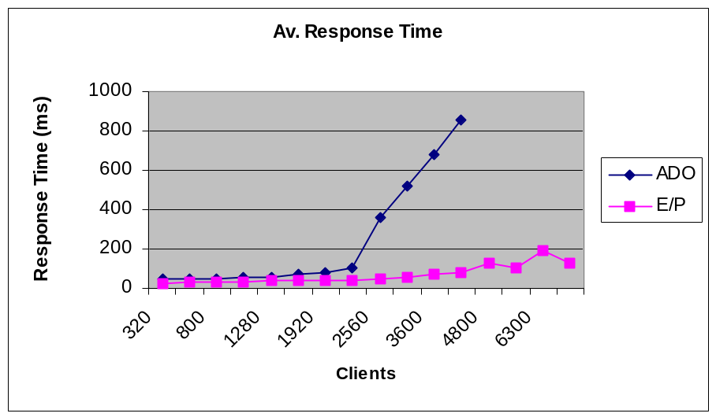
Graph 2: Shows ADO code response time vs. Entity/Proxy.

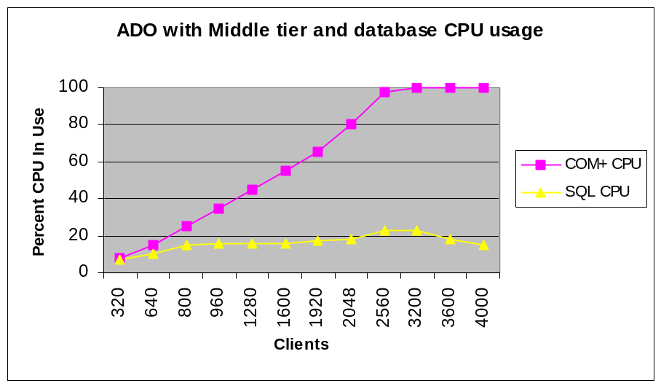
Graph 3: Shows Server CPU usage for ADO code.

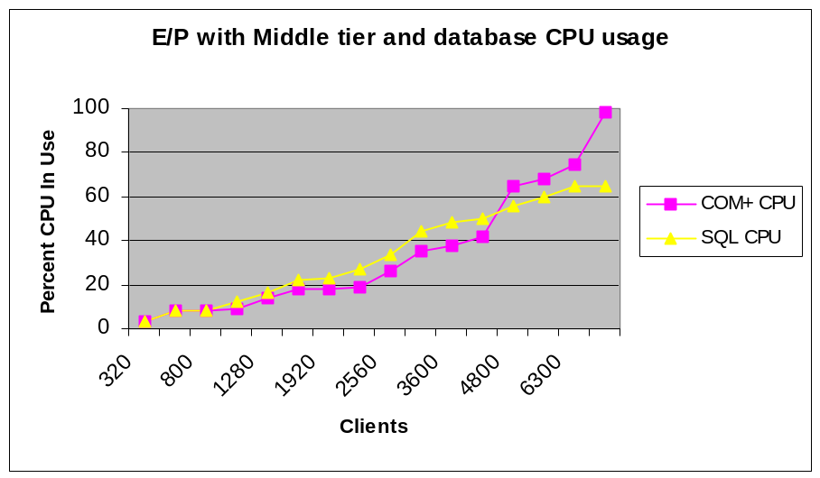
Graph 4: Shows Server CPU usage for Entity / Proxy code.

The core implementation technologies of Windows DNA applications consist of two elements:

Summary / Conclusion

- Data Access – the ability to connect to a database, send commands and retrieve results.
- Data Movement – the transfer of data from the data source across the tiers of a distributed application (either as method parameters or properties or even as the body of a message in MSMQ).

The performance and scalability of these two critical elements can be thought of being on the critical path to the performance and scalability of the whole application. Therefore careful and targeted investment in these areas can go a long way to improve the performance and scalability of the implementation. The Entity Proxy Implementation framework targets these two areas exclusively with the most performant and scalable technologies available.

However, as is often overlooked, the design of the system – both hardware and software – is also critical. Designing high performance Windows DNA applications will involve addressing the ideal working conditions of each tier:

- Client – the client developer wants to see long lived objects that can be programmed using object oriented techniques.
- Middle Tier – in the transactional case needs a “surgical strike” approach to work. The operations for the transaction are short and directed. Transformations, functions and modifications to data will happen within the protective embrace of the transaction. Once complete the data will either be safely persisted into the data store, or on the client ready for action.
- Database – data oriented logic should happen in the database. It makes little sense to move data out of the database, make some small change, and then immediately put the data back all within a single transaction. This kind of operation belongs in close proximity to the data – ie. In a stored procedure.

The Entity Proxy model defines an informal design pattern, designed provide the developer with a clear path to the ideal working conditions of each tier in the core of a Windows DNA application. Coupled with the implementation framework for SQL Server; scalability and performance are available to all developers irrespective of implementation language.

Overview

Appendix 1: The EPGen Tool
During the development and testing of the implementation framework, it became evident that a significant amount of very similar T/SQL and Visual Basic code would be written by developers using the components. As a result, a tool, called EPGen was created, and has been included as an element of Entity Proxy to generate template / sample code for the common usage scenarios.
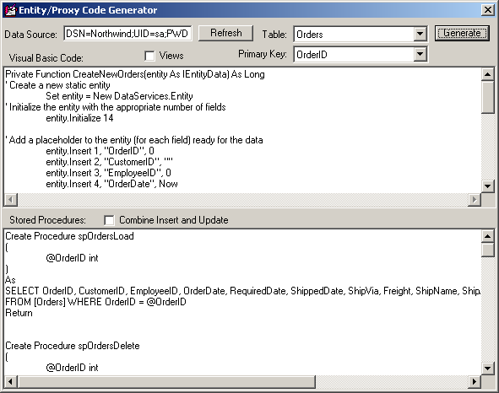

Screenshot – the EPGen tool in use

Visual Basic Code
The Visual Basic code that EPGen generates is the function that creates a new, empty Data Entity. This is generally used in insert or AddNew scenarios. The code generated, simple creates an instance of a Data Entity and populates its metadata with fieldnames, datatypes and default values. Default stored procedure names are also created and added to the Data Entity’s metadata. Moving this step into the code stage saves the often required, and very expensive, runtime database access in order to create a new database row – this is the standard mechanism for ADO’s Recordset.AddNew method.

T/SQL Stored Procedures
Four T/SQL stored procedures are created by EPGen. EPGen only caters for the simple case where an entity lives in a single table, and has a single value key. However the code generated is valid sample code for how to cater for the more complex case.
- sp<table>Load takes a single parameter that is the keyfield for the business entity. This stored procedure will pull together the data elements that make up the business entity.
- sp<table>Delete, again takes a single keyfield parameter. The stored procedure will delete the business entity from the database.
- sp<table>Update, takes a parameter for each data item in the business entity. The Data Entity will automatically generate the T/SQL code to call the stored procedure and add the required parameters. The code within the stored procedure updates the business entity – the simple case has a WHERE clause that uses the keyfield. Clearly this could be altered to encompass any of the parameters passed.
- sp<table>Insert. Very similar to the sp<table>Update stored procedure (indeed EPGen and the DataServices components support combining insert and update stored procedures). The parameter list is the same. The implementation of the stored procedure will insert entity data items into the relevant tables in the database. Once again, the simple case is a single table.

The stored procedures generated by EPGen have SET NOCOUNT ON in their implementation to prevent SQL communicating anything but the final result back to the Data Proxy. This is both an optimization (no traffic except those results explicitly requested will be passed back to the application) and to simplify the code written against the Data Proxy. The Data Proxy implementation supports the navigation of multiple resultsets, however this is not often required.

Overview

Appendix 2: Usage Scenarios
The following section includes the description of A number of common usage scenarios, together with Visual Basic code to implement sample business logic.

Scenario 1 – Sending a textual SQL command to the database.
Sending SQL commands to the database is very straightforward using the framework. The steps are as follows:

- Create an instance of DataServices.Proxy
- Call the ManualConstruct method, passing an ODBC datasource string, to connect to the database
- Call the DataServices.Proxy::Execute method to execute the SQL.

Visual Basic Code:

Dim dataproxy As DataServices.Proxy
Set dataproxy = New DataServices.Proxy

dataproxy.ManualConstruct “DSN=Northwind”
dataproxy.Execute “UPDATE Products SET UnitPrice = 31.0 Where ProductID = 10”

Scenario 2 - Read a single business entity from the database
In order to use the automatic entity loading system built into the framework (EntityLoad) a stored procedure that accepts a single key field value as a parameter is required. For entities that have a compound key then the EntityLookup method is more appropriate. The steps are as follows:

- Create stored procedure that accepts a single key value to return the business entity data (EPGen can generate this for single column entities)
- Create an instance of DataServices.Proxy
- Call the DataServices.Proxy::ManualConstruct method, passing an ODBC datasource string, to connect to the database
- Call the DataServices.Proxy::EntityLoad method passing the names of stored procedures for Load, Update, Delete, Insert, the name of the Key field and the key value.

T/SQL Stored Procedure (Load):

Create Procedure spProductsLoad
(
@ProductID int
)
As
SELECT ProductID, ProductName, SupplierID, CategoryID, QuantityPerUnit, UnitPrice, UnitsInStock, UnitsOnOrder, ReorderLevel, Discontinued
FROM [Products] WHERE ProductID = @ProductID
Return

Visual Basic Code:

Dim dataproxy As DataServices.Proxy
Dim product As DataServices.Entity
Set dataproxy = New DataServices.Proxy

dataproxy.ManualConstruct “DSN=Northwind”

Set product = proxy.EntityLoad("spProductsLoad", "spProductsUpdate", "spProductsDelete", "spProductsInsert", "ProductID", 10)

Scenario 3 – Read a business entity, make a change and save the results back
This scenario is a little unrealistic, since a simplistic change like this would be best achieved in a single SQL call through to the database, which would be both atomic and directed. The steps are as follows:

- Create a “load” stored procedure that accepts a single key value to return the business entity data (EPGen can generate this for single column entities)
- Create an “update” stored procedure that accepts all of the entity data items as parameters and updates the corresponding data in the database (once again, EPGen can create this for the single table case).
- Create an instance of DataServices.Proxy
- Call the DataServices.Proxy::ManualConstruct method, passing an ODBC datasource string, to connect to the database
- Call the DataServices.Proxy::EntityLoad method passing the names of stored procedures for Load, Update, Delete, Insert, the name of the Key field and the key value.
- Change one of the data items in the Data Entity
- Call the DataServices.Proxy::EntityUpdate (or DataServices.Proxy::Execute) to update the database via the update stored procedure.

The difference at step 7 represents a choice to either pass the Data Entity to the Data Proxy as a parameter, or to extract the UpdateCommand from the Data Entity and pass this as a simple SQL text command to the Data Proxy. Situations where this might be useful are if the Data Proxy is executing on a different machine to the business logic and a choice has been made to marshal the entire DataServices.Entity to the DataServices.Proxy’s location (maybe across the network).

T/SQL Stored Procedure (Update):

CREATE Procedure spProductsUpdate
(
@ProductID int,
@ProductName nvarchar(40),
@SupplierID int,
@CategoryID int,
@QuantityPerUnit nvarchar(20),
@UnitPrice money,
@UnitsInStock smallint,
@UnitsOnOrder smallint,
@ReorderLevel smallint,
@Discontinued bit
)
As
SET NOCOUNT ON
UPDATE [Products]
SET
ProductName = @ProductName,
SupplierID = @SupplierID,
CategoryID = @CategoryID,
QuantityPerUnit = @QuantityPerUnit,
UnitPrice = @UnitPrice,
UnitsInStock = @UnitsInStock,
UnitsOnOrder = @UnitsOnOrder,
ReorderLevel = @ReorderLevel,
Discontinued = @Discontinued
WHERE ProductID = @ProductID
SELECT @ProductID
Return

Visual Basic Code:

Dim dataproxy As DataServices.Proxy
Dim product As DataServices.Entity
Set dataproxy = New DataServices.Proxy

dataproxy.ManualConstruct “DSN=Northwind”

Set product = proxy.EntityLoad("spProductsLoad", "spProductsUpdate", "spProductsDelete", "spProductsInsert", "ProductID", 10)

product!UnitPrice = 31.0

dataproxy.EntityUpdate(product)
‘ or alternatively
‘ dataproxy.Execute (product.UpdateCommand)

Scenario 4 – Lookup an entity in the database where no Load stored procedure exists, and/or there will be more than a single entity returned
The DataServices.Proxy object supports the EntityLookup method. This method accepts a SQL text command, and the usual stored procedure names for update etc. If the results of the SQL command return more than a single entity, then the DataServices.Proxy::NextEntity method can be used to get each subsequent entity. This mechanism is only recommended for small resultsets. The steps are as follows:

- Create an instance of DataServices.Proxy
- Call the ManualConstruct method, passing an ODBC datasource string, to connect to the database
- Call the DataServices.Proxy::EntityLookup method to execute the SQL

Visual Basic Code:

Dim dataproxy As DataServices.Proxy
Dim product As DataServices.Entity
Set dataproxy = New DataServices.Proxy

dataproxy.ManualConstruct “DSN=Northwind”
Set product = dataproxy.EntityLookup(“SELECT * FROM Pruducts”)

‘ now call Set product = dataproxy.NextEntity
‘ for each additional entity

‘ finally, cleanup the Lookup

dataproxy. LookupFree

Scenario 5 – Query for many results / entities
The DataServices.Proxy::EntityQuery method allows the developer to query for a number of entities, and (unlike EntityLookup) return the entire resultset in a single marshal-by-value object. As with the other data loading calls, DataServices.Proxy::EntityQuery optionally accepts the stored procedures to provide the automatice update commands. The steps are as follows:

- Create an instance of DataServices.Proxy
- Call the ManualConstruct method, passing an ODBC datasource string, to connect to the database
- Call the DataServices.Proxy::EntityQuery method to execute the SQL

Visual Basic Code:

Dim dataproxy As DataServices.Proxy
Dim products As DataServices.Resultset
Set dataproxy = New DataServices.Proxy

dataproxy.ManualConstruct “DSN=Northwind”
Set products = dataproxy.EntityQuery(“SELECT * FROM Pruducts”)

Scenario 6 – Insert a new business entity into the database
In this scenario we will make use of DataServices’ built-in support for inserting new entities in to the database. We will write the code necessary to create a new empty entity (without hitting the database), populate it with required data and then insert it into the database. The steps are as follows:

- Create an “insert” stored procedure that accepts all of the entity data items as parameters and inserts the corresponding data into the database (once again, EPGen can create this for the single table case).
- Create an instance of DataServices.Proxy
- Call the DataServices.Proxy::ManualConstruct method, passing an ODBC datasource string, to connect to the database
- Call the method (optionally generated by EPGen) to create an empty DataServices.Entity object
- Populate with the required data
- Call the DataServices.Proxy::EntityUpdate (or DataServices.Proxy::Execute) to insert into the database via the insert stored procedure.

Visual Basic Code:

Dim dataproxy As DataServices.Proxy
Dim product As DataServices.IEntityData
Set dataproxy = New DataServices.Proxy

dataproxy.ManualConstruct “DSN=Northwind”

‘ Function generated by EPGen
CreateNewProduct(product)

product!ProductName = “Widget”
product!SupplierID = 1
product!UnitPrice = 99.99
‘ fill in the remainder of the fields as required

dataproxy.EntityUpdate(product)
‘ or alternatively
‘ dataproxy.Execute (product.InsertCommand)

For more information on the Windows Distributed interNet Applciation architecture see:

For more information
http://www.microsoft.com/dna/

For more information on performance and scalability, download the WinDNA Performance Kit from the Microsoft COM Web site at http://www.microsoft.com/com/resources/WinDNAperf.asp.

For more information on the Microsoft Solutions Framework, refer to:
http://www.microsoft.com/msf

To obtain the source code for the SQL Server 7.0 Entity Proxy implementation framework please refer to the Windows 2000 Platform SDK.

