C H A P T E R 5

General Interaction Techniques
This chapter covers basic interaction techniques, such as navigation, selection, viewing, editing, and creation. Many of these techniques are based on an object-action paradigm in which a user identifies an object and then identifies an action to apply to that object. Maintaining consistency with these techniques allows users to transfer their skills to new tasks.

Where applicable, support the basic interaction techniques for the mouse, keyboard, and pen. When adding or extending these basic functions, consider how the feature or function can be supported across input devices. Techniques for a particular device need not be identical for all devices. Instead, tailor techniques to optimize the strengths of that device. In addition, make it easy for the user to switch between devices so that an interaction that is started with one device can be completed with another. For example, the system supports mouse and keyboard access to menus. Both provide fast access to a menu item. Both allow a user to choose a menu item with one and complete the action with the other.

Navigation
One of the ways of most common ways of identifying an object is navigation. The following sections include information about mouse, pen, and keyboard techniques.

Mouse and Pen Navigation
Navigation with the mouse is simple; when a user moves the mouse left or right, the pointer moves in the corresponding direction on the screen. As the mouse moves away from or toward a user, the pointer moves up or down. By moving the mouse, a user can move the pointer to any location on the screen.

Pen navigation is similar to mouse navigation, except that you navigate by moving across the display without touching the screen.

Keyboard Navigation
Keyboard navigation uses specific keys and key combinations to move a cursor or input focus (the indication of where the input is being directed) to a particular location.

Basic Navigation Keys
The navigation keys are the four arrow keys, home, end, page up, page down, and the tab key. When combined with the ctrl key, the movement increment is increased. For example, pressing right arrow moves right one character in a text field. Pressing ctrl+right arrow moves right one word in the text field. You may assign navigation operations to keys in addition to those listed.

Table 5.1 Basic Navigation Keys
Key | Moves cursor to... | ctrl+key moves cursor to...
left arrow | Left one unit. | Left one (larger) unit.
right arrow | Right one unit. | Right one (larger) unit.
up arrow | Up one unit or line. | Up one (larger) unit.
down arrow | Down one unit or line. | Down one (larger) unit.
home | Beginning of line. | Beginning of data or file (topmost position).
end | End of line. | End of data or file (bottommost position).
page up | Up one screen (previous screen, same position). | Left one screen (or previous unit, if left is not meaningful).
page down | Down one screen (next screen, same position). | Right one screen (or next unit, if right is not meaningful).
tab | Next field. (shift+tab moves in reverse order). | Next larger field.

Unlike mouse and pen navigation, keyboard navigation typically affects existing selections. However, use the scroll lock key to enable scrolling navigation without affecting existing selections.

Navigation Keys with Controls
Keyboard navigation with controls commonly use the four arrow keys and the tab, enter, and esc keys.

n Pressing tab moves to the next control (except in menus) without activating it. Use the spacebar to activate the control.
n Pressing enter navigates to and activates a default command button. In menus, enter activates the command to which the user has navigated.
n Pressing esc navigates to and activates the Cancel or Close button. In menus, esc cancels the current menu level. (alt toggles a user in and out of the menu bar.)

You can also use arrow keys (or other navigation keys, such as home and end) to navigate between controls when the key is in use within the current control. However, such use is less common and cannot always be consistently applied.

For more information about default command buttons, see Chapter 8, "Secondary Windows."

You can also use access keys to support navigation to a particular control. Access keys use the alt key plus the key matching a specific character in the control's label. However, access keys combine navigation with activation. For some controls — for example, buttons — this will result in executing the associated command.

When using access keys to access a control, the input focus usually remains on that control unless:

n The action causes the control to be removed (the window or menu is no longer displayed).
n The action affects the content of a control that was navigated from. For example, if a user is currently working in a list box and uses the access key to choose an Add or Delete button that affects the content of that list box, pressing the appropriate access key activates the corresponding button (and its action), but returns the focus to the list.

Selection
Selection is the primary means by which the user identifies objects in the interface. As a result, the basic model for selection is one of the most important aspects of the interface.

Selection is typically an overt action by the user to identify an object — an explicit selection. Once an object is selected, the user can specify an action for the object.

There are also situations where the identification of an object can be derived by inference or context — an implicit selection. This method works most effectively where the association of object and action is simple and visible. For example, when the user drags a scroll box, the user establishes selection of the scroll box and the action of moving at the same time. Implicit selection may result from the relationships of a particular object. For example, selecting a character in a text document may implicitly select the paragraph of which the character is a part.

Selections are classified as single (involving only a single object) or multiple (involving multiple objects). You can further classify multiple selections as contiguous–where the selection set is made up of objects that are logically adjacent to each other, also known as a range selection. A disjoint selection set is made up of objects that are spatially or logically separated.

Multiple selections may also be classified as homogeneous or heterogeneous, depending on the type or properties of the selected objects. Even a homogeneous selection might have certain aspects in which it is heterogeneous. For example, a text selection that includes bold and italic text can be considered homogeneous with respect to the basic type (characters), but heterogeneous with respect to its font properties. The homogeneity or heterogeneity of a selection affects the access of the operations or properties of the objects in the selection. Other sections in this chapter cover those specific effects.

Selection Feedback
Always provide visual feedback as a selection is made. Display the appropriate selection appearance for each object included in the selection set. For more information about how to visually render the selection appearance of an object, see Chapter 13, "Visual Design."

Scope of Selection
The scope of a selection is the extent or region in which, if other selections are made, is considered part of the same selection set. For example, you can select two document icons in the same folder window. However, the selection of these icons is independent of the selection of the window's scroll bar, a menu, the window itself, or selections made in other windows. So, the selection scope of the icons is the area viewed through that window. Selections in different scopes are independent of each other. The scope of a selection is important because it defines the available operations for the selected items and how they are applied.

Hierarchical Selection
Range selections typically include objects at the same level. However, allow a user to elevate a range selection to the next higher level if it extends beyond the immediate containment of the object (but within the same window). When the range is adjusted back within the containment of the start of the range, return the selection to the original level. For example, extending a selection from within a cell in a table to the next cell should elevate the selection from the character level to the cell level; adjusting the selection back within the cell should reset the selection to the character level. Figure 5.1 demonstrates hierarchical selection.

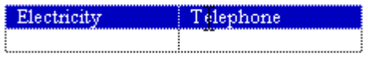
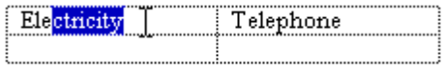

Figure 5.1 Hierarchical Selection.

Mouse Selection
Mouse selection relies on the basic actions of clicking and dragging. In general, clicking selects a single item or location, and dragging selects a single range consisting of all objects logically included from the button-down to the button-up location. If you have already used dragging for object movement, use modified mouse selection or region selection actions for selection.

Selection with the Mouse
The user can perform selections with a mouse using either button 1 or button 2. When the user presses the mouse button, they establish the starting point, or anchor point, of a selection. If, while pressing the mouse button, the user drags the mouse, the selection extends to the object nearest the hot spot of the pointer. If the user then drags the mouse within the selection, the selection extends only to the object nearest the pointer. This allows the user to dynamically adjust a range selection while the mouse button continues to be held down. Objects included in the selection indicate the selection state through highlighting or some other change in the visual state. For more information about selection appearance, see Chapter 13, "Visual Design."

The release of the mouse button ends the selection operation and establishes the active end of the selection. The user can adjust the selection with subsequent selection operations using the shift and ctrl keys. If the user presses mouse button 2 to make a selection, the release of the mouse button also displays a contextual pop-up menu for the selected objects. For more information about pop-up menus, see Chapter 7, "Menus, Controls, and Toolbars."

Generally, selection is optimized for the selection of a single object or a single range of objects⎯this is usually the more common and frequent type of selection. In this situation, creating a new selection within the same scope of an existing selection (for example, within the same area of the window) cancels the selection of the previously selected objects. This allows the creation of simple selections quickly and easily.

When using this technique, the user resets the selection when pressing the mouse button, and the pointer (hot spot) is interpreted as being outside (not on) any existing selection. However, if the pointer is over a selected item, the button down action does not cancel the former selection. Instead, the release of the button and the use of button 1 or 2 determines the appropriate behavior.

If the user presses mouse button 1 and the pointer does not move from the button down point, the effect depends on the context of the selection. The result may have no effect on the existing selection, the object under the pointer may receive some special designation (for example, become the next anchor point), or the selection may reset to be only the object under the pointer. If the user presses mouse button 2, the selection is not affected and a pop-up menu for selection is displayed.

While selection is typically done by positioning the pointer over an object, it may be inferred based on the logical proximity of an object to a pointer. For example, when selecting text, you can place the pointer on the blank area beyond the end of the line and the resulting selection is inferred as being the end of the line.

Selection Adjustment
A user can adjust a selection (elements added to or removed from the selection) using keyboard modifiers with the mouse. The ctrl key is the disjoint, or toggle, modifier. Pressing the ctrl key while making a new selection preserves any existing selection within that scope and resets the anchor point to the new mouse button down location. The selection state of the object under the pointer is toggled⎯that is, if not selected, it becomes selected; if already selected, it becomes unselected.

If a selection modified by the ctrl key is made by dragging, the selection state is applied for all objects included by the drag operation (from the anchor point to the current pointer location). This means if the first item included during a drag operation is not selected, all objects included in the range become selected. If the first item included was already selected, all the objects included in the range become unselected regardless of their original state. For example, the user selects the words "the things" in the following text by dragging.

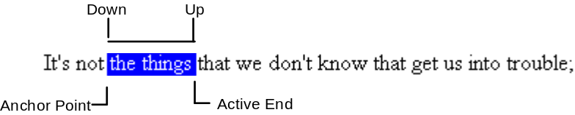
The user can then press the ctrl key and drag to create a disjoint selection, resetting the anchor point.

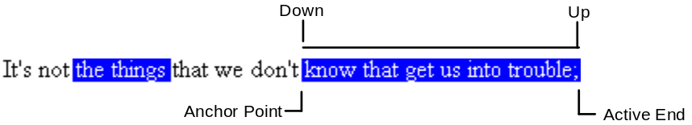
The user presses the ctrl key before using the mouse button for a disjoint (toggle) selection. However, after initiating a disjoint selection, it continues until the user releases the mouse button (even if the ctrl key is released before the mouse button).

Note Disjoint selections in text are an optional technique; therefore, you are not required to support them in all textual contexts.

The shift key adjusts (or extends) a single selection or range selection. The key resets the active end of a selection from the most recent anchor point to the location of the pointer when the user presses the mouse button. It tracks with the pointer to the object nearest to the mouse button release point. The anchor point does not change; only the selection made from the current anchor point is adjusted. Any other disjoint selections are not affected. The effect on the selection state of a particular object is based on the first item included in the selection range. If the first item is already selected, then all objects included in the range become selected. If the first item is not selected, then the objects included are unselected.

Pressing and holding down the shift key before pressing the mouse button adjusts the selection. The shift key continues to adjust the selection (even if the user releases the modifier key) until the mouse button is released.

The shift modifier key is a continuation of an existing selection or ctrl key modified selection. For example, the user could select the following text by dragging.
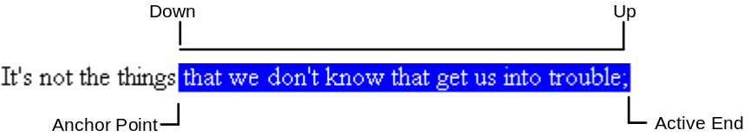
The user can accomplish this same result by making an initial selection.
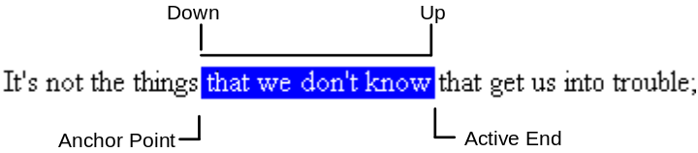

The user can then adjust the selection with the shift key and dragging.
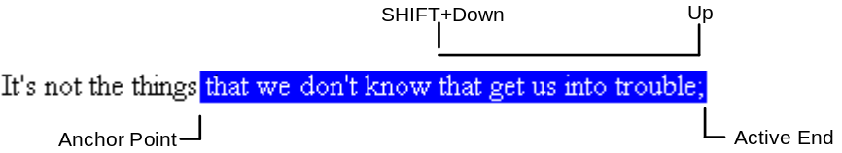
Use the shift key and dragging to adjust a disjoint selection. The user makes the initial selection by dragging.

Then the user presses the ctrl key and drags to create a disjoint selection.

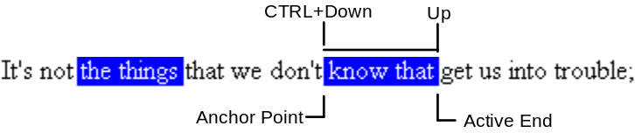
The user can then extend the disjoint selection using the shift key and dragging. This adjusts the selection from the anchor point to the button down point and tracks the pointer to the button up point.

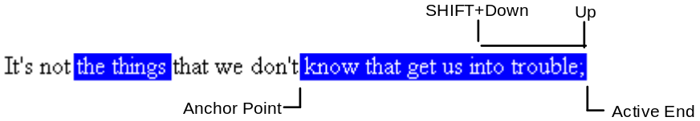
The following summarizes the mouse selection operations:

Operation | Mouse action
Select object (range of objects) | Click (drag)
Disjoint selection state of noncontiguous object (range of objects) | ctrl+click (drag)
Adjust current selection to object (or range of objects) | shift+click (drag)

For more information about the mouse interface, including selection behavior, see Appendix A, "Mouse Interface Summary."

Region Selection
In Z-ordered (layered) contexts, in which objects may overlap, a selection can begin on the background (sometimes referred to as white space). In this case, to determine the range of the selection, a bounding outline (sometimes referred to as a marquee) is drawn. The outline is typically a rectangle, but other shapes are possible. Holding down the mouse button and moving the pointer (a form of selection by dragging) displays the bounding region. All intersected or contained objects within the bounding region are affected by the selection rules. The decision whether to include an object — whether it is totally enclosed or intersected by the bounding region — is determined by the context of the application. During the selection operation, provide visual feedback to the user by changing the appearance of the selection. When the user releases the mouse button the bounding region is removed, but the selection remains. You can also support the shift or ctrl key modifiers with region selection, following the established conventions.

For more information about selection rules, see the section "Selection" earlier in this chapter. For more information about shift or ctrl key modifiers, see the section "Selection Adjustment" earlier in this chapter.

Pen Selection
When using the pen as the pointing device, you can use the same selection techniques defined for the mouse. For example, in textual input controls, the user can select text by dragging through it. In discrete object scenarios, like drawing programs, the user can select individual objects by tapping or by performing region selection by dragging. For more information about selection support in pen-enabled controls, see the section, "Pen-Specific Editing Techniques" later in this chapter.

In some contexts, you can also use the lasso-tap gesture to support selection of individual objects or ranges of objects. However, do not support the lasso-tap gesture when it might interfere with primary operations, like direct manipulation.

Lasso-tap involves making a circular gesture around the object, then tapping within the gesture. For example, in Figure 5.3, making the lasso-tap gesture selects the word "controversial".

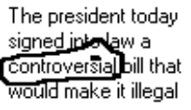

Figure 5.3 A Lasso-Tap Gesture.
In textual contexts, the selection is based on the extent of the lasso gesture and the character-word-paragraph granularity of the text elements covered. For example, if the user draws the lasso around a single character, only that character is selected. If the user draws the lasso around multiple characters within a word, the entire word is selected. If it encompasses characters in multiple words, then the range of the words logically included by the gesture become selected. This reduces the need for the user to be precise.

Keyboard Selection
Keyboard selection uses a cursor to define selected objects. The selection cursor can be an insertion point, a dotted outline box, or some other visual indication of the location where the user is directing keyboard input focus. For more information about keyboard input focus, see Chapter 13, "Visual Design."

In some contexts, selection may be implicit with navigation. When the user presses a navigation key, the cursor moves to the location (as defined by the key), and the object under the cursor is automatically selected.

In other contexts, it may be more appropriate that navigation moves the cursor and requires the user to make an explicit selection with the Select key. By default, the keyboard Select key is the spacebar, unless this assignment directly conflicts with the specific context–in which case, you can use ctrl+spacebar. (If this also conflicts with your software, define another key that best fits the context.) In some contexts, the Select key may also unselect objects; in other words, it toggles the selection state of an object.

Contiguous Selection
In textual contexts, the user selects a single insertion point with the keyboard by simply using the navigation keys to move to the desired location. The anchor point is set at the new location. The user selects a range of characters by using the shift key with any navigation key (or navigation key combinations, such as ctrl+end). The cursor then moves to the location defined by the navigation key and becomes the active end of the selection. All characters between the anchor point and the active end are selected. (The anchor point does not move.) If the user presses a subsequent navigation key, the selection collapses to just the cursor and the cursor moves the appropriate distance as defined by the key. If arrow keys are used, the selection is unselected, and the cursor moves to the end of the former selection range.

You can use this technique in other contexts where objects are logically contiguous, such as lists. However, in such situations, the selection state of the objects logically included from the anchor point to the active end depend on the selection state of the object at, or first traversed from, the anchor point. For example, if the object at the anchor point is selected, then all the objects in the range become selected regardless of their current state. If the object at the anchor point is not selected, then all the items in the range become unselected.

Disjoint Selection
The Select key is used for making disjoint selections. The user can use navigation keys or navigation keys modified by the shift key to establish the initial selection. The user can then use navigation keys to move to a new location and subsequently use the Select key to create an additional selection.

However, in some situations you may prefer to optimize the selection of a single object or single range. In this case, pressing a navigation key resets the selection to the current location. Creating a disjoint selection requires using the Add mode key (shift+f8). In this mode, navigation keys move the cursor without affecting the existing selections or the anchor point. Pressing the Select key toggles the selection state at the new location and resets the anchor point to that object. At any point, the user can use the shift+navigation key combination to adjust the selection from the current anchor point. Pressing the Add mode key a second time toggles out of the mode. Once out of Add mode and preserving the selections created in Add mode, if any new selections are made within that selection scope the selections are reset.

Selection Shortcuts
Double-clicking with mouse button 1 and double-tapping, its pen equivalent, is a shortcut for the default operation of an object. In textual contexts, it is commonly assigned as a shortcut to select a word. Using this shortcut selects the word and the space following the word, but not the punctuation marks.

Note This shortcut generally applies to text. In other contexts, it may perform other operations.

Your software may define additional selection shortcuts or techniques for specialized contexts. For example, selecting a column label may select the entire column. However, because these shortcuts cannot be generalized across the user interface, do not use the shortcuts as the only way to perform a selection.

General Conventions for Supporting Operations
There are many ways to support operations for an object, including direct manipulation of the object, direct manipulation of an object's control point (handle), menu commands, buttons, dialog boxes, tools, or programming. Support for a particular technique is not exclusive to other techniques. For example, the user can size a window through the Size menu command as well as dragging its border.

Design operations or commands to be contextual, or related to, the selected object to which they apply. That is, the presentation of commands or properties, or other aspects of an object, are determined (made accessible) by the characteristics of the object and its context (relationships). Often the context of an object may add to or suppress the traits of an object. For example, the pop-up menu for an object may include commands defined by the object's type as well as commands supplied by the object's current container.

Operations on a Multiple Selection
The available operations for a multiple selection is an intersection of the operations that apply to the members of that selection. The selection's content may add to or filter out the available operations or commands displayed to the user. It is also possible for a particular member of a selection to determine the effect of a operation for the entire selection. For example, when selecting a set of graphic objects, executing an alignment command could be relative to a particular item identified in the selection.

Operations are always limited to the scope of the selected objects. For example, deleting a selected word in one window should not delete selections in other windows (unless the windows are viewing the same thing).

Default Operations and Shortcut Techniques
An object can have a default operation; a default operation is an operation that is assumed when the user employs a shortcut technique, such as double-clicking or OLE drag and drop. For example, double-clicking a folder displays a window with the content of the folder. However, double-clicking a sound object might play the sound rather than open a window for editing. For other objects, double-clicking can display the properties of an object, or in text editing situations, select a word. The behavior is different because the default command in each case is different: for a folder, the default command is Open; for the sound object, Play; for a device object like a mouse, Properties, and for text, Select Word.

Shortcut techniques for default operations provide greater efficiency in the interface. However, because they typically require more skill or experience and because not all objects may have a default operation defined, avoid shortcut techniques as the exclusive means of performing a basic operation. For example, even though double-clicking can open an icon, an Open command should appear on its menu.

View Operations
The following are some of the common operations associated with viewing objects. While these operations may not always be used with all objects, when supported, they should follow similar conventions.

Operation | Action
Open | Opens a primary window for an object. For container objects, such as folders and documents, this window displays the content of the object.
Close | Closes a window. (Closing a window does not necessarily mean closing the processes associated with the object being viewed. For example, closing a printer's window does not cancel documents in its queue.)
Properties | Displays the properties of an object in a window, typically in a property sheet window.
Help | Displays a window with the contextual Help information about an object.

Opening a window displays it at the top of the Z-order of its peer windows and makes it active. This means that a supplemental window belonging to a particular application is displayed at the top of its local Z-order, not the Z-order of other primary windows.

However, if the user interacts with another window before the new window opens, the new window does not appear on top; instead, it appears where it would normally be displayed if the user activated another window. For example, if the user has opened window A, then opens window B, window B would appear on top of window A. However, if the user clicks back in window A before window B is displayed, window A remains active and at the top of the Z-order; window B appears behind window A.

Executing a view operation usually allows the user to edit the object. However, editing an object in its window depends on the type of access defined. You can base access on a number of factors including who the user is, the type of view being used, and the content being viewed.

If the window of an object is open, re-executing the command that opened that window should activate the existing window. For example, choosing the Properties command when the property sheet is already open activates the property sheet rather than opening a second window. For more information about opening windows, see Chapter 6, "Windows." For more information about opening property sheets, see Chapter 8, "Secondary Windows." For more information about opening Help windows, see Chapter 12, "User Assistance."

View Shortcuts
The following are the recommended shortcut techniques for the common viewing commands.

Shortcut | Operation
ctrl+o | Open
f1 | Contextual Help
shift+f1 | Contextual Help mode
Double-click (button 1) or enter | Default command
Double-click (button 2)  or alt+enter | Properties

Use double-clicking and the enter key to open a view of an object when that view command is the default command for the object. For example, double-clicking a folder opens a primary window for the folder. However, double-clicking a mouse object displays its property sheet; this is because the Open command is the default command for folders, and the Properties command is the default command for device objects.

Editing
Editing involves changing some fundamental aspect about the composition of an object. It generally involves adding, removing, or replacing some facet of the object. However, not all changes constitute editing of an object. For example, changing the view of a document to an outline or magnified view (which has no effect on the content of the document) does not constitute editing. The following sections cover some of the common interface techniques for editing objects.

Editing Text
Editing text requires that you target the input focus at the text to be edited. For mouse input, the input focus always coincides with the pointer (button down) location. For the pen, it is the point where the pen touches the screen. For the keyboard, the input focus is determined with the navigation keys. In all cases, the visual indication that a text field has the input focus is the presence of the text cursor, or insertion point.

Inserting Text
Entering text involves the user placing the insertion point at the appropriate location and then typing. The insertion point moves one character to the right (or left, depending on the language) for each character typed.

If the text field supports multiple lines, typically the text wordwraps; that is, automatically moves text to the next line, as the textual input exceeds the width of the text-entry area.

Overtype Mode
Overtype is an optional text-entry behavior that operates similarly to the insertion style of text entry except that text entered replaces existing characters⎯one for each character. Use a block cursor that appears at the current character position to support overtype mode; this looks the same as the selection of that character and provides the user with a visual cue about the difference between the text-entry modes. Figure 5.4 demonstrates the appearance of an overtype cursor.

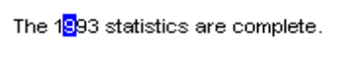
Figure 5.4 An Overtype Cursor.
Use the insert key to toggle between the normal insert text-entry convention and overtype mode.

Deleting Text
The delete and backspace key support deleting text. The delete key deletes the character to the right of the text insertion point. backspace removes the character to the left. In either case, text moves in the direction of the deletion to fill the gap — this is sometimes referred to as auto-joining. The deleted text is not placed on the Clipboard. For this reason, include at least a single-level undo operation in these contexts.

For a text selection, delete and backspace remove the entire block of selected text. Text selections are also deleted when new text is entered directly or by a transfer command. In this case, the selected text is replaced by the incoming input. For more information about transfer operations, see the section, "Transfer Operations" later in this chapter.

Handles
Objects may include special control points, called handles; handles facilitate certain types of operations, such as moving, sizing, scaling, cropping, shaping, or auto-filling. The type of handle you use depends on the type of the object. For example, for windows the title bar acts a "move handle." The borders of the window act as "sizing handles." For icons, the selected icon acts as the "move handle." In pen-enabled controls, special handles may appear for selection and access to the operations available for an object. For more information about these handles, see the section, "Pen-Specific Editing Techniques" later in this chapter.

A common of form of handle is a square box placed at the edge of an object as shown in Figure 5.5.

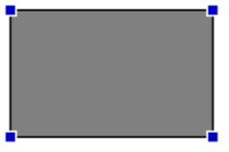

Figure 5.5 A Graphic Object with Handles.
When the handle's interior is solid, the handle implies that it can perform some operation, such as sizing, cropping, or scaling. If the handle is "hollow," then the handle does not currently support an operation. Such an appearance indicates selection even when an operation is not available. For more information about the design of handles, see Chapter 13, "Visual Design."

Transactions
A transaction is a unit of change to an object. The granularity of a transaction may span from the result of a single operation to a set of multiple operations. In an ideal model, transactions are applied immediately, and there is support for "rolling back" — or undoing transactions. Because there are times when this is not practical, specific interface conventions have been established for committing transactions. If there are pending transactions in a window when it is closed, prompt the user to apply or discard them.

Transactions can be committed at different levels and a commitment made at one level may not imply a permanent change. For example, the user may change font properties of a selection of text, but these text changes may require saving the document file before the changes are permanent.

Use the following commands for committing transactions at the file level.

Command | Function
Save | Saves all interim edits, or checkpoints, to disk and begins a new editing session.
Close | Prompts the user to save any uncommitted edits. If confirmed, the interim edits are saved and the window is removed.

Note Use the Save command in contexts where committing file transactions applies to transactions for an entire file, such as a document, and are committed at one time. It may not necessarily apply for transactions committed on an individual basis, such as record-oriented processing.

On a level with finer granularity, you can use the following commands for common handling transactions within a file:

Command | Function
Repeat | Duplicates the last/latest user transaction.
Undo | Reverses the last, or specified, transaction.
Redo | Restores the most recent, or specified, "undone" transaction.
Apply | Commits any pending transactions, but does not remove the window.
Cancel | Discards any pending transactions, and removes the window.

The recommended commands for handling process transactions are as follows:

Command | Function
Pause | Suspends a process.
Resume | Resumes a suspended process.
Stop | Halts a process.

Note Use the Cancel command to halt a process. However, it implies that the state will be restored to its previous state before the process was initiated.

Properties
Defining and organizing the properties of an application's components are a key part of evolving toward a more data-centered design. Commands such as Options, Info, Summary Info, and Format often describe features that can be redefined as properties of a particular object (or objects). The Properties command is the common command for accessing the properties of an object; this typically displays the property sheet for the selection. For more information about property sheets, see Chapter 8, "Secondary Windows."

Defining how to provide access to properties for objects, such as a selection of text, cells, or drawing objects, is straightforward because the objects are visible and identifiable. It may be more difficult to define how to access properties of less tangible objects, such as paragraphs. In some cases, you can include these properties by implication. For example, requesting the properties of a text selection may also provide access to the properties of the paragraph in which the text selection is included.

Another way to provide access to its properties is to create a representation of the object. For example, the properties of a page could be accessed through a graphic or other representation of the page in a special area (for example, the status bar) of the window.

Yet another technique to handle this may be to include specific property entries on the menu of a related object. For example, the pop-up menu of a text selection could include a menu entry for a paragraph. Or, use the cascading submenu of the Properties command for individual menu entries.

The Properties command is not the exclusive means of viewing the properties of an object. For example, folder views display certain properties of objects stored in the file system. In addition, you can use toolbar controls to display properties of selected objects.

Pen-Specific Editing Techniques
In addition to functioning as a pointing device, there are special interfaces and techniques for editing with the pen.

Editing in Pen-Enabled Controls
If a pen is installed, the system automatically provides a special interface, called the lens button, to make text editing as easy as possible, enhance recognition accuracy, and streamline correction of errors. The lens interface, as shown in Figure 5.6, adds a "magnifying glass" button to your standard text controls. (You can also add support for the lens for any special needs of your software.)

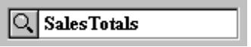

Figure 5.6 A Standard Text Box with the Lens Button.
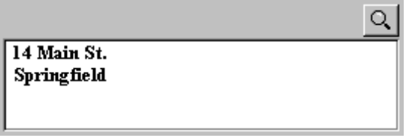

When the text box control has the focus, a selection handle appears. The user can drag this handle to make a selection.

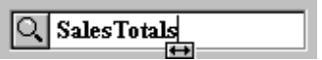

Tapping the lens button with a pen (or clicking it with a mouse) presents a special text editing window as shown in Figure 5.7. Within this window, the user can write text that is recognized automatically.

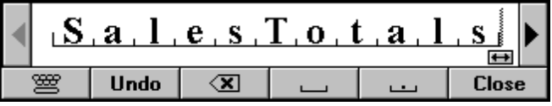

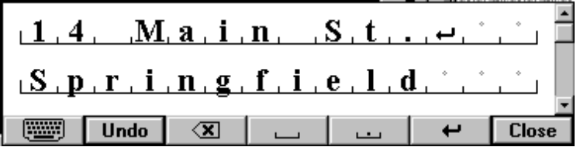

Figure 5.7 Single and Multiline Lens Text Editing Window.
In the lens editing window, each character is displayed within a special cell. If the user selects text in the original text field, the lens window reflects that selection. The user can reset the selection to an insertion point cursor by tapping between characters. This also displays a special selection handle that can be dragged to select multiple characters as shown in Figure 5.8.

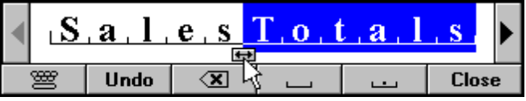

Figure 5.8 Selected Text with the Selection Handle.
The user can select a single character in its cell by tapping, or double-tapping to select a word. When tapping a single character, an action handle displays a list of alternative characters as shown in Figure 5.9.

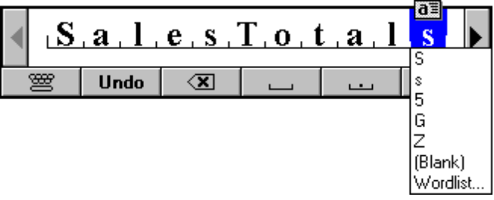

Figure 5.9 An Action Handle and a List of Alternatives.
Choosing an alternative replaces the selected character and removes the list. Writing over a character or tapping elsewhere also removes the list of alternatives. The new character replaces the existing one and resets the selection to an insertion point placed to the left of the new character.

The list also includes a list of word choices. When the user selects this choice, the word that contains the character becomes selected and a list of alternatives is displayed as shown in Figure 5.10. This list also appears when selecting a complete word by using double-tapping. Choosing an alternative replaces the selected word.

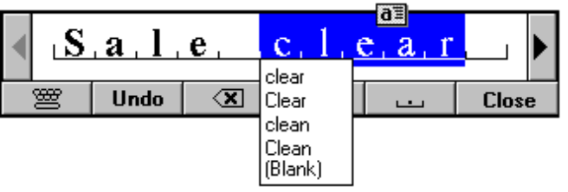

Figure 5.10 Tapping Presents a List of Choices.
When a selection exists in the window, an action handle appears; the user can use it to perform other operations on the selected items. For example, using the action handle moves or copies the selection by dragging, or the pop-up menu for the selection can be accessed by tapping on the handle as shown in Figure 5.11. For more information about pop-up menus, see Chapter 5, "Menus, Controls, and Toolbars."

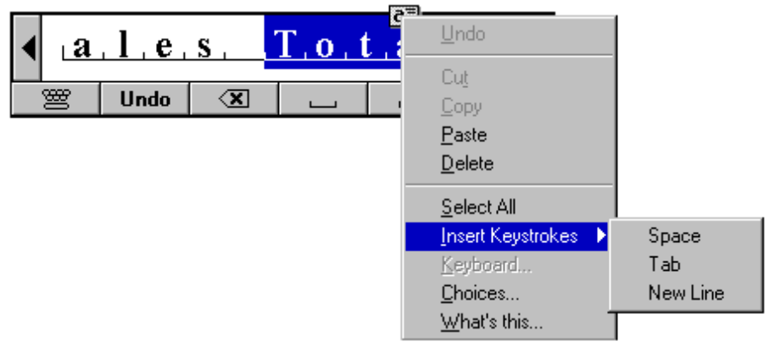

Figure 5.11 Tapping Action Handle Displays a Pop-up Menu.
The buttons on the lens window provide for scrolling the text as well as common functions such as Undo, Backspace, Insert Space, Insert Period, and Close (for closing the text window). A multiline lens window includes Insert New Line.

In addition, the lens window also provides a button for access to an onscreen keyboard as an alternative to entering characters with the pen as shown in Figure 5.12. The user taps the button with the corresponding keyboard glyph on it and the lens onscreen keyboard pop-up window replaces the normal lens window.

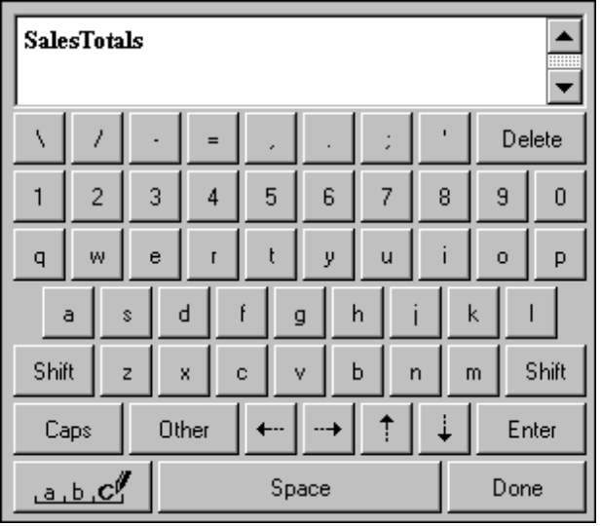

Figure 5.12 The Lens Onscreen Keyboard Pop-up Window.

The lens remembers its previous use — for text input or as an onscreen keyboard and opens in the appropriate editing window when subsequently used.

Pen Editing Gestures
The pen, when used as a pointing device, supports editing techniques defined for the mouse; the pen also supports gestures for editing. Gestures (except for Undo) operate positionally, acting on the objects on which they are drawn. If the user draws a gesture on an unselected object, it applies to that object, even if a selection exists elsewhere within the same selection area. Any pending selections become unselected. However, if a user draws a gesture over both selected and unselected objects, it only applies to the selected ones. Additionally, if a gesture is drawn over only one element of the selection, it applies to the entire selection. Finally, if the gesture is drawn in empty space (on the background), it applies to any existing selection within that selection scope. If no selection exists, then the gesture has no effect.

For most gestures, the hot spot of the gesture determines specifically which object the gestures apply to. If the hot spot occurs on any part of a selection, it applies to the whole selection.

Table 5.2 lists the common pen editing gestures. For these gestures, the hot spot of the gesture is the area inside the circle stroke of the gesture.

Table 5.2 Pen Editing Gestures
Gesture | Name | Operation
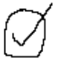 | check-circle | Edit (displays the lens editing window) for text; Properties for all other objects.
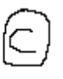 | c-circle | Copy
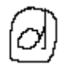 | d-circle | Delete (or Clear)
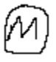 | m-circle | Menu
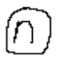 | n-circle | New line
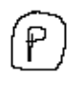 | p-circle | Paste
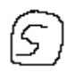 | s-circle | Insert space
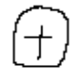 | t-circle | Insert tab
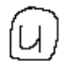 | u-circle | Undo
 | x-circle | Cut
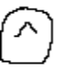 | ^-circle | Insert text

Note These gestures can be localized in certain international versions. In addition, for Kanji versions, the circle-k gesture is used to convert Kana to Kanji.

Transfer Operations
Transfer operations are operations that involve moving, copying, and linking objects from one location to another as well as other operations that may be derived from these basic operations. For example, printing an object is a form of a transfer operation because it can be defined as copying an object to a printer.

Three components make up a transfer operation: the data to be transferred, the destination of the transfer, and the operation to be performed. You can define these components either explicitly or implicitly, depending on which interaction technique you use.

The operation defined by a transfer is determined at the destination. Because a transfer may have several possible interpretations, a default operation and other optimal operations are defined. These are determined based on information provided by the source of the transfer and the compatibility and capabilities of the destination. For example, attempting to transfer an object to a container may result in one of the following alternatives:

n Rejecting the object.
n Accepting the object.
n Automatically encapsulating the object with an object the destination can accept.
n Accepting a subset or transformed form of the object (for example, extract its content or properties but discard its present containment, or convert the object into a new type).

Most transfers are based on one of the following three fundamental operations:

Operation | Description
Move | Relocates or repositions the selected object. Move operations do not change the basic identity of an object, therefore, a move operation is not the same as copying an object and deleting the original.
Copy | Makes a duplicate of an object. The resulting object is independent of its original. Duplication does not always produce an identical clone. Some of the properties of a duplicated object may be different from the original. For example, copying an object may result in a different name or creation date. Similarly, if some component of the object restricts copying, then only the unrestricted elements may be copied.
Link | Creates a connection between two objects. The result is usually an object in the destination that provides access to the original.

There are two different methods for supporting the basic transfer interface: the command method and the direct manipulation method.

For more information about these methods, see the sections “Command Method” and “Direct Manipulation Method,” later in this chapter.

Command Method
The command method for transferring objects uses the Cut, Copy, Paste, and Paste Link commands. Place these commands on the Edit drop-down menu as well as the pop-up menu for a selected object. Toolbar buttons can support these commands as well. The following describes the functions of the four transfer commands.

Command | Function
Cut | Removes the selected data and transfers it (or a reference to it) to the Clipboard.
Copy | Duplicates the selected data (or marks the data for duplication) and transfers it to the Clipboard.
Paste | Inserts the content of the Clipboard into the specified location.
Paste Link | Creates a link to the data copied to the Clipboard.

Note While it is recommended that the Cut command remove selected data when executed, there may be special circumstances where this is not practical. In these cases, display the selected objects in a special way to inform the user that a transfer is pending.

You can also include a Paste Special command. Choosing Paste Special should display a dialog box which gives the user explicit control over how to place the source data. For more information about the use of Paste Special, see Chapter 11, "Working with Embedded and Linked Objects."

To transfer an object, the user:

1. Makes a selection.
2. Chooses either Cut or Copy
3. Navigates to the destination (and sets the insertion location, if appropriate).
4. Chooses Paste or Paste Link (or Paste Special) to place the data.

Choosing Cut and Paste removes the selection from the source and relocates it to the destination, while choosing Copy and Paste inserts an independent duplicate of the selection and leaves the original unaffected. Using Copy and Paste Link inserts an object that is linked to the source at the destination.

After a Paste operation, the transferred data is typically displayed as selected, although a destination can determine whether this is appropriate. In most cases, display the transferred data as selected. For example, in text contexts, rather than displaying the transferred text as selected, the insertion point is placed after the inserted text.

Similarly, the destination also determines whether the transferred data replaces any existing selections or adds to them. Typically, in textual contexts, the incoming data replaces a pending selection in the destination. In drawing contexts, the data may be added.

A Paste command usually does not affect the content of the Clipboard. This means that data on the Clipboard can be pasted multiple times, though subsequent paste operations result in copies of the original. However, a subsequent Cut or Copy command replaces the last entry on Clipboard.

Direct Manipulation Method
The command method is particularly useful when navigating an editing operation that requires selecting the data to be transferred and then selecting its destination. However, for many transfers, the user may directly select and drag an object and drop it into place. Using the mouse, the user can transfer objects by dragging the object by pressing either mouse button 1 or 2.

When using a pen as a pointing device, or when using an action handle, the pen follows the same conventions as dragging with mouse button 1. Pens with barrel buttons can use the barrel+drag action as the equivalent of dragging with mouse button 2. There is no keyboard definition for direct manipulation transfers.

You can support direct manipulation transfers to any visible object. The object (for example, a window or icon) need not be currently active. For example, the user can drop an object in an inactive window. This action activates the window. If an inactive object cannot accept a direct manipulation transfer, it (or its container) should provide feedback to the user.

Default OLE Drag and Drop
Default OLE drag and drop is the dragging of an object with button 1. The interpretation of the operation is determined by what the destination defines as the appropriate default operation. If possible, the default operation should be nondestructive; when it is destructive, use a message box to confirm the intentions of the user, for example.

Using this transfer technique, the user can directly transfer data between documents defined by your application as well as to system resources, such as printers and mailboxes. Implement OLE drag and drop exactly the same as the system shell: the user presses button 1 down on an object, moves the mouse while holding the button down, and then releases the button at the destination. Most commonly, the default transfer operation is move, but the context of the operation (for example, the type of object or the type of destination) may reinterpret the operation to be whatever is most appropriate. Therefore, you could interpret a default OLE drag and drop operation as Copy or Link. The transfer operation is complete when the mouse button is released at the destination. (For the pen interface, the transfer is completed when the pen tip is lifted from the screen.)

Nondefault OLE Drag and Drop
Nondefault OLE drag and drop is the dragging of an object with button 2. In this case, rather than executing a default operation, a pop-up menu is presented when the user releases the mouse button at the destination. The menu contains the appropriate transfer completion commands⎯typically, Move Here, Copy Here, Link Here, and Cancel as shown in Figure 5.13.

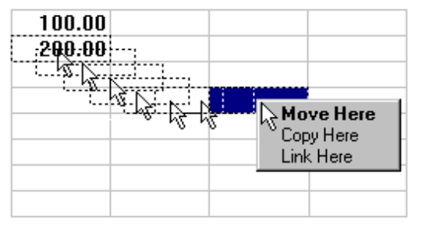

Figure 5.13 A Pop-up Menu at the End of a Nondefault OLE Drag and Drop Operation.
The destination determines which transfer commands to include on the resulting pop-up menu, usually factoring in information about the object supplied by the source location. The destination can display additional or alternative commands to the common set. For example, a printer displays Print Here as its default command. A spreadsheet cell could offer to transfer only the properties, the formula, or just the value of the source data. Use the common transfer completion verbs, Move Here, Copy Here, and Link Here, when transferring the data in its entirety. When supporting only a partial aspect or a transformation of the data, modify these commands or provide more descriptive indicators — for example, Copy Properties Here, or Transpose Here.

Canceling an OLE Drag and Drop Transfer
Dragging and dropping back to the original selection point usually cancels the operation. Pressing the esc key during a drag transfer also cancels the operation. In addition, include a Cancel command in the pop-up menu of a nondefault OLE drag and drop action. Choosing the command cancels the operation.

Differentiating Transfer and Selection When Dragging
Because dragging performs both selection and transfer operations, establish a convention to allow the user to differentiate between these operations. The convention depends on what is most appropriate in the current context of the object or by using specialized handles. However, it is commonly determined by the location of the pointer at the beginning of the drag operation. If the pointer is within an existing selection, then the drag is interpreted to be a transfer operation. If the drag begins outside of an existing selection, it is interpreted as a selection operation.

Scrolling When Transferring by Dragging
There are times when the user drags and drops an object from a scrollable area (such as a window, pane, or list box) to another. There are also occasions when the user drags an object within a scrollable area to a location that is currently out of view. In this latter case, it is convenient to automatically scroll the area while the object is dragged to the edge of that scrollable area. Both these behaviors can be accommodated by using the velocity of the dragging action; that is, if the pointer dragging the object approaches the edge of the area slowly, the area scrolls when the pointer reaches the edge of that area. If the pointer dragging the object approaches the edge quickly, the object leaves the area without triggering scrolling.

This technique is based on determining the exit velocity of the pointer as it traverses the edge of a scrollable region and defining an appropriate threshold velocity; this threshold velocity differentiates between scrolling or transfering the object outside the window. To determine the velocity of the dragging pointer, a hot zone is defined within the inner edge of the scrollable area. The system provides a parameter for the default size of the hot zone (NAMEOFVARIABLE). Set your hot zone to this value, or some percentage of this value, so that if the value changes — for example, because of a change in screen resolutions — your software adjusts. Figure 5.14 demonstrates the determining of the velocity of a pointer.

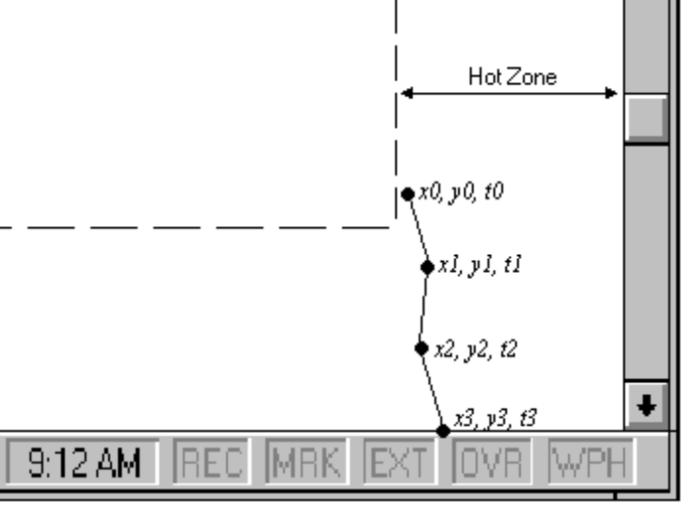

Figure 5.14 Determining the Velocity of the Pointer
During the drag operation once the pointer enters this region, the location and time of the pointer should be sampled. When the pointer touches the edge of the scrollable area, the square of the pointer velocity is approximated based on at least the last two locations of the pointer using the following calculation:

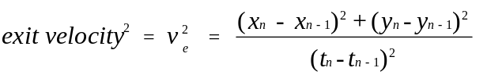

The pointer velocity value is then compared to an exit velocity threshold. The system supplies a user-configurable parameter for this threshold (NAMEOFTHRSHLDPMTR). Like the hot zone parameter, use this value or some percentage of it. If the square of the calculated exit velocity is less than or equal to the square of the exit velocity threshold, then the area scrolls. If pointer exit velocity exceeds the threshold, then the dragged object leaves the area and no scrolling occurs.

As an option, you can support variable rates of scrolling by the distance that the pointer travels beyond the edge; that is the greater the distance, the faster the scrolling. You can also support continued sampling of the pointer's velocity so that if the user accelerates the dragging of the pointer beyond the edge and exceeds the exit threshold, the action can be reinterpreted as dragging to transfer even if scrolling has been initiated.

Transfer Feedback
During a dragging transfer operation, provide visual feedback about the source object, the pointer, and the destination. Specifically:

n The source retains its selected appearance while the view has the focus. To indicate that a source is in a transfer state, it may display some additional visual appearance characteristics used by the system. (The state may change based on the default completion operation supported by the destination the pointer is currently over.)
n An outline or translucent representation (shown in Figure 5.15) of the object moves with the pointer.

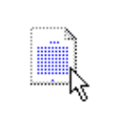
Figure 5.15 A Translucent Icon.
The source is responsible for providing the initial appearance, but any destination can change the appearance. Design the presentation of the destination of the object to provide feedback as to how the object will be received by that destination. For example, if an object will be embedded as an icon, the destination should present an icon. If the object will be incorporated as part of the native context of the destination, then the presentation supplied by the destination should reflect that; for example, if a table will be incorporated as a table, the representation could be an outline or translucent form of the table. On the other hand, the table could be converted to text, then a representation of text is supplied.
n Display the interpretation of the transfer operation to the right of the stem of the pointer. No additional glyph indicates that operation is interpreted as moving. A plus character (+) means the interpretation is copying. Use an equal sign character (=) for linking.
n Potential destinations indicate their receptivity as targets. Objects can use selection highlighting and optionally animate or display a representation of the transfer object in the destination. Optionally, a destination can also indicate when it cannot accept an object by using the "no drop" pointer when the pointer is over it as shown in Figure 5.16.



Figure 5.16 The "No Drop " Pointer.
When the transfer is completed, the transferred object appears selected in the destination's view (if the destination's window is opened).

While the transfer operation is in progress, a representation of the source object remains at the original location because, in most cases, the interpretation of the operation cannot be determined until the operation is complete. In addition, it provides a convenient visual reference point. For more information about the design of transfer feedback, see Chapter 13, "Visual Feedback."

Specialized Transfer Commands
In some contexts, a particular form of a transfer operation may be so common, that introducing an additional specialized command is appropriate. For example, if copying existing objects is a frequent operation, you may want to consider including a Duplicate command. The following are some common specialized transfer commands.

Command | Function
Delete | Removes an object from its container.
Clear | Removes the content of a container.
Duplicate | Copies an object.
Create Link | Creates a link to an object.
Print | Prints an object on the default printer.
Send | Mails an object

Shortcut Keys for Transfer Operations
The following are the defined shortcut techniques for transfer operations.

Shortcut | Operation
ctrl+x | Performs a cut operation.
ctrl+c | Performs a copy operation.
ctrl+v | Performs a paste operation.
ctrl+drag | Toggles the meaning of the default operation to copy (provided the destination can support copy). The modifier may be used with either mouse button.
esc | Cancels a drag and drop transfer operation.

Because of the wide use of these command shortcut keys throughout the interface, do not reassign them to other commands.

Creating New Objects

Creating new objects is a frequent operation in the interface. Creation is typically based on some predefined object or specification and can be supported in the interface in a number of ways.

Copy Command
Making a copy of an existing object is the fundamental paradigm for creating new objects. Copied objects can be modified and serve as prototypes for the creation of other new objects.

The transfer model conventions define the basic interaction techniques for copying objects. Copy and Paste commands and OLE drag and drop manipulation provide this interface.

New Command
The New command facilitates the creation of new objects. New is a command applied to a specific object that creates a new instance of the object's type. The New command differs from the Copy and Paste commands in that it is a single command that generates a new object in the same location.

Insert Command
The Insert command works similarly to the New command, except that it is applied to a container to create a new object, usually of a specified type, in that container. In addition to inserting native types of data, use the Insert command to insert objects of different types. For more information about the Insert Object command, see Chapter 11, "Working with Embedded and Linked Objects."

Using Controls
You can also use controls to support the automatic creation of new objects. For example, in a drawing program buttons are often used to specify tools or modes for the creation of new objects, such as drawing particular shapes or controls. For more information about using buttons to create new objects, see Chapter 11, "Working with Embedded and Linked Objects." For general information about using controls to perform operations, see Chapter 7, "Menu, Controls, and Toolbars."

Using Templates
A template is an object that automates the creation of a new object. To distinguish its purpose, a template icon should appear as a pad with the small icon of the type of the object to be created as shown in Figure 5.17.


Figure 5.17 A Template Icon.
The default operation for a template object is New; this starts the creation process which may be automatic or request specific input from the user. The default location for the newly created object is the same as the container of the template. However, the creation process can include a prompt that allows a user to specify some other destination.

