C H A P T E R 7

Menus, Controls, and Toolbars
Menus provide a list of items from which a user can choose. Each item represents a command. Controls are graphic objects that initiate specific actions or set values for parameters or properties. Toolbars are collections of controls usually grouped together to facilitate a particular task or set of tasks. This chapter describes these interactive elements for building an interface for Microsoft Windows 95.

Menus
Menus are a common way of presenting commands in an interface. They permit a user to see the available commands within a context without having to remember the specific names or syntax of those commands.

There are several forms of menus, including drop-down menus, pop-up menus, and cascading menus. The following sections cover these menus in more detail.

The Menu Bar and Drop-down Menus
A menu bar is one of the most common forms of menus. The menu bar is a special area displayed across the top of a window directly below the title bar. A menu bar (as shown in Figure 7.1) provides access to drop-down menus — collections of menu choices displayed when a user selects a particular entry on the menu bar.

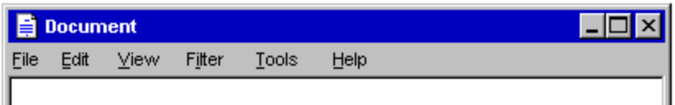

Figure 7.1 A Menu Bar.

While the use of a menu bar is a common convention for displaying commands, it is not a requirement. The long term design evolution of menu bars is toward unification with toolbars — specifically, a menu bar can be considered a toolbar configured with "menu" controls. Like toolbars, you can provide a user an option to display a menu bar. If you design your software to make a menu bar optional, supplement the interface with other interfaces, such as pop-up menus, handles, and toolbars, so that a user can access the functionality normally supplied by the menu bar through other means.
Note

Drop-down Menu Interaction
Choosing a particular menu title displays its associated drop-down menu. To display a drop-down menu with the mouse, the user points to the menu title and presses or clicks mouse button 1. This procedure highlights the menu title and opens the menu. The pen interface for drop-down menus is similar to the mouse interface; tapping with the pen has the same effect as clicking the mouse.

If the user opens a menu by pressing the mouse button while the pointer is over the menu title, the user can drag the pointer over menu items in the menu. As the user drags the pointer, each menu is highlighted, tracking the pointer as it moves through the menu. Releasing the mouse button with the pointer over a menu item chooses the command associated with that menu item and removes the drop-down menu. If the user moves the pointer off the menu and then releases the mouse button, the menu is "canceled" and the drop-down menu is removed. However, if the user moves the pointer back onto the menu (before the mouse button is released), the highlighting returns to tracking the pointer and the user can select a menu item.

If the user opens a menu by clicking on the menu title, the menu title is highlighted and the drop-down menu remains displayed until the mouse is clicked again. If the user clicks a menu item in the drop-down menu (or drags over and releases on a menu item), the command associated with the menu item is executed, and the drop-down menu is no longer displayed.

The keyboard interface for drop-down menus uses the alt key to activate the menu bar. Pressing an alphanumeric key while holding the alt key, or after the alt key is released, displays any drop-down menu whose access key matches the alphanumeric key (matching is not case sensitive). Pressing a subsequent alphanumeric key chooses the first menu item with the matching access character.

The user can also use arrow keys to access drop-down menus from the keyboard. If the user presses the alt key, but has not yet selected a drop-down menu, left arrow and right arrow keys can select a menu title on the menu bar. At the end of the menu bar, pressing another arrow key in the corresponding direction wraps around to the other end of the menu bar. Pressing the enter key displays the drop-down menu associated with the selected menu title. If a drop-down menu is already displayed on that menu bar, then pressing left arrow or right arrow navigates to the next drop-down menu in that direction, unless the drop-down menu has multiple columns, in which case the arrow keys move to the next column in that direction.

Pressing up arrow or down arrow also displays a drop-down menu if none is currently open. In an open drop-down menu, pressing one of these keys moves to the next menu item in that direction, wrapping around at the top or bottom. If the drop-down menu has multiple columns, then pressing the arrow keys wraps around to the next column.

The user can close a drop-down menu by pressing the alt key whenever the menu bar is active. This not only closes the drop-down menu, it also deactivates the menu bar. Pressing the esc key also closes a drop-down menu. However, the esc key closes only the current menu level. For example, if a drop-down menu is open, pressing esc closes the drop-down, but leaves its menu title highlighted. Pressing esc a second time unhighlights the menu title and deactivates the menu bar, returning input focus to the content information in the window.

If the user presses a shortcut key to access a command in a drop-down menu, the command executes immediately; the menu that contains the command can optionally highlight its menu title, but the drop-down menu is not displayed.

Common Drop-down Menus
This section describes the conventions for some common drop-down menus. While these menus are not required for all applications, apply these guidelines when including these menus in your software interface.

The File Menu
The File menu provides an interface for the primary operations on an object as a whole — that is, a complete file. Include commands such as Open, Save, Send, or Print. These commands usually correspond to those included on the pop-up menu of the icon displayed in the title bar of the window.

If your application supports an Exit command, place this command at the bottom of the File menu. Use the Exit command to close any open windows and files and stop any further processing. If the object remains active even when its window is closed — for example, like a folder or printer — then use Close instead of Exit.

The Edit Menu
Include general purpose commands for editing the objects displayed in the window on the Edit menu. These include the transfer commands⎯Cut, Copy, Paste, and Paste Link, as well as the following commands (if they are supported):

Command | Function
Undo | Reverses last action.
Repeat | Repeats last action.
Find and Replace | Searches for and substitutes text.
Delete | Removes the current selection.
Duplicate | Creates a copy of the current selection.

Consider including these commands on this menu on the pop-up menu of a selected object.

The Edit menu also includes command items for OLEobjects. For more information about menus for OLE objects, see Chapter 11, "Working with Embedded and Linked Objects."

The View Menu
The View menu includes commands for changing the user's view of data in the window. Include commands on this menu that affect the view and not the data itself (for example, magnification commands, such as Zoom). Also include commands for controlling the display of particular interface elements in the view (for example, Show Ruler). You can find View menu items on the pop-up menu of a window.

The Window Menu
The Window menu is used in multiple document interface-style (MDI) applications. Include commands for managing the windows within an MDI workspace. You should also include these commands on the pop-up menu of the parent MDI window.

For more information about the design of MDI software, see Chapter 9, "Window Management."

The Help Menu
The Help menu contains commands that provide access to Help information. Include a Help Topics command that provides access to the Help Topics browser which displays main topics included in your application's Help file. You may also include commands that provide access to other forms of user assistance here.

For more information about the Help Topics browser and support for user assistance, see Chapter 12, "User Assistance."

If you wish to provide access to copyright and version information for your application, you may include an About <application name> command on this menu. When the user chooses this command, display a window containing the application's name, version number, copyright information, and any other informational properties of the object. You can include this information in a special dialog box or by displaying a copyright page of the property sheet of the application's main executable (.EXE) file.

Pop-up Menus
Even if you include a menu bar in your software's interface, you should also incorporate pop-up menus as shown in Figure 7.2. Pop-up menus provide an efficient way for the user to access the operations of objects. Because pop-up menus are displayed at the pointer's current location, they eliminate the need for the user to move the pointer to the menu bar or a toolbar. Because pop-up menus contain commands that are specific to the context or object, they can reduce the number of commands the user must browse through, and because pop-up menus are displayed only upon demand, they do not take up dedicated screen space.

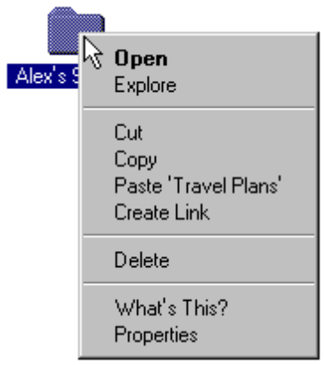

Figure 7.2 A Sample Pop-up Menu.
The appearance of a pop-up menu is similar to a drop-down menu, except that it does not have a menu title. It is best to keep the size of the pop-up menu as small as possible. Avoid including individual properties or lists of items. Also, avoid creating pop-up menus with only a single menu item.

The menu items in a pop-up menu are contextual to the selected object (or objects); the commands in the menu apply only to that selection or its immediate context. For example, a pop-up menu for a text selection might include the font properties of the text as well as the properties of paragraph of which the selection is a part; although usually it is best to present these properties in a property sheet the user can display by choosing the Properties command from the menu.

The commands included on a pop-up menu may not always be supplied by the object itself, but rather be a combination of those commands provided by the object and by its current container. For example, the pop-up menu for files in a directory folder include transfer commands. However, the folder (container) supplies these commands, not the files.

For more information about the integration of commands for OLE objects, see Chapter 11, "Working with Embedded and Linked Objects."

Avoid using a pop-up menu as the exclusive means to a particular operation. However, the menu items in a pop-up menu need not be limited only to commands that are provided in menu bar drop-down menus.

The following are the general guidelines for ordering menu items in a pop-up menu.

n Place an object's primary commands first (for example, commands such as Open, Play, and Print), transfer commands, other commands supported by the object (whether provided by the object or by its context), and a What's This? command.
n Order the transfer commands as Cut, Copy, Paste, Paste Link.
n Place the Properties command, when present, as the last command on the menu.

For more information about transfer commands, see Chapter 5, "General Interaction Techniques." For more information about the What's This? command, see Chapter 12, "User Assistance." For more information about recommendations for the commands on pop-up menus for icons, see the section "Icon Pop-up Menus," later in this chapter.

Pop-up Menu Interaction
With a mouse, the user displays a pop-up menu by clicking an object with button 2. The down transition of the mouse button identifies the object. The up transition displays the menu, typically to the right and below the hot spot of the pointer (although this is adjusted to avoid the menu being clipped by the edge of the screen).

If the pointer is over an existing selection when the user invokes the menu, the menu applies to that selection. If the menu is outside a selection but within the same selection scope, then the button down point establishes a new selection (usually resetting the current selection in that scope) and displays the menu for the new selection. However, if the user clicks the button a second time within the same selection, the menu is simply removed. Pressing the esc key also dismisses the menu as will clicking the selected object again with button 1.

You can support pop-up menus for objects that are implicitly selected or cannot be selected directly. For example, you can provide pop-up menus for controls such as scroll bars through button 2 click or for static items in a status area. However, when providing pop-up menus for objects such as controls, include the menu items that relate to commands that the control represents. For example, a scroll bar represents a navigational view of a document, so commands might include Beginning of Document, End of Document, Next Page, and Previous Page. The exception is when the control is treated as an object itself in a forms layout or window design environment.

The pen interface uses an action handle in pen-enabled controls to access the pop-up menu for the selection. Tapping on the action handle displays the pop-up menu as shown in Figure 7.3.

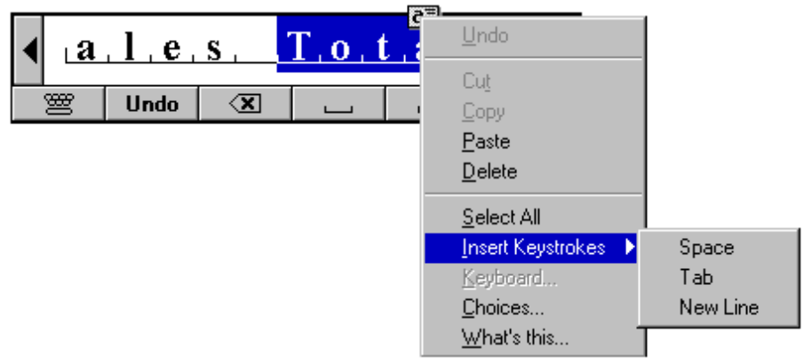

Figure 7.3 The Action Handle Provides Access to Pop-up Menus.
In addition, use techniques like barrel tapping or the pop-up menu gesture to display a pop-up menu. This interaction is equivalent to a mouse button 2 click.

For more information about pen interaction techniques, see Chapter 5, "General Interaction Techniques."

The keyboard interface for displaying a pop-up menu for a selection is shift+f10. In addition, menu access keys, arrow keys, enter, and esc keys all operate in the same fashion in the menu as they do in drop-down menus.

Common Pop-up Menus
The pop-up menus included in any application depend on the objects and context supplied by that application. However, there are some common pop-up menus that you should support.

The Window Pop-up Menu
The window pop-up menu (not to be confused with the Window drop-down menu found in MDI applications) is a pop-up menu associated with the window. It replaces the former Control menu (also known as the System menu). The common commands included on this menu are Close, Restore, Move, Size, Minimize, and Maximize.

You can also include other commands on the window's menu that apply to the window or the view within the window. For example, an application can append a Split command to the menu to facilitate splitting the window into panes. Similarly, you can add commands that affect the view (for example, Outline), commands that add, remove, or filter elements from the view (for example, Show Ruler/Hide Ruler), or commands that open certain subordinate or special views in secondary windows (for example, Show Color Palette).

The user can display a window's pop-up menu by clicking mouse button 2 on any area of the window that is not part of the data viewed in the window. Specifically, this allows access to the window pop-up menu from anywhere in the title bar area, including the title bar buttons, but excluding the title bar icon and any sizable border. In addition, you can access the window pop-up menu by clicking button 1 on the icon in the title bar. For the pen, performing the pop-up menu equivalent (barrel tapping or pop-up menu gesture) on these areas displays the menu. Use alt+spacebar to access the menu from the keyboard.

Icon Pop-up Menus
Pop-up menus displayed for icons display operations of the objects represented by the icons. Accessing the pop-up menu of an application or document icon follows the standard conventions for pop-up menus (for example, displayed with a mouse button 2 click).

The pop-up menu of an application's icon (for example, the Microsoft Wordpad executable file) typically includes the following commands.

Table 7.1 Application File Icon Pop-up Menu Items
Command | Meaning
Cut | Removes the file to the Clipboard.
Copy | Places a copy of the file on the Clipboard.
Create Link | Creates a link of the file in the same location (directory).
Delete | Deletes the file.
What's This? | Displays contextual Help information for the application.
Properties | Displays the properties for the application file.

For more information about the What's This? command, see Chapter 12, "User Assistance." For more information about the Properties command, see Chapter 8, "Secondary Windows."

If the application creates data or document files that are separate from the application file, then you may include a New command that creates a datafile of the type supported by the application. Optionally, the command can display a list of datafile types the application can create from which the user may choose. Typically, the newly created datafile is opened.

The icon in the title bar of a window also represents an object. As a result, include a pop-up menu with appropriate commands for the title bar's icon in addition to the icon that appears on the desktop or folders.

When the icon of the application appears in the title bar (that is, an application that does not load or save files, such as the Windows Calculator program), then the commands on the pop-up menu for the title bar icon are the same as the main icon, except that Close replaces the Open command.

For an icon representing a data or document file, the following are the suggested menu items for the pop-up menu for its icon.

Table 7.2 Document (or Data File) Icon Pop-up Menu Items
Command | Meaning
Open | Opens the document's (primary) window.
Print | Prints the document on the current default printer.
Cut | Removes the file to the Clipboard.
Copy | Places a copy of the file on the Clipboard.
Delete | Deletes the document (file).
What's This? | Displays contextual Help information for the document.
Properties | Displays the properties for the document (file).

The pop-up menu for the icon in the title bar of the data or document file's open window has the same commands, with the following exceptions: replace the Open command with a Close command and add Save if the edits in the document require explicit saving to the document's file.

For MDI-style applications, include the following commands, where appropriate, on the pop-up menu for the application's icon in the title bar of the parent MDI window:

Table 7.3 MDI Application Pop-up Menu Items
Command | Meaning
Close (or Exit) | Closes the MDI workspace.
Save All | Saves all documents open in the MDI workspace (and the state of the MDI window).
Insert New... | Creates a new document or displays a list of documents supported from which the user can choose to create a new one.
Find... | Displays a window that allows the user to specify criteria to locate a document.
What's This? | Displays contextual Help information for the application.
Properties | Displays properties of the MDI workspace.

For more information about the design of MDI-style applications, see Chapter 9, "Window Management."

Cascading Menus
A cascading menu (also known as a hierarchical menu or child menu) is a submenu of a menu item. The visual cue for a cascading menu is the inclusion of a triangular arrow on the right side of its parent menu item.

You can use cascading menus to provide additional choices rather than taking up additional space in the parent menu. However, they tend to add complexity to the menu interface. The further a user must navigate to get to a particular choice, the more burdensome the interface. Cascading menus require more coordination to handle the changes in direction necessary to navigate through them. Because of these design tradeoffs, use cascading menus sparingly, and when you use them, limit them to a single level. As an alternative, consider making the choices available in a dialog box, particularly when the choices are independent settings; this allows the user to select multiple options in one invocation of the command or as options on a toolbar.

The user interaction for a cascading menu is similar to that of a drop-down menu from the menu bar, except a cascading menu displays after a short timeout. This avoids unnecessary flashing of the menu if the user is browsing or navigating to another item in the parent menu. In addition, the menu is also removed after a short timeout. This enables the user to drag more directly from the parent menu item into the cascading menu.

Menu Titles
All drop-down and cascading menus have a menu title. For drop-down menus, the menu title is the label that appears in the menu bar. For cascading menus, the menu title is the name of the parent menu item. (A pop-up menu typically does not have a menu title.) Titles for menus represent the entire menu and should communicate as clearly as possible the purpose of all items on the menu.

Use single words for menu titles. Multiple word titles or titles with spaces may be indistinguishable from two one-word titles. In addition, avoid uncommon compound titles, such as Fontsize.

Define one character of each menu title as its access key. This character provides keyboard access to the menu. Windows 95 displays the access key for a menu title as an underlined character as shown in Figure 7.4.

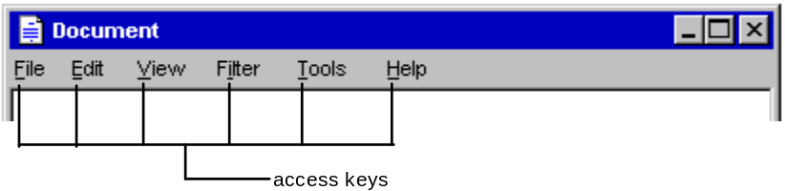

Figure 7.4 Access Keys in a Menu Bar.

Define unique access keys for each menu title. Using the same access key for more than one menu title may eliminate direct access to a menu.

For more information about keyboard input and defining access keys, see Chapter 4, "Input Basics."

Menu Items
Menu items are the individual choices that appear in a menu. Menu items can be words, graphics (for example, icons), or graphics and word combinations that represent the actions presented in the menu. The format for a menu item can provide the user with visual cues about the nature of the effect it represents.

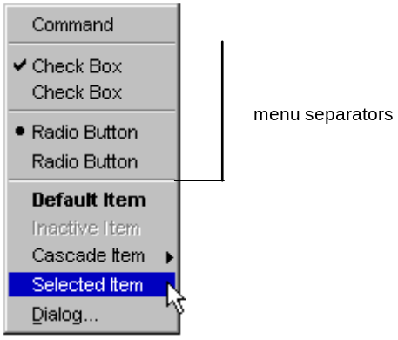

Figure 7.5 Different Menu Items.
Whenever a menu contains a set of related menu items, you can separate those sets with a grouping line known as a separator. The standard separator is a single line that spans the width of the menu. Avoid using textual menu items as group separators as shown in Figure 7.6.

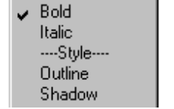

Figure 7.6 Inappropriate Use of a Textual Menu Item as a Separator.
Always provide the user with a visual indication about which menu items can be applied. If a menu item is not appropriate or applicable in a particular context, then disable or remove it. Leaving the menu item enabled and presenting a message box when the user selects the menu item is a poor method for providing feedback. It is preferable to disable a menu item rather than remove it because this provides more stability in the interface. However, if the context is such that the menu item is no longer relevant, then you can remove it. For example, if a menu displays a set of open files and one of those files is closed or deleted, it is appropriate to remove the corresponding menu item. Similarly, if all items in a menu are disabled, disable its menu title. If you disable a menu item or its title, it does not prevent the user from browsing it. If the user explicitly chooses a disabled item, you can optionally provide a brief message explaining why the command is unavailable.

The system provides a standard interface for disabling menu items. If you are supplying your own visuals for a menu item, follow the visual design guidelines for disabled items. For more information about displaying commands with an unavailable appearance, see Chapter 13, "Visual Design."

Types of Menu Items
Many menu items take effect as soon as they are chosen. If the menu item is a command that requires additional information prior to execution, follow the command with ellipses (...). The ellipses inform the user that the information is incomplete. When it is used with a command, it indicates they need to provide more information to complete that command. Such commands usually result in the display of a secondary window, such as a dialog box.

However, an ellipsis does not simply mean that a dialog box or other secondary window will appear. For example, the Properties command does not have an ellipsis after it because executing the Properties command displays a properties window. The execution of the command is complete. Similarly, commands that provide message windows do not include ellipses. A command such as Save As does include an ellipsis because the command is not complete until the user supplies or confirms a filename.

While you can use menu items to execute commands, you can also use menu items to switch a mode or set a state or property, rather than initiating a process. For example, choosing an item from a menu that contains a list of tools or a view implies changing to that item. In other cases, it may set a specific property value (for example, Bold). State setting menu items may be independent or interdependent:

n Independent settings are the menu equivalent of check boxes. For example, if a menu contains text properties, such as Bold and Italic, they form a group of independent settings. The user can change each setting without affecting the others, even though they both apply to a single text selection. Include a check mark to the left of an independent setting when that state applies
n Interdependent settings are the menu equivalent of option buttons. For example, if a menu contains alignment properties such as Left, Center, and Right, they form a group of interdependent settings. Because a particular paragraph can have only one type of alignment, choosing one resets the property to be the chosen menu item setting. When an interdependent setting is selected, place an option button mark (dot) to the left of the menu item.

In some cases, it is appropriate to reflect the change of a setting by changing the text of the menu item, rather than adding a graphic. Consider the following guidelines:

n If the two states of a setting are obvious opposites, such as the presence or absence of a property, use a check mark. For example for a menu with a text property and a menu item called Bold, show a check mark next to the menu item when the text selection is bold and no check mark when it is not. If a selection contains mixed values for the same state reflected in the menu, no check mark appears next to the item.
n If the two states of the setting are not obvious opposites, use a pair of alternating menu item names to indicate the two states. For example, a naive user might guess that the opposite of a menu item called Full Duplex is Empty Duplex or Not Full Duplex. Because of this ambiguity, pair the command with the alternative name Half Duplex, rather using a graphic to indicate the alternative states.
If there is room in a menu, include both alternatives as individual menu items and interdependent choices. This avoids confusion because both options may be viewed simultaneously. You can also use menu separators to group the choices.
If there is not sufficient room in the menu for the alternative choices, use a single menu item and change its name to the alternative action when selected. In this case, the menu item's name does not reflect the current state; it indicates the state after choosing the item. If possible, create names that use the same access key. For example, the letter D could be used for a menu item that toggles between Full Duplex and Half Duplex.

Avoid defining menu items that change depending on the state of a modifier key. Such techniques hide functionality from a majority of users.
Note

Names of Menu Items
Include a descriptive name or graphic for each menu item. The following are guidelines for naming menu items:

n Define unique item names within a menu. Item names can be repeated in different menus to represent similar or different actions.
n Use a single word or multiple words, but keep the wording brief and succinct. Verbose menu item names can make it harder for the user to scan the menu.
n Define access keys for each menu item. This provides keyboard access to the menu item. The guidelines for selecting an access key for menu items are the same as for menu titles, except that the access key for a menu item can also be a number included at the beginning of the menu item name. This is useful for menu items that vary, such as filenames.
n Follow book title capitalization rules for menu item names. Capitalize the first letter of every word, except for articles, conjunctions, and prepositions that occur other than at the beginning or end of a multiple word name. For example, the following menu names are correct: New Folder, Go To, Select All, Table of Contents.
n Avoid formatting individual menu item names with different text properties. Even though these properties illustrate a particular text style, they also make the menu cluttered, illegible, or confusing. For example, if may be difficult to indicate an access key if an entire menu entry were underlined.

Shortcut Keys in Menu Items
In addition, a menu item can also display a keyboard shortcut associated with the entry. Display the shortcut key on the menu next to the item. Align shortcuts with other shortcuts in the menu. Typically, they are left aligned at the first tab position after the longest item in the menu that has a shortcut. Do not use spaces for alignment because they do not work properly with the proportional font used for menu text.

Match key names with those inscribed on the keyboard. Display ctrl and shift key combinations as Ctrl+key (rather than Control+key or CONTROL+key or ^+key) and Shift+key. As an optional alternative, you may use graphical representations of the key caps. When using function keys for menu item shortcuts, the name of the key should appear as Fn, where n is the function key number. For more information about the selection of shortcut keys, see Chapter 4, "Input Basics."

Controls
Controls are graphic objects that represent the properties or operations of other objects. Some controls display and allow editing of particular values. Other controls initiate an associated command.

Like most elements of the interface, controls provide feedback indicating when they have the input focus and when they are activated. For example, when interacting with controls using a mouse, each control indicates its selection on the down transition of the mouse button, but does not activate until button up (unless the control supports auto-repeat).

Controls are generally interactive only when the pointer (hot spot) or focus is on the control. If the user moves the pointer off the control (or for some controls, such as scroll bars, outside a defined hot zone of the control), the control no longer responds to the input device. However, if the user moves the pointer back onto the control, it once again responds to the input device.

While controls provide specific interfaces for user interaction, you can also include pop-up menus for controls. This can provide an effective way to transfer the value of the control or to provide access to contextual Help information. The interface to pop-up menus for controls follows the standard conventions for pop-up menus, except that it does not affect the state of the control; that is, clicking the control with button 2 does not have the same effect as clicking the control with button 1. The only action is the display of the pop-up menu.

For more information about the access to contextual Help information using a pop-up menu, see Chapter 12, "User Assistance."

A pop-up menu for a control is contextual to what the control represents, rather than the control itself. Therefore, do not include commands, such as Set, Unset, Check, or Uncheck. The exception is in a forms design or window layout context, where the commands on the pop-up menu can apply to the control itself.

When controls are nested or used on a white background, their appearance is different. For more information about presenting controls in this situation, see Chapter 13, "Visual Design."

Buttons
Buttons are controls that initiate actions or change properties. There are three basic types of buttons: command buttons, option buttons, and check boxes.

Command Buttons
A command button, also known as a push button, is a control, commonly rectangular in shape, that includes a label (text, graphic, or sometimes both) as shown in Figure 7.7.

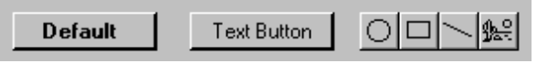

Figure 7.7 Command Buttons.

Clicking a command button with mouse button 1 (for pens, tapping) executes the command associated with the button. When the user presses the mouse button, the input focus moves to the button, and button state changes to the pressed appearance. If the user moves the pointer off the command button while the mouse button remains pressed, the button returns to its original state. However, if the user moves the pointer back over the button while the mouse button is pressed, the button returns to the pressed state.

When the user releases the mouse button and the pointer remains on the command button, the command associated with the control is executed. If the pointer is not on the control when the user releases the mouse button, no action occurs.

You can define access keys and shortcut keys for command buttons. In addition, the spacebar activates a command button if the user moves the input focus to the button, for example, in a dialog box.

For more information about navigation and activation of controls, see Chapter 8, "Secondary Windows."

The effect of choosing a button is immediate with respect its context. For example, in toolbars, clicking a button carries out the associated action. In a secondary window, such as a dialog box, activating a button may initiate a transaction within the window, or apply a transaction and close the window.

The command button's label represents the action the button initiates. When using a textual label the text should follow the same capitalization conventions defined for menus. If the control is unavailable (disabled), the label of the button appears unavailable.

For more information about the appearance of unavailable buttons, see Chapter 13, "Visual Design."

Include an ellipsis (...) as a visual cue for buttons associated with commands that require additional information. Like menu items, the use of ellipses indicates that further information is needed, not simply that a window will appear. Executing some buttons can result in the display of a message box, but this does not imply that the command button's label should include an ellipsis.

You can use command buttons to enlarge a secondary window and display additional options, also known as an unfold button. An unfold button is not really a different type of control, but the use of a command button for the specific function. When using a command button for this purpose, include a double chevron (>>) as part of the button's label.

For more information about the use of buttons with ellipses and unfold buttons in secondary windows, see Chapter 8, "Secondary Windows."

In some cases, a command button can represent an object and its default action. For example, the task bar buttons represent an object's window as well as the Restore command. Clicking on the button with mouse button 1 executes the default command of the object. Clicking on the button with mouse button 2 displays a pop-up menu associated with the object.

You can also use command buttons to reflect a mode or property value (similar to the use of option buttons or check boxes). While the typical interaction for a command button is to return to its normal "up" state, if you use it to represent a state, display the button in the option-set appearance, which is a checkerboard pattern in the button's highlight color on the background of the button as shown in Figure 7.8.

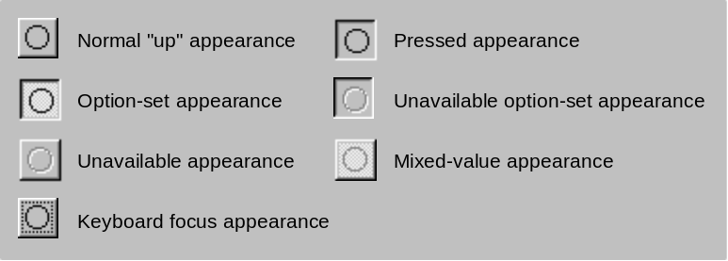

Figure 7.8 Command Button Appearances.
For more information about the appearance of different states of buttons, see Chapter 13, "Visual Design."

You can also use command buttons to set tool modes — for example, in drawing or forms design programs for drawing out specific shapes or controls. In this case, design the button labels to reflect the tool's use. When the user chooses the tool (that is, when the button is clicked), display the button using the option-set appearance and change the pointer to indicate the change of the mode of interaction.

Menu Buttons
A menu button uses a command button to display a pop-up menu. While this is not a specific control provided by the system, you can create this interface using the standard components.

A menu button looks just like a standard command button. However, as a part of its label, it includes a triangular arrow similar to the one found in cascading menu titles as shown in Figure 7.9.

Illustration

of a command button
that is pressed
and its accompanying menu

Figure 7.9 A Menu Button.
A menu button supports the same type of interaction as a drop-down menu; the menu is displayed when the button is pressed. This allows the user to drag into the menu from the button and make menu selections, through the use of highlighting, to track the movement of the pointer.

Clicking a command button also displays the menu. Interaction with the menu is the same as with any pop-up menu. For example, clicking a menu item executes the associated command. Clicking outside the menu or on the command button removes the menu.

When pressed, the command button displays the pressed appearance. When the user releases the button and the menu is displayed, the command button displays the option-set appearance, a checkerboard appearance using the button's highlight color on the background of the button. Otherwise, the command button's appearance is the same as a typical command button. For example, if the button is unavailable, the button displays the unavailable appearance.

For more information about the appearance of button states, see Chapter 13, "Visual Design."

Option Buttons
An option button (also known as a radio button) represents a single choice within a limited set of mutually exclusive choices — that is, in any group of option buttons, only one option in the group can be set. Accordingly, always group option buttons in sets of two or more as shown in Figure 7.10.

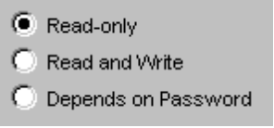

Figure 7.10 A Set of Option Buttons.
Option buttons appear as a set of small circles. When an option button choice is set, a dot appears in middle of the circle. When the choice is not the current setting, the circle is empty. Avoid using option buttons to initiate an action other than the setting of a particular option or value represented by the option button. The only exception is that you may support double-clicking the option button as a shortcut for setting the value and executing the default command of the window in which the option buttons appear, if choosing an option button is the default user action for the window

You can use option buttons to represent a set of choices for a particular property. When the option buttons must reflect a selection with mixed values for that property, then display all the buttons in the group using the mixed-value appearance to indicate multiple values exist for that property as shown in Figure 7.11.

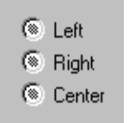

Figure 7.11 An Option Buttons with Mixed-Value Appearance.
If the user chooses any of option buttons with mixed-value appearance, then that value is applied to property; the dot appears in that button and all the other buttons in the group appear empty.

For more information about mixed-value appearance, see Chapter 13, "Visual Design."

Limit use of option buttons for small sets of options, (typically seven or less, but always at least two). If you need more choices, consider using another control, such as a single selection list box or drop-down list box.

Option buttons include a textual label. If you need graphic labels, then consider using command buttons instead. Define the label to best represent the value or effect for that choice. You also use the label to indicate when the choice is unavailable.

For more information about unavailable appearance, see Chapter 13, "Visual Design."

Because option buttons appear as a group, you can use a group box control to visually define the group. The group box can have its own label, which allows you to label option buttons to be relative to group box's label. For example, a group of option buttons labeled Alignment, might have individual labels such as Left, Right, and Center.

As with command buttons, the mouse interface for choosing a button uses a click with mouse button 1 (for pen, tap), either on the button's circle or on the button's label. The input focus moves to the option button when the user presses the mouse button, and the button displays its pressed appearance. If the user moves the pointer off the option button before releasing the mouse button, the option button returns to its former state. The option is not set until the user releases the mouse button while the pointer is over the control. Releasing the mouse button outside of the option button or its label has no effect on the current setting of the option button. In addition, successive mouse clicks on the same option button do not toggle the button's state; the user needs to explicitly select an alternative choice in the group to cancel a choice.

Assign access keys to option button labels to provide a keyboard interface to the buttons. You can also define the tab or arrow keys to allow the user to navigate and choose a button.

For more information about navigation and interaction with option buttons, see Chapter 8, "Secondary Windows."

Check Boxes
Like option buttons, check boxes support options that are either on or off; however check boxes differ from option buttons ine that you use check boxes for nonexclusive choices. A check box appears as a square box with an accompanying label. When the choice is set, a check mark appears in the box. When the choice is not set, the check box is empty as shown in Figure 7.12.

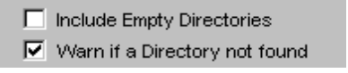

Figure 7.12 A Set of Check Boxes.
As in the case of independent settings in menus, use check boxes only when both states of the choice are clearly opposite and unambiguous. If this is not the case, then consider using option buttons or some other form of single selection choice control instead.

A check box's label is typically textual. Use command buttons when you need a graphical label. Define the label to appropriately express the value or effect of the choice. You can also use the label to indicate when the control is unavailable.

Group related check box choices. Grouping check boxes does not prevent the user from setting the check boxes on or off in any combination. Each check box's setting is typically independent of the others; however, you can use a check box's setting to affect other controls. For example, you can use the state of a check box to filter the content of a list. If you have a large number of choices or if the number of choices may vary, consider using a multiple selection list box instead of check boxes.

Clicking a check box with mouse button 1 (for pen, tap), either on the check box square or on the check box's label, chooses that button and toggles its state. When the user presses the mouse button, the input focus moves to the control and the check box assumes its pressed appearance. Like option buttons and other controls, if the user moves the pointer off the control while holding down the mouse button, the control's appearance returns to its original state. The setting state of the check box does not change until the user releases the mouse button. To change the control's setting, position the pointer over the check box or its label when releasing the mouse button.

Define access keys for check box labels to provide a keyboard interface for navigating to and choosing a check box. In addition, the spacebar toggles a check box when the input focus is on the check box (for example, in a dialog box).

For more information about the guidelines for selecting access keys, see Chapter 4, "Input Basics." For more information about navigation and choosing controls with the keyboard, see Chapter 8, "Secondary Windows."

If you use a check box to display the value for the property of a multiple selection whose values for that property differ (for example, for a text selection that is partly bold), display the check box in its mixed-value appearance that uses a checkerboard pattern inside the box as shown in Figure 7.13.



Figure 7.13 A Mixed-Value Check Box (Magnified).
For more information about the mixed-value appearance, see Chapter 13, "Visual Design."

Choosing a mixed-value check box sets the associated value by placing a check mark in it. Choosing it again turns off the value. Choosing it a third time toggles the value back to the mixed-value state. This three-state toggling only occurs when the values are mixed.

List Boxes
A list box is a convenient, preconstructed control for displaying a list of choices for the user. The choices may be text, color, icons, or other graphics. The purpose of a list box is to display a collection of items and, in most cases, support selection of a choice of an item (or items) in the list.

List boxes are best for displaying large numbers of choices that vary in number or content. If a particular choice is not available, omit the choice from the list. For example, if a point size is not available for the currently selected font, do not display that size in the list.

For more information about unavailable appearance, see Chapter 13, "Visual Design."

Order entries in a list that is the most appropriate for the content in the list and to faciliate easy user browsing. For example, alphabetize a list of filenames, but put a list of dates in chronological order. If there is no natural or logical ordering for the content, use alphabetical ordering (ascending; for example, 0-9, A-Z).

List box controls do not include their own labels. However, you may include a label using a static text field; the label enables you to provide a descriptive reference for the control as well as keyboard access to the control. Make certain that your support for keyboard access moves the input focus to the list box and not the static text field label.

For information about navigation to controls in a secondary window, see Chapter 8, "Secondary Windows." For information about defining access keys for control labels, see Chapter 4, "Input Basics."

When a list box is disabled, display its label using an unavailable appearance. If possible, display all of the entries in the list in unavailable appearance to avoid confusing the user as to whether the control is enabled or not.

For more information about displaying information in unavailable appearance, see Chapter 13, "Visual Design."

The width of the list box should be sufficient to display the average width of an entry in the list. If that is not practical, because of space or the variability of what the list may include, consider one or more of the following options:

n Make the list box wide enough to allow the entries in the list to be sufficiently distinguished.
n Use ellipses (...) in the middle or at the end of long text entries to shorten them, while preserving the important characteristics needed to distinguish them. For example for long pathnames, usually the beginning and end of the path are the most critical; you can use ellipses to shorten the entire name: \SAMPLE\...\EXAMPLE.
n Include a horizontal scroll bar. This option reduces some usability, because adding the scroll bar reduces the number of entries you can view at one time. In addition, if most entries in the list box would not need to be horizontally scrolled, including a horizontal scroll bar accomodates the infrequent case.

List boxes can be classified by how they display a list and by the type of selection they support.

Single Selection List Boxes
A single selection list box is designed for the selection of only one item in a list. Therefore, the control provides a mutually exclusive operation similar to a group of option buttons, except that a list box can more efficiently handle a large number of items. Define a single selection list box to be tall enough to show at least three to eight choices (depending on the design constraints of where the list box is used) as shown in Figure 7.14. It should always include a vertical scroll bar. If all the items in the list are visible, then follow the window scroll bar guidelines for disabling the scroll arrows and enlarging the scroll box to fill the scroll bar shaft.

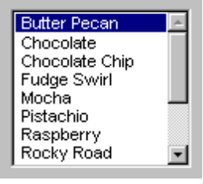

Figure 7.14 A Single Selection List Box.
The currently selected item in a single selection list box is highlighted using selection appearance.

The user can select an entry in a single selection list box by clicking on it with mouse button 1 (for pen, tapping). Because this type of list box supports only single selection, choosing an entry unselects any other item selected in the list. The scroll bar in the list box allows the mouse user to scroll through the list of entries, following the interaction defined for scroll bars. The keyboard interface uses navigation keys, such as the arrow keys, home, end, page up, and page down, as well as alphanumeric keys (for example, pressing M scrolls the entry beginning with M to the top of the list). These keys not only navigate to an entry in the list, but also select it.

For more information about the interaction techniques of scroll bars, see Chapter 6, "Windows."

If the choices in the list box represent values for a property of a selection, then make the current value visible and selected when displaying the list. If the list box reflects mixed values for a multiple selection, then no entry in the list should be selected.

Drop-down List Boxes
Like a single selection list box, a drop-down list box provides for the selection of a single item from a list of items; the difference is that the list is displayed upon demand. In its closed state, the control displays the current value for the control. The user opens the list to change the value. Figure 7.15 shows the drop-down list box in its closed and opened state.

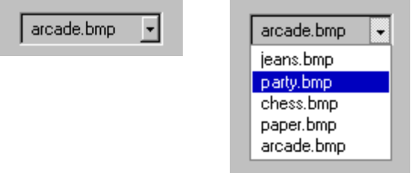

Figure 7.15 Drop-down List Box (Closed and Opened State).
Make the width of a closed drop-down list box a few spaces larger than the average width of the items in its list. The open list component of the control should be tall enough to show three to eight items, following the same conventions of a single selection list box. The width of the list should be wide enough not only to display the choices in the list, but also to allow the user to drag directly into the list.

The interface for drop-down list boxes is similar to that of menus. For example, the user can press the mouse button to display (open) the list. Choosing an item in the list automatically closes the list. Similarly, arrow keys display the list. Using alt+up arrow, alt+down arrow, a navigation key, or an access key to move to another control automatically closes the list. When the list is closed, preserve any selection made while the list was open (unless the user presses a Cancel command button).

Drop-down list boxes are an effective way to conserve space and reduce clutter. However, the design tradeoff is that they require more user interaction for browsing and selecting an item than a single selection list box.

If the choices in a drop-down list represent values for the property of a multiple selection and the values for that property are mixed, then display no value in the current setting component of the control.

Extended and Multiple Selection List Boxes
Although most list boxes are single selection lists, some contexts require the user to choose more than one item. Extended selection list boxes and multiple selection list boxes support this functionality.

Extended and multiple selection list boxes follow the same conventions for height and width as single selection list boxes. Base the width of the box on the average width of the entries in the list. The height should be able to display no less than three items and generally no more than eight, unless the size of the list varies with the size of the window.

Extended selection list boxes support the selection interface for contiguous and disjoint selection. That is, extended selection list boxes are optimized for a single item selection or for a single range, while still providing for disjoint selections.

For more information about contiguous and disjoint selection techniques, see Chapter 5, "General Interaction Techniques."

When you want to support user selection of several entries from a list, but the grouping of the entries does not make extended selection efficient, you can define a multiple selection list box. Whereas extended selection list boxes are optimized for individual item or range selection, multiple selection list boxes are optimized for independent selection.

Use check boxes that precede each item for items for items in a multiple selection list box as shown in Figure 7.16. Such an appearance helps the user to distinguish the difference in the interface of the list box with a familiar convention. It also serves to differentiate keyboard navigation from the state of a choice.

When using check boxes in a list box, the appearance of the check box differs slightly. For more information about the appearance of controls in a list box, see Chapter 13, "Visual Design."

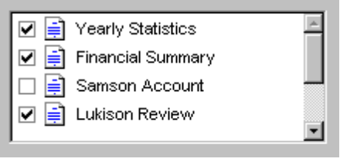

Figure 7.16 A Multiple Selection List Box.

List View Boxes
A list view is a special extended selection list box control that displays of a set of objects. It supports viewing objects by their large icon, small icon, as a list, or a table. It is often used with a tree control which is described in the following section.

Tree Control Boxes
A tree control is a special list box control that displays a set of objects as an indented outline based on their logical hierarchical relationship. The control includes buttons that allow the outline to be expanded and collapsed as shown in Figure 7.17. You can use a tree control to display the relationship between a set of containers or other hierarchical views.
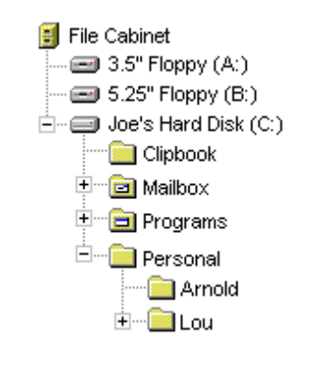

Figure 7.17 A Tree Control.

Text Fields
Windows 95 includes a number of controls that facilitate the display, entry of text, or editing of a text value. Some of these controls combine a basic text entry field with other types of controls.

Text fields do not include labels as a part of the control. However, you can add one using a static text field. Including a label helps identify the purpose of a text field and provides the means of indicating when the field is disabled. You can also define access keys for the text label to provide keyboard access to the text field. When using a static text label, define keyboard access to move the input focus to the text field with which the label is associated rather than the static text field itself.

For more information about text fields, see "Static Test Fields" later in this chapter.

When using a text field for input of a restricted set of possible values, for example, a field where only numbers are appropriate, consider validating user input immediately, either by ignoring inappropriate characters or by providing feedback indicating that the value is invalid or both.

For more information about validation of input, see Chapter 8, "Secondary Windows."

You can use text fields to display information that is read-only; that is, they are appropriate for text that cannot be directly edited by a user. Read-only text fields allow the data to be selected but not edited.

For more information about the visual presentation of read-only text fields, see Chapter 13, "Visual Design."

Text Boxes
A text box (also known as an edit control) is a rectangular control where the user enters or edits text as shown in Figure 7.18. It can be defined to support a single line or multiple lines of text. The outline border of the control is optional, although typically displayed.

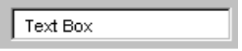

Figure 7.18 Standard Text Box.
The standard text box control provides basic text input and editing support. Editing support includes the insertion or deletion of characters and the option of text wrapping. Individual font or paragraph properties are not supported (although the entire control can support font properties).

A text box supports standard interactive techniques for navigation and contiguous selection. Horizontal scrolling is supported for single line text boxes, and horizontal and vertical scroll bars are supported for multiple line text boxes.

For more information about the conventions for selection and editing of text, see Chapter 5, "General Interaction Techniques."

You can limit the number of characters accepted as input for a text box to whatever is appropriate for the context. In addition, text boxes defined for fixed-length input can also support auto-exit; that is, as soon as the last character is typed in the text box, the focus moves to the next control. For example, you can define a five-character auto-exit text box to facilitate the entry of zip code, or three two-character auto-exit text boxes to support the entry of date. However, because the automatic focus shift behavior may be unexpected, use auto-exit text boxes sparingly. They are best limited to situations involving extensive data entry.

Rich-text Boxes
A rich-text box (as shown in Figure 7.19) supports the same basic text editing support as a standard text box. In addition, a rich-text box supports individual character font and paragraph formatting (properties).

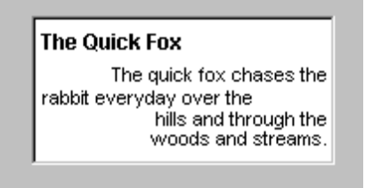

Figure 7.19 A Rich-Text Box.

Combo Boxes
A combo box is a control that combines a text box with a list box as shown in Figure 7.20. This allows the user to type in an entry or choose one from the list.

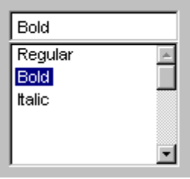

Figure 7.20 A Combo Box.
The text box and its associated list box have a dependent relationship. As text is typed into the text box, the list scrolls to the nearest match. In addition, selecting an item in the list box automatically uses that entry to replace the content of the text box.

The interface for the control follows the conventions supported for each component, except that up arrow and down arrow only move in the list box.

Drop-down Combo Boxes
A drop-down combo box (as shown in Figure 7.21) combines the characteristics of a text box with a drop-down list box. Being more compact than a regular combo box, it can be used when space needs to be conserved, trading off the additional interaction like drop-down lists.

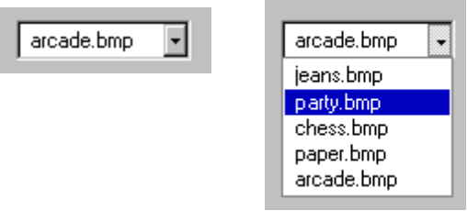

Figure 7.21 Combo Box (Closed and Open).
The closed state of a drop-down combo box is similar to that of a drop-down list, except that the text box is interactive. Clicking the button component of the control opens the list. Clicking the button component a second time, choosing an item in the list, or clicking another control also closes the list. Pressing up arrow or down arrow (or alt+up arrow or alt+down arrow) also display the list.
Pressing a navigation key, such as tab, or an access key (or alt+up arrow or alt+down arrow) will close the list. When the list is closed, preserve any selection made while the list was open (unless a Cancel command button is pressed).

When the list is displayed, the interdependent relationship between the text box and list is the same as it is for standard combo boxes when text is typed into the text box. When the user chooses an item in the list, the interaction is the same as for drop-down lists; the selected item becomes the entry in the text box.

Spin Boxes
Spin boxes are text boxes that accept a limited set of discrete ordered input values. A spin box is a combination of a text box and a pair of buttons as shown in Figure 7.22. The buttons on the control allow the user to increment or decrement values in the text box.

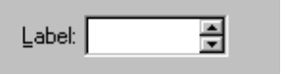

Figure 7.22 A Spin Box.

The user can type a text value directly into the control or use the buttons to change the value. Pressing up arrow or down arrow also changes the value.

You can use a single set of spin box buttons to edit a sequence of related text boxes, for example, time as expressed in hours, minutes, and seconds. The buttons affect only the text box that currently has the input focus.

Static Text Fields
You can use static text fields to present read-only textual information. However, an application can still alter read-only text, if appropriate, to reflect a change in state. For example, you can use static text to display the current directory path or the status information such as page number, key states, or time and date. Figure 7.23 demonstrates a static text field.



7.23 A Static Text Field.
You can also use static text fields to provide labels or descriptive information for other controls. Using static text fields as labels for other controls allows you to provide access-key activation for the control with which it is associated. Make certain that the input focus moves to its associated control and not to the static field.

Other General Controls
The system also provides support for other controls for special types of interfaces and controls designed to organize other controls.

Scroll Bars
Scroll bars are horizontal or vertical scrolling controls you can use to create scrollable areas other than on the window frame or list box where they are automatically included. Use scroll bars only for supporting scrolling contexts, not for setting values. Instead, you can use a slider or other control, such as a spin box, to set or adjust values. Using a scroll bar to set values may confuse the user as to the purpose or interaction of the control.

While scroll bar controls can support the input focus, avoid defining this type of interface. Instead, define the keyboard interface of your scrollable area so that it can scroll without requiring the user to move the input focus to a scroll bar. This makes your scrolling interface more consistent with the user interaction for window and list box scroll bars.

Sliders
Use a slider for setting or adjusting values or the position on continuous dimensions, such as volume or brightness. A slider is a control that consists of a bar that defines the extent or range of the adjustment, and an indicator that both shows the current value for the control and provides the means for changing the value as shown in Figure 7.24.



Figure 7.24 A Slider.
The user can move the slide indicator by dragging to a particular location or clicking in the hot zone area of the bar, which moves the slide indicator directly to that location. Arrow keys also move the slide indicator in the respective direction represented by the key.

Sliders support a number of options. You may set a slider as vertical or horizontal and define the length and height of the slide bar component.

Because a slider does not include its own label, use a static text field to create one. You can also add text and graphics to the control to help the user interpret the scale and range of the control.

Progress Indicators
A progress indicator is a control you can use to show the percentage of completion of a particular process. The bar "fills" from left to right as shown in Figure 7.25.



Figure 7.25 A Progress Indicator.
Display options for progress indicators include height, width, color, solid or segmented bar, and horizontal or vertical orientation. Because a progress indicator displays information, it is noninteractive. However, it may be useful to add static text or other information to help communicate the purpose of the progress indicator.

Tabs
A tab is control that looks similar to a notebook divider as shown in Figure 7.26. You can use this control for navigation between logical "pages" or sections of information.

Figure 7.26 A Tab Control.
Clicking a tab switches to that tab. When the user moves the input focus to a tab, left arrow or right arrow moves between tabs. ctrl+tab also switches between tabs. Optionally, you can also define access keys for navigating between tabs.

Wells
A well is a special field that displays graphical information such as a color, pattern, or image used as a property value as shown in Figure 7.27. This control is not currently provided by the system; however, its purpose and interaction guidelines are described here to provide a consistent interface.

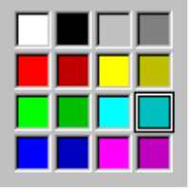

Figure 7.27 A Well Control for Selection Colors.
When the control is interactive, it uses the same border pattern as a check box or text box. If you use the control to choose a value, then the current set value is indicated by a border drawn around the border. Because this control is similar to option buttons, follow the same interaction techniques.

For more information about the option-set appearance, see Chapter 13, "Visual Design."

Group Boxes
A group box is a special control you can use to organize a set of controls. A group box is a rectangular frame with an optional label that surrounds a set of controls as shown in Figure 7.28. Group boxes generally do not directly process any input.

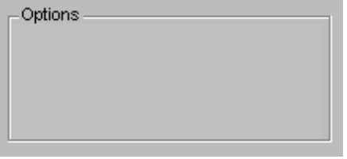

Figure 7.28 A Group Box.
You can make the label for controls that you place in a group box relative to the group box's label. For example, a group labeled Alignment can have option buttons labeled, Left, Right, and Center.

Column Headings
You can use a column heading control to display properties of a selected object in a multicolumn list as shown in Figure 7.29. The control allows you to define the displayed property and the sort order based on the property for items in the list.

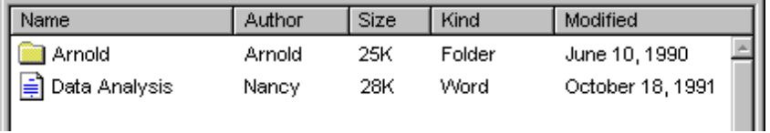

Figure 7.29 Column Headings.

Property Sheet Controls
A property sheet control provides the basic framework for defining a property sheet. It provides the common controls used in a property sheet and accepts dialog box layout definitions to automatically create tabbed property pages.

For more information on property sheets, see Chapter 8, "Secondary Windows."

Pen Specific Controls
When a pen is installed, single line text boxes and combo boxes automatically acquire the lens button. In addition, the system provides the following controls for supporting pen input.

For more information about the lens button, see Chapter 5, "General Interaction Techniques."

Boxed Edit Controls
A boxed edit control provides the user with a discrete area for entering characters. It looks and operates similar to a lens window without some of the lens window's buttons as shown in Figure 7.30.

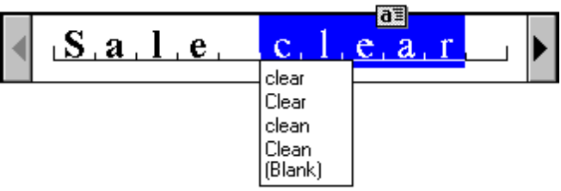

Figure 7.30 A Single Line Boxed Edit Control.
Both single and multiple line boxed edit controls are supported. Figure 7.31 shows a multiple line boxed edit control.

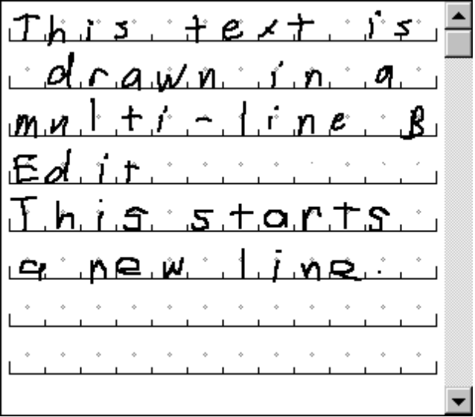

Figure 7.31 A Multiple Line Boxed Edit Control.
Like the lens window, these controls provide a selection handle for selection of text and an action handle for operations on a selection. They also provide easy correction by overwriting and selecting alternative choices.

Ink Edit Controls
The ink edit is a control in which the user can create and edit ink; no recognition occurs here. It is a drawing area designed for ink input as shown in Figure 7.32.

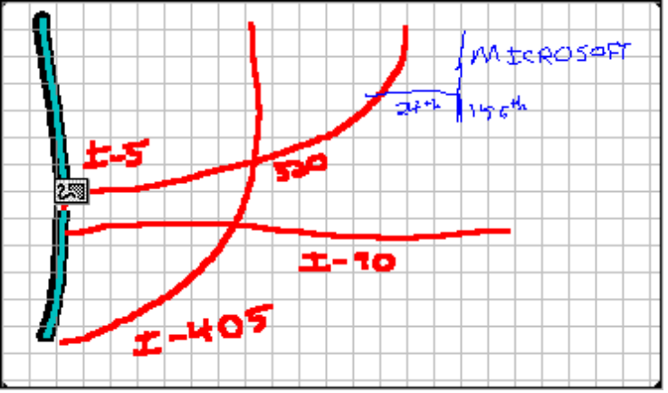

Figure 7.32 An Ink Edit Control.
The control provides support for an optional grid, optional scroll bars, and optional display of a frame border. Selection is supported using tapping to select a particular stroke; lasso-tapping is also supported for selecting single or multiple strokes. After making a selection, an action handle is displayed. Tapping on the action handle displays a pop-up menu that includes commands for Undo, Cut, Copy, Paste, Delete, Use Eraser, Resize, What's This?, and Properties. Choosing the Properties command displays a property sheet associated with the selection — this allows the user to change the stroke width and color.

If you use an ink edit control, you may want to also include some controls for special functions. For example, a good addition is an Eraser toolbar button as shown in Figure 7.33.

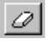

Figure 7.33 The Eraser Toolbar Button.
Implement the Eraser toolbar button to operate as a "spring-loaded" mode; that is, choosing the button causes the pen to act as an eraser while the user presses the pen to the screen. As soon as it is lifted, the pen reverts to its drawing mode.

Toolbars and Status Bars
Like menu bars, toolbars and status bars are special interface constructs for managing sets of controls. A toolbar is a panel that contains a set of controls (as shown in Figure 7.34) designed to provide quick access to specific commands or options. Specialized toolbars are sometimes called ribbons, tool boxes, and palettes.

Figure 7.34 A Toolbar.

A status bar is a special area within a window that displays information about the current state of what is being viewed in the window or any other contextual information (for example, keyboard state, time). Figure 7.35 shows a status bar. You can also use status bar to provide descriptive messages about a selected menu or toolbar button. Like a toolbar, a status bar can contain controls; however, the controls typically reflect read-only or noninteractive information. It is also usually configured as a part of a window.

For more information about status bar messages, see Chapter 12, "User Assistance."

Figure 7.35 A Status Bar.

Provide the user with the option to display or hide toolbars and status bars. Because toolbars and status bars may be hidden, avoid including controls on them that are not also provided elsewhere in the interface. Where appropriate, also include options that allow the user to change or rearrange the controls in toolbars and status bars.

Design toolbars so that they can be windowed or docked, aligned to the edge of a window or pane, at the discretion of the user. In a windowed state, display the controls in a sizable palette window that includes a title area so the user can move the control bar around. Preserve the current position and size (and other state information) of toolbar windows so that they can be restored to their former position.

For more information about palette windows, see Chapter 8, "Secondary Windows."

To dock a toolbar, the user drags it until it comes in contact with the edge of an appropriate boundary (for example, window or pane) at which point it "snaps" to align to that edge. To change a docked toolbar to its windowed state, the user drags anywhere in the "blank" area of the toolbar and moves anywhere that is not a dockable location. After dragging the toolbar to its new location, the toolbar displays as a window. Optionally, you can support double-clicking in the blank area of a toolbar to restore it to its windowed state. Your software can also dock multiple control bars side by side, reconfiguring their arrangement and size as necessary.

The system includes toolbar and status bar controls that you can use to implement these interfaces in your applications. The toolbar control supports docking and windowing functionality. The status bar control includes a special area that supports sizing the window.

Interaction with Controls in Toolbars and Status Bars
The user can access the controls included in a toolbar or status bar with the mouse or pen through the normal means of interaction for those controls. Support keyboard access using either shortcut keys or access keys. Because a control in a toolbar or status bar may not have a text label, access keys may not be as effective. Further, if a particular access key is already in use, it may not be available for accessing the control in the toolbar. For example, if the menu bar of the primary window is already using a particular access key, then the menu bar will get the key event.

When the user interacts with controls in a toolbar or status bar that reflect properties there is usually an immediate effect on the data. For example, if a command button in a toolbar changes the property of text to bold, choosing that button immediately changes the text to bold; no further confirmation or transaction action is required. The only exception is if the control, such as a command button, requires additional parameters (for example, the selection of an object or a set of input values through a dialog box), then the effect may not be realized until the user provides the information for those parameters.

Common Toolbar Buttons
The following table illustrates the button glyphs that should be used for common functions.

Table 7.4 Common Toolbar Buttons
Button | Function
 | New
 | Open
 | Save
 | Print
 | Cut
 | Copy
 | Paste
 | Properties
 | What's This? (contextual Help mode)
 | Open parent folder
 | View as large icons
 | View as small icons
 | View as list
 | View as details
 | Selection tool
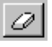 | Eraser tool

Use these images only for the function described. The advantage of using these common tool images is that the user learns and remembers from product to product. If you use one of the standard images for a different function, you can confuse the user.

For more information about the design of toolbar buttons, see Chapter 13, "Visual Design."

