C H A P T E R 6

Windows
Windows are a fundamental part of the Microsoft Windows 95 interface; consistency in window design is particularly important because it enables users to easily transfer their learning skills and focus on their tasks rather than learning new conventions. This chapter describes the common types of windows, as well as recommendations regarding general window appearance and operations.

Common Types of Windows
Windows provide the fundamental way a user views and interacts with data. Because windows provide access to different types of of information, they can be classified according to common usage. Interacting with objects typically involves a primary window in which most of primary viewing and editing activity takes place. In addition, multiple or supplemental secondary windows may be included to allow users to specify parameters or options, or to provide more specific details about the objects or actions included in the primary window. For more information about secondary windows, see Chapter 8, "Secondary Windows."

Primary Window Components
A typical primary window consists of a frame (or border) that defines its extent, and a title bar that identifies what is being viewed in the window. If the viewable content of the window exceeds the current size of the window, scroll bars are used. The window can also include other components like menu bars, toolbars, and status bars. For more information about these components, see Chapter 7, "Menus, Controls, and Toolbars" and the section “Scrolling Windows” later in this chapter.

Figure 6.1 shows the common components of a primary window.

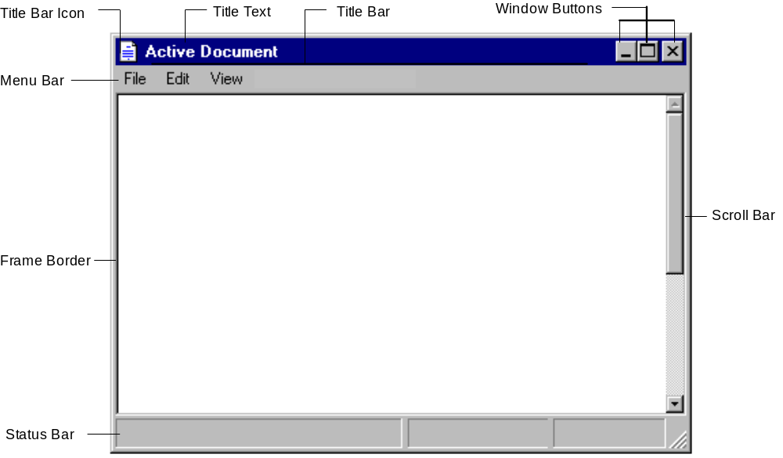
Figure 6.1 Typical Primary Window.

The Window Frame
Every window has a boundary that defines its shape. A sizable window has a distinct border area that provides a control point for resizing the window using direct manipulation. If the window cannot be resized, the border coincides with the edge of the window.

The Title Bar
At the top edge of the window, inside of its border, is the title bar which extends across the width of the window. The title bar identifies what the window is viewing, such as a document, spreadsheet, or application. It also serves as a control point for moving the window as well as access to commands that apply to the windows and its associated view. For example, clicking on the title bar with mouse button 2 displays the pop-up menu for the window. For more information about pop-up menus, see Chapter 7, "Menus, Controls, and Toolbars."

The Title Bar Icon
The small version of the icon of the object appears in the upper-left corner of the title bar. The title bar icon provides access (through a pop-up menu) to the operations for that object. For more information about icon design, see Chapter 13, "Visual Design."

If the window represents a "tool" (that is, it does not create, load, and save separate data files), then it uses the small version of the application's icon in its title bar, as shown in Figure 6.2.

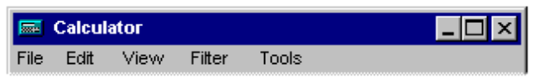

Figure 6.2 "Tool" Object Title Bar.

If the application loads and saves documents or data files, then place the icon that represents its document or data type in the title bar as shown in Figure 6.3.

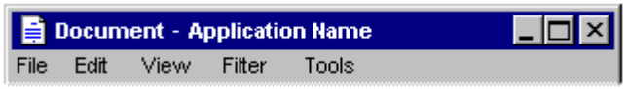

Figure 6.3 Document Title Bar.

If the application uses the multiple document interface (MDI), then use the application's icon in the parent window's title bar, and use an icon that reflects the application data file type in the child window's title bar as shown in Figure 6.4.

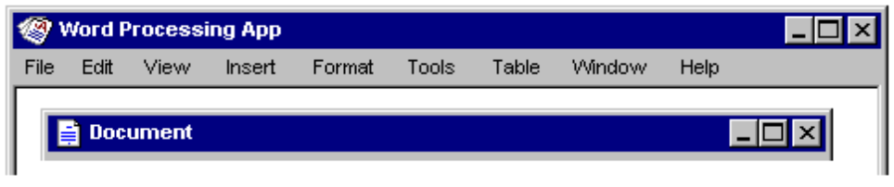

Figure 6.4 MDI Application and Document Title Bars.

However, if a user maximizes the child window, hides the title bar, and its title information merges with the parent, then the icon from the child window's title bar is displayed in the menu bar of the parent window. If multiple child windows are open within the MDI parent window, then the icon from the active (topmost) child window's icon is displayed.

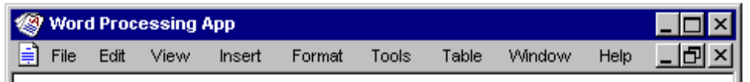

Figure 6.5 MDI Parent Window Title Bar with a Maximized Child Window.
For more information about MDI, see Chapter 9, "Window Management."

Title Text
The title text is a label that identifies the name of the object being viewed through the window. It should also correspond to the current icon in the title bar; that is, if a document or data file is being viewed, the name of the document appears. The name and icon always represent the outmost container — the object that was opened even if the user selects an embedded object or navigates down the internal hierarchy of an object.

If the object currently has no user-supplied name, then include a placeholder in the title, such as (untitled), or the short type name, for example Document n, Sheet n, Chart n, where n is a number (as in Document 1). Ideally, use this name as the proposed default filename for the object. For more information about short type names, see Chapter 10, "Interacting with the Shell."

When the title is a filename, do not include the full storage (path) name because it is usually not meaningful for most users and may be confusing. Display the text exactly as it is stored in the file system (using both uppercase and lowercase, as appropriate).

The title text can also optionally include the name of the application in use. The name of the document appears first, followed by a dash, then the application name as shown in Figure 6.6. If the application is a tool that has no associated data files, then only the application's name is displayed.

The order of the document (or data) filename and application name is a change from Windows 3.1.
Note

Figure 6.6 Title Text Order: Document Name — Application Name.
If the name of the displayed object in the window changes — for example, when the user edits the name in the object's property sheet — then update the title text to reflect that change. Always maintain the association between the object and its open window.

Avoid having your application drawing directly into the title area or adding other controls. Such added items may make it difficult for the user to read the name in the title, particularly because the size of the title bar varies with the size of the window. In addition, the system uses this area for displaying special controls. For example, in some international versions of Windows 95, the title area provides information or controls associated with the input of certain languages.

Window Buttons
Command buttons appear on the right side of the title bar. They are associated with the commands of the window and act as shortcuts to specific commands. Clicking a title bar button with mouse button 1 invokes the command associated with the button. Clicking a title bar command button with button 2 displays the pop-up menu for the window. For the pen, tapping and barrel-tapping support (or the menu gesture), respectively. For more information about command buttons in the pop-up menu of a window, see Chapter 7, "Menus, Controls, and Toolbars."

Typically, the following buttons appear in a primary window (provided that the window supports the respective functions).

Command button | Operation
 | Closes the window.
 | Minimizes the window.
 | Maximizes the window.

Basic Window Operations
There are a number of basic operations for a window. These operations include:

n Activation and deactivation
n Opening and closing
n Moving and sizing
n Scrolling and splitting

The following sections describe these operations.

Activating and Deactivating Windows
While the system supports the display of multiple windows, the user generally works within a single window at a time. This window is called the active window. The active window is typically at the top of the window order. It is also visually distinguished by its title bar displayed in the active window title color. All other windows are inactive with respect to the user's input; that is, while other windows may have ongoing processes, only the active window receives the user's input. The title bar of an inactive window displays the system inactive window color of the system.

The user activates a window by switching to it; this inactivates any other windows. With the mouse or pen, the user simply clicks or taps on any part of the window, including its interior, to activate it. If the window is minimized, the user clicks (taps) on the button representing the window in the task bar. From the keyboard, the alt+tab key combination switches between primary windows. (shift+alt+tab also switches between windows, but in reverse order.) The reactivation of a window should not affect any pre-existing selection; the selection and focus are restored to the previously active state.

When reactivating a primary window, the window and all its secondary windows come to the top of the window order and maintain their relative positions. If the user activates a secondary window, its primary window comes to the top of the window order along with the primary window's other secondary windows.

When a window becomes inactive, the highlighting of any selection within it is hidden to prevent confusion as to which window is receiving keyboard input. A direct manipulation transfer (OLE drag and drop) is an exception. Here, the selection may be shown if the pointer is over the window during the drag. However, the window is not activated unless you release the mouse button (pen tip is lifted) in that window. For more information about selection appearance, see Chapter 13, "Visual Design."

Opening and Closing Windows
When you open a primary window, an entry for it is included on the task bar. If the window has been previously opened, restore the window to its size and position when it was last closed. If possible and appropriate, reinstate the other related view information, such as selection state, scroll position, and type of view. When opening a primary window for the first time, open it to a reasonable default size and position as best defined by the object (or application). Opening the primary window activates that window and places it at the top of the window order. If the user attempts to open a primary window that is already open, within the same desktop, follow these recommendations:

File type | Action when open is re-executed
Document or data file. | Activates the window of the object and displays it at the top of the Z-order.
Application file. | Presents a message box indicating the open instance(s) of that application and offers the user the option to switch to a particular open instance or create a new instance. Either choice activates that window and brings it to the top of the Z-order.
Document file that is already open in a multiple document interface (MDI) application. | Activates the window of the object; the MDI parent window comes to the top of the Z-order, and the document appears at the top of its Z-order within the MDI parent window.
Document file that is not already open, but its associated multiple document interface (MDI) application is already running (open). | Opens a new instance of the MDI application (at the top of the Z-order) loaded with the document window.

For more information about MDI, see Chapter 9, "Window Management."

When opening a window, consider the size and orientation of the current screen upon which it will be opened. For example with some systems, the screen may be landscape oriented (long dimension along the bottom) and with others it may be portrait. The screen resolution may vary as well. In such cases, adjust the size and position of the window from its stored state so that it will appear appropriately on the screen.

A primary window is closed by clicking (for pen, tapping) the Close button in the title bar or choosing the Close command from the window's pop-up menu. In addition, double-clicking (with the pen, double-tapping) on the title bar icon is a shortcut for closing the window and, if appropriate, exiting the application.

After attempting to close a window, if there are any pending transactions, a message is displayed asking the user whether to save any changes, discard any changes, or cancel the close operation. If there are no pending transactions, the window is closed.

Closing the primary window of an object closes any of its dependent secondary windows as well. Whether closing the primary window also ends all the application processes depends on the design of the software. For example, closing the window of a document typically terminates any active code or processes remaining for inputting or formatting text. However, closing the window of a printer has no effect on the jobs in the printer's queue. In both cases, closing the window removes its entry from the task bar.

Moving Windows
A window can be moved either by dragging its title bar (with the mouse or pen) or by using the Move command on the window's pop-up menu. With most systems, an outline representation moves with the pointer during the operation, and the window is redisplayed in the new location after the completion of the move. With the keyboard interface, after choosing the Move command, arrow keys move the outline and pressing the enter key ends the operation — the window is redrawn at the new location. After moving a window, allow the user to reposition it but the window cannot be positioned entirely off the screen. For more information about the pop-up menu of a window, see Chapter 7, “Menus, Controls, and Toolbars.”

A window need not be active before moving it. The action of moving the window implicitly activates it. Moving a window may result in clipping or revealing information shown in the window, and activation may affect the view state of the window (for example, the current selection can be displayed). In general, however, moving a window does not affect the content being viewed in that window.

Resizing Windows
The size of primary windows can be changed by dragging the sizing border with the mouse or pen at the edge of a window or by using the Size command on the window's menu. With most systems, an outline representation of the window moves with the pointer. After completing the size operation, the window assumes its new size. With the keyboard, the user can choose the Size command, use the arrow keys, and press the enter key to size a window. For more information about the pop-up menu or a window, see Chapter 7, “Menus, Controls, and Toolbars.”

A window does not need to be active before it is sized. The action of sizing the window implicitly makes it active and it remains active after the sizing operation. Generally, after making a window smaller through resizing, information is clipped. However, there may be situations where the information may need to be displayed differently (rewrapping or scaling) so that it fits within the window. However, consider and test such variations carefully because they will not be consistent with the resizing behavior of most windows.

While the size of a primary window varies, based on the user's preference, you can define a window's maximum and minimum size. When defining these sizes, consider the reasonable usage within the window, and the size and orientation of the screen.

Maximizing Windows
Maximizing a window increases the size of the window to its largest, optimum size. While the system default setting for the maximum size is as large as the screen, you can to define the size to be less (or, in some cases, more) than the screen dimensions. In addition, because screen resolution and orientation varies, your software should not assume a fixed screen size, but should adapt to the shape and size defined by the system.

Although the user may be able to directly resize a window to its maximum size, the Maximize command optimizes this operation. The command is available on a window's pop-up menu, as well as the Maximize command button in the title bar of a window.

Minimizing Windows
The user can choose the Minimize command on the window's pop-up menu or the title bar Minimize command button to minimize a window. Minimizing a window means to reduce it to its smallest size. For primary windows, minimizing removes the window from the screen, but leaves its entry in the task bar. For information about managing MDI document windows, see Chapter 9, "Window Management."

The former Windows 3.1 representation of a minimized window as an icon is no longer appropriate. To reflect some status information about the open, but minimized window, use the entry on the task bar. For more information about status notification, see Chapter 10, "Interacting with the Shell."
Note

Restoring Windows
After maximizing or minimizing a window, you can use the Restore command to restore it to its previous size. For maximized windows, this command can be made available from the window's pop-up menu or the button which replaces the Maximize button in the title bar of the window. A minimized window is restored to its former size by clicking (for pen, tapping) on its button in the task bar that represents the window or using alt+tab (or shift+alt+tab). In addition, choosing the Restore command from the pop-up menu or its button in the task bar restores the window.

Scrolling Windows
When the content viewed in a window exceeds the size of that window, the window should support scrolling. Scrolling enables the user to view portions of the object that are not currently visible in a window. Scrolling is commonly supported with a scroll bar. A scroll bar is a rectangular control consisting of scroll arrows, a scroll box, and the scroll bar shaft as shown in Figure 6.7.

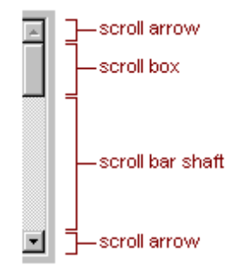

Figure 6.7 Scroll Bar and Its Components.
A window can have a vertical scroll bar, a horizontal scroll bar, or both. The scroll bar aligns with the edge of the window for the respective orientation it supports. If the content is never scrollable in a particular direction, do not include a scroll bar for that direction.

Common practice is to display scroll bars if, under any circumstances, the view requires scrolling. If the window becomes inactive or resized, so that its content does not require scrolling, it is recommended that the display of the scroll bars be maintained. While removing the scroll bars potentially allows the display of more information as well as feedback about the state of the window, it also requires the user to explicitly activate the window to scroll. In addition, consistently displaying scroll bars provides a more stable environment.

Scroll Arrows
Scroll arrow buttons appear at each end of a scroll bar, pointing in opposite directions away from the center of scroll bar. The scroll arrows point in the direction that the window "moves" over the data. When the user clicks (with pen, taps) a scroll arrow, the data in the window appears to move in the opposite direction to reveal information in the direction of the arrow in increments of the appropriate amount. The granularity of the increment depends on the nature of the content and context. For textual content, this is typically one line of text for vertical scrolling; for spreadsheets, it is one row. In most cases, it is best to maintain the scrolling granularity throughout a window. When a window cannot be scrolled any further in a particular direction, disable the associated scroll arrow.

The scroll arrow buttons have a special auto-repeat behavior when pressed and held. This action causes the window to continue scrolling in the associated direction as long as the pointer remains over the arrow button. While pressing the mouse button (for pen, while the tip remains down), if the pointer is moved off the arrow button, the auto-repeat behavior stops unless the pointer is moved back over to the arrow button.

Scroll Box
The scroll box (sometimes referred to as the elevator, thumb, or slider) moves along the scroll bar to indicate how far the visible portion is from the top (for vertical scroll bars), or from the left edge (for horizontal scroll bars). For example, if the current view is in the middle of a document, the scroll box in the vertical scroll bar is in the middle of the scroll bar.

The size of the scroll box can also vary. This reflects the relationship of what is visible in the window and the entire content of the document as shown in Figure 6.8.

The proportional scroll box was not supported in earlier releases of Windows.
Note

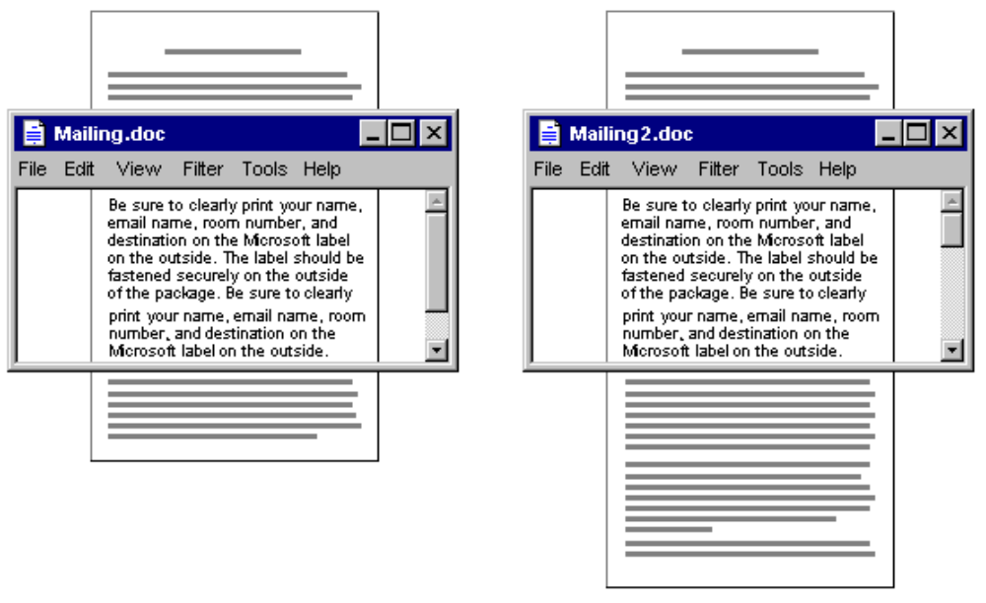
Figure 6.8 Proportional Relationship Between Scroll Box and View Content.

For example, if the content of the entire document is visible in a window, the scroll box extends the entire length of the scroll bar, and the scroll arrows are disabled. Avoid making the minimum size of the scroll box smaller than the width of a sizing handle, such as a window's sizing border.

The user can also scroll a window by dragging the scroll box. Your software should update the view continuously as the scroll box is moved. However, if you cannot support scrolling at a reasonable speed, scroll the information at the end of the drag operation.

If the user starts dragging the scroll box and then moves outside of the scroll bar, the scroll box returns to its original position. The distance the user can move the pointer off the scroll bar before the scroll box snaps back it original position is proportional to the width of the scroll bar. If dragging ends at this point, you cancel the scroll action (no scrolling occurs). However, if the user moves the pointer back within this scroll sensitivity area, it returns to tracking with the pointer movement. This behavior allows a user to scroll without having to remain within the scroll bar, as well as to selectively cancel the initation of a drag-scroll operation.

Dragging the scroll box to the end of the scroll bar implies scrolling to the end of that dimension. However, this may not always mean that the area cannot be scrolled further. If the structure that contains the data is larger than the data itself, then you may interpret dragging the scroll box to the end of its scroll bar as moving to the end of the data rather than the end of the structure. For example, the structure of a typical spreadsheet exceeds the data in that spreadsheet — that is, the spreadsheet may have 65,000 rows, but there is only data in the first 50. So dragging the scroll box to the bottom of the vertical scroll bar can be implemented such that it scrolls to the last row containing data rather than the last row of the spreadsheet.

Scroll Bar Shaft
The scroll bar shaft not only provides a visual context for the scroll box, it also serves as part of the scrolling interface. Clicking in the scroll bar shaft scrolls the height of the visible area in the direction of the click. For example for a vertical scroll bar, if the user clicks in the shaft below the scroll box, the view scrolls the height of the view.

When scrolling the view, allow one unit of overlap from the previous view as shown in Figure 6.9. For example, if the user clicks below the scroll box, the top line of the next screen becomes the line that was at the bottom of the former screen. The same thing applies for clicking above the scroll box and horizontal scrolling. This helps the user maintain a reference point.

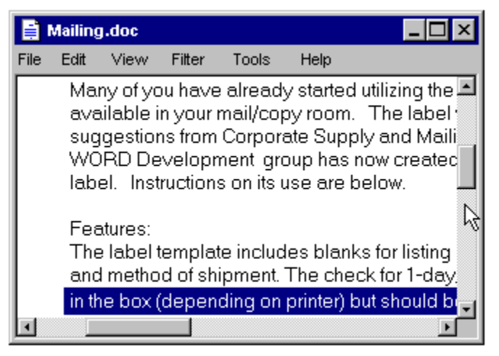
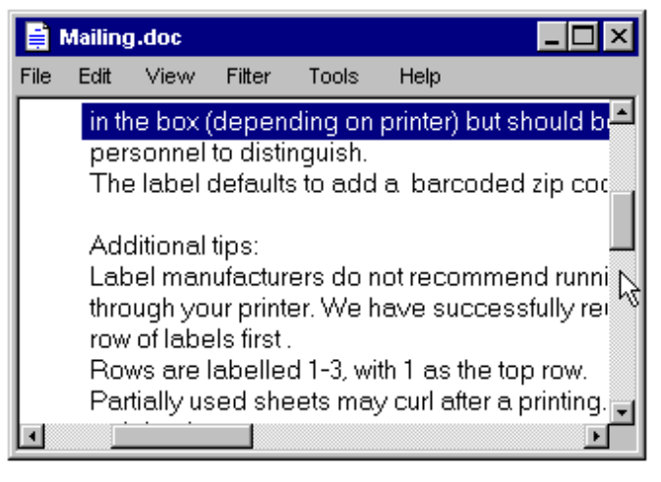

Figure 6.9 Clicking in the Scroll Bar Shafts Scrolls by Screenfuls.
Pressing and holding mouse button 1 with the pointer in the shaft auto-repeats the scrolling action. If the user moves the pointer outside the scroll bar sensitivity area while the pressing continues, the scrolling action stops. The user can resume scrolling by moving the pointer back into the scroll bar area. (This behavior is similar to the effect of dragging the scroll box.)

Automatic Scrolling
The techniques previously summarized describe the explicit ways for scrolling. However, the user may also scroll as a secondary result of some situations. This type of scrolling is called automatic scrolling. The situations in which automatic scrolling occurs are as follows:

n When the user begins or adjusts a selection and drags past the edge of the scroll bar or window, scroll the area in the direction of the drag.
n When the user drags an object and approaches the edge of a scrollable area, scroll the area if the user pauses at the edge.
n When the user enters text from the keyboard at the edge of a window or moves or copies an object into a location at the edge of a window, the view should scroll to allow the user to focus on the currently visible information. The amount to scroll depends on context. For example, for typing in text vertically, scroll a single line at a time. However when scrolling horizontally, scroll in units greater than a single character to prevent continuous or uneven scrolling. Similarly for graphic objects, scroll based on the size of the object, rather than individual pixels.
n If an operation results in a selection or moves the cursor, scroll the view to display the new selection. For example, for a Find command that selects a matching object, scroll the object into view because usually the user wants to focus on that location. In addition, other forms of navigation may cause scrolling. For example, completing an entry of a field in a form may result in navigating to the next field. In this case, if the field is not visible, the form scrolls to display it.
For more information about scrolling, see Chapter 4, “Input Basics.”

Keyboard Scrolling
Navigation keys support scrolling with the keyboard. When using a navigation key, the cursor moves to the appropriate location. For example, pressing arrow keys at the edge of a scrollable area scrolls in the corresponding direction in addition to moving the cursor. Similarly, page up and page down scroll comparably to clicking in the scroll bar shaft, but also move the cursor.

You may optionally use the scroll lock key to facilitate keyboard scrolling. In this case, when the scroll lock key is toggled on, navigation keys move without affecting the selection.

Adjacent Controls
It is sometimes convenient to locate controls or status bars adjacent to a scroll bar and position the end of the scroll bar to accommodate them. Split box controls are an example of such controls; however, you can also use other types of controls. Take care to avoid cluttering up the scroll bar area; this can make it difficult for users to scroll, particularly if you reduce the scroll bar too much. If you need a large number of controls, a toolbar may be a better approach. For more information about toolbars, see Chapter 7, "Menus, Controls, and Toolbars."

Splitting Windows
A window may be split into two or more separate area viewing areas, called panes. For example, a split window can allow the user to examine two parts of a spreadsheet at the same time. A split window can also display different, yet simultaneous views of the same object (data) as shown in Figure 6.10.

Illustration

Figure 6.10 A Split Window.
The panes that appear in a window can either be implemented as part of a window's basic design or as a user-configurable option. To support splitting a window, use a split box. A split box consists of a special control contained in the scroll bar. The size of the split box should be just large enough for the user to successfully target it with the pointer. (The default size of a size handle, such as the window size border, is a good guideline.) If the window is not split, the split box is typically located at the top of the up arrow button of the vertical scroll bar and to the left of the left arrow button of a horizontal scroll bar.

The user can split a window by dragging the split box to the desired position. Dragging its split box to the end of the scroll bar closes the split. Double-clicking (or with the pen, double-tapping) is the optional shortcut for splitting the window, for closing a split, or splitting a window at some default location: for example, in the middle of the window or to the last split location.

When positioning the hotspot of the pointer over a split box, change the pointer's image to provide feedback to the user and help them target the split box. In addition, a representation of the split box and split bar should move with the pointer while dragging the split box.

When a window is split, display two parallel lines extend from the split box to the other side of the window. These lines are called the split bar. Separate the lines by at least one pixel of blank space.

A Split command is added to the window or view's menu to provide a keyboard interface for splitting the window. The Split command splits the window in the middle or a context-defined location. Arrow keys move the split box up or down (or dragging with the mouse or pen); pressing enter sets the split at the current location. Pressing esc cancels the split mode.

You can also use other commands to create a split window. You can define specialized views, that when selected by the user, split a window. Similarly, you can remove the split of a window by closing that view by unselecting or closing that view.

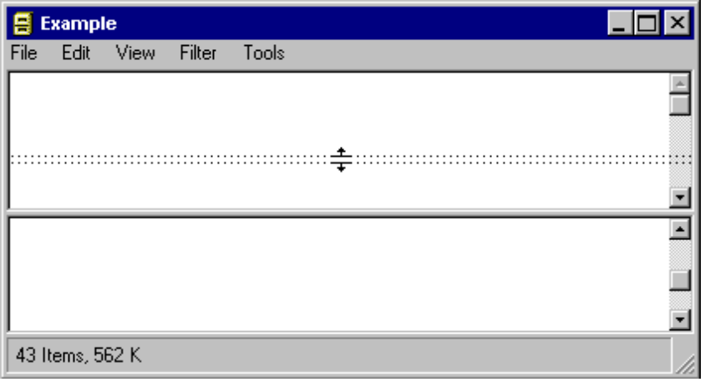

Figure 6.11 Moving the Split Bar.
When the user splits a window, add scroll bars if the resulting panes require scrolling. In addition, the information in panes may need to be scrolled so that the split bar does not obscure the content over which it appeared. The scroll bars usually independently scroll the view in the panes in the direction that is opposite of the split. For example, the vertical scroll bars of a set of panes in a horizontally split window would typically be controlled separately. Use a single scroll bar (at the appropriate side of the window) for a set of panes that scroll together. However, if the panes require independent scrolling, then a scroll bar should appear in each pane for that purpose.

When you use split window panes to provide separate views, maintain each one's view properties independently, such as view type and selection state. However, if you want selection state shared across the panes, display a selection in all panes and support selection adjustment across panes.

When a window is closed, save the window's split state (that is, number of splits, where they appear, scrolled position in each split, and its selection state) as part of the view state information for that window so that it can be restored the next time the window is opened.

