Windows 95
Compatibility Tests

Audio Compatibility Tests (ACT)
- Audio Compression Test
- Mixer Driver Test
- Wave Driver Test

Copyright 1990, 1992, 1994 (c) Microsoft Corporation

November 29, 1994

Audio Compatibility Tests
The Windows 95 Audio Compatibility Tests (ACT) will assist Sound Card Vendors in their hardware and driver’s compatibility with Windows 95.

The Main ACT Window
(See CTSHELL.DOC for instructions on using the Compatibility Test Shell)
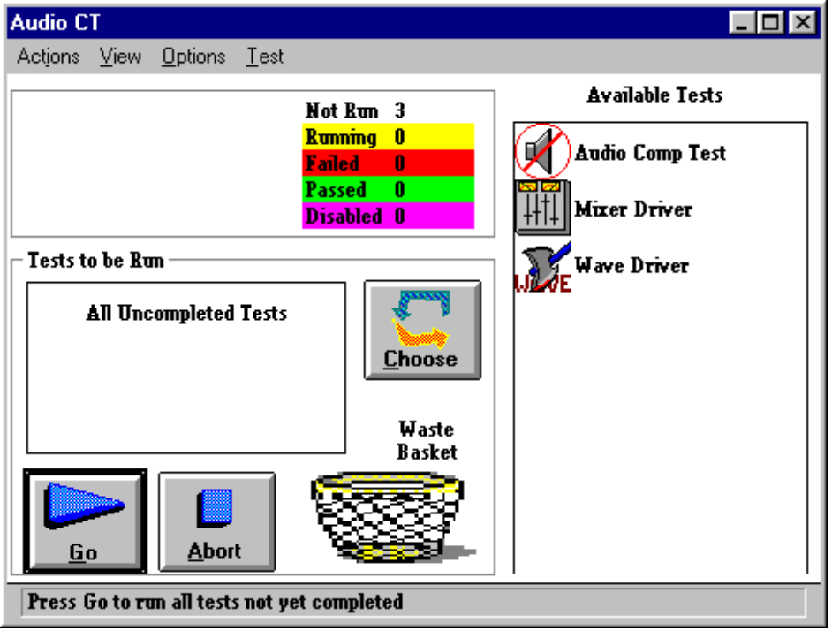

Audio Compression Test
Background:
ACMDRTST.EXE is designed to verify the correct behavior of an ACM (Audio Compression Manager) driver. An ACM driver allows manipulation of wave (digital audio) data; this includes conversion (like 8-bit audio to 16-bit audio), Compression/Decompression, and filtering (like echo).

Type: Automatic (manual cases to be added later)
Time to run: 50-100 hours

What is Tested:
Consistency between reported device capabilities and actual support from the driver. Correct data generation under stress conditions. Consistency between query and actual results. Parameter validation required of the driver. Adherence to performance standards.

Description:
This test verifies that the driver does what it is supposed to do. This includes conversion between data types that it suggests. Consistency between reported capabilities and actual behavior. Verification that driver does not modify data that it should not (like input data). Verification that driver does not crash under stress conditions.

Instructions:
1. This test requires speakers and a microphone to be attached to the audio card being tested and an audio driver to be installed.

2. The test can also be run in manual mode where the user can select specific test cases to run individually and set test options such as log filename and logging level for more detailed information. See the on-line help provided with the test app for more details.

3. The version included with the SCT only runs for about 20 minutes and is a subset of the full version included in the ACT.

Expected Results:
The test should simply run and it is expected that all tests will pass.

Examining/Verifying Results:
The test reports an overall result (PASS if all tests pass, FAIL if any one test fails), and results of individual test cases to the encrypted log file.

Mixer Driver Test
Background:
MXDRVTST.EXE is designed to verify the correct function of an audio mixer driver associated with a multimedia sound card. A mixer driver allows support for such features as volume control of various portions of a sound card and mixing or routing of different types of audio (such as wave and MIDI) to the output speakers or as input for recording. Mixer drivers are new to the Windows system in Chicago - in Windows 3.1, most of the features implemented in a Chicago mixer driver would have been handled in a very custom way by an auxiliary or other driver.

Type: Automatic (manual cases to be added later)
Time to run: 2 minutes

What is Tested:
Support for required driver messages. Correct implementation of mixer lines and controls supported by the driver. Parameter validation required of the mixer driver. Actual control of the audio card with interactive (manual) verification.

Description:
This test verifies that the driver behaves correctly for the features that it supports. This includes verifying support for all required mixer message, and correct support for the specific types of mixer lines and controls supported by the driver. The test does not test custom controls or undefined line types unique to a particular driver. This test will also verify the volume control and mixing functions of the driver in an interactive way (e.g. verify that the volume really changes when the driver says it did)..

Instructions:
1. The test will run through a series of automatic tests first and then begin interactive tests that prompt the user for input aimed at verifying test results. This test requires that speakers (and the next version a microphone) be attached to the system and that a Chicago style mixer driver is installed.

2. The test can also be run in manual mode where the user can select specific test cases to run individually and set test options such as log filename and logging level for more detailed information. See the on-line help provided with the test app for more details.

Expected Results:
If the test does not find a mixer driver installed, it will inform the user of this and exit. If there is a mixer device available on the system, then the test will run tests based on the configuration of the device and it is expected that all of them will pass.

Examining/Verifying Results:
The test reports an overall result (PASS if all tests pass, FAIL if any one test fails), and results of individual test cases to the encrypted log file.

Wave Driver Test
Background:
WAVETEST.EXE is designed to verify the correct function of an audio wave driver typically associated with an audio card. A wave driver allows the playback of digital audio typically in a number of formats. This type of sound is what is typically tied to system events (like Windows Startup and Windows Exit).

Type: Automatic (manual cases to be added later)
Time to run: 20 minutes

What is Tested:
Consistency between reported device capabilities and actual support from the driver. Correct reproduction and recording of digital audio. Correct behavior of callback notification. Parameter validation required of the driver. Adherence to performance standards.

Description:
This test verifies that the audio wave driver does what it is supposed to do. This includes verifying support for all base wave functionality (including correct playback and recording) and support for extended functionality included in device capabilities. This also includes meeting performance standards in terms of accurate (timely) notifications. This test does not include extended support unaccessible through documented API's for a particular driver.

Instructions:
1. The current test is mostly automatic and runs in about 20 minutes. This test requires speakers and a microphone to be attached to the audio card being tested and an audio driver to be installed.

2. The test can also be run in manual mode where the user can select specific test cases to run individually and set test options such as log filename and logging level for more detailed information. See the on-line help provided with the test app for more details.

Expected Results:
If the test does not find a wave driver installed, it will inform the user of this and exit. If there are any wave devices available on the system, then it will run tests based on the configuration of the device (in case of multiple devices, it will pick the first one enumerated by the system) and it is expected that all of them will pass.

Examining/Verifying Results:
The test reports an overall result (PASS if all tests pass, FAIL if any one test fails), and results of individual test cases to the encrypted log file.

MIDI Driver Tests
Background:
Mididrvt is designed to test Windows MIDI input and output drivers that are written to control the MIDI functions on multimedia sound cards and dedicated MIDI cards. MIDI drivers can control synthesizer chips, MIDI input ports, and MIDI output ports. The tests in mididrvt are designed to test all three types of MIDI device drivers.

Type: Manual
The first time an input test case requiring a loopback runs, a message appears telling the user to set up a loopback. After that, all of the current test cases are automatic.
Time to run: 7 minutes

What is Tested:
MIDI device drivers. Currently this test application concentrates on testing MIDI input device drivers. This test application does not cover functionality specific to polymessage recording and playback.

Description:
MIDI device drivers are tested by verifying that they respond correctly to messages passed to it by MMSYSTEM through the MIDI API. For input, it verifies that an input device can record both sysex and short messages. The input tests require that a MIDI output port be present and assumes that the output port driver is working properly.

Instructions:
1. The first step is to select the devices to be tested. Under the “Input Device” menu, select an input device. Under the “Output Device” menu, select an output device. If no devices are selected by the user, an input device (if available) and an output device will be selected by mididrvt. The current test cases are all automatic and require no user interaction. If an input device driver is on the system, however, the user will be presented a message telling him/her to setup a loopback between an output port and the input port whose driver is being tested. The tests will not continue until this dialog is dismissed. The tests require that a MIDI driver be present on the system. If an input port is present on the system, then an output port and a MIDI cable are required. The MIDI cable must be used to send the output data from an output port to the input port.

2. The tests can also be run in manual mode where the user can select specific test cases to run individually and set test options such as log filename and logging level for more detailed information. See the on-line help provided with the test app for more details.

Expected Results:
If the test does not find a MIDI driver installed, it will inform the user of this and exit. If there is a MIDI device available on the system, then the test will run test cases based on the capabilities of the device and it is expected that all of them will pass.

Examining/Verifying Results:
The test reports an overall result (PASS if all tests pass, FAIL if any one test fails), and logs the results of individual test cases to the encrypted log file.

