DTA User's Guide

DTA Version 2.45

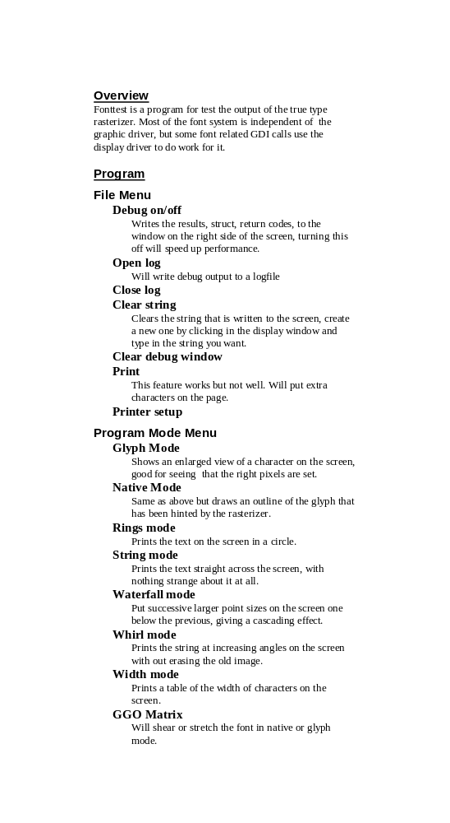March 6, 1992
Table Of Contents
Introduction to DTA 3
GDI / Display Driver Interaction 3
What is DTA? 3
Speed Test 3
GDI Test 3
Drawing Options 3
Common Features: 4
Pushbuttons: 4
Controls: 4
Colors: 4
Random Variations: 4
Primitives Dialog 4
Pen Dialog 4
Pen Style 5
Pen Color 5
Pen Width 5
Brush Dialog 5
Brush Style 5
Brush Color 5
Miscellaneous Dialog 5
Background, Display and Text Colors 6
ROP2 Codes 6
Background Mode 6
Points Dialog 6
Principal Points: 6
Points for Polygon and Polyline: 6
Logging Dialog 7
Logging Destination 7
Logging Behavior 7
Stop On Failure: 7
Objects: 7
Parameters: 7
Time Stamp: 7
Random All 7
Repeat Last 7
Default Settings 7
Smart Prompting 7
Cycle 8
ROP3s Dialog 8
Bitmap Conversions Dialog 8
Verification: 8

Introduction to DTA
The Display Test Application (DTA) was designed to test the display driver's ability to accurately execute various commands issued by the Graphics Device Interface (GDI).

GDI / Display Driver Interaction
When a Windows application wishes to draw something, it does so by making a series of calls into GDI. When GDI receives these requests, it first checks the capabilities of the display driver to see if the display driver is capable of servicing the application's request.

If the requested service is supported by the display driver, GDI is able to send the call on to the display driver, where it is handled without any further assistance from GDI. This is often the case if your video card has specialized hardware such as Graphic System Processors (GSP) to perform various operations faster than GDI. If the display driver does not support the specific call, or if the driver returns failure for the specific call, then GDI will process the call and pass the information to the display driver on a lower level (via scan lines, pixels or points).

Display drivers register their capabilities through the GDIINFO structure (see Windows DDK). Windows is able to check the state of these capabilities through use of the GetDeviceCaps() function (see Windows Programmer's Reference). All display drivers are required to support SetDiBits(), GetDIBits() and SetDIBitsToDevice().

What is DTA?
DTA provides the user with the ability to test the display driver's ability to accurately render basic GDI primitives (rectangles, ellipses, arcs, etc.) using user specified or randomly generated attributes. Through the user interface, it is possible to test many combinations of primitives, pens, brushes, ROP2 codes, background modes, text color, etc..

Speed Test
DTA provides a rough benchmark of the amount of time needed for a driver to draw a specific primitive or primitives. To do this, the number of iterations must be chosen via the Repetitions submenu. Selecting Go! will instruct DTA to draw the identical primitive on the display as many times as specified, and then return the total elapsed time. This is not a precise benchmark, and should only be used to get a general feel for where a driver can be optimized. For example, drawing with a hatched brush will often have significant differences, depending on whether the background mode is OPAQUE or TRANSPARENT.

GDI Test
By using a timer to draw primitives, DTA can exercise drivers without human attention or intervention. The Delay Time submenu allows the test engineer to specify the minimum delay time (in milliseconds) between drawing. The actual delay time may be longer if the time required to draw the primitive exceeds the specified delay interval.

Timed Drawing is started via the Start menu item, or via the F1 accelerator. It is halted via the Stop menu item, or the F2 accelerator.

The final option in this menu, Step, is not actually associated with the timer. The Step option instructs DTA to draw a primitive using the current settings. This allows the test engineer to create a specific scenario for testing and/or regression. This option may also be activated through the F3 accelerator or by pressing the right mouse button when within DTA's client area.

Drawing Options
All drawing options used by DTA can be controlled through the various dialogs of the Options menu. Specifically, these dialogs allow the definition of Pen and Brush attributes, the GDI function(s) to be called, the points used for drawing, and other factors such as background color and ROP2 codes. DTA uses these settings for drawing.

Common Features:
Each of the pen, brush, primitives, points, and miscellaneous dialogs contain similar controls. They are outlines here, rather than in each control

Pushbuttons:
Any of these dialogs may conveniently be accessed from any other, merely by pressing the appropriate pushbutton in the dialog. This allows a test engineer to more easily specify a complex set of conditions. Each dialog is fully independent of any other, and changing the settings in one dialog has no effect on the others.

Controls:
The controls of each dialog are initialized to their most recent values when the dialog is first displayed. The most recent values are either the values used to draw the most recent primitive, or the values most recently specified by the test engineer. No changes are made until the OK button is pressed, and pressing Cancel at any time will leave the settings unchanged.

Colors:
DTA has 16 pre-defined colors, which correspond to the 16 pure colors supported by the standard VGA driver. Colors are all controlled by a combination of a combobox and three edit controls. Selecting any of the 16 predefined colors in the combobox will automatically update the edit fields with the values of Red, Green and Blue (RGB) associated with the standard color. Similarly, changing the edit fields will automatically update the color shown in the combobox. If the color is one of the standard colors, that color's name will be shown in the combobox. If the RGB values do not identify a standard color, then "Custom" will be displayed in the combobox.

Random Variations:
Most controls have a checkbox to indicate random variation. These checkboxes are generally indicated by "Rand" or "Random", and tell DTA whether the value for that control should be based upon the setting of the control (checkbox not checked) or upon an pseudo-random number sequence (checkbox checked)

Primitives Dialog
The primitive dialog allows the test engineer to select any combination of primitives to draw. Each primitive has a corresponding check box:

Rectangle | RoundRect | Ellipse
Arc | Chord | Pie
LineTo | Polyline | Polygon

To draw a specific primitive, simply check its correcponding checkbox. DTA can draw multiple primitives, and will draw each checked primitive with the same parameters and coordinates. (Note: Smart Prompting only understands single primitives, so it should not be used as a guide if multiple primitives are checked).

Pen Dialog
The pen dialog allows the test engineer to specify the characteristics of the pen used by DTA. These characteristics include Style, Color, and Width.

Pen Style
The pen style can be selected as any of the following, as defined in the SDK:
Solid | Dash | Dot
Dash Dot | Dash Dot Dot | Null
Inside Frame

Important note: For pen widths > 1, the driver should use the solid pen style for all pen styles except ps_null and ps_insideframe (See note on color and ps_insideframde style, below)

Pen Color
The pen color may be set to any value, as indicated above.

Important note: The driver should convert non pure pen colors (i.e. colors that are dithered) to the nearest pure color. The only exceptions to this are pens of the ps_insideframe style, which should be dithered if the pen width is greater than 1, and pens with ps_null style, which are simply not drawn.

Pen Width
The pen color may be fixed or varied within a specified range. To vary the pen width, simply indicate the minimum and maximum widths in the appropriate edit fields, then check the Random Pen Width checkbox.

Brush Dialog
The brush dialog allows the test engineer to control the characteristics of the brush DTA uses to draw. These characteristics are color and style.

Brush Style
This combobox indicates which style the brush will use, and includes the following options:
Horizontal | Vertical | Fdiagonal
Bdiagonal | Cross | Diagcross
Solid | MonoWeave | MonoBricks
RedBricks | ColorPattern | Null

The first six brush styles (horizontal, vertical, fdiagonal, bdiagonal, cross, diagcross) are the standard hatched brush styles (see CreateHatchBrush() in the SDK). The next style (solid) is simply a solid brush (see CreateSolidBrush() in the SDK). The next two brush styles (monoweave and monobricks) use monochrome DIB patterns (see CreatePatternBrush() in the SDK). The next two styles (redbricks and colorpattern) use color DIB patterns (see CreateDIBPatternBrush() in the SDK). The last Style (null) uses a NULL brush, where no brush is used and pixels in the region normally affected by the brush are not changed by the driver.

Brush Color
The pen color may be set to any value, as indicated above. For solid brushes, the display driver should support dithered colors. For styled brushed, however, the brush color should always be the nearest pure color supported by the device. The RedBricks and ColorPattern brushes are based on a color bitmap, and are unaffected by the selected brush color. Brush color obviously has no effect on a NULL brush.

Miscellaneous Dialog
This dialog allows the test engineer to select settings for background, display, and text colors, as well as the background mode and ROP2 code to use.

Background, Display and Text Colors
These allow the selection of any color, as described above. Note, however, that DTA will force the display color to a pure color, and the driver should force the Display and Text colors to pure colors.

ROP2 Codes
ROP2 stands for binary raster operation. The rop2 combo box the selection of one of the sixteen predefined ROP2 operations to be used when drawing:
R2_BLACK | R2_NOTMERGEPEN | R2_MASKNOTPEN
R2_NOTCOPYPEN | R2_MASKPENNOT | R2_NOT
R2_XORPEN | R2_NOTMASKPEN | R2_MASKPEN
R2_NOTXORPEN | R2_NOP | R2_MERGENOTPEN
R2_COPYPEN | R2_MERGEPENNOT | R2_MERGEPEN
R2_WHITE

Background Mode
GDI has two defined background modes: OPAQUE and TRANSPARENT.

With an OPAQUE background mode, GDI fills any gaps in the pen, brush, or text with the currently selected background color. This color is then modified by the current ROP2 selection. This color should always be a non-dithered color, regardless of the RGB value.

With a TRANSPARENT background mode, GDI leaves the gaps unfilled, so whatever was displayed in the gap will be unchanged. The current ROP2 affects the brush and pen, but has no effect on the background.

Points Dialog
This dialog allows the test engineer to specify which points will be used to draw primitives. There are two portions to this dialog: The Principal Points and the Points for Polygon and Polyline.

Principal Points:
These coordinate pairs specify the point values that are passed to all drawing functions except Polyline and Polygon. For Arc, Chord, Ellipse, Pie, Rectangle, and RoundRect, there is a direct dorrelation between the values specified for X1, Y1, X2, Y2, X3, Y3, X4, and Y4 and the values passed to the functions. For LineTo, however, (X1,Y1) indicates the starting of the line, (X2,Y2) the end of the line (MoveTo, followed by LineTo). Currently, X and Y must both be varied or both be fixed. There is no way to vary either X or Y while keeping the other value constant.

Points for Polygon and Polyline:
These coordinate pairs define the array of points passed to either Polygon or Polyline, and have no influence on any other functions. The points are displayed in a listbox, in the order that will be used by the driver. Selecting a point in the listbox copies its X and Y values to the X and Y edit fields for updating or copying. Five pushbuttons control the manipulation of points in the dialog:

Add Appends the current X,Y pair to the end of the list
Insert Inserts the current X,Y pair before the currently selected point
Remove Removes the currently selected point
Change Replaces the currently selected point with the current X,Y pair
Clear All Removes all points from the list

The number of points in the list is provided to simplify editing of long point lists. Checking the Generate Random Points checkbox will randomly generate between 3 and 30 points to be used for drawing. There is no way to generate a fixed length list of random points.

Logging Dialog
The logging dialog controls what debug information will be logged, as well as where the information should be sent.

Logging Destination
The logging destination may be set to any COM port supported by Windows (settings used are those set in the control panel), to a disk file, or to none. It should be noted that the disk file is buffered, so the most recent output will not generally be in the file unless the buffer is flushed. Flush the buffer by selecting another logging destination, then choosing OK. If the same filename is then specified for logging, the extension of the old file will be changed to the first unused extension of the pattern .001, .0202, .003, etc., and a new file created.

Logging Behavior
These checkboxes allow the contents and behavior of logging to be controlled:

Stop On Failure:
When checked, timed drawing will automatically stop when a primitive returns an error.

Objects:
When checked, information about the drawing objects will be logged.

Parameters:
When checked, the points (X1,Y1), (X2,Y2), (X3,Y3), and (X4,Y4) will be logged. If a Polygon or Polyline is drawn, the points used will also be logged.

Time Stamp:
When checked, the date and time will be logged. This is most useful for timed drawing.

Random All
This is a simple way to instruct DTA to vary all parameters randomly, rather than specifying them all individually.

Repeat Last
This is a simple way to instruct DTA to repeat all parameters used for the previous object, rather than disabling all random variations individually.

Default Settings
This option resets all DTA settings to their default values. It clears all random variations and resets all drawing options to their start-up conditions.

Smart Prompting
Smart Prompting is a feature to simplify analysis of drawn objects. Based on the information used to draw the current primitive, DTA will use an internal template, combined with its own understanding of GDI and some of the most fundamental driver calls (GetColorInfo, RealizeBrush) to draw an approximate picture of how the current primitive should look. Some aspects of the picture (specifically, scaling of styled lines, where in the style the lines begin and end, pen width if greater than 1, # of points used in polygon/polyline calls, and exact shape of the primitive) are based on a fixed template and may not always match exactly what is drawn on the screen, although they will give a general idea. Other aspects of the picture (Opacity, Background colors, Pen color and general style, Brush color and style, and ROP2 codes used) should be an exact match. If smart prompting's behavior appears incorrect, compare it to a Microsoft driver of equivalent color capabilities. This feature toggles on and off through this menu item. Smart prompting is unavailable if timed drawing is being used or if Bitmap Conversions (below) are being used.

Cycle
This option only applies when timed drawing is being used. It instructs DTA to cycle through the supported primitives, drawing a different one on each timer interval. It has no effect on primitives drawn using the GDI Test.Step (F3) command.

ROP3s Dialog
Located under the Options Menu is the ROP3s... menu item. This brings up a dialog that allows the test engineer to test either all ROP3 codes, or a specific ROP3 code selected from the list. The test combines a Yellow (RGB 255,255,0) source, a Cyan RGB 0,255,255) destination, and a Magenta (RGB 255,0,255) pattern with the specified ROP3 code(s). DTA then uses the source, pattern, and destination bitmaps to predict what the result should be. If the actual result does not match, DTA will report that ROP3 as failing the test.

If your driver supports 15 bits per pixel and fails this test, add "Unused Bits=1" to the Display Test Application section of WIN.INI. This instructs DTA to allow one bit to be ignored when it does the comparison. This flag should not be set for any other type of driver.

Bitmap Conversions Dialog
All display drivers must be able to correctly render colors to both their native color format and to a monochrome bitmap. This dialog allows the test engineer to verify this functionality. The dialog has a checkbox to activate the Bitmap conversion process (off by default), as well as four radio buttons to select what sort of conversions should be done. The options are: Mono to Mono, Mono to Color, Color to Mono, and Color to Color. In each case, the primitive is first drawn to a memory bitmap and displayed on the left portion of the screen without conversion, then is transferred to another memory bitmap (using BitBlt), which automatically performs any necessary conversion, and the resulting image is displayed on the right portion of the screen.

Verification:
These are the rules for bitmap conversion:
Monochrome to Monochrome:
No conversion, images should be identical.
Monochrome to Color:
White (source) is mapped to the Text color (destination)
Black (source) is mapped to theBackground color (destination)
Color to Monochrome:
Pixels that match the background color (source) are mapped to white (destination)
Pixels that don't match the background color (source) are mapped to black (destination)
Color to Color:
No conversion, images should be identical.

