Viewing Documents
Century Schoolbook Fonts - Word provides four ways to view your document on the screen: normal view, page layout view, print preview, and outline view. Each view shows you different aspects of your work. Green.
Justified Paragraph - In all views except print preview, you can edit text and you can enlarge or reduce the size of the document on the screen to get an overview of an entire page or to get a closer look at text that’s formatted in a small font size. Regardless of the display size, you can edit as you normally do. The display size does not affect the printed document. Magenta.
Small Caps - is the best all-purpose working view. You will probably do most of your typing, editing, and formatting in this view. Yellow.
Strikethroughs - displays the layout of each page in your document as it will look when printed. You can see multiple-column layout, headers, footers, and footnotes in place on the page as well as the accurate position of any item you put in a frame. Use this view to work with frames or multiple columns, or to check the final appearance of your document and make last-minute changes to the text, formatting, and layout. You can move framed items on the page by dragging with the mouse. Green.
Underlined Words- shows a miniature version of your document exactly as it will print, reduced in size to display one or two pages on the screen. Although you can’t edit text in this view, it provides a quick and convenient way to review the final page layout and adjust page breaks and margins. Red.
Double Underlined Centered - is useful even if you don’t write your documents from an outline. This view makes it easy to move and copy text, to reorganize long documents, and to move quickly to a different location within the document. Black.
Normal View
All Caps right justified, the default view in Word, is best for the everyday work of entering and formatting text and graphics. You can see most text formatting—the font, font size, line spacing, indents, and so forth—as it will look when printed, but the arrangement of text and graphics on the page is simplified. Columns, though shown in their actual width, are displayed in one continuous column, instead of side by side on the page. Text and graphics you positioned using the Frame command on the Format menu appear in the order you inserted them in your document, not in the position where they will print. Cyan.
Blue Text Double Spaced Paragraph - Normal view makes it easy to edit text across page breaks, shown as dotted lines, and section breaks, shown as double dotted lines. To work with headers, footers, and footnotes, you open a separate pane.
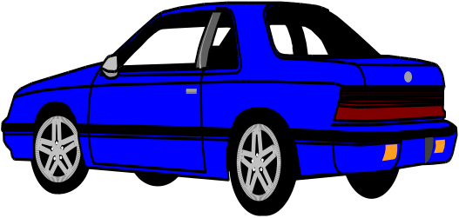
This is the Blusedan.wmf from Winword's Clipart. Shaded border.

This paragraph has a one point shadow box with a Cyan interior and Blue border.

This paragraph has a two point shadow box with a Magenta interior and Red border.

This paragraph has a three point shadow box with a Yellow interior and Dark Blue border.

This paragraph has a four point shadow box with a Green interior and Dark Cyan border.

This paragraph has a five point shadow box with a Red interior and Dark Red border.

This paragraph has a one point double line box with a Cyan interior and Dark Green border.

This paragraph has a two point double line box with a Green interior and Blue border.

This paragraph has a three point double line box with a Yellow interior and Dark Magenta border.

This is a table with various colored text and background combinations...
White Text, Black Background | White Text, Blue Background | Black Text, Cyan Background | Black Text, Green Background
White Text, Magenta Background | White Text, Red Background | Black Text, Yellow Background | Black Text, White Background
White Text, Dark Blue Background | White Text, Dark Cyan Background | White Text, Dark Green Background | White Text, Dark Magenta Background
White Text, Dark Red Background | White Text, Dark Yellow Background | White Text, Dark Gray Background | Black Text, Light Gray Background
White Text, Black Background | Blue Text, White Background | Cyan Text, Black Background | Green Text, White Background
Magenta Text, Black Background | Red Text, White Background | Yellow Text, Black Background | Dark Blue Text, Black Background
Dark Cyan Text, White Background | Dark Green Text, White Background | Dark Magenta Text, White Background | Dark Red Text, White Background
Dark Yellow Text, White Background | Dark Gray Text, White Background | Light Gray Text, Black Background

 | <<== This is a 3G Graphics WMF file called Pizza.WMF
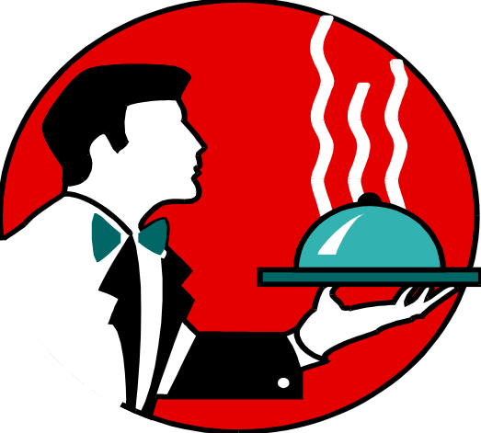 | <<== This is a 3G Graphics WMF file called Waiter.WMF
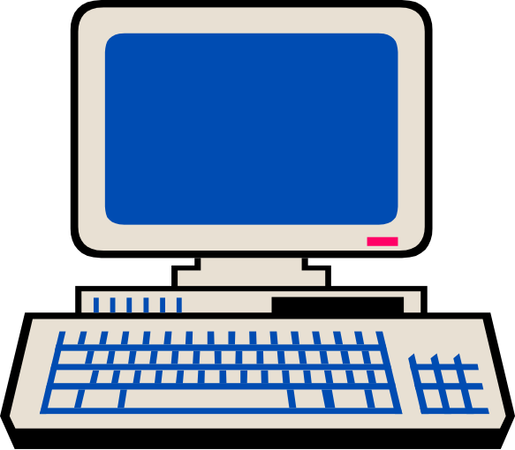 | <<== This is a 3G Graphics WMF file called Computer.WMF
Clipart provided by "Copyright 3G Graphics, Inc."

