Multiple Router Provider
APIs Test Tool
(MPRT)

An interactive and automated test tool that
simplifies testing of Windows 95 MPR APIs.

June 1994
What is MPRT?

The Multiple Provider Router (MPR) exports the Win32 general networking APIs. It interacts with the underlying Network Provider(s) (NP) and at most one Windows 3.1 compatible network (WINNET16.DLL) to provide these services. It also exports the additional interfaces needed by Explorer and the common dialog library (COMMDLG.DLL) to access the underlying network(s).

The Multiple Provider Router Test Tool (MPRT) is an intuitive Windows networking application, designed to help testers and developers set valid and invalid parameters to pass to each API. Results are displayed in real time and written to a log file for later review. Because it can test third party network providers by way of the networking APIs, MPRT can test each API’s enable calling for different network client setups. MPRT may also be used for automatic testing through the use of script files following .INI file format.

Main Features of MPRT

Network API Menus - Lists all APIs that MPR supports, grouped by function. For each API, MPRT provides common controls that allow the user to select valid and invalid parameters, or enter custom values for a given test case.
Debug Window - Displays all debug information. Debug information includes passed parameters, return values and error messages. Return values are also translated to text to make them easier to read.
Automatic Test Dialog Box - Initially a dialog box to allow selection of a script file, this window displays the status of each API call during script processing and totals the results upon completion.
Log File - Debug information is normally written to a log file for later analysis, but this feature may be disabled to save time. Because debug output is appended to the log, the user can scroll through the results of several tests, or even add new results to existing log files. The default log file name is MPRTLOG.DAT, but may be changed as needed.

Using MPRT

In order to run MPRT, MPR.DLL must be in the Windows 95 system directory. The Microsoft Network, Microsoft Client for NetWare or any other third party network calling these APIs may be selected as the client for MPR testing.

- To test a specific API, just go to the MPR APIs menu item, select an ASCII or UNICODE category and click the API that you want to test.
- The beginning of each script lists its format. Script files follow the .INI file format. (See Appendix B for full details of script formats.)
- Automatic tests may be set up for any test case.

See Appendix A for a complete listing of menu selections.

The MPRT User Interface

Selecting an API is simple when using MPRT’s straightforward user interface:

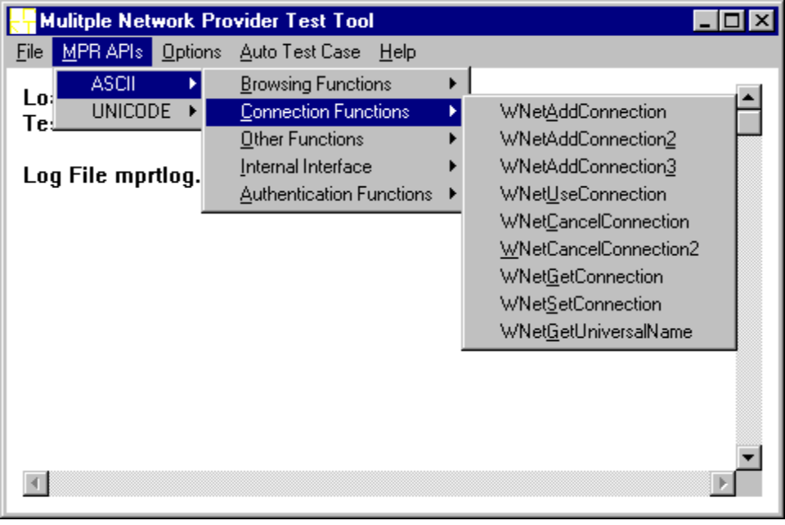
Figure 1: MPRT Main Window

Selecting a MPR APIs menu item brings up a dialog box similar to this one for the WNetOpenEnum API:

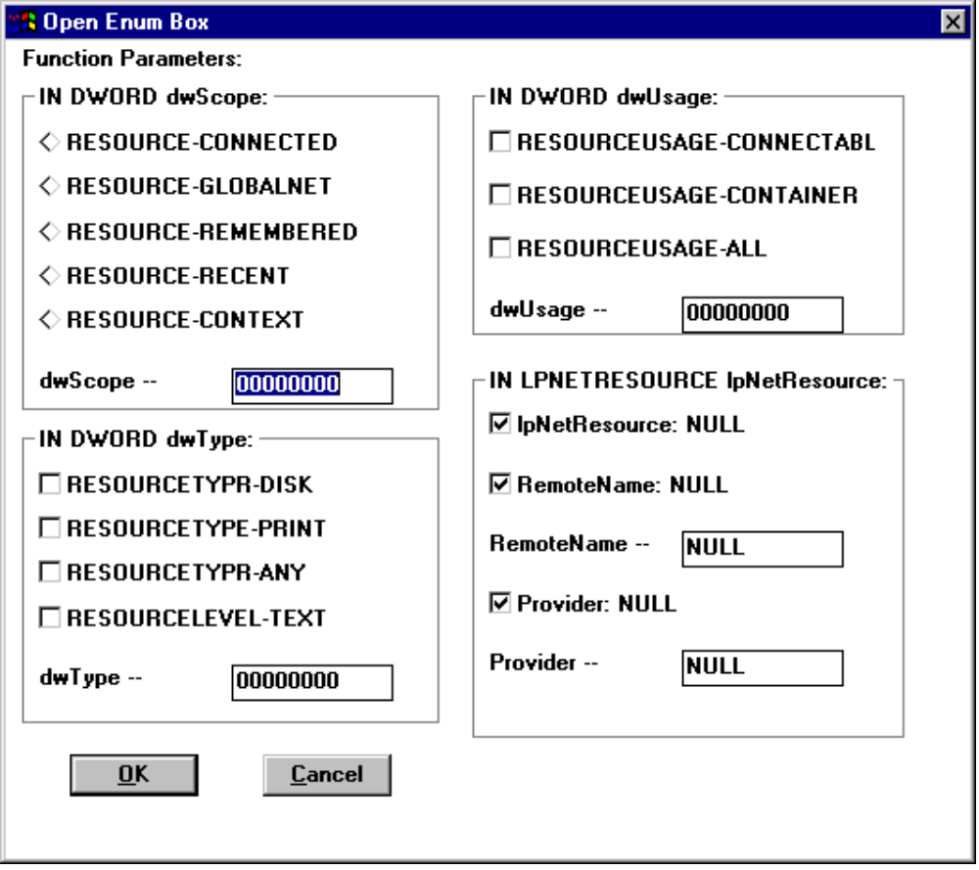
Figure 2: Network API Window

Choosing parameters for an API is as easy as checking the value(s) desired, or by entering custom values in an edit box. NULL pointers or strings may also be used by checking the appropriate box. (Checking the NULL option disables the text box associated with that selection.)

Clicking OK calls the API with the selected parameters. Choosing CANCEL will dismiss the dialog without calling the API.

After each API call, all information, including passed parameters and return values, is shown in a Debug Window similar to the following:

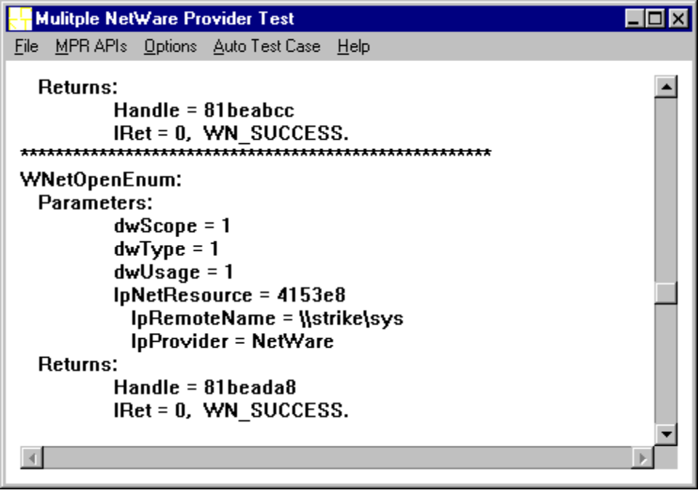
Figure 3: Debug Window with call results

The user may scroll through the test results or select Options|RefreshDebugWin to clear the screen. Information in the log file (if used) is not affected.

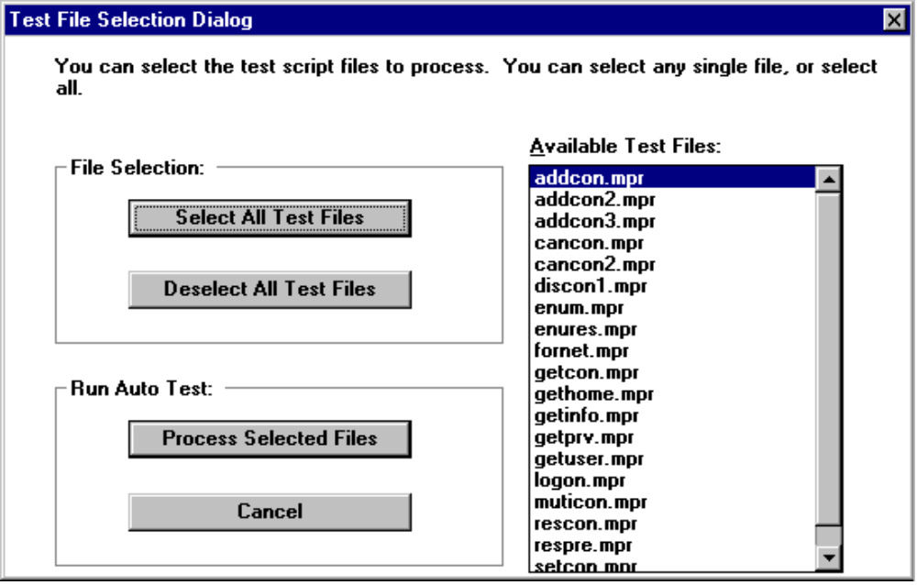
Figure 4: Automatic Test Window showing available scripts

Select an individual script by clicking its name or select all of the scripts listed by clicking the appropriate button. Once all the desired scripts have been selected, click Process Selected Files to begin processing.
Real time results display in the Automatic Test Window, similar to this one for the ADDCON.MPR script:

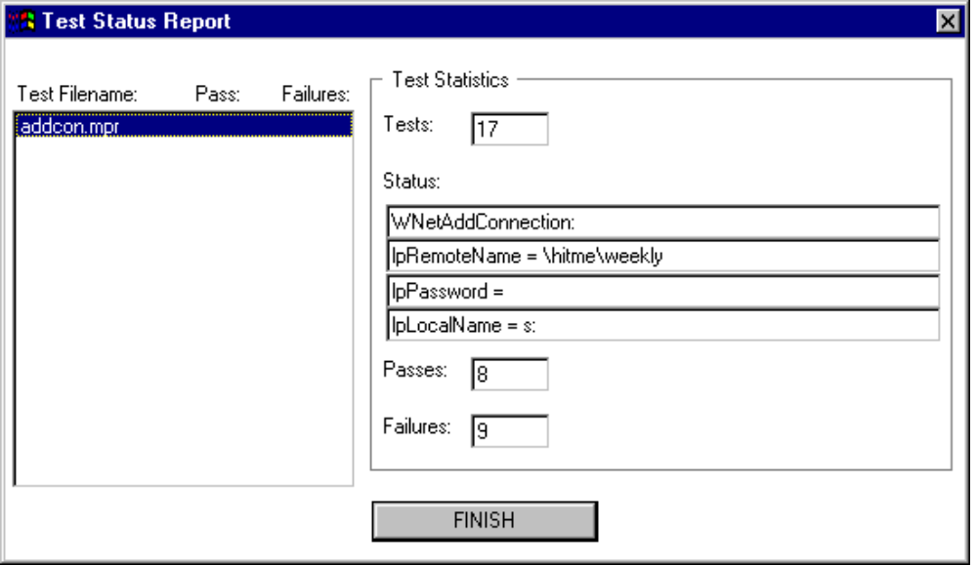
Figure 5: Automatic Test Window after script processing

Upon completion of a script, MPRT displays a summary of the script parameters, including the total number of passes and failures. Click FINISH to return to the Debug Window and see full details of the script results:

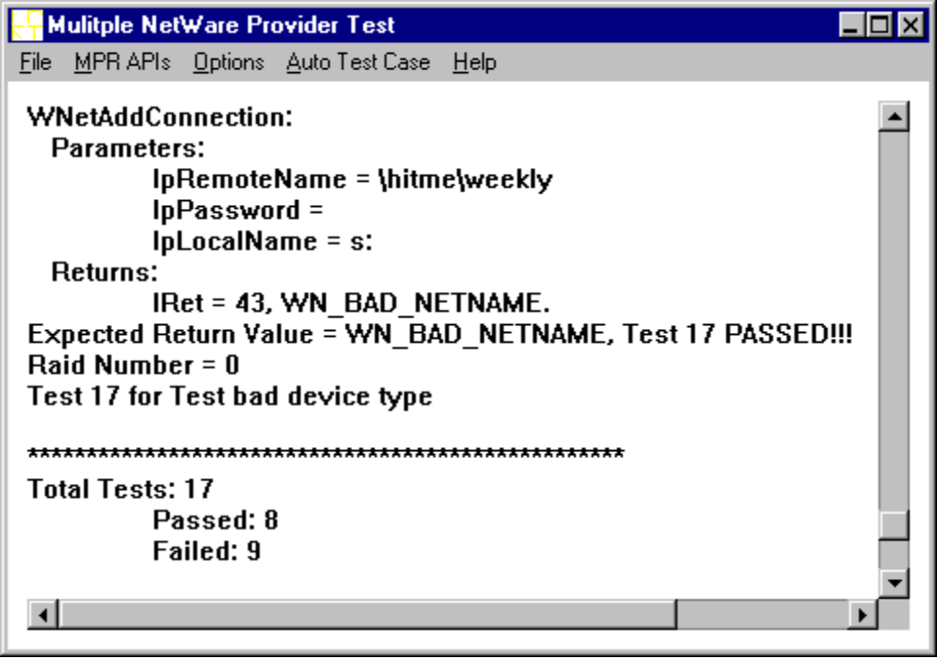
Figure 6: Debug Window showing automatic test results
Appendix A: Index of Features

File:
Default Log File Select this to output all debug information to the default log file MPRTLOG.DAT.
Open Log File Select this to output the debug information to an alternate log file name.
Exit Exit MPRT.

Network APIs:
ASCII APIs selected from this category take all string parameters in ASCII format. The names of ASCII APIs end in “A”.
UNICODE APIs selected from this category take all string parameters in UNICODE format. The names of UNICODE APIs end in “W”.
Browsing Functions
WNetOpenEnum
WNetEnumResource
WNetCloseEnum
WNetGetResourceInformation
WNetGetResourceParent
Connection Functions
WNetAddConnection
WNetAddConnection2
WNetAddConnection3
WNetUseConnection
WNetCancelConnection
WNetCancelConnection2
WNetGetConnection
WNetSetConnection
WNetGetUniversalName
Other Functions
WNetGetUser
WNetConnectionDialog
WNetConnectionDialog1
WNetDisconnectionDialog
WNetDisconnectionDialog1
WNetGetLastError
WNetGetNetworkInformation
WNetGetProviderName
Internal Interface (The interface between the shell and MPR.)
WNetRestoreConnection
WNetFormatNetworkName
MultinetGetConnectionPerformance
WNetGetEnumText
Authentication Functions
WNetLogon
WNetLogoff
PwdChangePassword
PwdGetPasswordStatus
PwdSetPasswordStatus
WNetGetHomeDirectory

Options:
Write To LogFile Select this option to output debug information to a log file. This is on by default, but may be turned off to speed processing.
Display Debug Info Select this option to output debug information to the screen. This is on by default, but may be turned off to speed processing.
RefreshDebugWin Debug information is appended to both the screen display and the log file. Select this option to clear the results from the screen without affecting the contents of the log file.

AutoTestCase:
Select Test File Select this to choose which script file(s) should be used for automatic test processing.

Help:
About... Select this to see the full name of MPRT, author name and copyright date.

Appendix B: Automatic Test Script Format

[INFORMATION]
NUMBERCOMMANDS=14 // the number of test case in this file

COMMAND: // use defined number for each API
WNetOpenEnum 1
WNetEnumResource 2
WNetCloseEnum 3
WNetGetResourceInformation 4
WNetGetResourceParent 5
WNetAddConnection 6
WNetAddConnection2 7
WNetAddConnection3 8
WNetUseConnection 9
WNetCancelConnection 10
WNetCancelConnection2 11
WNetGetConnection 12
WNetSetConnection 13
WNetGetUniversalName 14
WNetGetUser 15
WNetConnectionDialog 16
WNetDisconnectDialog 17
WNetConnectionDialog1 18
WNetDisconnectDialog1 19
WNetGetLastError 20
WNetGetNetworkInformation 21
WNetGetProviderName 22
WNetRestoreConnection 23
WNetFormatNetworkName 24
MultinetGetConnectionPerformance 25
MultinetGetErrorText 26
WNetLogon 27
WNetLogoff 28
PwdChangePassword 29
PwdGetPasswordStatus 30
PwdSetPasswordStatus 31
WNetGetHomeDirectory 32

PARAMETERS:
DWSCOPE "dwScope"
dwScope:
- RESOURCE_CONNECTED 0X00000001
- RESOURCE_GLOBALNET 0X00000002
- RESOURCE_REMEMBERED 0X00000003
- RESOURCE_RECENT 0X00000004
- RESOURCE_CONTEXT 0X00000005
DWTYPE "dwType"
dwType
- RESOURCETYPE_DISK 0X00000001
- RESOURCETYPE_PRINT 0X00000002
- RESOURCETYPE_TEXT 0X00000008
- RESOURCETYPE_ANY 0X00000004
DWUSAGE "dwUsage"
dwUsage
- RESOURCEUSAGE_CONNECTABLE 0X00000001
- RESOURCEUSAGE_CONTAINER 0X00000002
- RESOURCEUSAGE_ALL (0X00000001 | 0X00000002)
LPNETRESOURCE "lpNetResource"
LPNETREMOTENAME "lpNetResource->lpRemoteName"
LPNETPROVIDER "lpNetResource->lpProvider"
LPNETLOCALNAME "lpNetResource->lpLocalName"
NETDWTYPE "lpNetResource->dwType"
LPREMOTENAME "lpRemoteName"
LPPASSWORD "lpPassword"
LPLOCALNAME "lpLocalName"
LPUSERID "lpUserID"
LPPROVIDER "lpProvider"
LPCCOUNT "lpcCount"
BUFFERSIZE "BufferSize"
DWFLAGS "dwFlags"
FFORCE "fForce"
LPNAME "lpName"
DWPROPERTY “dwProperty”
DWVALUE “dwValue”
ERRORBUFSIZE “nErrorBufSize’
NAMEBUFSIZE “nNameBufSize”
DWINDEX “dwIndex”
DWSTATUS “dwStatus”
DWINFOLEVEL “dwInfoLevel”
LPLOCALPATH “lpLocalPath”
MYLPCHANGEPWDINFO “lpChangePwdInfo”
LPUSERNAME “lpUsername”
CBPASSWORD “cbPassword”
lpDISCDLGSTRUCT "lpDiscDlgStruct"
LPDISCLOCALNAME "lpDiscDlgStruct->lpLocalName"
LPDISCREMOTENAME "lpDiscDlgStruct->lpRemoteName"
LPDISCCBSTRUCTURE "lpDiscDlgStruct->cbStructure"
LPDISCDWFLAGS "lpDiscDlgStruct->dwFlags"
WNETTYPE "wNetType"
LPDEVICE “lpDevice”
CHARPERLINE “dwAveCharPerLine”
LENGTH “lpnLength”
LPNETCONINFOCBSTRUCTURE “lpNetConnectionInfoStructure->cbStructure”
HWNDOWNER “hwndOwner”

NULL_POINT "[null point]"
NULL_STRING "[null string]"
EMPTY_STRING "[empty string]"
VALID_POINT "[valid point]"
EXPECTRESULT "expected_result"

[COMMAND1] // Test case 1
comment = Test bad local name // Write any comment for this case
COMMAND = 6 // 6 is WNetAddConnection API
lpRemoteName = \\xxxxx\yyyyy // Any valid Remote Name
lpPassword = [empty string] // Valid Password, [empty string]
lpLocalName = c: // Invalid local name, such as ?, %, f, ...
expected_result = WN_BAD_LOCALNAME // Use any defined return value

