Network Provider
SPIs Test Tool
(NPST)

An interactive test tool that simplifies testing of
Windows 95 Network Provider SPIs.

June 1994
What is NPST?

The networking model of Windows 95 requires that each network implements a network provider (NP) and relies upon Windows to communicate with all the providers present to provide an integrated network interface. The integration is handled by the Multiple Provider Router (MPR) component of Windows 95, which is implemented as a Dynamic Link Library (DLL). MPR calls each NP through the service provider interfaces (SPIs) implemented by the NP. Applications do not call these SPIs directly; the Win32 functions they call are routed by MPR to the SPIs of the appropriate provider.

The Network Provider SPIs Test Tool (NPST) is an intuitive Windows networking application, designed to help testers and developers set valid and invalid parameters to pass to each SPI. It does this by testing the functionality of the SPIs and, through them, verifying the support of the NP(s) that provided them. Results are displayed in real time and written to a log file for later review.

Main Features of NPST

Network SPIs - Lists all SPIs that the Network Provider supports, grouped by function. For each SPI, NPST provides common controls that allow the user to select valid and invalid parameters, or enter custom values for a given test case.
Debug Window - Displays all debug information. Debug information includes passed parameters, return values and error messages. Return values are also translated to text to make them easier to read.
Network Providers - Lists the Network Providers that may be tested. They include the Microsoft Network client, Microsoft NetWare-compatible client and any user-defined Network Provider.
Log File - Debug information is normally written to a log file for later analysis, but this feature may be disabled to save time. Because debug output is appended to the log, the user can scroll through the results of several tests, or even add new results to existing log files. The default log file name is NPSTLOG.DAT, but may be changed as needed.
Using NPST

In order to run NPST, the appropriate NP DLLs (MSNP32.DLL, NWNP32.DLL, etc) and MPR.DLL must be in the Windows 95 system directory. MPR is necessary to call a WNet API and ensure proper loading of the NP being tested.

- The user should select a Network Provider before selecting any SPIs to test, as SPI support depends upon the NP being used. NPST checks this by calling NPGetCaps with its related bit mask.
- To test a specific SPI, just go to the NP SPIs menu item, select a category and click the SPI that you want to test. (All supported SPIs, their ordinals and mask bits are listed in Appendix B.)

See Appendix A for a complete listing of menu selections.

The NPST User Interface

Selecting a SPI is simple when using NPST’s straightforward user interface:

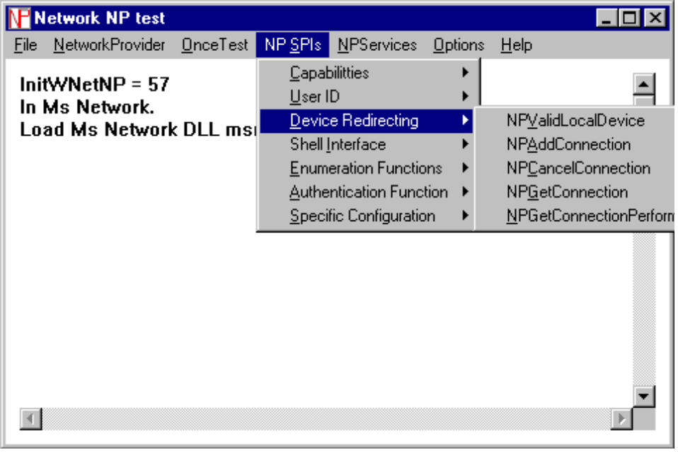
Figure 1: NPST Main Window

Selecting a NP SPIs menu item brings up a dialog box similar to this one for the NPGetCaps SPI:

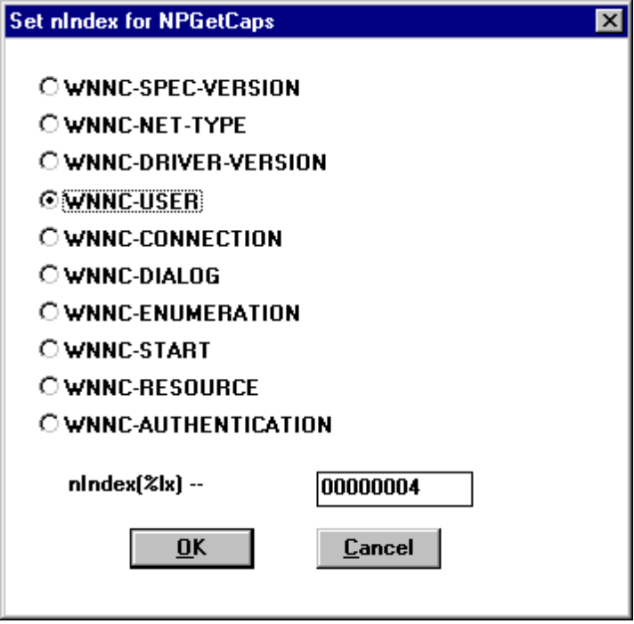
Figure 2: Network SPI Window

Choosing parameters for a SPI is as easy as checking the value(s) desired. NPST places the parameter value for the selection (nIndex, in this example) into an edit box, but the user may enter any custom value to specify an invalid test case.

Clicking OK calls the SPI with the selected parameters. Choosing CANCEL will dismiss the dialog without calling the SPI.
After each SPI call, all information, including passed parameters and return values, is shown in a Debug Window similar to the following:

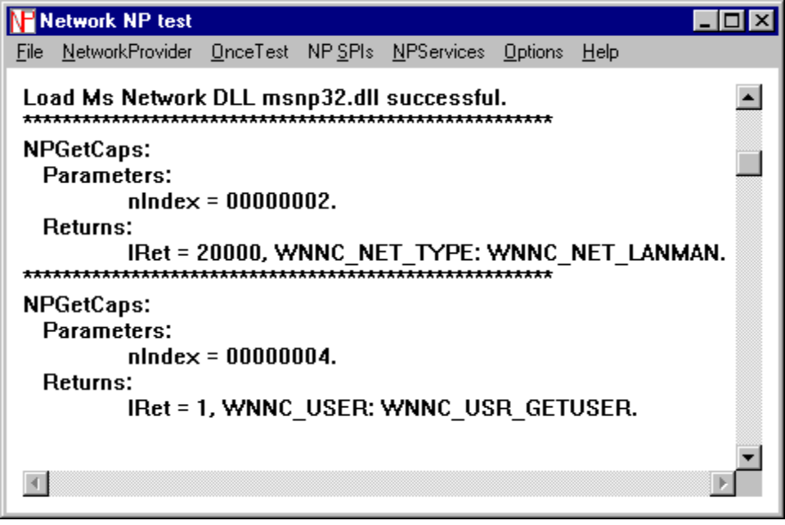
Figure 3: Debug Window with call results

The user may scroll through the test results or select Options|RefreshDebugWin to clear the screen. Information in the log file (if used) is not affected.

Appendix A: Index of Features

File:
Default Log File Select this to output all debug information to the default log file NPSTLOG.DAT.
Open Log File Select this to output the debug information to an alternate log file name.
Exit Exit NPST.

Network Provider:
Microsoft Microsoft Network.
MSNetWareCompatible Microsoft NetWare-Compatible Network.
OtherNetwork Provider Select this to choose the DLL of the NP to be
tested.

Once Test: Calls most SPIs for the NP selected.

NP SPIs:
Capabilities
NPGetCaps
UserID
NPGetUser
DeviceRedirection
NPValidLocalDevice
NPAddConnection
NPCancelConnection
NPGetConnection
NPGetConnectionPerformance
Shell Interface
NPFormatNetworkName
Enumeration Functions
NPOpenEnum
NPEnumResource
NPCloseEnum
NPGetResourceParent
NPGetResourceInformation
Authentication
NPLogon
NPLogoff
NPChangePassword
NPGetPasswordStatus
NPGetHomeDirectory
NPGetPolicyPath
Specific Configuration
NPDeviceMode

NP Services :
NPDeviceGetNumber
NPDeviceGetString

Options:
Write To LogFile Select this option to output debug information to a log file. This is on by default, but may be turned off to speed processing.
RefreshDebugWin Debug information is appended to both the screen display and the log file. Select this option to clear the results from the screen without affecting the contents of the log file.

Help:
About... Select this to see the full name of NPST, author name and copyright date.
Appendix B: Network Provider SPI Table

SPI Ordinal Mask Bit Set
NPGetCaps 13
NPGetUser 16 WNNC_USER_GETUSER 0X01
NPAddConnection 17 WNNC_CON_ADDCONNECTION 0X01
NPDevicemMode 14 WNNC_DLG_DEVICEMODE 0X001
NPCancelConnection 18 WNNC_CON_CANCELCONNECTION 0X02
NPGetConnection 12 WNNC_CON_GETCONNECTION 0X04
NPOpenEnum 33 WNNC_ENUM_GLOBAL 0X01
NPEnumResource 34 WNNC_ENUM_LOCAL 0X02
NPCloseEnum 35 WNNC_ENUM_CONTEXT 0X04
NPGetDisplayLayout 39 WNNC_DLG_GETDISPLAYLAYOUT 0X200
NPGetEnumText 40 WNNC_DLG_GETENUMTEXT 0X400
NPGetResourceParent 41 WNNC_DLG_GETRESOURCEPARENT 0X100
NPValidDevice 42 WNNC_RES_VALIDLOCALDEVICE 0X80
NPLogon 43 WNNC_AUTH_LOGON 0X01
NPLogoff 44 WNNC_AUTH_LOGOFF 0X02
NPGetHomeDirectory 45 WNNC_AUTH_GETHOMEDIRECTORY 0X10
NPFormatNetworkName 46 WNNC_DLG_FORMATNETWORKNAME 0X080
NPChangePassword 47 WNNC_AUTH_CHANGEPASSWORD 0X08
NPGetConnectionPerformance 49 WNNC_CON_GETPERFORMANCE 0X08

