Windows 95
Compatibility Tests

System Compatibility Tests (SCT)
- Wave Driver Test | - PC 95 Verification
- Mouse Driver | - WKey Look
- DOS Mouse | - System Timer
- Disptest | - Multi Mathtest
- Modem HCT | - VM Key State
- Net Bios | - CD Audio
- EMM 386 | - Shell Drag and Drop
- PnP ISA Cards | - Net File I/O
- Serial Port | - XMS Test
- MathTest | - Parallel Port
- ML Key API | - WinMath
- Global Stress 32 | - Stress 16
- BCT Shell | - Virtual Stress 32
- XMS Single Mode | - VFW Performance
- VFW AVI

Copyright 1990, 1992, 1994 (c) Microsoft Corporation

November 29, 1994

System Compatibility Tests (SCT)

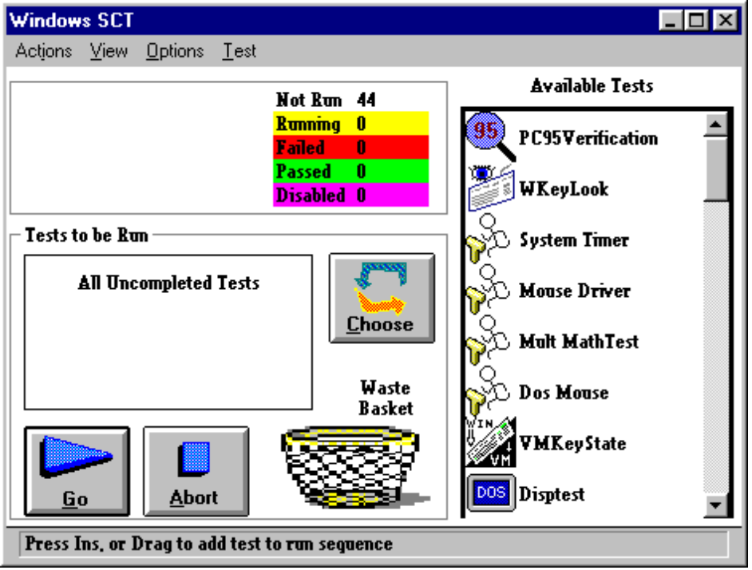

Installing the SCT

Recommendations
Backing up data - If you have important data on the machine on which you are going to be executing the SCT suite, it is recommended you back it up prior to testing.

Outline of Systems (SCT) Program Procedures

PC system manufacturers, please perform the following steps:

1. Install Windows 95 DDK on the system to be tested. CT Setup is explained in detail in the CT.DOC found in the same directory as this file.
2. Print and distribute copies of the SCT manual to your testing staff.
3. Install and run the Windows 95 SCT application on each hardware system to be tested. The tests to be run will be presented automatically by the Windows 95 CT shell when it is invoked.
4. When all tests have been completed, results will be automatically saved to disk when the tester selects Wrap-Up from the Actions menu of the CT Shell. Some tests will require manual verification but the results will be recorded automatically when a selection is made by the test engineer. When a test status is FAIL, use the Poblem Report Form option to generate a problem report.

Note It is not necessary to debug a problem when one is encountered while performing a test. It is much more efficient to record the problem in detail via the Problem Report Form and continue with the remaining tests. In many cases the problem may have already been reported or a Microsoft engineer may be able to determine the root of the problem from the bug description. A test error or failure does not always indicate that a vendor's system is incompatible with Windows 95. Some errors are expected to occur on certain configurations. You will be notified of the outcome of your test report.

5. Be prepared to submit additional information and/or hardware to the Windows 95 Compatibility Test Team or MCL for debugging purposes. All SCT results submitted to Microsoft Compatibility Labs should mailed directly to:
Microsoft Windows 95: SCT
Microsoft Corporation
One Microsoft Way
Bldg 20/1182
Redmond, WA 98052-6399
Attn.: Scott Herrboldt, SCT Coordinator
Compuserve Acct.: 71034,3643
scthelp@hicrosoft.com

