Chapter 1
Windows 95 on Other Networks
This chapter is a draft document and may not accurately represent the final version.
Note

This chapter provides details about installing and running Windows 95 on other networks. This chapter also includes information about mainframe connectivity for Windows 95 using emulators with Attachmate, DCA™, Hewlett-Packard®, IBM®, and Wall Data™ Rumba® products.

Installing Support for Other Networks 10-3
In This Chapter
Using 16-bit Real-Mode WinNet Drivers 10-6
Artisoft LANtastic 10-7
Banyan VINES 10-8
Beame and Whiteside NFS 10-9
DEC Pathworks 10-10
IBM OS/2 LAN Server 10-11
SunSelect PC-NFS 10-12
TCS 10-Net 10-13
Mainframe Connectivity and Windows 95 10-14

Chapter 7, “Network Technical Issues,” for technical details related to running Windows 95 on a network, including troubleshooting
See Also
Chapter 9, “Windows 95 on NetWare Networks,” for information about installing and using Windows 95 on NetWare networks

Installing Support for Other Networks

All the Setup options for installing and configuring network support described in this chapter can be defined in setup batch scripts for automatic installation, as described in Chapter 4, “Network Setup.” Chapter 4 also provides specific steps for setting up a network server as the source for Windows 95 Setup or for running a shared copy of Windows 95 on network workstations.
Important

This section describes how to install Windows 95 with network support from another vendor. For installation details related to your specific network, see the section for that network later in this chapter.

If you want to install Windows 95 on a computer that already had networking support from a network vendor other than Microsoft or Novell® NetWare®, you should be sure the network client from that vendor is correctly installed under MS-DOS, Windows version 3.1, or Windows for Workgroups.
Important
If you are not running the network when you set up Windows 95, and Setup detects a network adapter, it installs Client for Windows Networks by default.
Notice that the Configuration tab in Network Control Panel provides the same controls for adding and removing networking components after Windows 95 Setup is complete. However, Microsoft recommends that you install networking support during Windows 95 Setup.

To add a network client while running Windows 95 Setup
1. Be sure the network client from your vendor is already installed under MS-DOS, Windows 3.1, or Windows for Workgroups. The network should be running when you start Windows 95 Setup.
2. Start Windows 95 Setup as described in Chapter 3, “Introduction to Windows 95 Setup,” and choose Custom Setup as the Setup Type.
3. When the Network Configuration dialog box appears, your network client should appear in this list, because Setup should detect the network you are running. If it is correct, click OK to continue with Setup.
If you need to add the network client manually, click the Add button. Then select Client, and click the Add button. Select the appropriate network vendor in the Manufacturers list and the name of the network client in the Models list. Then click OK, and click the Close button.
4. Because the network clients keep track of the network adapter and protocols, no protocols or adapters should be listed in the Network Configuration dialog box.
5. If you want to install Client for Windows Networks in addition to the network client from your vendor, follow the steps in the next procedure. Otherwise, click the Next button and continue with Windows 95 Setup.
6. After Windows 95 is installed, check the AUTOEXEC.BAT file to ensure that all commands point to the correct directory for your network software.

In Windows 95, all real-mode networking components, including PROTOCOL.INI, are located in the root directory. The settings in PROTOCOL.INI only affect real-mode network components. Changing these values has no effect on the protected-mode network. If you need to change any settings in PROTOCOL.INI, use Network Control Panel to make changes.

Tip for Protected-Mode Network Providers from Other Vendors
In addition to the protected-mode network clients (Client for Windows Networks and Client for NetWare Networks) provided with Windows 95, any network vendor can create a 32-bit, protected-mode network provider and install it into the Windows 95 network architecture for multiple network interoperability.
For example, if Banyan® VINES® and SunSelect® PC-NFS® 32-bit network providers become available, then Windows 95 can support Microsoft networks, Novell NetWare, Banyan VINES, and Sun PC-NFS connectivity at the same time through the Network Neighborhood.
Contact your network vendor to determine when protected-mode software for Windows 95 will be available for your network.

If you want to install the 32-bit, protected mode Client for Windows Networks in addition to a network client from another vendor, follow these steps. For information about configuring and using this network client, see Chapter 8, “Windows 95 on Microsoft Networks.”
To install Client for Windows Networks with a network client from another vendor
1. Start Windows 95 Setup as described in Chapter 3, “Introduction to Windows 95 Setup,” and choose Custom Setup as the Setup Type.
– Or –
After Setup, double-click Network Control Panel.
2. In the Network Configuration dialog box, click the Add button. Then select Clients, and click the Add button.
3. In the Add dialog box, select Microsoft in the Manufacturers list, and select Client for Windows Networks in the Models list. Click OK, and then click the Close button.
4. Usually hardware detection detects the correct network adapter card and selects the corresponding driver. If you must add a network adapter card, click the Add button, select Adapters, and then click the Add button. Select the name of your adapter vendor in the Manufacturers list, and select the name of the adapter in the Models list. Click OK.
5. In the Network Configuration dialog box, select the adapter and click the Properties button. Verify the settings on the property sheets. For information, see Chapter 7, “Network Technical Issues.”
6. Click OK, and click the Close button to return to the main Network Configuration dialog box.
Setup automatically chooses the appropriate protocols.
7. Click OK to continue with Setup.
– Or –
If you are adding support after Windows 95 has been installed, you must shut down and restart the computer.

To install a shared copy of Windows 95 on a server for other networks
- Follow the instructions in “Task 1: Copying Windows 95 Files to a Server” in Chapter 4, “Network Setup.”

Using 16-bit Real-Mode WinNet Drivers
In addition to multiple 32-bit Windows 95 network providers, Windows 95 can also support a single 16-bit WinNet driver for a network product that does not provide a 32-bit network provider.
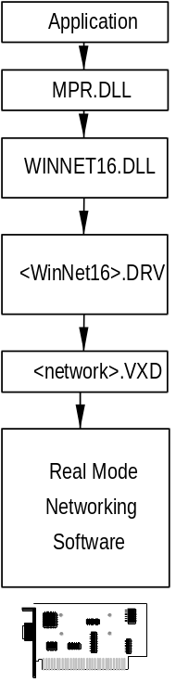
If the 16-bit network provider from another network vendor does not provide a browsing scheme, Network Neighborhood will be empty in Windows 95, indicating that this is not a browsable network. You must use the Map Network Drive dialog boxes for network access. Also, notice that a drive connected through the Windows 95 user interface is accessible in all VDMs. A connection made at an MS-DOS Prompt, however, will be avialable only in that VDM and will not be available in the Windows 95 user interface.
The following list summarizes the components for the 16-bit real-mode network drivers.
Component | Description
WINNET16.DLL | Provides a 32-bit to 16-bit thunk and translation between the 32-bit Windows 95 Network Provider Interface (NPI) and the 16-bit WinNet API.
winnet16.DRV | A 16-bit Windows 3.x network driver that provides a basic Map Network Drive dialog box.
network.VXD | A Windows 3.x VxD that allows virtualized access to the real-mode network software for all virtual machines (including the winnet16.DRV in the Windows System VM and VDMs).
Real-mode network software | This can include proprietary network adapter card drivers, protocol drivers, client (redirector), and network utilities loaded through CONFIG.SYS and AUTOEXEC.BAT (or other batch file).

The net command options for the real-mode MS-NET – Compatible Client are the same as Windows for Workgroups 3.11, except that net start nwlink can be used to load the IPX/SPX-compatible protocol. For a list of the net commands, see Appendix A, “Summary of Command-Line Commands.”
Note

You can install the real-mode MS-NET – Compatible Client as part of Windows 95 Setup, or you can add this client later.
To add Microsoft’s real-mode MS-NET compatible client support
1. In the Network Control Panel, click the Configuration tab, and then click the Add button.
2. In the Select Network Components dialog box, select Client, and then click the Add button.
3. In the Select Device dialog box, select Microsoft from the Manufacturers list, and then select Real Mode MS-NET – Compatible in the Models list.
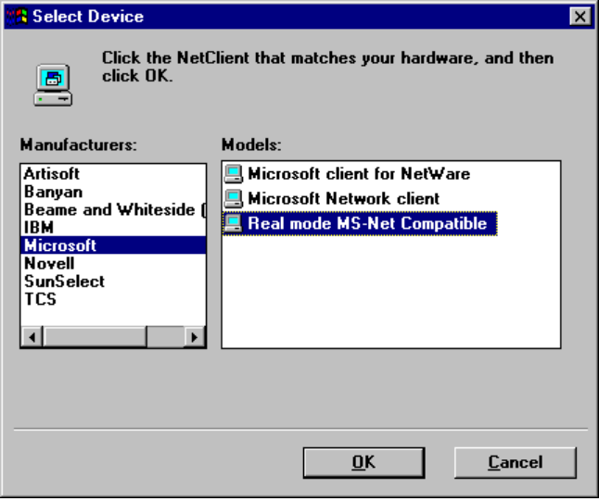
4. Click OK, and click OK again in the Network properties sheet. Then restart the computer.

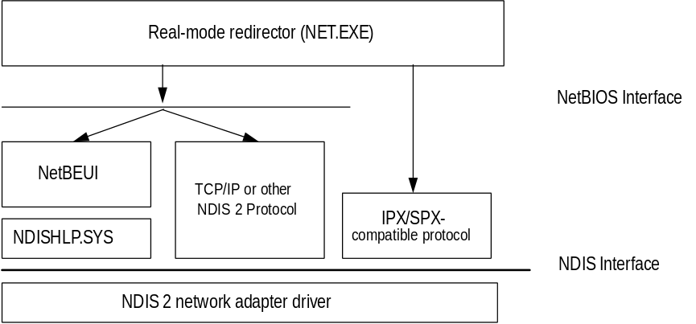
Windows 95 architecture for the real-mode MS-NET – Compatible Client
Real-mode redirector. The network client supports making drive and print connections, plus named pipes, mailslots APIs, and the ability to log onto a Windows NT domain.
Protocols. The real-mode redirector can work over any NDIS real-mode protocols that support a NetBIOS interface, including NetBEUI and TCP/IP. The real-mode MS-NET – Compatible Client does not support connectivity over real-mode DLC. (DLC does not support a NetBIOS interface, so the redirector cannot use DLC directly.)
IPX connectivity. The redirector supports direct connectivity using the IPX/SPX-compatible protocol provided with Windows 95. NetBIOS over IPX is not required.
The real-mode MS-NET – Compatible Client uses real-mode NDIS 2 protocols for NetBEUI and IPX/SPX, and network adapter card drivers use PROTOCOL.INI to store values.

Artisoft LANtastic
Windows 95 can be installed and run with Artisoft LANtastic version 5.x. or later LANtastic servers will not appear in Network Neighborhood. You can connect to servers at the command prompt.
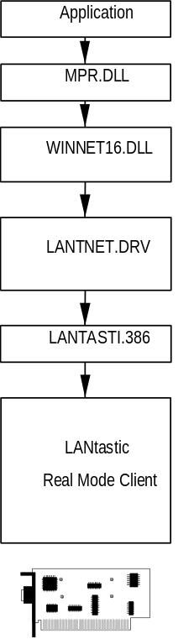
Artisoft LANtastic can be configured only as the primary network. Additional 32-bit network providers are not possible in this case.
To set up Windows 95 with Artisoft LANtastic real-mode network client support
- Ensure the LANtastic client is already installed under MS-DOS, Windows 3.1, or Windows for Workgroups. The network should be running when you start Windows 95 Setup. Then follow the steps in “Installing Support for Other Networks” earlier in this chapter. No other steps are required.
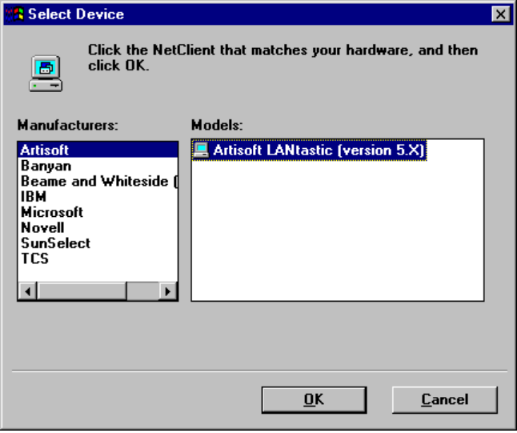

The LANtastic server cannot be run during Windows 95 Setup.
Note

To connect to a LANtastic server when running Windows 95
- You must type the complete server name and share name in a Map Network Drive dialog box or at the MS-DOS Prompt.

Banyan VINES
Windows 95 can be installed and run with Banyan VINES version 5.52(5) or later. Banyan VINES servers do not show up in Network Neighborhood. You can use the Map Network Drive dialog boxes that are presented in Windows 95.
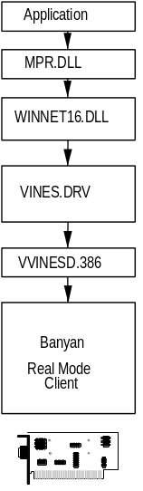
Banyan Vines as the primary network. If Banyan is installed using a Banyan LAN driver, Windows 95 can support Banyan as the primary network.
Banyan Vines as an additional 16-bit Windows 95 client. If Banyan is installed with an NDIS 2 network adapter card driver, then Banyan can be installed as an additional 16-bit network client, and you can install 32-bit, protected-mode clients such as Client for Windows Networks or Client for NetWare Networks.
To set up Windows 95 with Banyan VINES real-mode network client support
- Ensure the Banyan VINES client is already installed under MS-DOS, Windows 3.1, or Windows for Workgroups. The network should be running when you start Windows 95 Setup. Then follow the steps in “Installing Support for Other Networks” earlier in this chapter. No other steps are required.
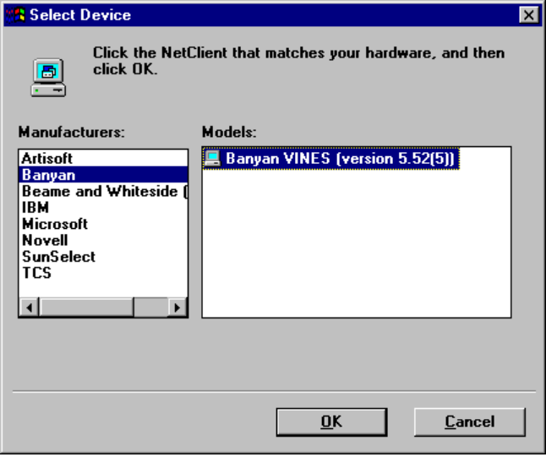

If you have Banyan Vines version 5.53(6) or 5.52(5), and are having problems with the Banyan popup dialog box the first time Windows 95 starts, you can create a VINES.INI file in your Windows directory that contains these entries:
Note
[newrev]
dontcopy=1
vines.version=5.53 (6) USA ; or vines.version=5.52(5) USA
windows.version=3.95

Beame and Whiteside NFS
Windows 95 can be installed and run with Beame and Whiteside version BW-NFS 3.0c. BW-NFS servers will not appear in Network Neighborhood. You can connect to servers at the command prompt.
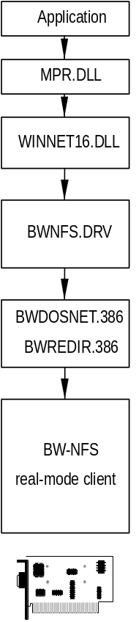
BW-NFS as the primary network. If BW-NFS is installed using a BW-NFS LAN driver, Windows 95 can support BW-NFS as the primary network. BW-NFS uses NDIS packet drivers or ODI network adapter card drivers.
BW-NFS as an additional 16-bit Windows 95 client. If BW-NFS is installed with an NDIS 2 network adapter card driver, then BW-NFS can be installed as an additional 16-bit network client, and you can install 32-bit, protected-mode clients such as Client for Windows Networks or Client for NetWare Networks.
To set up Windows 95 with BW-NFS real-mode network client support
- Ensure the Beame and Whiteside BW-NFS network client is already installed under MS-DOS, Windows 3.1, or Windows for Workgroups. The network should be running when you start Windows 95 Setup. Then follow the steps in “Installing Support for Other Networks” earlier in this chapter. No other steps are required.
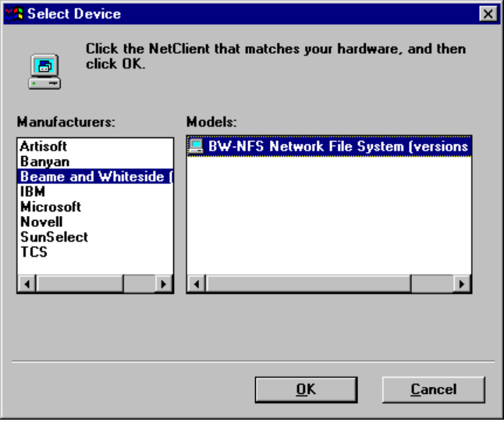

DEC Pathworks
Windows 95 can be installed and run with DEC Pathworks versions 4.x and versions 5.x. You must install Client for Windows Networks plus the DEC Pathworks protocol provided by DEC (there is no DEC Pathworks 4.x or 5.x client). DEC Pathworks uses NDIS network adapter card drivers.
After Windows 95 is installed, you can browse DEC Pathworks servers running version 5.x using Network Neighborhood. You can also use the standard Windows 95 methods for connecting to printers. If the server is running version 4.x, you can only connect by specifying the server and share name in Map Network Drive dialog boxes.

At this writing, DEC Pathworks users must use the disk from DEC to install support for Windows for Workgroups 3.x before running Windows 95 Setup.
Note

To set up Windows 95 with DEC Pathworks version 4.x or 5.x real-mode network support
1. Ensure the DEC Pathworks support is already installed under Windows for Workgroups. The network should be running when you start Windows 95 Setup.
2. Run Windows 95 Setup and choose Custom Setup.
3. In the Network Configuration dialog box, click the Add button, select Client, and then click the Add button.
4. Select Microsoft in the Manufacturers list and Client for Windows Networks in the Models list. Click OK, and then click the Close button to return to the main Network Configuration dialog box.
5. Click the Add button, select Protocol, and then click the Add button.
6. Select DEC in the Manufacturers list and the appropriate DEC Pathworks 4.x or 5.x protocol in the Models list. Click OK, and then click Close to return to the main Network Configuration dialog box.
7. Click the Next button to continue with Setup.

The Windows 95 AUTOEXEC.BAT file contains the following line to start DEC Pathworks:
STARTNET.BAT

IBM OS/2 LAN Server
Windows 95 can be installed and run with these versions:
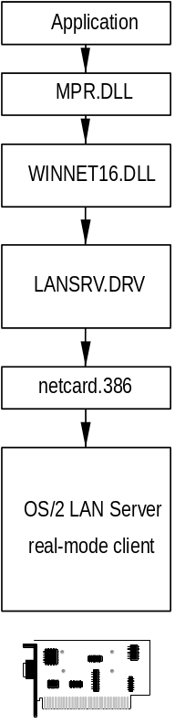
- IBM OS/2® LAN Server version 1.3 CSD
- IBM OS/2 LAN Server version 2.0
- IBM OS/2 LAN Server versions 1.2 and 1.3

If OS/2 LAN Server is installed using a OS/2 LAN Server LAN driver, Windows 95 can support OS/2 LAN Server as a primary network only. You cannot install Client for Windows Networks as an additional network client. OS/2 LAN Server servers will appear in Network Neighborhood. Users can use the Map Network Drive dialog boxes for connecting to servers.
To set up Windows 95 with IBM OS/2 LAN Server real-mode network client support
- Ensure the OS/2 LAN Server client is already installed under MS-DOS, Windows 3.1, or Windows for Workgroups. The network should be running when you follow the steps in “Installing Support for Other Networks” earlier in this chapter. No other steps are required.
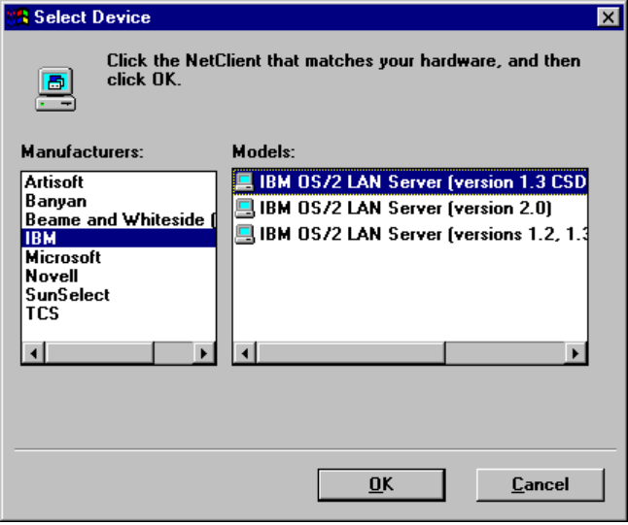

Windows 95 does not support installation of IBM DOS LAN Requestor. To access an IBM LAN Server, install Client for Windows Networks. Then all networking operations should be successful with the LAN Server. You must remove all references to DOS LAN Requestor from CONFIG.SYS and AUTOEXEC.BAT before starting Windows 95.
Important

SunSelect PC-NFS
Windows 95 can be installed and run with SunSelect PC-NFS version 5.0. SunSelect servers will not appear in Network Neighborhood. You can use the Map Network Drive dialog box to connect to servers.
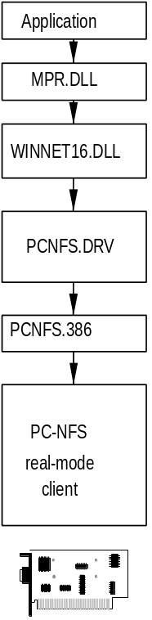
Sun PC-NFS as the primary network. If Sun PC-NFS is installed using a Sun PC-NFS LAN driver, Windows 95 can support Sun PC-NFS as the primary network. Additional 32-bit network providers are not possible in this case.
Sun PC-NFS as an additional 16-bit Windows 95 client. If Sun PC-NFS is installed with an NDIS 2 network adapter card driver or with an ODI driver, then Sun PC-NFS can be installed as an additional 16-bit network client, and you can install 32-bit, protected-mode clients such as Client for Windows Networks or Client for NetWare Networks.
To set up Windows 95 with SunSelect PC-NFS real-mode network client support
- Ensure the SunSelect PC-NFS client is already installed under MS-DOS, Windows 3.1, or Windows for Workgroups. The network should be running when you follow the steps in “Installing Support for Other Networks” earlier in this chapter. No other steps are required.
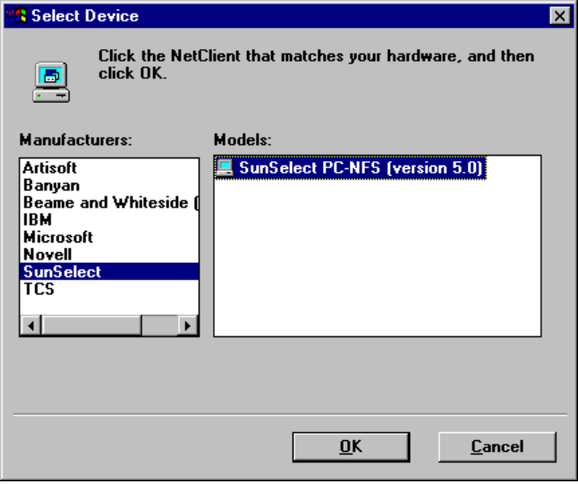

TCS 10-Net
Windows 95 can be installed and run with these versions of TCS 10-Net:
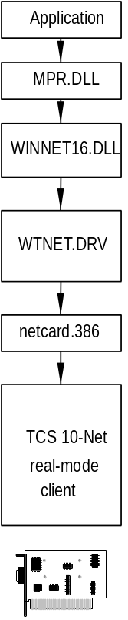
- TCS 10-Net version 4.1x with DCA 1M
- TCS 10-Net version 4.1x
- TCS 10-Net version4.2 and above
- TCS 10-Net version 5.0

TCS 10-Net servers will appear in Network Neighborhood, so users can browse and connect to resources.
TCS 10-Net as the primary network. If TCS 10-Net is installed using a TCS 10-Net LAN driver, Windows 95 can support TCS 10-Net as the primary network.
TCS 10-Net as an additional 16-bit Windows 95 client. If TCS 10-Net is installed with an NDIS 2 network adapter card driver, then TCS 10-Net can be installed as an additional 16-bit network client, and you can install 32-bit, protected-mode client such as Client for Windows Networks or Client for NetWare Networks.
To set up Windows 95 with TCS 10-NET real-mode network client support
- Ensure the TCS 10-Net client is already installed under MS-DOS, Windows 3.1, or Windows for Workgroups. The network should be running when you start Windows 95 Setup. Then follow the steps in “Installing Support for Other Networks” earlier in this chapter. No other steps are required.
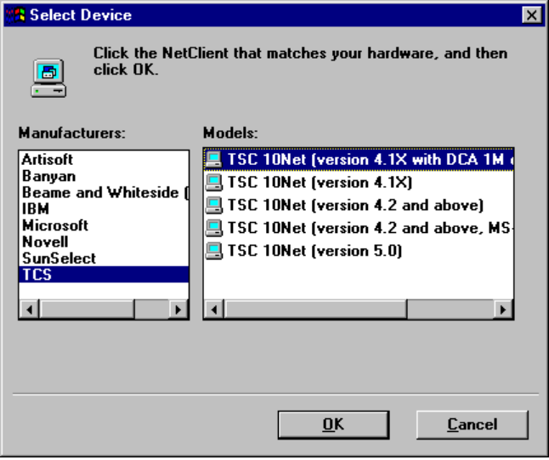

Mainframe Connectivity and Windows 95
This section describes how to install common protocols for mainframe connectivity, and then provides specific information for installing connectivity support from these providers:
- Attachmate
- DCA
- Hewlett-Packard
- IBM
- Wall Data Rumba

Common Protocols for Mainframe Connectivity
The common network protocols used to support mainframe connectivity include the following:
- IPX/SPX
The IPX/SPX-compatible protocol provided with Windows 95 is compatible with Novell NetWare IPX/SPX, and can also be installed to support mainframe connectivity. For information about installing and configuring this protocol with Windows 95, see Chapter 7, “Network Technical Issues.”
- NetBIOS
The NetBIOS extended user interface (NetBEUI) protocol provided with Windows 95 supports a NetBIOS programming interface and conforms to the IBM NetBEUI specifications. It also includes performance enhancements related to NetBIOS 3.0. NetBEUI can be installed to provide NetBIOS support for mainframe connectivity. For information about installing and configuring NetBEUI, see Chapter 7, “Network Technical Issues.”
- DLC
Data Link Control (DLC) protocol is used primarily to access IBM mainframe computers. This protocol isn’t used for general networking with Windows 95. The following section provides details about using DLC for connecting to mainframes.

Microsoft DLC for Mainframe Connectivity
If you want to connect to and communicate with a mainframe computer that uses DLC, the Microsoft DLC protocol must be installed on the computer running Windows 95. The Microsoft DLC protocol allows computers running Windows 95 to connect to IBM mainframes using 3270 emulators. You can also connect to IBM AS/400® computers using 5250 emulators. The DLC protocol works with either token ring or ethernet media access control (MAC) drivers. The DLC protocol works with 32-bit and 16-bit Windows-based applications.
Microsoft DLC is also used to provide connectivity to local-area printers connected directly to the network. For example, DLC can be used to print to a printer such as a Hewlett-Packard HP® 4Si, which uses an HP JetDirect® network adapter to connect directly to the network, instead of to a port on a print server. The DLC protocol must be installed and running on the print server for the printer. Computers sending print jobs to a print server for a DLC network printer do not need the DLC protocol — only the print server requires DLC.
To take advantage of the DLC protocol device driver, you must create a network printer in the Printers folder. For information, see Chapter 17, “Printing.”
You can install the Microsoft DLC protocol using Network Control Panel.
To install the Microsoft DLC protocol on a computer running Windows 95
1. In Network Control Panel, click the Configuration tab.
2. Click the Add button, select Protocol, and then click the Add button.
3. In the Select Device dialog box, select Microsoft in the Manufacturers list, and select Microsoft DLC in the Models list, and then click OK.
4. Select the network adapter card, and click Properties.
5. Click the option to configure the driver as a real-mode 16-bit NDIS 2 driver.
6. Edit PROTOCOL.INI to remove or comment out the lanabase= line.
7. Save PROTOCOL.INI. Then shut down and restart the computer.

Each time you change a setting such as configuring a network adapter card, check PROTOCOL.INI to be sure that lanabase= is commented out.
Note

The following sections provide details for configuring Windows 95 for direct DLC connections.

Real-Mode DLC with ODI Network Card Drivers
This configuration allows you to connect the real-mode DLC driver from Windows for Workgroups Connection to ODI driver, which is an NDIS 2.0-compliant driver. To connect to other NDIS 3.1 drivers, you need to include ODIHELP.EXE, which is the real-mode component that connects to the MSODISUP.VXD driver.
The AUTOEXEC.BAT file should contain the following entries:
net init
lsl
odi_driver.com
odinsup.exe ;Novell component
msdlc.exe
net start netbind
odihelp.exe ;Microsoft component

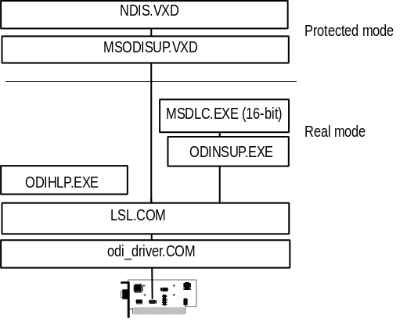

Real-Mode DLC with All NDIS 2.0 Drivers
This configuration allows you to connect a real-mode DLC driver to NDIS 2.0 network adapter card drivers. This assumes you also want to connect to other NDIS 3.1 drivers.
The AUTOEXEC.BAT file should contain the following entries:
net init
msdlc.exe
net start netbind

The PROTOCOL.INI file should contain the following entries:
[msdlc$]
DriverName=msdlc$
Bindings=netcard_name

Real-Mode DLC with NDIS 2.0 Network Adapter Card and IBM LanSupport Program
This allows you to connect to the mainframe using your current configuration of DXMAOMOD.SYS and DXMCOMOD.SYS drivers from IBM.
The AUTOEXEC.BAT file should contain the following entries:
net init
LSL
LANSUP ; Novell component

The CONFIG.SYS file should contain the following entries:
dxmaomod.sys
dxmcomod.sys

ODIHELP.EXE should be installed if you need to communicate with NDIS 3.1 protocols, plus DXMAOMOD.SYS and DXMCOMOD.SYS.
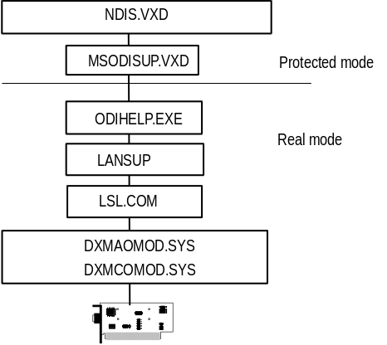

Gateways for Connectivity
A client computer can use any protocol that the gateway supports, and in turn the gateway can connect directly to the mainframe or FEP.

SNA Server 2.0
In this configuration, you can use the 16-bit network client to connect to a current Microsoft SNA Server version 2.0. Notice, however, that you cannot use Windows NT for this, because the network client makes only Windows NT-specific calls.
The following shows the correct configuration file entries for SNA Server 2.0:
[Wnap]
WBinPath=C:\SNA.WIN
Remote=\\MYSNA-CORP3
NosType=LANMAN
NosSetup=LANMAN
NetSetup=NO

[SnaServerWin3270]
WindowLeft=80
WindowTop=88
WindowRight=560
WindowBottom=409
ShowWindow=1
WindowMaxX=-1
WindowMaxY=-1
LUOrPoolName=BLUEBIRD

SNA Server 2.1
SNA Server 2.1 supports NETBEUI, TCP/IP, IPX/SPX, and Banyan IP protocols.

Connecting to AS/400
The following shows the AUTOEXEC.BAT entries to support an AS/400 connection with Microsoft DCL and IBM PC support:
msdlc.exe
startrtr
pcswin.com

Attachmate Connectivity
To be provided.

DCA Connectivity
To be provided.

Hewlett-Packard Connectivity
To be provided.

IBM Connectivity
To be provided.

Wall Data Rumba Connectivity
To be provided.

