Chapter 1
Network security controls who can access which network resources. Windows 95 provides for share-level security on your Windows 95 network. It also offers the ability to leverage the power of the security model provided by your existing Windows NT or Novell® NetWare® network to apply pass-through logon validation and user-level security to your Windows 95 systems.
Security
This chapter describes logon and network security features of Windows 95. It also describes options for using a master password and password caching, and describes Windows 95 security for remote administration.

A good security model requires advanced planning. Be sure to plan for security before you set up your Windows 95 network. For more information, see Chapter 1, “Deployment Guide.”
Important

Logging On to Windows 95 11-2
In This Chapter
Enabling Pass-through Security 11-3
Windows 95 Network Security Overview 11-9
Enabling File and Print Sharing 11-12
Setting Up Share-Level or User-Level Security 11-13
Using Share-Level Security 11-15
Using User-Level Security 11-17
Using a Master Password 11-23
Using the Windows 95 Password Cache 11-24
Windows 95 Security for Remote Administration 11-27
Troubleshooting Security Issues 11-28

Logging On to Windows 95
As soon as Windows 95 starts on their computers, most users will see a logon dialog box like this one:
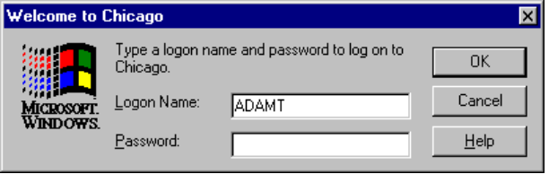
Windows 95 uses this logon information to identify the user and find the appropriate user profile information for that user. User profiles define user preferences, such as the fonts and colors used on the desktop, and access information for the user. (For more information about user profiles, see Chapter 12, “System Management.”)
As described earlier in this book, you can configure a computer that runs Windows 95 to participate in a Windows NT, Novell NetWare, or other network. When you run as part of a Windows NT or NetWare network, you can take advantage of the security features of those networks.
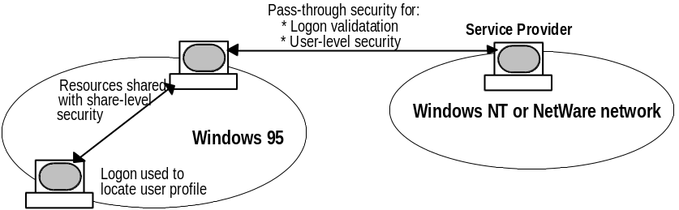
When a computer running Windows 95 is part of a Windows NT or NetWare network, Windows 95 implements a pass-through technology where Windows 95 passes the logon user name and password to a server (also known as a security provider) for validation. The server must validate the name and password combination before the user is allowed to access the local computer and network resources.
(Pass-through security also includes pass-through user-level security, as described in “Windows 95 Network Security” later in this chapter.)
Depending on how the network is configured, therefore, the Windows 95 logon dialog box may prompt for more information than the user name and password.
When the computer is part of a Windows NT domain and when validated logon is enabled, the Windows 95 logon dialog box prompts the user for a user name, password, and domain name, as shown below. Once the user name and password pair are validated by the network server’s authentication process, the user is allowed to use Windows 95 and resources shared on the network.
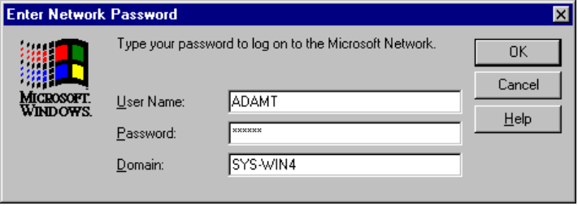
When the user’s computer is part of a NetWare network with validated logon enabled, the user specifies a preferred server as part of logon:
add picture of Novell logon
If the user is not validated, the user cannot bypass this screen, thus preventing access to the local computer’s resources (information and files on the local hard drive).

Enabling Pass-through Security
During Setup, you can specify whether your computer will participate on a Windows NT or NetWare network. You can also specify this after Setup, as described below.
Windows 95 includes two networking clients — the Client for Windows Networks and the Client for NetWare Networks. By adding and configuring one of these networking clients, you can configure a computer running Windows 95 to participate on a Windows NT or NetWare network. When you do this, you also enable pass-through logon validation for your computer.

Before you can use validated logon on the computer running Windows 95, you must have a Windows NT or NetWare server with appropriate permissions defined for the user. For more information about setting up permissions for your Windows NT or NetWare server, see the administrator’s documentation for your server. For related information, see Chapter 8, “Windows 95 on Microsoft Networks” and Chapter 9, “Windows 95 on NetWare Networks.”
Important

To use a Windows NT domain controller for pass-through security
1. From the Start button, choose Settings, and then click Control Panel.
2. Double-click the Network Control Panel icon.
3. Click the Configuration tab and click Client for Windows Networks. Click Properties.
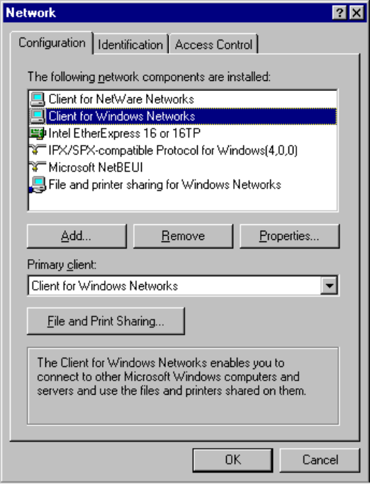
4. Check Log On To Windows NT Domain and specify the domain name.
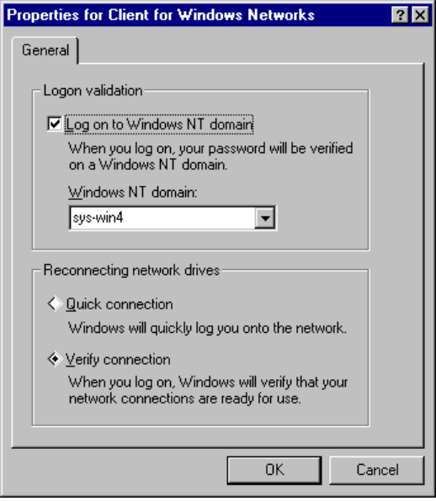
5. Select either Quick Connection or Verify Connection. Click OK.

The domain controller for the Windows NT domain will now provide pass-through logon validation and pass-through user-level security support for your computer.
To use a Novell NetWare server for pass-through security
1. From the Start button, choose Settings, and then click Control Panel.
2. Double-click the Network Control Panel icon.
3. Click the Configuration tab and click Client for NetWare Networks. Click Properties.
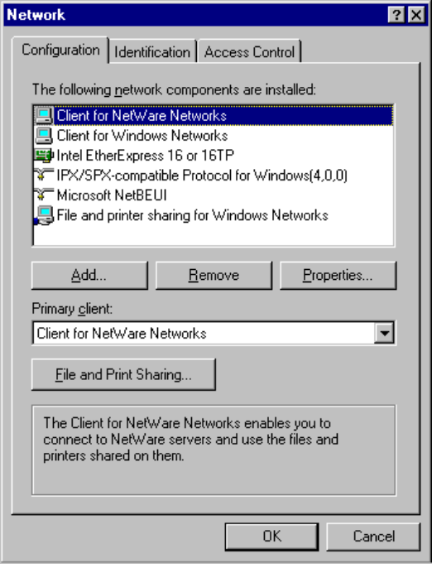
4. Specify the name of the Preferred Server, the letter of the First Network Drive, and Search Mode.
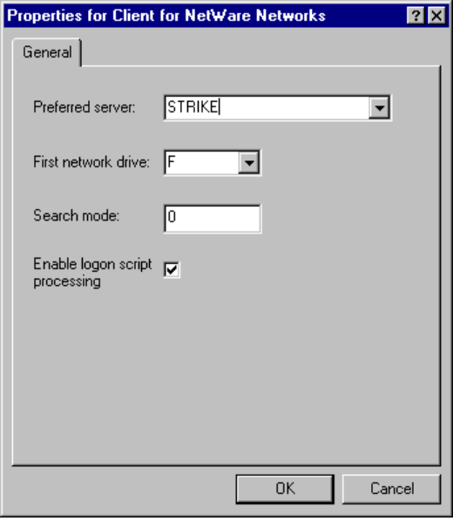
5. Check Enable Logon Script Processing. Click OK.

The NetWare server will now provide pass-through logon validation and pass-through user-level security support for your computer.
To enable validated logon directly through the local Registry
1. From the Start button, choose Programs, then choose Accessories, and then System tools. Click System Policy Editor.
2. Using the Local Registry (opened by default), double-click Local Computer. The policies for that computer are displayed.
3. Click Network; then click Logon, as shown here.
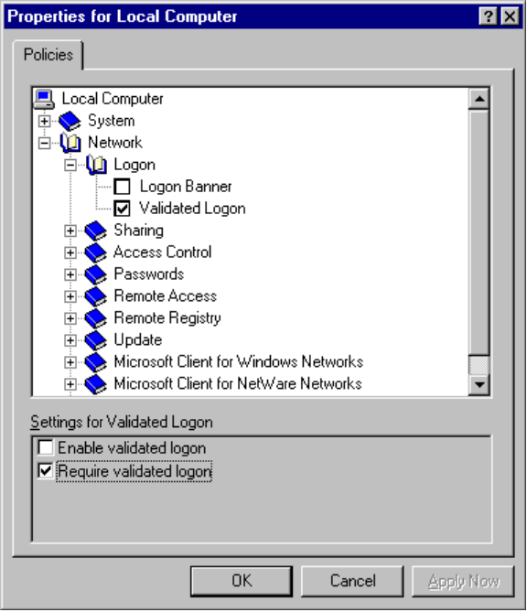
4. Under settings for Validated Logon, check Enable Validated Logon, and then check Require Validated Logon. Click OK.
5. From the File menu, choose Save.

To enable validated logon by making changes to a policy file
1. From the Start button, choose Programs, then choose Accessories, and then choose System tools. Click System Policy Editor.
2. From the File menu, click Open, then specify the appropriate POLICY.POL file for the computer running Windows 95.
3. Make the changes described in the preceding example.
4. From the File menu, click Save.

For more information on how to use the System Policy Editor and how to implement a POLICY.POL file for computers running Windows 95, see Chapter 12, “System Management.”

Windows 95 Network Security Overview
Once logged onto the network, a user can access a computer running Windows 95 in several ways. When you use one of Microsoft’s file and print service providers to share files and printers, other users can access these resources on your computer. Likewise, by enabling remote administration capabilities on your computer, administrators can use built-in remote access Remote Procedure Call (RPC) capabilities to access your computer. Computers running Windows 95 can be accessed through the network or through a modem.
Windows 95 supports two types of network security:
- Share-level security, where access to shared resources is determined by passwords assigned to resources.
- User-level security, where access to shared resources is determined by permissions granted to individual users.

Notes
- If you are running Microsoft File and Printer Sharing for NetWare, you cannot use share-level security.
- Using system policies, a network administrator can easily and quickly control access to all computer resources. For more information, see Chapter 12, “System Management.”

Windows 95 does not implement its own unique user-level security mechanism but instead leverages the existing user-level security provided by a Windows NT or NetWare network.
For user-level security, whenever a user tries to access a Windows 95 resource, Windows 95 forwards user authentication requests to the security provider. A security provider can be a Windows NT domain controller or Novell NetWare server that provides a list of user accounts and authentication services to Windows 95. (This is the same computer that provides pass-through logon validation.) Before the user is allowed access, the security provider must be validated from the central account list.

Because the service provider maintains a network-wide list of user accounts and passwords, Windows 95 does not store a local list of accounts.
Note

The following illustration shows the four-step pass-through authentication process:
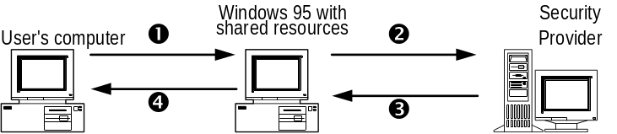
1. A user tries to access a file or other shared resource on a computer running Windows 95. The computer running Windows 95 has enabled pass-through user-level security.
2. Information from the request to access the shared resource is passed to the security provider to verify the user’s identity.
3. The security provider verifies that the user name and password combination is valid.
4. Windows 95 grants access to the user.

Notes
- If you are running Microsoft Network File and Print Sharing, then the provider of the user list and authentication must be a Windows NT Server domain controller.
- If you are running Microsoft File and Print Sharing for NetWare, then the user list and authentication provider must be either a Novell NetWare server or a Novell NetWare 4.x server running bindery emulation.

User-Level Security in Multiple Domain Environments
Although Windows NT allows multiple domains, a computer running Windows 95 can list only one domain when specifying user-level security. To allow a computer running Windows 95 to access domains other than the one listed, one of two things must be true:
- The domain listed by Windows 95 must contain all of the accounts (the enterprise list).
- The domain listed must have a trust relationship with the domain that owns the enterprise list.

The following are examples of how you can use user-level security with Windows 95 in various domain configuration scenarios.

Single Domain Example
In this example, the domain Corporate is the only domain on a Windows NT network. Corporate contains all the user accounts for the domain.
The Windows 95 user simply lists Corporate as the security provider.

Master Domain Example
Corporate, Sales, and Marketing are three domains on a Windows NT network. Corporate is the user account domain and contain all user accounts. Sales and Marketing are domains that offer shared resources but do not contain any user accounts. Sales and Marketing domains “trust” the Corporate domain. This allows all the user accounts in the Corporate domain to be available in the resource domains for assigning rights to resources and logging onto the network.
The Windows 95 user lists Corporate as the security provider.

Multiple Master Domain Example
Two domains, Development and Corporate, contain user accounts. Development trusts the Corporate domain; therefore, user accounts in the Corporate domain are available in the Development domain.
Users who list Corporate as the security provider see the list of users in the Corporate domain.
Users who list Development as the security provider see the list of users in both the Development and Corporate domains.

Complete Trust Example
To be provided.

Windows 95 in Multiple NetWare Bindery Environments
NetWare 2.x and 3.x servers store all the information on users, groups, passwords, and rights in a database stored on the server called the bindery. NetWare 4.x servers can appear to have a bindery through bindery emulation, a feature which is enabled by default. There is a separate bindery for each NetWare server. Windows 95 can use the bindery of only one NetWare server.
It is common for a company to have one or more NetWare servers per department, where users log on to the server for their department. The scenario can pose a problem when the list of accounts differs from one NetWare server to another.
For example, Sue and Bob log onto the Sales server and Fred logs onto the R&D server. Because Sue is running Windows 95 and can list only one server for pass-through validation, she lists Sales (the server she uses for logon). She can now grant access to shared resources on her computer to Bob but cannot grant access to Fred.
The only workaround to this problem is to include all user accounts for all servers on one NetWare server. This server should be listed as the security provider for every computer running Windows 95 with File and Printer Sharing Services for NetWare.

Windows 95 does not support the use of NetWare domains and the NetWare Name Service (NNS), an add-on service for NetWare 3.x servers.
Note

Enabling File and Print Sharing
On a computer running Windows 95, you can share your computer’s files and printers so that others on the network can have access to them. To do so, you must first enable file and/or print sharing.
To enable file and printer sharing on your computer
1. From the Network Control Panel, click File and Print Sharing.
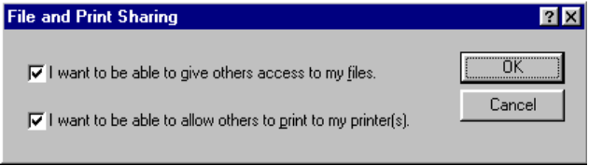
2. Check either or both of the check boxes in the File and Print Sharing dialog box to if you want to share files and/or printers on your computer.

You must also add one of the file and print sharing services provided by Microsoft to enable sharing on your computer. If you do not do this, the sharing options will not display on the printer and directory context menus, and Security property sheets will not be available.
Important

Setting Up Share-Level or User-Level Security
Before you can share a specific printer or directory, you need to specify whether you will use share-level or user-level security for network access of your computer’s resources.
To set up share-level security
Share-level security is enabled by default, unless you are running Microsoft File and Print Sharing for NetWare. You can change from share-level to user-level security using the Network Control Panel.
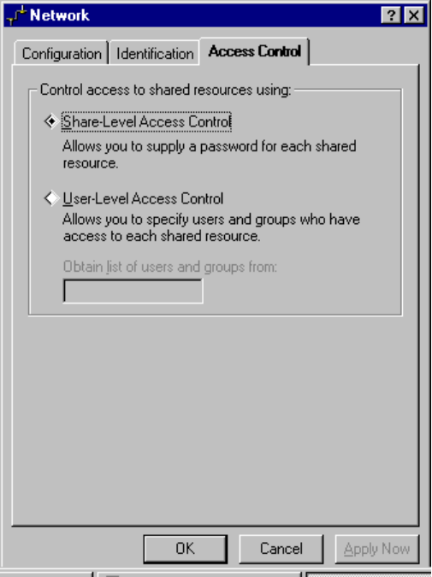
To set up user-level security
1. From the Start button, choose Settings, and then click Control Panel.
2. Double-click the Network Control Panel icon.
3. Click the Access Control tab, and then click User-level Access Control. Type the name of the security provider (either a Windows NT domain or a Novell NetWare server). Click OK.
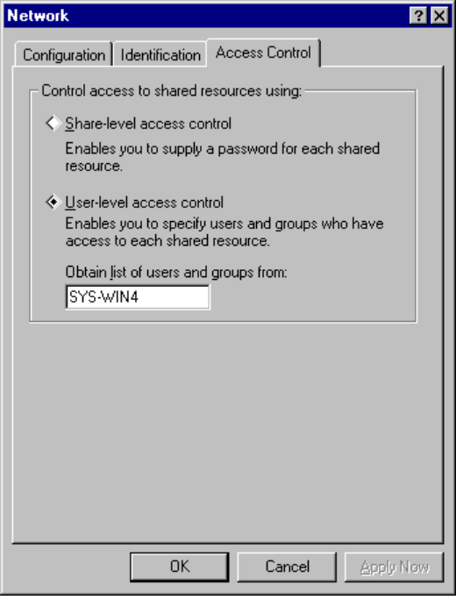

Using Share-Level Security
Each shared directory and shared printer can have a read-only and/or a full-access password associated with it.

Share-level security is the default security type for File and Printer Sharing for Windows Networks.
Note

To share a directory or printer using share-level security
1. Right-click the icon for the directory or printer you want to share. When the context menu displays, click Sharing.
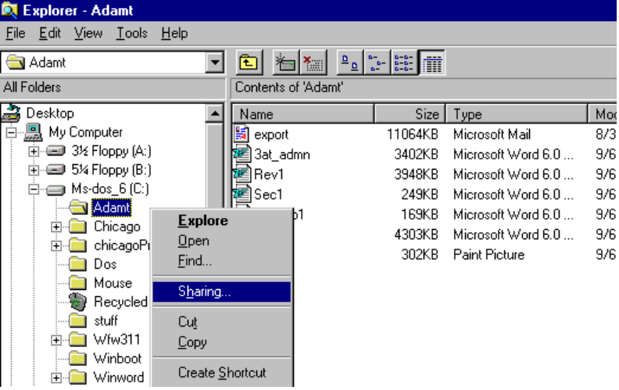
2. Select the Sharing tab to view the Sharing property sheet.
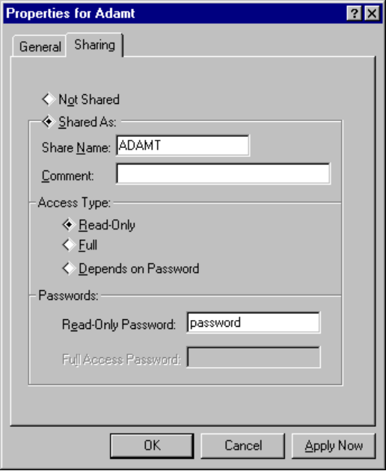
3. Click Share As and type a share name for the resource. Network users will type this same name when they want to access this resource.
4. Specify whether you want users to have read-only or full access to this resource. You can also choose to have two levels of access, depending on the password the user types.
5. Type the password (or passwords) for the resource. Click OK.

You can share a directory but hid it from the Network Neighborhood browsing list by adding a dollar-sign character ($) to the end of its share name (for example, ADAM$).
Tip

Using User-Level Security
For each resource or service that is governed by user-level security, there is a list of users and groups — called trustees — that can access that resource. For each trustee, there is a set of rights assigned for a resource. The kinds of rights that you can give depend on the kind of resource you are securing.
- For shared directories, you can allow a user to have read-only access, full access, or custom access. Within custom access, you can grant the user any or all of the following rights: read, write, create, list, delete, change file attributes, and change permissions.
- For shared printers, a user either has the right to access the printer or not.
- For remote administration, a user either has the right to be an administrator or not.

Permissions are enforced on a resource as follows:
1. If the user has explicit rights to the resource, then those rights are enforced.
2. If the user does not have explicit rights to the resource, then the permissions are computed by taking all of the rights of each group to which the user belongs.
3. If none of the groups to which the user belongs has any rights for that resource, then the user is not granted access to the resource.

When access rights for a file or directory on a Windows 95 computer have not been assigned explicitly, implied rights are used instead. The file or directory inherits the access rights assigned to its nearest “ancestor” (such as the parent directory). If none of its ancestors, up to and including the root directory of the drive, has explicit rights, no access is allowed.

Managing Users and Groups with User-Level Security
Windows 95 user-level security always depends on a list of accounts and groups that is located on a security provider. Windows 95 does not store the security provider list locally. Rather, the users and groups that are listed when specifying users are always temporarily downloaded from the security provider.
Users and groups are managed on the security provider. Windows 95 does not have the ability to add or remove users and groups from the security provider list, nor does it include any utilities to remotely administer this list. On a Windows NT domain, the administrator uses the User Manager tool for user and group management. On a NetWare bindery environment, users and groups are managed using SYSCON for NetWare 2.x or 3.x and NETADMIN for NetWare 4.x.
Windows 95 does store the access control list (ACL) locally. The ACL defines which users and groups have which permissions to which resources on the local computer. Windows 95 has the ability to add or remove users and groups to or from the ACL.

An individual’s security information is also maintained in that person’s user profile. For a complete discussion on how to create and maintain user profiles for Windows 95, see Chapter 12, “System Management.”
Note

Specifying Permissions for Directories
Permissions specify what a given user can do in a given directory shared from a computer running Windows 95. With Windows 95,you can assign permissions to directories, but not to individual files. (This is different from both Windows NT and NetWare, where you are can assign permissions to individual files.)
Permissions set for a directory apply to all of its subdirectories.
For a directory, you can assign read-only, full access, or custom access. (Read-only and full access are equivalent to the same values used by Windows for Workgroups with share-level security.) Custom access allows you to specify exactly what is allowed in the directory for an individual user or group. The permissions are based on the LAN Manager permission set:

Windows 95 permissions for a directory
Permission | Meaning
R | Read and open files in a directory
W | Write to files in a directory
C | Create new files and directories
L | Allow users to see files in a directory
D | Delete existing files and directories
A | Modify file/directory attributes or rename
P | Allows users to modify permissions

The following table shows which permissions a user needs to perform various common activities:
File operation | Required permissions
Read from a closed file | Read files
See a filename | List files
Search a directory for files | List files
Write to a closed file | Write, create, delete, change file attributes
Run an .EXE file | Read, list files
Create and write to a file | Create files
Copy files from a directory | Read, list files
Copy files to a directory | Write, create, list files
Make a new directory | Create files
Delete a file | Delete files
Remove a directory | Delete files
Change directory or file attributes | Change file attributes
Rename a file or directory | Change file attributes
Change permissions | Change permissions

Equivalent NetWare Rights
The following are the equivalent NetWare rights for Windows 95 permissions:
Windows 95 Permission Equivalent NetWare Right
(R)ead Files (R)ead
(W)rite to Files (W)rite
(C)reate Files (C)reate
(L)ist Files (F)ile Scan
(D)elete Files (E)rase
Change File (A)tributes (M)odify
Change (P)ermissions (A)ccess Control

To share a directory if you are running File and Print Sharing for Microsoft Networks
1. From Windows Explorer, right-click the icon for the directory you want to share. When the context menu displays, click Sharing.
2. Click the Sharing tab and type a share name for the directory. Click Add.
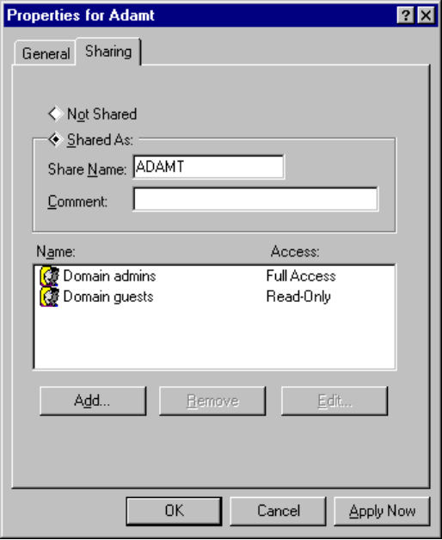
3. Specify which users can access the directory, and specify whether they can have Read Only, Full, or Custom access.
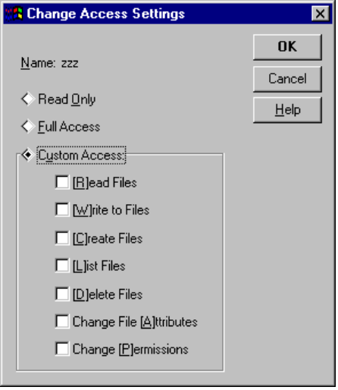
4. Type a password for the resource. Click OK.
To share a directory if you are running File and Print Sharing for NetWare Networks
- In Explorer, right-click the directory, and click Sharing on the menu. Then click the Add button to display the Add Users dialog box.
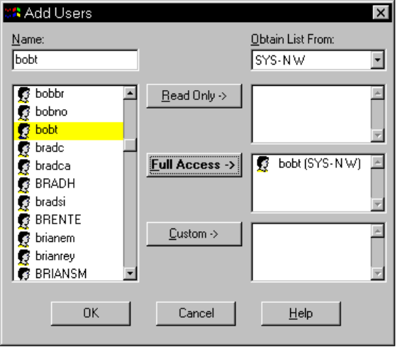
Notice in the illustration above that the list of users shown in the Add Users dialog box is from the SYS-NW server’s bindery. This means two things:
- All user management is done in the name space of the existing NetWare server. The NetWare server is administered using all the same tools that are currently in place; Windows 95 has not added another name space to administer.
- Only valid user accounts and groups can be specified for sharing on File and Printer Sharing for NetWare Networks.

When the computer running Windows 95 receives a connection request from a user attempting to access a shared device, Windows 95 uses the NetWare server to validate the user name or group membership. If the name or group membership is validated, then Windows 95 checks to see if this validated name or group has been granted access rights to the shared resource, and then grants or denies the connection request.

Share Names vs. NetWare Volume Names
When you share a local directory with Windows 95, you must give it a share name to identify it on the network.
- When you share resources on a local hard drive using File and Printer Sharing for NetWare Networks, the share name associated with the shared directory structure becomes a volume name in the Novell designation server/volume or the UNC designation \\server\volume.
- You can use the UNC designation with net commands to connect to and disconnect from either Microsoft networking \\server\sharename shares or NetWare server/volume shares.

Windows 95 does not make this distinction between shares and volumes, because all shares and volumes appear as folders. This distinction becomes important when you use NETX or VLM and NetWare utilities. NetWare does not use or understand the concept of share names. NetWare uses volumes for drive resources and print queue names for print resources.
Therefore, for a shared drive or printer resource to be available to all the different types of clients, when a computer configured with File and Printer Sharing for NetWare Networks shares a drive resource, the share name becomes equivalent to a NetWare volume. When this same computer shares a printer resource, the share name becomes equivalent to the NetWare print queue.
DIRECTORY SHARE NAME ----> VOLUME
PRINTER SHARE NAME ------> PRINT QUEUE

When Windows 95 shares a printer, it shares the Windows SYSTEM directory with the shared resource named PRINTER$ for Point and Print support. This share is now a volume that is visible to real-mode NetWare clients and NetWare utilities.

Using a Master Password
Windows 95 also includes the capability for a master password. The master password in Windows 95 can provide a unified logon for all system components requiring password authentication services, as well as any applications that choose to use the master password services. For example, spreadsheets or databases can use the master key services to keep data secure. These applications would have to be specifically written to the Master Password API. (For more information, see the Windows 95 Software Development Kit.)
The master password associates the user name and password supplied at Windows 95 logon to other authentication-aware programs or system components. However, it’s also possible to maintain separate passwords, when required for higher security. A network administrator can choose to associate other passwords, for example, with vital corporate data access or other sensitive network services.
To define and use a Windows 95 master password
1. From the Passwords Control Panel, click the Change Password tab.
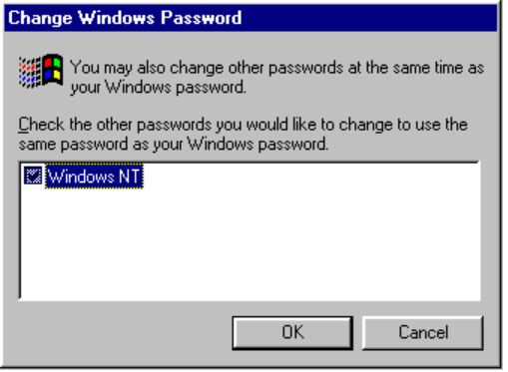
2. Click Change Windows Password.
3. Check the check box for the network you are using. Click OK.
4. Type in the current (old) password, then the newly selected password. Verify the new password. Click OK.

Using the Windows 95 Password Cache
When you use share-level security, a password can be assigned to any shared resource. The password cache stores these passwords in an encrypted file of resources and passwords on a local hard drive. Each resource typically has its own password. If there are 30 shared resources, for example, there will be 30 passwords stored in the password cache.
Having so many passwords to keep track of can a problem for users. Often, they either forget the passwords or write them down and post lists of passwords near their computers. When this happens, the security you put in place is no longer doing the job it was meant to do — to allow access to those who should have it and to deny access to those who shouldn’t.
The Windows 95 password caching solves this problem by storing passwords for resources in the password cache at the time you use the resources. At logon, when you type your logon name and master key password, this cache is unlocked and all the resource passwords stored in the cache are made available. Then, when you need to access a shared, password-protected resource you have accessed before, password cache automatically takes the password from cache and unlocks the resource. To prevent unauthorized access of password files, the cached file can be “unlocked” only by the user’s logon name and password.
If you click the Cancel button while logging on to bypass the logon screen (and validated logon is not required), the cache will not be opened and you will be prompted for a password each time you attempt to use a protected device.
When you access a password-protected resource for the first time, you can check Save This Password In Your Password List to save your password in a cached password file.
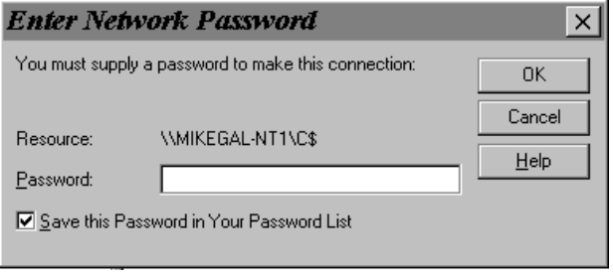
Password caching builds the password file as you type new passwords. When a password for a specific resource has been cached, Windows 95 automatically uses that password for you the next time you want to access that resource. The password cache works for any resource that requires a password, but it works only from within Windows 95.

Passwords can contain up to 14 characters and must not contain spaces or punctuation marks.
Note

The password cache is stored in the *.PWL files in the Windows directory. Passwords for network connections are stored encrypted in the SHARES.PWL file. Passwords are encrypted using the Data Encryption Standard (DES) algorithm. A non-encrypted password is never sent across the network.

If you delete the *.PWL files, you will lose all previously listed passwords. You will need to retype each password.
Caution

With the Windows 95 customized password cache, users can determine which passwords they want keyed to their master password and which they want entered separately. For example, a user can choose to cache passwords for the main directories and printers used, but not cache passwords for Microsoft® Mail or Microsoft® Schedule+, or for networks occasionally accessed.

Setting Password Policy
A good password policy helps users protect their passwords from other individuals. This helps to reduce the probability of someone logging on with another user’s password and gaining unauthorized access to data.
The following guidelines should help you create a basic security policy:
- Tell users not to write down their passwords.
- Tell users not to use obvious passwords such as their name, their spouse’s name, the names of their children, and so forth.
- Do not distribute user accounts and passwords in the same communication. For example, if administrators are sending a new user’s account name and password in writing, send the user name and the password at different times.

The following Windows 95 features can be used to enforce a password policy and thus provide better protection for unauthorized use of passwords:
- When a new account is created, force the user to change the password at the first logon. This will ensure that the administrator or supervisor does not know the user’s password.
- Enforce a reasonable minimum password length and, hence, increase the number of permutations needed to randomly or programatically guess someone’s password. Additionally, you can enforce an alphanumeric password combination to achieve the same security.
- Enforce maximum and minimum password age. A maximum password age protects against the possibility that someone may be looking over a person’s shoulder over a period of time and learn the password by remembering the keystrokes. A minimum password age prevents a user from immediately reverting back to a previous password after a change.
- Enforce password uniqueness and maintain password history. This prevents users from toggling between their favorite passwords. Administrators can specify the number of unique passwords that a user must have before that user can use a password that has been used.

For more information about setting policies, see Chapter 12, “System Management.”

Windows 95 Security for Remote Administration
Windows 95 includes features that enable you to remotely administer network computers. So that you can control who can access and modify computer settings remotely, you should add a password for remote administration, as described in the following procedure. For more information on remote administration, see Chapter 12, “System Management.”
To set a password for remote administration on a computer with share-level security
1. From the Passwords Control Panel, click the Remote Administration tab.
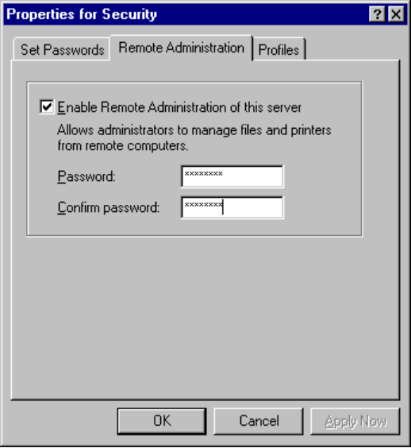
2. Check the Enable Remote Administration... option.
3. Type and confirm the password for remote administration. Click OK.

To set a password for remote administration on a computer with user-level security
1. From the Passwords Control Panel, click the Remote Administration tab.
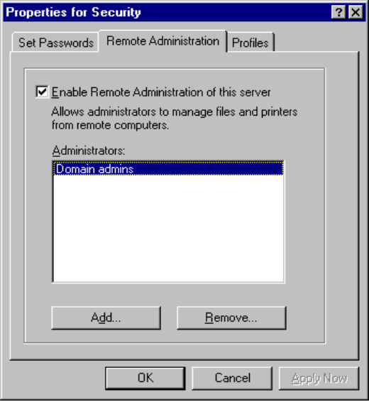
2. Check the Enable Remote Administration... option.
3. Click Add, and then specify which users have Remote Administration permissions.
4. Click OK.

For information about remote administration and Windows 95 remote administration tools, see Chapter 12, “System Management.”

Troubleshooting Security Issues

I want to share a printer or directory, but can’t find the sharing options.
Right-click the icon for the printer or directory you want to share. Sharing should be listed. If it is not, do the following:
1. From the Network Control Panel, click Add.
2. Click Services, and click Add.
3. Click Microsoft in the left pane, and click the appropriate file and print sharing service in the right pane. Click OK.
4. From the Configuration property sheet, click File and Print Sharing and enable one or both options. Click OK.

